Digital Health and Care Wales
NHS Wales Websites CMS Service

NHS Wales Websites CMS: October 2026 Release Notes | Release ID: 1022

Releases
Log a release.
Proposed (5)
Awaiting Build & Test (0)
Awaiting SIT (0)
Awaiting OAT (0)
Awaiting RT (0)
Ready to Deploy (0)
Deployed (0)
Aborted (0)
All (5)

Closed
Schedule of change
Calendar
Historic record of change
List options
Release Logged Title Release ID Release Date Owner Related deployment changes Related release changes Related Services
815

Releases
Log a release.
Proposed (5)
Awaiting Build & Test (0)
Awaiting SIT (0)
Awaiting OAT (0)
Awaiting RT (0)
Ready to Deploy (0)
Deployed (0)
Aborted (0)
All (5)

Closed
Schedule of change
Calendar
Historic record of change
List options
Release Logged Title Release ID Release Date Owner Related deployment changes Related release changes Related Services
815

These Release Notes describe the scope and content of
Release ID: 1022 for the NHS Wales Websites CMS Service

Version: | 0.3
Status: | Final
Owner: | DHCW Corporate Apps Team
Author: | DHCW Corporate Apps Team
Approver: | DHCW Corporate Apps Team

Date: | 20/08/2026
Next Review Date: | 14/10/2026

1 DOCUMENT HISTORY 4
1.1 Revision History 4
1.2 Authorisation 4
1.3 Document Location 4
2 INTRODUCTION 4
3 RELEASE NOTES REQUIREMENT 4
3.1 Release Identification 4
3.2 Description of New or Modified Functionality 5
4 Summary 22
4.1 Problems Fixed 22
4.2 New Problems Identified During Testing and Associated Workarounds 23
4.3 Pre-requisites to Deploy the Release 23
4.4 Training Requirements 23
4.5 Step-by-Step Deployment Instructions 23
4.6 Deployment Plan 23
4.7 Back-Out Plan 23
4.8 Release Available for Deployment Date 23

DOCUMENT HISTORY

Revision History
Date | Version | Author | Revision Summary
20/08/2026 | 0.1 | DHCW Corporate Apps Team | Document created for the NHS Wales Websites CMS Release
02/10/2026 | 0.2 | DHCW Corporate Apps Team | Example images updated
14/10/2026 | 0.3 | DHCW Corporate Apps Team | Finalize Notes

Authorisation
The signing of this document indicates acceptance of its contents.
Author’s Name: | DHCW Corporate Apps Team

Approver’s Name: | DHCW Corporate Apps Team

Document Location
Type | Location
Electronic | NHS Wales Websites CMS Support Site – What’s New

INTRODUCTION
The NHS Wales Release Management Policy considers that effective Release Management is essential for protecting the integrity of the operational environment. A key objective of the release process is to ensure that users, support staff and other stakeholders are kept informed as to what is planned and how this will affect them. One of the ways that this can be achieved is through the publication of release notes prior to the deployment of the Release.
These notes contain information on the agreed scope and content of Release ID CMS/05-2026 for the CMS descriptions of new or modified functionality and problem fixes, descriptions of new problems and workarounds identified during the testing of this Release, training requirements, deployment instructions, references to deployment and back-out plans and key dates within the release process.

RELEASE NOTES REQUIREMENT

Release Identification
1022 - CMS/05-2026

Description of New or Modified Functionality

Item | Description of the Change | Requestor
Bug Fixes
3.2.1 Buttons Collection Icon Fix | An issue was identified where the Arrow icons for the Buttons Layout were instead displayed as lines on the Safari browser for iPhones.  A fix has now been implemented, so the arrows will display correctly across all mobile browsers.  Before: After:  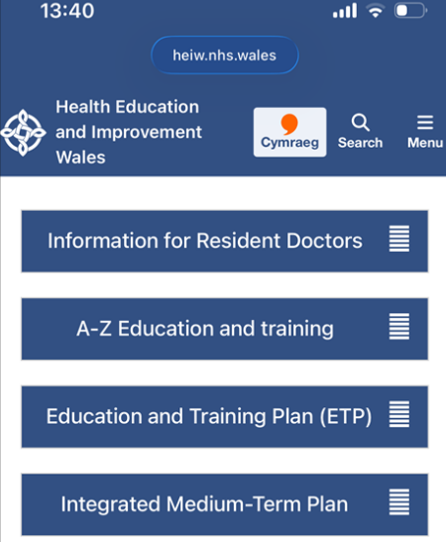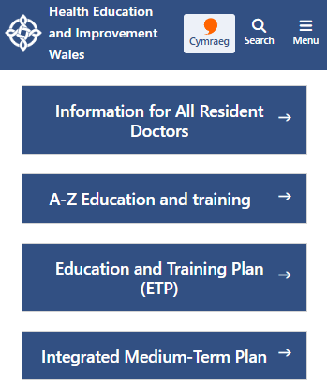  See the CMS Support Site for more information on the Buttons Layout | CMS Support Team
3.2.2 Section List – Fix Text Colour Issue | It was identified that when a text colour was applied to a Section List layout, some content did not update consistently.  This has now been improved so that all headings and bullet-point text within the layout automatically use the selected text colour.  Before: After:  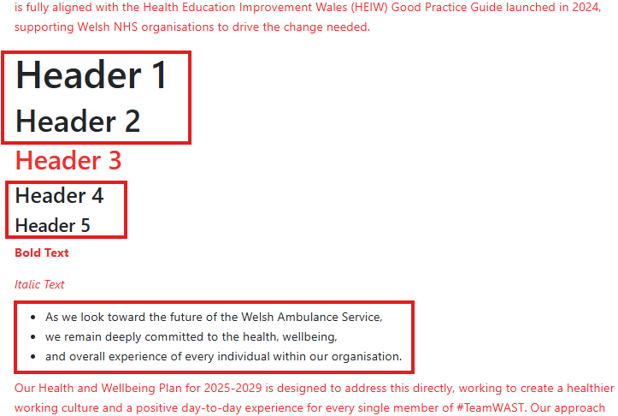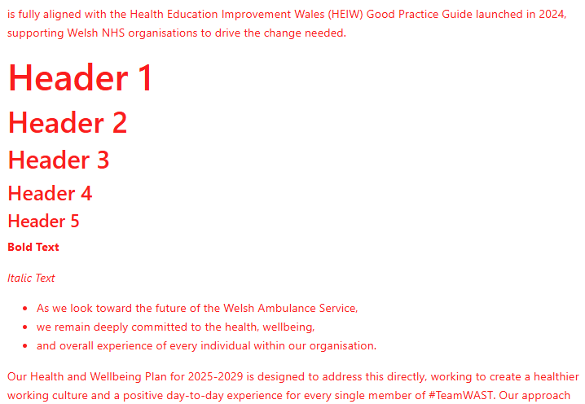  See the CMS Support Site for more information on Section List | CMS Support Team
3.2.3 Filter By – Fix Tabs in Mobile View | It was identified that the Tab button text on Filter by Category did not wrap correctly in Mobile and cut off the text at the end.  We have implemented a fix so that long tab title text will wrap onto multiple lines instead of one long line.  Before: After:  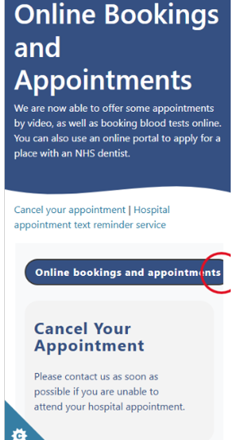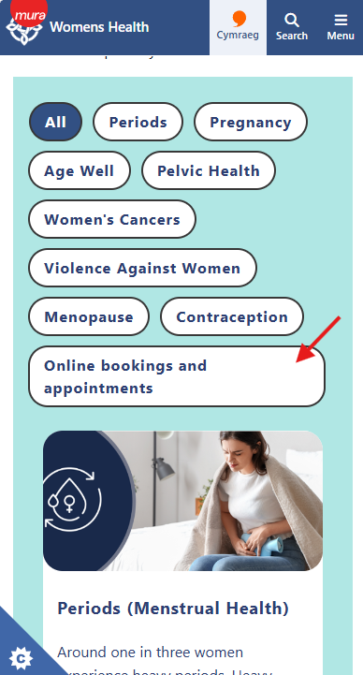  See the CMS Support Site for more information on the Filter by Category | CMS Support Team
3.2.4 Cookie Controller Fix | An intermittent issue was discovered with the Cookie Controller Panel, where the Website Usage Cookies section would disappear. A fix has now been implemented to make sure these items always appear within the panel.  See the CMS Support Site for more information on the Cookie Controller | CMS Support Team
3.2.5 Fix Acronym Tooltip to not show NULL | An issue was identified when clicking on and off the acronym description tool. At first, it would display the acronym description, but if you clicked off and clicked BACK into the text, the description would display with NULL instead.  A fix has now been implemented, so that the acronym description text will display correctly once a user clicks back to it.  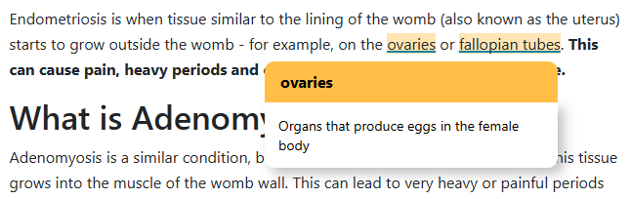  See the CMS Support Site for more information on the Acronym Tool | CMS Support Team
3.2.6 Accordion 2 – Fix Colour Link | A fix has now been implemented for the Accordion 2 text colours and links, so that it now matches the behaviour of Accordion 1.  All default text will appear black, with linked text displaying as hyperlink blue. However, if Admins choose to amend the Content text colour within the Accordion settings, all the text including links will change to the new set colour.  Accordion 2 Example:  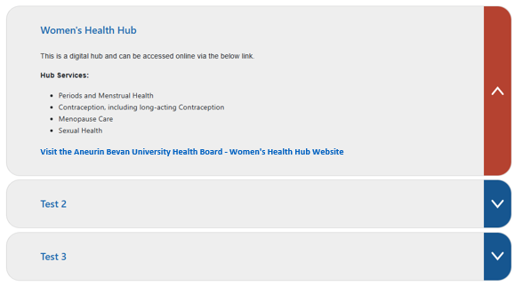  See the CMS Support Site for more information on Accordion 2 | CMS Support Team
3.2.7 Buttons Collection Layout Update | We have now resolved an issue where longer button titles could appear misaligned on mobile devices. Button text is now centred consistently across all screen sizes.  Before: After:  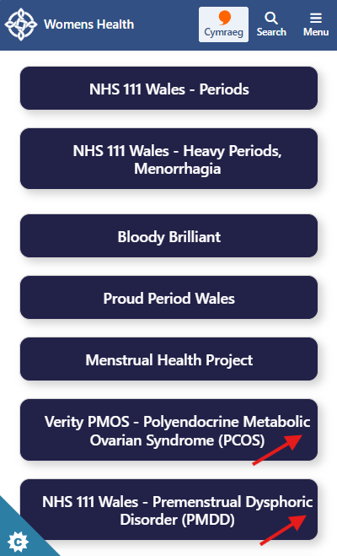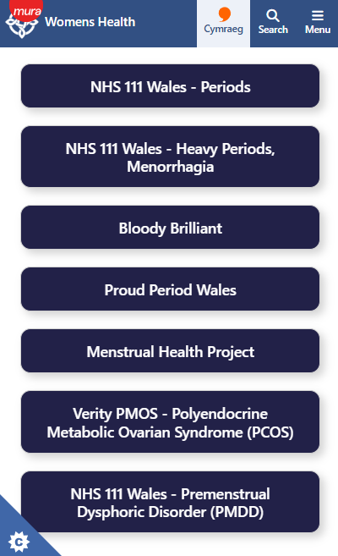  See the CMS Support Site for more information on the Buttons Layout
Plugin & Layout Updates
3.2.8 New Functionality - View Enlarged Image | New Visual Indicators have been applied to the Image Plugin, to help users quickly identify when an image can be enlarged or opened in a new window. When users hover over an image, the relevant icon becomes more prominent, providing a clearer indication of the available action.  Available indicators:  - Magnifying Glass – Indicates the image can be enlarged.  - Open in New Window – Indicates the image can be viewed in a separate browser window.  Example: Both icons in use, when a user hovers over the image the icons will appear bolder  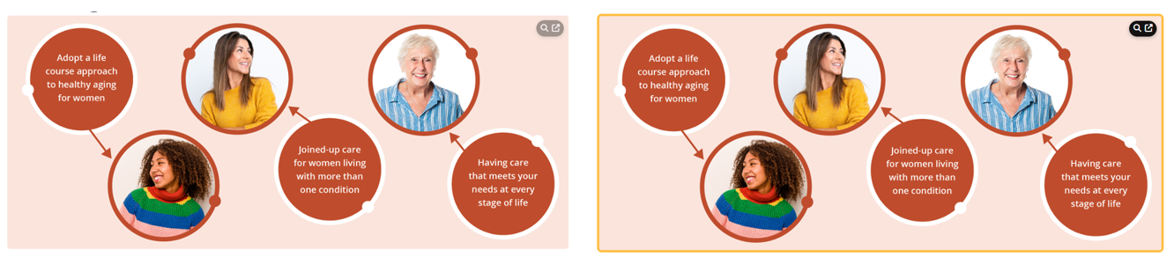  See the CMS Support Site for more information on the Image Plugin | CMS Support Team
3.2.9 New Layout – Multi Content Display 8 | We have created a new layout - Multi Content Display 8.  MCD8 highlights include:  - Three image shape options: Square, Rounded, and Circular  - Customisable colour settings  - Interactive hover effect  - Scrollable navigation arrows for improved content browsing  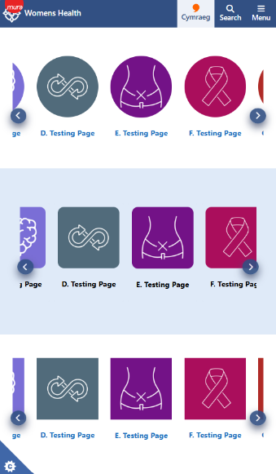  Desktop Example: Rounded Corners Mobile Example:  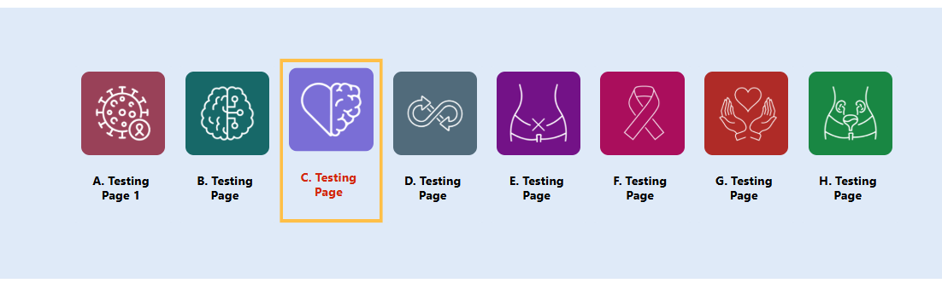  Desktop Example: Scroll Bar Arrows  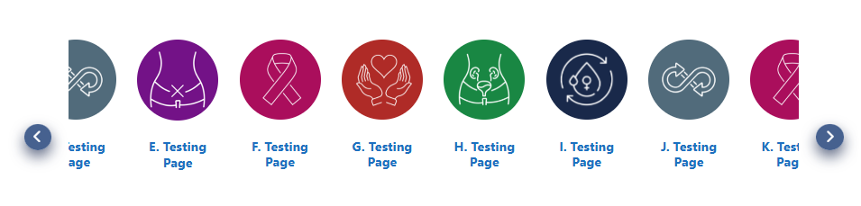  See the CMS Support Site for more information on Multi Content Display 8 | CMS Support Team
3.2.10 Grid Layout – Add Padding in Mobile View | In Mobile, the Grid Title text and image were very close together, so it wasn’t very clear which image the title was associated with.  We have now applied some padding so that each Grid item has the appropriate spacing between them.  Before: After:  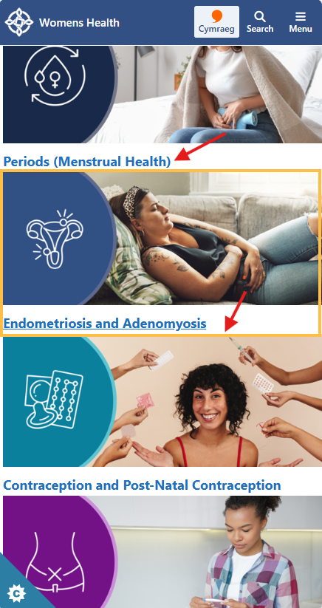  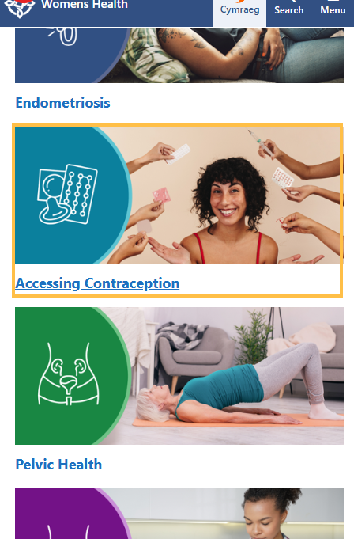  See the CMS Support Site for more information on Grid Layout | CMS Support Team
3.2.11 Multi Content Display 7 – Update Scroll functionality for Mobile | We have updated the Multi Content 7 scroll functionality in Mobile Display.  Previously, it would display as a scroll bar. This has now been updated to Scrollable arrows with customisable colours and a drop shadow.  Before: After:  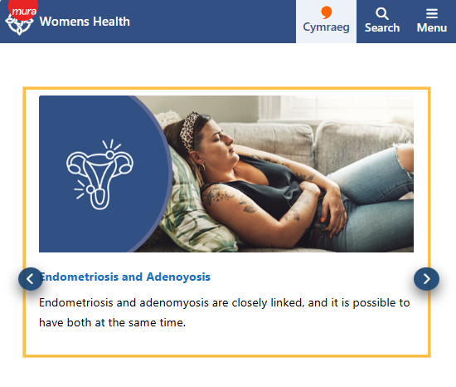  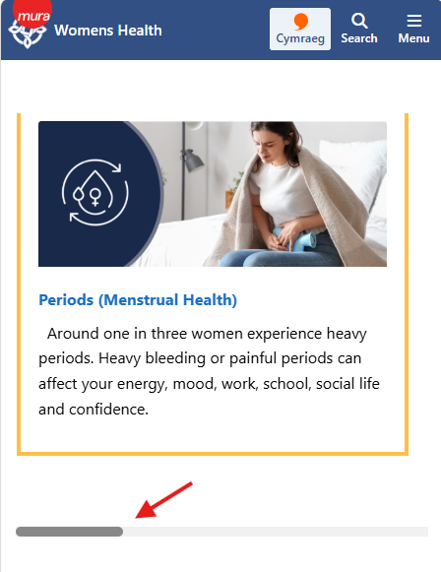  See the CMS Support Site for more information on Multi Content Display 7 | CMS Support Team
3.2.12 Filter by – Improve Jump Feature | An improvement has been made to the Jump to Items’ option within the Filter by Category layout.  The new update will now display the full first item once a category tab is selected, whereas previously it would only show only most of the top half.  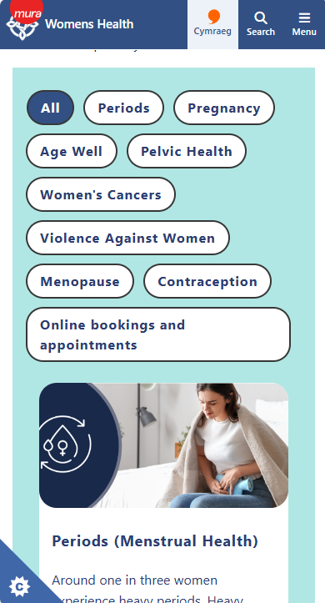  Before: After: Pre-selection Filter Selected  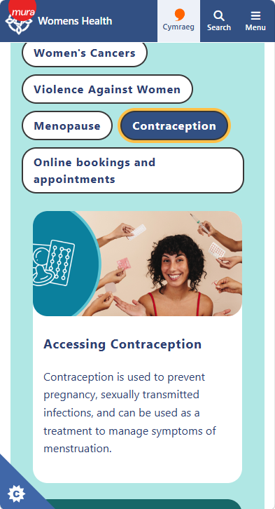  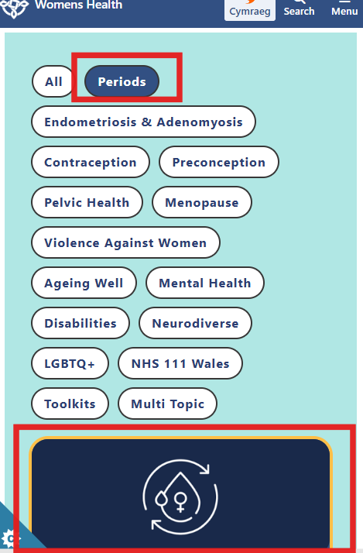  See the CMS Support Site for more information on the Filter by Category | CMS Support Team
3.2.13 Filter by Category - Separate Scrollable Options | We have updated the Scrollable arrow settings for the Filter by Category Layout.  Previously, the scrollable arrows would apply to all devices. Admins can now manage scrollable content and tab scrolling separately for Desktop and Mobile devices.  Previous Settings: New Settings:  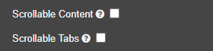  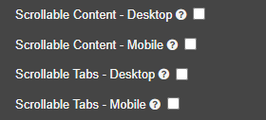  Desktop Examples: Mobile Examples:  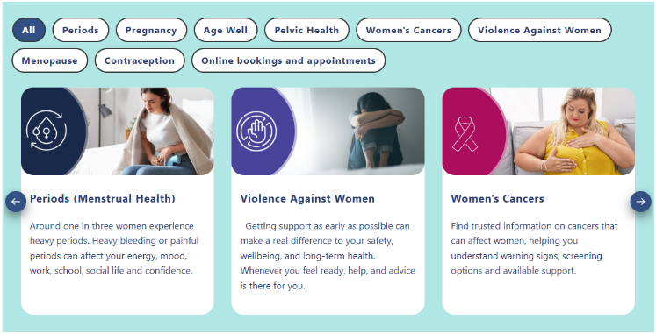  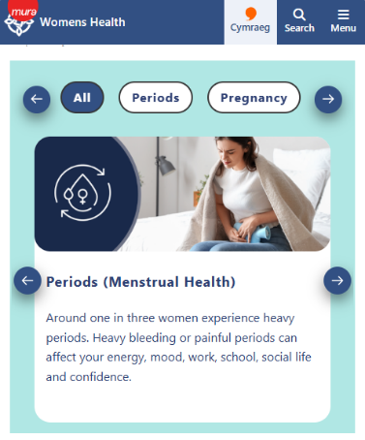  See the CMS Support Site for more information on the Filter by Category | CMS Support Team
3.2.14 Tabbed List – Styling Updates | The Tabbed List layout has been updated with a range of new styling options and visual improvements, including:  - Rounded outer corners  - Additional colour options  - Updated pagination styling  - New pill-style tab design  - Configurable tab text sizes  - Enhanced mobile styling  - Improved spacing and padding  Desktop Example:  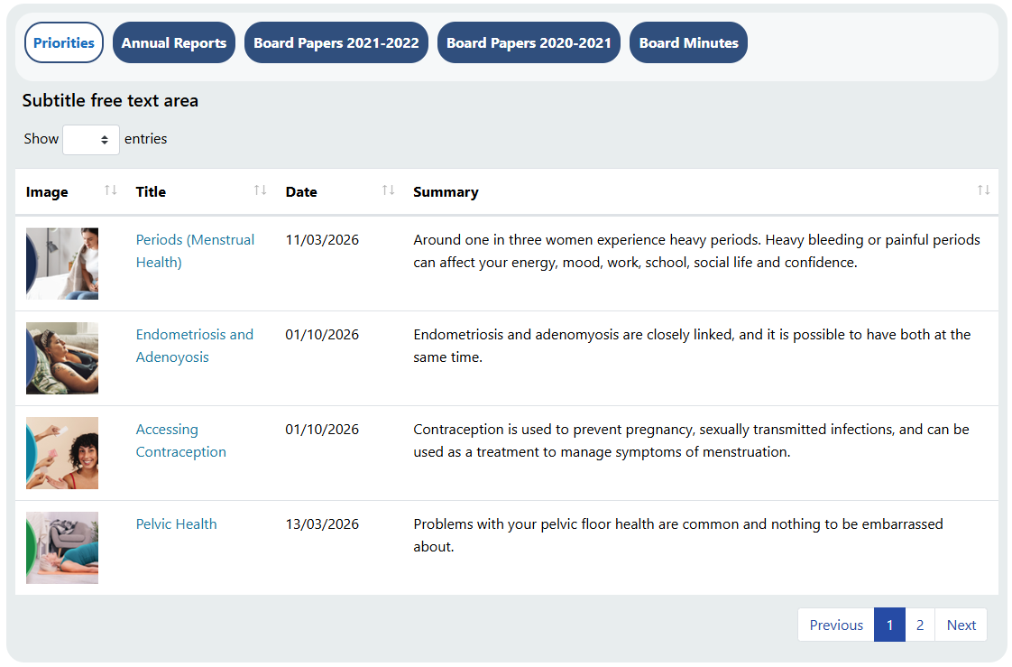  Mobile Example: Unselected Mobile Example: Selected  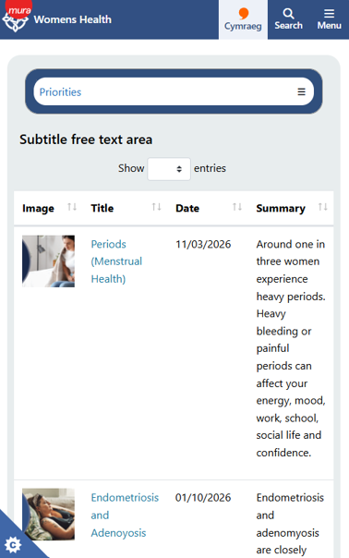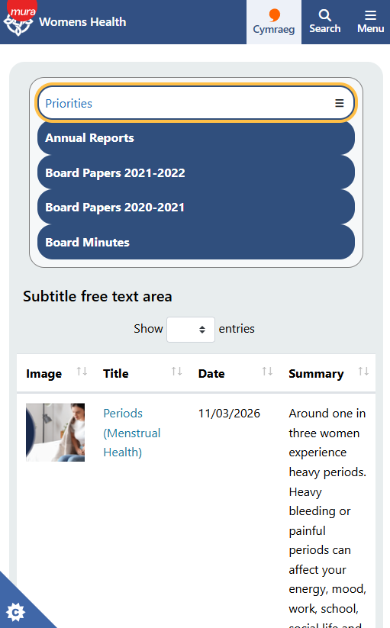  See the CMS Support Site for more information on Tabbed List | CMS Support Team
3.2.15 Header Panel 2 – Image and Wrapped Text Update | Admins can now display an icon on either the left or right side of a Header Panel 2. We've also reduced the spacing around the title area, providing more room for heading text and reducing unnecessary wrapping.  Before:  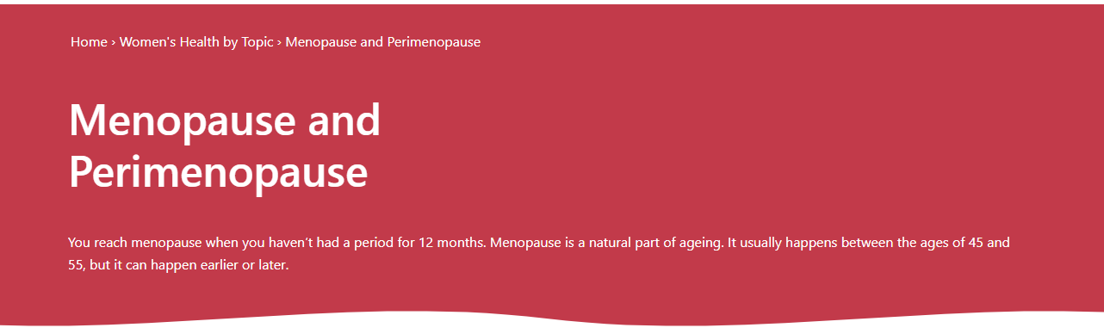  After: Extended text real estate Example  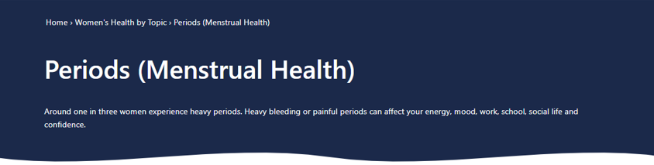  After: Right-hand Icon display Example  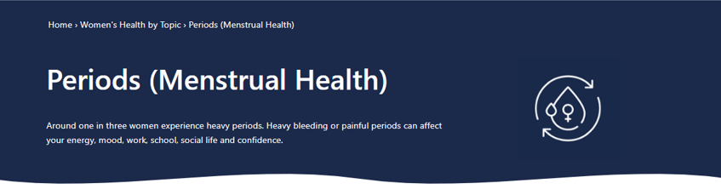  See the CMS Support Site for more information on Header Panel 2 | CMS Support Team
3.2.16 New Layout – Multi Content Display 4 | A new Multi Content Display 4 layout has been introduced, allowing up to 100 content items to be displayed in image-based content cards.  The layout includes options to:  - Configure image sizes  - Customise layout colours  - Display content as Image and Title or Image, Title and Summary Text  - Option to display Category tags  Desktop Example: With Summary Mobile Example:  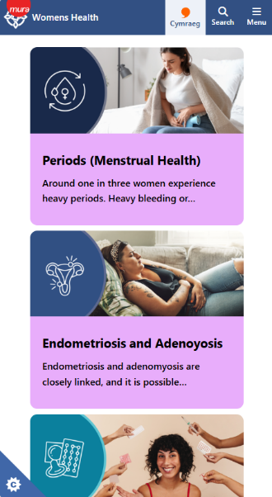  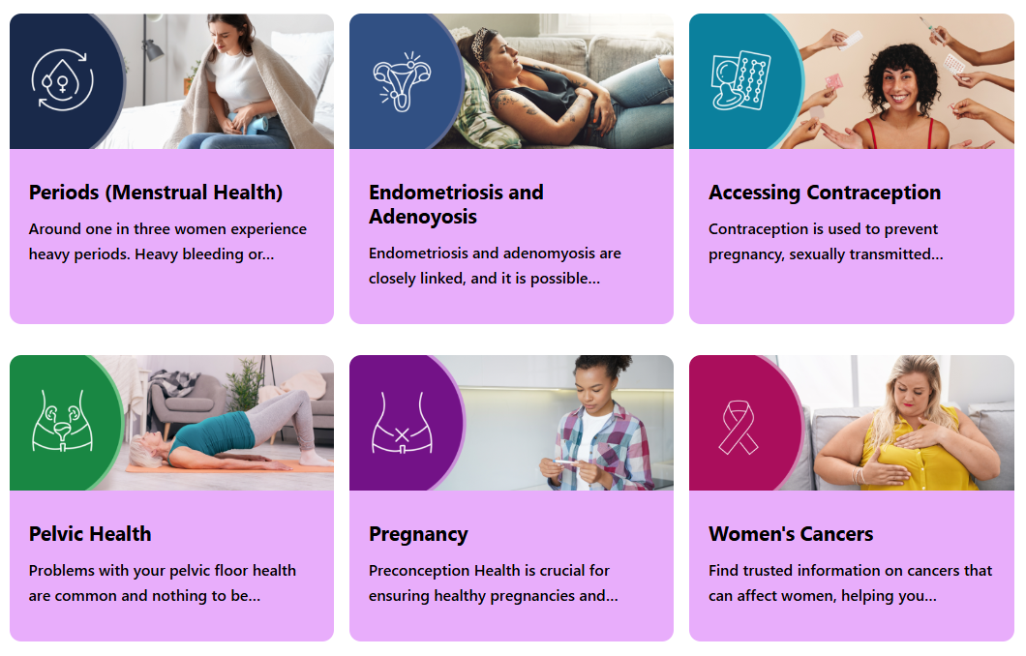  Desktop Example: With Category Tags Mobile Example:  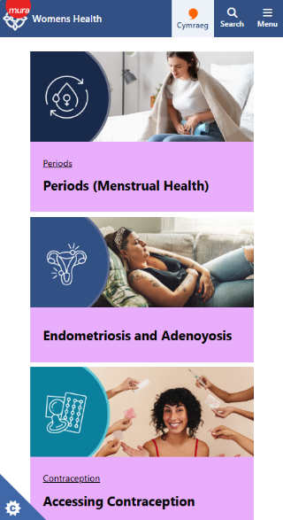  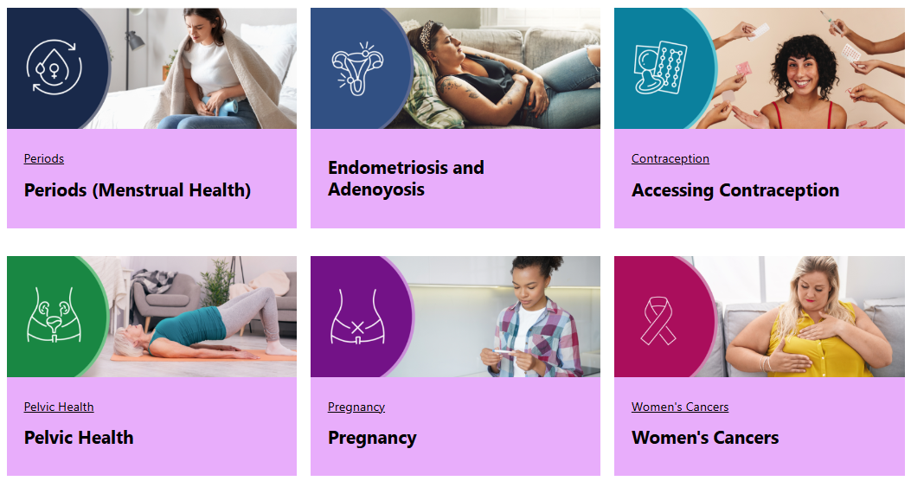  See the CMS Support Site for more information on Multi Content 4 | CMS Support Team
3.2.17 New Layout -Multi Content 5 | A new Multi Content Display 5 layout has been introduced, providing a flexible way to present content in configurable content cards.  Available options include:  - Display Title, Summary, and Image  - Optional More button, with editable text  - Single or multi-column layouts  - Optional rounded corners styling  Desktop Example: With More Button Mobile Example:  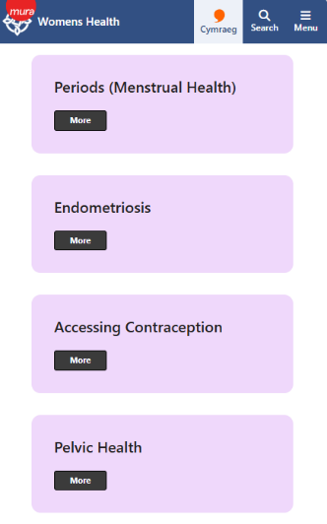  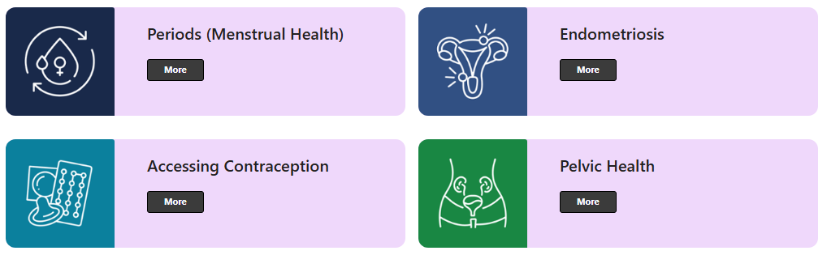  Desktop Example: With Summary Mobile Example:  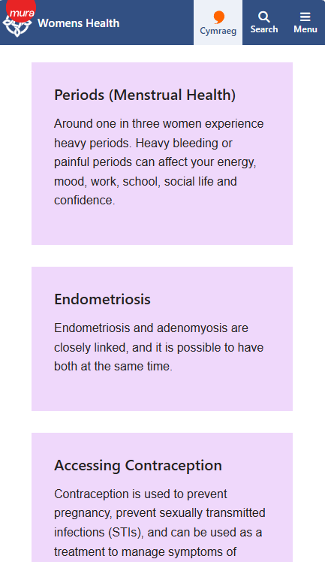  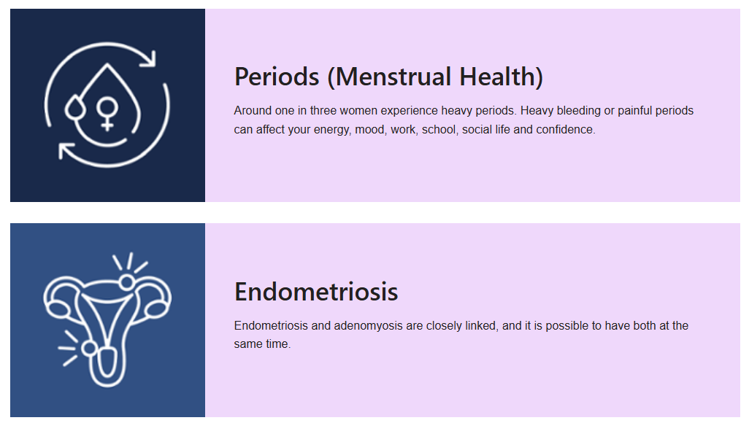  See the CMS Support Site for more information on Multi Content 5 | CMS Support Team
3.2.18 New Layout -Multi Content 6 | A new Multi Content Display 6 layout has been introduced, providing a simple and effective way to highlight key content in styled content boxes.  Available options include:  - Display up to 5 content items  - Show Title and Summary text  - Customisable left border colour  Desktop Example: Mobile Example:  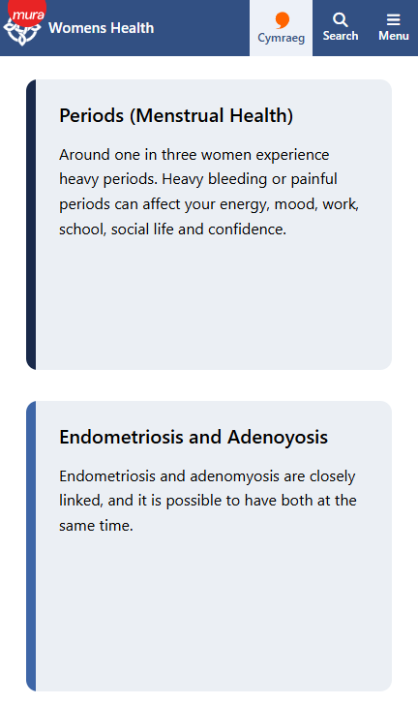  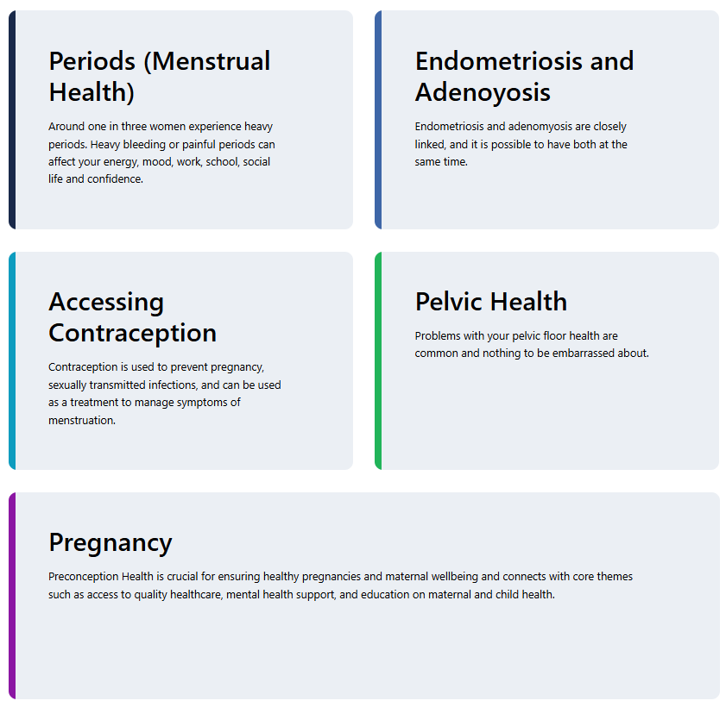  Desktop Example: Mobile Example:  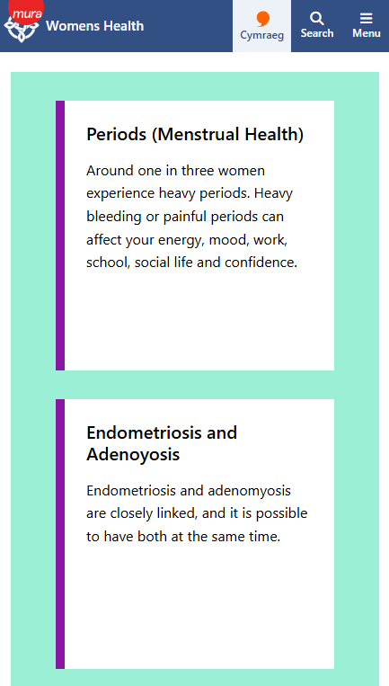  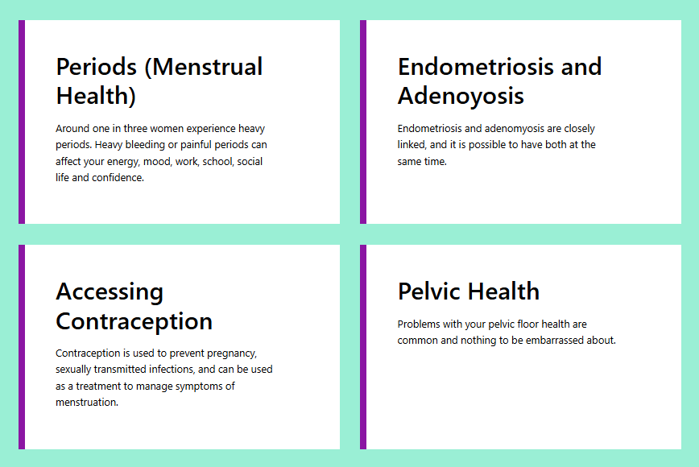  See the CMS Support Site for more information on Multi Content 6 | CMS Support Team
3.2.19 Text Box Plugin –Space/Padding Update | The Text Box layout has been updated with additional Wave Pattern settings, providing greater flexibility over how decorative wave styling is applied.  Example:  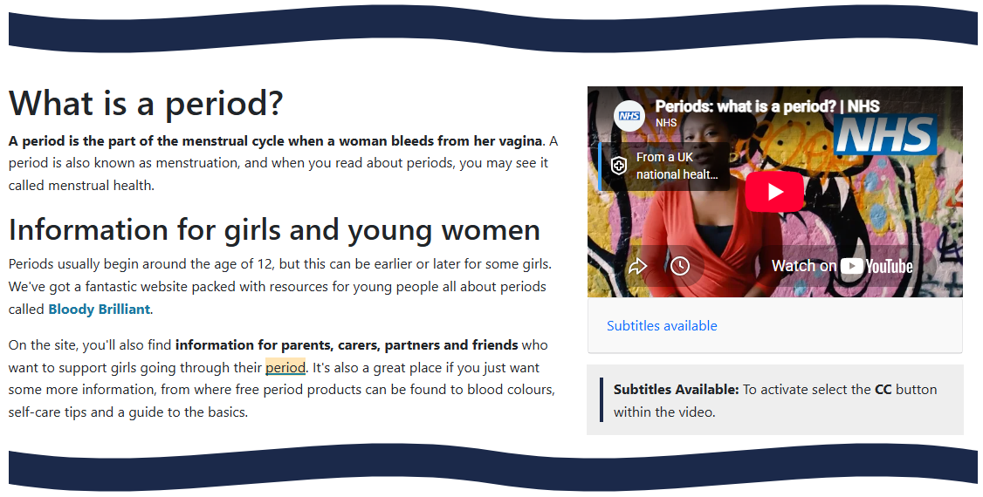  New Settings:  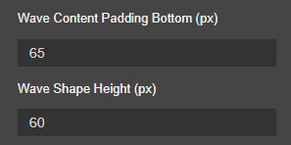  See the CMS Support Site for more information on the Text Plugin | CMS Support Team
3.2.20 Section List – Tabbed Template Update | The font weight of Section List tab titles within the Tabs Template has been increased to improve visibility and make headings stand out more clearly.  This enhancement applies to the desktop view only.  Before:  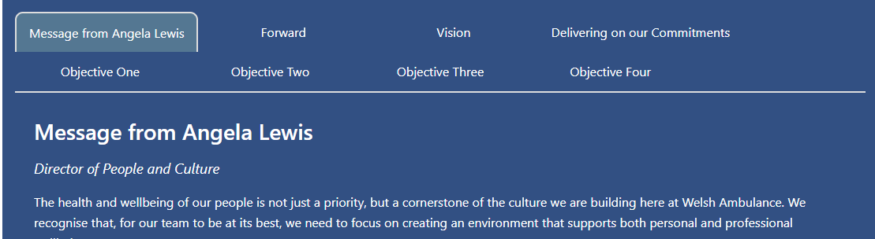  After:  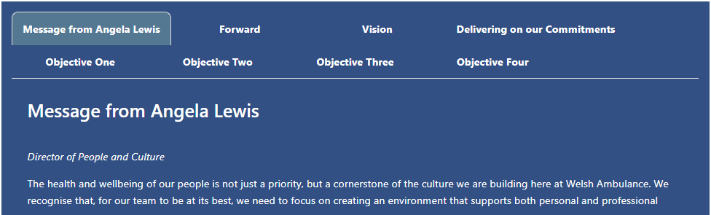  See the CMS Support Site for more information on the Section List Layout | CMS Support Team
3.2.21 Single Button – New Styling Options | We have added a new styling update to the Single Button Layout.  Admins will now have the option to have a pill or square button via the Border Corner setting.  Shape Examples: New Setting:  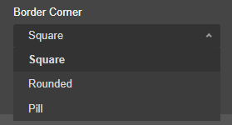  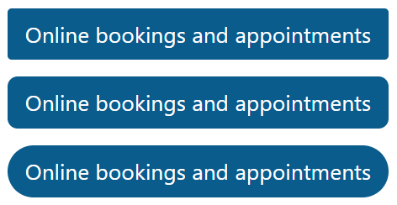  See the CMS Support Site for more information on Single Button | CMS Support Team
3.2.22 Update to the Content Date Display Module | A new option has been added to allow the Date Stamp to be shown or hidden on the homepage. To improve clarity for visitors, the homepage will now display only the Last Updated date when the Date Stamp is enabled.  New Setting:  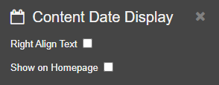  Example – Homepage Display:  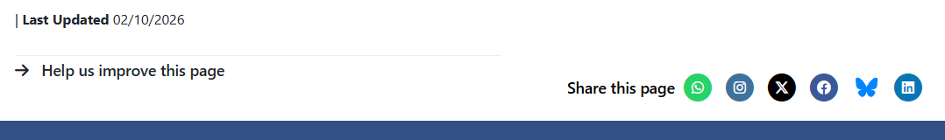  See the CMS Support Site for more information on Content Date Display
Accessibility Standards
3.2.23 Accessibility Fixes | Several Accessibility issues were reported after an Axe tool review from BCUHB. The following issues have now been addressed:  - Elements should not have tabindex greater than zero  - Document should have one main landmark  - Landmarks should have a unique role or role/label/title (i.e. accessible name) combination  - All page content should be contained by landmarks  See the CMS Support Site for more information on Accessibility Best Practice | BCUHB
3.2.24 Update Label for ‘Transcript’ in Video Module | We have updated the Transcript box on the Video Plugin. The config setting has been updated to ‘Transcript Label‘ and the default Transcript text displayed on the plugin is now amendable.  Before: Updated Setting:  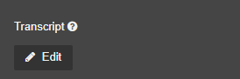  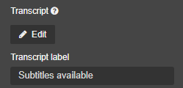  Collapsed Transcript Example: Expanded Transcript Example:  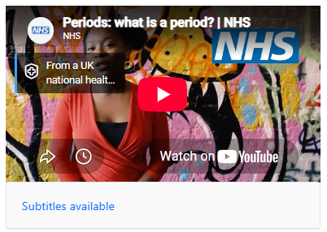  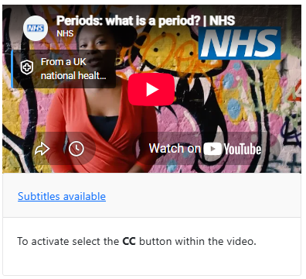  See the CMS Support Site for more information on the Video Plugin | CMS Support Team
3.2.25 Buttons Layout – Mobile Background Colour Fix | It was identified that Button background colour on a mobile device adds an opaque background, failing accessibility against the button link text.  This has now been updated so the background active colour sets as white, which passes accessibility with the blue link active colour.  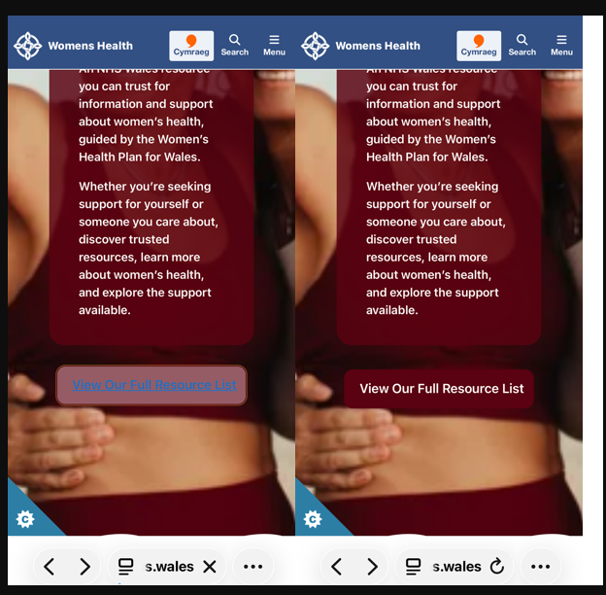  See the CMS Support Site for more information on the Buttons Layout | CMS Support Team
3.2.26 Multi Content Display 7 – Visual Indicator Fix | It was identified that the Yellow Indicator box for Multi Content 7 was cutting off across the top. A fix has now been applied to ensure the full box is always visible.  Before: After:  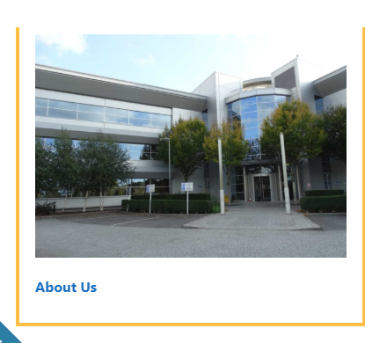  See the CMS Support Site for more information on Multi Content 7
Welsh Language Standards
3.2.27 Update Mobile Language button size | The height of the Cymraeg and English button link has been updated to match the Search and Menu links for consistency. This applies to the NHS and HDHC Themes in Mobile.  Before:    After:    See the CMS Support Site for more information on Welsh Language Standards | CMS Support  Team
3.2.28 Update EN Language Button Icon | During a discussion in the CMS Working Group, it was raised that the EN icon in Mobile was too similar to the Cymraeg Speech Bubble Icon. This has now been replaced with the approved ‘EN’ icon.  Before:    After:  See the CMS Support Site for more information on Welsh Language Standards | CMS Working Group
System Updates
3.2.29 Update NHS Wales Top Header Links | It was identified that the website Header Links still used the old wales.nhs.uk links, that would then re-direct to their equivalent nhs.wales website.  A script has now been run to update all the header links in one go, so that the wales.nhs.uk links are replaced with the nhs.wales URLs.  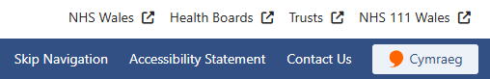  See the CMS Support Site for more information on Header Links | CMS Support Team
3.2.30 Site Search Update for Mobile | Following the recent Site Theme updates, for consistency we have now modernised and updated the Mobile Site Search.  The new search will have rounded fields, the background colour has been updated to match the blue mobile Header, and the colours have been updated from the gradient theme to the NHS blue.  Before: After:  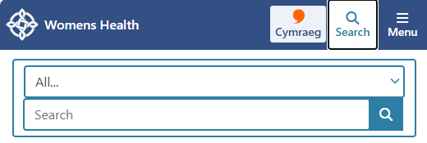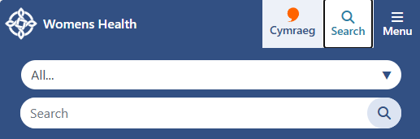  See the CMS Support Site for more information on the Site Search | CMS Support Team
3.2.31 Cookie Controller – Theme Colour Update | We have updated the colours within the Cookie Controller to match the NHS Wales Blue Theme update recently made on the websites.  Before: After:  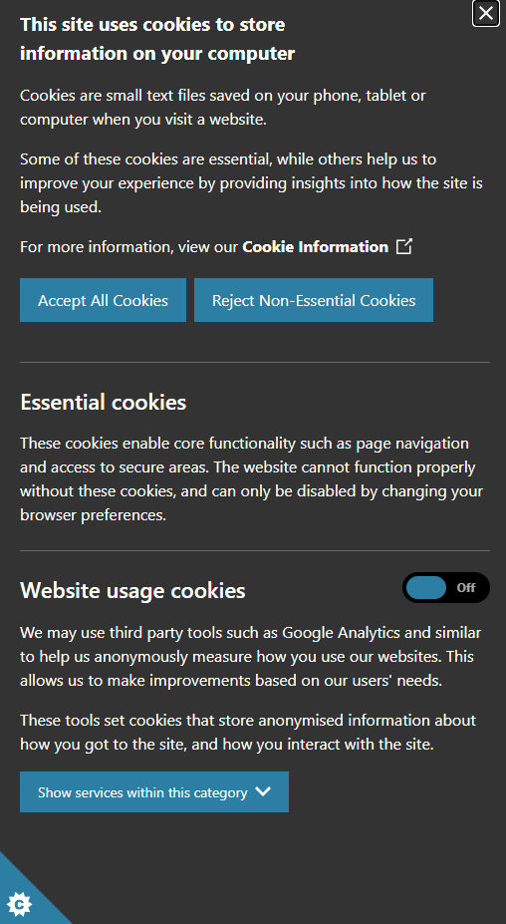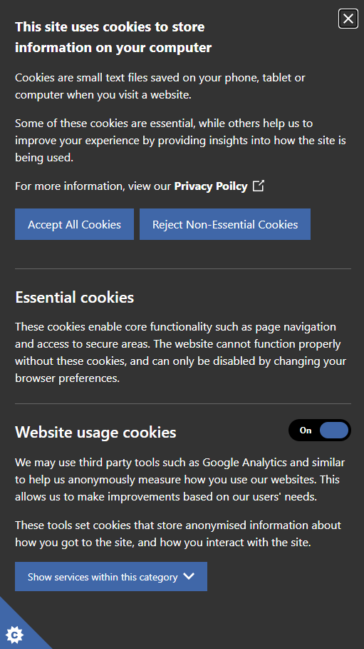  See the CMS Support Site for more information on the Cookie Controller | CMS Support Team

Summary
Number of Changes
31
Bug Fixes | Plugin & Layouts | Accessibility Standards | Welsh Language Standards | System Updates
7 | 15 | 4 | 2 | 3

Problems Fixed
35399 – Cookie Controller Issue
33342 – DHCW Password Protection Issue
34737 – Accordion 2 Text Colour Issue

New Problems Identified During Testing and Associated Workarounds
Testing did not identify any new issues, and no workarounds are currently required.

Pre-requisites to Deploy the Release
There are no pre-requisites for deploying this release. Standard deployment processes can be followed.

Training Requirements
No formal training is required for this release. Users should refer to the CMS Support Site links provided for further details and instructions on the updates and new features listed.

Step-by-Step Deployment Instructions
No Deployment actions required by Health Boards.

Deployment Plan
Changes to be implemented as specified in the Change Record. Release to be deployed via Change Record: 160695

Back-Out Plan
Back out as detailed on the Change record 160695

Release Available for Deployment Date
NHS Wales Websites CMS: Wednesday 21st October, 2026

