Digital Health and Care Wales
NHS Wales IT Service Management

NHS Wales Websites CMS June 2026 Release Notes | Release ID: 1002

Releases
Log a release.
Proposed (5)
Awaiting Build & Test (0)
Awaiting SIT (0)
Awaiting OAT (0)
Awaiting RT (0)
Ready to Deploy (0)
Deployed (0)
Aborted (0)
All (5)

Closed
Schedule of change
Calendar
Historic record of change
List options
Release Logged Title Release ID Release Date Owner Related deployment changes Related release changes Related Services
815

Releases
Log a release.
Proposed (5)
Awaiting Build & Test (0)
Awaiting SIT (0)
Awaiting OAT (0)
Awaiting RT (0)
Ready to Deploy (0)
Deployed (0)
Aborted (0)
All (5)

Closed
Schedule of change
Calendar
Historic record of change
List options
Release Logged Title Release ID Release Date Owner Related deployment changes Related release changes Related Services
815

These Release Notes describe the scope and content of
Release ID: 1002 for the NHS Wales Websites CMS Service

Version: | 0.3
Status: | Final
Owner: | DHCW Corporate Apps Team
Author: | DHCW Corporate Apps Team
Approver: | DHCW Corporate Apps Team

Date: | 22/04/2026
Next Review Date: | 27/05/2026

1 DOCUMENT HISTORY 4
1.1 Revision History 4
1.2 Authorisation 4
1.3 Document Location 4
2 INTRODUCTION 4
3 SERVICE MANAGEMENT BOARD (SMB) 4
4 RELEASE NOTES REQUIREMENT 5
4.1 Release Identification 5
4.2 Description of New or Modified Functionality 5
5 Summary 25
5.1 Problems Fixed 25
5.2 New Problems Identified During Testing and Associated Workarounds 25
5.3 Pre-requisites to Deploy the Release 25
5.4 Training Requirements 25
5.5 Step-by-Step Deployment Instructions 25
5.6 Deployment Plan 25
5.7 Back-Out Plan 26
5.8 Release Available for Deployment Date 26

DOCUMENT HISTORY

Revision History
Date | Version | Author | Revision Summary
22/04/2026 | 0.1 | DHCW Corporate Apps Team | Document created for the NHS Wales Websites CMS Release
18/05/2026 | 0.2 | DHCW Corporate Apps Team | Revised Text and New Images
27/05/2026 | 0.3 | DHCW Corporate Apps Team | Revised Text and images

Authorisation
The signing of this document indicates acceptance of its contents.
Author’s Name: | DHCW Corporate Apps Team

Approver’s Name: | DHCW Corporate Apps Team

Document Location
Type | Location
Electronic | NHS Wales Websites CMS Support Site – What’s New

INTRODUCTION
The NHS Wales Release Management Policy considers that effective Release Management is essential for protecting the integrity of the operational environment. A key objective of the release process is to ensure that users, support staff and other stakeholders are kept informed as to what is planned and how this will affect them. One of the ways that this can be achieved is through the publication of release notes prior to the deployment of the Release.
These notes contain information on the agreed scope and content of Release ID CMS/03-2026 for the CMS descriptions of new or modified functionality and problem fixes, descriptions of new problems and workarounds identified during the testing of this Release, training requirements, deployment instructions, references to deployment and back-out plans and key dates within the release process.

SERVICE MANAGEMENT BOARD (SMB)
The CMS Service Management Board has overall responsibility for ensuring that these Release Notes accurately describe the Release and that it is kept under constant review and updated to reflect any modifications to the Release prior to its deployment.

RELEASE NOTES REQUIREMENT

Release Identification
1002 - CMS/03-2026

Description of New or Modified Functionality

Item | Description of the Change | Requestor
Bug Fixes
4.2.1 Site Map - Cache Fix | It was found that the Site Map still showed offline pages, old page titles and did not display newly created content items hours after they had been updated.  We have now removed the cache on the Site Map, so any content updates will now display on the Site Map automatically.  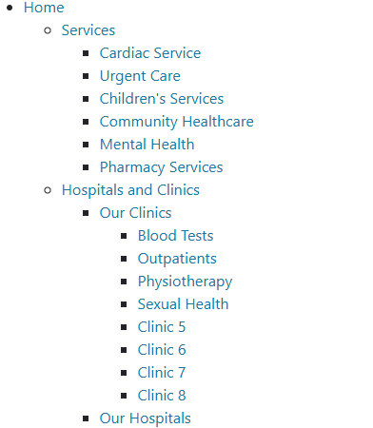  See the CMS Support Site for more information on the Site Map | HDUHB
4.2.2 Google Map Plugin - Journey Planner Fix | A bug was identified with the Google Maps plugin, where if more than one Journey Planner were displayed on a page or within accordions, the Journey Planner Find button would not work.  A fix has now been implemented, so that the Journey Planner Find button will work with two or more Google Maps on a Page/Accordion page.  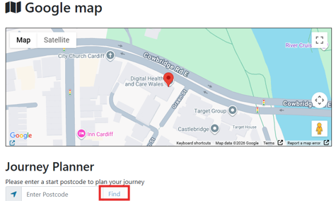  See the CMS Support Site for more information on Google Maps | CMS Support Team
4.2.3 Accordion 2 – Text Size Fix | A text size issue was identified within the Accordion 2 layout. Any text that had been added in a bullet point list or div would display in varied sizes compared to the rest of the accordion text.  A fix has now been implemented, so that all text within the accordion, including any bullet point or div text will now display in the same size.  Before:  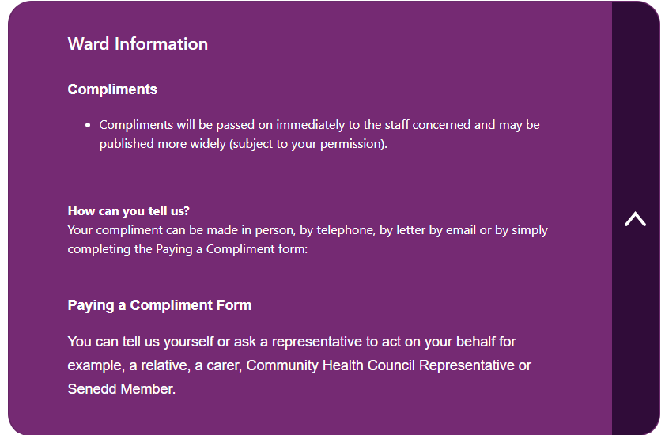  After:  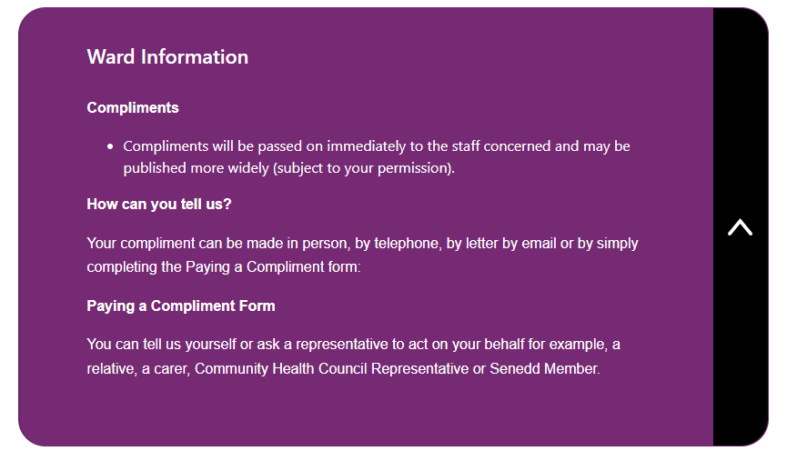  See the CMS Support Site for more information on Accordion 2 | CMS Support Team
4.2.4 Accordion 2 – Mobile Display Fix | An issue was identified with the Accordion 2 layout when viewed in Mobile. The tab title and content displaying within the Accordion would appear squished and tight.  The spacing and layout have now been improved, with reduced padding and a narrower right-hand arrow bar, to allow content to display clearly on Mobile.  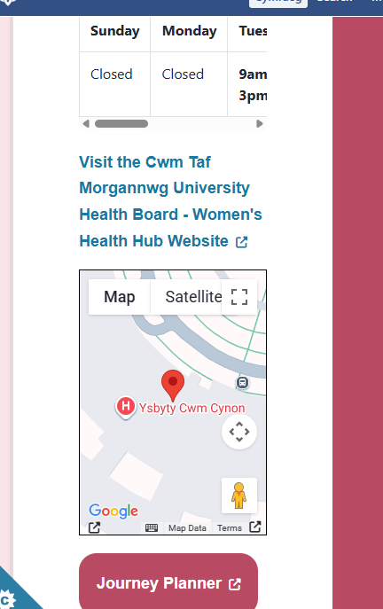  Before: After:  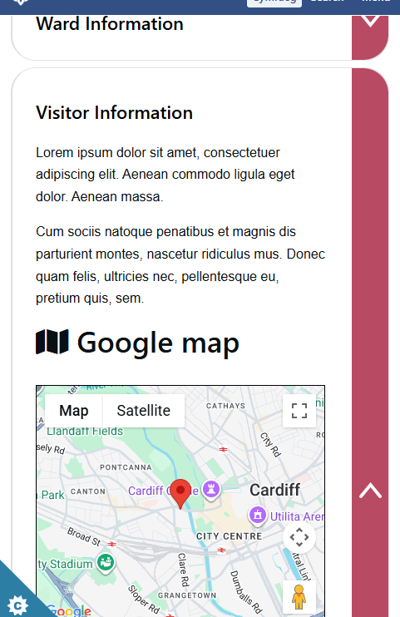  See the CMS Support Site for more information on Accordion 2 | CMS Support Team
4.2.5 A-Z Collection – Letter Tab Fix | An issue was found in the A-Z Collection layout for the Welsh sites, where specific characters were highlighted as having content in the tabs, but when selected there was no assigned content beginning with that letter.  We have now implemented a fix, so the letters only highlight when there is content available.  See the CMS Support Site for more information on the A-Z Collection | CMS Support Team
Plugin & Layout Updates
4.2.6 Filter by Category – New Scrollable Features | We have added new functionality options to the Filter by Category layout.  Admins will now have the choice to add a scrollable feature to the Category tabs and the Content items. The scroll feature will add horizontal arrow buttons, allowing site users to scroll through the tabs and/or content items instead of using the pagination. The arrow colours can also be customised, with the option of adding a drop-shadow.  New Configurator settings and display:  - Scrollable Content  - Scrollable Tabs  - Show Shadow on Scrollable Arrows  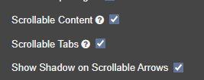  New Custom Colour Options (Available under the Style Tab > Colour Options):  - Arrow Colour  - Arrow Background Colour  - Shadow Colour  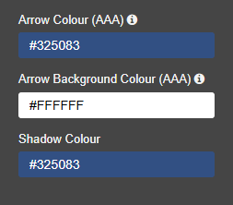  Desktop Display Example  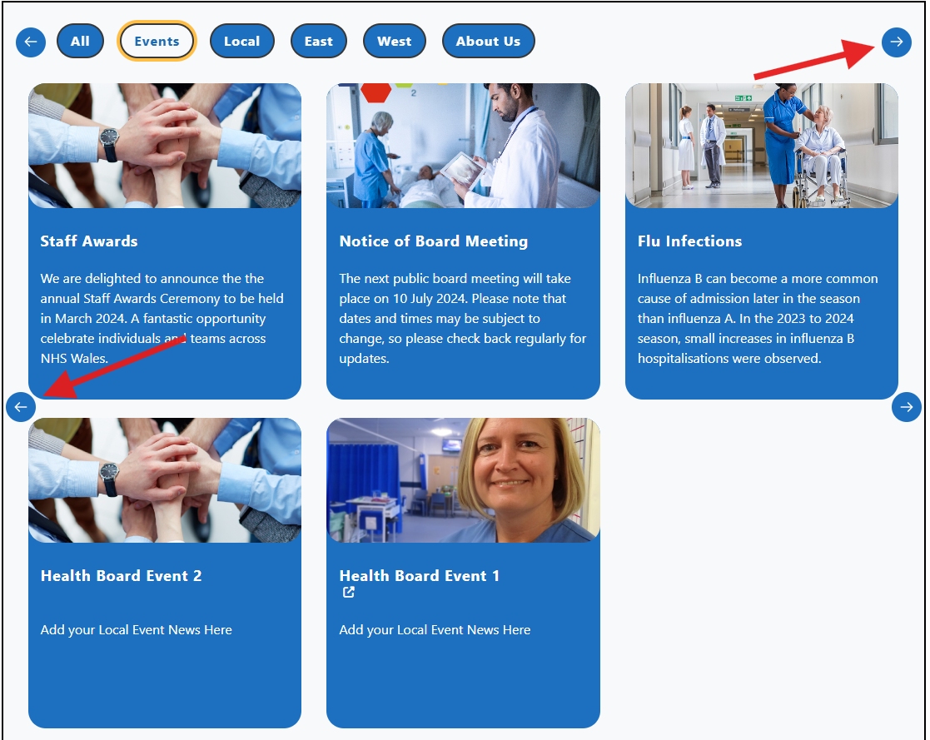  Mobile Display Example  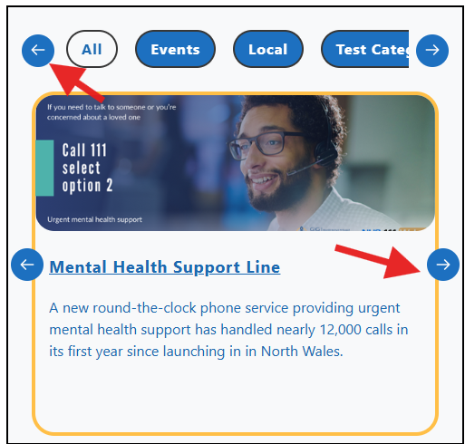  See the CMS Support Site for more information on the Filter by Category | CMS Support Team
4.2.7 Header Panel 2 Plugin – Background Image for Wave Effect | We have now added the ability to include an image for the Header Panel 2 plugin wave effect.  This option is already available for the Header Panel 2, but it was not configured to work alongside the Wave Effect. This update will allow the image to fill the whole wave panel.  The image can be added via the Style tab > Content > Background Image  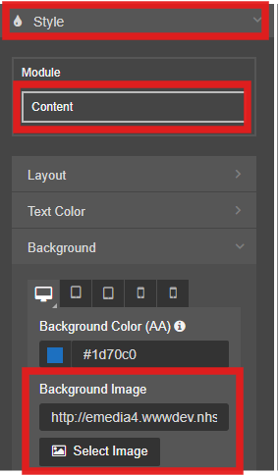  Example:    See the CMS Support Site for more information on Header Panel 2 | CMS Support Team
4.2.8 Directory of Service (DOS) Plugin – Service Finder Styling | We have now added new colour styling options to the Directory of Services (DoS) plugin, for the Service Finder layout.  Admins are now able to choose:  - The Title Text Colour  - Title Background Colour  - Main Background Colour  Custom Colour Settings:  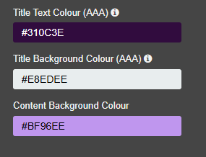  Example:  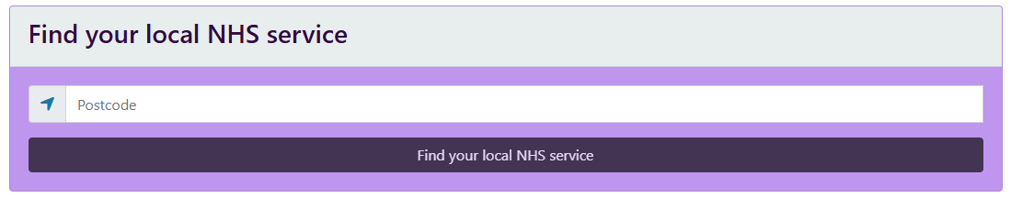  See the CMS Support Site for more information on the Directory of Services Plugin | CMS Support Team
4.2.9 Link Organiser Layout – Styling Updates | We have added new styling updates to the Link Organiser layout.  The new configurator settings include:  - Border Corner – Admins will now be able to give the Link Organiser either rounded or squared corners.  Configurator setting:  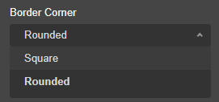  Rounded Corners Example:  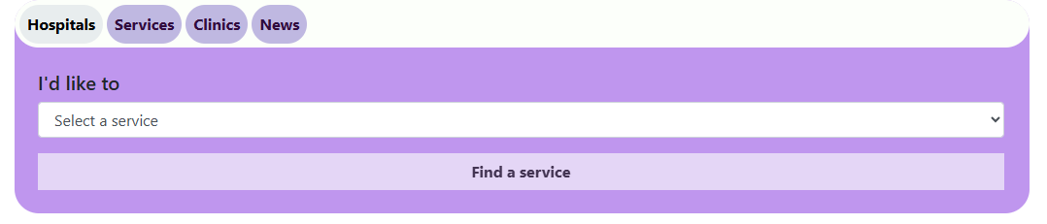  Square Corners:  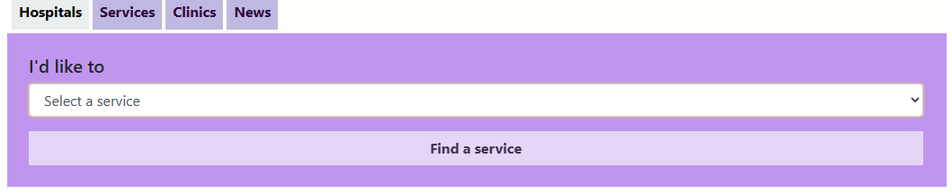  - New custom colour options to add colour to the Link Organiser background.  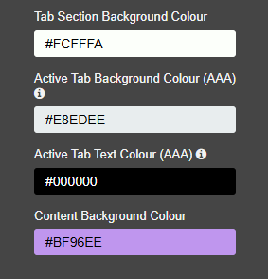  - Increased padding on Mobile devices and reduced width on screen, for easier reading and visually separated from screen edges.  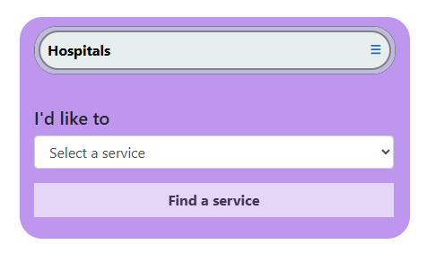  See the CMS Support Site for more information on Link Organiser | CMS Support Team
4.2.10 Accordion Update – New Rounded Corners | We have now added a new styling option to the Accordion layout, to include rounded corners on the Accordion tab.  Configurator setting:  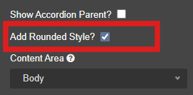  Example:  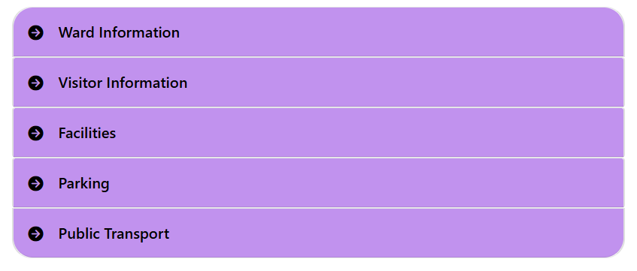  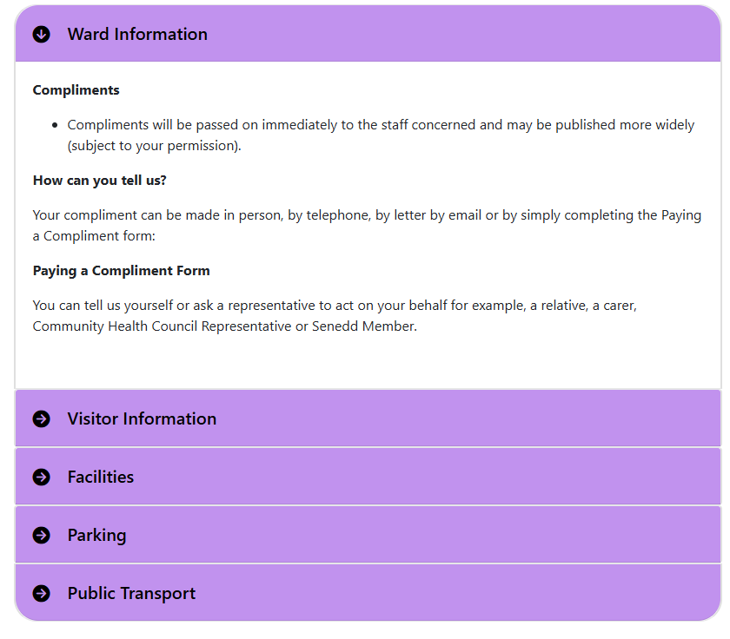  See the CMS Support Site for more information on the Accordion Layout | CMS Support Team
4.2.11 Google Map Plugin - Journey Planner Styling Update | We have added a new styling option for the Journey Planner display within the Google Map plugin.  The Journey Planner title text size can now be controlled via a new dropdown setting. Admins will have five text sizes to choose from.  Configurator setting:  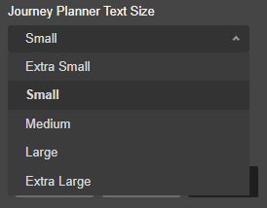  We have also added more spacing between the Journey Planner text and map.  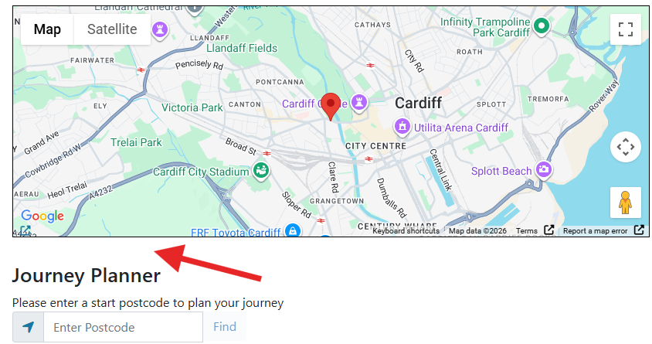  See the CMS Support Site for more information on Google Maps | CMS Support Team
4.2.12 Text Plugin – New Wave Effect | We have now added the Wave Effect to the Text Box plugin. The Wave Effect mirrors the same options available within the Header Panel 2 Plugin.  Admins will be able to select from five wave effects, which will be added to the bottom of the Text Box, to create visually appealing content within the body of the page.  Configurator setting:  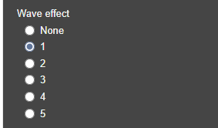  Examples:  Wave Effect 2 with Quotation Marks and Image Background    Wave Effect 4 with Colour Background  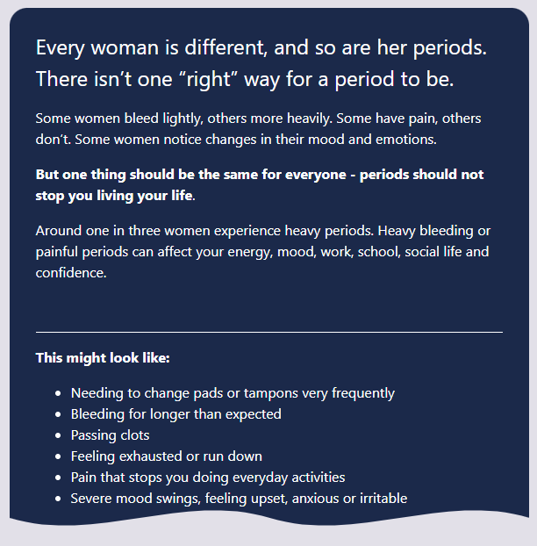  See the CMS Support Site for more information on the Text Box Plugin | CMS Support Team
4.2.13 Filter by Category – Update Spacing Between Items | We have increased the spacing between the Filter by Category content item rows, as previously these were very tight. We have also improved the padding on the text alignments, so they are now more even.  Before: Tight Spacing between content items  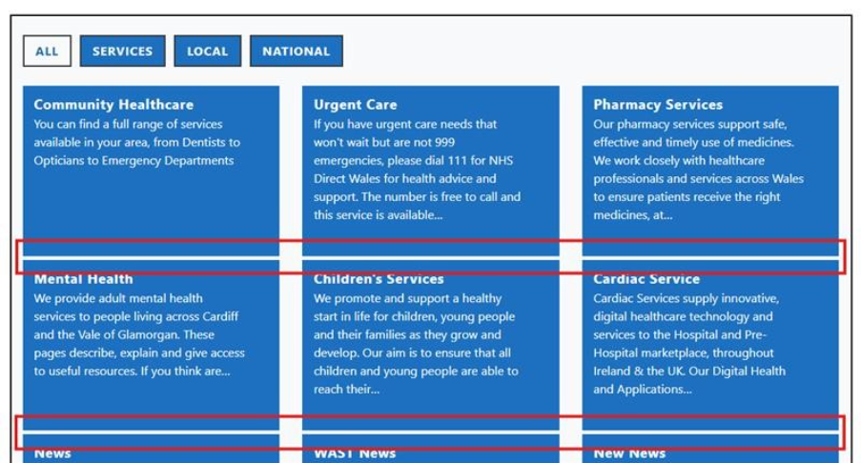  After: Improved spacing between content items  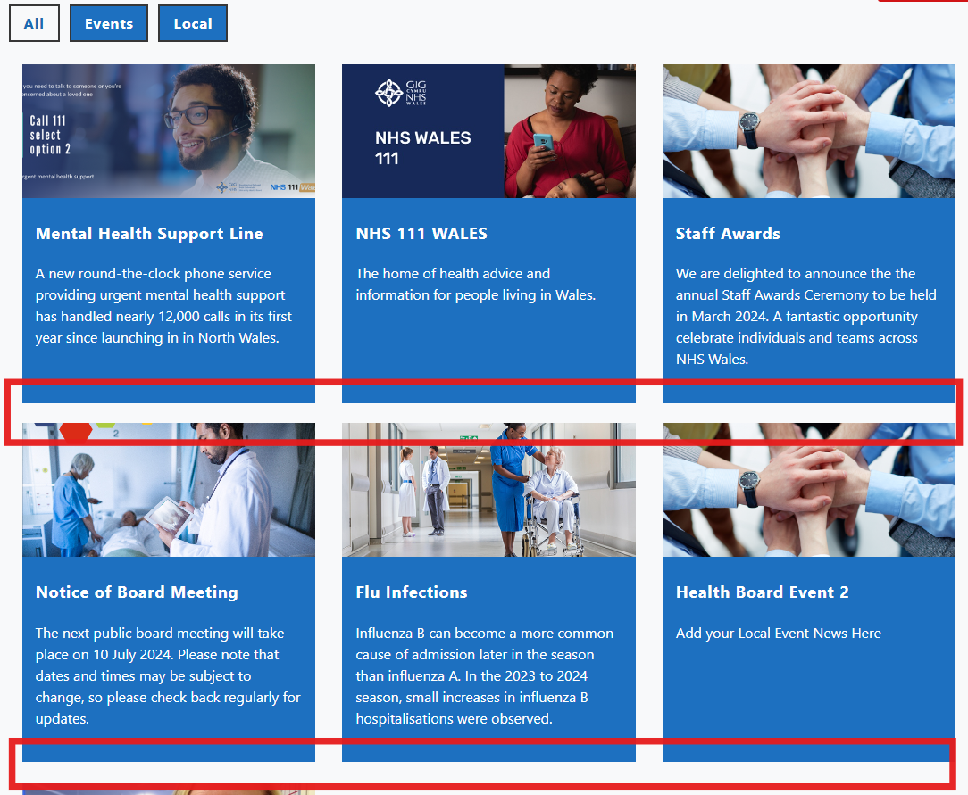  Before: Left aligned text did not sit correctly.  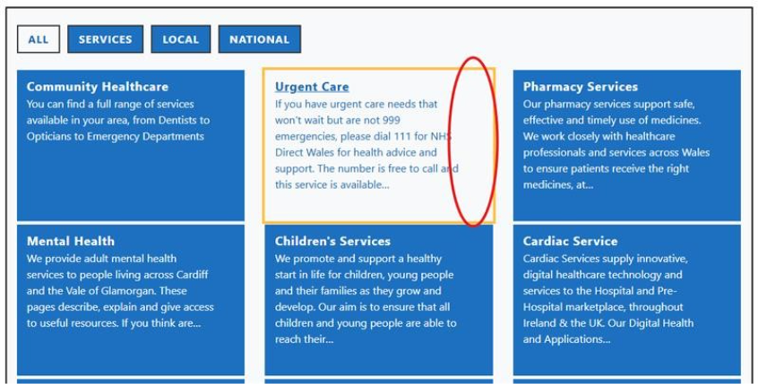  After: Improved Left Alignment spacing.  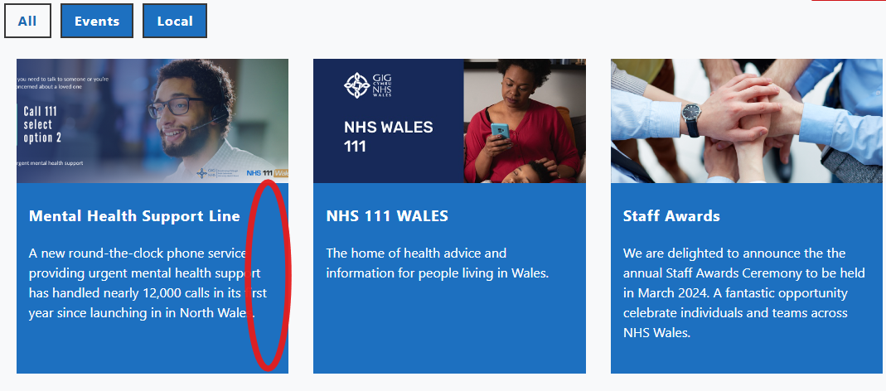  Before: When text alignment was set as center, there was more padding to the right.  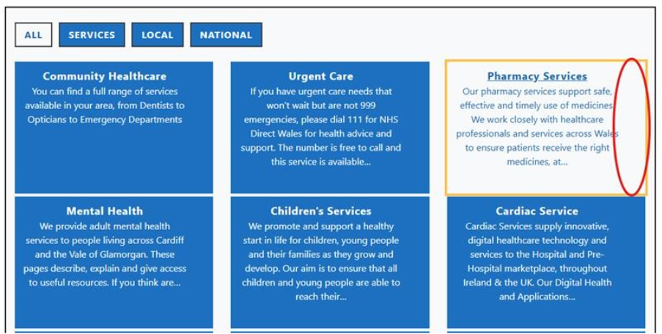  After: Improved spacing for center alignment  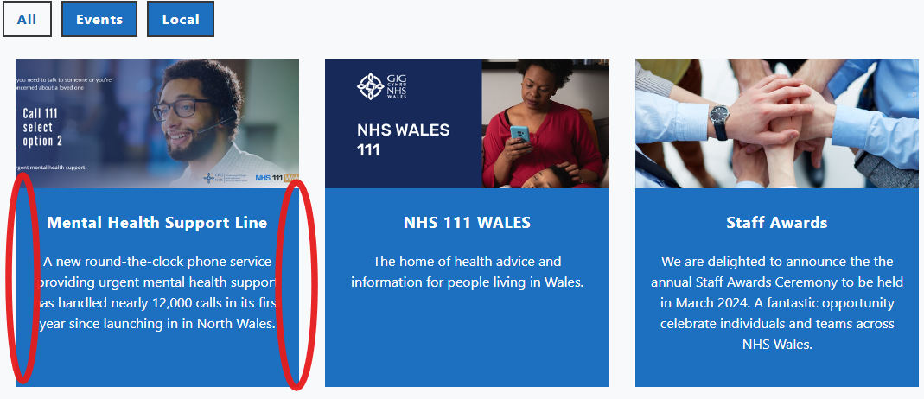  See the CMS Support Site for more information on Filter by Category | CMS Support Team
4.2.14 New Plugin – Quick Quiz | We have created a new plugin for the CMS called Quick Quiz.  This new plugin allows admins to create a quick question and answer module.  - Admins will have the ability to add a Question Text and Question Image, and Answer text and an optional Answer image.  - Admins can select either rounded or squared corners for the module display, and there is also an optional Reset Quiz button.  - This would be useful for any learning or topic pages and creates a fun, interactive experience for site visitors.  Please note: The Quiz Question and Answer Text fields must be completed, and a Question Image selected for this plugin to work.  Configurator settings:  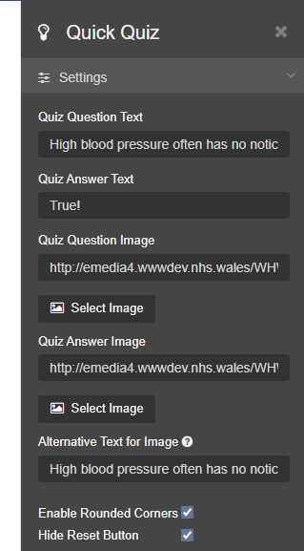  Quick Quiz Examples:  - Rounded Corners example on first display  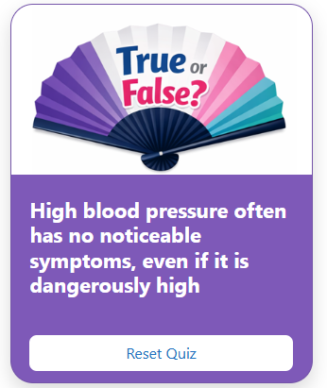  - Once a user clicks on the module, the Quiz Answer text will display and the image will update, if an Answer Image has also been added.  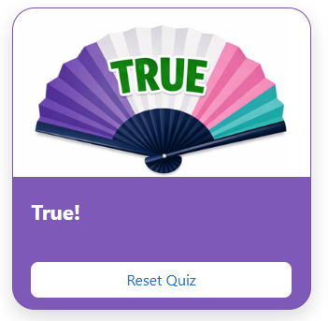  - Squared Corners Example, with Reset Quiz button hidden.  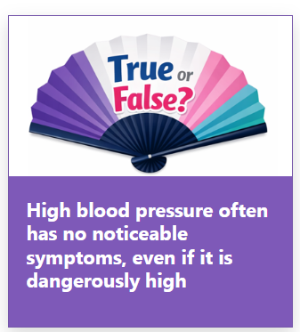  See the CMS Support Site for more information on the Quick Quiz Plugin | CMS Support Team
Accessibility Standards
4.2.15 Acronym Tool – Accessibility Issue Fix | We have made accessibility updates to the Acronym tool; these have been added following advice from Digital Public Services Wales:  - Updated the highlight text colour, to include a dark text decoration and a lighter yellow background, to make this clearer against the text  - Added a tooltip role – this informs keyboard users and accessibility assistants what is being interacted with  Before:  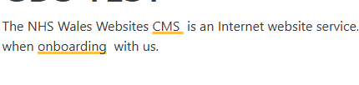  New display example:  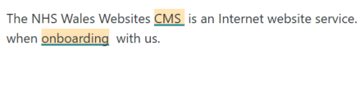  Tooltip Role:  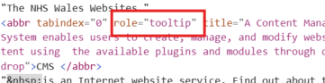  See the CMS Support Site for more information on the Acronym Tool | HDUHB
4.2.16 Remove Acronym Pop Up for Trac Jobs | When we released our new Acronym tool, we discovered a confliction with the coding of the CMS Acronym tool and the Trac plugin code, which added an acronym to all PDF and KB text within the Trac document links.  We have now updated this so our acronym tool will no longer appear in these areas.  Before:    After:  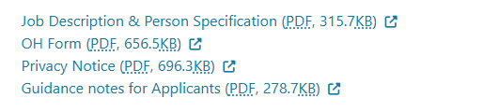  See the CMS Support Site for more information on the Acronym Tool | CMS Support Team
4.2.17 A-Z Collection Layout – Display Update | We have now increased the spacing between the A-Z Collection columns.  The extra spacing makes the links more distinctive, to show that these are separate links in separate columns.  Before:  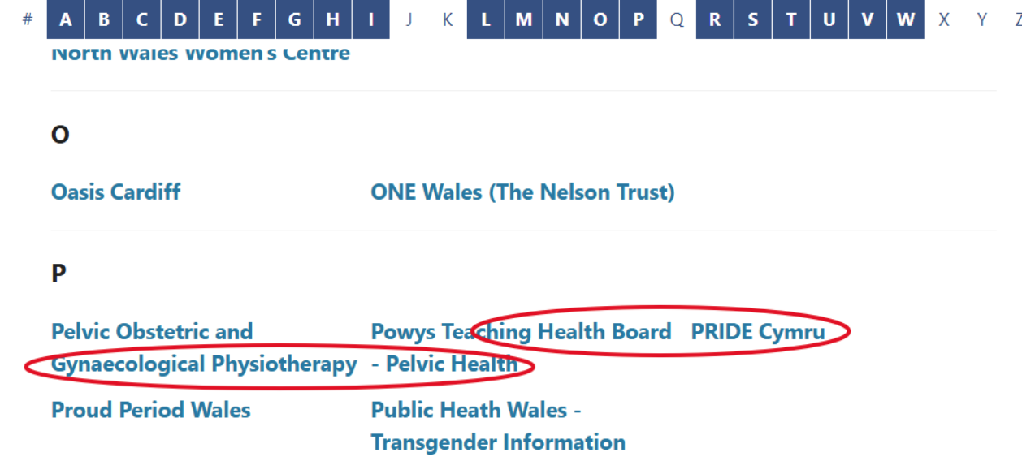  After:  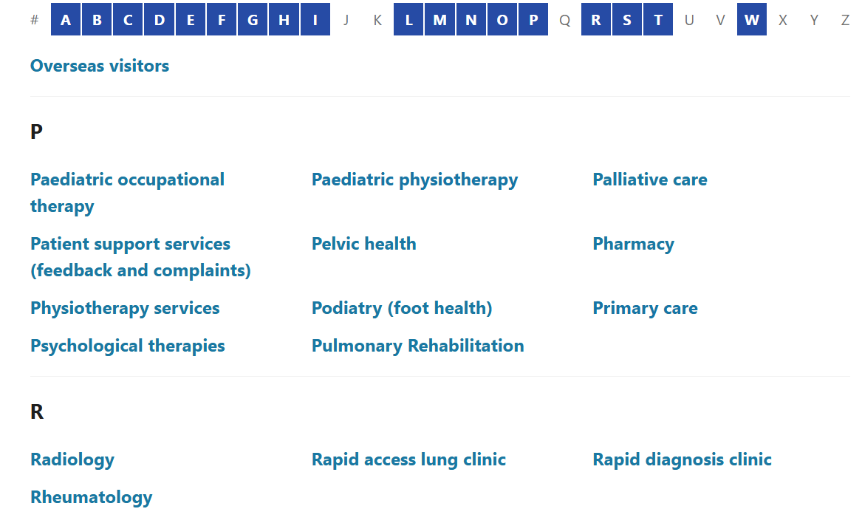  See the CMS Support Site for more information on the A-Z Collection | CMS Support Team
Welsh Language Standards
4.2.18 Advanced Table List – Default Text on Welsh | To keep consistent with other layouts on the Welsh websites, we have now made the text within the Advanced Table List display in Welsh by default for the following settings:  - Text Field Placeholder  - Search Button Text  - Advanced Search Button Text  - Clear Button Name  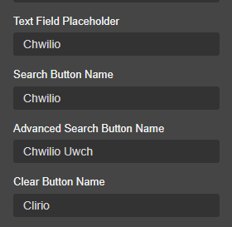  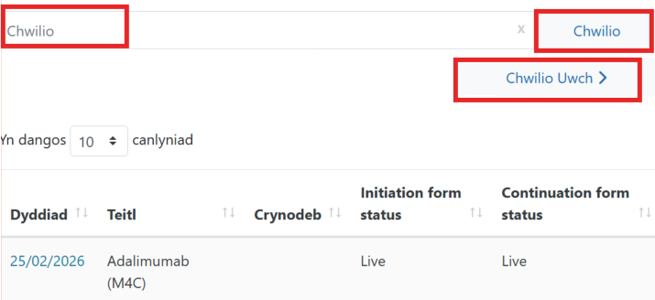  See the CMS Support Site for more information on Advanced Table List | JCC
System Updates
4.2.19 Update to English Language Mobile Button | We have made an update to the English language toggle button on Mobile only.  We have now added an icon to the English button, to keep in line with the Welsh toggle button.  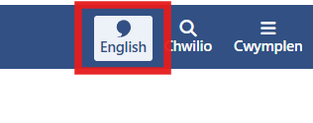  Before: After:  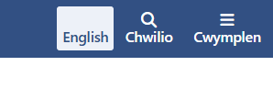 | CMS Support Team

Summary
Number of Changes
19
Bug Fixes | Plugin & Layouts | Accessibility Standards | Welsh Language Standards | System Updates
5 | 9 | 3 | 1 | 1

Problems Fixed
N/A

New Problems Identified During Testing and Associated Workarounds
Testing did not identify any new issues, and no workarounds are currently required.

Pre-requisites to Deploy the Release
There are no pre-requisites for deploying this release. Standard deployment processes can be followed.

Training Requirements
No formal training is required for this release. Users should refer to the CMS Support Site links provided for further details and instructions on the updates and new features listed.

Step-by-Step Deployment Instructions
No Deployment actions required by Health Boards.

Deployment Plan
Changes to be implemented as specified in the Change Record. Release to be deployed via Change Record: 157348

Back-Out Plan
Back out as detailed on each change record 157348

Release Available for Deployment Date
NHS Wales Websites CMS: Wednesday, 3rd June 2026

