Digital Health and Care Wales
NHS Wales IT Service Management

NHS Wales Websites CMS July 2026 Release Notes | Release ID: 1014

Releases
Log a release.
Proposed (5)
Awaiting Build & Test (0)
Awaiting SIT (0)
Awaiting OAT (0)
Awaiting RT (0)
Ready to Deploy (0)
Deployed (0)
Aborted (0)
All (5)

Closed
Schedule of change
Calendar
Historic record of change
List options
Release Logged Title Release ID Release Date Owner Related deployment changes Related release changes Related Services
815

Releases
Log a release.
Proposed (5)
Awaiting Build & Test (0)
Awaiting SIT (0)
Awaiting OAT (0)
Awaiting RT (0)
Ready to Deploy (0)
Deployed (0)
Aborted (0)
All (5)

Closed
Schedule of change
Calendar
Historic record of change
List options
Release Logged Title Release ID Release Date Owner Related deployment changes Related release changes Related Services
815

These Release Notes describe the scope and content of
Release ID: 1014 for the NHS Wales Websites CMS Service

Version: | 0.3
Status: | Final
Owner: | DHCW Corporate Apps Team
Author: | DHCW Corporate Apps Team
Approver: | DHCW Corporate Apps Team

Date: | 09/06/2026
Next Review Date: | 22/07/2026

1 DOCUMENT HISTORY 4
1.1 Revision History 4
1.2 Authorisation 4
1.3 Document Location 4
2 INTRODUCTION 4
3 SERVICE MANAGEMENT BOARD (SMB) 4
4 RELEASE NOTES REQUIREMENT 5
4.1 Release Identification 5
4.2 Description of New or Modified Functionality 5
5 Summary 11
5.1 Problems Fixed 11
5.2 New Problems Identified During Testing and Associated Workarounds 11
5.3 Pre-requisites to Deploy the Release 11
5.4 Training Requirements 11
5.5 Step-by-Step Deployment Instructions 12
5.6 Deployment Plan 12
5.7 Back-Out Plan 12
5.8 Release Available for Deployment Date 12

DOCUMENT HISTORY

Revision History
Date | Version | Author | Revision Summary
09/06/2026 | 0.1 | DHCW Corporate Apps Team | Document created for the NHS Wales Websites CMS Release
08/07/2026 | 0.2 | DHCW Corporate Apps Team | Revise Text and Images
22/07/2026 | 0.3 | DHCW Corporate Apps Team | Remove Item and revise text

Authorisation
The signing of this document indicates acceptance of its contents.
Author’s Name: | DHCW Corporate Apps Team

Approver’s Name: | DHCW Corporate Apps Team

Document Location
Type | Location
Electronic | NHS Wales Websites CMS Support Site – What’s New

INTRODUCTION
The NHS Wales Release Management Policy considers that effective Release Management is essential for protecting the integrity of the operational environment. A key objective of the release process is to ensure that users, support staff and other stakeholders are kept informed as to what is planned and how this will affect them. One of the ways that this can be achieved is through the publication of release notes prior to the deployment of the Release.
These notes contain information on the agreed scope and content of Release ID CMS/04-2026 for the CMS descriptions of new or modified functionality and problem fixes, descriptions of new problems and workarounds identified during the testing of this Release, training requirements, deployment instructions, references to deployment and back-out plans and key dates within the release process.

SERVICE MANAGEMENT BOARD (SMB)
The CMS Service Management Board has overall responsibility for ensuring that these Release Notes accurately describe the Release and that it is kept under constant review and updated to reflect any modifications to the Release prior to its deployment.

RELEASE NOTES REQUIREMENT

Release Identification
1014 - CMS/04-2026

Description of New or Modified Functionality

Item | Description of the Change | Requestor
Bug Fixes
4.2.1 Scroll fix for Multi Content Display 1 and 7 | The scrollable arrows on Multi Content 7 and Multi Content 1 did not function properly when more than 4 items were displayed.  In Desktop view, the arrow disappeared before you could scroll to the last item available in the content layout, so it looked like the last item was not appearing at all.  We have now implemented a fix, so the arrow no longer disappears before you reach the last item. | CMS Support Team
4.2.2 Filter by Category Layout –Pagination Fix | In Mobile, it was identified that the pagination on the Filter by Category was displaying incorrectly. In some instances, it would display pages from 6,7,8 onwards instead of 1,2,3 and still displayed when only one page of content was available.  We have now added a fix, so the pagination starts from 1,2,3 onwards, and only displays when more than one page of content is available.  See the CMS Support Site for more information on the Filter by Category | CMS Support Team
System Updates
4.2.3 Quick Upload - Warning for Large Document Files | We recently updated the Quick Upload to warn users if an image couldn’t be uploaded due to its size.  We’ve now added this warning message for document file types e.g. pdf, docx, xlsx etc. If Admins attempt to upload a file exceeding 29.56MB, the below message will appear, stating the file is too large, what the current system upload limit is and that the file will not be added.  Example of Warning Message:  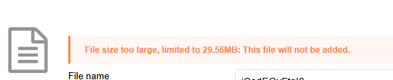  See the CMS Support Site for more information on Uploading Documents | CMS Support Team
4.2.4 Quick Upload -Warning for File Name Duplication | We’ve now added a warning message for Admins if a file with a duplicate name is being uploaded. The file can still be uploaded, but this will serve as a message to inform Admins that the file name already exists within the system.  This is currently only available on Quick Upload.  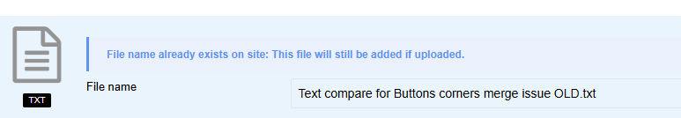  See the CMS Support Site for more information on Uploading Documents | NWJCC
4.2.5 Alert Message for Draft Pages on Front End View | When Admins are updating a Live page in the back-end of the site that also contains a draft version, an alert will display on publishing to warn users that by Publishing this content, all un-published drafts will be removed.  We have now added this message to the front-end page edit.  Alert message:  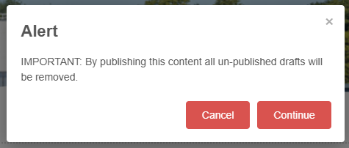  See the CMS Support Site for more information on Pages | NWJCC
Plugin & Layout Updates
4.2.6 New Plugin – Content Date Display | With the updated content retention policies coming into effect, we have now created a new Plugin called ‘Content Date Display’.  When added to the bottom row of a page, the plugin will display the pages Created Date and Last Updated Date and inherit onto any child pages (depending on site inheritance).  The Dates will appear at the bottom of the page and left aligned on default but can be switched to Right aligned within the Configurator.  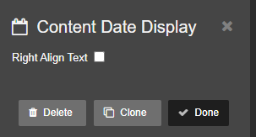  Configurator  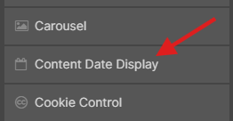  Desktop Display  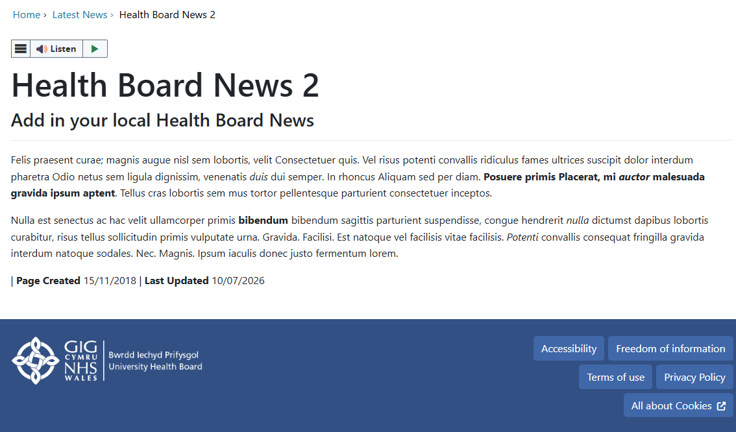  Mobile Display  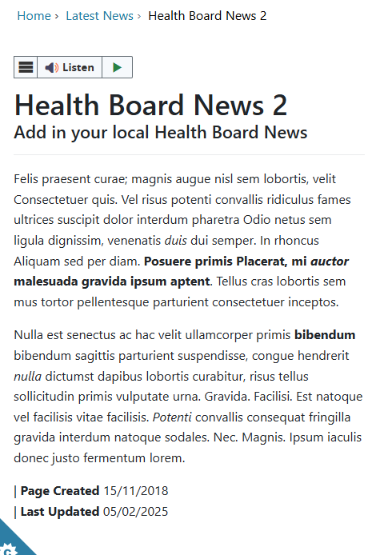  See the CMS Support Site for more information on the Content Date Display | CMS Working Group
4.2.7 Toggle Form Update – New Text Size Option | We have added a new styling option for the Toggle Form display.  The Toggle Form title text size can now be controlled via a new dropdown setting. Admins will have 5 text sizes to choose from.  Configurator setting:  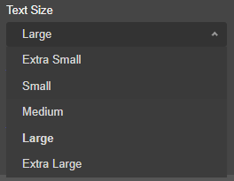  See the CMS Support Site for more information on the Toggle Form | CMS Support Team
4.2.8 Social Bar Update – New Text Size Option | We have added a new styling option for the Social Bar display.  The Social Bar title text size can now be controlled via a new dropdown setting. Admins will have 5 text sizes to choose from.  Configurator setting:  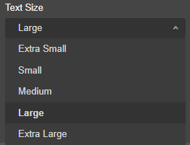  See the CMS Support Site for more information on Social Bar | CMS Support Team
4.2.9 Buttons Layout – New Button Styling | We have added a new styling update to the Button Layouts.  Admins will now have the option to have a pill shape button via the Border Corner setting.  Configurator Setting:  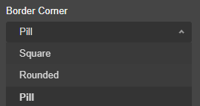  Pill Shape Example:    See the CMS Support Site for more information on Buttons | CMS Support Team
4.2.10 New Layout Templates – SectionList | We have created 2 new layout templates for the SectionList.  As well as the default SectionList layout, Admins will now have the option of a tab or dropdown layout, to show either the summary or the body of text within the selected tab/drop down.  Configurator Setting:  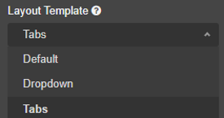  Dropdown Example:  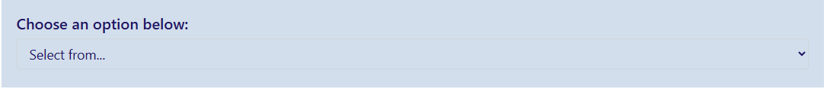  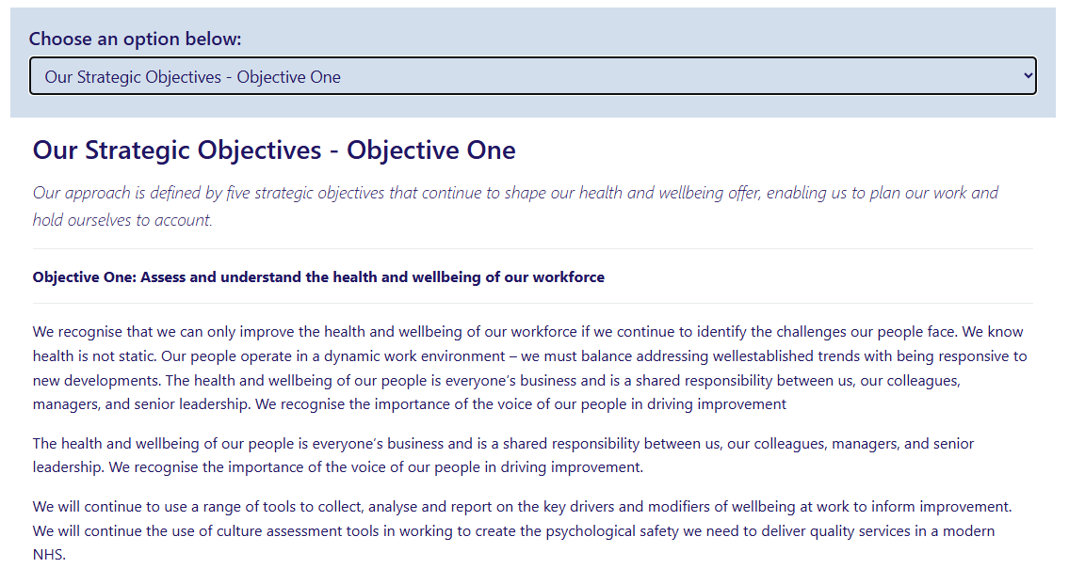  Once an item is selected, the body or summary text will display  Tabs Example:  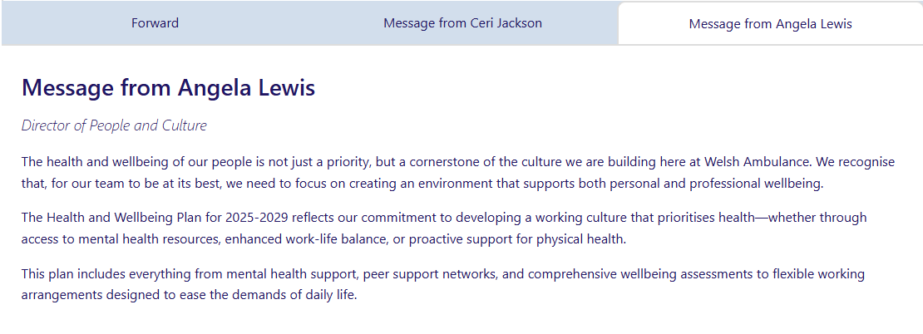  See the CMS Support Site for more information on the Section List | ABUHB and DHCW
Accessibility Standards
4.2.11 Update to Font Sizes across CMS Themes | Due to user feedback regarding the Mobile Font Sizes, we have reviewed and updated all Font Sizes across the CMS Themes and Devices.  For Desktop, Tablet and Mobile Devices the new Font Sizes are now: | CMS Support Team
  Desktop | Tablet | Mobile
  H1: 50px  H2: 40px  H3: 34px  H4: 28px  H5: 24px  H6: 20px  Lead text: 18px  Base text: 16px | H1: 42px  H2: 36px  H3: 30px  H4: 26px  H5: 22px  H6: 18px  Lead text: 16px | H1: 36px  H2: 30px  H3: 26px  H4: 22px  H5: 20px  H6: 16px  Lead text: 15px
Welsh Language Standards
4.2.12 Audio Player – Fix Incorrect Appearance of Welsh Characters | An issue was identified within the Audio Player layout on the Welsh websites, where the Keyboard Shortcuts text box contained special characters instead of the full Welsh Text. We have now implemented a fix so that the Welsh Text now displays correctly.  Before: After:  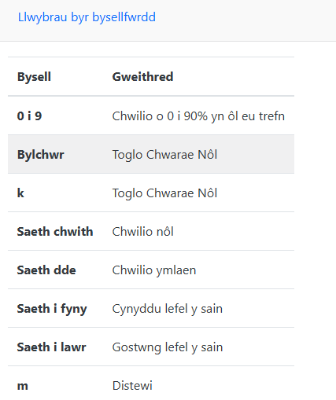  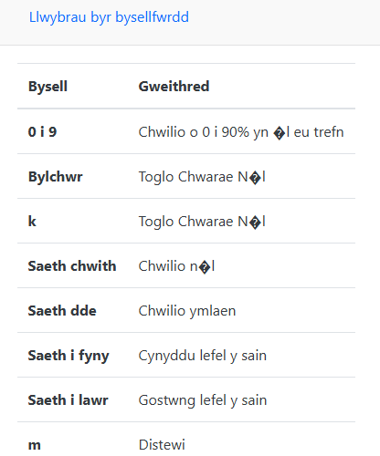  See the CMS Support Site for more information on the Audio Player | HDUHB

Summary
Number of Changes
12
Bug Fixes | System Updates | Plugin & Layout Updates | Accessibility Standards | Welsh Language Standards
2 | 3 | 5 | 1 | 1

Problems Fixed
N/A

New Problems Identified During Testing and Associated Workarounds
Testing did not identify any new issues, and no workarounds are currently required.

Pre-requisites to Deploy the Release
There are no pre-requisites for deploying this release. Standard deployment processes can be followed.

Training Requirements
No formal training is required for this release. Users should refer to the CMS Support Site links provided for further details and instructions on the updates and new features listed.

Step-by-Step Deployment Instructions
No Deployment actions required by Health Boards.

Deployment Plan
Changes to be implemented as specified in the Change Record. Release to be deployed via Change Record: Change 159737

Back-Out Plan
Back out as detailed on each change record

Release Available for Deployment Date
NHS Wales Websites CMS: Wednesday, the 29th July 2026

