Digital Health and Care Wales
NHS Wales IT Service Management

NHS Wales Websites CMS February 2026 Release Notes | Release ID: 980

Releases
Log a release.
Proposed (5)
Awaiting Build & Test (0)
Awaiting SIT (0)
Awaiting OAT (0)
Awaiting RT (0)
Ready to Deploy (0)
Deployed (0)
Aborted (0)
All (5)

Closed
Schedule of change
Calendar
Historic record of change
List options
Release Logged Title Release ID Release Date Owner Related deployment changes Related release changes Related Services
815

Releases
Log a release.
Proposed (5)
Awaiting Build & Test (0)
Awaiting SIT (0)
Awaiting OAT (0)
Awaiting RT (0)
Ready to Deploy (0)
Deployed (0)
Aborted (0)
All (5)

Closed
Schedule of change
Calendar
Historic record of change
List options
Release Logged Title Release ID Release Date Owner Related deployment changes Related release changes Related Services
815

These Release Notes describe the scope and content of
Release ID: 980 for the NHS Wales Websites CMS Service

Version: | 0.3
Status: | Final
Owner: | DHCW Corporate Apps Team
Author: | DHCW Corporate Apps Team
Approver: | DHCW Corporate Apps Team

Date: | 06/01/2026
Next Review Date: | 28/01/2026

1 DOCUMENT HISTORY 4
1.1 Revision History 4
1.2 Authorisation 4
1.3 Document Location 4
2 INTRODUCTION 4
3 SERVICE MANAGEMENT BOARD (SMB) 4
4 RELEASE NOTES REQUIREMENT 5
4.1 Release Identification 5
4.2 Description of New or Modified Functionality 5
5 Summary 13
5.1 Problems Fixed 13
5.2 New Problems Identified During Testing and Associated Workarounds 14
5.3 Pre-requisites to Deploy the Release 14
5.4 Training Requirements 14
5.5 Step-by-Step Deployment Instructions 14
5.6 Deployment Plan 14
5.7 Back-Out Plan 14
5.8 Release Available for Deployment Date 14

DOCUMENT HISTORY

Revision History
Date | Version | Author | Revision Summary
06/01/2026 | 0.1 | DHCW Corporate Apps Team | Document created for the NHS Wales Websites CMS Release
19/01/2026 | 0.2 | DHCW Corporate Apps Team | Images added and text revised
28/01/2026 | 0.3 | DHCW Corporate Apps Team | Final images and text revised

Authorisation
The signing of this document indicates acceptance of its contents.
Author’s Name: | DHCW Corporate Apps Team

Approver’s Name: | DHCW Corporate Apps Team

Document Location
Type | Location
Electronic | NHS Wales Websites CMS Support Site – What’s New

INTRODUCTION
The NHS Wales Release Management Policy considers that effective Release Management is essential for protecting the integrity of the operational environment. A key objective of the release process is to ensure that users, support staff and other stakeholders are kept informed as to what is planned and how this will affect them. One of the ways that this can be achieved is through the publication of release notes prior to the deployment of the Release.
These notes contain information on the agreed scope and content of Release ID CMS/01-2026 for the CMS descriptions of new or modified functionality and problem fixes, descriptions of new problems and workarounds identified during the testing of this Release, training requirements, deployment instructions, references to deployment and back-out plans and key dates within the release process.

SERVICE MANAGEMENT BOARD (SMB)
The CMS Service Management Board has overall responsibility for ensuring that these Release Notes accurately describe the Release and that it is kept under constant review and updated to reflect any modifications to the Release prior to its deployment.

RELEASE NOTES REQUIREMENT

Release Identification
980 - CMS/01-2026

Description of New or Modified Functionality

Item | Description of the Change | Requestor
Bug Fixes
4.2.1 Accordion 2 Text Colour Fix | We identified an issue with Accordion 2 text colour configurator and panel.  If you had text displaying within the Accordion Panel that was in a Div or Bullet pointed list, then it always pulled in as black - no matter what colour you change this to in the Content - text colour configurator settings.  We have made an update so that all text within the accordion panel updates to the selected colour, regardless of paragraphs, bullet point lists and div elements.  Old:  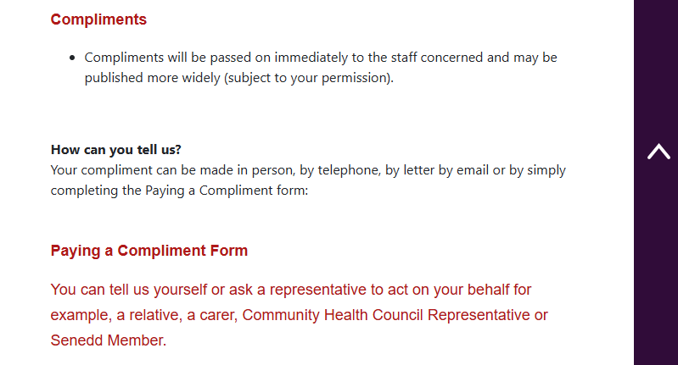  New:  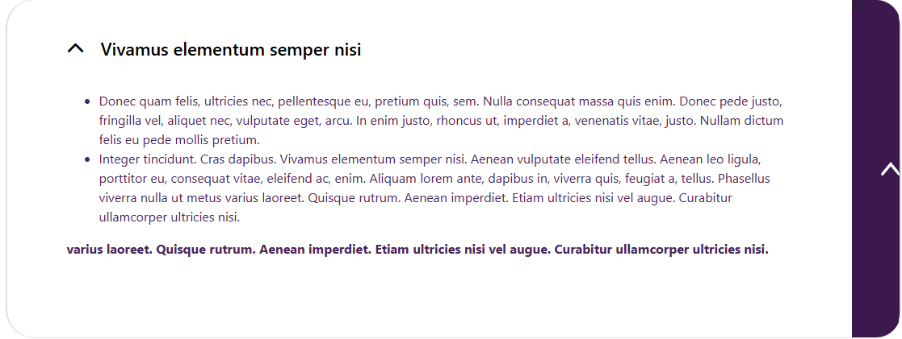  See the CMS Support Site for more information on the Accordion 2 Layout | CMS Support Team
4.2.2 Filter by Category Bug Fixes | We have identified and fixed a few bug issues with Filter by Category.  Apostrophe in Category Name Fix– When a Category containing an Apostrophe was pulled into the Filter by Category layout, the Category Tab would not Filter the results once selected. Our fix will now allow you to filter Category tabs that contain Apostrophes.  Hide Brief Display of Code within Tabs – On first loading, some coding was briefly visible within the Category tabs of the Filter by Category display. We have added a fix to hide this code on first load.  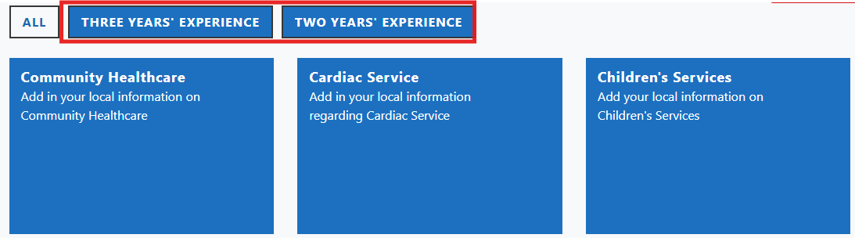  See the CMS Support Site for more information on Filter by Category | CMS Support Team
4.2.3 Hide Archive Navigation on Mobile Display Fix | We identified an issue with the Breakpoint behaviour configuration for Archive Navigation. When the option to Hide the Archive Navigation was selected for a Mobile Device, the navigation would still display on Mobile.  We have now implemented a fix for this setting, so that when Hide is selected for Mobile devices, the Archive Navigation will no longer display.  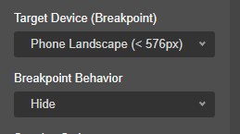  See the CMS Support Site for more information on the Site Navigation | CMS Support
Plugin & Layout Updates
4.2.4 New Exit Button Module | We have now introduced a new Exit Button Plugin. When applied to your pages, the Exit Button will appear as a ‘floating’ button on the right-hand side of the screen. Once selected, it will direct you to the NHS Wales website homepage, The button and text colour is configurable and is available across all NHS Wales Themes.  This feature will be especially useful on pages featuring domestic abuse help advice, to allow users to browser safely and quickly exit these pages if needed.  Configurator Settings  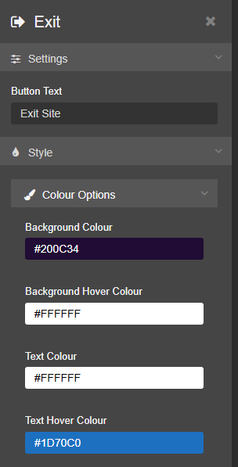  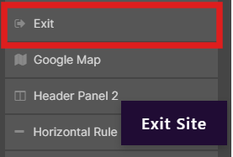  Desktop Display  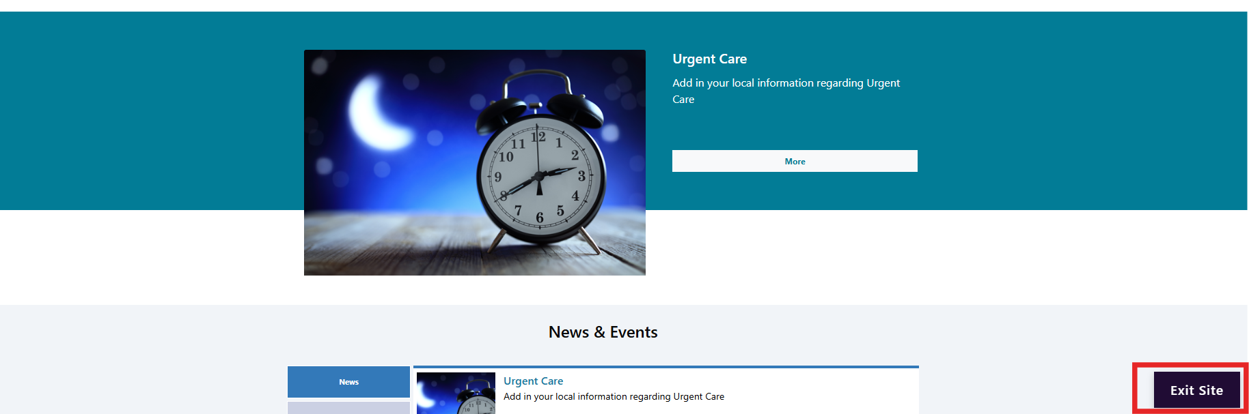  Mobile Display  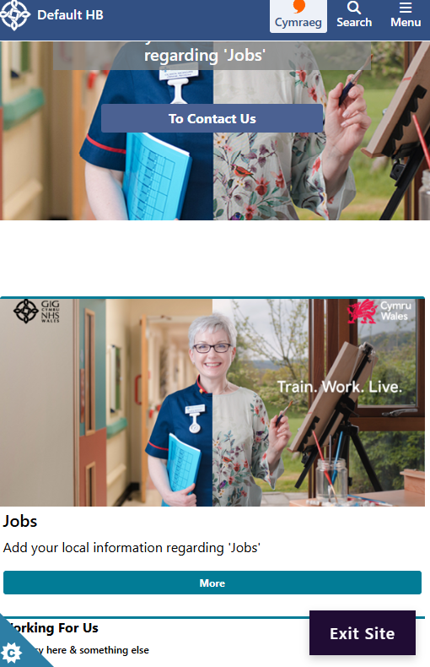  See the CMS Support Site for more information on the Exit Plugin | CMS Support Team
4.2.5 Multi Content Display 7 – Show Title and Image Only | We have added a new display option for the Multi Content Display 7 Layout.  Content Area - None: When None is selected from the drop-down box, the front-end output will hide the body and summary, so only the Image and Title are displayed within the Multi Content 7 layout  Configurator Setting:  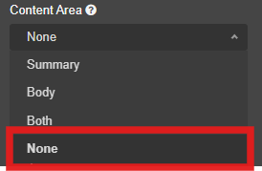  Multi Content Display:    See the CMS Support Site for more information on Multi Content Display 7 | CMS Support  Team
4.2.6 Link Organiser Updates | We have made some improvements to the Link Organiser Collection Layout, to make the text more readable and create a more visually appealing and prominent layout:  - The Tab and Button text will now display in a larger font size  - The Tab Text colour is now configurable, with an additional hover over colour  - The Tab Background colour is now configurable, with an additional hover over colour  - An Active Tab Background and Text Colour , so that text within the selected tab remains readable with its background  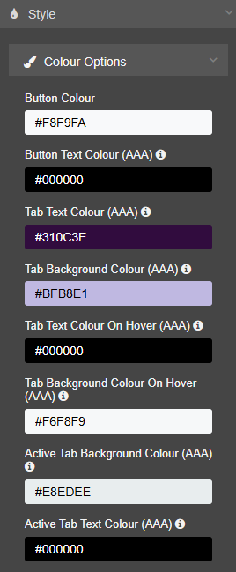  Configurator Settings:  Link Organiser Display:  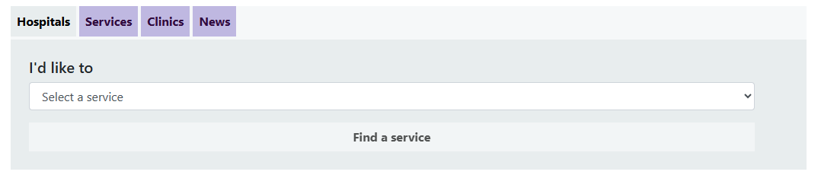  Please Note: If you are currently using the Link Organiser layout, the colours and tab/text display may change once this is implemented on the Live websites. We would advise reviewing this layout after the release.  See the CMS Support Site for more information on the Link Organiser | CMS Support Team
4.2.7 Video Carousel Update – Thumbnail Image | We have added an update to the Video Carousel Collection Layout, to give the option to present a thumbnail image as the opening slide to a video rather than the video itself. This will help create a more visually appealing layout.  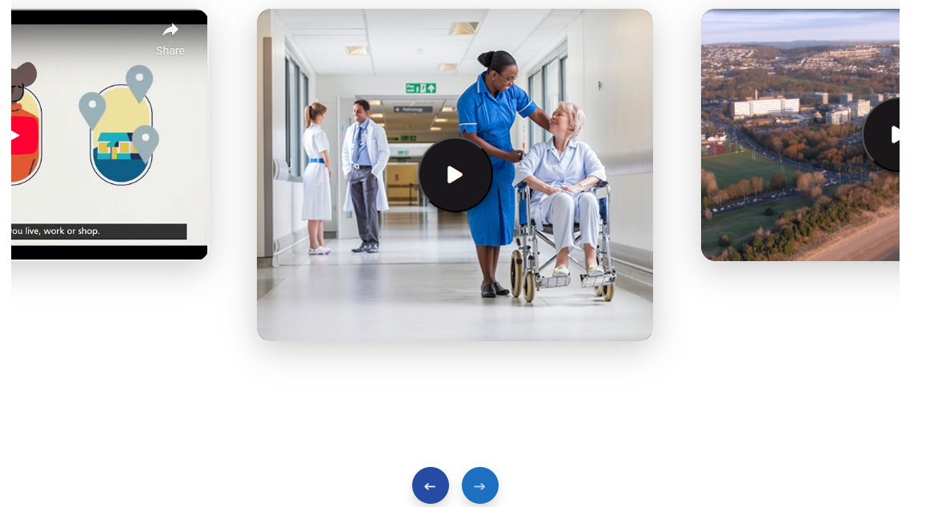  See the CMS Support Site for more information on the Video Carousel | CMS Support Team
4.2.8 Single Button Margin Update | We have added an additional configurator option to the Single Button layout. This update will remove unwanted background/boarder spacing that appears around the button.  We have also made an update to the Content - Background colour configurator settings. Previously, the background colour would always display a default colour even if none was selected. To keep in line with other layouts, the colour is now optional.  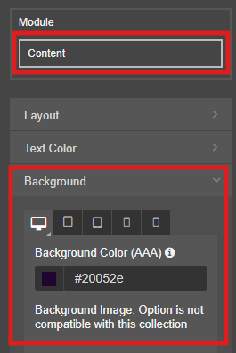  Configurator Setting Updates:  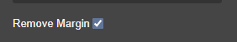  See the CMS Support Site for more information on the Single Button layout | CMS Support Team
4.2.9 Section List Update | On the new Section List Layout, we have amended the amount of content items you can pull through. This was previously limited to 20 items, but to keep in line with other layouts, we have added additional amounts to include 25, 50, 100 or All within the configurator.  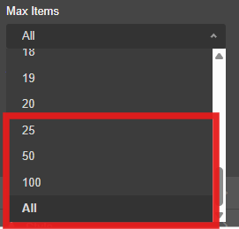  See the CMS Support Site for more information on Section List | CMS Support Team
Accessibility Standards
4.2.10 Acronym Tool – Accessibility Update | An Accessibility issue was identified on the Abbreviation/Acronym tool, whereby the popup box would not close when selecting the Escape (Esc) key button on a keyboard.  We have now implemented an update to allow this function.  See the CMS Support Site for more information on the Acronym Tool | CMS Support Team

Summary
Number of Changes
10
Bug Fix | Plugin & Layout Updates | Accessibility Standards
3 | 6 | 1

Problems Fixed
N/A

New Problems Identified During Testing and Associated Workarounds
Testing did not identify any new issues, and no workarounds are currently required.

Pre-requisites to Deploy the Release
There are no pre-requisites for deploying this release. Standard deployment processes can be followed.

Training Requirements
No formal training is required for this release. Users should refer to the CMS Support Site links provided for further details and instructions on the updates and new features listed.

Step-by-Step Deployment Instructions
No Deployment actions required by Health Boards.

Deployment Plan
Changes to be implemented as specified in the Change Record. Release to be deployed via Change Record: Change 154623

Back-Out Plan
Back out as detailed on each change record

Release Available for Deployment Date
NHS Wales Websites CMS: Wednesday, the 4th February 2026

