Digital Health and Care Wales
NHS Wales IT Service Management

NHS Wales Websites CMS April 2026 Release Notes | Release ID: 995

Releases
Log a release.
Proposed (5)
Awaiting Build & Test (0)
Awaiting SIT (0)
Awaiting OAT (0)
Awaiting RT (0)
Ready to Deploy (0)
Deployed (0)
Aborted (0)
All (5)

Closed
Schedule of change
Calendar
Historic record of change
List options
Release Logged Title Release ID Release Date Owner Related deployment changes Related release changes Related Services
815

Releases
Log a release.
Proposed (5)
Awaiting Build & Test (0)
Awaiting SIT (0)
Awaiting OAT (0)
Awaiting RT (0)
Ready to Deploy (0)
Deployed (0)
Aborted (0)
All (5)

Closed
Schedule of change
Calendar
Historic record of change
List options
Release Logged Title Release ID Release Date Owner Related deployment changes Related release changes Related Services
815

These Release Notes describe the scope and content of
Release ID: 995 for the NHS Wales Websites CMS Service

Version: | 0.3
Status: | Final
Owner: | DHCW Corporate Apps Team
Author: | DHCW Corporate Apps Team
Approver: | DHCW Corporate Apps Team

Date: | 04/03/2026
Next Review Date: | 01/04/2026

1 DOCUMENT HISTORY 4
1.1 Revision History 4
1.2 Authorisation 4
1.3 Document Location 4
2 INTRODUCTION 4
3 SERVICE MANAGEMENT BOARD (SMB) 4
4 RELEASE NOTES REQUIREMENT 5
4.1 Release Identification 5
4.2 Description of New or Modified Functionality 5
5 Summary 13
5.1 Problems Fixed 13
5.2 New Problems Identified During Testing and Associated Workarounds 14
5.3 Pre-requisites to Deploy the Release 14
5.4 Training Requirements 14
5.5 Step-by-Step Deployment Instructions 14
5.6 Deployment Plan 14
5.7 Back-Out Plan 14
5.8 Release Available for Deployment Date 14

DOCUMENT HISTORY

Revision History
Date | Version | Author | Revision Summary
04/03/2026 | 0.1 | DHCW Corporate Apps Team | Document created for the NHS Wales Websites CMS Release
17/03/2026 | 0.2 | DHCW Corporate Apps Team | Add images, new items and text amendments
01/04/2026 | 0.3 | DHCW Corporate Apps Team | Final images and text revised

Authorisation
The signing of this document indicates acceptance of its contents.
Author’s Name: | DHCW Corporate Apps Team

Approver’s Name: | DHCW Corporate Apps Team

Document Location
Type | Location
Electronic | NHS Wales Websites CMS Support Site – What’s New

INTRODUCTION
The NHS Wales Release Management Policy considers that effective Release Management is essential for protecting the integrity of the operational environment. A key objective of the release process is to ensure that users, support staff and other stakeholders are kept informed as to what is planned and how this will affect them. One of the ways that this can be achieved is through the publication of release notes prior to the deployment of the Release.
These notes contain information on the agreed scope and content of Release ID CMS/02-2026 for the CMS descriptions of new or modified functionality and problem fixes, descriptions of new problems and workarounds identified during the testing of this Release, training requirements, deployment instructions, references to deployment and back-out plans and key dates within the release process.

SERVICE MANAGEMENT BOARD (SMB)
The CMS Service Management Board has overall responsibility for ensuring that these Release Notes accurately describe the Release and that it is kept under constant review and updated to reflect any modifications to the Release prior to its deployment.

RELEASE NOTES REQUIREMENT

Release Identification
995 - CMS/02-2026

Description of New or Modified Functionality

Item | Description of the Change | Requestor
Bug Fixes
4.2.1 Missing Release Date Fix | There were a few instances where the Release Date for items was not automatically added by the CMS System. This meant some newly created pages such as News items were not appearing in their News Folders on the front end, which are ordered by Release Date.  A permanent fix has now been implemented to ensure the release date is always added automatically by the system when creating a new content item.  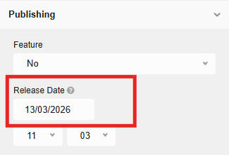  See the CMS Support Site for more information on Page Settings | HEIW and JCC
4.2.2 Quick Upload and Search Results Issue | An issue was identified with Quick Upload, where newly uploaded documents did not appear in the site search results. They would only feature once the document had been updated in the backend.  A fix has been implemented, so that any documents uploaded via Quick Upload will now appear in the search results, without needing to amend the document first. | JCC
System Updates
4.2.3 Failed Upload Message on Quick Upload – Images | We have added a new warning message on Quick Upload for Images. The warning message will alert admins as to why a particular upload has failed.  Types of warning messages will include:  - Image File Size too large: Will alert admins when an image exceeds the file size limit of 10MB  - Restricted Image File Type: Will alert admins when an unsupported image file type is being used  Warning message examples:  Image File Too Large  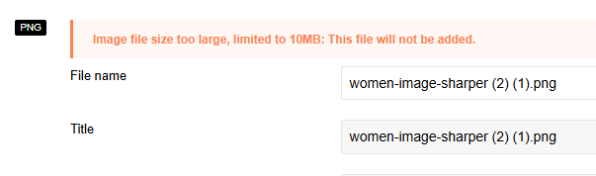  Restricted Image File Type  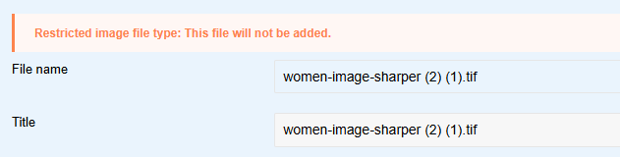  Please note: The warning messages will appear for Images on Quick Upload only. The development team are working on an update to include a warning message for File Documents. This will feature in a future CMS Release.  See the CMS Support Site for more information on Image Upload Options | CMS Support Team
Plugin & Layout Updates
4.2.4 Filter by Category – Max Items Update | We have amended the amount of content items you can pull through in each category for the Filter by Category layout.  This was previously limited to 50 items, but to keep in line with other layouts, we have added additional amounts to include 100 or All within the configurator.  Configurator Setting:  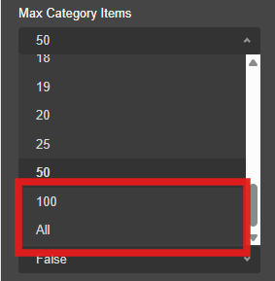  See the CMS Support Site for more information on the Filter by Category Layout | CMS Support Team
4.2.5 Filter by Category – New Sort by Option | We have added a new Sort By option in the Filter by Category layout settings. Previously there were only 2 sort options available: Last Update and Title.  Admins can now choose to sort the content by Date Created.  Configurator Setting:  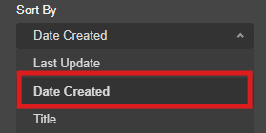  See the CMS Support Site for more information on the Filter by Category Layout
4.2.6 Filter by Category – New ‘Jump to Items’ Functionality | A new setting ‘Jump to Items on Tab Click’ is now available on the Filter by Category Layout.  Once enabled, when a user selects a category tab, the page will jump to the top of the filtered category items section. This functionality will be particularly useful in Mobile if the layout has several Category Tabs displayed.  Configurator Setting:  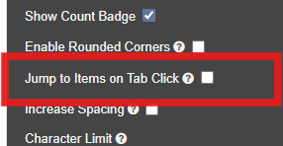  When this setting is enabled, when a user selects a Category Tab:  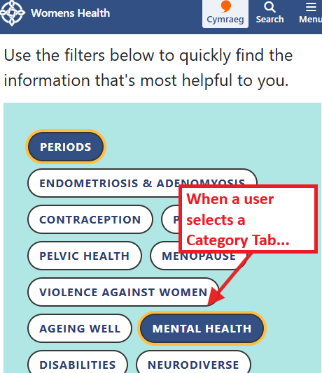  The users focus will jump to the top of the filtered content items section.  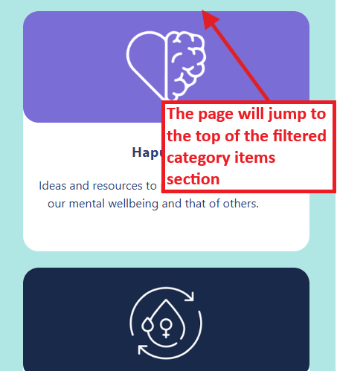  See the CMS Support Site for more information on the Filter By Category Layout | CMS Support Team
4.2.7 Filter by Category – Hide Category Tabs | A new configurator setting has now been added to the Filter by Category called ‘Hide Category Tabs’.  This will hide all category tabs added to the Filter by Category but will still display the content items.  Configurator Setting:  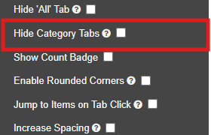  Setting On: All Category Tabs including All will now be hidden, just leaving the tagged Category content items displaying  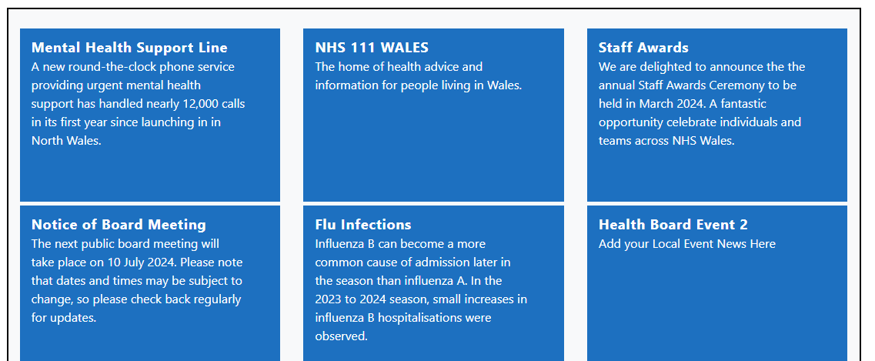  Setting Off: All Category Tabs will display including All (unless you have chosen to hide ‘All’ within the configurator separately).  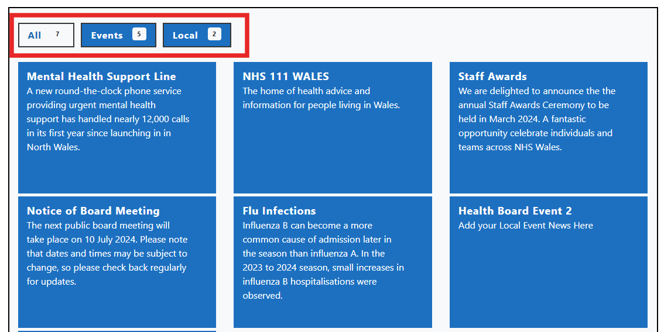  See the CMS Support Site for more information on the Filter by Category Layout | BCUHB
4.2.8 Accordion 2 – Padding amendment on Accordion Tab | On desktop, the Accordion 2 tabs appeared much larger in height compared to the tabs on the standard Accordion layout. We have now reduced the height padding on the Accordion 2 tabs, to create a more visually appealing layout.  Old Display:  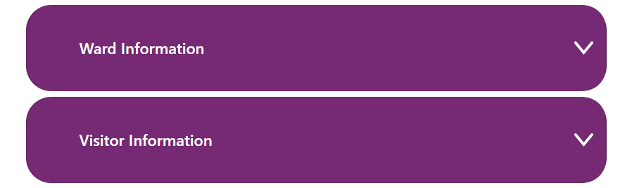  New Display:  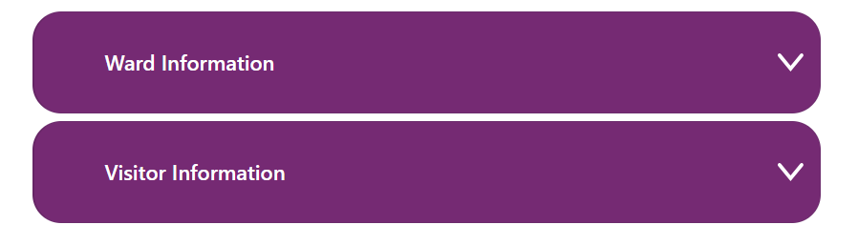  See the CMS Support Site for more information on the Accordion 2 Layout | CMS Support Team
4.2.9 Image Plugin – New Corner Styling | Currently the Image Plugin displays images with rounded corners only.  We have now added an additional setting within the Configurator so Admins can choose to have rounded or squared corners on images.  Rounded Corners:  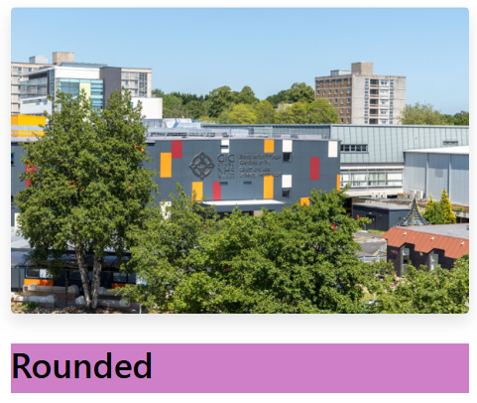  Squared Corners:  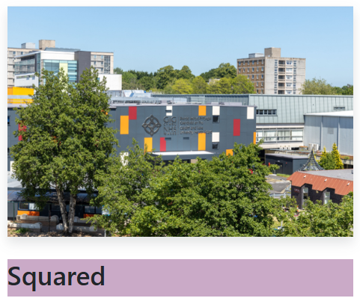  Configurator setting:  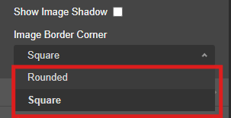  Please note: This will work on all Image Size fits except for Scale Down, as the image itself is scaled down within the image area, which makes the image corner square.  See the CMS Support Site for more information on the Image Plugin | HEIW
4.2.10 Toggle Form Update – Icons | An update has been made to the Toggle Form, so admins can choose to add an icon to the Toggle Form. The icon will indicate to users that this is a clickable item to open and close.  Configurator Settings:  Tick the Show Toggle Icon box to bring up the Toggle Icon Type dropdown display. Admins can choose to have an Arrow or Plus Icon.  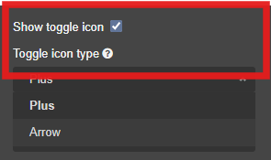  Plus Icon:  Closed  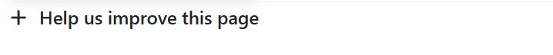  Open  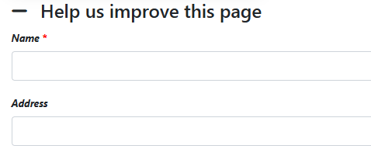  Arrow Icon:  Closed  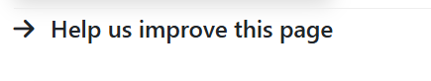  Open  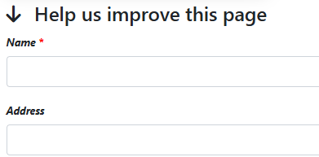  See the CMS Support Site for more information on the Toggle Form | CMS Support Team
4.2.11 Advanced Table List – Hide Table Content | A new layout setting has been added to the Advanced Table List – ‘Only Display Results on Search’.  When ticked, the content within the Advanced Table List will be hidden on initial display, showing the Search Bar and Advanced Search only.  Once a search term has been entered, the results will then display within the ATL.  Configurator Setting:  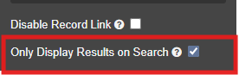  Advanced Table List Display with Setting on: With this setting on, when users view your ATL it will show the search bar and advanced search options only.  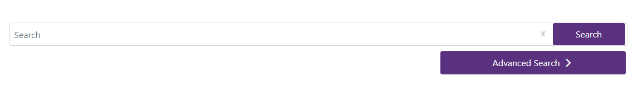  Results will then appear once a search has been performed:  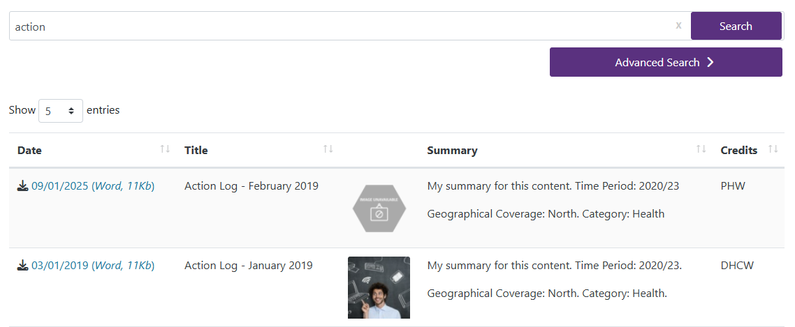  See the CMS Support Site for more information on Advanced Table List | JCC
Accessibility Standards
4.2.12 Filter by Category – Category Tab Letter Case Update | To follow consistent casing and Accessibility Best Practice we have now updated the Filter by Category letter tab display.  Previously, the Category tab text would only display in Uppercase letters. This update will now honour the exact casing entered when creating your initial category in the backend Categories area.  Example: The Category tab will honour the casing that has been entered when creating your Categories in the backend:  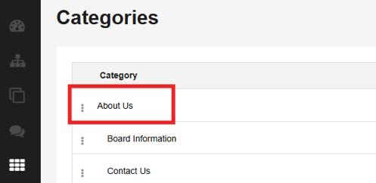  So, on the front end, the category tab text will display exactly as it has been entered in the backend  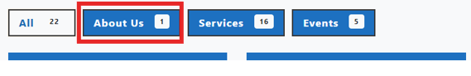  See the CMS Support Site for more information on the Filter by Category Layout | HDUHB
4.2.13 Image Plugin – Yellow Highlight for Links Indicator | Previously when adding a link to an Image Plugin, it did not display the yellow highlight which indicates to users that the image is a clickable link.  To keep in line with other layouts, we have now added this functionality to the Image Plugin when using links within it.    See the CMS Support Site for more information on the Image Plugin | CMS Support Team
4.2.14 Single Button – Yellow Highlight for Links Indicator | Previously when adding a link to a Single Button, it did not display the yellow highlight box which indicates to users that the button is a clickable link.  To keep in line with other layouts, we have now added this functionality to the Single Button when using links within it.  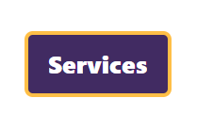  See the CMS Support Site for more information on the Single Button layout | CMS Support Team

Summary
Number of Changes
14
Bug Fixes | System Updates | Plugin & Layout Updates | Accessibility Standards
2 | 1 | 8 | 3

Problems Fixed
N/A

New Problems Identified During Testing and Associated Workarounds
Testing did not identify any new issues, and no workarounds are currently required.

Pre-requisites to Deploy the Release
There are no pre-requisites for deploying this release. Standard deployment processes can be followed.

Training Requirements
No formal training is required for this release. Users should refer to the CMS Support Site links provided for further details and instructions on the updates and new features listed.

Step-by-Step Deployment Instructions
No Deployment actions required by Health Boards.

Deployment Plan
Changes to be implemented as specified in the Change Record. Release to be deployed via Change Record: Change 151041

Back-Out Plan
Back out as detailed on each change record

Release Available for Deployment Date
NHS Wales Websites CMS: Wednesday, the 8th April 2026

