Digital Health and Care Wales
NHS Wales IT Service Management

NHS Wales Websites CMS October 2025 Release Notes | Release ID: 951

Releases
Log a release.
Proposed (5)
Awaiting Build & Test (0)
Awaiting SIT (0)
Awaiting OAT (0)
Awaiting RT (0)
Ready to Deploy (0)
Deployed (0)
Aborted (0)
All (5)

Closed
Schedule of change
Calendar
Historic record of change
List options
Release Logged Title Release ID Release Date Owner Related deployment changes Related release changes Related Services
815

Releases
Log a release.
Proposed (5)
Awaiting Build & Test (0)
Awaiting SIT (0)
Awaiting OAT (0)
Awaiting RT (0)
Ready to Deploy (0)
Deployed (0)
Aborted (0)
All (5)

Closed
Schedule of change
Calendar
Historic record of change
List options
Release Logged Title Release ID Release Date Owner Related deployment changes Related release changes Related Services
815

These Release Notes describe the scope and content of
Release ID: 951 for the NHS Wales Websites CMS Service

Version: | 0.3
Status: | Final
Owner: | DHCW Corporate Apps Team
Author: | DHCW Corporate Apps Team
Approver: | DHCW Corporate Apps Team

Date: | 20/08/2025
Next Review Date: | 30/09/2025

1 DOCUMENT HISTORY 4
1.1 Revision History 4
1.2 Authorisation 4
1.3 Document Location 4
2 INTRODUCTION 4
3 SERVICE MANAGEMENT BOARD (SMB) 4
4 RELEASE NOTES REQUIREMENT 5
4.1 Release Identification 5
4.2 Description of New or Modified Functionality 5
5 Summary 17
5.1 Problems Fixed 17
5.2 New Problems Identified During Testing and Associated Workarounds 17
5.3 Pre-requisites to Deploy the Release 17
5.4 Training Requirements 17
5.5 Step-by-Step Deployment Instructions 17
5.6 Deployment Plan 17
5.7 Back-Out Plan 17
5.8 Release Available for Deployment Date 17

DOCUMENT HISTORY

Revision History
Date | Version | Author | Revision Summary
20/08/2025 | 0.1 | DHCW Corporate Apps Team | Document created for the NHS Wales Websites CMS Release
08/09/2025 | 0.2 | DHCW Corporate Apps Team | Added Extra Items
30/09/2025 | 0.3 | DHCW Corporate Apps Team | Added Extra Items and Images

Authorisation
The signing of this document indicates acceptance of its contents.
Author’s Name: | DHCW Corporate Apps Team

Approver’s Name: | DHCW Corporate Apps Team

Document Location
Type | Location
Electronic | NHS Wales Websites CMS Support Site – What’s New

INTRODUCTION
The NHS Wales Release Management Policy considers that effective Release Management is essential for protecting the integrity of the operational environment. A key objective of the release process is to ensure that users, support staff, and other stakeholders are kept informed as to what is planned and how this will affect them. One of the ways that this can be achieved is through the publication of release notes prior to deployment of the Release.
These notes contain information on the agreed scope and content of Release id CMS/04-2025 for the CMS descriptions of new or modified functionality and problem fixes, descriptions of new problems and workarounds identified during the testing of this Release, training requirements, deployment instructions, references to deployment and back-out plans and key dates within the release process.

SERVICE MANAGEMENT BOARD (SMB)
The CMS Service Management Board has overall responsibility for ensuring that these Release Notes accurately describe the Release and that it is kept under constant review and updated to reflect any modifications to the Release prior to its deployment.

RELEASE NOTES REQUIREMENT

Release Identification
951 - CMS/04-2025

Description of New or Modified Functionality

Item |  | Description of the Change | Requestor
Bug Fixes
4.2.1 Content Expiration Notification Emails Restored |  | We have now resolved an issue where content expiration notification emails were not being sent as expected. This functionality has been restored.  When using the Content Expiration feature within the Publishing tab, if a site user is selected, they will now receive an email notification 7 days before the page’s expiration date.  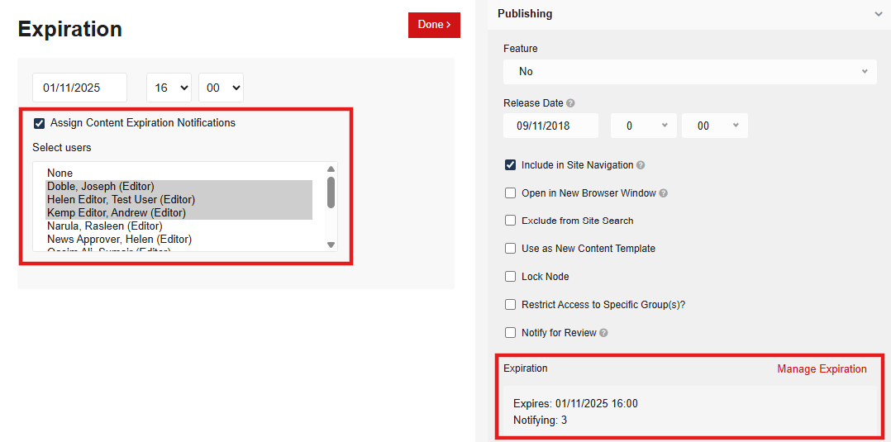  Please Note:  This email serves only as a reminder to review or refresh the content and will not automatically remove the page from the live site.  See the CMS Support Site for more information on Content Expiration | CMS Support Team
4.2.2 Editor Access – Image Plugin |  | Site Editors have reported issues accessing Images and Documents through the File Manager (via the site Plugins), with searches running slowly, hanging, or failing to return results at all (though this worked correctly for full-site admins).  We have now improved performance in order to load the users' results faster, preventing timeouts and ensuring Editors can view and select their site’s Images and Documents without issue. | CMS Support Team
4.2.3 Trac Layout Adjustment |  | Extra padding was being applied to the Trac Style; this was pushing the sectors' boxes out of line with each other. We have now rectified this issue.  Previous Layout:  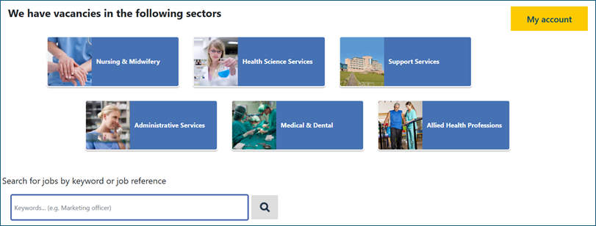  New Layout:  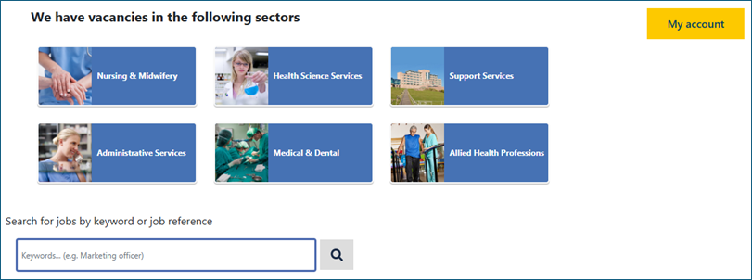 | CMS Support Team
4.2.4 Trac Pagination Adjustment |  | The Trac pagination was appearing incorrectly, overlapping text and displaying words instead of icons. We have now rectified this issue.  Previous Layout:  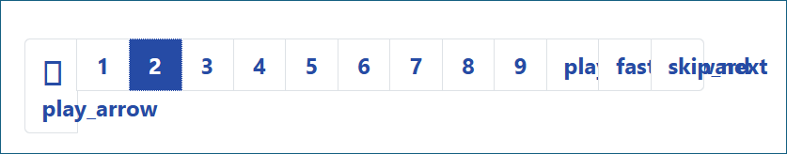  New Layout:  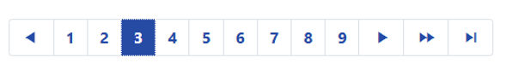 | CMS Support Team
4.2.5 Content Rater Update |  | The site Content Rater was only allowing users to rate content when signed in as a site user. This issue has now been rectified so that site visitors are able to rate the content pages  See the CMS Support Site for more information on the Content Rater | HEIW
Accessibility Standards
4.2.6 Search Bar Update |  | We have now introduced an accessibility-focused improvement to the primary Navigation Search Bar:  - The ‘×’ (clear) icon will now only appear when text is entered in the search box.  - When the search box is empty, the '×' icon is no longer shown, aligning with best accessibility practices.  - Clicking the '×' icon clears the search field, and the icon disappears again once the field is empty.  Accessibility Compliance:  This update ensures a clearer and more intuitive experience for users navigating via screen readers and keyboard, while also creating a cleaner interface overall.  This change aligns with WCAG 2.2 – Guideline 1.3.1: Info and Relationships (Level A), by ensuring that controls are only presented when they have a clear and meaningful function, improving usability for assistive technologies.  Previous Display New Display  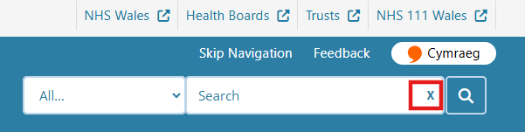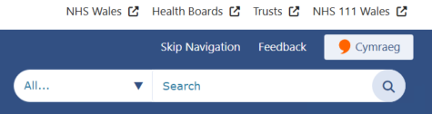  See the CMS Support Site for more information on the Site Search | CMS Support Team
System Updates
4.2.7 Site Search Update – Tagging | We have now made two enhancements to the CMS Site Search to make it easier for users to find the content they need.  - When a user searches for a Specific Keyword, any content marked with a matching Tag will now appear higher in the search results list. This update makes search results more relevant and helps users find what they need more quickly and efficiently.  - User’ search results will now prioritise matching Webpages over matching PDFs/Documents. This means users are more likely to see relevant page content first, with supporting documents still included further down the results.  See the CMS Support Site for more information on Tagging  See the CMS Support Site for more information on the Site Search |  | HDUHB
4.2.8 CMS Websites Theme Update (Phase 1) | As approved at the June CMS SMB meeting, we have now implemented an updated Header & Footer Theme across all CMS websites.  What's New in the Updated Theme  The visual and functional enhancements aim to provide a more modern, consistent, and accessible user experience. Key changes include:  - Top Navigation Bar - Refreshed design for better usability and consistency.  - Desktop Header Gradient – Removal of gradient banner for single colour block to enhance visual appeal on larger screens.  - Search Box Appearance – Styling update to size and shape.  - Language Button – Styling update to the Cymraeg toggle button.  - Footer Link Styling - Styling update to size and shape.  - Primary Navigation Items - Refined layout and spacing.  - Second Row Navigation (Hover Style) - Clearer hover to aid navigation.  - Footer Links (Hover Style) - Improved visual feedback on interaction.  - DHCW Link (Desktop) - Updated styling to better align with the overall theme.  New CMS Theme Design  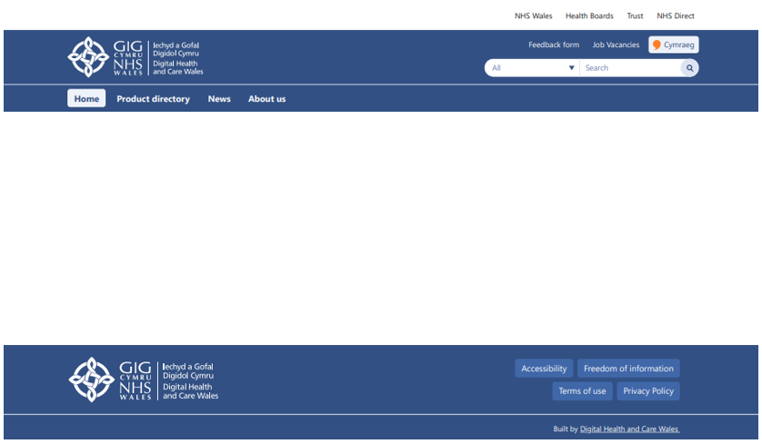  See the CMS Support Site for more information on the CMS Theme |  | CMS SMB (Service Management Board) Approved
4.2.9 New Page Type – Side Bar Contents | We have introduced a new page type called "Section List".  This new page type allows site admins to create webpage versions of PDF reports. Admins can add subheadings for each text section, which will automatically generate a clickable contents list.  When users select a subheading, they will be navigated directly to that section. Additionally, admins can choose whether to display the contents list as a sidebar or at the top of the page, offering greater flexibility in layout.  Desktop View  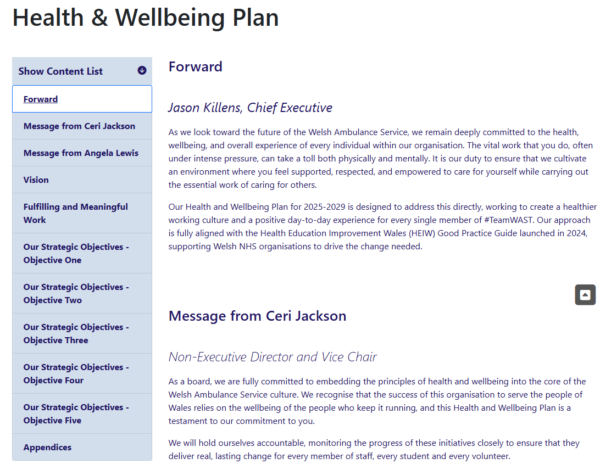  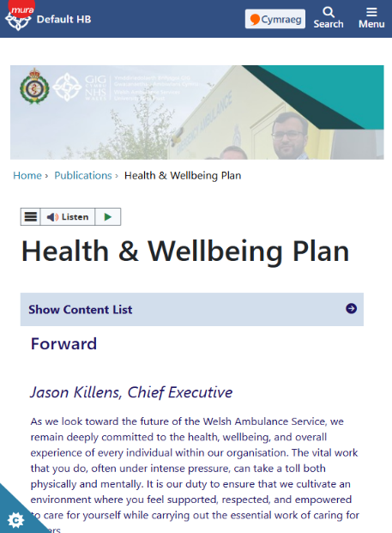  Mobile View – The Section titles in the Content List will display in a collapsed state  See the CMS Support Site for more information on Section List |  | WAST
4.2.10 Links Quick Upload | We have now introduced a new feature that allows users to create multiple links in a single action, where previously, links could only be added one at a time. This improvement will help make content management faster and more efficient, significantly reducing the need for repetitive tasks.  The new Quick Links option is available within the Content Types:  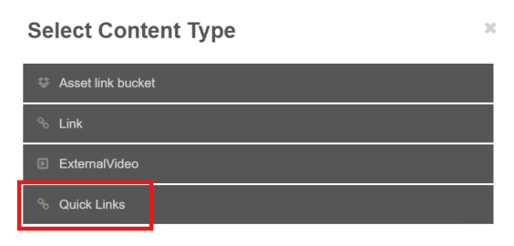  The new page allows up to 5 Links to be created in one single action. The "Add Additional Link" option is also available at the bottom of the screen to allow for more Links if required.  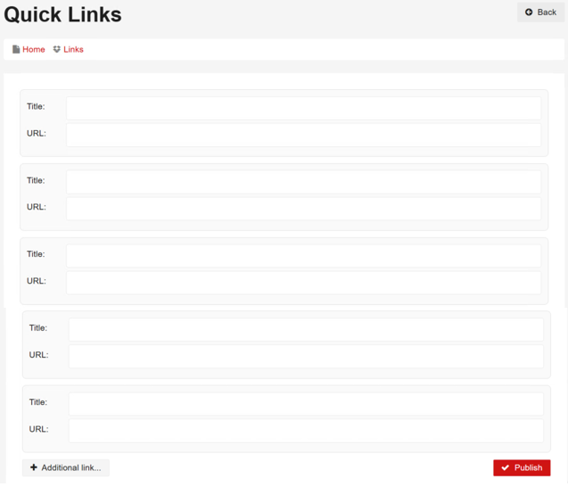  See the CMS Support Site for more information on creating Links |  | NHS Wales Performance & Improvement
4.2.11 Approval Change – Admin Comments | The current Approval/Rejection email sent from an Approval Chain does not pull in the Acceptance/Rejection comments that the content approver has left.  We have now added the ability to pull these comments directly into the email that the user receives. This can be added per site upon request.  Example Email  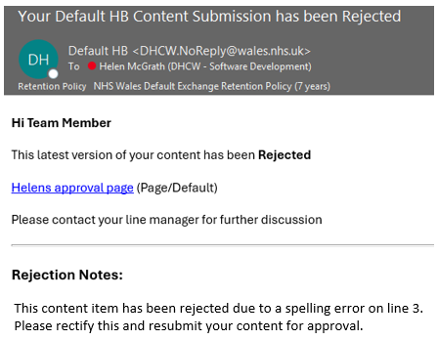  See the CMS Support Site for more information on Approval Chains |  | HEIW
4.2.12 Friendly URL Click Count in | We have now created a new report available within the dashboard area of the backend of the CMS websites.  This report allows users to view the number of hits/visits each friendly URL has received, giving valuable insight into how users are accessing content. By tracking the popularity of specific friendly URLs, you can make informed decisions regarding site usage and engagement.  Log a call to the CMS Support Team to enable the Dashboard on your website  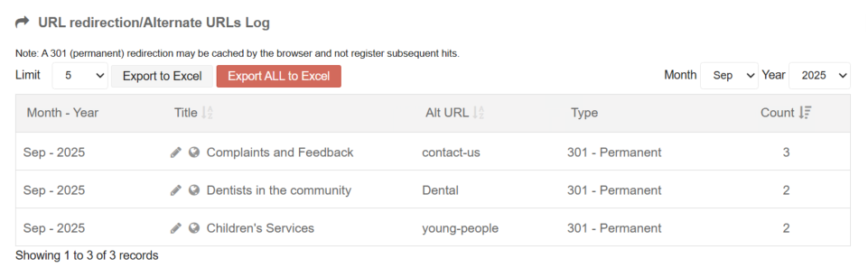  See the CMS Support Site for more information on CMS Reports Available |  | HDUHB
4.2.13 New CMS Report Available | Generate a one-off extract of all content - Users can request a complete content extract from the CMS database, encompassing all pages and/or documents. This extract provides a full snapshot of the data for reporting, analysis, and archival purposes.  The exported data includes the following details: Title, Page URL, Admin URL, Type, Subtype, Created Date, Release Date, Last Updated, Expiry Date, Display Status, Approval Status, and Navigation Status.  *This report will only be made available in Excel format upon request.  Please log your request to the CMS Support Team  See the Support Site for more information on Available CMS Reports |  | PCOne
4.2.14 New CMS Report Available 2 | Generate a one-off extract of all Documents NOT being displayed - Users can request an extract from the CMS database, encompassing all documents that are not currently linked anywhere on the website.  The exported data includes the following details: Title, Page URL, Admin URL, Created Date, Last Updated, and File Extension.  *This report will only be made available in Excel format upon request.  Please log your request to the CMS Support Team  See the Support Site for more information on Available CMS Reports |  | HDUHB
4.2.15 Forms – Text Area | We have now introduced new options to make it easier for administrators to control the default height of Text Area Boxes within Mura forms. This gives flexibility to choose the text area default size, from Standard, Medium, or Large.  By applying one of the following pieces of text within the Advanced Tab CSS Class:  - muraFormTextAreaMedium  - muraFormTextAreaLarge  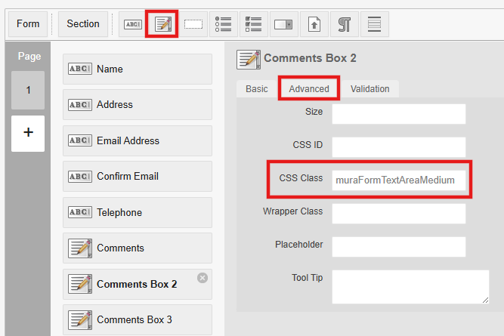  The Comments Boxes will then appear as below, to your site visitors:  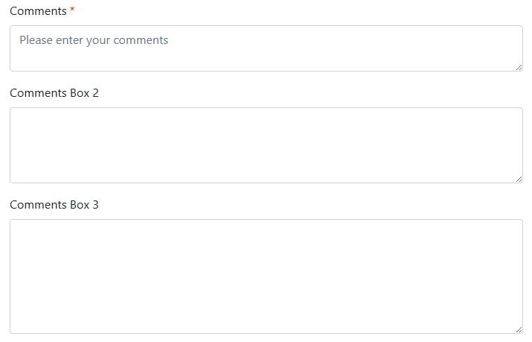  See the CMS Support Site for more information on Forms |  | ABUHB
4.2.16 User Maintenance Form - Increase Field Size | We have now updated the CMS User Maintenance Form to make it more flexible. The Company and Job Title fields now support up to 100 characters, allowing users to enter longer and more detailed information.  See the CMS Support Site for more information on User Accounts |  | CMS Support Team
Plugin & Layout Updates
4.2.17 RSS Feed Images Update |  | As part of the June 2025 CMS Release, we introduced the ability to pull in RSS feeds containing images from other CMS websites. Following this, we’ve now implemented a further update to improve the visual presentation of these feeds in order to maintain a more consistent look and feel.  Current Display New Display  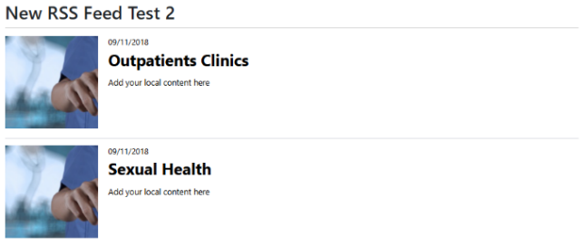  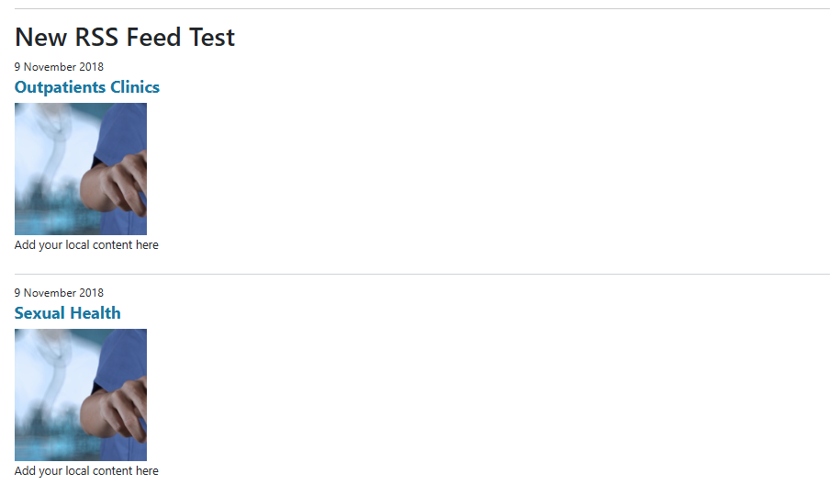  See the CMS Support Site for more information on RSS Feeds | CMS Support Team
4.2.18 Accordion Anchor Links |  | We’ve introduced a new enhancement to the Accordion Layout that allows users to link directly to a specific Accordion tab using a unique Anchor URL.  When creating content using the "Page/Accordion" content type, by adding ?# and the Accordion Tab name to the end of the URL. This means:  - If a user clicks or searches for that specific URL, the page will load with the relevant Accordion tab already expanded.  - Site admins can use these unique URLs to create internal bookmark links, directing users straight to a specific tab in an open state, improving navigation and user experience.  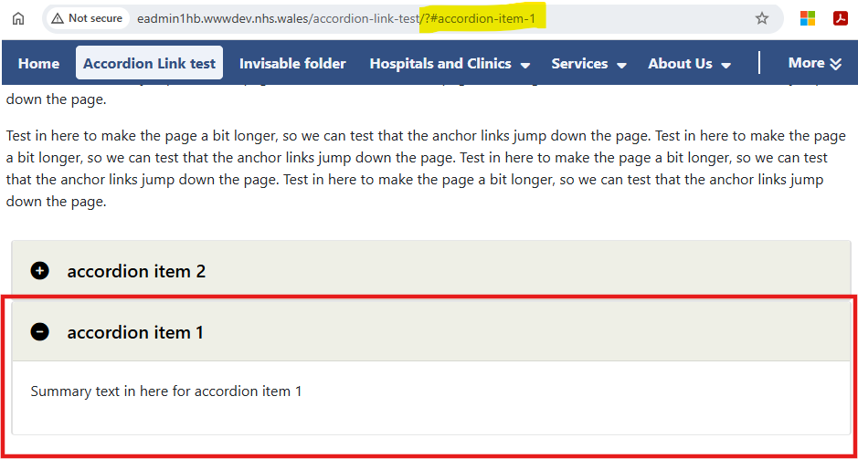  See the CMS Support Site for more information on Accordions | CMS Support Team
4.2.19 Accordion Icons and Text Alignment |  | Following feedback from ABUHB, we've made some updates to the Accordion Layout. These changes improve the visual alignment and overall readability of Accordion components across all pages.  Icon Alignment  The icon next to the accordion title is now vertically aligned with the text for a cleaner, more consistent look.  Padding Adjustment  The title text had a slight bottom padding, which caused the text to appear off-centre vertically. This padding has been adjusted to ensure the text is now vertically centred more neatly within the accordion bar.  Current Accordion Display New Accordion Display  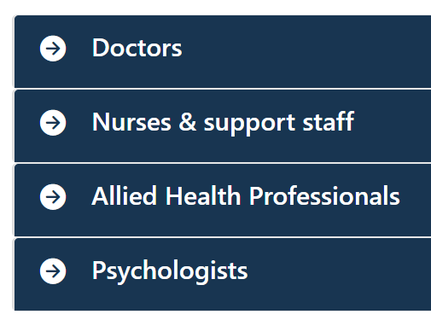  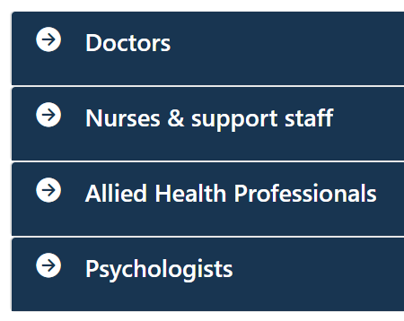 | ABUHB
4.2.20 DoS Plugin – Pharmacy Update |  | 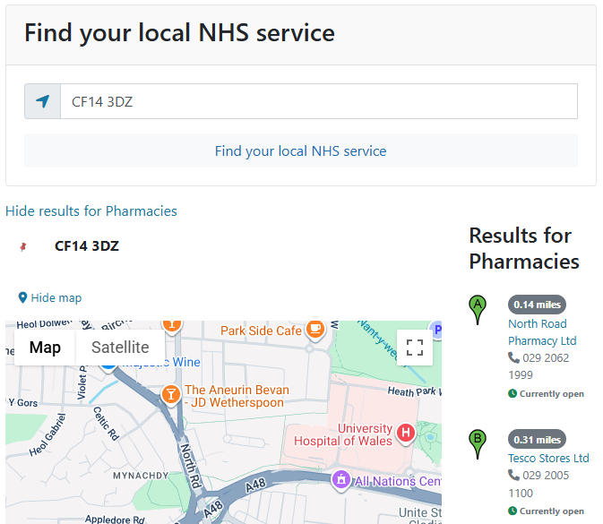  We have updated the CMS Directory of Services (DoS) Plugin to ensure it now displays the most up-to-date Pharmacy details for each Health Board, including name, address, and split opening hours.  These details are pulled directly from the Welsh Reference Data Service (WRDS).  Any data updates can be requested by Health Board Pharmacy admins through WRDS Forms  See the CMS Support Site for more information on the DoS
4.2.21 Video Carousel Update |  | We have introduced an update to the Video Carousel Plugin, adding a new display setting. Administrators can now choose between two display options: "Video Carousel Standard" and "Video Carousel Expanded."  Selecting "Video Carousel Expanded" will enlarge the carousel, allowing multiple videos to be visible on either side of the main video. Users can navigate through the displayed videos using the navigational arrows. And the option to include a video transcript.  Desktop View  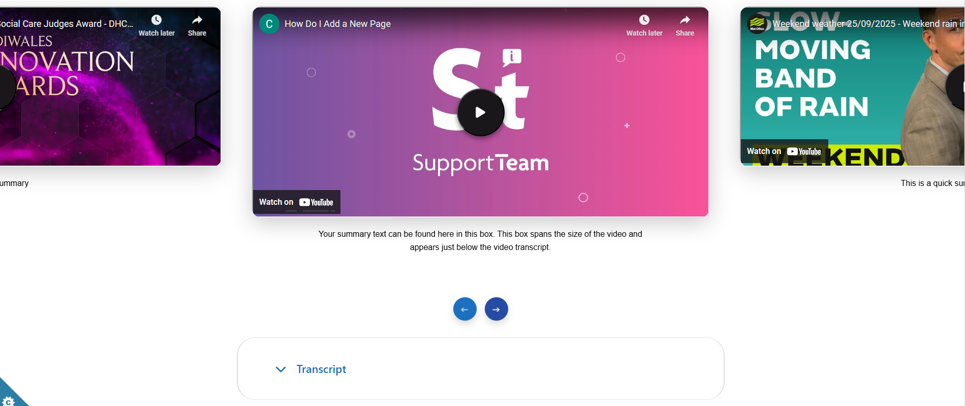  Mobile View - Videos will appear stacked when viewed on a Mobile platform.  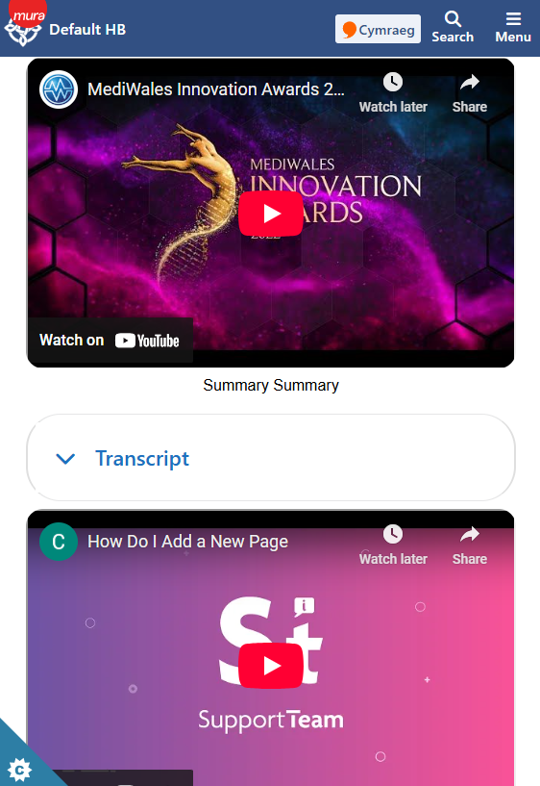  See the CMS Support Site for more information on Video Carousel | CMS Support Team
4.2.22 New Layout – Single Button |  | We have now introduced a brand-new layout option called Single Button. This new layout is designed to make it quicker and easier to add a single standalone call-to-action button to your page, without needing a full button collection.  Site admins will be able to add a customisable link and display bespoke linking text. The Single Button layout comes with a range of customisation options, allowing you to tailor the button to your site’s styling, while still meeting accessibility requirements. With the added option to include an Icon/Image.  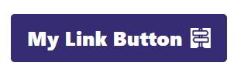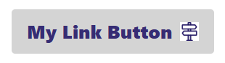    See the CMS Support Site for more information on the Single Button | CMS Support Team

Summary
Number of Changes
22
Bug Fix | System Updates | Plugin & Layout Updates | Accessibility Standards
5 | 10 | 6 | 1

Problems Fixed
N/A

New Problems Identified During Testing and Associated Workarounds
Testing did not identify any new issues, and no workarounds are currently required.

Pre-requisites to Deploy the Release
There are no pre-requisites for deploying this release. Standard deployment processes can be followed.

Training Requirements
No formal training is required for this release. Users should refer to the CMS Support Site links provided for further details and instructions on the updates and new features listed.

Step-by-Step Deployment Instructions
No Deployment actions required by Health Boards.

Deployment Plan
Changes to be implemented as specified in the Change Record. Release to be deployed via Change Record: Change 150024

Back-Out Plan
Back out as detailed on each change record

Release Available for Deployment Date
NHS Wales Websites CMS: Wednesday, the 8th October 2025

