Digital Health and Care Wales
NHS Wales IT Service Management

NHS Wales Websites CMS June 2025 Release Notes | Release ID: 929

Releases
Log a release.
Proposed (5)
Awaiting Build & Test (0)
Awaiting SIT (0)
Awaiting OAT (0)
Awaiting RT (0)
Ready to Deploy (0)
Deployed (0)
Aborted (0)
All (5)

Closed
Schedule of change
Calendar
Historic record of change
List options
Release Logged Title Release ID Release Date Owner Related deployment changes Related release changes Related Services
815

Releases
Log a release.
Proposed (5)
Awaiting Build & Test (0)
Awaiting SIT (0)
Awaiting OAT (0)
Awaiting RT (0)
Ready to Deploy (0)
Deployed (0)
Aborted (0)
All (5)

Closed
Schedule of change
Calendar
Historic record of change
List options
Release Logged Title Release ID Release Date Owner Related deployment changes Related release changes Related Services
815

These Release Notes describe the scope and content of
Release ID: 929 for the NHS Wales Websites CMS Service

Version: | 0.2
Status: | Final
Owner: | DHCW Corporate Apps Team
Author: | DHCW Corporate Apps Team
Approver: | DHCW Corporate Apps Team

Date: | 13/05/2025
Next Review Date: | 04/06/2025

1 DOCUMENT HISTORY 4
1.1 Revision History 4
1.2 Authorisation 4
1.3 Document Location 4
2 INTRODUCTION 4
3 SERVICE MANAGEMENT BOARD (SMB) 4
4 RELEASE NOTES REQUIREMENT 5
4.1 Release Identification 5
4.2 Description of New or Modified Functionality 5
5 Summary 9
5.1 Problems Fixed 9
5.2 New Problems Identified During Testing and Associated Workarounds 9
5.3 Pre-requisites to Deploy the Release 9
5.4 Training Requirements 10
5.5 Step-by-Step Deployment Instructions 10
5.6 Deployment Plan 10
5.7 Back-Out Plan 10
5.8 Release Available for Deployment Date 10

DOCUMENT HISTORY

Revision History
Date | Version | Author | Revision Summary
13/05/2025 | 0.1 | DHCW Corporate Apps Team | Document created for the NHS Wales Websites CMS Release
29/05/2025 | 0.2 | DHCW Corporate Apps Team | Items list finalized
04/06/2025 | 0.3 | DHCW Corporate Apps Team | Images Updated

Authorisation
The signing of this document indicates acceptance of its contents.
Author’s Name: | DHCW Corporate Apps Team

Approver’s Name: | DHCW Corporate Apps Team

Document Location
Type | Location
Electronic | NHS Wales Websites CMS Support Site – What’s New

INTRODUCTION
The NHS Wales Release Management Policy considers that effective Release Management is essential for protecting the integrity of the operational environment. A key objective of the release process is to ensure that users, support staff and other stakeholders are kept informed as to what is planned and how this will affect them. One of the ways that this can be achieved is through the publication of release notes prior to deployment of the Release.
These notes contain information on the agreed scope and content of Release id CMS/03-2025 for the CMS descriptions of new or modified functionality and problem fixes, descriptions of new problems and workarounds identified during the testing of this Release, training requirements, deployment instructions, references to deployment and back-out plans and key dates within the release process.

SERVICE MANAGEMENT BOARD (SMB)
The CMS Service Management Board has overall responsibility for ensuring that these Release Notes accurately describe the Release and that it is kept under constant review and updated to reflect any modifications to the Release prior to its deployment.

RELEASE NOTES REQUIREMENT

Release Identification
929 - CMS/03-2025

Description of New or Modified Functionality

Item |  | Description of the Change | Requestor
Bug Fixes
4.2.1 Associated Image Search Update |  | Users reported that searching for an Associated Image could be slow, occasionally resulting in a 504-error message. We have now implemented improvements to enhance the performance of these search results.  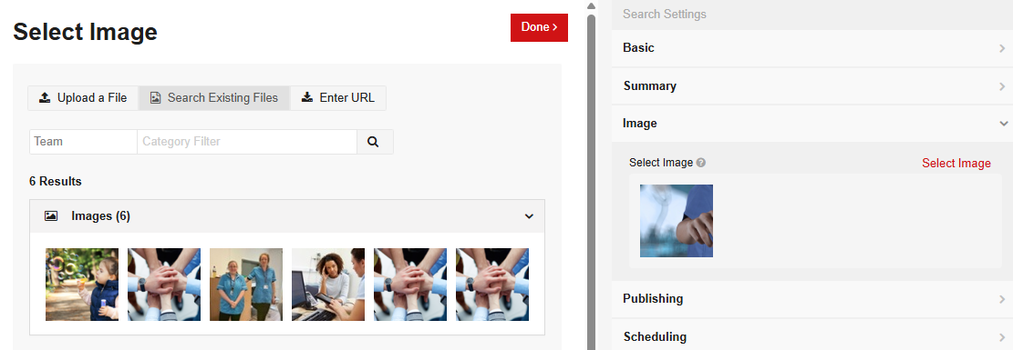  See the CMS Support Site for more information on Associated Images | DHCW
4.2.2 Mobile Nav Content Ordering |  | Users have reported that Mobile Navigation did not follow the A-Z sort order when the ‘Long Title’ option was selected in the Modify view field.  We have now implemented an update to ensure that the chosen sort order is always respected in both the Desktop and Mobile Navigation Menus.  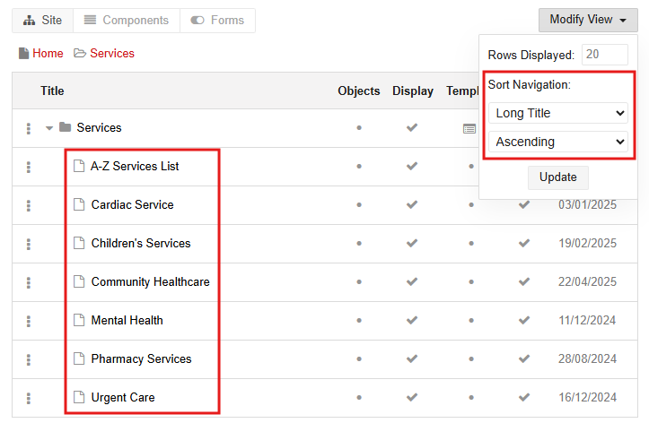  Incorrect Sort Order Displaying Correct Sort Order Displaying  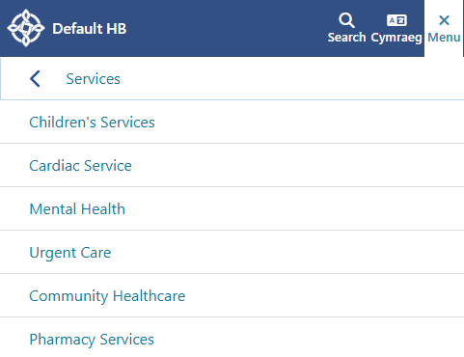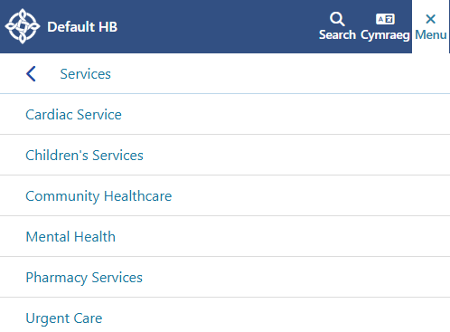 | HDUHB
4.2.3 Site Search Update |  | During an investigation into another issue, it was identified that homepage content was not appearing in search results on the NHS Wales Websites CMS.  We have now implemented an update to ensure homepage content is included in the Site Search results. | CMS Support Team
System Updates
4.2.4 New Dashboard ALT URLs area | We have introduced a new report within the Site Dashboard area, accessible via the Reports Tab. The new report, titled "URL Redirection/Alternate URLs", allows users to easily access data related to alternate URLs and redirections for any site content.  The alphabetical results list includes the Page Title & Alt URL, along with View and Edit icons, which enable users to navigate directly to the front or back end of the page, depending on the selected icon.  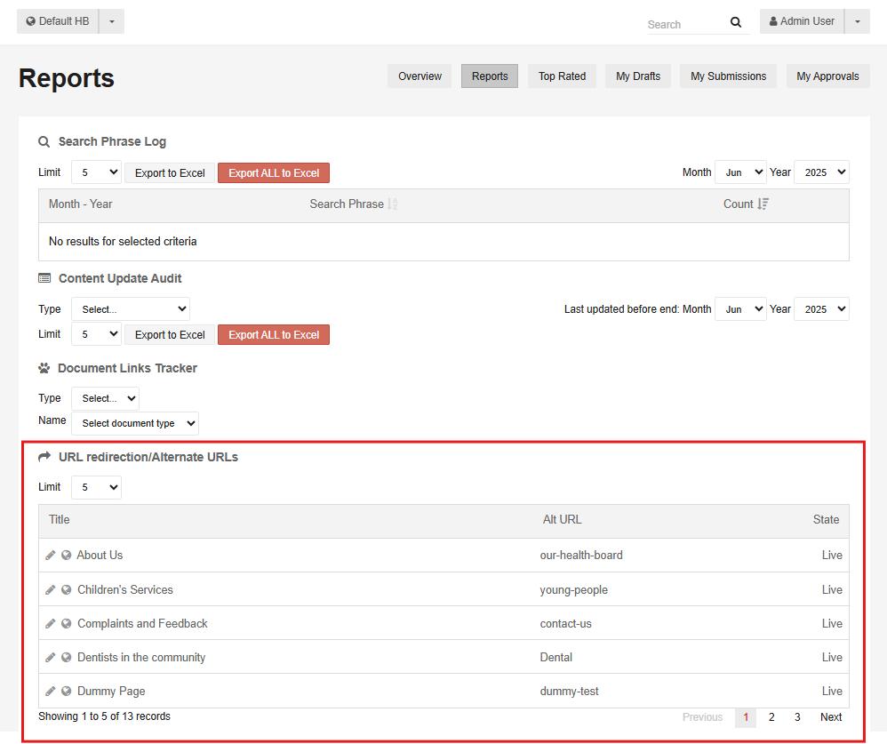  See the CMS Support Site for more information on Reports |  | PHW
4.2.5 New Warning Message | We have introduced a new error warning message to alert administrators when a page URL exceeds the system's allowable length.  How it Works:  When an admin amends the title of a page that has multiple child or descendant pages, and the amendment would cause one or more of the child page URLs to exceed 255 characters, the following message will appear upon attempting to publish:  "The dynamically generated filename for this content node will be too long. Please shorten the URL Title property."  This message ensures that overly long URLs are identified and corrected before they are published. |  | CMS Support Team
Plugin & Layout Updates
4.2.6 Buttons Layout Update |  | During testing, an issue was identified with the "Card Title Horizontal Position" setting within the Buttons Layout, where the Centre and Right alignment options were not functioning correctly on Mobile view.  We have now implemented an update to ensure that the Buttons Layout consistently respects all alignment settings on both desktop and mobile platforms.  Incorrect Mobile Behaviour Correct Mobile Behaviour  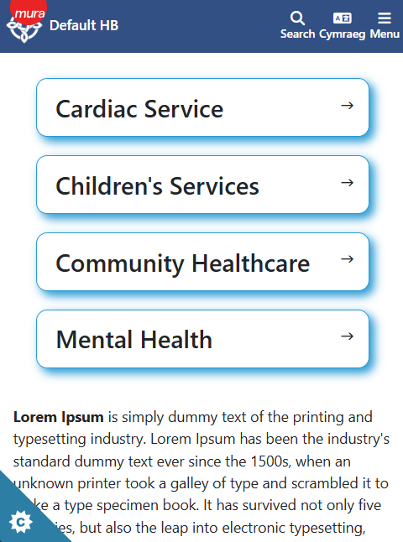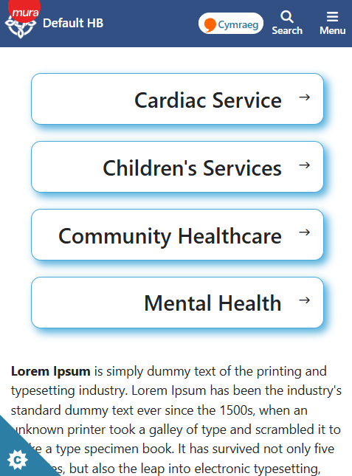  See the CMS Support Site for more information on Buttons | CMS Support Team
4.2.7 Header Panel 2 Update |  | We have introduced a new layout option within the Header Panel 2 settings. This update allows administrators to reposition the page breadcrumb, giving the option to display it either On or Above the Header Panel block.  Additionally, users can choose Not to display the breadcrumb at all, offering greater flexibility in page design.  Option 1 – No Breadcrumb    Option 2 – Breadcrumb displayed on the Header Panel    Option 3 – Breadcrumb displayed above the Header Panel    See the CMS Support Site for more information on Header Panel 2 | WKN
4.2.8 RSS Feeds Update |  | We have now enhanced the RSS Feed functionality. When pulling in an RSS feed from another CMS-managed site, administrators will find that a second RSS feed URL is now available.  This will allow admins to choose whether or not to include the content items associated image (where available).  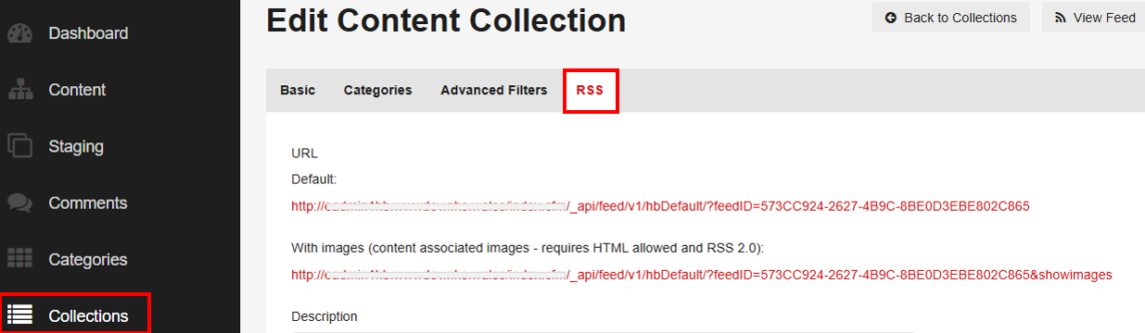  See the CMS Support Site for more information on RSS Feeds | HDUHB
Welsh Language Standards
4.2.9 Cymraeg Toggle on a Mobile |  | We have introduced a cosmetic update to the Cymraeg Toggle on CMS websites to enhance its appearance within the Mobile View of the site navigation. This update improves the visual consistency and usability of the language switcher.  This change was requested and approved by the NHS Wales Websites CMS Service Management Board (SMB).  Old Style Cymraeg Link – Mobile View  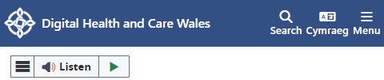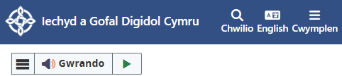  New Style Cymraeg Link – Mobile View  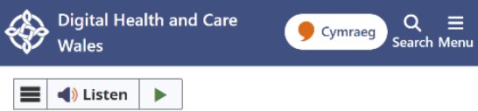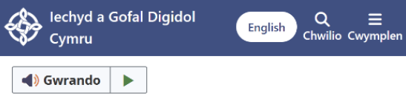 | CMS SMB

Summary
Number of Changes
9
Bug Fix | System Updates | Plugin & Layout Updates | Welsh Language Standards
3 | 2 | 3 | 1

Problems Fixed
N/A

New Problems Identified During Testing and Associated Workarounds
N/A

Pre-requisites to Deploy the Release
N/A

Training Requirements
N/A

Step-by-Step Deployment Instructions
No Deployment actions required by Health Boards.

Deployment Plan
Changes to be implemented as specified in the Change Record. Release to be deployed via change record: Change 147105

Back-Out Plan
Back out as detailed on each change record

Release Available for Deployment Date
NHS Wales Websites CMS: Wednesday, the 18th June 2025

