Digital Health and Care Wales
NHS Wales IT Service Management

NHS Wales Websites CMS December 2025 Release Notes | Release ID: 968

Releases
Log a release.
Proposed (5)
Awaiting Build & Test (0)
Awaiting SIT (0)
Awaiting OAT (0)
Awaiting RT (0)
Ready to Deploy (0)
Deployed (0)
Aborted (0)
All (5)

Closed
Schedule of change
Calendar
Historic record of change
List options
Release Logged Title Release ID Release Date Owner Related deployment changes Related release changes Related Services
815

Releases
Log a release.
Proposed (5)
Awaiting Build & Test (0)
Awaiting SIT (0)
Awaiting OAT (0)
Awaiting RT (0)
Ready to Deploy (0)
Deployed (0)
Aborted (0)
All (5)

Closed
Schedule of change
Calendar
Historic record of change
List options
Release Logged Title Release ID Release Date Owner Related deployment changes Related release changes Related Services
815

These Release Notes describe the scope and content of
Release ID: 968 for the NHS Wales Websites CMS Service

Version: | 0.3
Status: | Final
Owner: | DHCW Corporate Apps Team
Author: | DHCW Corporate Apps Team
Approver: | DHCW Corporate Apps Team

Date: | 31/10/2025
Next Review Date: | 26/11/2025

1 DOCUMENT HISTORY 4
1.1 Revision History 4
1.2 Authorisation 4
1.3 Document Location 4
2 INTRODUCTION 4
3 SERVICE MANAGEMENT BOARD (SMB) 4
4 RELEASE NOTES REQUIREMENT 5
4.1 Release Identification 5
4.2 Description of New or Modified Functionality 5
5 Summary 13
5.1 Problems Fixed 13
5.2 New Problems Identified During Testing and Associated Workarounds 14
5.3 Pre-requisites to Deploy the Release 14
5.4 Training Requirements 14
5.5 Step-by-Step Deployment Instructions 14
5.6 Deployment Plan 14
5.7 Back-Out Plan 14
5.8 Release Available for Deployment Date 14

DOCUMENT HISTORY

Revision History
Date | Version | Author | Revision Summary
31/10/2025 | 0.1 | DHCW Corporate Apps Team | Document created for the NHS Wales Websites CMS Release
07/11/2025 | 0.2 | DHCW Corporate Apps Team | Finalized list items
28/11/2025 | 0.3 | DHCW Corporate Apps Team | Added Extra Items and Images

Authorisation
The signing of this document indicates acceptance of its contents.
Author’s Name: | DHCW Corporate Apps Team

Approver’s Name: | DHCW Corporate Apps Team

Document Location
Type | Location
Electronic | NHS Wales Websites CMS Support Site – What’s New

INTRODUCTION
The NHS Wales Release Management Policy considers that effective Release Management is essential for protecting the integrity of the operational environment. A key objective of the release process is to ensure that users, support staff and other stakeholders are kept informed as to what is planned and how this will affect them. One of the ways that this can be achieved is through the publication of release notes prior to the deployment of the Release.
These notes contain information on the agreed scope and content of Release ID CMS/05-2025 for the CMS descriptions of new or modified functionality and problem fixes, descriptions of new problems and workarounds identified during the testing of this Release, training requirements, deployment instructions, references to deployment and back-out plans and key dates within the release process.

SERVICE MANAGEMENT BOARD (SMB)
The CMS Service Management Board has overall responsibility for ensuring that these Release Notes accurately describe the Release and that it is kept under constant review and updated to reflect any modifications to the Release prior to its deployment.

RELEASE NOTES REQUIREMENT

Release Identification
968 - CMS/06-2025

Description of New or Modified Functionality

Item | Description of the Change | Requestor
Bug Fixes
4.2.1 Intermittent Image/Doc Download Issue | Some users may have noticed intermittent errors or failed downloads when trying to download Images/Documents from your CMS websites.  This issue has now been fully resolved. Site Admins can now once again download Images/Documents without issue or error messages.  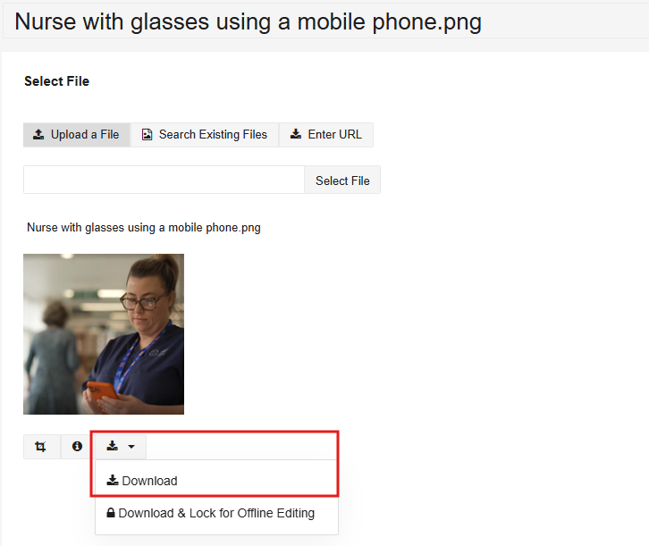 | HEIW
4.2.2 Editor Access – Image Plugin | Site Editors have reported issues accessing Images and Documents through the File Manager (via the site Plugins), with searches running slowly, hanging, or failing to return results at all (though this worked correctly for full-site admins).  We have now improved performance to load the users' results faster, preventing timeouts and ensuring Editors can view and select their site’s Images and Documents without issue. | CMS Support Team
System Updates
4.2.3 Forms - Label Styles | We have now introduced new options to make it easier for administrators to control to amend the formatting of the CMS Form Labels within Mura forms. This gives flexibility to choose from Italic, Bold, Small, Medium, Large, or a combination of any.  By applying one of the following pieces of text within the Top-Level Form CSS Class:  - formLabelItalic  - formLabelBold  - formLabelFontSmall  - formLabelFontMedium  - formLabelFontLarge  Or a mix of any of the above, e.g.  - formLabelBold formLabelFontLarge  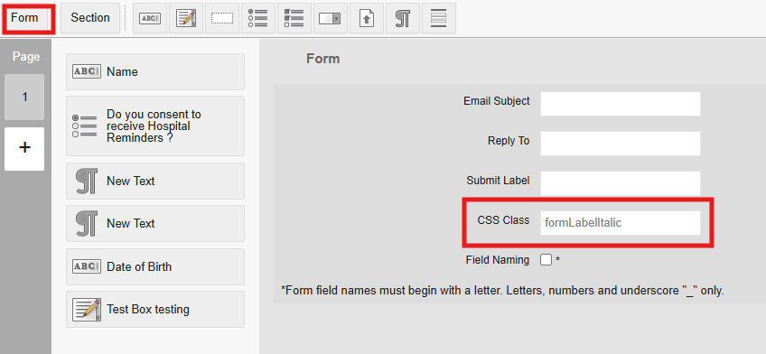  The Form Label will then appear as below:  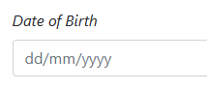  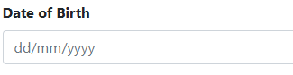  formLabelItalic formLabelBold  formLabelFontSmall formLabelFontMedium  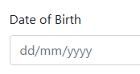  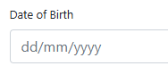  formLabelFontLarge formLabelBold formLabelFontLarge  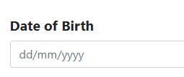  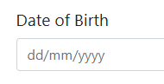  See the CMS Support Site for more information on CMS Forms | ABUHB
4.2.4 Document Links Tracker Update | The Document Links Tracker report enables admin users to identify where a document is being displayed across the site. It also provides the exact location of the document link, such as within a specific Plugin or in a particular Region of the page.  We have now introduced extra functionality within this report. Admins will now see the field Title, which can be used in conjunction with the existing Type field.  This will allow admins to refine their search results and more easily locate the documents they need.  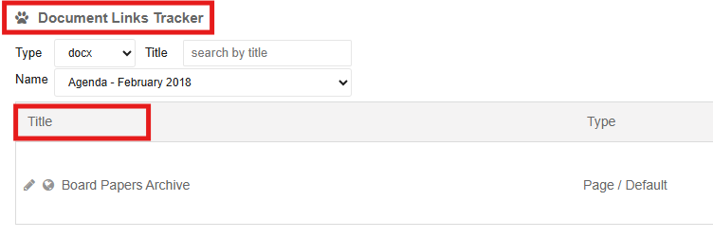  See the CMS Support Site for more information on Document Links Tracker | HDUHB
4.2.5 Language Toggle Update - Mobile | We have now made an update to the Welsh language toggle, when viewed on a mobile platform.  Current Display  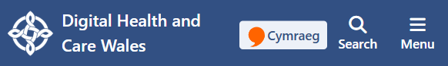  New Display  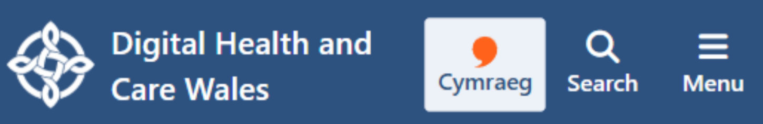 | CMS Support Team
4.2.6 NHS Wales App Download Links | We have now created the ability to add a block into the footer links area of your site that, when clicked, will allow users to download the NHS Wales App via the Apple App Store or the Google Play Store.    See the CMS Support Site for more information on the NHS Wales App Links | CMS Support Team
4.2.7 Acronym Tool Update | We’ve enhanced the existing Acronym Tool, which allows admins to define and manage explanations for acronyms and abbreviations used across the site.  These improvements make it easier for admins to populate and maintain definitions, helping users better understand the terminology within your content.  - Visual Indicator: Acronyms and abbreviations will now display with a yellow underline, showing they’re interactive.  - Instant Explanation: When a user hovers over (or focuses on, using the keyboard) an acronym, they will see a pop-up with its full meaning and description.  - Accessible Experience: The pop-up disappears automatically when the user moves their mouse or tabs away.  - Consistent Display: Existing acronyms and abbreviations now automatically use this new behaviour – so, no extra work is needed!  - Admin Editing: In the CMS editor, admins will still see a dotted underline with a standard tooltip-style pop-up for easy editing.  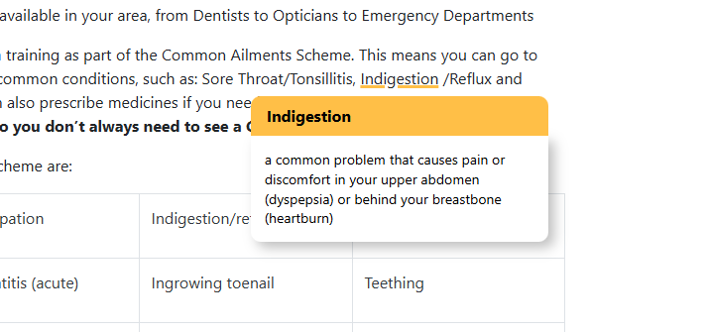  See the CMS Support Site for more information on the Acronym Tool | CMS Support Team
Plugin & Layout Updates
4.2.8 Header Panel 2 Update - Wave Effect | We have now enhanced the Header Panel 2 layout to include options to have a Wave Effect on the bottom of the image/colour block to enhance the visual appearance of the header panel. There are 5 wave layouts to choose from, with a custom colour picker. A future update will include the ability to use images as the Wave Background.  Wave 1:    Wave 2:    Wave 3:    Wave 4:    Wave 5:    See the CMS Support Site for more information on Header Panel 2 | CMS Support Team
4.2.9 New Layout - Accordion 2 | We have now introduced a new Accordion layout, Accordion 2. This new option offers a fresh look and feel compared to the original Accordion layout (which remains available).  You can now choose between both styles to better match your page design and content needs.  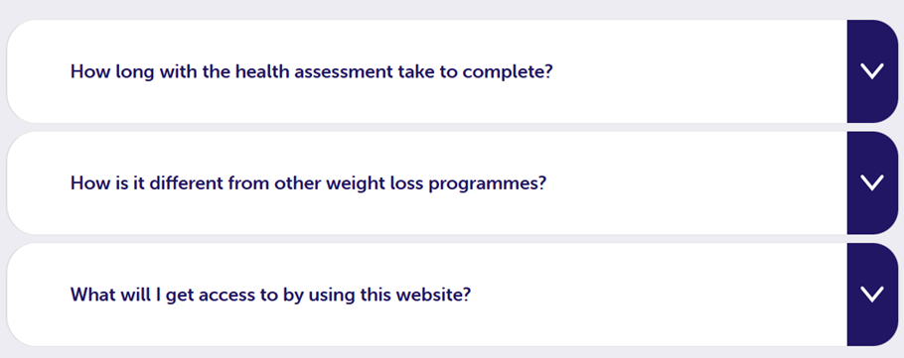  See the CMS Support Site for more information on Accordion 2 | CMS Support Team
4.2.10 Filter by Category Formatting Updates | We have made several improvements to the Filter by Category Layout to give you more control over its appearance and accessibility.  - Custom Corners – Choose between Squared or Rounded corners for both Category buttons and Images to match your site’s style.  - Adjustable Padding – Add padding between the image, title, and summary to improve spacing and readability.  - Better Layout Spacing – Increased the padding between top category buttons for a cleaner look.  - Increased Spacing Option – Amend the vertical spacing between image, title, and summary.  - Aligned Summaries – Summaries now start at the same height, even when titles have varying lengths, keeping all cards neatly aligned.  - Flexible Text Sizing – Set the title text size independently of the summary text.  - Expanded Colour Options – More colour settings for text and backgrounds (both hover and non-hover) to enhance visual clarity and accessibility.  - Accessible Default Colours – Updated the layout’s default colour scheme to ensure it meets accessibility standards right from the start.  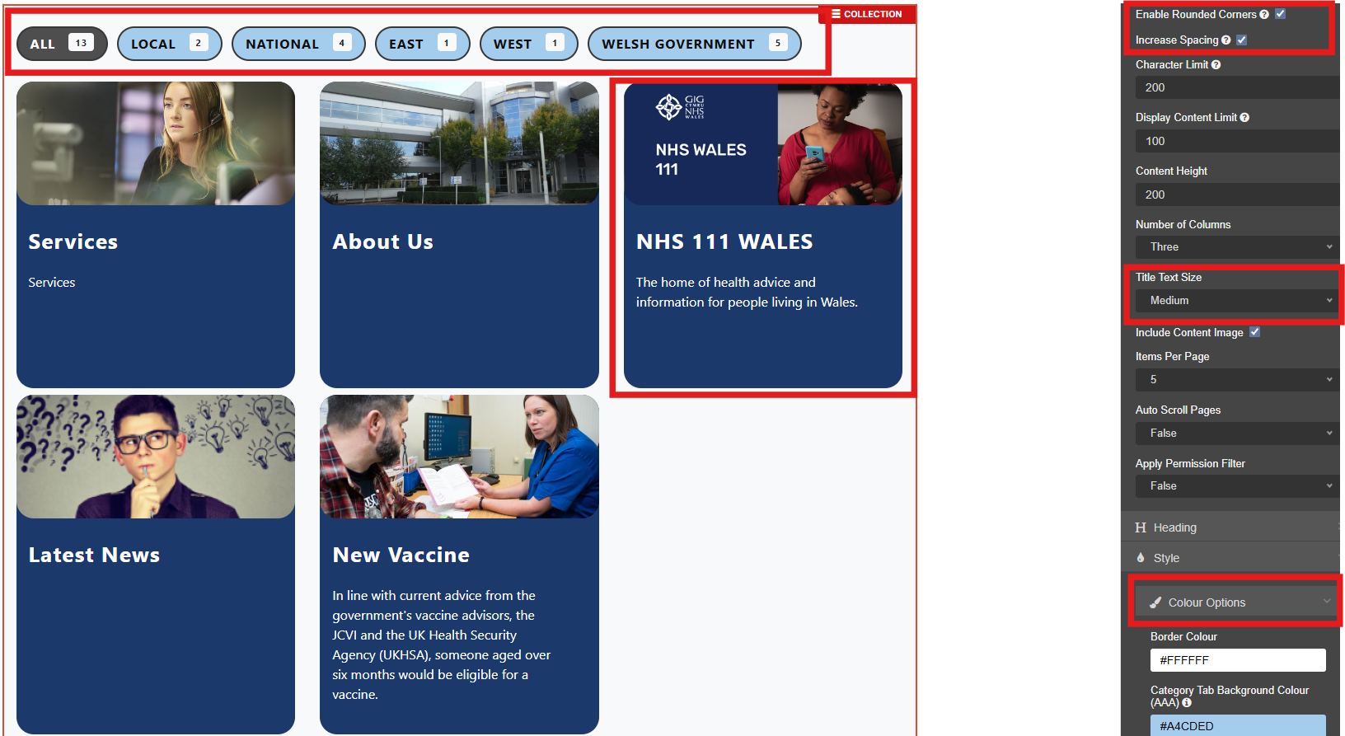  See the CMS Support for more information on the Filter By Category Layout | CMS Support Team
4.2.11 Filter by Category Functionality Updates | We have now made two updates to the functionality of the Filter by Category Layout:  - The Category by Filter block will now correctly display site links that have been categorised with the selected term.  - Pagination will now only appear when there’s more than one page of content for users to navigate to.  See the CMS Support Site for more information on Filter by Category
4.2.12 New Text Quote Plugin | We have now introduced a brand-new Quote Plugin that lets admins easily create stylish text blocks for quotes.  You can now choose from shape options: Square, Rectangular, Rounded Corners, or Circular, each automatically displaying quotation marks.  Square Rectangular  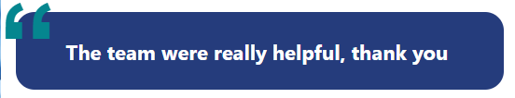  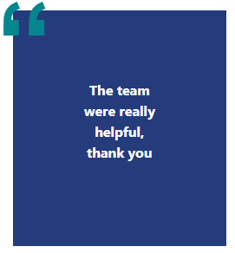  Rounded Corners Circular  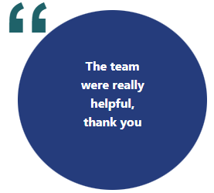  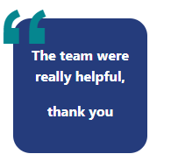  See the CMS Support Site for more information on Quote Text Box | CMS Support Team
4.2.13 Share Bar Update | We have now updated the CMS Share Bar to include two new sharing options - WhatsApp & Blue Sky.  These additional icons make it easier for users to share your content across their preferred platforms.  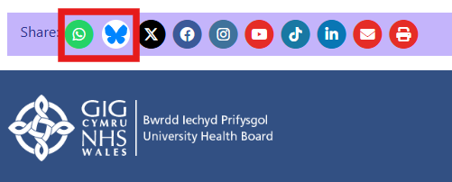  See the CMS Support Site for more information on the Share Bar
4.2.14 Section List – Search Update | We have made an update to the recently added Section List so that individual Section List pages will no longer appear within the site search results.  Now, when a Section List section title is searched, only the main page where the full Section List is displayed will be returned. This helps users find the most relevant content quickly and easily.  For example, if a Section List page is titled Forward, searching for this will not return the Section List page itself. Instead, the main page where the Section List is displayed will appear in the search results.  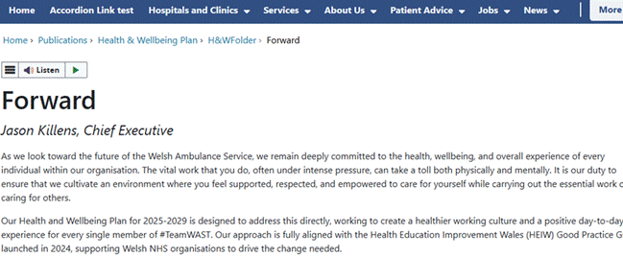  Instead, the main page where the Section List is displayed will appear in the search results.  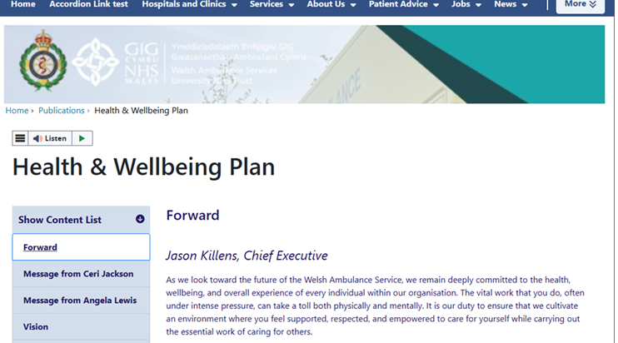  See the CMS Support Site for more information on the Section List | CMS Support Team
4.2.15 Add a Burger Menu Option to the Archive Navigation | We have now added a new option for the Archive Navigation to improve mobile usability.  When enabled, the Archive Nav will appear as a burger menu on mobile devices, keeping long lists accessible without taking up too much screen space. This option, called ‘Use burger menu for Mobile view’, is off by default to maintain backward compatibility, and can be easily toggled in the configurator.  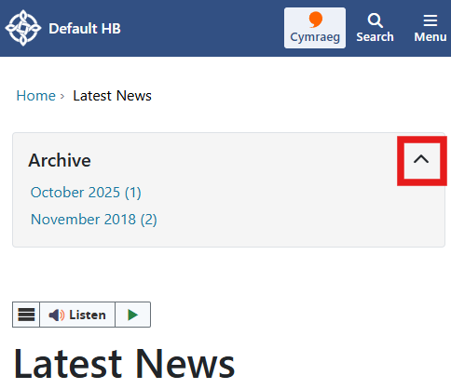  Mobile View – Collapsed Mobile View - Open  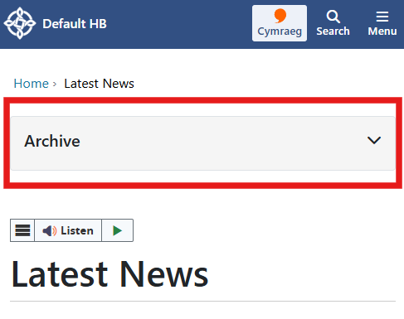  See our CMS Support Site for more information on the Site Navigation | ABUHB

Summary
Number of Changes
15
Bug Fix | System Updates | Plugin & Layout Updates
2 | 5 | 8

Problems Fixed
N/A

New Problems Identified During Testing and Associated Workarounds
Testing did not identify any new issues, and no workarounds are currently required.

Pre-requisites to Deploy the Release
There are no pre-requisites for deploying this release. Standard deployment processes can be followed.

Training Requirements
No formal training is required for this release. Users should refer to the CMS Support Site links provided for further details and instructions on the updates and new features listed.

Step-by-Step Deployment Instructions
No Deployment actions required by Health Boards.

Deployment Plan
Changes to be implemented as specified in the Change Record. Release to be deployed via Change Record: Change 152540

Back-Out Plan
Back out as detailed on each change record

Release Available for Deployment Date
NHS Wales Websites CMS: Wednesday, the 3rd December 2025

