Digital Health and Care Wales
NHS Wales IT Service Management

NHS Wales Websites CMS April 2025 Release Notes | Release ID: 890

Releases
Log a release.
Proposed (5)
Awaiting Build & Test (0)
Awaiting SIT (0)
Awaiting OAT (0)
Awaiting RT (0)
Ready to Deploy (0)
Deployed (0)
Aborted (0)
All (5)

Closed
Schedule of change
Calendar
Historic record of change
List options
Release Logged Title Release ID Release Date Owner Related deployment changes Related release changes Related Services
815

Releases
Log a release.
Proposed (5)
Awaiting Build & Test (0)
Awaiting SIT (0)
Awaiting OAT (0)
Awaiting RT (0)
Ready to Deploy (0)
Deployed (0)
Aborted (0)
All (5)

Closed
Schedule of change
Calendar
Historic record of change
List options
Release Logged Title Release ID Release Date Owner Related deployment changes Related release changes Related Services
815

These Release Notes describe the scope and content of
Release ID: 890 for the NHS Wales Websites CMS Service

Version: | 0.3
Status: | Final
Owner: | DHCW Corporate Apps Team
Author: | DHCW Corporate Apps Team
Approver: | DHCW Corporate Apps Team

Date: | 29/04/2025
Next Review Date: | 29/04/2025

1 DOCUMENT HISTORY 4
1.1 Revision History 4
1.2 Authorisation 4
1.3 Document Location 4
2 INTRODUCTION 4
3 SERVICE MANAGEMENT BOARD (SMB) 4
4 RELEASE NOTES REQUIREMENT 5
4.1 Release Identification 5
4.2 Description of New or Modified Functionality 5
5 Summary 12
5.1 Problems Fixed 12
5.2 New Problems Identified During Testing and Associated Workarounds 12
5.3 Pre-requisites to Deploy the Release 12
5.4 Training Requirements 12
5.5 Step by Step Deployment Instructions 12
5.6 Deployment Plan 12
5.7 Back-Out Plan 12
5.8 Release Available for Deployment Date 12

DOCUMENT HISTORY

Revision History
Date | Version | Author | Revision Summary
12/02/2025 | 0.1 | DHCW Corporate Apps Team | Document created for the NHS Wales Websites CMS Release
10/03/2025 | 0.2 | DHCW Corporate Apps Team | Added/Removed Items
29/04/2025 | 0.3 | DHCW Corporate Apps Team | New Change Number

Authorisation
Signing of this document indicates acceptance of its contents.
Author’s Name: | DHCW Corporate Apps Team

Approver’s Name: | DHCW Corporate Apps Team

Document Location
Type | Location
Electronic | NHS Wales Websites CMS Support Site – What’s New

INTRODUCTION
The NHS Wales Release Management Policy considers that effective Release Management is essential for protecting the integrity of the operational environment. A key objective of the release process is to ensure that users, support staff and other stakeholders are kept informed as to what is planned and how this will affect them. One of the ways that this can be achieved is through the publication of release notes prior to deployment of the Release.
These notes contain information on the agreed scope and content of Release id CMS/02-2025 for the CMS descriptions of new or modified functionality and problem fixes, descriptions of new problems and workarounds identified during the testing of this Release, training requirements, deployment instructions, references to deployment and back-out plans and key dates within the release process.

SERVICE MANAGEMENT BOARD (SMB)
The CMS Service Management Board has overall responsibility for ensuring that these Release Notes accurately describe the Release and that it is kept under constant review and updated to reflect any modifications to the Release prior to its deployment.

RELEASE NOTES REQUIREMENT

Release Identification
890 - CMS/02-2025

Description of New or Modified Functionality

Item |  | Description of the Change | Requestor
Bug Fixes
4.2.1 Navigation Update – Open Dyslexic extension |  | We have fixed an issue affecting the Main Navigation Bar whilst using the Open Dyslexic extension.  Previous Behaviour:  When zooming the screen to 175%, the Navigation Bar correctly reordered the menu titles. However, upon returning to 100% zoom, some menu items failed to reappear.  New Behaviour:  The Navigation Bar functions correctly when zooming in and out, ensuring all menu items are displayed as expected. | CMS Support Team
4.2.2 Bullet Points with Responsive screen sizes |  | We have identified an issue with responsive text display on smaller devices (e.g., tablets). When the screen is resized, bullet point text is reducing to a different size than the surrounding text, causing inconsistencies in formatting.  We are currently working on a fix to ensure that bullet point text remains consistent in size with the rest of the content across all screen sizes.  Previous Bullet Point Tablet Behaviour (enlarged text)  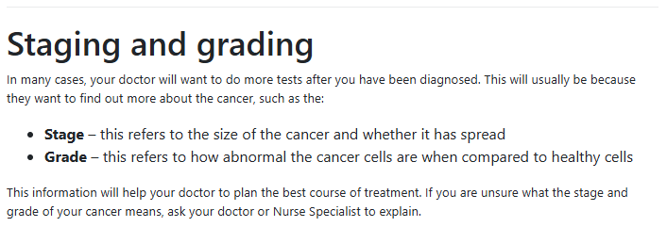  New Bullet Point Tablet Behaviour  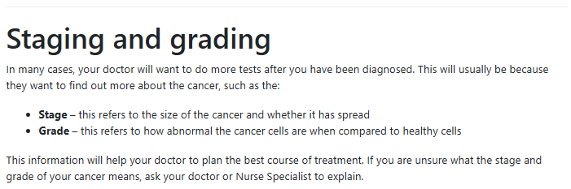 | ABUHB
System Updates
4.2.3 Mobile Navigation Update | We have updated the Mobile Navigation to better align with the Desktop Navigation. The Mobile Main Navigation Menu will now display only up to two levels deep within the site structure.  This change was approved by the NHS Wales Websites CMS SMB and ensures a consistent user experience across devices  Old Nav – 3rd Level content in the Nav New Nav – 3rd Level content out of the Nav  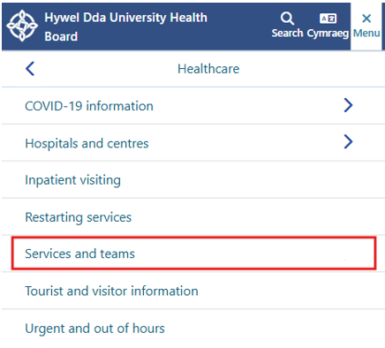  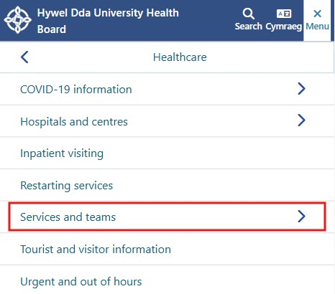 |  | CMS Support Team
4.2.4 Site Search Update 1 | Site Search Improvements  Previously, content placed within a Text Box plugin was invisible to the site search, preventing users from finding pages with relevant keywords.  With this update, the CMS Site Search now works in conjunction with the Text Box plugin, ensuring that content within these areas is searchable.  Important Note:  Content within inherited regions will not appear in search results. - Only the content from the top-level page (where the inherited content originates) will be listed. |  | CMS Support Team
4.2.5 Site Search Update 2 | Site Search Improvements  To enhance the CMS site search functionality, we have now made site ‘Tags’ searchable. Previously, tagging content with keywords only contributed to the internal Tag Cloud and the improvement of site SEO.  With this update, the CMS search algorithm will now factor in tagged words when generating search results.  Search Outcome:  Exact matches are still prioritised. - The frequency of a keyword appearing in the Title, Summary, Body, and now Tags will influence the ranking of search results. |  | CMS Support Team
4.2.6 Mura Docs Tracking | We have been investigating an issue where file downloads on Mura sites are not being tracked correctly in Google Analytics.  This is due to the way Mura handles file downloads, which does not register as a standard file download event in Google Analytics. As a result, admins are unable to track user interactions with downloadable content, leading to gaps in reporting and analysis.  We are exploring potential solutions within Google Analytics tracking settings and reviewing whether adjustments can be made within Mura’s file handling process. This may involve custom event tracking, modifying Mura’s URL structure for downloads, or integrating additional tracking mechanisms.  Our goal is to ensure that all file downloads are properly recorded, providing accurate insights into user engagement with downloadable content.  See the CMS Support Site for more information on Tracking File Downloads |  | CMS Support Team
Plugin & Layout Updates
4.2.7 Filter by Category Pagination |  | We have introduced pagination to the Filter by Category layout. If the maximum number of items to display exceeds the set Items per Page, pagination will automatically appear at the bottom of the layout block.  This update includes Prev, Next and number tabs, allowing users to navigate through content more efficiently.  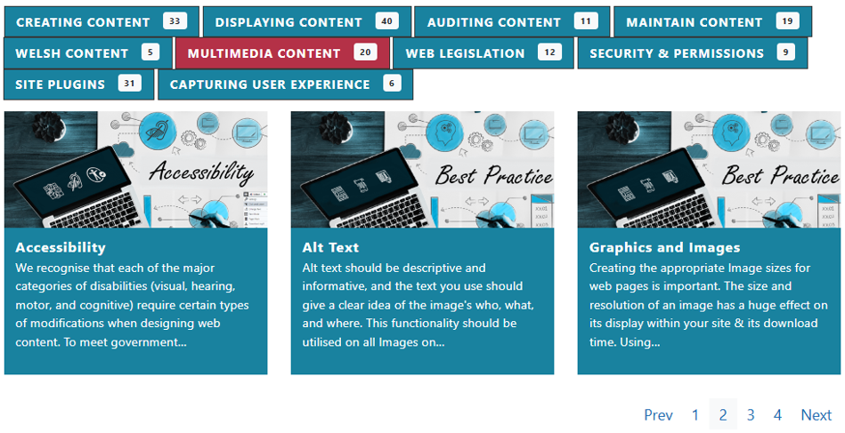  See the CMS Support Site for more information on the Filter by Category | HIEW
4.2.8 Box Block Update |  | We have identified an issue affecting some Box Block layouts, where the absence of a Summary text is causing misalignment or incorrect rendering of the display boxes.  This update ensures that even if a Summary is missing, the Box Block layout will now function correctly, maintaining proper alignment and appearance across your page.  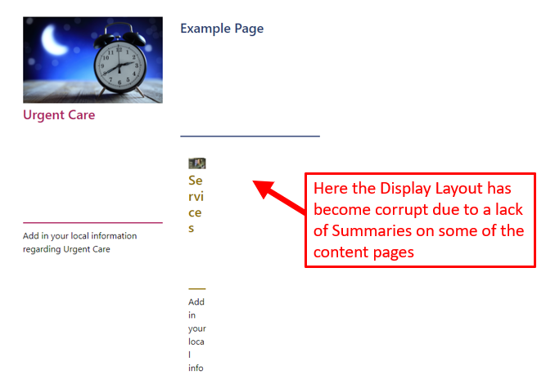  See the CMS Support Site for more information on Box Block | CMS Support Team
Accessibility Standards
4.2.9 Accessibility Audit fixes |  | The Cabinet Office has completed new accessibility audits on 3 sites within the NHS Wales Websites CMS; Velindre, NHS Wales and DHCW websites.  As a result, we have made the following Accessibility updates:  WCAG 1.4.1 Use of Color: - Links must be distinguishable without relying on colour. Link colour has now been updated to #1978A3 as per the Cabinet Office Audit guidance  WCAG 2.4.1 Bypass Blocks and WCAG 4.1.2 Name, Role, Value: Frames must have an accessible name. Video Titles. (Update 4.2.10)  WCAG 2.4.3 Focus Order – At 200% zoom and more, once the hamburger menu has been expanded, the keyboard tabs onto the cookie icon at the bottom of the webpage rather than onto links within the menu. (Update 4.2.13) | Cabinet Office Audit
4.2.10 Video Plugin Accessibility |  | We have now fixed the accessibility issue related to missing titles in video iframes, as identified in a recent Cabinet Office accessibility audit report, regarding missing titles in video iframes. The problem was due to the Mura Video Module not pulling in a title from a content item. This can now be added via the Video settings.  We have added a new field in the settings, users can manually add a video title. This title will then be applied to the iframe title attribute, improving accessibility for screen readers.  An info icon (‘i’) will be placed next to the new field to clarify that the title won’t appear on screen but is required for accessibility compliance.  Important: This update will only apply to newly added videos—existing videos will need to be updated manually to meet accessibility standards.  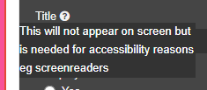  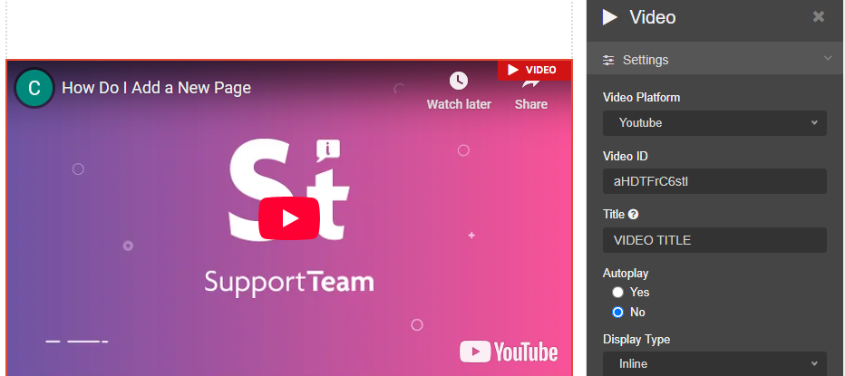  See the CMS Support Site for more information on the Video Plugin | Cabinet Office Audit
4.2.11 Multi Content 1 – Accessibility Issue |  | 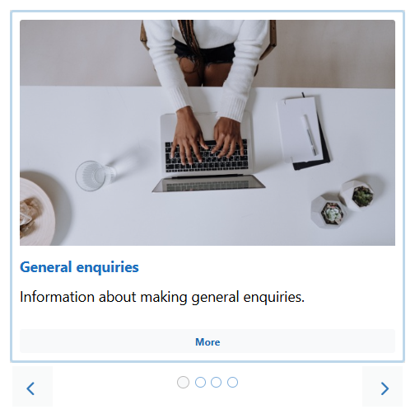  Previously, when viewed at 300% +, the Multi Content 1 layout transformed into a carousel, but users could not tab through the content items.  With this update, users can now navigate through each item in the carousel using the keyboard tab controls, improving accessibility and ease of use.  See the CMS Support Site for more information on Multi Content 1 | Cabinet Office Audit
4.2.12 Cookie Icon - Mobile Platform |  | Previously, when users interacted with the Cookie Controller by selecting the up/down navigational arrow, it was not immediately clear that additional content had expanded below.  With this update, a visible scroll bar will now appear when the arrow is selected, clearly indicating that there is now further content available for the user to scroll through.  Up/Down Navigational Arrow – Without Scroll Bar  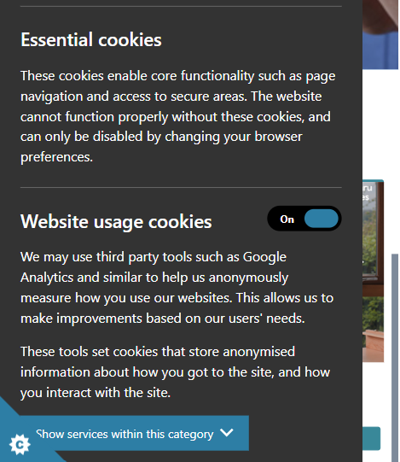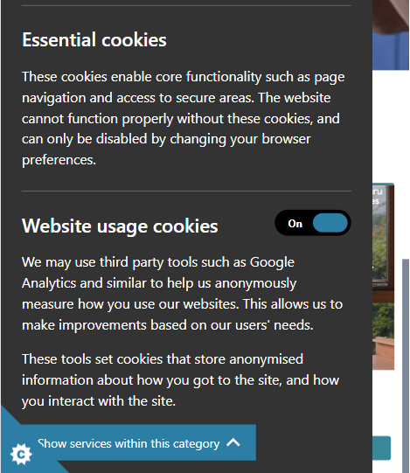  Up/Down Navigational Arrow – With Scroll Bar  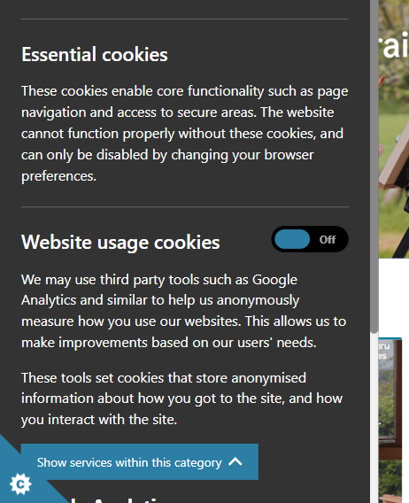 | Cabinet Office Audit
4.2.13 Navigation – Tabbing Order |  | 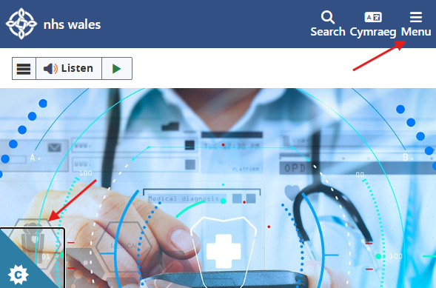  Previously, when viewing the website at 200%+ zoom and using the keyboard to tab through the Navigation, the focus would jump from ‘Menu’ directly to the Cookie Controller Icon, bypassing the main content.  With this update, after tabbing to ‘Menu’, the next focus item will now correctly be the page content. | Cabinet Office Audit
4.2.14 Header Panel 2 Update |  | We have now fixed the issue with Header Panel 2 when using the default plugin settings.  Previously, when using Header Panel 2, the default setting automatically used the page title as an H1 heading within the panel. However, if the ‘Show title’ option was unchecked in the settings, the H1 title was removed entirely, leaving the page without a main heading.  This update ensures that an appropriate H1 heading will always be present, even if the ‘Show title’ option is disabled. The fix improves accessibility and SEO compliance by maintaining a proper page structure while still allowing users to hide the visible title if needed.  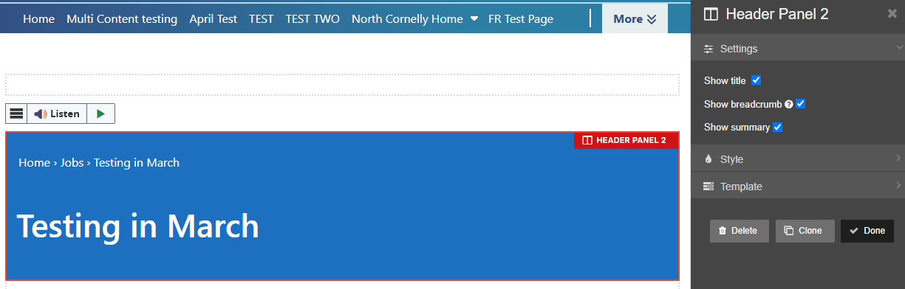  See the CMS Support Site for more information on Header Panel 2 | CMS Support Team
Welsh Language Standards
4.2.15 Cymraeg Toggle Update |  | We have introduced a cosmetic update to the Cymraeg Toggle on CMS websites, improving its appearance within the PC view of the site navigation. This update enhances the visual consistency and usability of the language switcher.  Please note that this change only applies to the PC view—an update for the Mobile platform view will follow in a future release.  This change was requested and approved by the NHS Wales Websites CMS Service Management Board (SMB).  Old Style Cymraeg Link – PC  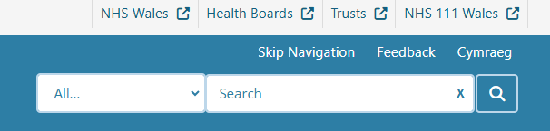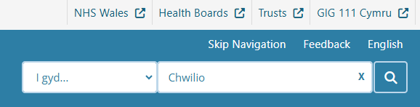  New Style Cymraeg Link – PC  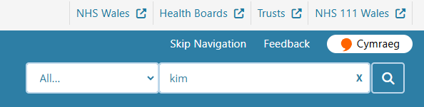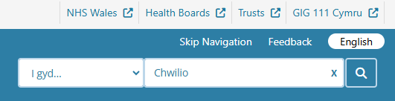 | CMS Support Team

Summary
Number of Changes
15
Bug Fix | System Updates | Plugin & Layout Updates | Accessibility Standards | Welsh Language Standards
2 | 4 | 2 | 6 | 1

Problems Fixed
N/A

New Problems Identified During Testing and Associated Workarounds
N/A

Pre-requisites to Deploy the Release
N/A

Training Requirements
N/A

Step by Step Deployment Instructions
No Deployment actions required by Health Boards.

Deployment Plan
Changes to be implemented as specified in the Change Record. Release to be deployed via change record: Change 146892

Back-Out Plan
Back out as detailed on each change record

Release Available for Deployment Date
NHS Wales Websites CMS: Wednesday the 2nd April 2025
Release Postponed until 16th April 2025
Release Postponed until 30th April 2025

