Digital Health and Care Wales
NHS Wales IT Service Management

NHS Wales Websites CMS August 2024 Release Notes | Release ID: 858

Releases
Log a release.
Proposed (5)
Awaiting Build & Test (0)
Awaiting SIT (0)
Awaiting OAT (0)
Awaiting RT (0)
Ready to Deploy (0)
Deployed (0)
Aborted (0)
All (5)

Closed
Schedule of change
Calendar
Historic record of change
List options
Release Logged Title Release ID Release Date Owner Related deployment changes Related release changes Related Services
815

Releases
Log a release.
Proposed (5)
Awaiting Build & Test (0)
Awaiting SIT (0)
Awaiting OAT (0)
Awaiting RT (0)
Ready to Deploy (0)
Deployed (0)
Aborted (0)
All (5)

Closed
Schedule of change
Calendar
Historic record of change
List options
Release Logged Title Release ID Release Date Owner Related deployment changes Related release changes Related Services
815

These Release Notes describe the scope and content of
Release ID: 858 for the NHS Wales Websites CMS Service

Version: | 1.0
Status: | Final
Owner: | DHCW Corporate Apps Team
Author: | DHCW Corporate Apps Team
Approver: | DHCW Corporate Apps Team

Date: | 16/09/2024
Next Review Date: | 14/10/2024

1 DOCUMENT HISTORY 4
1.1 Revision History 4
1.2 Authorisation 4
1.3 Document Location 4
2 INTRODUCTION 4
3 SERVICE MANAGEMENT BOARD (SMB) 4
4 RELEASE NOTES REQUIREMENT 5
4.1 Release Identification 5
4.2 Description of New or Modified Functionality 5
5 Summary 12
5.1 Problems Fixed 12
5.2 New Problems Identified During Testing and Associated Workarounds 12
5.3 Pre-requisites to Deploy the Release 13
5.4 Training Requirements 13
5.5 Step by Step Deployment Instructions 13
5.6 Deployment Plan 13
5.7 Back-Out Plan 13
5.8 Release Available for Deployment Date 13

DOCUMENT HISTORY

Revision History
Date | Version | Author | Revision Summary
16/09/2024 | 0.1 | DHCW Corporate Apps Team | Document created for the NHS Wales Websites CMS Release
03/10/2024 | 0.2 | DHCW Corporate Apps Team | Revised Items List
14/10/2024 | 1.0 | DHCW Corporate Apps Team | Updating Images

Authorisation
Signing of this document indicates acceptance of its contents.
Author’s Name: | DHCW Corporate Apps Team

Approver’s Name: | DHCW Corporate Apps Team

Document Location
Type | Location
Electronic | NHS Wales Websites CMS Support Site – What’s New

INTRODUCTION
The NHS Wales Release Management Policy considers that effective Release Management is essential for protecting the integrity of the operational environment. A key objective of the release process is to ensure that users, support staff and other stakeholders are kept informed as to what is planned and how this will affect them. One of the ways that this can be achieved is through the publication of release notes prior to deployment of the Release.
These notes contain information on the agreed scope and content of Release id CMS/06-2024 for the CMS descriptions of new or modified functionality and problem fixes, descriptions of new problems and workarounds identified during the testing of this Release, training requirements, deployment instructions, references to deployment and back-out plans and key dates within the release process.

SERVICE MANAGEMENT BOARD (SMB)
The CMS Service Management Board has overall responsibility for ensuring that these Release Notes accurately describe the Release and that it is kept under constant review and updated to reflect any modifications to the Release prior to its deployment.

RELEASE NOTES REQUIREMENT

Release Identification
858 - CMS/06-2024

Description of New or Modified Functionality

Item |  | Description of the Change |  | Requestor
Bug Fixes
4.2.1 Single Content Block 2 – hover over |  | An issue was identified with Single Content Block 2 where the yellow hover (link indicator) outline was not appearing around the block. This has been resolved in the current release.  Current Display  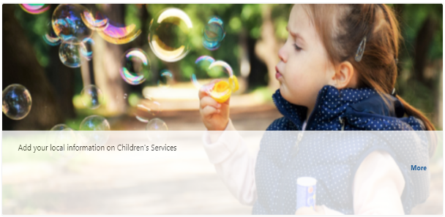  New Display  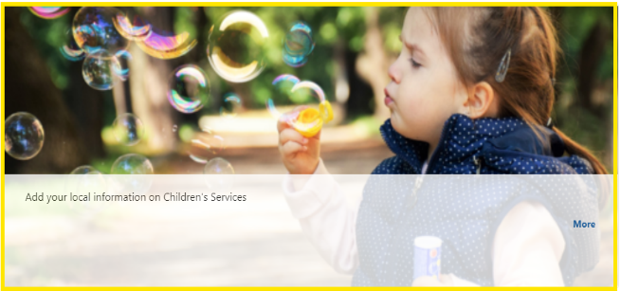  See the CMS Support Site for more information on Single Content Block 2 |  | CMS Support Team
4.2.2 Send Alert email when Friendly/Alt URL is reset to blank |  | We have identified an intermittent issue in the system where some friendly URLs are disappearing from the pages they have been applied to. This behavior is currently under investigation, and we are working to determine the root cause.  To manage this issue while we continue our investigation, we will be implementing an alert system. This alert will trigger whenever a friendly URL is detected as missing. The alert will notify the CMS Support Team and Site Admin, allowing for immediate action.  The email notification will include the following information: Site ID/ Site Name/ Page Title/ Friendly URL before & after it changed/ Date & Time Updated/ Updated By  Alt URL notification  The following page has recently been updated by two users at the same time. This may have resulted in changes being overwritten.  In particular, any alt URL(s) for the page may have changed.  Site: Beaumaris Health Centre (BHGP)  Page: My Test Page  Latest ALT URL(s) published by: Joe Bloggs (Content from: 10/10/2024 16:30:45 Updated: 10/10/2024 16:32:38)  Previous ALT URL(s) published by: Joe Bloggs (Updated: 10/10/2024 16:32:01)  Test Page 2  Please check that any alt URL(s) and latest published page contents are correct and as required.  Action Required:  Upon receiving this alert, please:  - Review the affected page: Verify the missing friendly URL.  - Restore the friendly URL: if applicable.  - Escalate to the development team: if further assistance is needed.  We will keep you updated as we continue to investigate and resolve this issue. |  | CMS Support Team
System Updates
4.2.3 Form Label Updates | It has been noted that the Labels of the fields within Mura Forms are all of different lengths. We have now brought all Label lengths in line with each other; at 250 Characters.  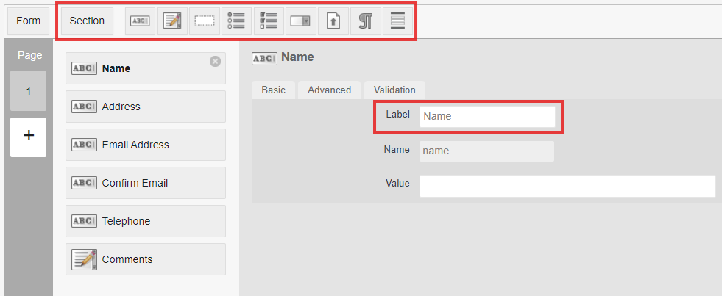 |  | CMS Support Team
4.2.4 Displaying Deleted Forms | We have addressed an issue where, after a form is deleted from the back end of the site, some form code is still left behind in the source code on the page it once appeared on.  To help users resolve this, we have added a new section to the Dashboard that will assist in identifying which pages your form once existed on. This will allow you to locate and delete any errant code that may have been left behind after the form’s removal.  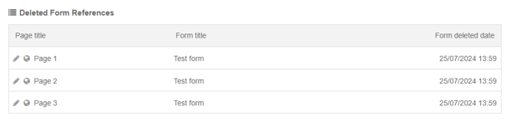 |  | CMS Support Team
4.2.5 Navigation Bar Update – Large Text | When using some Accessibility features such as the Recite Me (text increase/ decrease) or the OpenDyslexic Chrome Extension, when the text is enlarged you lose items from the Navigation Bar. This issue has now been resolved.  Navigation Bar with Standard Text Size  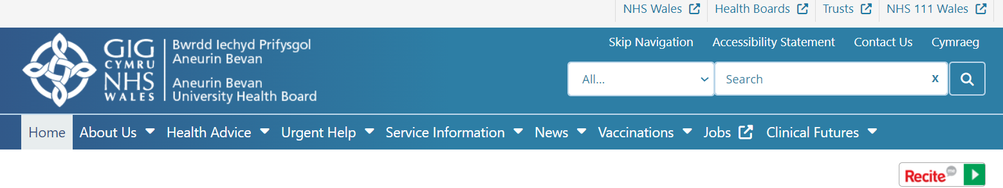  Recite me with Enlarged Text  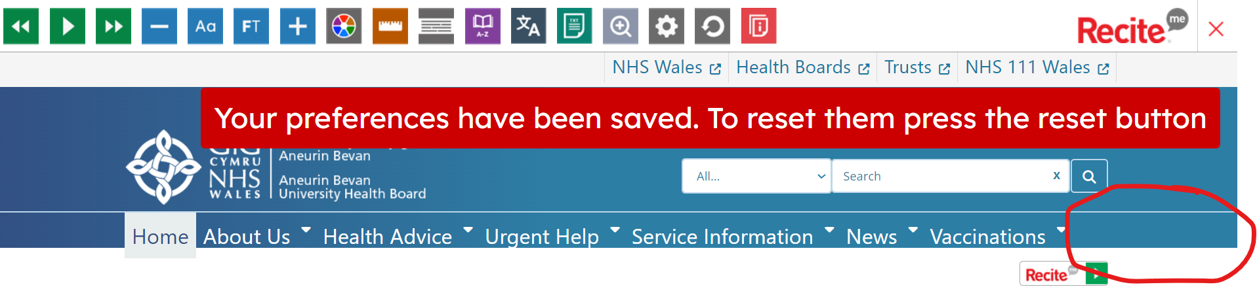  Chrome Extension Open Dyslexic with Enlarged Text  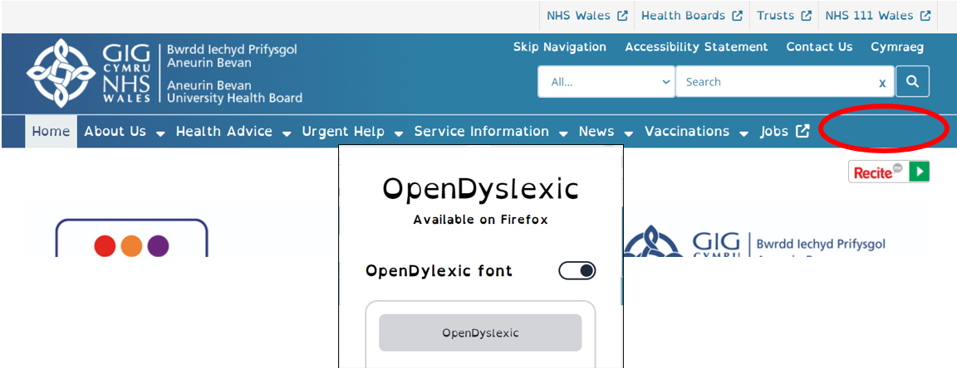 |  | DHCW
4.2.6 Trac Anchors – Mobile View Update | Previously, when the Trac Jobs plugin was added to the middle or bottom of a page and a user selected a jobs category, the page would refresh and return the user to the top. This caused users, particularly those on mobile devices, to have to scroll down to find the opened tab, creating a disorienting experience.  This issue has now been repaired. When users select a jobs category, the page will anchor directly to the opened tab. |  | CAVUHB
4.2.7 3rd Level Navigation – Long strings breaking responsiveness | Where long strings (long Titles) with no breaks, have been added to the primary and secondary nav, this is currently preventing the responsiveness as the system sees the title as one long word.  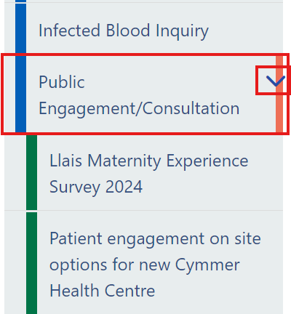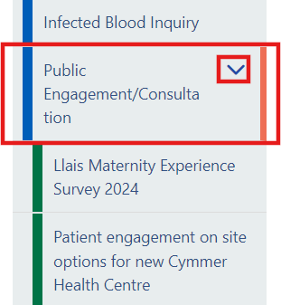 |  | CMS Support Team
4.2.8 3rd Level Navigation – Colour Indentation | We have noted an issue when a section is utilizing the ‘Start a New Cascade’ option, along with the 3rd Level Navigation. When the section is first selected; on the front end of the website, the Colour and Indentation of the Navigation Tabs is missing. This issue has now been resolved.  Colour and Indentation Missing Colour and Indentation Present  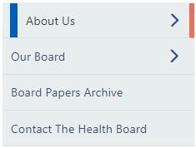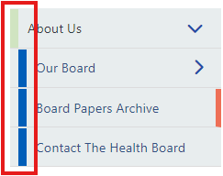 |  | CMS Support Team
4.2.9 Create SQL Mura –Cookie Controller | We have now created a SQL Script that can be run against the database upon request, in order to identify the pages where Inheritance has been broken and the Cookie Controller Plugin has been added manually.  Admins will be able to use this extract to identify pages that are displaying a separate Cookie Controller, in order to check if the site Google Analytics code had been added. |  | CMS Support Team
Plugin & Layout Updates
4.2.10 Collection Layouts - Custom image size |  | The Custom Image Size within the layout settings is not correctly honoring the selected sizes entered. This is then causing the layouts to break, as below:  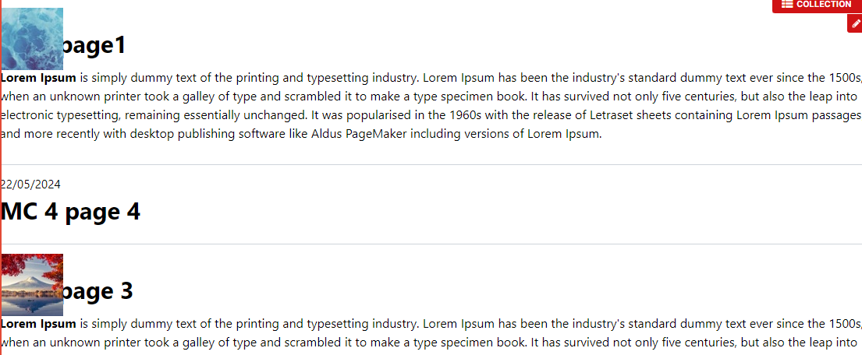  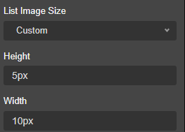  Current Display  For instance, when setting the Height to 5px and Width to 10px, the change was not reflected as expected, leading to layout issues:  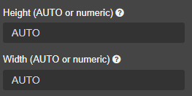  New Display  To address this, we have added a warning label to the Height and Width input boxes. The labels now clearly state that these boxes can ONLY contain either the word "AUTO" or a Numerical Value, but not units such as "px" or "%". |  | CMS Support Team
4.2.11 Box Block display in Accordion |  | We have resolved an issue where the Box Block layout was not displaying correctly when used within an Accordion. This previously caused the Title and Summary Content to overlap. The issue has now been fixed. The Box Block layout will now display correctly within the Accordion, ensuring that the Title and Summary Content are properly aligned and do not overlap.  Error Display  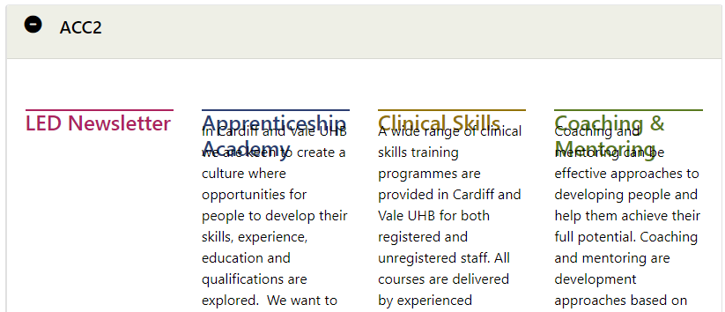 |  | CMS Support Team
4.2.12 New Layout – Buttons |  | We have now introduced a new Collection Layout – Buttons  The layout will only show the title of each content item and will appear in a BUTTON shape. Buttons can be displayed in a grid with options to show from 1 to 4 buttons across. Additional content will be ordered into grid columns, with an unlimited maximum number of items.  Mock-up – PC Display  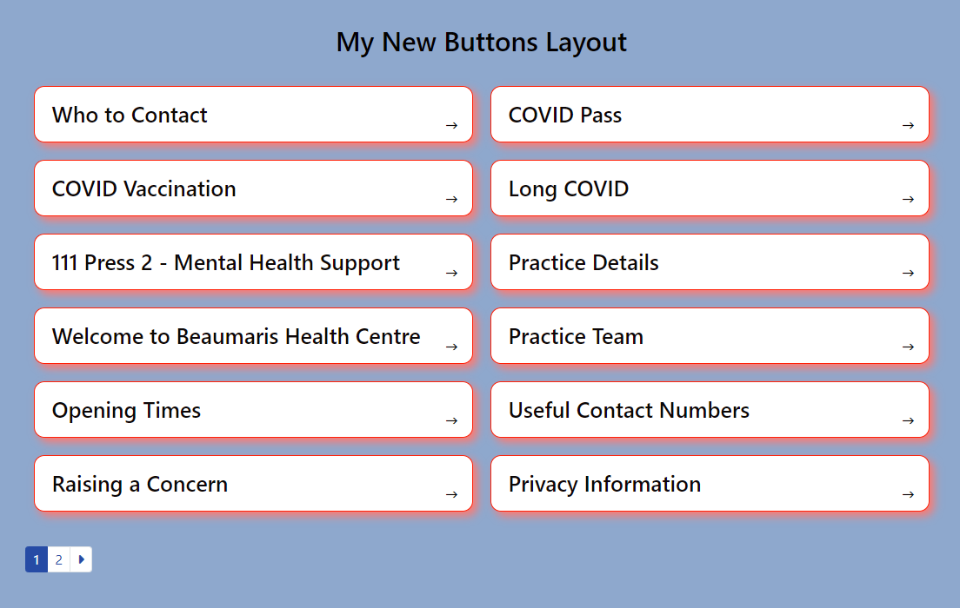  On mobile devices, the buttons will stack vertically similar to the Box Block 3 layout, ensuring a consistent user experience.  Mock-up Mobile Display  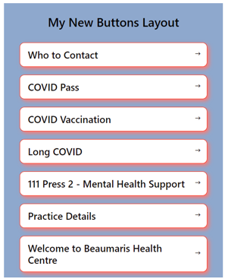  See the CMS Support Site for more information on Buttons |  | CMS Support Team
4.2.13 New Layout – Single Content Block 6 |  | We have now introduced a new Collection Layout – Single Content 6  This new layout will allow a link to 1 single content item. It can display a Title & Summary, and a ‘Read-More’ link to the content item as well as a mix of 4-6 Images.  PC Display  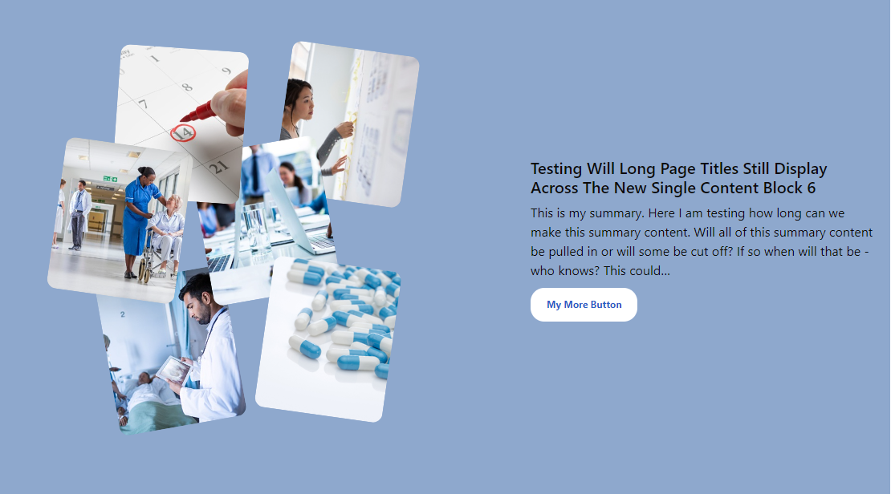  When viewed on a Mobile the Box will wrap, with the text showing below the Images & with fewer images displaying.  Mobile Display  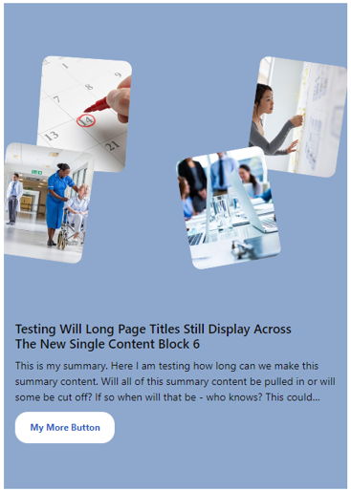  See the CMS Support Site for more information on Single Content Block 6 |  | WBS
Accessibility Standards
4.2.14 Update Automatic Corresponding Content Alert |  | The Automatic Corresponding Content plugin displays a message to site editors within the Mura Admin when you create a new page, informing you that a holding page has been created on the equivalent other language site.  However, it has been noted that if a page is created on the front end of the website, although the warning message does appear when you go to the backend of the page, if you were to remain on the front end of the page then you would not see this alert. This could lead to a lack of awareness of the corresponding content item.  To resolve this issue, when creating content on the front the website, editors will now see the warning message appear in a blue box on the page.  Mock-up Message  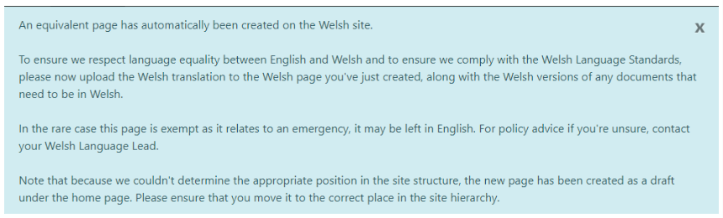 |  | CMS Support Team

Summary
Number of Changes
14

Bug Fix | System Updates | Plugin & Layout Updates | Accessibility Standards
2 | 7 | 4 | 1

Problems Fixed
N/A

New Problems Identified During Testing and Associated Workarounds
N/A

Pre-requisites to Deploy the Release
N/A

Training Requirements
N/A

Step by Step Deployment Instructions
No Deployment actions required by Health Boards.

Deployment Plan
Changes to be implemented as specified in the Change Record. Release to be deployed via change record: Change 139011

Back-Out Plan
Back out as detailed on each change record

Release Available for Deployment Date
NHS Wales Websites CMS: Wednesday the 6th November 2024

