Digital Health and Care Wales
NHS Wales IT Service Management

NHS Wales Websites CMS May 2024 Release Notes | Release ID: 843

Releases
Log a release.
Proposed (5)
Awaiting Build & Test (0)
Awaiting SIT (0)
Awaiting OAT (0)
Awaiting RT (0)
Ready to Deploy (0)
Deployed (0)
Aborted (0)
All (5)

Closed
Schedule of change
Calendar
Historic record of change
List options
Release Logged Title Release ID Release Date Owner Related deployment changes Related release changes Related Services
815

Releases
Log a release.
Proposed (5)
Awaiting Build & Test (0)
Awaiting SIT (0)
Awaiting OAT (0)
Awaiting RT (0)
Ready to Deploy (0)
Deployed (0)
Aborted (0)
All (5)

Closed
Schedule of change
Calendar
Historic record of change
List options
Release Logged Title Release ID Release Date Owner Related deployment changes Related release changes Related Services
815

These Release Notes describe the scope and content of
Release ID: 843 for the NHS Wales Websites CMS Service

Version: | 1.0
Status: | Final
Owner: | DHCW Corporate Apps Team
Author: | DHCW Corporate Apps Team
Approver: | DHCW Corporate Apps Team

Date: | 19/04/2024
Next Review Date: | 15/05/2024

1 DOCUMENT HISTORY 4
1.1 Revision History 4
1.2 Authorisation 4
1.3 Document Location 4
2 INTRODUCTION 4
3 SERVICE MANAGEMENT BOARD (SMB) 4
4 RELEASE NOTES REQUIREMENT 5
4.1 Release Identification 5
4.2 Description of New or Modified Functionality 5
5 Summary 11
5.1 Problems Fixed 11
5.2 New Problems Identified During Testing and Associated Workarounds 11
5.3 Pre-requisites to Deploy the Release 11
5.4 Training Requirements 11
5.5 Step by Step Deployment Instructions 11
5.6 Deployment Plan 12
5.7 Back-Out Plan 12
5.8 Release Available for Deployment Date 12

DOCUMENT HISTORY

Revision History
Date | Version | Author | Revision Summary
19/04/2024 | 0.1 | DHCW Corporate Apps Team | Document created for the NHS Wales Websites CMS Release
02/05/2024 | 0.2 | DHCW Corporate Apps Team | Adding Release Items
15/05/2024 | 1.0 | DHCW Corporate Apps Team | Removing 3 Items. Adding Images

Authorisation
Signing of this document indicates acceptance of its contents.
Author’s Name: | DHCW Corporate Apps Team

Approver’s Name: | DHCW Corporate Apps Team

Document Location
Type | Location
Electronic | NHS Wales Websites CMS Support Site – What’s New

INTRODUCTION
The NHS Wales Release Management Policy considers that effective Release Management is essential for protecting the integrity of the operational environment. A key objective of the release process is to ensure that users, support staff and other stakeholders are kept informed as to what is planned and how this will affect them. One of the ways that this can be achieved is through the publication of release notes prior to deployment of the Release.
These notes contain information on the agreed scope and content of Release id CMS/03-2024 for the CMS descriptions of new or modified functionality and problem fixes, descriptions of new problems and workarounds identified during the testing of this Release, training requirements, deployment instructions, references to deployment and back-out plans and key dates within the release process.

SERVICE MANAGEMENT BOARD (SMB)
The CMS Service Management Board has overall responsibility for ensuring that these Release Notes accurately describe the Release and that it is kept under constant review and updated to reflect any modifications to the Release prior to its deployment.

RELEASE NOTES REQUIREMENT

Release Identification
843 - CMS/03-2024

Description of New or Modified Functionality

Item | Description of the Change | Requestor
Bug Fixes
4.2.1 Tag Cloud Fix | In recent testing it was noticed that Tags in Tag Cloud do not work if they are composed of more than one word, e.g. 'Clinic', ‘News’ & ’Services’ are ok, but 'Welsh Gov' is not.  This fix will now allow Tags of 2 words to work in the same manner as a one-word tag.  In that they will both take you to a cut down version of the Search Results page – displaying only content Tagged with that specific Tag (word/s).  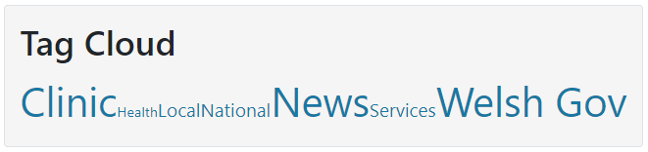  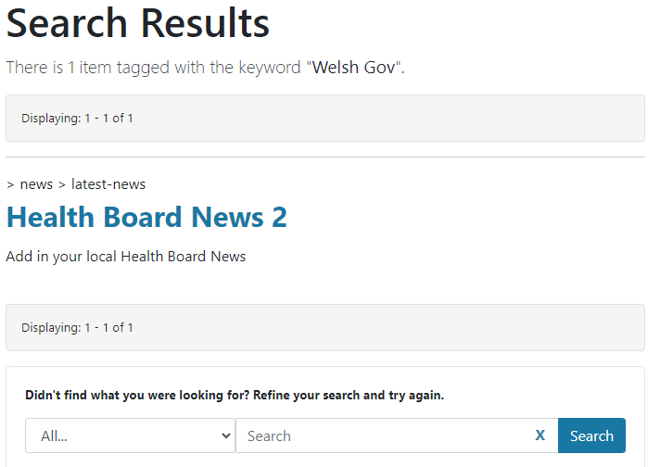  See the CMS Support Site for more information on Tag Clouds | CMS Support Team
4.2.2 Audio Player – Transcript Formatting Fix | Currently the Summary box on an Audio file (Transcript Area) is unable to accept formatting on the text entered.  This fix will now see that any HTML styles & formatting added will now be reflected within the Summary area on the front end of the Audio Player Plugin. If no text is entered this area, it will automatically display: 'no transcript found’.  New Display  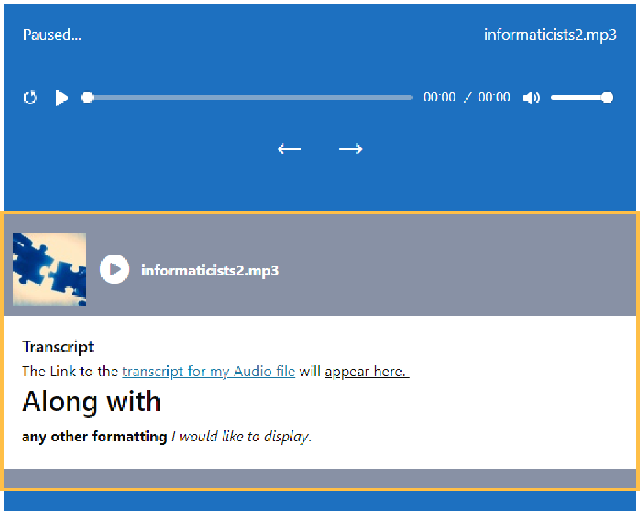  See the CMS Support Site for more information on the Audio Player Plugin | HDUHB
4.2.3 Form Update - Links | As a result of testing the CMS Forms it was discovered that when using the option - Text Area - this will only allow a user to add a maximum of 6 URL Links; with any further links added resulting in the Form, Not to be Submitted and to be marked as Spam.  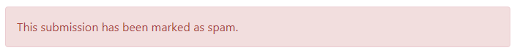  The fix that we have now implemented will now allow your users to add a max of 20 URL Links per ‘Text Area’ Option.  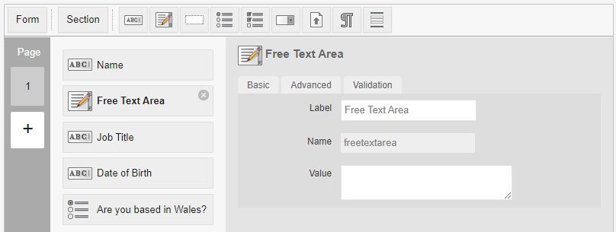  See the CMS Support Site for more information on site Forms | SBUHB
4.2.4 Alternate Direction URL | When on the back end of the site, if a user was to switch to the Welsh language site and then navigate to the Alternative URL area. The URL displayed in this area matches the URL in the browser instead of the URL of the site you have switched over to. This cosmetic issue has now been corrected.  Current Display  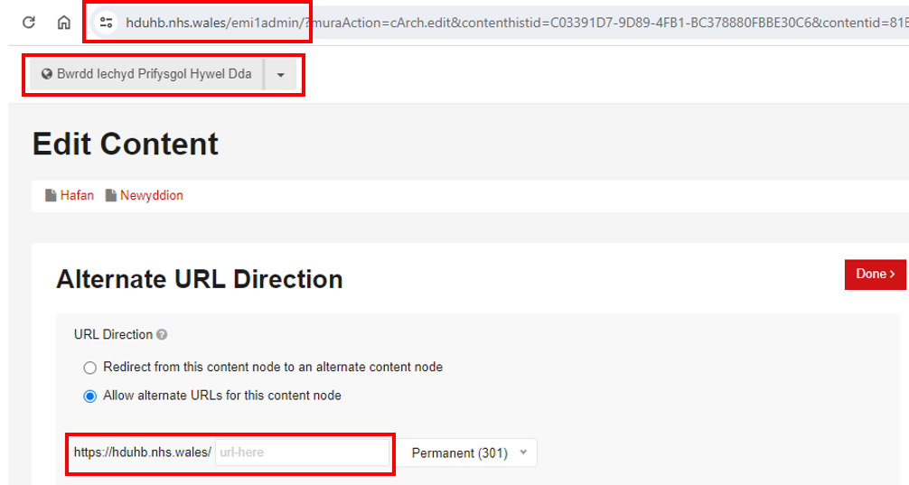  New Display  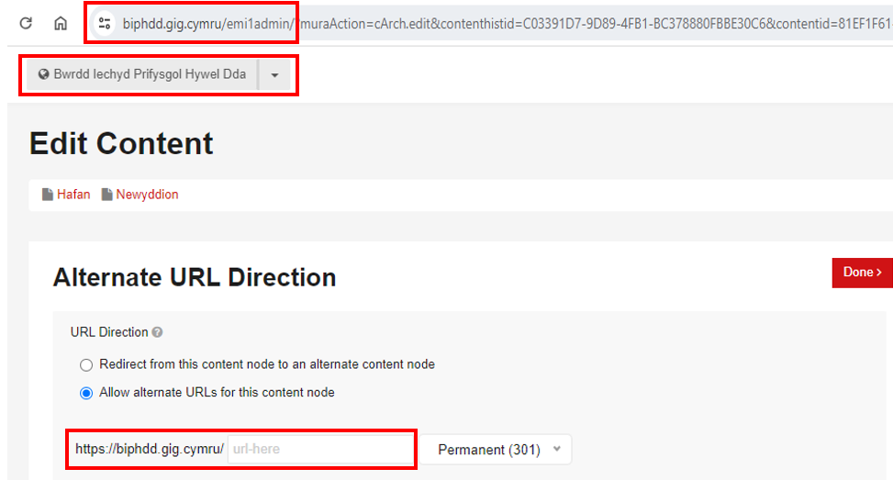 | HDUHB
4.2.5 Deletion Update | Users have been experiencing ongoing issues with deleting content within their websites. We have now made an update to the CMS to speed up the deletion process, so that all users should see an improvement with this process. | CMS Support Team
System Updates
4.2.6 RSS Feeds to include HTML | RSS Feeds are created in the CMS Websites via the Content Collection Indexes. Once created these RSS Feeds can be drawn into other websites and be displayed as news feeds.  We have now made an update to the HTML that is included within the RSS feed, this will allow text items to display correctly alongside their corresponding images.  See the CMS Support Site for more information on RSS Feeds | PTHB
4.2.7 Dashboard Update | We have now made an update to the Active Pages area of the Dashboard Site Summary. It was felt that the term ‘Active pages’ was a vague term in relation to site content items, as this included Live & Draft, Folders & Buckets.  These terms have now been separated out to make it easier for admins to see what types of content they have.  Current Display New Display  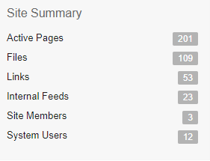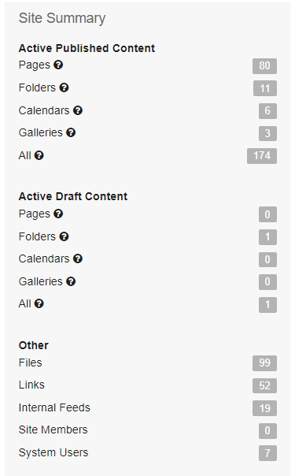  See the CMS Support Site for more information on the Dashboard | CMS Support Team
4.2.8 Automatic Corresponding Content – Dashboard Update | 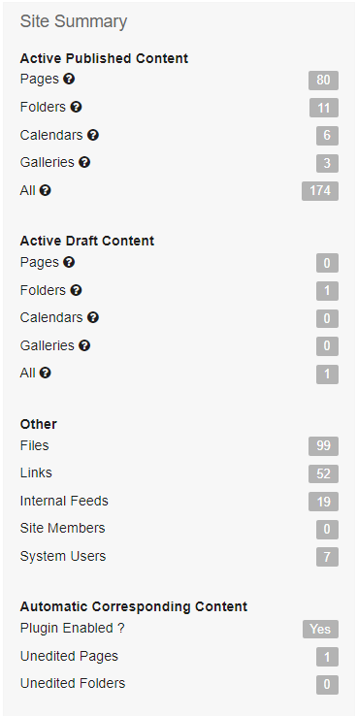  We have made an update to the Dashboard in regard to the data drawn in via the Automatic Corresponding Content.  Under Site Summary will now display another area labelled "Automatic Corresponding Content".  This area will show 3 data points:  - Is the Plugin Enabled? Yes/No  - Number of Corresponding Pages that have been Created but not Edited.  - Number of Corresponding Folders that have been Created but not Edited.  The Corresponding Content can also be tracked on the back end of your website select Plugins > Automatic Corresponding Content > Select Content – Audit  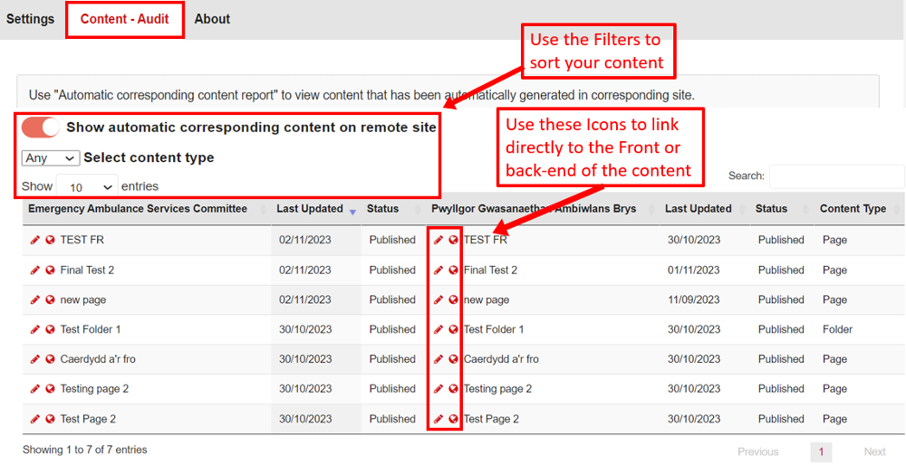  See the CMS Support Site for more information on Corresponding Content Plugin | CMS Support Team
Plugin & Layout Updates
4.2.9 Advanced Table List Update | When used in conjunction with a Content Collection Index; the Advanced Table List does not currently honour the Categories or the Advanced Filters Tabs.  We have now made an update to the ATL, so that users can now filter the content pulled into their feed by the Categories Tag. The Advanced Filter Tab will be fixed in a future Release.  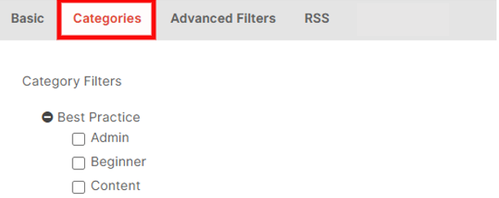  For more information on Advanced Table Lists  For more information on Content Collection Indexes | PHW
Accessibility Standards
4.2.10 Navigation Update | We have now made an Accessibility Update to the site 3rd Level Navigation. Currently when tabbing through the 3rd level Navigation, the tabbing order is not ordering as expected.  This will now order: Main Nav Tab > Dropdown Arrow > Sub Page Tab > Dropdown Arrow > Further Child Page > Dropdown Arrow > Sub Page Siblings  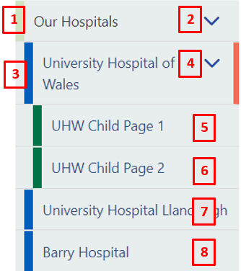  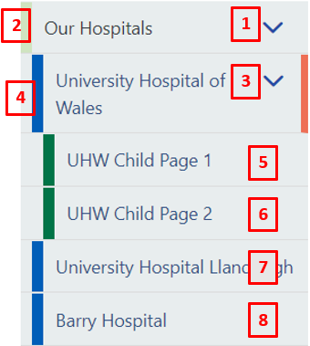  Current illogical Nav Order New Nav Order | CMS Support Team
4.2.11 Wave style sheet fixes | SBUHB have had some advice from gov.uk on accessibility needs they should meet when the site styles are turned off. They tested this using the WAVE Tool (which can be added to your browser as a Chrome extension), turning off style sheets and identified several issues in need of work.  These issues were set into 5 tasks that we have now repaired:  1.Duplicate Carousel values  2.Grid not got content in links  3.Missing label on Category search dropdown  4.Contrast issue with search  5.ALT text in mobile logo | SBUHB

Summary
Number of Changes
11

Bug Fix | System Updates | Plugin & Layout Updates | Accessibility Standards
5 | 3 | 1 | 2

Problems Fixed
N/A

New Problems Identified During Testing and Associated Workarounds
N/A

Pre-requisites to Deploy the Release
N/A

Training Requirements
N/A

Step by Step Deployment Instructions
No Deployment actions required by Health Boards.

Deployment Plan
Changes to be implemented as specified in the Change Record. Release to be deployed via change record: Change 134255

Back-Out Plan
Back out as detailed on each change record

Release Available for Deployment Date
NHS Wales Websites CMS: Wednesday the 22nd May 2024

