Digital Health and Care Wales
NHS Wales IT Service Management

NHS Wales Websites CMS July 2024 Release Notes | Release ID: 848

Releases
Log a release.
Proposed (5)
Awaiting Build & Test (0)
Awaiting SIT (0)
Awaiting OAT (0)
Awaiting RT (0)
Ready to Deploy (0)
Deployed (0)
Aborted (0)
All (5)

Closed
Schedule of change
Calendar
Historic record of change
List options
Release Logged Title Release ID Release Date Owner Related deployment changes Related release changes Related Services
815

Releases
Log a release.
Proposed (5)
Awaiting Build & Test (0)
Awaiting SIT (0)
Awaiting OAT (0)
Awaiting RT (0)
Ready to Deploy (0)
Deployed (0)
Aborted (0)
All (5)

Closed
Schedule of change
Calendar
Historic record of change
List options
Release Logged Title Release ID Release Date Owner Related deployment changes Related release changes Related Services
815

These Release Notes describe the scope and content of
Release ID: 848 for the NHS Wales Websites CMS Service

Version: | 1.0
Status: | Final
Owner: | DHCW Corporate Apps Team
Author: | DHCW Corporate Apps Team
Approver: | DHCW Corporate Apps Team

Date: | 04/06/2024
Next Review Date: | 25/06/2024

1 DOCUMENT HISTORY 4
1.1 Revision History 4
1.2 Authorisation 4
1.3 Document Location 4
2 INTRODUCTION 4
3 SERVICE MANAGEMENT BOARD (SMB) 4
4 RELEASE NOTES REQUIREMENT 5
4.1 Release Identification 5
4.2 Description of New or Modified Functionality 5
5 Summary 9
5.1 Problems Fixed 9
5.2 New Problems Identified During Testing and Associated Workarounds 9
5.3 Pre-requisites to Deploy the Release 9
5.4 Training Requirements 9
5.5 Step by Step Deployment Instructions 9
5.6 Deployment Plan 9
5.7 Back-Out Plan 9
5.8 Release Available for Deployment Date 9

DOCUMENT HISTORY

Revision History
Date | Version | Author | Revision Summary
04/06/2024 | 0.1 | DHCW Corporate Apps Team | Document created for the NHS Wales Websites CMS Release
12/06/2024 | 0.2 | DHCW Corporate Apps Team | Adding Release Items
25/06/2024 | 1.0 | DHCW Corporate Apps Team | Updated Images

Authorisation
Signing of this document indicates acceptance of its contents.
Author’s Name: | DHCW Corporate Apps Team

Approver’s Name: | DHCW Corporate Apps Team

Document Location
Type | Location
Electronic | NHS Wales Websites CMS Support Site – What’s New

INTRODUCTION
The NHS Wales Release Management Policy considers that effective Release Management is essential for protecting the integrity of the operational environment. A key objective of the release process is to ensure that users, support staff and other stakeholders are kept informed as to what is planned and how this will affect them. One of the ways that this can be achieved is through the publication of release notes prior to deployment of the Release.
These notes contain information on the agreed scope and content of Release id CMS/04-2024 for the CMS descriptions of new or modified functionality and problem fixes, descriptions of new problems and workarounds identified during the testing of this Release, training requirements, deployment instructions, references to deployment and back-out plans and key dates within the release process.

SERVICE MANAGEMENT BOARD (SMB)
The CMS Service Management Board has overall responsibility for ensuring that these Release Notes accurately describe the Release and that it is kept under constant review and updated to reflect any modifications to the Release prior to its deployment.

RELEASE NOTES REQUIREMENT

Release Identification
848 - CMS/04-2024

Description of New or Modified Functionality

Item | Description of the Change | Requestor
Bug Fixes
4.2.1 Multi Point Map Update | The pin Icons on the MultiPoint Map are no longer displaying correctly. These icons have now been updated within the left-hand list and on the Map itself.  Current Display  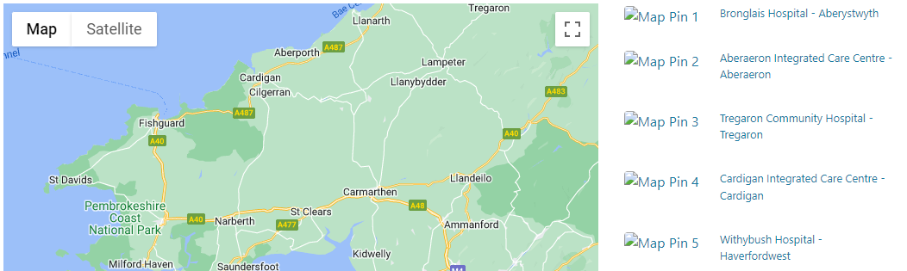  New Display  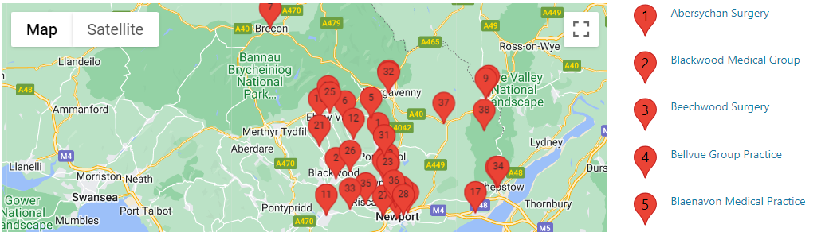  See the CMS Support Site for more information on Multi-Point Maps | HDUHB
4.2.2 Accordion Update | We recently added a new content type 'Folder - No title or crumb', During testing it has been noted that you can't add an Accordion under this folder type, as you can for a normal folder. This issue has now been repaired.  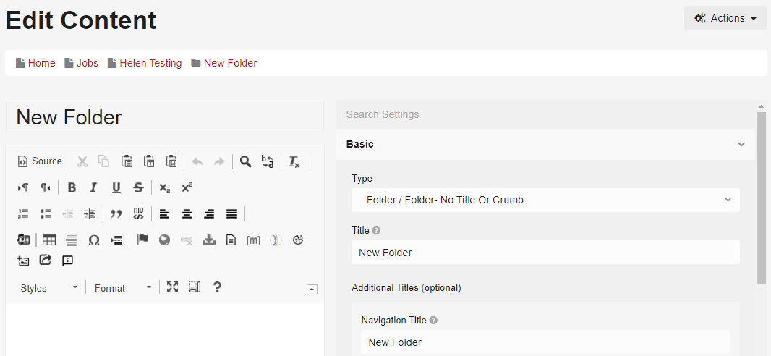  See the CMS Support Site for more information on Accordions | CMS Support Team
4.2.3 Automatic Corresponding Content Update | The admin warning message triggered when creating content on a site that has the Automatic Corresponding Content, was showing only to Full Site Admins and not to Site Editors, we have now resolved this issue.  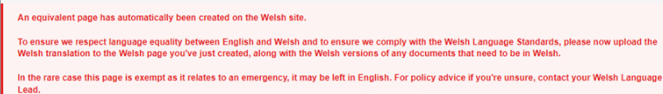  See the CMS Support Site for more information on ACC | CMS Support Team
4.2.4 Sticky Nav Bar issue | An Issue with the Navigation Bar was noticed during testing - When there is a large amount of content on a page meaning that a user has scroll a lot, the main menu becomes a sticky header moving with the scroll.  When a user then scrolls back to top the Navigation Bar should then return to its original position.  Current Erroring Sticky Nav Bar  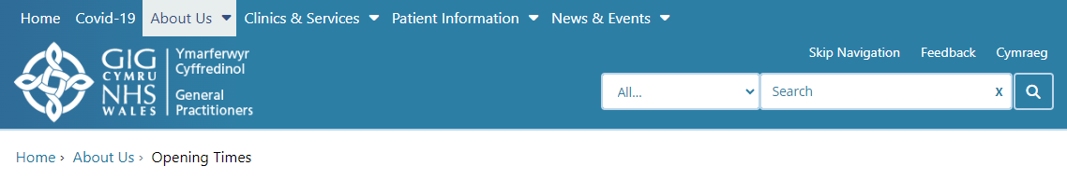  Correct Nav Bar Behaviour  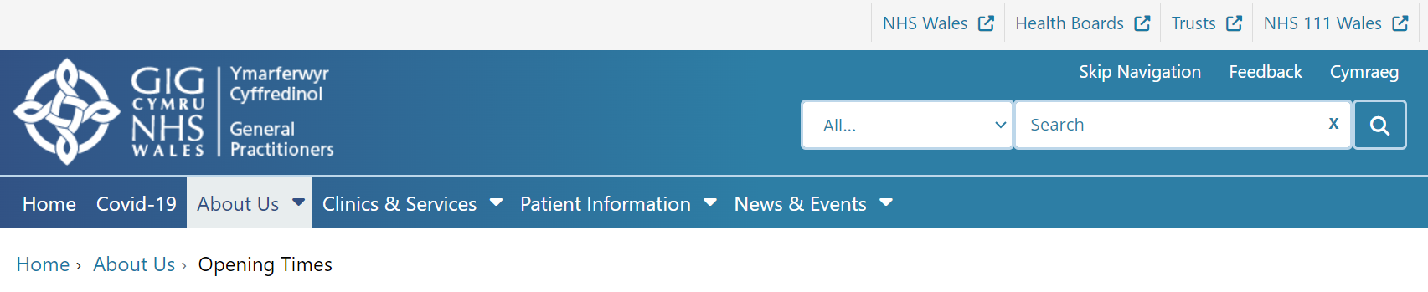 | CMS Support Team
System Updates
4.2.5 URL Redirect Report | We have now created a SQL Script that can be run against the CMS database upon request, in order to create am Excel extract report of all Alternate/friendly URLs in place and which pages these are associated with. This would include Live and Draft pages.  To request the report be run against your site please log a call to the CMS Support Team.  See the CMS Support Site for more information on CMS Reports Available | CMS Support Team
4.2.6 Accordion Page Update | We have now made an update to the site Accordion pages. We have now made a change so that site users will not be able to access an Accordion page directly, users should only ever see an Accordion page when it is viewed as part of an Accordion.  As a CMS Site Admin/Editor – When I log into the website and go to the direct URL of an Accordion page, I will be able to view and access this page on the front and backend of the website. On the front end of the site, I will be able to edit the page to add content such as site plugins.  As a CMS Site User – When viewing the website, if I attempt to go directly to an Accordion page URL, I will be automatically redirected to the parent page that the Accordion (that contains my accordion page) appears on. If the Accordion has not been added to a page, then I would be redirected to the website home page.  See the CMS Support Site for more information on Accordions | CMS Support Team
4.2.7 Dashboard Update – Site Search Terms | We recently introduced the ability to record your users’ site search terms. (By default, this new functionality will be set to Disabled. To have this new functionality added to your site/s, admins would need to log a call with the CMS Support Team).  We have now made an update to allow this data to be available within the site Dashboard. This new functionality will allow you to view Search Terms month by month and also give the added option of exporting this data to Excel.  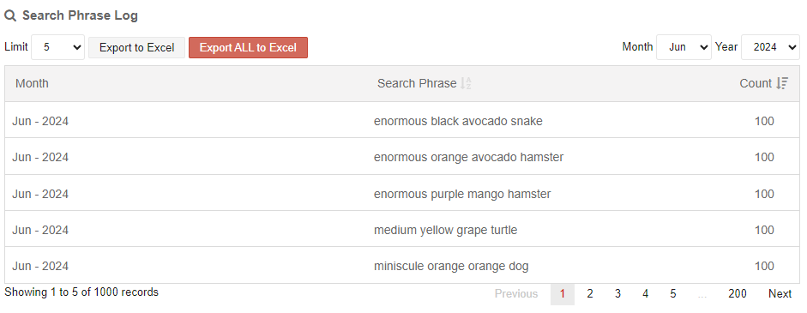  See the CMS Support Site for more information on CMS Dashboard | CTMUHB
Plugin & Layout Updates
4.2.8 New Layout – Multi Content 7 | We will be introducing a new Collection Layout – Multi Content 7  This new layout will allow users to display up to 3 items of content on a page, with an Image, Title & Summary. On a hover over the Title text changes colour and an arrow links to the full item.  PC Display    See the CMS Support Site for more information on Multi Content 7
Accessibility Standards |  |  | Accessibility Standards
4.2.9 3rd Level Navigation Update | An inconsistence with the 3rd Level Navigation has been noticed, this has now been updated so that it is in line with Accessibility Standards.  Current Behaviour - Always show the Active page at the top of the list (Orange Tab). So that you don’t have to scroll down to it and then list other sibling pages below it.  New Behaviour - Always show the Active page in its correct position with sibling pages above and/or below it, keeping it consistent with other nav such as top level primary nav  Current Behaviour New Behaviour  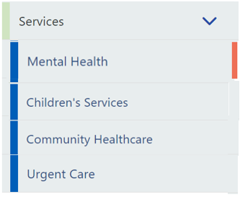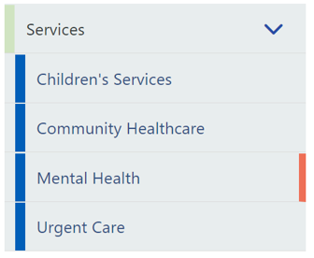  See the CMS Support Site for more information on 3rd Level Nav | CMS Support Team

Summary
Number of Changes
9

Bug Fix | System Updates | Plugin & Layout Updates | Accessibility Standards
4 | 3 | 1 | 1

Problems Fixed
N/A

New Problems Identified During Testing and Associated Workarounds
N/A

Pre-requisites to Deploy the Release
N/A

Training Requirements
N/A

Step by Step Deployment Instructions
No Deployment actions required by Health Boards.

Deployment Plan
Changes to be implemented as specified in the Change Record. Release to be deployed via change record: Change 135920

Back-Out Plan
Back out as detailed on each change record

Release Available for Deployment Date
NHS Wales Websites CMS: Wednesday the 10th July 2024

