Digital Health and Care Wales
NHS Wales IT Service Management

NHS Wales Websites CMS January 2024 Release Notes | Release ID: 823

Releases
Log a release.
Proposed (5)
Awaiting Build & Test (0)
Awaiting SIT (0)
Awaiting OAT (0)
Awaiting RT (0)
Ready to Deploy (0)
Deployed (0)
Aborted (0)
All (5)

Closed
Schedule of change
Calendar
Historic record of change
List options
Release Logged Title Release ID Release Date Owner Related deployment changes Related release changes Related Services
815

Releases
Log a release.
Proposed (5)
Awaiting Build & Test (0)
Awaiting SIT (0)
Awaiting OAT (0)
Awaiting RT (0)
Ready to Deploy (0)
Deployed (0)
Aborted (0)
All (5)

Closed
Schedule of change
Calendar
Historic record of change
List options
Release Logged Title Release ID Release Date Owner Related deployment changes Related release changes Related Services
815

These Release Notes describe the scope and content of
Release ID: 823 for the NHS Wales Websites CMS Service

Version: | 1.0
Status: | Final
Owner: | DHCW Corporate Apps Team
Author: | DHCW Corporate Apps Team
Approver: | DHCW Corporate Apps Team

Date: | 11/12/2024
Next Review Date: | 05/01/2024

1 DOCUMENT HISTORY 4
1.1 Revision History 4
1.2 Authorisation 4
1.3 Document Location 4
2 INTRODUCTION 4
3 SERVICE MANAGEMENT BOARD (SMB) 4
4 RELEASE NOTES REQUIREMENT 5
4.1 Release Identification 5
4.2 Description of New or Modified Functionality 5
5 Summary 13
5.1 Problems Fixed 13
5.2 New Problems Identified During Testing and Associated Workarounds 13
5.3 Pre-requisites to Deploy the Release 13
5.4 Training Requirements 13
5.5 Step by Step Deployment Instructions 13
5.6 Deployment Plan 13
5.7 Back-Out Plan 13
5.8 Release Available for Deployment Date 13

DOCUMENT HISTORY

Revision History
Date | Version | Author | Revision Summary
11/12/2023 | 0.1 | DHCW Corporate Apps Team | Document created for the NHS Wales Websites CMS Release
27/12/2023 | 0.2 | DHCW Corporate Apps Team | Added in Extra Items
05/01/2024 | 1.0 | DHCW Corporate Apps Team | Extra Items & Final Images added

Authorisation
Signing of this document indicates acceptance of its contents.
Author’s Name: | DHCW Corporate Apps Team

Approver’s Name: | DHCW Corporate Apps Team

Document Location
Type | Location
Electronic | NHS Wales Websites CMS Support Site – What’s New

INTRODUCTION
The NHS Wales Release Management Policy considers that effective Release Management is essential for protecting the integrity of the operational environment. A key objective of the release process is to ensure that users, support staff and other stakeholders are kept informed as to what is planned and how this will affect them. One of the ways that this can be achieved is through the publication of release notes prior to deployment of the Release.
These notes contain information on the agreed scope and content of Release id CMS/01-2024 for the CMS descriptions of new or modified functionality and problem fixes, descriptions of new problems and workarounds identified during the testing of this Release, training requirements, deployment instructions, references to deployment and back-out plans and key dates within the release process.

SERVICE MANAGEMENT BOARD (SMB)
The CMS Service Management Board has overall responsibility for ensuring that these Release Notes accurately describe the Release and that it is kept under constant review and updated to reflect any modifications to the Release prior to its deployment.

RELEASE NOTES REQUIREMENT

Release Identification
823 - CMS/01-2024

Description of New or Modified Functionality

Item | Description of the Change | Requestor
Bug Fixes
4.2.1 Single Content Block 4 Update | Since added a fix for the Blue Banners in a previous release, it has been noted that the Single Content Block 4 Layout is not functioning as expected when the information source is set as Custom Data.  The background of this layout is currently fixed as the colour blue and doesn’t not allow the user to edit this in any way. We have now implemented a fix that will allow the selection of any colour or Image as the background to this layout.  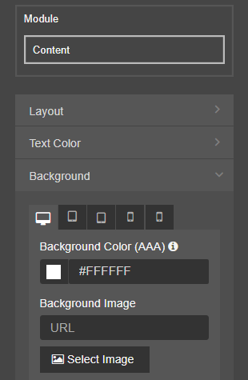  Current Settings Options New Settings Options  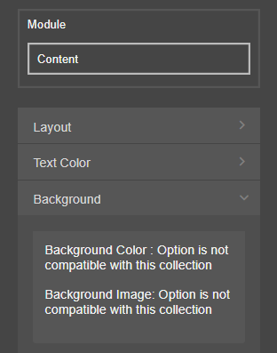  See the CMS Support site for more information on Single Content 4 | CMS Support Team
4.2.2 eConsult Banner Update | 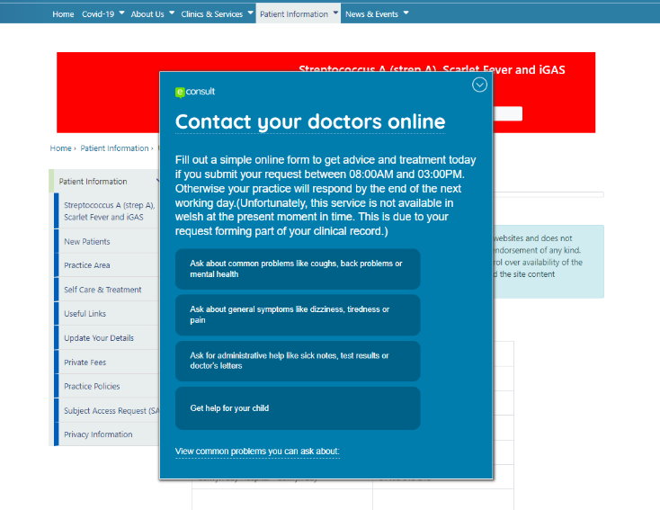  It has been reported that the eConsult Banner was failing to honor the collapse /close arrow on certain pages.  We have now added a fix so that when selected the Banner will now remain collapsed throughout the site.  See the CMS Support site for more information on the eConsult Banner | CMS Support Team
System Updates
4.2.3 Site Map Update | We have now made some updates to the Mura Site Map that is available within the System Plugin. The Site Map setting now contains Filters to allow site admins to add/remove specific content from the Site Map display.  Current Site Map Display  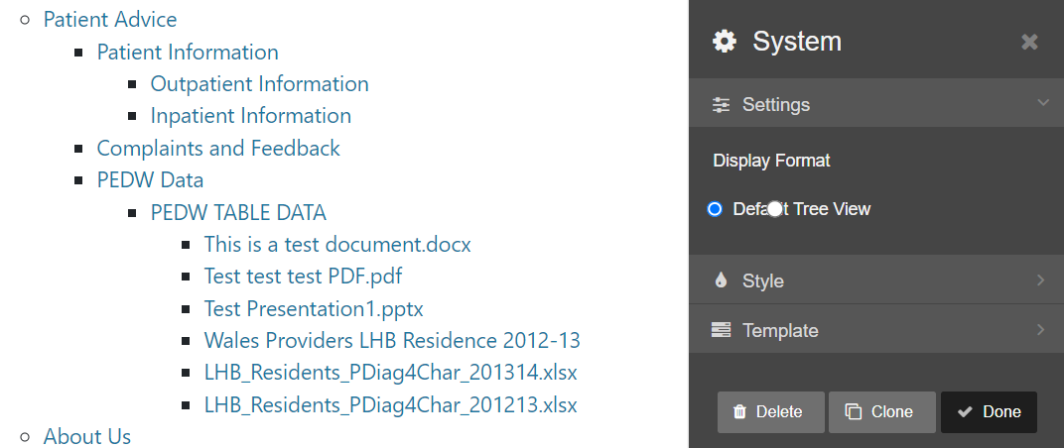  New Site Map Display  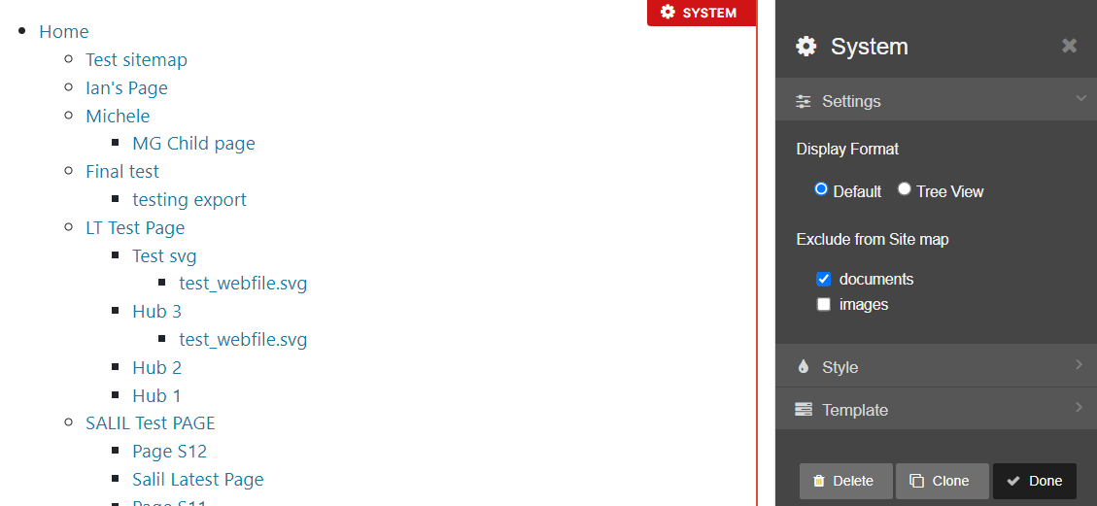  See the CMS Support site for more information on the Site Map
4.2.4 Dashboard – Additional Info | We have now made an update to the Site Dashboard. The Dashboard currently displays a summary of the number of Pages/ Files/ Links etc.  We have now made an update to show Site Capacity data. To have the Dashboard added to your site please log a call to the CMS Support site: rfw-web@wales.nhs.uk  Current Dashboard Display  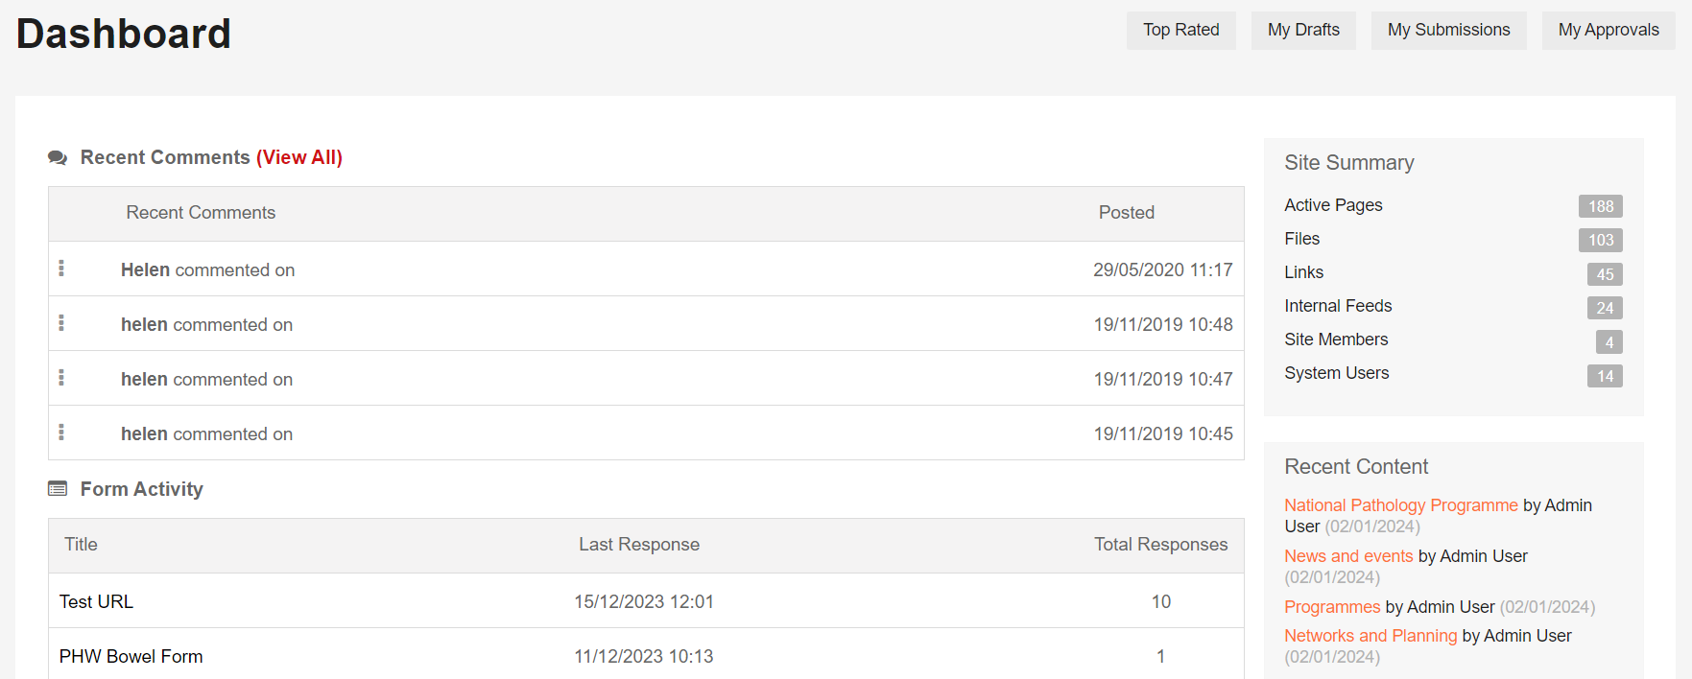  New Dashboard Display  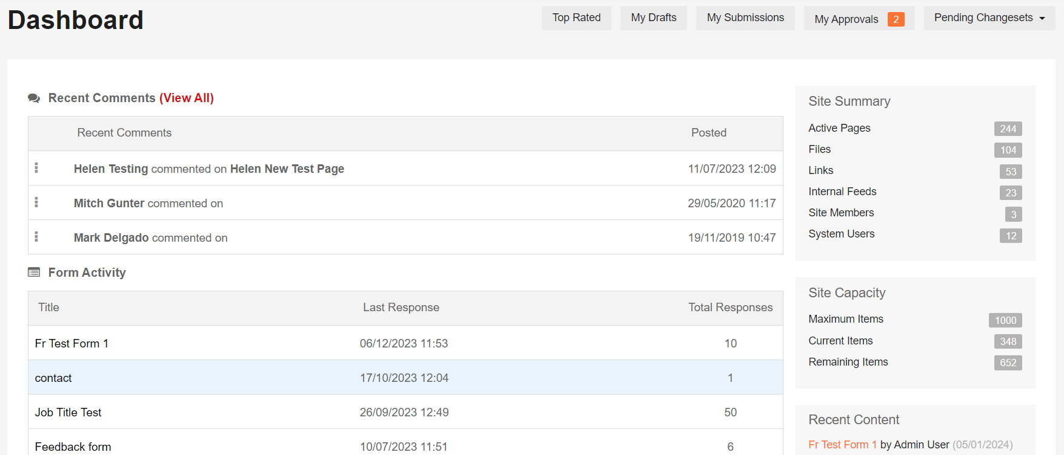  See the CMS Support site for more information on the Dashboard | CMS Support Team
4.2.5 Audit Reports Update | We have now introduced some changes to the Audit Report display pages, for the Mura Translation and Automatic Corresponding Content Plugins. The new Filter will allow site admins to filter the list by Content Type – Page/Folder. We have also amended the links to the content so the admins can link directly to the front or back end of each piece of content, by clicking the World or Pen Icons.  Current Displays  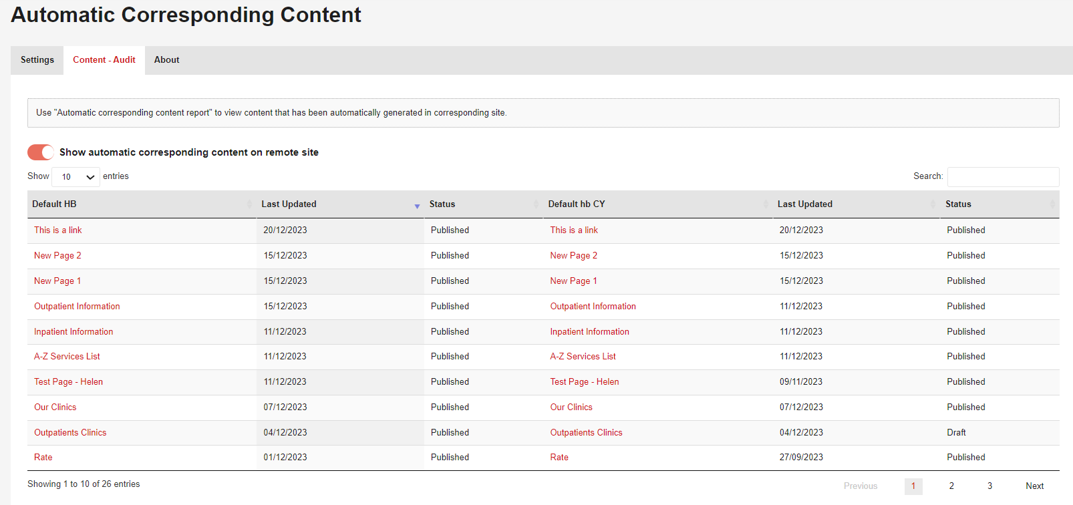  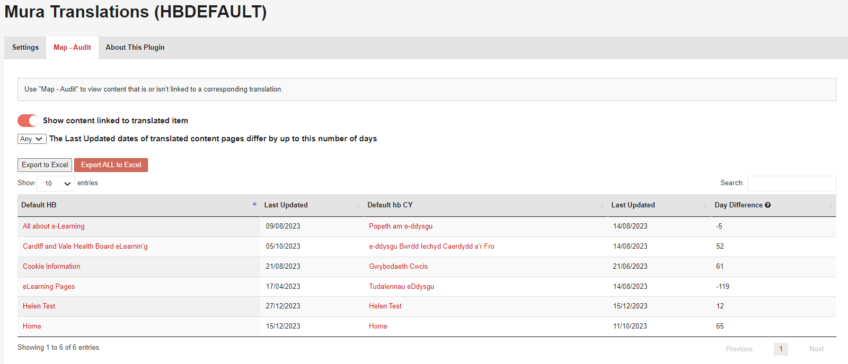  New Displays  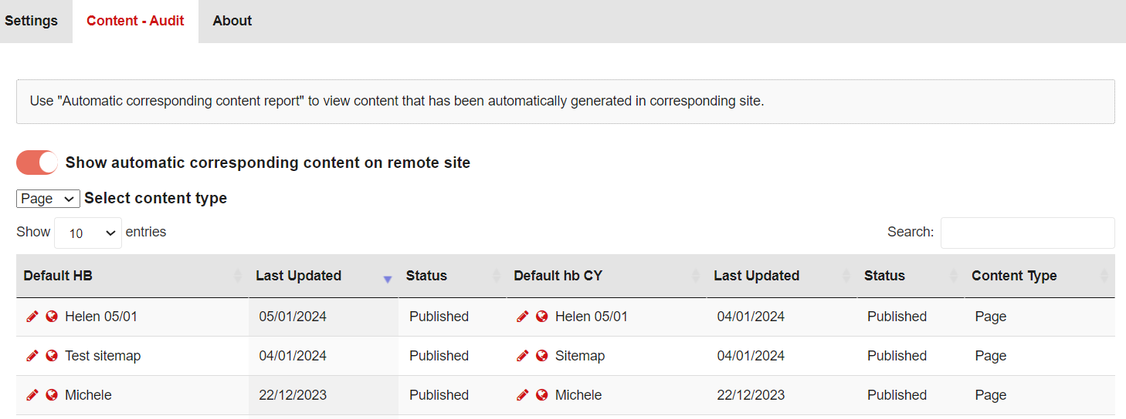  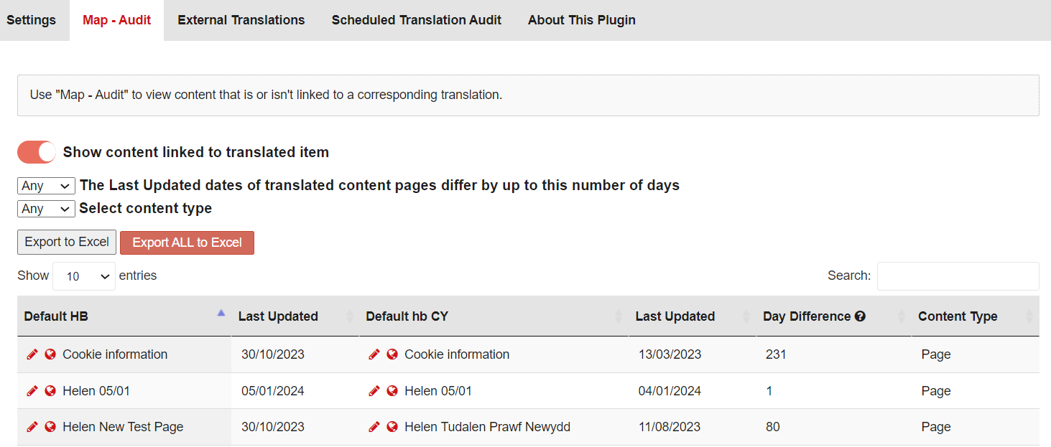  See the CMS Support site for more information on Auditing Content
4.2.6 Recording Site Search Terms | We have now introduced the ability to record your users’ site search terms. By default, this will be set to Disabled.  To have this new functionality added to your site, admins would need to log a call with DHCW. Once turned on we can then provide the site admin with a report of the top site search terms per month upon request.  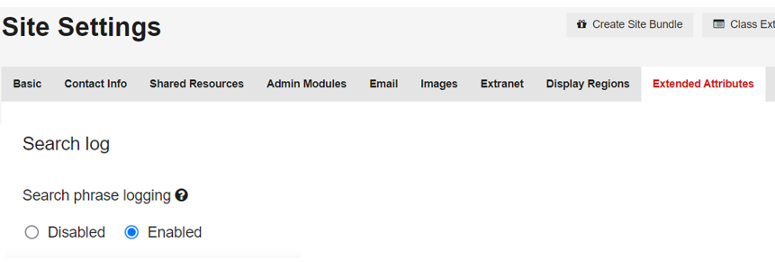
Plugin & Layout Updates
4.2.7 Multi Point Map Update | We have made an improvement to the behavior of the Multi-Point Map on both desktop and Mobile. Currently the ‘Map Points’ are marked with a letter A-Z, which ends at 26 items, this has now been amended to numbers and has no top limit.  Currently the Map Points are shown in one continuous list to the right of the map, overextending past the map where there are a large number of Map Points. This has now been resolved with 2 separate solutions, one for Desktop and one for Mobile.  Current Desktop Display New Desktop Display  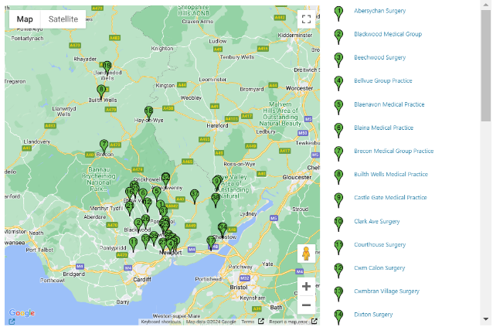  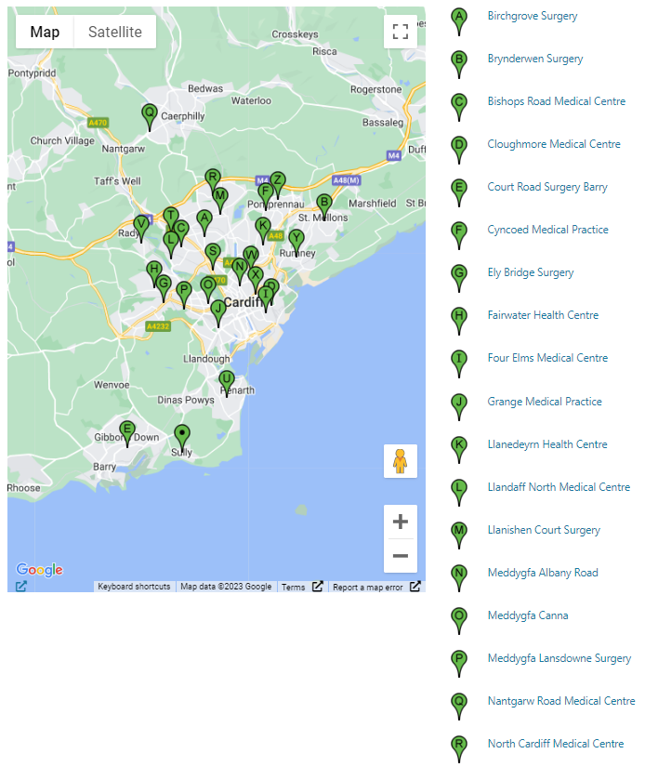  Current Mobile Display New Mobile Display – Collapsed & Expanded  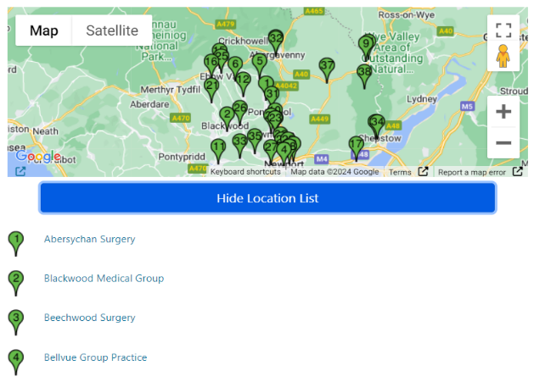  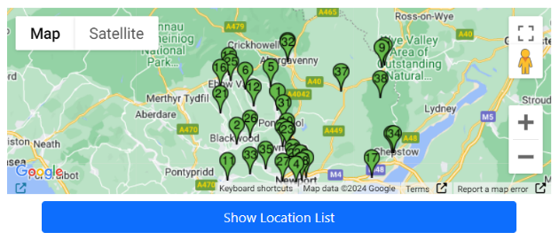  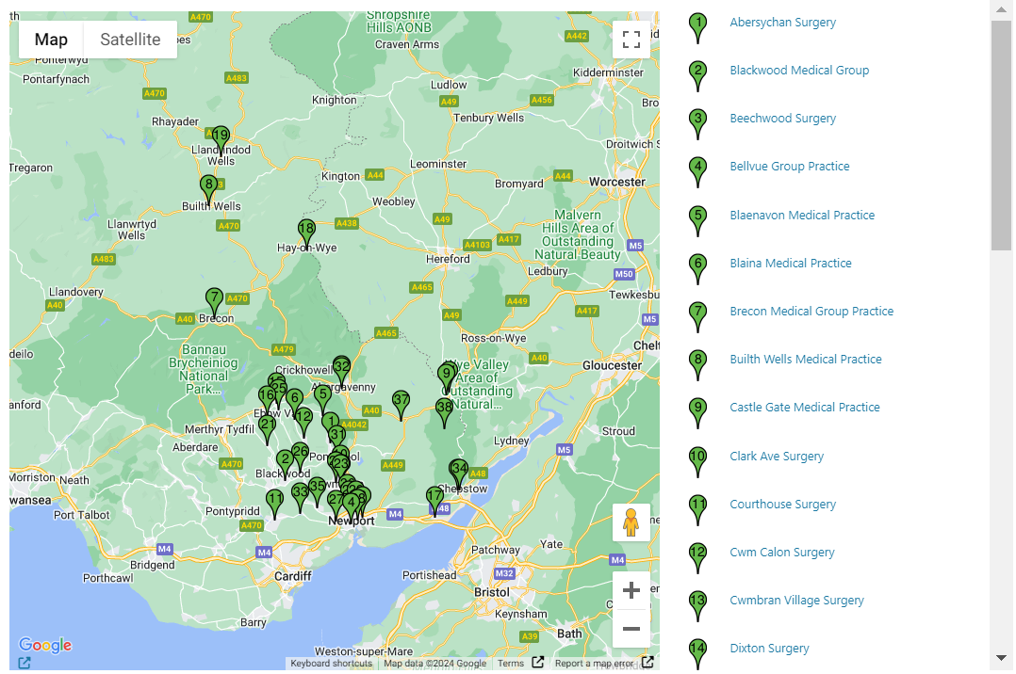  On a Desktop – There is a scroll bar to scroll through all Markers.  On a Mobile – Where Show Location List is in a closed state. Selecting this text would then open a Scrollable list.  See the CMS Support site for more information on the Multi-point Map | CMS Support Team
4.2.8 Update of the DOS Details Page | We have now made an update to the look at feel of the Mura Dos Details page. This design can now be found against GP Practices.  Current Display  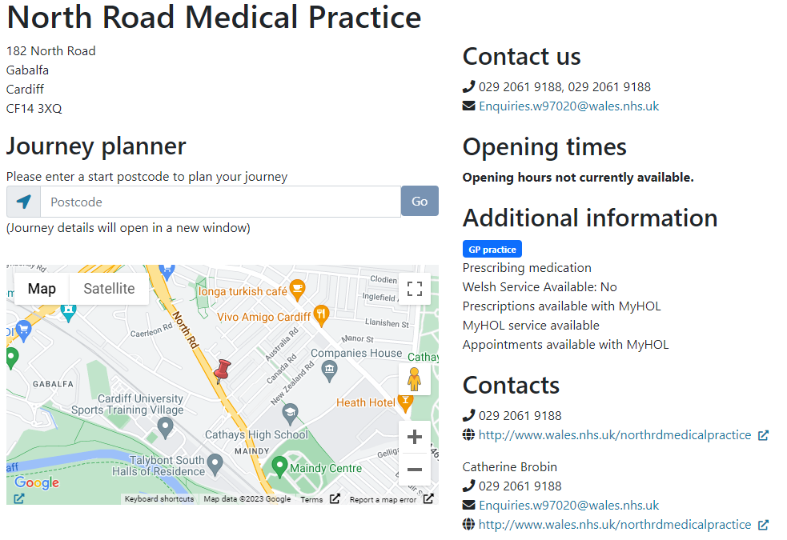  New Display  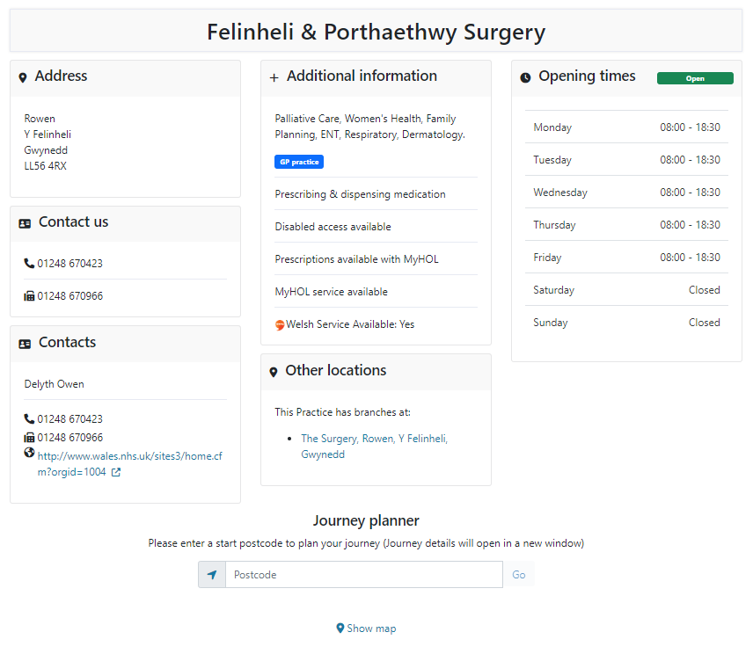 | CMS Support Team
4.2.9 Update to the DOS Details Map | We have now made an update to how the Google Map will appear when viewing site details within the Mura DOS. The Google Map will now be in a ‘hidden’ state when a user first goes to the page, to view the map the users will need to select the ‘View’ button.  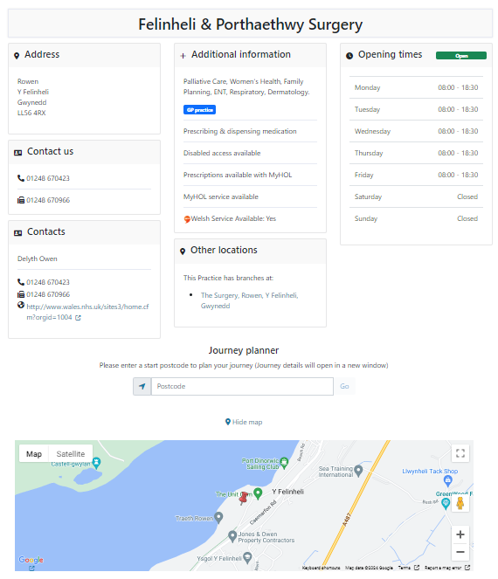  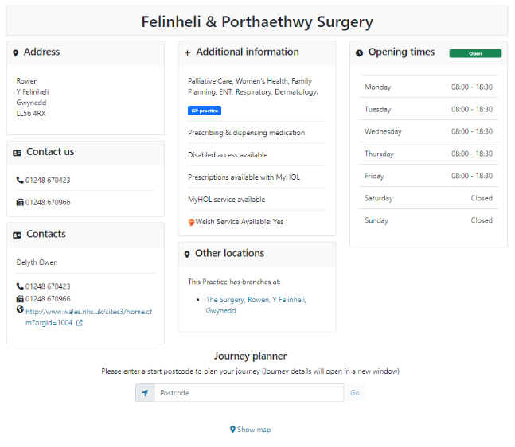  GP Map Collapsed GP Map Expanded  See the CMS Support site for more information on the DoS | CMS Support Team
Welsh Language Standards
4.2.10 Automatic Corresponding Content Update | We have now made an update to the Automatic Corresponding Content Plugin. The change we have made will now automatically add the Mura Translation link to the corresponding pages to allow English/Cymraeg Toggle at the top of the site to be automatically added.  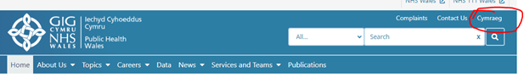  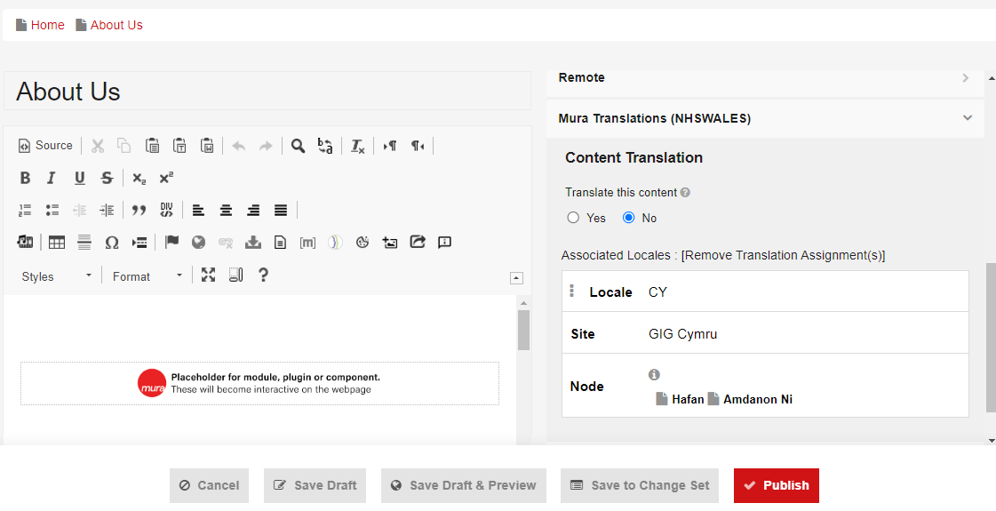  See the CMS Support site for more information on Automatic Corresponding Content | CMS Support Team
4.2.11 Welsh Language Update to the DOS Details Page | We have now made an improvement to the Mura DOS, this is to ensure that the Welsh language is displayed in all areas whilst viewing this data on a Welsh language site.  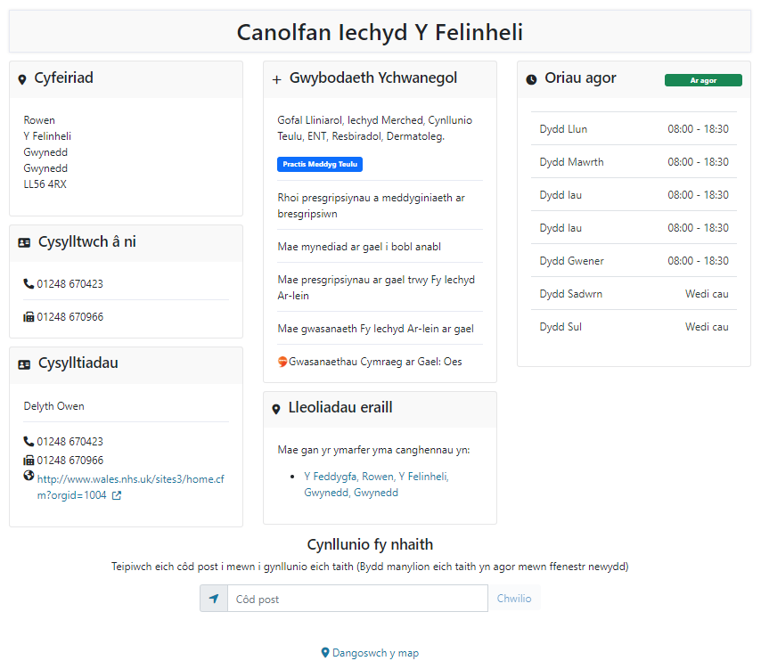 | CMS Support Team

Summary
Number of Changes
11

Bug Fix | System Updates | Plugin & Layout Updates | Welsh Language Standards
2 | 4 | 3 | 2

Problems Fixed
N/A

New Problems Identified During Testing and Associated Workarounds
N/A

Pre-requisites to Deploy the Release
N/A

Training Requirements
N/A

Step by Step Deployment Instructions
No Deployment actions required by Health Boards.

Deployment Plan
Changes to be implemented as specified in the Change Record. Release to be deployed via change record: Change 129078

Back-Out Plan
Back out as detailed on each change record

Release Available for Deployment Date
NHS Wales Websites CMS: Wednesday the 24th January 2024
Postponed
New Release Date: 21th February 2024

