Digital Health and Care Wales
NHS Wales IT Service Management

NHS Wales Websites CMS August 2024 Release Notes | Release ID: 852

Releases
Log a release.
Proposed (5)
Awaiting Build & Test (0)
Awaiting SIT (0)
Awaiting OAT (0)
Awaiting RT (0)
Ready to Deploy (0)
Deployed (0)
Aborted (0)
All (5)

Closed
Schedule of change
Calendar
Historic record of change
List options
Release Logged Title Release ID Release Date Owner Related deployment changes Related release changes Related Services
815

Releases
Log a release.
Proposed (5)
Awaiting Build & Test (0)
Awaiting SIT (0)
Awaiting OAT (0)
Awaiting RT (0)
Ready to Deploy (0)
Deployed (0)
Aborted (0)
All (5)

Closed
Schedule of change
Calendar
Historic record of change
List options
Release Logged Title Release ID Release Date Owner Related deployment changes Related release changes Related Services
815

These Release Notes describe the scope and content of
Release ID: 852 for the NHS Wales Websites CMS Service

Version: | 1.0
Status: | Final
Owner: | DHCW Corporate Apps Team
Author: | DHCW Corporate Apps Team
Approver: | DHCW Corporate Apps Team

Date: | 02/08/2024
Next Review Date: | 12/08/2024

1 DOCUMENT HISTORY 4
1.1 Revision History 4
1.2 Authorisation 4
1.3 Document Location 4
2 INTRODUCTION 4
3 SERVICE MANAGEMENT BOARD (SMB) 4
4 RELEASE NOTES REQUIREMENT 5
4.1 Release Identification 5
4.2 Description of New or Modified Functionality 5
5 Summary 9
5.1 Problems Fixed 9
5.2 New Problems Identified During Testing and Associated Workarounds 9
5.3 Pre-requisites to Deploy the Release 9
5.4 Training Requirements 9
5.5 Step by Step Deployment Instructions 9
5.6 Deployment Plan 9
5.7 Back-Out Plan 9
5.8 Release Available for Deployment Date 9

DOCUMENT HISTORY

Revision History
Date | Version | Author | Revision Summary
02/08/2024 | 0.1 | DHCW Corporate Apps Team | Document created for the NHS Wales Websites CMS Release
12/08/2024 | 1.0 | DHCW Corporate Apps Team | Adding Updated Images to Items

Authorisation
Signing of this document indicates acceptance of its contents.
Author’s Name: | DHCW Corporate Apps Team

Approver’s Name: | DHCW Corporate Apps Team

Document Location
Type | Location
Electronic | NHS Wales Websites CMS Support Site – What’s New

INTRODUCTION
The NHS Wales Release Management Policy considers that effective Release Management is essential for protecting the integrity of the operational environment. A key objective of the release process is to ensure that users, support staff and other stakeholders are kept informed as to what is planned and how this will affect them. One of the ways that this can be achieved is through the publication of release notes prior to deployment of the Release.
These notes contain information on the agreed scope and content of Release id CMS/05-2024 for the CMS descriptions of new or modified functionality and problem fixes, descriptions of new problems and workarounds identified during the testing of this Release, training requirements, deployment instructions, references to deployment and back-out plans and key dates within the release process.

SERVICE MANAGEMENT BOARD (SMB)
The CMS Service Management Board has overall responsibility for ensuring that these Release Notes accurately describe the Release and that it is kept under constant review and updated to reflect any modifications to the Release prior to its deployment.

RELEASE NOTES REQUIREMENT

Release Identification
852 - CMS/05-2024

Description of New or Modified Functionality

Item |  | Description of the Change |  | Requestor
Bug Fixes
4.2.1 Accordion Update |  | An issue has been noted within the Accordion layout. When selecting the Style Tab > Content area > Background – If you remove the background colour this causes a 500 Error Message. This update has now rectified this issue.  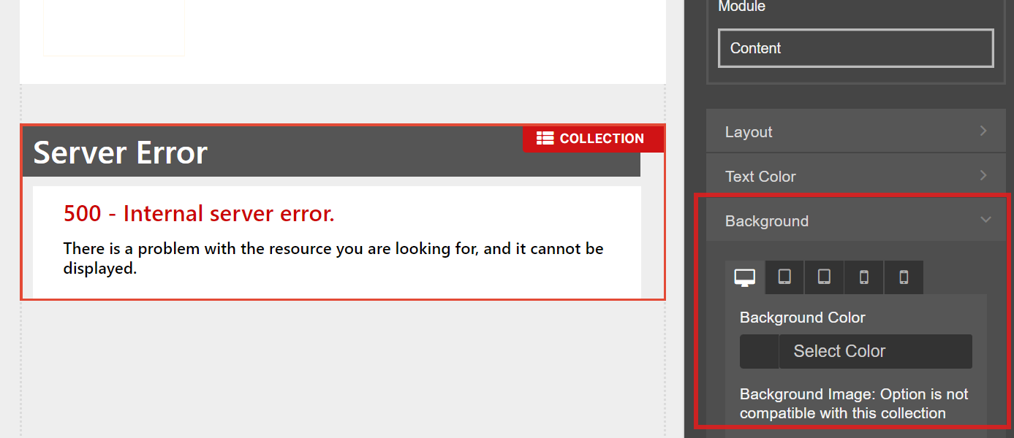 |  | CMS Support Team
System Updates
4.2.2 Slow Deletion Update | Users have been experiencing ongoing issues with deleting content within their websites. We have now made an update to the CMS to speed up the deletion process, so that all users should see an improvement with this process. |  | CMS Support Team
Plugin & Layout Updates
4.2.3 New Layout – Tabbed List |  | We have now introduced a new Collection Layout – Tabbed List  This new layout will allow users to display content items in multiple lists, each list would have a Header Tab and the users can toggle between the Header Title Tabs to choose which list they wish to view.  PC Display  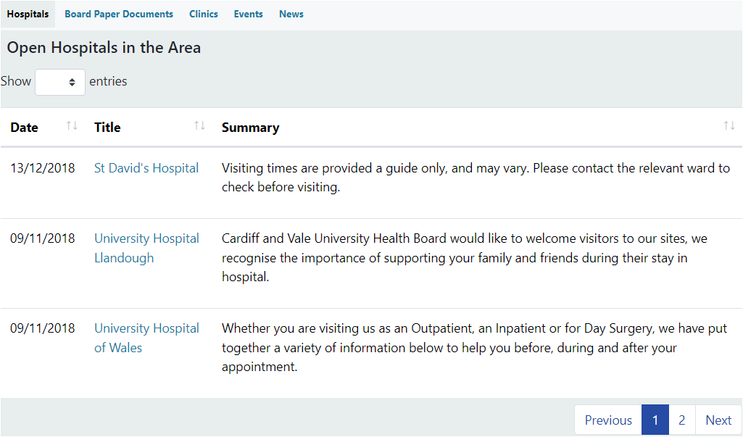  Mobile Display  When viewed on a Mobile the Header Title Tabs will appear within a dropdown burger menu, users can toggle between the titles to choose which list they wish to view.  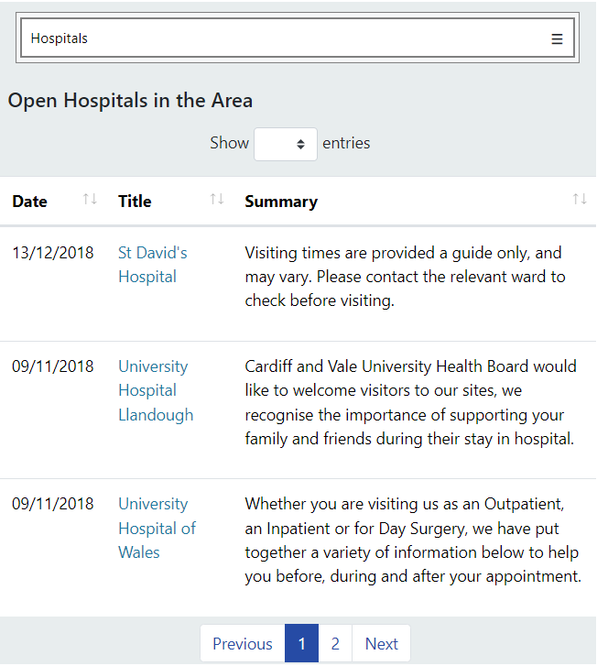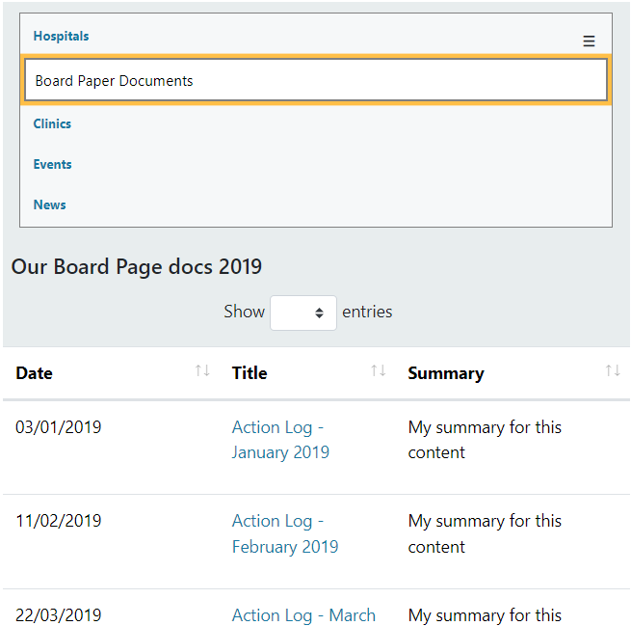  See the CMS Support Site for more information on Tabbed List |  | PHW
4.2.4 New Layout – Box Block 3 |  | We have now introduced a new Collection Layout – Box Block 3  This new layout will allow users to display up to 4 items of content on a page, with the Title and an image/colour block hover over effect. When viewed on a Mobile the Boxes will collapse into stacked bars with a ‘More’ arrow and the hover over would no longer display.  PC Display  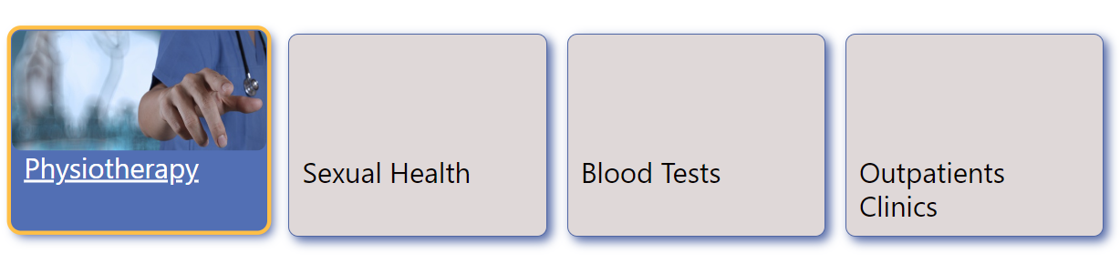  Mobile Display  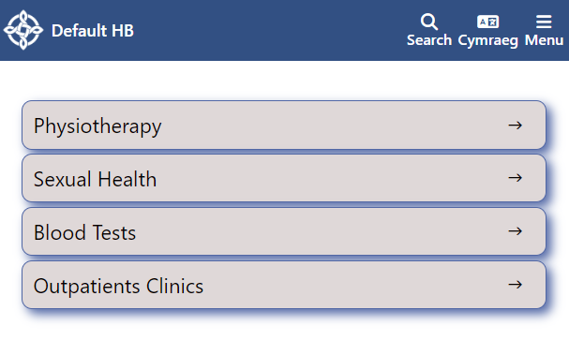  See the CMS Support Site for more information on Box Block 3 |  | WBS
4.2.5 Video Module Update |  | We have now made an update to the Video Plugin to allow admins to choose to add a ‘Video controls’ ribbon (pause, forward, rewind etc.) to YouTube Videos. This can be selected within the Video Plugin Settings.  YouTube Without Video Controls YouTube With Video Controls  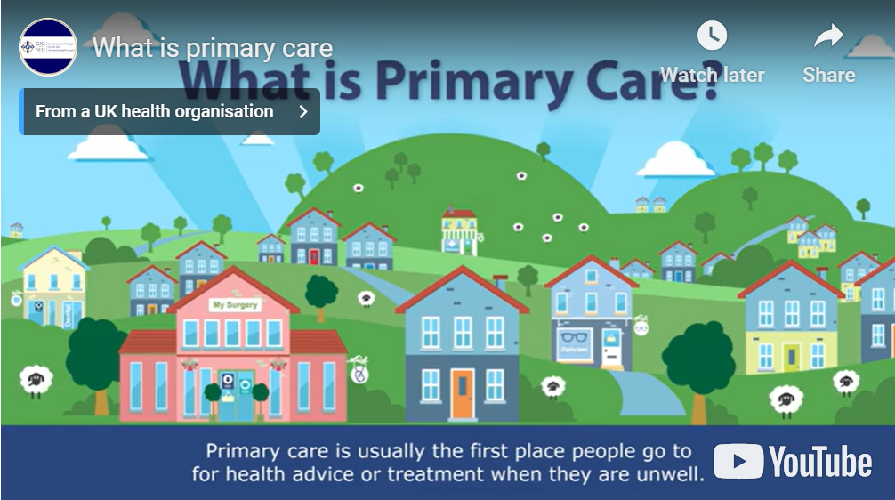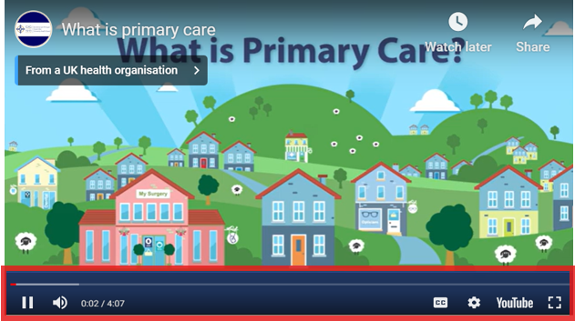  See the CMS Support Site for more information on the Video Plugin |  | HDUHB
4.2.6 Advance Table List Update |  | When used in conjunction with a Content Collection Index, the Advanced Table List does not currently honour the Categories - 'Match All Selected Category option. The Advanced Filter Tab will be fixed in a future Release.  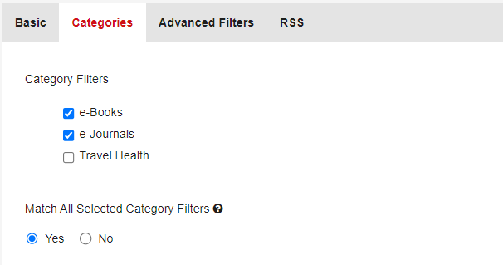  For more information on Advanced Table Lists  For more information on Content Collection Indexes |  | CMS Support Team
Accessibility Standards
4.2.7 Style Tab Colour Contrast Checker Update |  | We are in the process of adding Accessibility values to all areas of the Style Tab settings. This field will now include the Accessibility values: AAA/AA/! when an admin user selects a colour on the Heading, Module or Content Tabs – Text Vs Background.  Current Display Accessibility Values e.g.  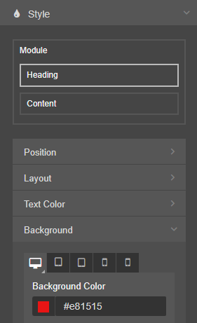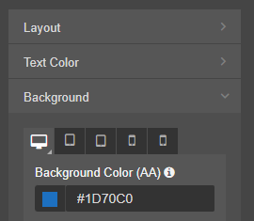 |  | CMS Support Team

Summary
Number of Changes
7

Bug Fix | System Updates | Plugin & Layout Updates | Accessibility Standards
1 | 1 | 4 | 1

Problems Fixed
N/A

New Problems Identified During Testing and Associated Workarounds
N/A

Pre-requisites to Deploy the Release
N/A

Training Requirements
N/A

Step by Step Deployment Instructions
No Deployment actions required by Health Boards.

Deployment Plan
Changes to be implemented as specified in the Change Record. Release to be deployed via change record: Change 137749

Back-Out Plan
Back out as detailed on each change record

Release Available for Deployment Date
NHS Wales Websites CMS: Wednesday the 21st August 2024

