Digital Health and Care Wales
NHS Wales IT Service Management

NHS Wales Websites CMS April 2024 Release Notes | Release ID: 829

Releases
Log a release.
Proposed (5)
Awaiting Build & Test (0)
Awaiting SIT (0)
Awaiting OAT (0)
Awaiting RT (0)
Ready to Deploy (0)
Deployed (0)
Aborted (0)
All (5)

Closed
Schedule of change
Calendar
Historic record of change
List options
Release Logged Title Release ID Release Date Owner Related deployment changes Related release changes Related Services
815

Releases
Log a release.
Proposed (5)
Awaiting Build & Test (0)
Awaiting SIT (0)
Awaiting OAT (0)
Awaiting RT (0)
Ready to Deploy (0)
Deployed (0)
Aborted (0)
All (5)

Closed
Schedule of change
Calendar
Historic record of change
List options
Release Logged Title Release ID Release Date Owner Related deployment changes Related release changes Related Services
815

These Release Notes describe the scope and content of
Release ID: 829 for the CMS MURA Service

Version: | 1.0
Status: | Final
Owner: | DHCW Corporate Apps Team
Author: | DHCW Corporate Apps Team
Approver: | DHCW Corporate Apps Team

Date: | 11/03/2024
Next Review Date: | 03/04/2024

1 DOCUMENT HISTORY 4
1.1 Revision History 4
1.2 Authorisation 4
1.3 Document Location 4
2 INTRODUCTION 4
3 SERVICE MANAGEMENT BOARD (SMB) 4
4 RELEASE NOTES REQUIREMENT 5
4.1 Release Identification 5
4.2 Description of New or Modified Functionality 5
5 Summary 9
5.1 Problems Fixed 9
5.2 New Problems Identified During Testing and Associated Workarounds 9
5.3 Pre-requisites to Deploy the Release 9
5.4 Training Requirements 9
5.5 Step by Step Deployment Instructions 10
5.6 Deployment Plan 10
5.7 Back-Out Plan 10
5.8 Release Available for Deployment Date 10

DOCUMENT HISTORY

Revision History
Date | Version | Author | Revision Summary
11/03/2024 | 0.1 | DHCW Corporate Apps Team | Document created for the NHS Wales Websites CMS Release
19/03/2024 | 0.2 | DHCW Corporate Apps Team | Final Images added
03/04/2024 | 1.0 | DHCW Corporate Apps Team | CMS Support Links added

Authorisation
Signing of this document indicates acceptance of its contents.
Author’s Name: | DHCW Corporate Apps Team

Approver’s Name: | DHCW Corporate Apps Team

Document Location
Type | Location
Electronic | NHS Wales Websites CMS Support Site – What’s New

INTRODUCTION
The NHS Wales Release Management Policy considers that effective Release Management is essential for protecting the integrity of the operational environment. A key objective of the release process is to ensure that users, support staff and other stakeholders are kept informed as to what is planned and how this will affect them. One of the ways that this can be achieved is through the publication of release notes prior to deployment of the Release.
These notes contain information on the agreed scope and content of Release id CMS/02-2024 for the CMS descriptions of new or modified functionality and problem fixes, descriptions of new problems and workarounds identified during the testing of this Release, training requirements, deployment instructions, references to deployment and back-out plans and key dates within the release process.

SERVICE MANAGEMENT BOARD (SMB)
The CMS Service Management Board has overall responsibility for ensuring that these Release Notes accurately describe the Release and that it is kept under constant review and updated to reflect any modifications to the Release prior to its deployment.

RELEASE NOTES REQUIREMENT

Release Identification
829 - CMS/02-2024

Description of New or Modified Functionality

Item | Description of the Change | Requestor
Bug Fixes
4.2.1 Tag Cloud | 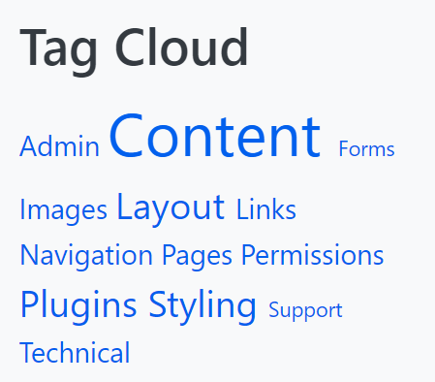  It has been reported that the Tag Cloud has stopped functioning.  We have now added a fix that will allow the Tag Cloud to function correctly.  *Keep in mind that TAGs should be only 1 word long  See the CMS Support site for information on Tag Clouds | CMS Support Team
4.2.2 eConsult Banner Update | It has been noted that when the eConsult Banner is placed within the bottom row of the website; when expanded this then falls outside of the bounds of the site. We have now implemented a fix to ensure this will no longer occur.  Current Display  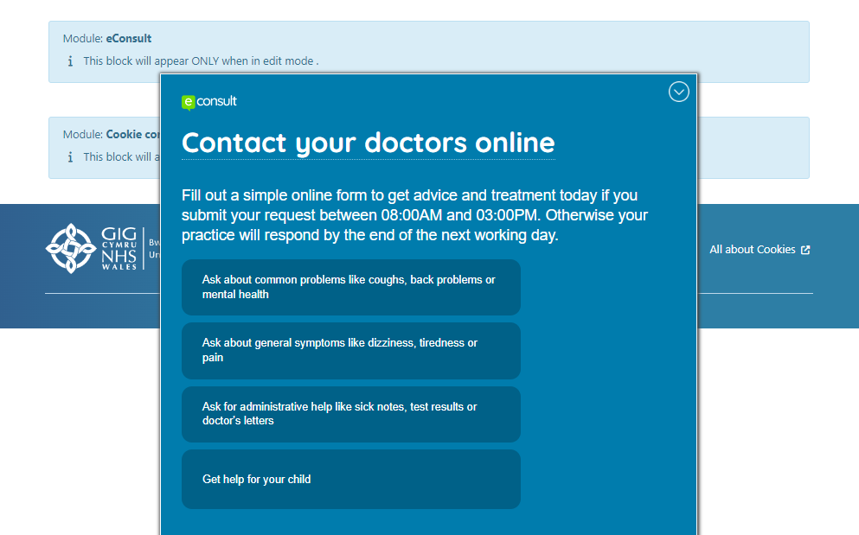  New Display  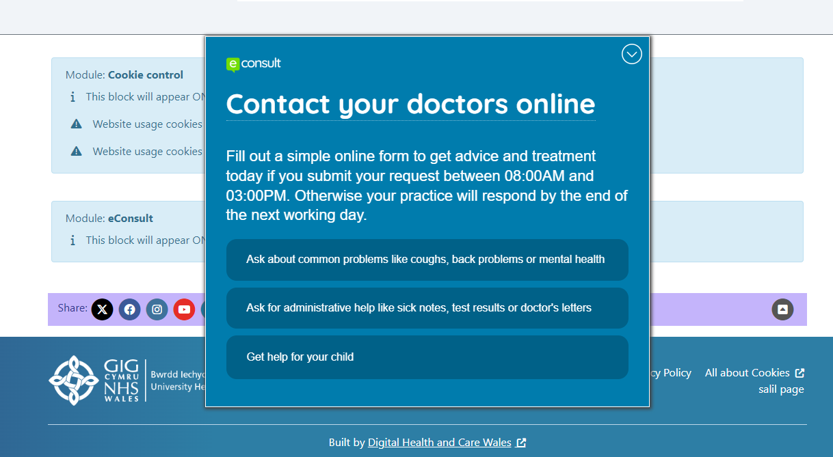  See the CMS Support site for more information on the eConsult Banner | CMS Support Team
System Updates
4.2.3 Image Download Button | We have now introduced a ‘download button’ to enable your site users to click on a download link next to an Image on a webpage and have the corresponding Image then download to their local machine.  This new functionality is enabled by adding this Mura Tag underneath your image:  [mura]getImageDownloadLink(href='add path to image')[/mura]  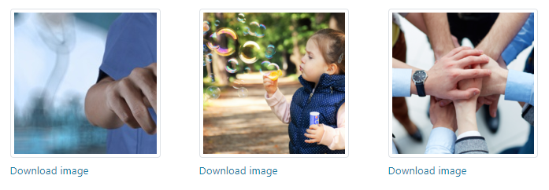  See the CMS Support site for information on Displaying Images | PHW
Plugin & Layout Updates
4.2.4 Site Document List | We have now made an update to the Advanced Table List Layout in order to allow site admins to create and display a full site Document List.  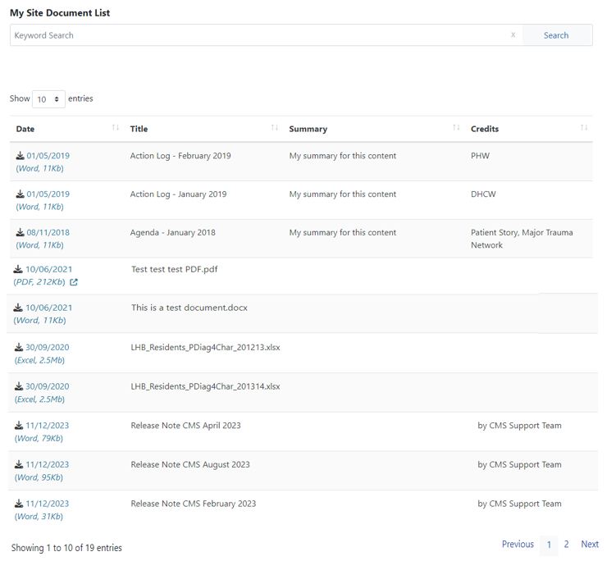  See the CMS Support site for information on creating a Document List | CMS Support Team
4.2.5 YouTube Icon Update | The YouTube Icon has recently been updated; this change will now see that we are no longer pulling in an ‘X’ and are now pulling in the most up to date Icon.  Current Display New Display  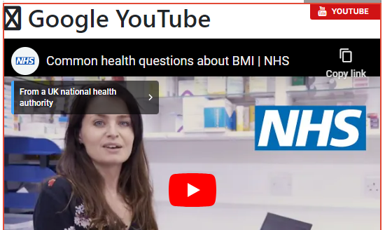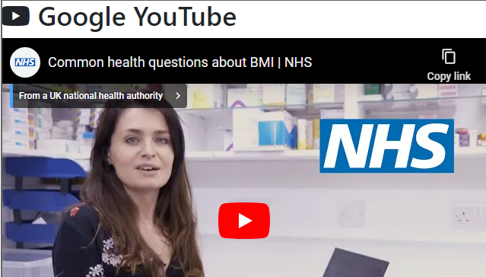  See the CMS Support site for more information on YouTube | CMS Support Team
4.2.6 New Plugin - Header Panel 2 | When creating pages on your website we have now created a new Header Panel Plugin which can be added to change the look and feel of your page.  This new plugin will allow site admins to place a Banner at the top of the page and then have the ability to amend the Colour/Image/Title/Summary/Breadcrumbs.  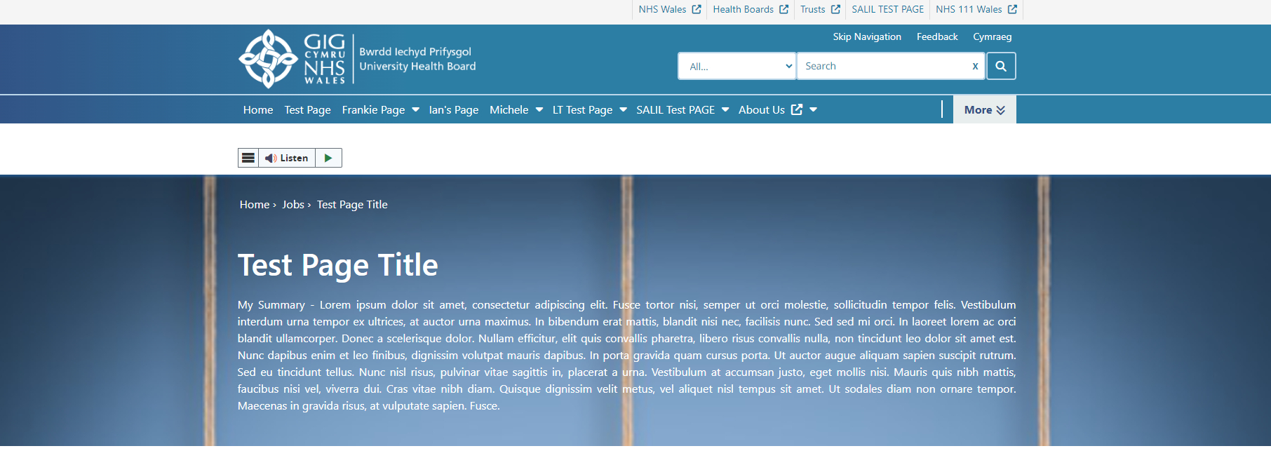  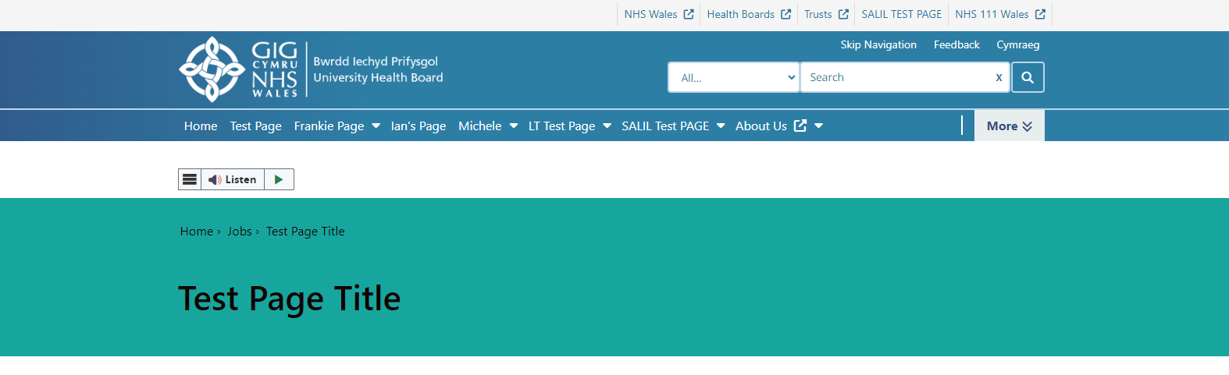  See the CMS Support site for more information on Header Panel 2 | CMS Support Team
4.2.7 Table List Update | This change will see the introduction of a new option within the settings of the Table List Layout. This new setting will enable users to control the Order by Direction of the list between Ascending & Descending.  We have also moved the Pagination display from the top to the bottom of the list, this is to improve consistency between the Table List and other list types within the CMS.  Current Display New Display  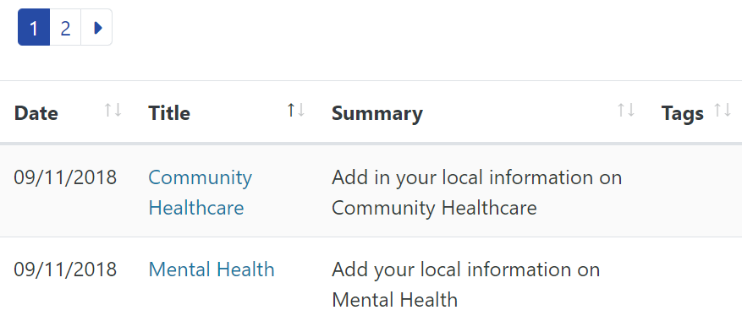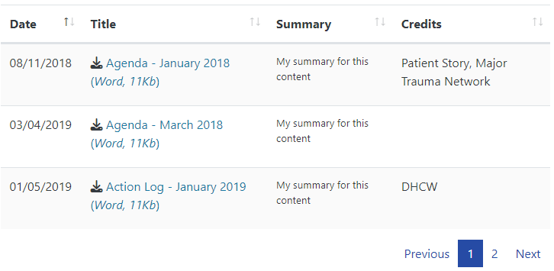  See the CMS Support site for more information on Table Lists | CMS Support Team
Welsh Language Standards
4.2.8 Mura Translation Tab Update | 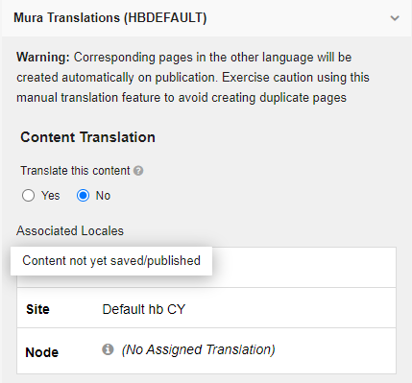  When a new page is created within the CMS, the Mura Translation Tab currently automatically displays the option to link this page to a Welsh language page.  We have now updated this so that a message will display informing the user that they must first save the page before this option becomes available. | CMS Support Team

Summary
Number of Changes
8

Bug Fix | System Updates | Plugin & Layout Updates | Welsh Language Standards
2 | 1 | 4 | 1

Problems Fixed
N/A

New Problems Identified During Testing and Associated Workarounds
N/A

Pre-requisites to Deploy the Release
N/A

Training Requirements
N/A

Step by Step Deployment Instructions
No Deployment actions required by Health Boards.

Deployment Plan
Changes to be implemented as specified in the Change Record. Release to be deployed via change record: Change 131554

Back-Out Plan
Back out as detailed on each change record

Release Available for Deployment Date
NHS Wales Websites CMS: Wednesday the 24th April 2024

