Digital Health and Care Wales
NHS Wales IT Service Management

CMS MURA September 2023 Release Notes | Release ID: 812

Releases
Log a release.
Proposed (5)
Awaiting Build & Test (0)
Awaiting SIT (0)
Awaiting OAT (0)
Awaiting RT (0)
Ready to Deploy (0)
Deployed (0)
Aborted (0)
All (5)

Closed
Schedule of change
Calendar
Historic record of change
List options
Release Logged Title Release ID Release Date Owner Related deployment changes Related release changes Related Services
815

Releases
Log a release.
Proposed (5)
Awaiting Build & Test (0)
Awaiting SIT (0)
Awaiting OAT (0)
Awaiting RT (0)
Ready to Deploy (0)
Deployed (0)
Aborted (0)
All (5)

Closed
Schedule of change
Calendar
Historic record of change
List options
Release Logged Title Release ID Release Date Owner Related deployment changes Related release changes Related Services
815

These Release Notes describe the scope and content of
Release ID: 812 for the CMS MURA Service

Version: | 1.0
Status: | Final
Owner: | Helen McGrath
Author: | Helen McGrath
Approver: | Michele Golpaykar-Rad

Date: | 21/08/2023
Next Review Date: | 12/09/2023

1 DOCUMENT HISTORY 4
1.1 Revision History 4
1.2 Reviewers 4
1.3 Authorisation 4
1.4 Document Location 4
2 INTRODUCTION 5
3 SERVICE MANAGEMENT BOARD (SMB) 5
4 RELEASE NOTES REQUIREMENT 5
4.1 Release Identification 5
4.2 Description of New or Modified Functionality 5
5 Summary 13
5.1 Problems Fixed 13
5.2 New Problems Identified During Testing and Associated Workarounds 13
5.3 Pre-requisites to Deploy the Release 13
5.4 Training Requirements 13
5.5 Step by Step Deployment Instructions 14
5.6 Deployment Plan 14
5.7 Back-Out Plan 14
5.8 Release Available for Deployment Date 14

DOCUMENT HISTORY

Revision History
Date | Version | Author | Revision Summary
21/08/2023 | 0.1 | Michele Golpaykar-rad | Document created for CMS MURA Release
29/08/2023 | 0.2 | Helen McGrath | Updated text and Images
12/09/2023 | 1.0 | Helen McGrath | Updated text and Images

Reviewers
This document requires the following reviews:
Date | Version | Name | Position
12/09/2023 | 1.0 | Helen McGrath | Senior Support & Business Analyst

Authorisation
Signing of this document indicates acceptance of its contents.
Author’s Name: | Helen McGrath
Role: | Principal Support & Business Analyst
Signature: | Helen McGrath

Approver’s Name: | Michele Golpaykar-Rad
Role: | Principal Support & Business Analyst
Signature: | Michele Golpaykar-Rad

Document Location
Type | Location
Electronic | CMS MURA Support Site – What’s New

INTRODUCTION
The NHS Wales Release Management Policy considers that effective Release Management is essential for protecting the integrity of the operational environment. A key objective of the release process is ensuring that users, support staff and other stakeholders are kept informed as to what is planned and how this will affect them. One of the ways that this can be achieved is through the publication of release notes prior to deployment of the Release.
These notes contain information on the agreed scope and content of Release id CMS/05-2023 for the CMS descriptions of new or modified functionality and problem fixes, descriptions of new problems and workarounds identified during the testing of this Release, training requirements, deployment instructions, references to deployment and back-out plans and key dates within the release process.

SERVICE MANAGEMENT BOARD (SMB)
The CMS Service Management Board has overall responsibility for ensuring that these Release Notes accurately describes the Release and that it is kept under constant review and updated to reflect any modifications to the Release prior to its deployment.

RELEASE NOTES REQUIREMENT

Release Identification
812 - CMS/05-2023

Description of New or Modified Functionality

Item | Description of the Change | Requestor
Bug Fixes
4.2.1 Update to Layouts Summary | Multiple layouts have been updated so that if special characters such as: & £, !, $, % are in the summary of a page that is pulled into a layout, it will show that character in the snippet, as currently it is not displaying.  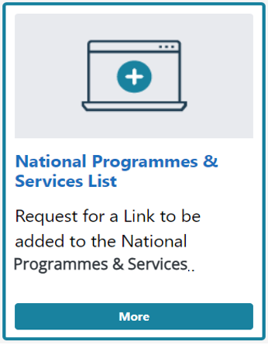  Current Display New Display  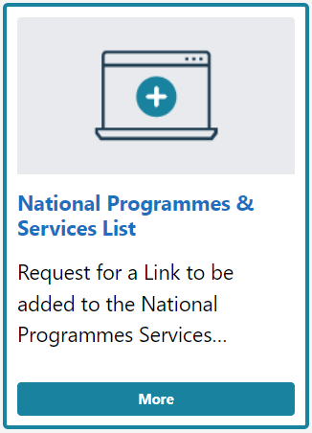 | CMS Support Team
4.2.2 Issue with Grid & Card Layouts | It has been noted that when using the Grid & Card Layout on the same page an error is being caused where the layouts collapse into each other. We have now added a fix that will stop this from happening, allowing both layouts to work correctly and independently when added to the same page.  Current Display  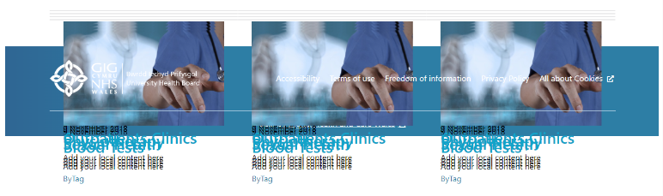  New Display  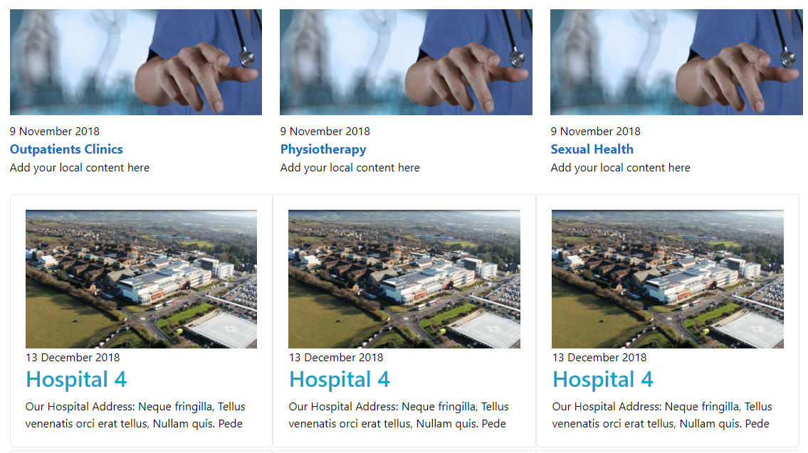 | CMS Support Team
System Updates
4.2.3  Additional File Type | The filetype .dotx is now allowed to be uploaded to Mura. DOTX file is a document template created by Microsoft Word  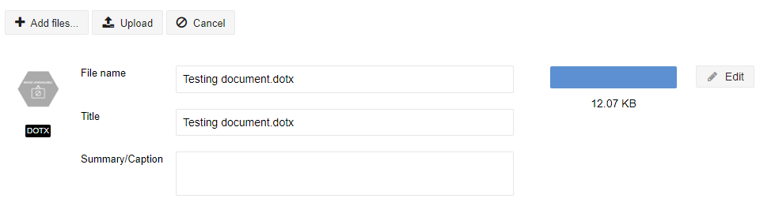  See the Support site for a Full List of Supported File Types | WAST
4.2.4 New Hover Over Tag for ALT/Tooltip Text | A new feature has been added to the CKEDITOR so that admins can add an abbreviation and a pop-up explanation. Admins would need to highlight the Abbreviation on the page, select the new Key in the toolbar, and enter the Abbreviation and Explanation and save.  A dotted line will then appear under the Abbreviation so that when users visiting the website hover over the abbreviation, a tooltip will appear to show the explanation.  Back-end Display  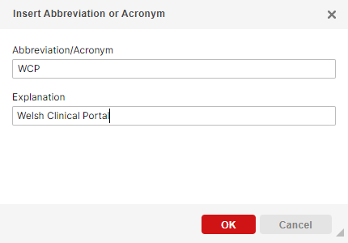  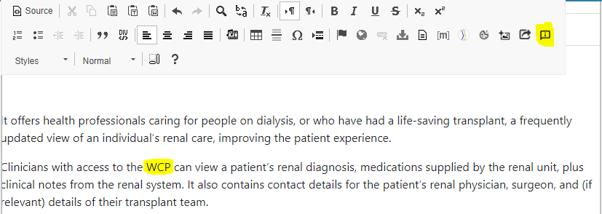  Front-end Display  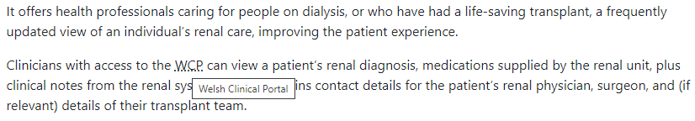 | CMS Support Team
4.2.5 Update to Navigation Menu Dropdowns | We have introduced an update to the Top-Level Navigation (blue bar). Currently if there are more heading items than fit horizontally across the screen - the overflowing items can be seen by clicking on the ‘More’ option on the right of the menu bar.  We have now implemented a change so that as items start to fall off the Navigation Bar, they will align into a grid with the arrows aligned, allowing for four items in a row. The links are arranged in rows of three when the screen size is below 992px.  Current Display  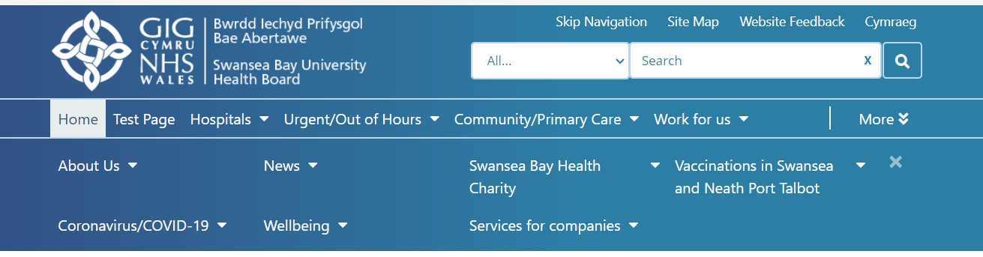  New Display  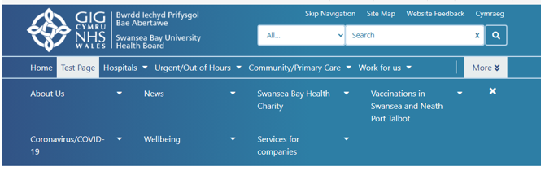  When hovering off the dropdown, there should be a small delay and then the dropdown menu will collapse.  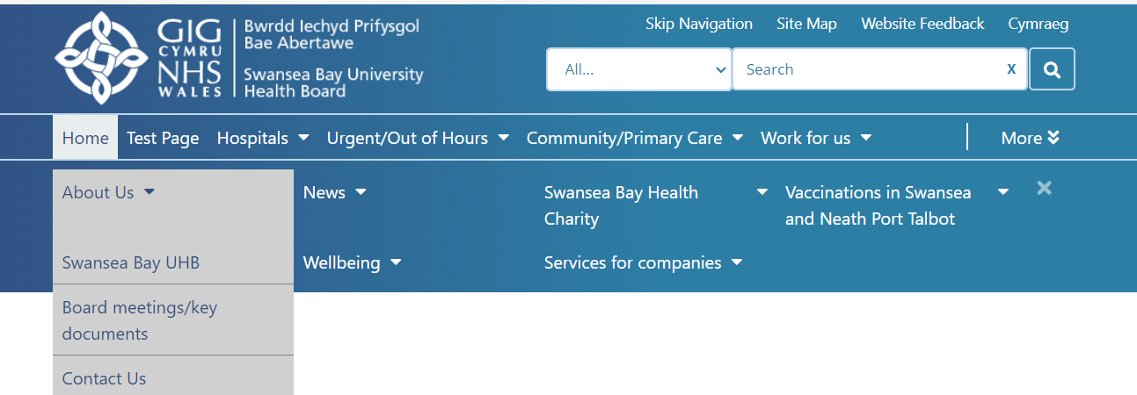  When Tabbing through the Menu the arrow next to the content name will allow keyboard users to ‘step-inside’ and tab through the available child items.  Users tabbing with a keyboard will also now be able to collapse the dropdown menu by using the escape key.  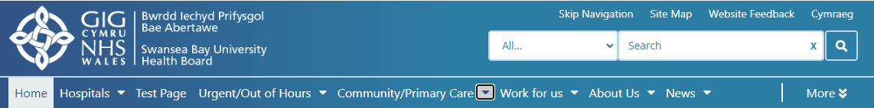  For further information see our Support site Guide: Navigation Bar Updates | CAVUHB GDS Audit
Plugin & Layout Updates
4.2.6 Twitter Update | 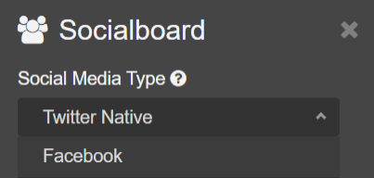  The Non-Native Twitter option is no longer supported. This choice will now be removed from the Social Media Type plugin options to prevent confusion. The only social media type will now be Native Twitter  For further information see our Support site Guide: Add a Twitter Feed | CMS Support Team
4.2.7 Events Calendar Update | The following improvements have been made to the Event Calendar:  - The Event Related Topics alignment was centralized, this has been improved so you can align to the left etc.  Current Display  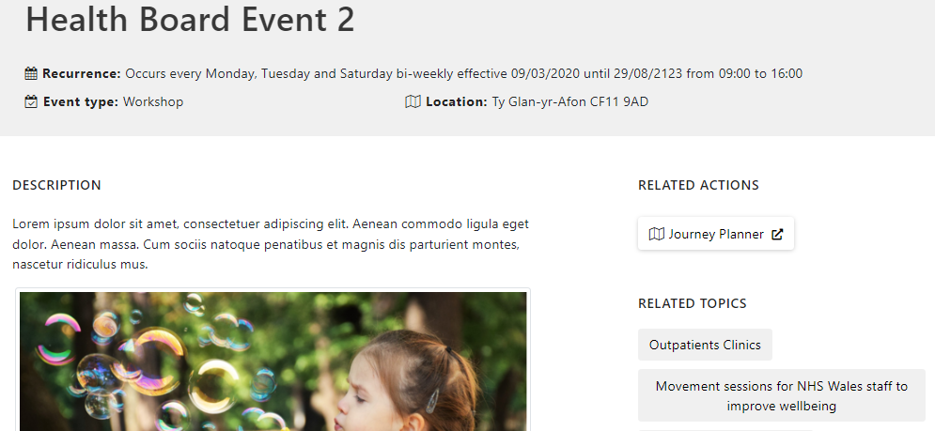  New Display  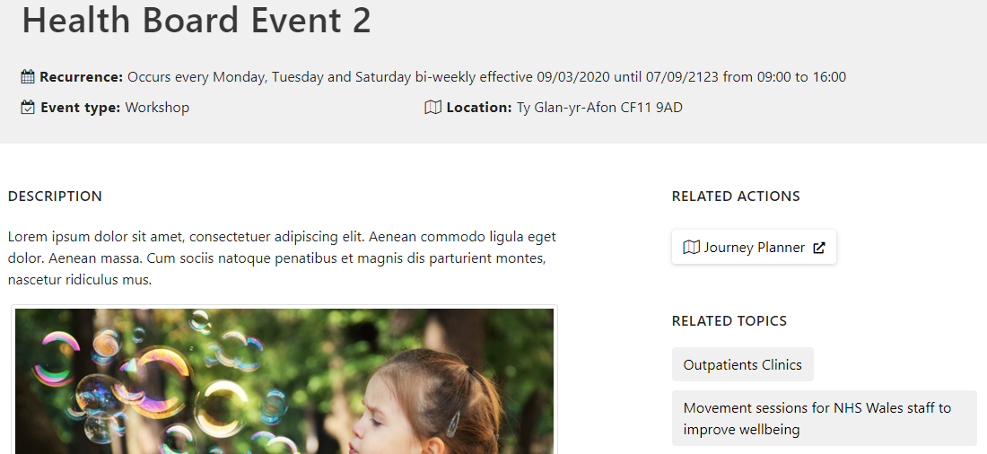  - The Event Text Display has been made enlarged, so it fills the calendar space.  Current Display  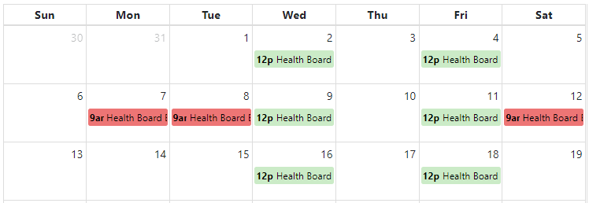  New Display  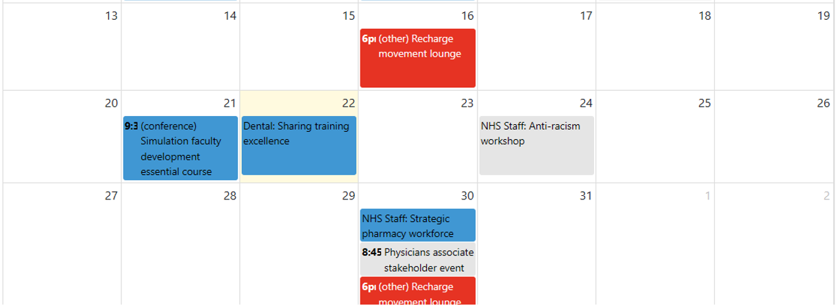  - The calendar selector has been improved to a multi select dropdown so you can combine or show all.  Current Display New Display  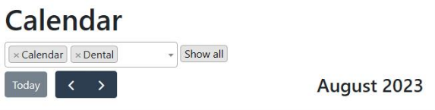  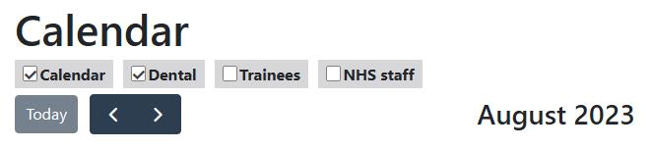  New Dropdown selector  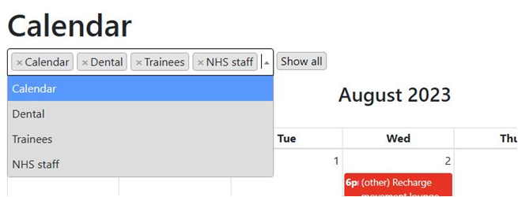  For further information see our Support site Guide: Events Calendars | HEIW
Welsh Language Standards
4.2.8 Enforce Welsh Content | This New Functionality is being Piloted & Tested with CTMUHB – Once the Pilot phase is complete this will then be open to all organisations.  To help adhere to Welsh Language Standards and ensure the equivalent Welsh pages are created on websites the following enhancement has been made to enforce the creation of Welsh content. We have created a new plugin called 'Automatic Corresponding Content' that would need to be set against both the English and Welsh language websites, that wish to use it.  Going forward, on publishing a new English Language webpage this would then trigger the creation of an equivalent page on the Welsh Language site; with a site-specific text notification message displaying, warning the user that the full Welsh content now needs to be filled in.  Text Examples – To the Admin  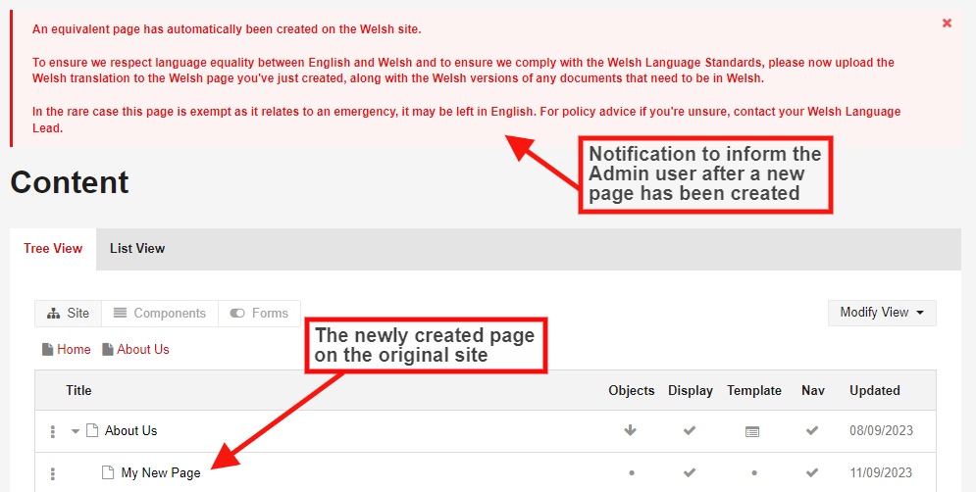  Text Examples – To the Users  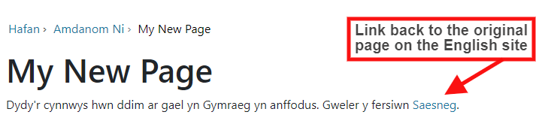  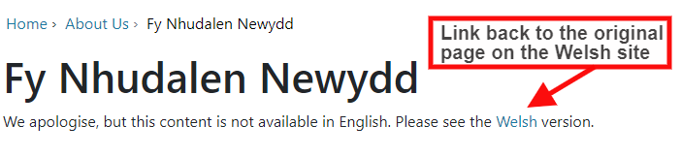  The auto generated pages would then be listed in your site Content Audit, where you can see if & when an auto generated page was last Created/Updated.  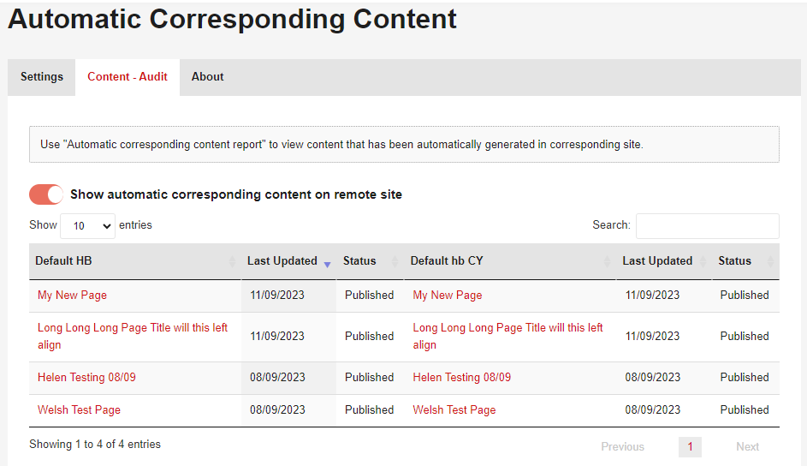  Please Note At this stage of the development:  This functionality will only be available for content which is of Types Page or Folders where subtype is default. All other types of content will be ignored by this plugin at this stage of development.  The 2 corresponding pages will not be automatically Page Mapped together, this would be a manual task that the site Admin would need to complete.  For further information see our Support Guides:  Automatic Corresponding Content Manual Page Mapping | Welsh Language Commission / EASC
Accessibility
4.2.9 Accessibility Issues Identified in Axe Tool | The Axe tool noted these accessibility issues below, which have now been fixed:  - Certain ARIA roles must be contained by particular parents – ARIA has been added for menu, presentation, and menu item.  - ARIA hidden element must not be focusable or contain focusable elements.  - Elements must meet minimum color contrast ratio thresholds.  - IDs of active elements must be unique. | GDS Report  ABUHB  HDUHB  HDDCH  CAV
4.2.10 Accessibility Update to Link Organiser | When tabbing through the link organiser in "mobile" view (or high zoom level e.g., 200%) the keyboard focus disappears as it moves through the hidden items.  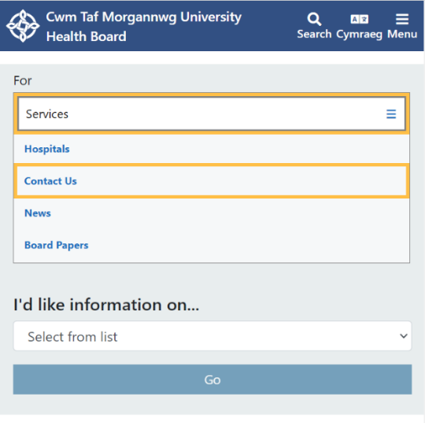  As shown here when in Mobile view (though this is zoomed in to recreate the mobile look on the modules) when you tab to the 'For' dropdown it is highlighted yellow as in the image below. However, when you tab again it will tab through the items in the 'For' dropdown list but does not open the list, so the user would lose track of where it's tabbing to.  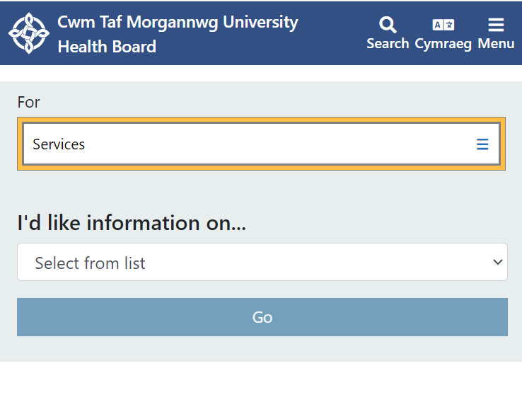  This issue has now been fixed, If the user clicks Enter and opens the 'For' dropdown list they will now be able to continue to tab through it, as the options will be visible to the user. If the user does not click Enter, leaving the 'For' dropdown list closed, then they will skip to the next tab item and NOT tab through the 'For' list. | CMS Support Team

Summary
Number of Changes
10

Bug Fix | Plugin & Layout Updates | System Updates | Welsh Language Standards | Accessibility Updates
2 | 3 | 2 | 1 | 2

Problems Fixed
N/A

New Problems Identified During Testing and Associated Workarounds
N/A

Pre-requisites to Deploy the Release
N/A

Training Requirements
CMS Support Site will be updated with any changes that introduce new functionality or changes to workflow.
You may have noticed warning banners appear on your pages in Edit mode.
Where we have made all functions within the Style tab available to all Layouts, we've placed warning messages where there is a function that would not work with that Layout.
These warnings are only available when you are signed into the website. When you log out of the page, these warning messages will not display.
Any concerns/queries please log these through our Support site as per the normal process: https://cmssupport.nhs.wales/contact-us/

Step by Step Deployment Instructions
No Deployment actions required by Health Boards.

Deployment Plan
Changes to be implemented as specified in the Change Record. Release to be deployed via change record: Change 124834

Back-Out Plan
Back out as detailed on each change record

Release Available for Deployment Date
NHS Wales CMS: Wednesday the 27th September 2023

