Digital Health and Care Wales
NHS Wales IT Service Management

CMS MURA November 2023 Release Notes | Release ID: 820

Releases
Log a release.
Proposed (5)
Awaiting Build & Test (0)
Awaiting SIT (0)
Awaiting OAT (0)
Awaiting RT (0)
Ready to Deploy (0)
Deployed (0)
Aborted (0)
All (5)

Closed
Schedule of change
Calendar
Historic record of change
List options
Release Logged Title Release ID Release Date Owner Related deployment changes Related release changes Related Services
815

Releases
Log a release.
Proposed (5)
Awaiting Build & Test (0)
Awaiting SIT (0)
Awaiting OAT (0)
Awaiting RT (0)
Ready to Deploy (0)
Deployed (0)
Aborted (0)
All (5)

Closed
Schedule of change
Calendar
Historic record of change
List options
Release Logged Title Release ID Release Date Owner Related deployment changes Related release changes Related Services
815

These Release Notes describe the scope and content of
Release ID: 820 for the CMS MURA Service

Version: | 1.0
Status: | Final
Owner: | Helen McGrath
Author: | Helen McGrath
Approver: | Michele Golpaykar-Rad

Date: | 05/10/2023
Next Review Date: | 31/10/2023

1 DOCUMENT HISTORY 4
1.1 Revision History 4
1.2 Reviewers 4
1.3 Authorisation 4
1.4 Document Location 4
2 INTRODUCTION 5
3 SERVICE MANAGEMENT BOARD (SMB) 5
4 RELEASE NOTES REQUIREMENT 5
4.1 Release Identification 5
4.2 Description of New or Modified Functionality 5
5 Summary 15
5.1 Problems Fixed 15
5.2 New Problems Identified During Testing and Associated Workarounds 15
5.3 Pre-requisites to Deploy the Release 15
5.4 Training Requirements 15
5.5 Step by Step Deployment Instructions 15
5.6 Deployment Plan 15
5.7 Back-Out Plan 15
5.8 Release Available for Deployment Date 15

DOCUMENT HISTORY

Revision History
Date | Version | Author | Revision Summary
05/10/2023 | 0.1 | Helen McGrath | Document created for CMS MURA Release
13/10/2023 | 0.2 | Helen McGrath | Added in extra items
31/10/2023 | 1.0 | Helen McGrath | Updated text and Images

Reviewers
This document requires the following reviews:
Date | Version | Name | Position
31/10/2023 | 1.0 | Helen McGrath | Senior Support & Business Analyst

Authorisation
Signing of this document indicates acceptance of its contents.
Author’s Name: | Helen McGrath
Role: | Principal Support & Business Analyst
Signature: | Helen McGrath

Approver’s Name: | Michele Golpaykar-Rad
Role: | Principal Support & Business Analyst
Signature: | Michele Golpaykar-Rad

Document Location
Type | Location
Electronic | CMS MURA Support Site – What’s New

INTRODUCTION
The NHS Wales Release Management Policy considers that effective Release Management is essential for protecting the integrity of the operational environment. A key objective of the release process is to ensure that users, support staff and other stakeholders are kept informed as to what is planned and how this will affect them. One of the ways that this can be achieved is through the publication of release notes prior to deployment of the Release.
These notes contain information on the agreed scope and content of Release id CMS/06-2023 for the CMS descriptions of new or modified functionality and problem fixes, descriptions of new problems and workarounds identified during the testing of this Release, training requirements, deployment instructions, references to deployment and back-out plans and key dates within the release process.

SERVICE MANAGEMENT BOARD (SMB)
The CMS Service Management Board has overall responsibility for ensuring that these Release Notes accurately describe the Release and that it is kept under constant review and updated to reflect any modifications to the Release prior to its deployment.

RELEASE NOTES REQUIREMENT

Release Identification
820 - CMS/06-2023

Description of New or Modified Functionality

Item | Description of the Change | Requestor
Bug Fixes
4.2.1 Site Search Speed | It was noted that after implementing an update to the Site Search (Full Search Phrase Ranking) that the speed of the site search had been negatively affected.  We have now implemented a fix to return the site search speed back to what it previously had been.  See the CMS Support site for more information on the Site Search | CMS Support Team
4.2.2 Event Colour Update | In the September Release we added in a number of calendar updates. However, when you have several calendars displayed together on one calendar the colours that have been selected for each of the events are slow to update on screen.  We have now implemented a fix to speed up the process of pulling in all Event details to display on the Calendar.  See the CMS Support site for more information on Event Calendar | CMS Support Team
4.4.3 Cookie Notice – Mobile Display Update | When viewed on a mobile platform the On/Off toggle overlaps the text. We have now implemented a small fix to resolve this issue.  Current Display New Display  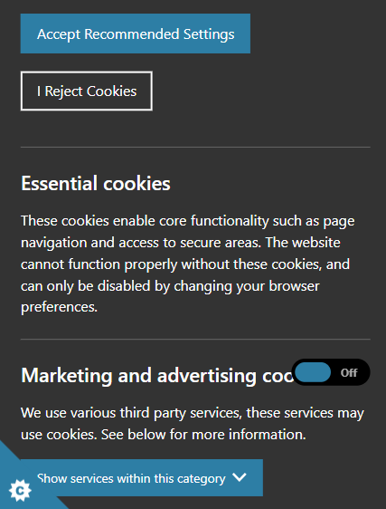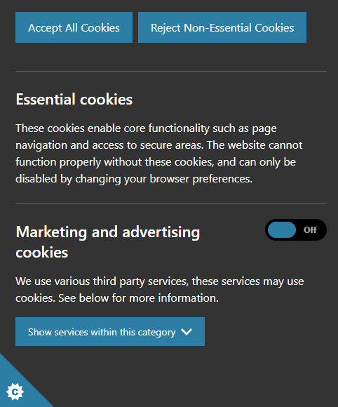 | CMS Support Team
4.2.4 Links Organiser – Allow apostrophes | It was noted by users that when searching within a Links Organiser (Post Code search) if any of the content URLs contained an apostrophe that this would then break the search, pulling back no content.  We have now implemented a change to allow for apostrophes within page titles. | PHW
System Updates
4.4.5 Abbrev/ Acronym ToolTip Update | This item was introduced in the September Release. We have now made a small update to enable users to use Right-Click to edit the Abbreviations and Acronyms.  As an Admin when you hover-over an active Abbrev and select the right-click 'Edit Abbreviation Acronym' will pop up. When this is selected the Insert box will open up per-populated with the current text and available for you to make edits.  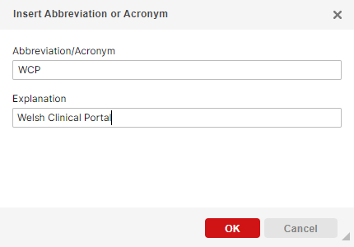  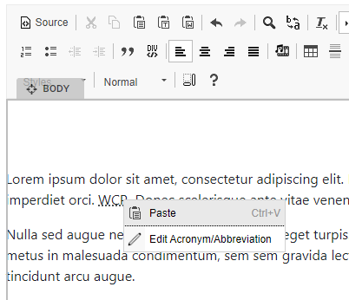 | CMS Support Team
4.2.6 Removal of BLUE WARNING BANNERS | In a previous release several functions from within the Collection Plugin Layouts were moved to be integrated with the Style Tab. This was to improve consistency across all Plugins and Layouts within the site so that the same functions will always be found in the same area – The Style Tab.  However as not all functions of the Style Tab apply to all Layouts, we introduced the Blue Warning banners to alert admins as to which functions were unavailable.  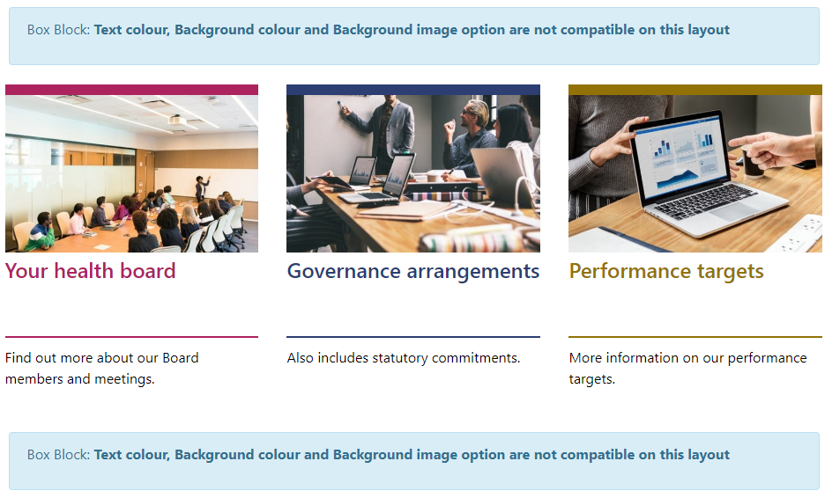  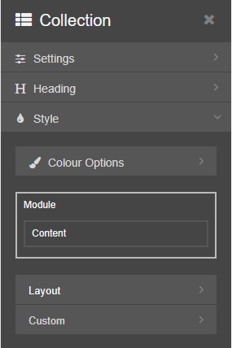  After user feedback from several Organisations, it has been agreed that these are large, intrusive and don’t give the admins a clear view of how the page will look to site users.  We have now removed these banners. Instead, we have now removed the non-compatible functions within the Style Tab for each layout.  So, each layout will have a bespoke set of options available.  See the CMS Support Site for more Information on the Style Tab | CMS Support Team
4.4.7 Cookie Notice – Button Colours | According to the ICO’S guidance the colours of the Accept and Reject Cookie buttons are to match, so giving no greater weight to either option.  “A consent mechanism that emphasises ‘agree’ or ‘allow’ over ‘reject’ or ‘block’ represents a non-compliant approach, as the online service is influencing users towards the ‘accept’ option.”  As such we have now updated the colours of these buttons.  Current Display New Display  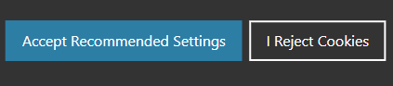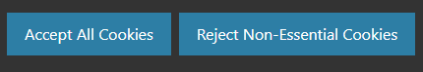 | CMS Support Team
4.4.8 Cookie Notice – Functionality Update | Over the past 2/3 months we have been rolling the new Cookie Notice out to all our Mura CMS Websites, we expect to have all sites moved over to the new Cookie Notice by the end of November.  Now that site admins are having first-hand experience of the functionality of this item a few small changes have been requested.  Current functionality  When a user selects ‘Accept Recommended Settings’ only essential cookies are accepted, and as any Analytical data is not deems ‘essential’ these cookies are not automatically added.  So, for any Google Analytics (or other analytical data) to be captured it requires the user to open the Cookie Settings Scroll to ‘Website Usage Cookie’ and select ‘On’.  When a user selects ‘I Reject Cookies’ Analytical Cookies are rejected, and Essential Cookies are still added.  When a user selects ‘Settings’ They can use the toggle to accept and reject any cookies other than essential cookies.  A Change of Behavior  This behavior was discussed and accepted by the SMB. However, as it has now been noted by several organizations what a detrimental effect this would have on the ability to collect any Analytical data.  We have now revised the Cookie Notice behavior to be more in keeping with the ICO’s (Information Commissioner’s Office) Cookie Notice functionality and amended the button names accordingly.  New Functionality  The text on the Cookie Notice describes the fact that some Cookies we will place will be to “help us to improve your experience by providing insights into how the site is being used.”  When a user selects ‘Accept All Cookies’ they accept both Essential & Analytical cookies.  When a user selects ‘Reject Non-Essential Cookies’ Analytical Cookies are rejected, and Essential Cookies are still added.  When a user selects ‘Settings’ They can use the toggle to accept and reject any cookies other than essential cookies.  New Behavior  This New Cookie Notice behavior will mean that we are: Abiding by the Cookie legislation; Our users are making an informed choice, and that our site admins are able to collect some analytical data. | CMS Support Team
4.2.9 Cookie Notice – Microsoft Clarity | We have now added the details and Cookie page for a third-party analytical tool - Microsoft Clarity.  Microsoft Clarity works in conjunction with your Google Tag Manager account, placing your Clarity key within your Tag manager account will add this tool to your site (as long as Google Tag Manager is added to your site).  If you would like to use Microsoft Clarity, you would need to:  - Create a Microsoft Clarity Account  - Copy your Clarity Key  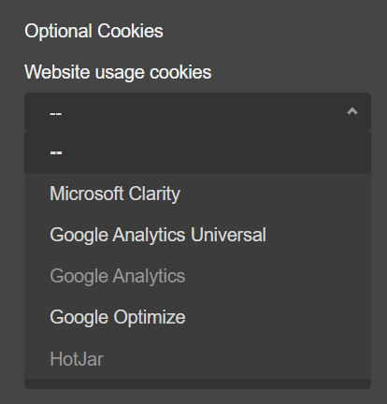  - Open your Google Tag Manager and create a New Tag.  - Add your Microsoft Clarity Key to this Tag.  - Open up your new Cookie Notice settings.  - Under ‘Website Usage Cookies’ select Microsoft Clarity.  - You will need to repeat this step on any pages that do not inherit from the Home Page as they have a separate Cookie Notice added to those pages.  - The explanation Table for the Cookies that Clarity collects will then be added to your Cookie Information page. | ABUHB
4.2.10 Additional File Type | The filetype .svg is now allowed to be uploaded to Mura. SVG (Scalable Vector Graphics) files use XML-based formatting and can be opened with a web browser or an image tool like Photoshop. This file type has some caveats when displayed on a web page.  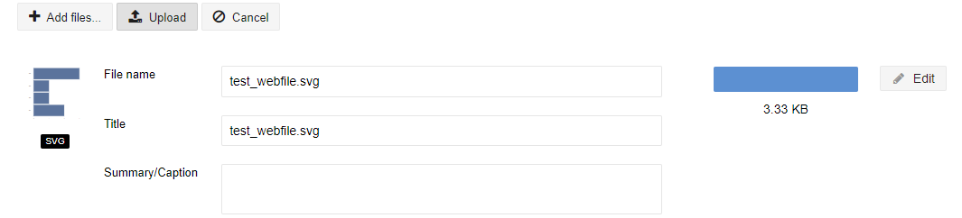  See the CMS Support Site for more Information on the SVG Files | CMS Support Tea=
Plugin & Layout Updates
4.2.11 Share Bar Icon Update – Twitter-X /TikTok | We have now updated the Share Bar icon for Twitter – to reflect its change over to X. The Bar will also now pull in the TikTok icon when added as a link.  Current Display New Display  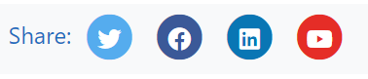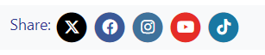 | CMS Support Team
4.2.12 Resource Hub – Mobile View Update | When viewing the Resource Hub module in a mobile view, the images do not resize to suit the size of the mobile platform in use.  We have now introduced a change so that when the Resource Hub is being used in conjunction with a List Advanced Layout; and is viewed on a mobile platform the images with now resize according to the list size on a particular platform.  Current Display New Display  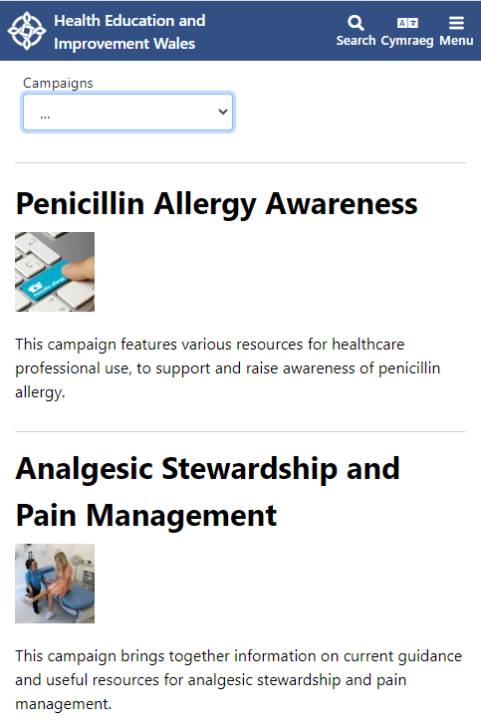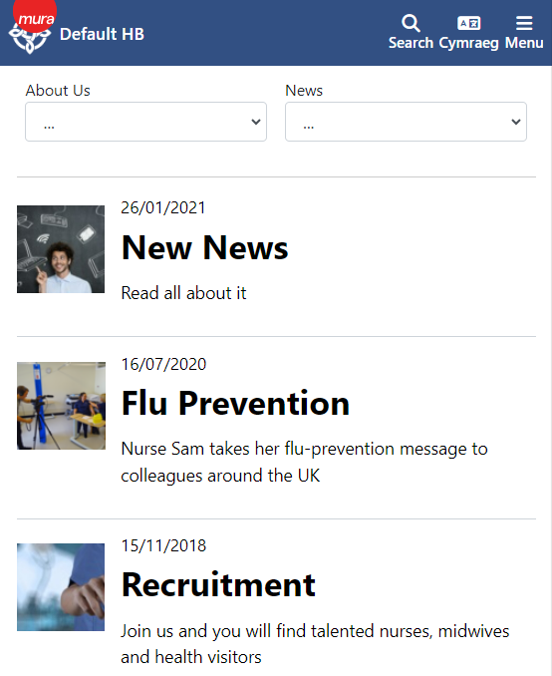  See the CMS Support Site for more Information on the Resource Hub | HEIW
4.2.13 Links Organiser – Warning Message Update | When using the Post Code search on the Links Organiser, when there is an error in the settings a Warning Message appears just above the block in a Blue Banner. We have now implemented a small change to amend this warning message banner from Blue to Red.  Current Display New Display  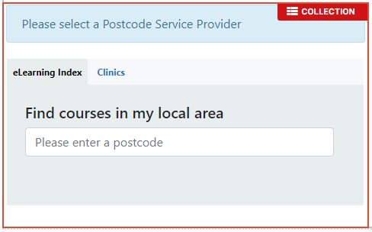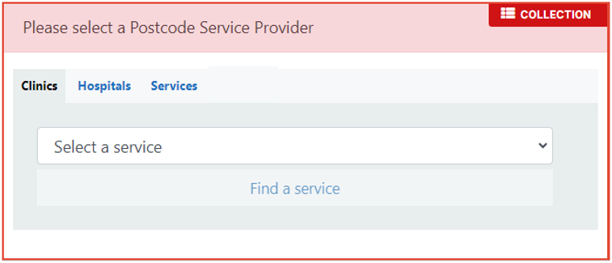  See the CMS Support Site for more Information on the Links Organiser | CMS Support Team
4.2.14 DOS GP Update | We have now made an update to the DOS display for when users are searching for my nearest GP. If checked ‘yes’ within the database ‘Accepting NHS Patients’ will appear on the GP Details page.  The update will now allow this detail to also display on the GP results page, before stepping into a specific practice.  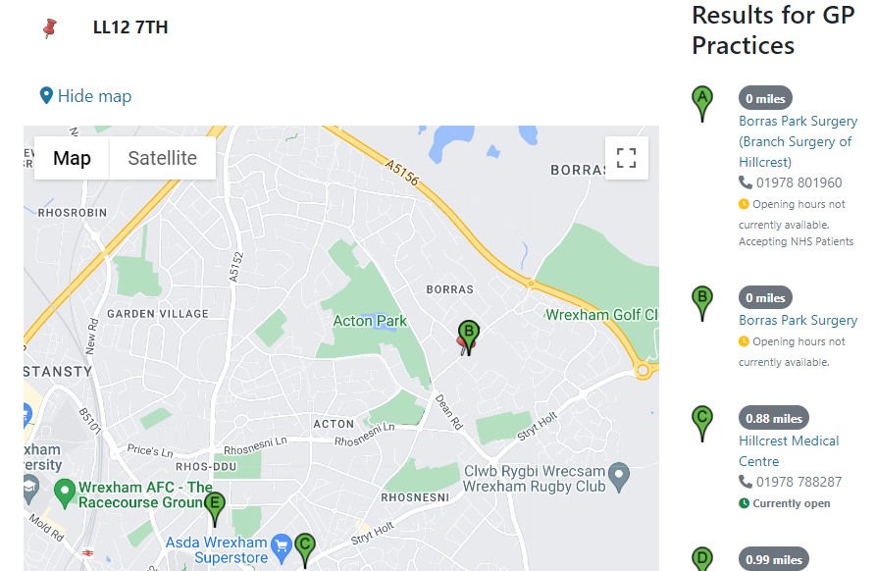  See the CMS Support Site for more Information on the DOS | CMS Support Team
4.2.15 Filter by Category -Tab Order Update | There is currently no way in which site admins can adjust the order that the Filter by Category Tab appear in. We have now implemented this change so that users are now able to control the order of the Tabs by the order in which they are entered into the ‘Category List’ setting.  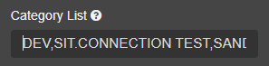  Current Display  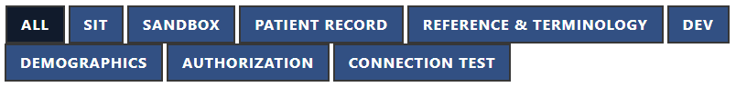  New Display  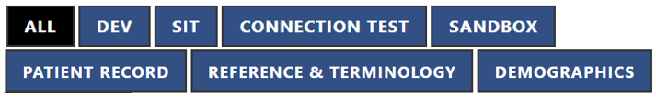 | CMS Support Team
4.2.16 Filter by Category – Display Update | When displaying the Filter by Category Layout on a page it has been noted that the Title and Summary (if displayed) of the cards appear very close together, this small change will now allow some space between the two in order to improve the display of the layout.  Current Display  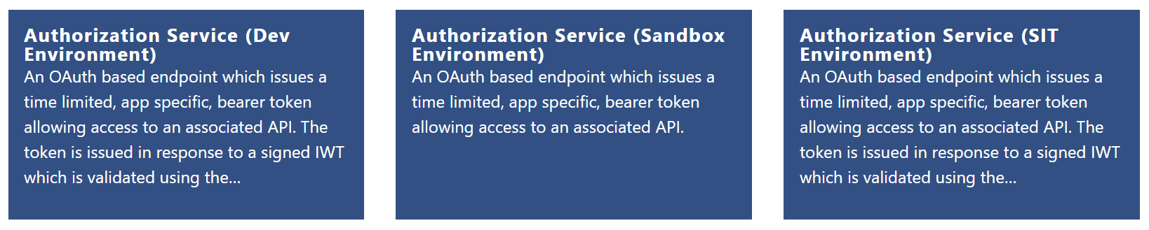  New Display  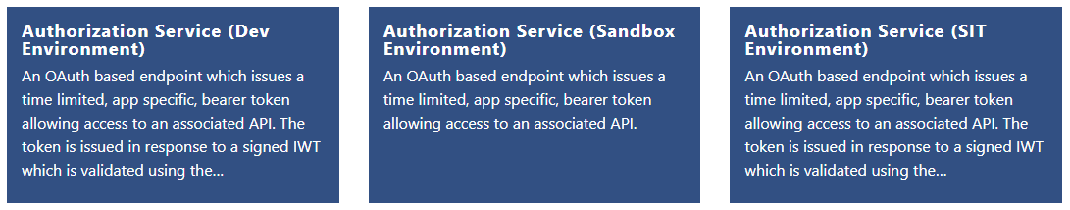  5px Margin  See the CMS Support Site for more Information on the Filter by Category | CMS Support Team
4.2.17 New Interactive PDFs | We have created Interactive PDFs, this new Collection Layout (PDF Embed Viewer) will allow your users to select your PDF, edit it as they see fit and then download their new bespoke copy of the PDF; without affecting the original copy. There are some caveats to the use of this on your site.  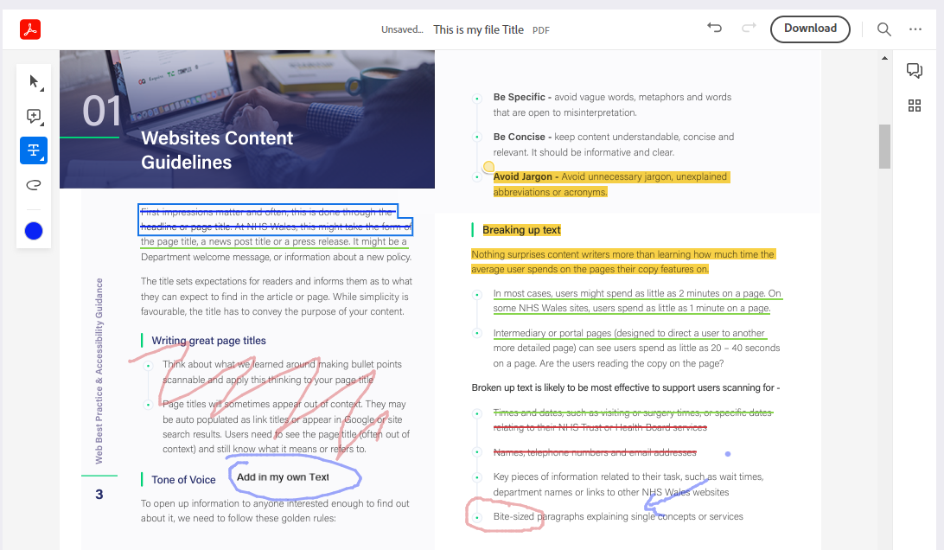  See the CMS Support Site for more Information on Interactive PDFs | CMS Support Team
Welsh Language Standards
4.2.18 Map Audit Update | We have made an update to the Map-Audit area within the Mura Translation plugin to aid users with keeping track of corresponding Welsh language content.  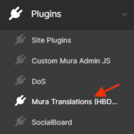  This area currently displays All Pages/Folders/Asset Buckets created within your site. A toggle on the page allows you to change the list from showing which items are linked to any Welsh language content via the Mura Translation function and which items are not.  We have now updated this list to pull out items that would not necessarily need a Welsh translated page i.e., Asset buckets/Accordion pages. So that only relevant records are displayed, this should now make the list more manageable.  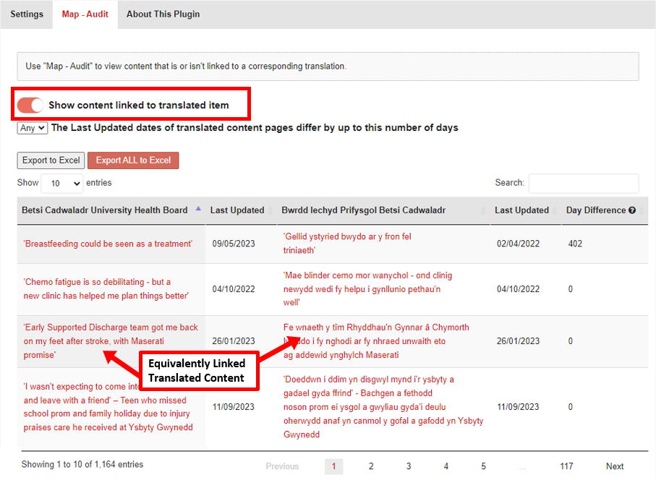  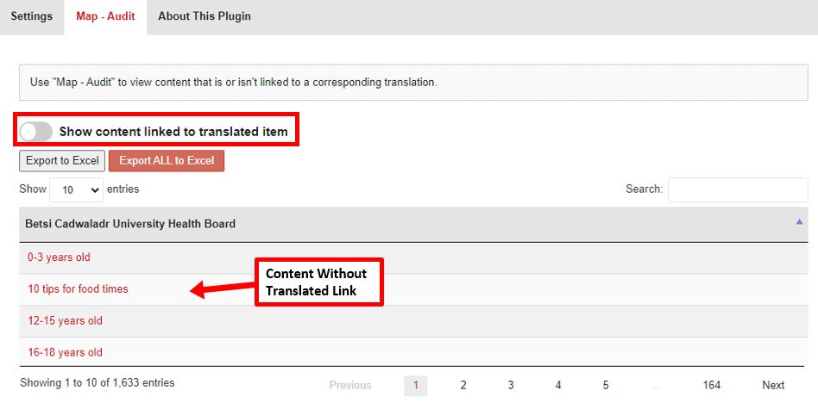 | CMS Support Team
Accessibility
4.2.19 Read Speaker Update | We have now updated the destination of the Help Link for the Read Speaker. Currently the help text pops-up as an inline modal, this has now been updated to link to a new site in a new window.  Currently Display New Display  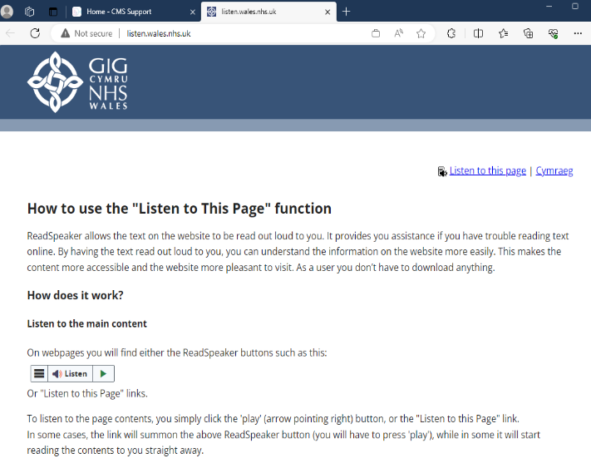  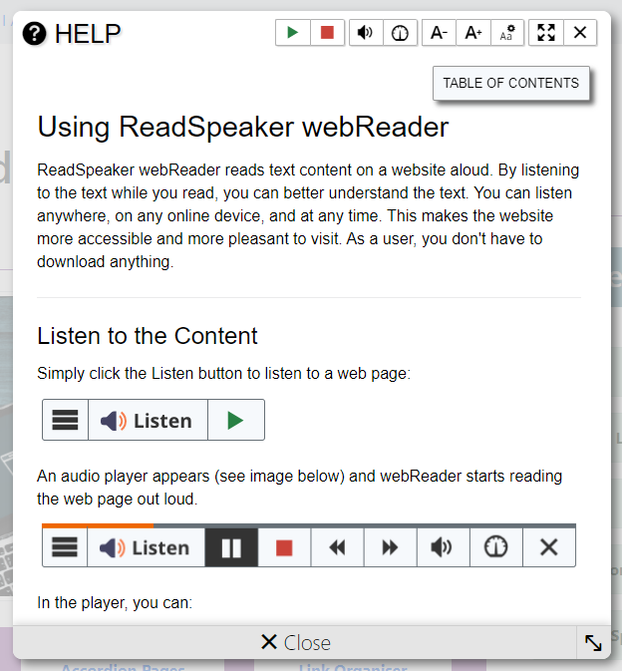 | CMS Support Team
4.2.20 Read Speaker Update | We have now implemented an accessibility update to the Read Speaker, when used in conjunction with the Accordion Layout.  When the Read Speak gets to an Accordion within the page content it will read out the Title of the Tab and then drop inside and read the content within that Tab before moving on to the next Title Tab. However, it does this without giving any visual indication that it is in fact reading from within the Accordion Tabs.  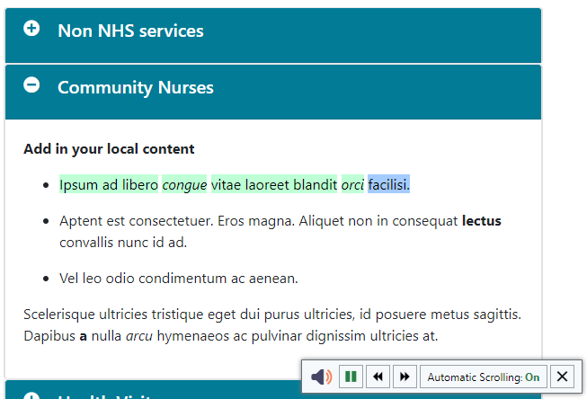  The change we have now introduced will mean that once the Title of the Accordion Tab has been read the Accordion Tab will then open up so that you can visually follow where the Read Speaker is.  Once the content is read the Tab would be closed and the Read Speaker will move on to the next Title Tab.  See the CMS Support Site for more Information on the Read Speaker | CMS Support Team

Summary
Number of Changes
20

Bug Fix | System Updates | Plugin & Layout Updates | Welsh Language Standards | Accessibility Updates
4 | 6 | 7 | 1 | 2

Problems Fixed
N/A

New Problems Identified During Testing and Associated Workarounds
N/A

Pre-requisites to Deploy the Release
N/A

Training Requirements
N/A

Step by Step Deployment Instructions
No Deployment actions required by Health Boards.

Deployment Plan
Changes to be implemented as specified in the Change Record. Release to be deployed via change record: Change 127595

Back-Out Plan
Back out as detailed on each change record

Release Available for Deployment Date
NHS Wales CMS: Wednesday the 15th November 2023

