Digital Health and Care Wales
NHS Wales IT Service Management

CMS MURA June 2023 Release Notes | Release ID: 796

These Release Notes describe the scope and content of
Release ID: 796 for the CMS MURA Service

Version: | 1.1
Status: | Final
Owner: | Helen McGrath
Author: | Helen McGrath
Approver: | Michele Golpaykar-Rad

Date: | 17/05/2023
Next Review Date: | 26/05/2023

1 DOCUMENT HISTORY 4
1.1 Revision History 4
1.2 Reviewers 4
1.3 Authorisation 4
1.4 Document Location 4
2 INTRODUCTION 5
3 SERVICE MANAGEMENT BOARD (SMB) 5
4 RELEASE NOTES REQUIREMENT 5
4.1 Release Identification 5
4.2 Description of New or Modified Functionality 5
5 Summary 9
5.1 Problems Fixed 10
5.2 New Problems Identified During Testing and Associated Workarounds 10
5.3 Pre-requisites to Deploy the Release 10
5.4 Training Requirements 10
5.5 Step by Step Deployment Instructions 10
5.6 Deployment Plan 10
5.7 Back-Out Plan 10
5.8 Release Available for Deployment Date 10

DOCUMENT HISTORY

Revision History
Date | Version | Author | Revision Summary
17/05/2023 | 1.0 | Helen McGrath | Document created for CMS MURA Release
26/05/2023 | 1.1 | Helen McGrath | Updated Instructions and Images

Reviewers
This document requires the following reviews:
Date | Version | Name | Position
26/05/2023 | 1.1 | Michele Golpaykar-Rad | Principal Support & Business Analyst

Authorisation
Signing of this document indicates acceptance of its contents.
Author’s Name: | Helen McGrath
Role: | Senior Support & Business Analyst
Signature: | Helen McGrath

Approver’s Name: | Michele Golpaykar-Rad
Role: | Principal Support & Business Analyst
Signature: | Michele Golpaykar-Rad

Document Location
Type | Location
Electronic | CMS MURA Support Site – What’s New

INTRODUCTION
The NHS Wales Release Management Policy considers that effective Release Management is essential for protecting the integrity of the operational environment. A key objective of the release process is ensuring that users, support staff and other stakeholders are kept informed as to what is planned and how this will affect them. One of the ways that this can be achieved is through the publication of release notes prior to deployment of the Release.
These notes contain information on the agreed scope and content of Release id CMS/03-2023 for the CMS descriptions of new or modified functionality and problem fixes, descriptions of new problems and workarounds identified during the testing of this Release, training requirements, deployment instructions, references to deployment and back-out plans and key dates within the release process.

SERVICE MANAGEMENT BOARD (SMB)
The CMS Service Management Board has overall responsibility for ensuring that these Release Notes accurately describes the Release and that it is kept under constant review and updated to reflect any modifications to the Release prior to its deployment.

RELEASE NOTES REQUIREMENT

Release Identification
796 - CMS/03-2023

Description of New or Modified Functionality

Item | Description of the Change | Requestor
Bug Fix
4.2.1 Information Banner Fix | The Character limit for the Information Banner should be set to 150, however it has been noted that the system is incorrectly including characters in the code, within this character limit. We have now added a fix so that the only characters taken into account are those within the display text.  Current Incorrect Character Limit  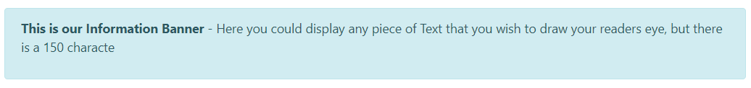  Current Character Limit  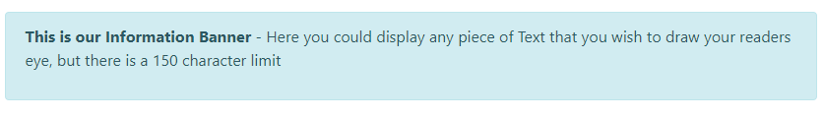  For further information see our Support site Guide: Information Banner | CMS Support Team
Plugin & Layout Updates
4.2.2 Mura Forms Update | By request we have now created a new Validation Type - Age Verification within our Mura Forms. When users complete your site forms you may wish to use age verification to check the user's date of birth is between a lower and upper age limit (of your choosing).  Adding this new feature will add a Date of Birth field and two hidden fields for the lower and upper age limits.  The New Hidden Fields  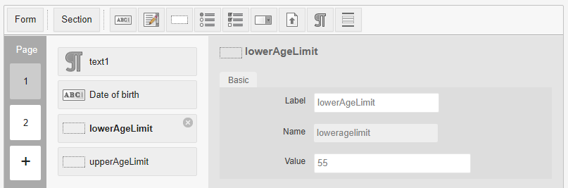  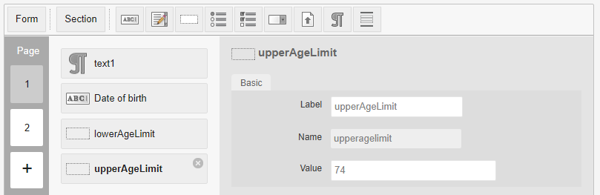  If the date of birth entered is outside of the calculated age range, then the user will be unable to submit the form, and the user will be prompted to correct this before submission.  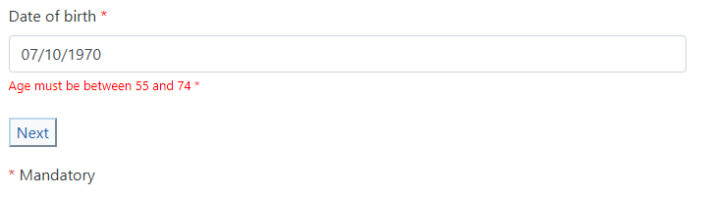  If the age, calculated from the entered Date of Birth, is outside of the age range, the user will receive the below error message upon submission of the Form.  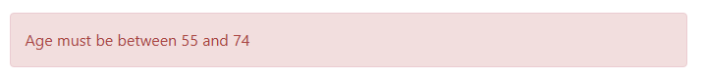  For further information see our Support site Guide: Age Range Validation | PHW
4.2.3 New Video Header Available | A new Video Header 2 Plugin was created for the Healthy Weight Healthy You website. After several users requests, we have now made this Plugin available within all Mura websites, this can be found within the Collection Plugin.  Plugin Example  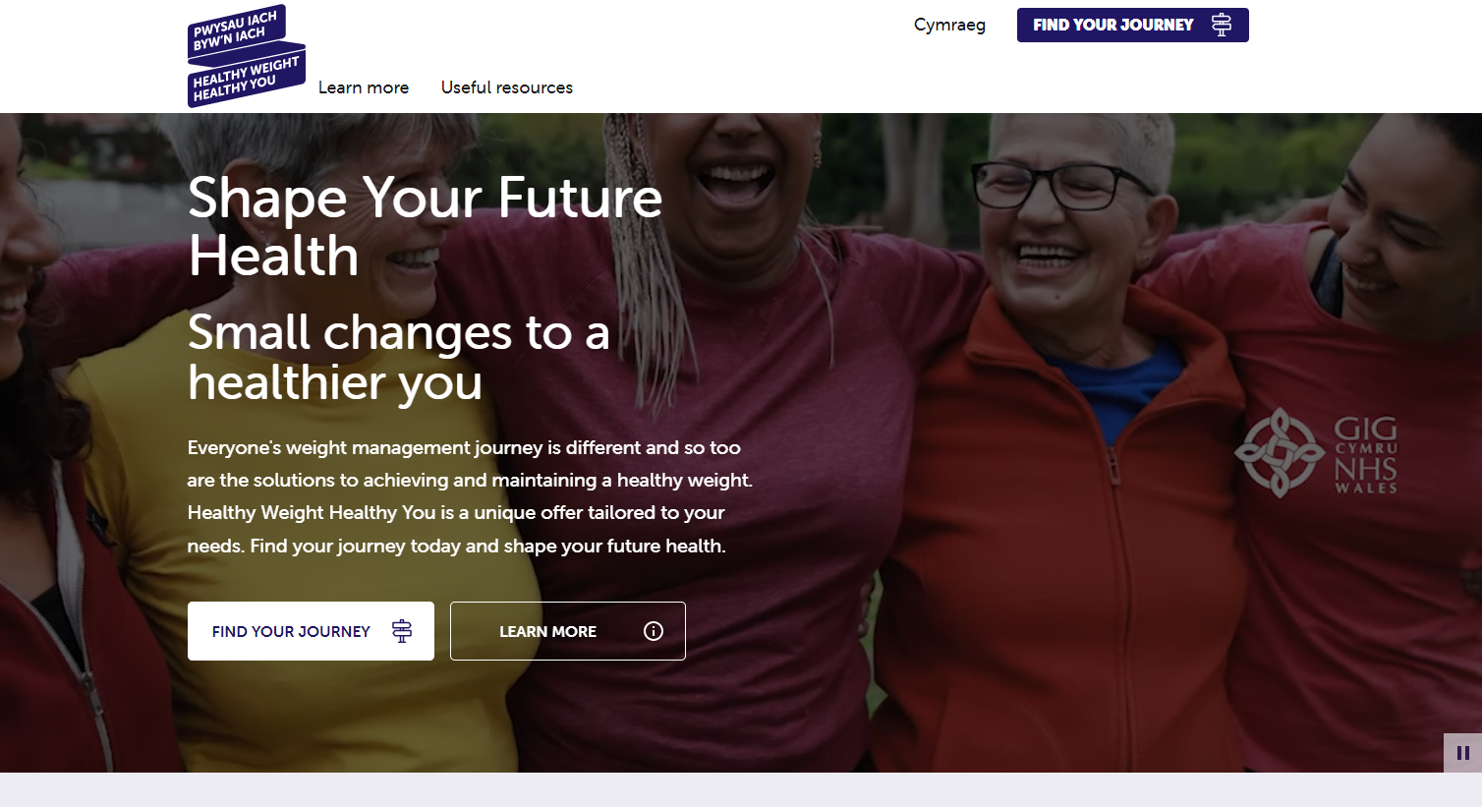  For further information see our Support site Guide: Video Header 2 | CMS Support Team
4.2.4 Filter by Category Update | Currently when using the Filter by Category layout in conjunction with Events, only Events listed with a date equal to ‘today’ or prior to ‘today’ will display. Events that are dated in the future do not display at all, so are unable to be advertised.  We have now added an update to the Filter by Category layout so that Events dated within the next 12months (from ‘today’) will now display.  We have also added a new Sort By option which will now allow you to sort these results either alphabetically or by the last updated date.  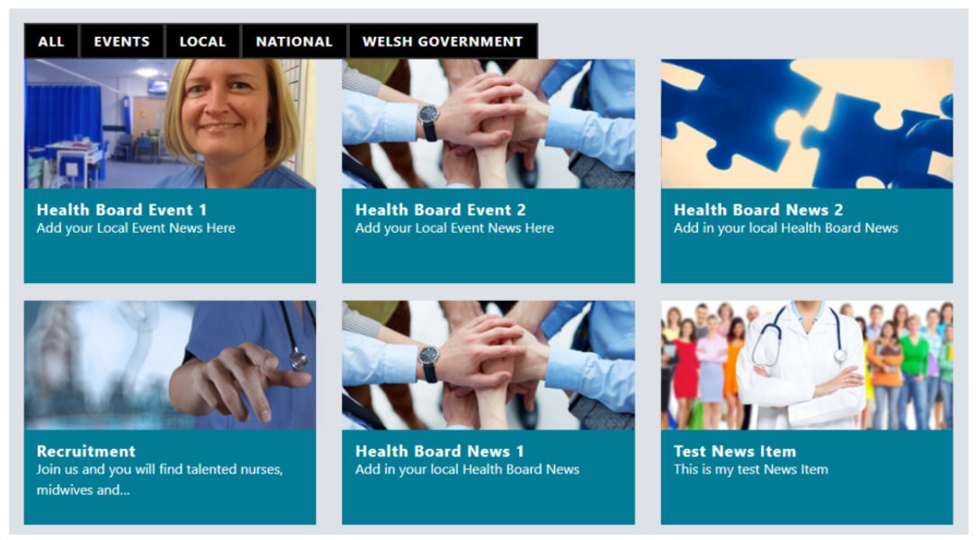  For further information see our Support site Guide: Filter by Category | HEIW
System Updates
4.2.5 Content Selector Update | 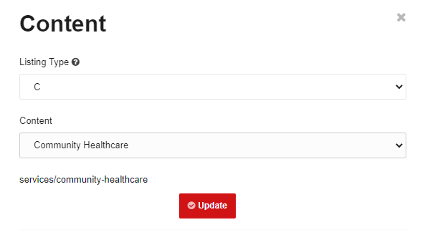  Currently when you select an image or a page within the Content Selector of some of our Layouts, it's not clear what the path of the item you are selecting is; and as it is very possible that there may be more than one item with the same name, this can make it difficult to make the correct selection.  We have now added a visible path/URL to each search result so that admins can make a more informed decision on which item to select. | CMS Support Team
Welsh Language Standards
4.2.6 Events - Missing Welsh Translations | 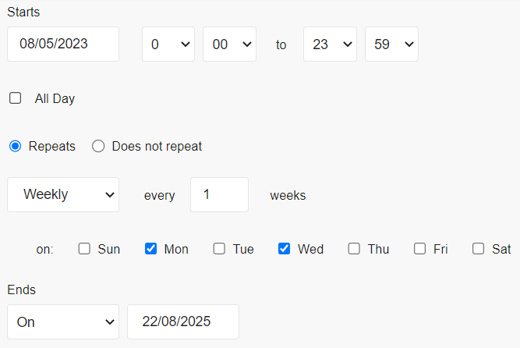  Currently, when adding a Re-occurring Event to a Welsh language Website though the Events Calendar, when you make your selections, these are not correctly translating onto the Event itself.  We have now added in a number of Welsh Translations in this area so that any type of schedule selected will have the correct Welsh translation when viewed on the front end of the website.  Current Display  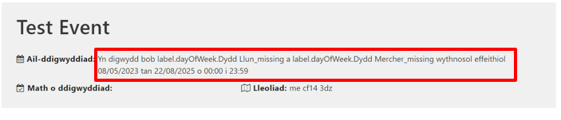  Current Display  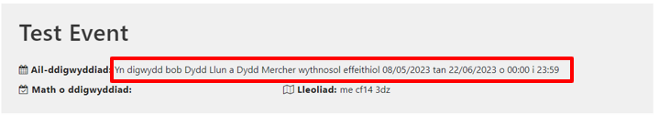  For further information see our Support site Guide: Events Calendar | CMS Support Team
Accessibility Updates
4.2.7 Accessibility Update | Currently some of our Plugins and Layouts have buttons that appear in Enabled and Disabled states, but the difference is not always visible. We have now made some additions to the code in order for both states of the button to be clearly distinguishable in both states. A red Icon (as below) will display when the button is disabled.  Link Organiser Example – Disabled Icon  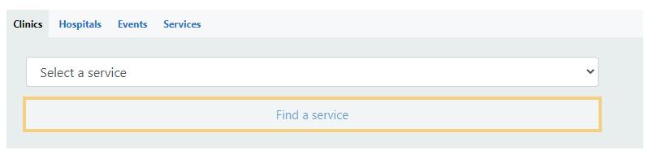  For further information see our Support site Guide: Link Organiser | CMS Support Team
4.2.8 Navigation Tabbing | 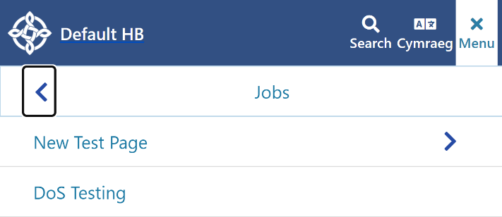  Currently when zoomed to 200% (mobile mode) there are some issues with the Navigation Menu.  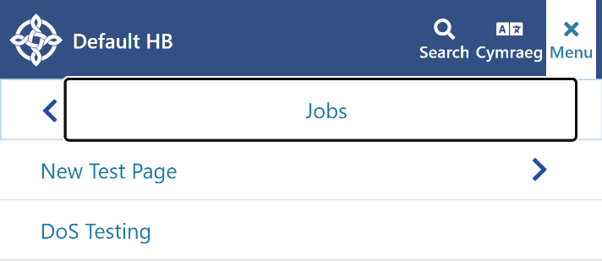  We have now made some updates to the code in order to make the menu parent focusable, give the ability access 1st link of the menu & to be able to access the back chevron on the 1st link of the menu so that users can go back to the previous menu. | CMS Support Team
4.2.9 The New Cookie Notice | **Please do not attempt to add this to your website**  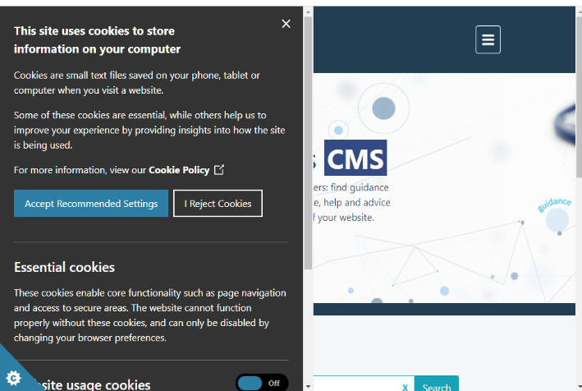  If you would like the new Cookie Notice, please log a call with the Support Team here: rfw-web@wales.nhs.uk We can then arrange a time and date to add this to your site. (As we have backend items we need to put in place before this is added to your site)  For further information see our Support site Guide: Cookie Control | CMS Support Team

Summary
Number of Changes
9

Bug Fix | Plugin & Layout Updates | System Updates | Welsh Language Standards | Accessibility Updates
1 | 3 | 1 | 1 | 3

Problems Fixed
N/A

New Problems Identified During Testing and Associated Workarounds
N/A

Pre-requisites to Deploy the Release
N/A

Training Requirements
CMS Support Site will be updated with any changes that introduce new functionality or changes to workflow.

Step by Step Deployment Instructions
No Deployment actions required by Health Boards.

Deployment Plan
Changes to be implemented as specified in the Change Record. Release to be deployed via change record: Change 121789

Back-Out Plan
Back out as detailed on each change record

Release Available for Deployment Date
NHS Wales CMS: 14/06/2022

