Digital Health and Care Wales
NHS Wales IT Service Management

CMS MURA FEBRUARY 2023 Release Notes | Release ID: 777

These Release Notes describe the scope and content of
Release ID: 777 for the CMS MURA Service

Version: | 1.1
Status: | Final
Owner: | Helen McGrath
Author: | Helen McGrath
Approver: | Michele Golpaykar-Rad

Date: | 12/01/2023
Next Review Date: | 07/02/2023

1 DOCUMENT HISTORY 4
1.1 Revision History 4
1.2 Reviewers 4
1.3 Authorisation 4
1.4 Document Location 4
2 INTRODUCTION 5
3 SERVICE MANAGEMENT BOARD (SMB) 5
4 RELEASE NOTES REQUIREMENT 5
4.1 Release Identification 5
4.2 Description of New or Modified Functionality 5
5 Summary 11
5.1 Problems Fixed 11
5.2 New Problems Identified During Testing and Associated Workarounds 11
5.3 Pre-requisites to Deploy the Release 11
5.4 Training Requirements 11
5.5 Step by Step Deployment Instructions 11
5.6 Deployment Plan 11
5.7 Back-Out Plan 11
5.8 Release Available for Deployment Date 11

DOCUMENT HISTORY

Revision History
Date | Version | Author | Revision Summary
12/01/2023 | 1.0 | Helen McGrath | Document created for CMS MURA Release
07/02/2023 | 1.1 | Helen McGrath | Updated Instructions and Images

Reviewers
This document requires the following reviews:
Date | Version | Name | Position
07/02/2023 | 1. | Michele Golpaykar-Rad | Principal Support & Business Analyst

Authorisation
Signing of this document indicates acceptance of its contents.
Author’s Name: | Helen McGrath
Role: | Senior Support & Business Analyst
Signature: | Helen McGrath

Approver’s Name: | Michele Golpaykar-Rad
Role: | Principal Support & Business Analyst
Signature: | Michele Golpaykar-Rad

Document Location
Type | Location
Electronic | CMS MURA Support Site – What’s New

INTRODUCTION
The NHS Wales Release Management Policy considers that effective Release Management is essential for protecting the integrity of the operational environment. A key objective of the release process is ensuring that users, support staff and other stakeholders are kept informed as to what is planned and how this will affect them. One of the ways that this can be achieved is through the publication of release notes prior to deployment of the Release.
These notes contain information on the agreed scope and content of Release id CMS/01-2023 for the CMS descriptions of new or modified functionality and problem fixes, descriptions of new problems and workarounds identified during the testing of this Release, training requirements, deployment instructions, references to deployment and back-out plans and key dates within the release process.

SERVICE MANAGEMENT BOARD (SMB)
The CMS Service Management Board has overall responsibility for ensuring that these Release Notes accurately describes the Release and that it is kept under constant review and updated to reflect any modifications to the Release prior to its deployment.

RELEASE NOTES REQUIREMENT

Release Identification
777 - CMS/01-2023

Description of New or Modified Functionality

Item | Description of the Change | Requestor
Bug Fixes
4.2.1 eConsult Update | Currently when using the eConsult Banner if ‘Overlay’ has been selected, then when this is minimized, it overlays the Website Footer. We have now introduced a fix to stop this from happening.  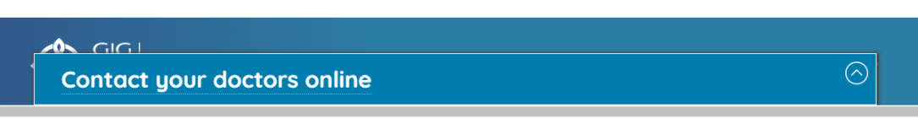  Current Display  New Display  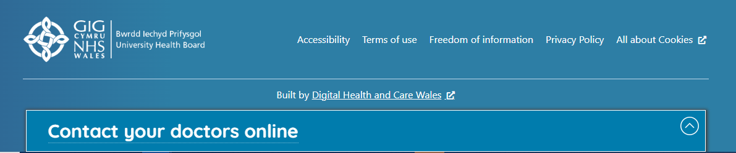  For further information see our Support Site Guide: GP eConsult Banner | CMS Support Team
4.2.2 Audio Player Transcript | When adding an item to our Audio Player in has been noted that any Transcripts Hyper-linked within the Summary are not pulling through as a clickable links in the display field. We have now introduced a fix to stop this from happening, all links added to the Summary will now be clickable with the Transcript area.  Current Display New Display  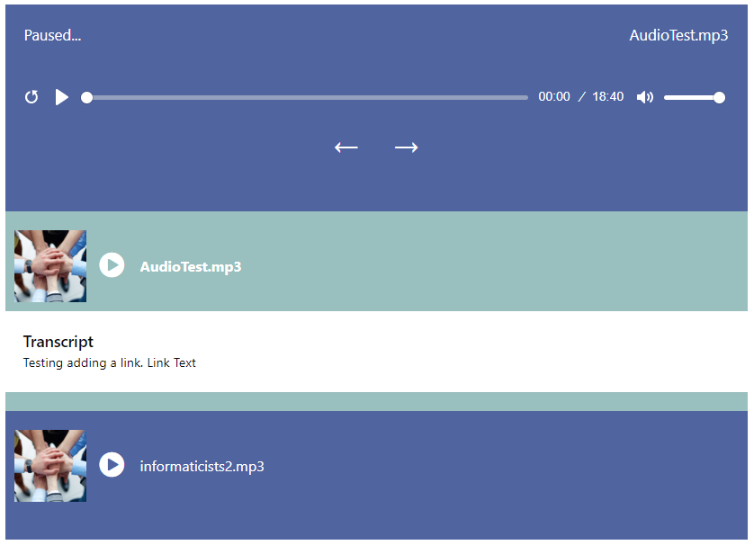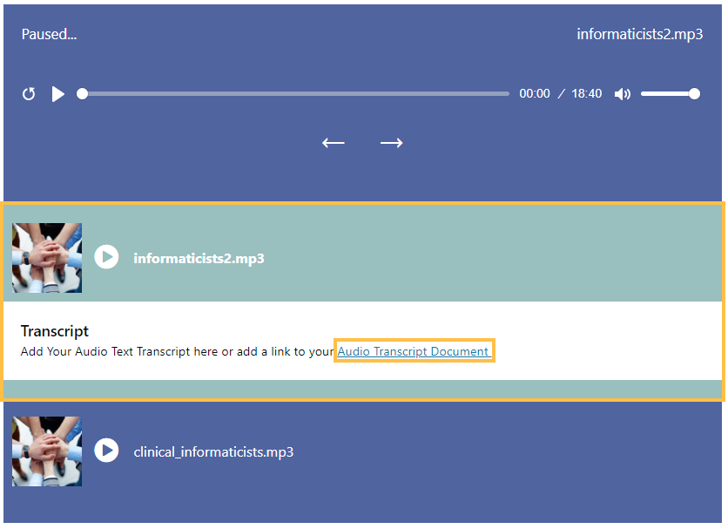  Linking Text is now displaying as a clickable link  Linking Text not displaying as a clickable link  For further information see our Support Site Guide: Audio Player | HDUHB/PHW
4.2.3 Scroll Bar Removal | Currently when a site Admin sets any of the Layout Modules to appear as Full-Width an unnecessary Scroll bar is being added to the bottom of the website. We have now introduced a fix to stop this from happening.  Current Display  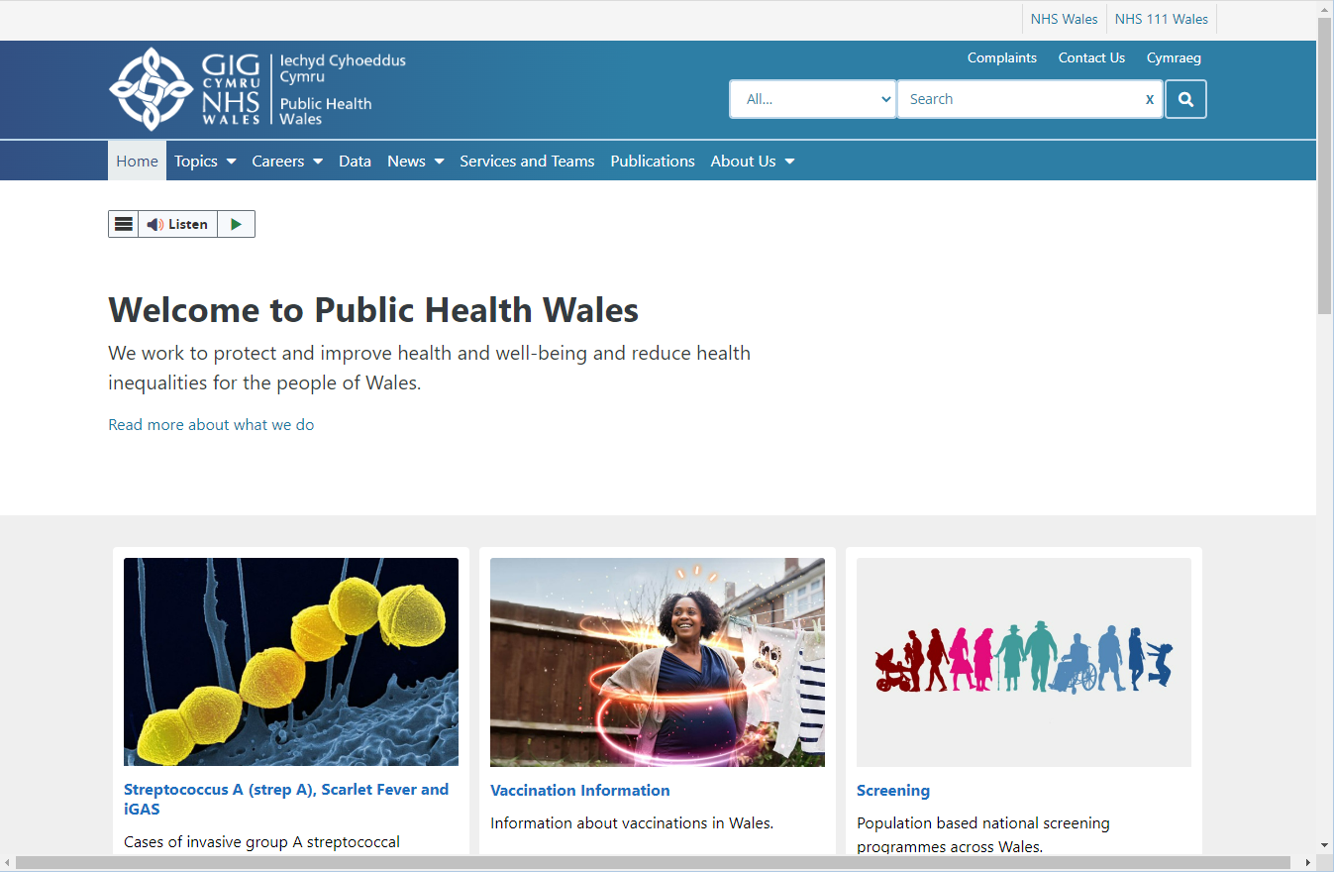 | CMS Support Team
Plugin & Layout Updates
4.2.4 A-Z Collection Display Update | The current logic behind the A-Z Collection Plugin does not distribute Items to the 3rd column until there are 5+ items within any lettered section.  We have now made an update to this Module so that Column 2 is always used when a 2nd item is added to the list, and Column 3 is always used when a 3rd item is added to the list.  Current Display  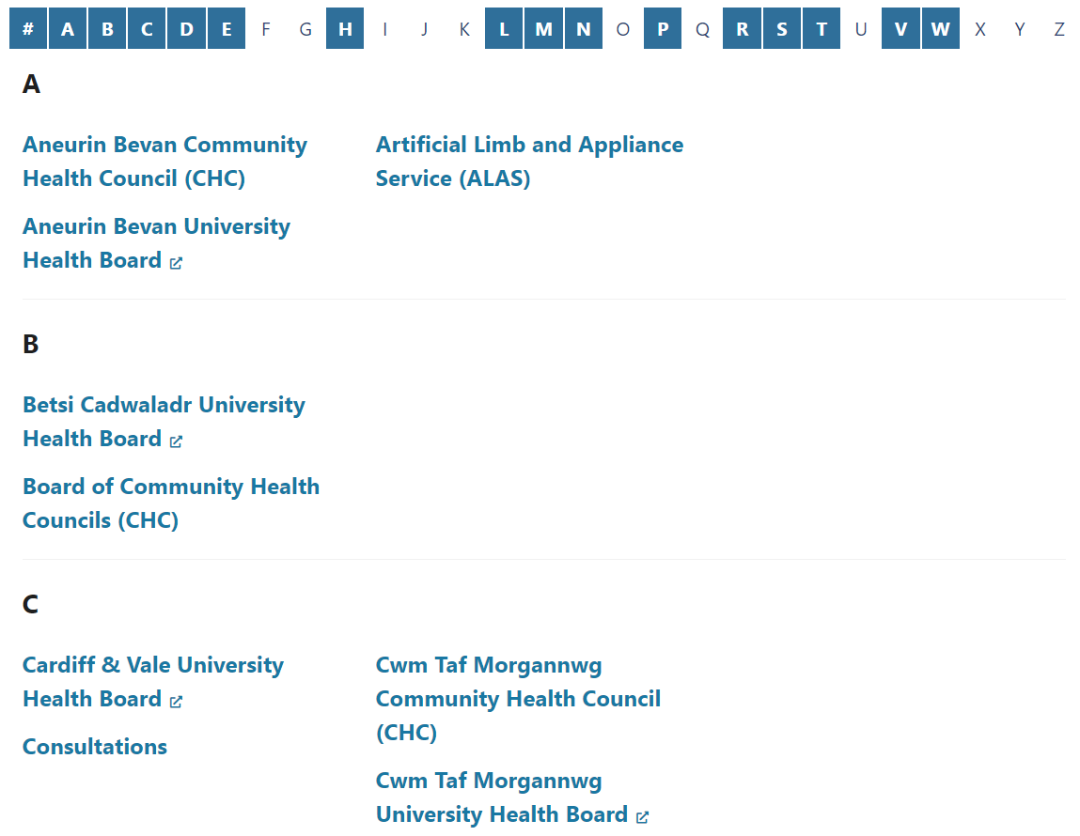  2nd Column not being utilized  3rd Column not being utilized  3rd Column not being utilized  New Display  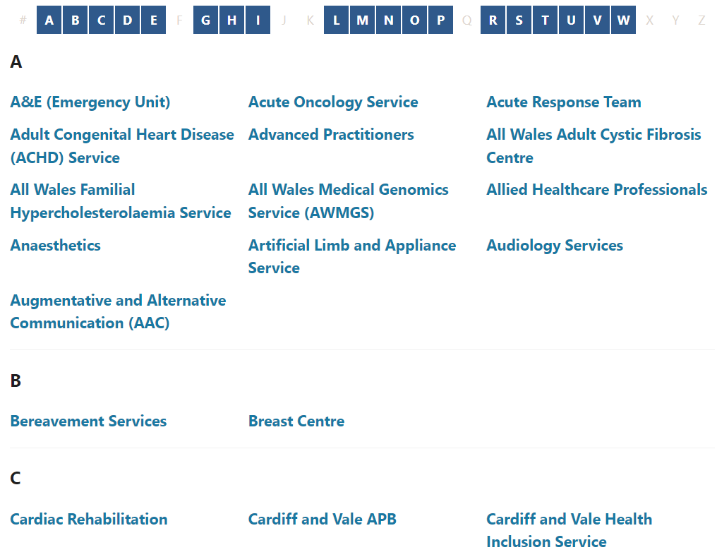  For further information see our Support Site Guide: A-Z Collection Plugin | HEIW
System Updates
4.2.5 Cookie Notice Update – Trial period | We are in the process of introducing a new Cookie Notice Display. This new notice will be trialed this month with 3 Health Boards, you can go to these websites to view the new Cookie Notice Display.  Once the trial period has expired and any issues have been fed back and resolved, this will then be rolled out across all Mura websites.  Current Cookie Notice Display  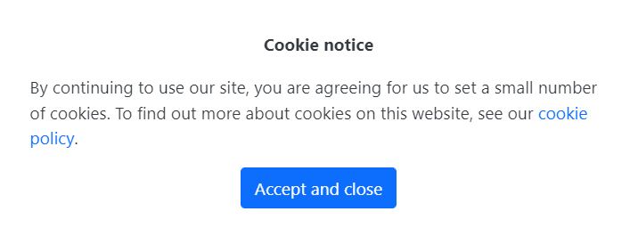  New Cookie Notice Display  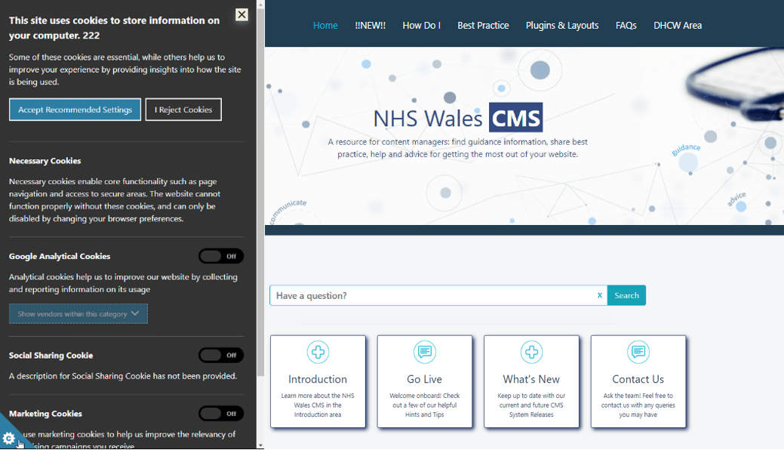  For further information see our Support Site Guide: New Cookie Notice | CMS Support Team
New CMS Sites Introduced
New CMS Sites | NHS Wales – https://www.nhs.wales/ - This is a replacement site for the Health in Wales site that has now been decommissioned  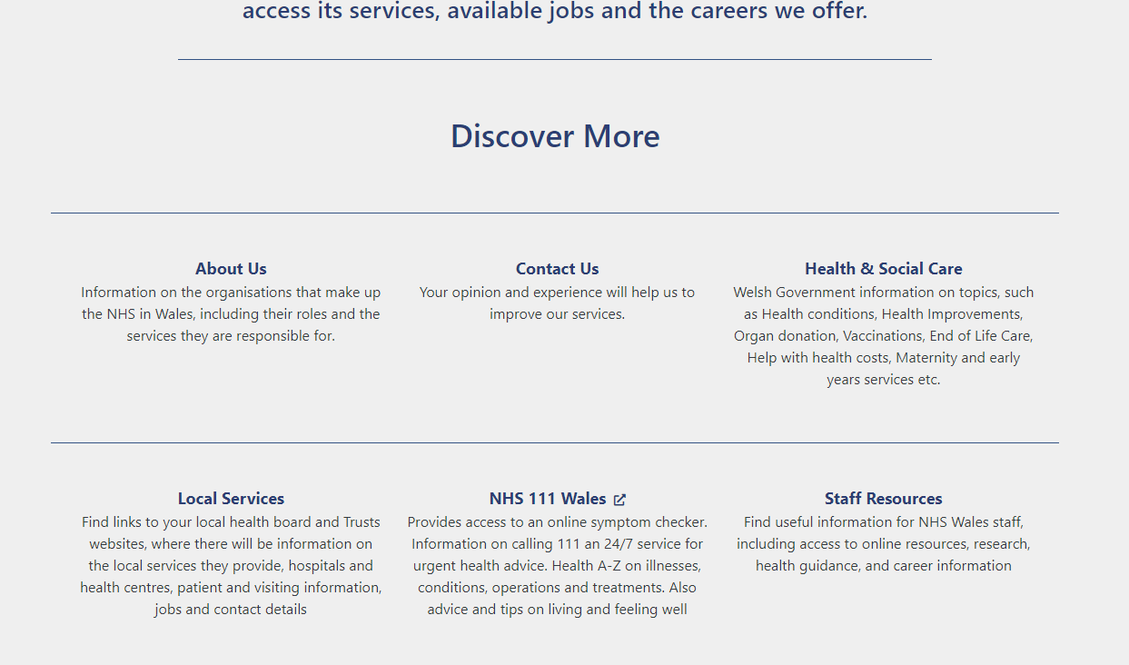  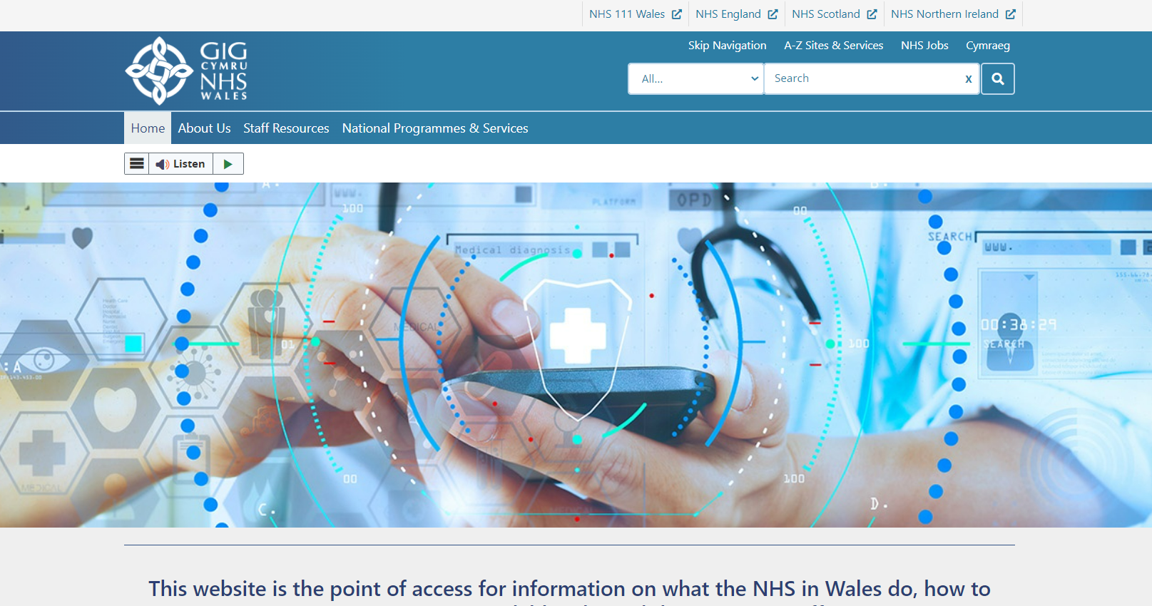  
New CMS Sites | 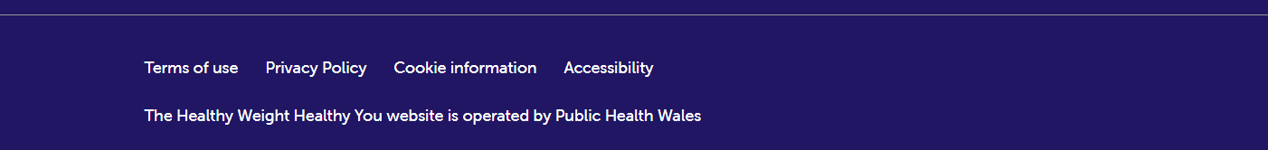        Healthy Weight Healthy You - https://healthyweight.wales/ | Welsh Government/ PHW

Summary
Number of Changes
5

Bug Fixes | Plugin & Layout Updates | System Updates
3 | 1 | 1

Problems Fixed
N/A

New Problems Identified During Testing and Associated Workarounds
N/A

Pre-requisites to Deploy the Release
N/A

Training Requirements
CMS Support Site will be updated with any changes that introduce new functionality or changes to workflow.

Step by Step Deployment Instructions
No Deployment actions required by Health Boards.

Deployment Plan
Changes to be implemented as specified in the Change Record. Release to be deployed via change record: Change 118247

Back-Out Plan
Back out as detailed on each change record

Release Available for Deployment Date
NHS Wales CMS: 22/02/2022

