Digital Health and Care Wales
NHS Wales IT Service Management

CMS MURA August 2023 Release Notes | Release ID: 806

These Release Notes describe the scope and content of
Release ID: 806 for the CMS MURA Service

Version: | 1.2
Status: | Final
Owner: | Helen McGrath
Author: | Helen McGrath
Approver: | Michele Golpaykar-Rad

Date: | 21/06/2023
Next Review Date: | 26/07/2023

1 DOCUMENT HISTORY 4
1.1 Revision History 4
1.2 Reviewers 4
1.3 Authorisation 4
1.4 Document Location 4
2 INTRODUCTION 5
3 SERVICE MANAGEMENT BOARD (SMB) 5
4 RELEASE NOTES REQUIREMENT 5
4.1 Release Identification 5
4.2 Description of New or Modified Functionality 5
5 Summary 11
5.1 Problems Fixed 12
5.2 New Problems Identified During Testing and Associated Workarounds 12
5.3 Pre-requisites to Deploy the Release 12
5.4 Training Requirements 12
5.5 Step by Step Deployment Instructions 12
5.6 Deployment Plan 12
5.7 Back-Out Plan 12
5.8 Release Available for Deployment Date 12

DOCUMENT HISTORY

Revision History
Date | Version | Author | Revision Summary
21/06/2023 | 1.0 | Helen McGrath | Document created for CMS MURA Release
03/07/2023 | 1.1 | Helen McGrath | Updated Instructions and Images
26/07/2023 | 1.2 | Helen McGrath | Added Noteworthy changes from the system upgrade

Reviewers
This document requires the following reviews:
Date | Version | Name | Position
26/07/2023 | 1.1 | Michele Golpaykar-Rad | Principal Support & Business Analyst

Authorisation
Signing of this document indicates acceptance of its contents.
Author’s Name: | Helen McGrath
Role: | Senior Support & Business Analyst
Signature: | Helen McGrath

Approver’s Name: | Michele Golpaykar-Rad
Role: | Principal Support & Business Analyst
Signature: | Michele Golpaykar-Rad

Document Location
Type | Location
Electronic | CMS MURA Support Site – What’s New

INTRODUCTION
The NHS Wales Release Management Policy considers that effective Release Management is essential for protecting the integrity of the operational environment. A key objective of the release process is ensuring that users, support staff and other stakeholders are kept informed as to what is planned and how this will affect them. One of the ways that this can be achieved is through the publication of release notes prior to deployment of the Release.
These notes contain information on the agreed scope and content of Release id CMS/04-2023 for the CMS descriptions of new or modified functionality and problem fixes, descriptions of new problems and workarounds identified during the testing of this Release, training requirements, deployment instructions, references to deployment and back-out plans and key dates within the release process.

SERVICE MANAGEMENT BOARD (SMB)
The CMS Service Management Board has overall responsibility for ensuring that these Release Notes accurately describes the Release and that it is kept under constant review and updated to reflect any modifications to the Release prior to its deployment.

RELEASE NOTES REQUIREMENT

Release Identification
806 - CMS/04-2023

Description of New or Modified Functionality

Item | Description of the Change | Requestor
Plugin & Layout Updates
4.2.1 Video Plugin Update | 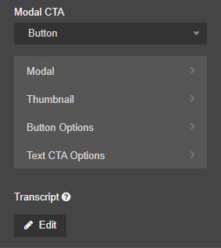  We have now made an update to the Settings within Video Plugin.  A new setting has been added – Under Transcript there is now a new Edit box, that when selected will open a Text Box allowing admins to add in text or a link to a document.  This additional feature will then appear to the users as an accordion style tab below the Video content. When this new tab is opened the user would then be able to view the Video Transcript that has been added.  For further information see our Support site Guide: Video Plugin  No Transcript  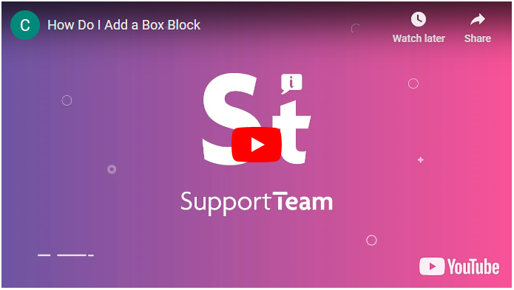  Transcript in a Closed State  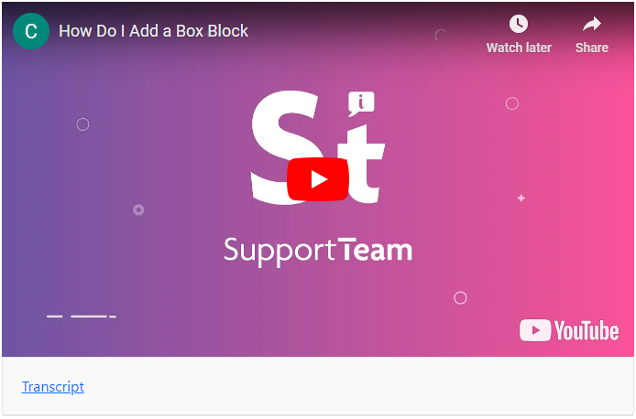  Transcript in an Open State  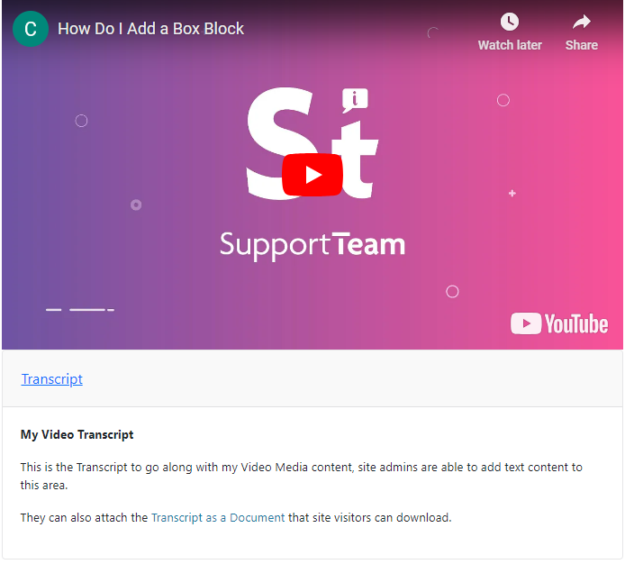 | CMS Support Team
4.2.2 Advanced Table List Sorting Update | We have made an update to the Advanced Table List when used in conjunction with a Specifically created site Document Type. When using one of your unique Extended Attributes as a column in your Advanced Table List, you can now use this Extended Attribute as a Sort order for your Documents.  When an Attribute such as, Category is chosen users can select the arrows to show the list Alphabetically ascending/descending.  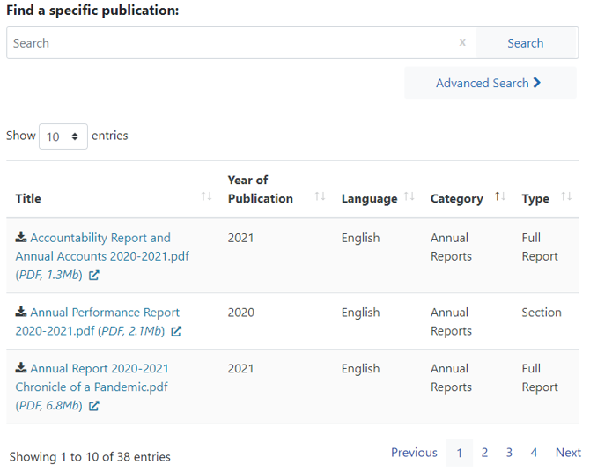  This sort order will remain true on when stepping into pages 2/3/4 when previously the Sort Order would be lost.  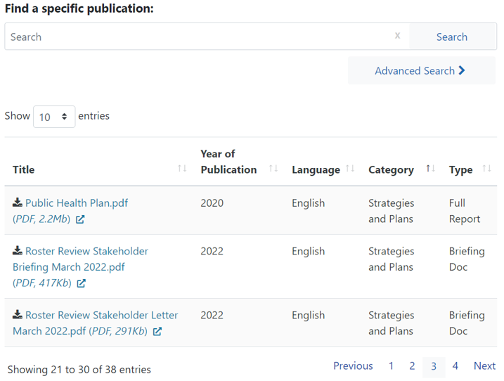  For further information see our Support site Guide: Advanced Table List | WAST
4.2.3 Full Width Background | Currently many of our Layouts/Plugins have the ‘Full Width Background’ setting available under the Settings Tab, this function has now been moved to display under the Style Tab By selecting Style > Layout > Expand Width.  All remaining colour settings have also been moved, so you will now only see colour options within the Style Tab > Colour Options Tab.  Colour Options Tab  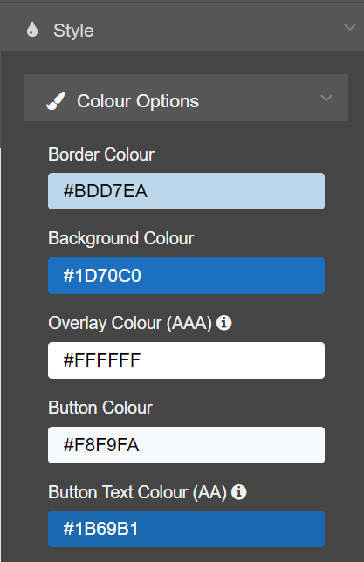  Current Display New Display  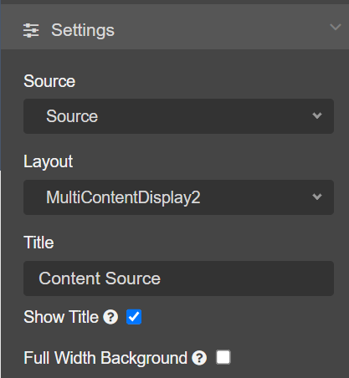  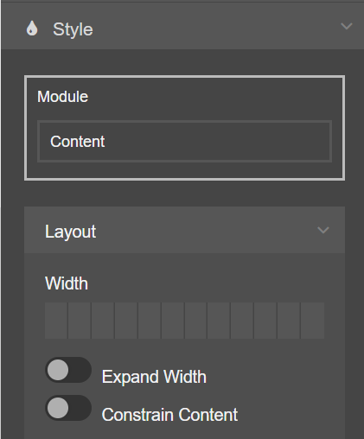 | CMS Support Team
System Updates
4.2.4 Site Search Update | Currently when a user enters a specific search phrase such as “Maternity Services” the Maternity Services page does not appear first or even high in the search results as other similarly named content maybe appear above this page.  We have made an update to the Site Search, this will mean that when a user enters a specific search phrase, if there are any content items/pages which have a Title that matches the Search Phrase then that page/item will now appear at the top of the search results list. So that users can search for and find the content page they want more easily and reliably.  Search Phrase: Maternity Services  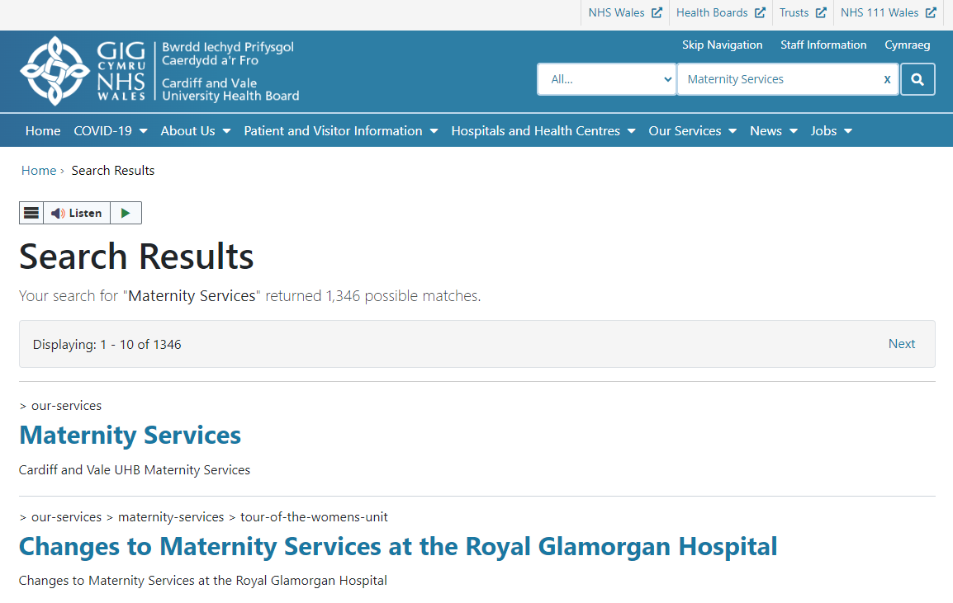  For further information see our Support site Guide: The Site Search | CAVUHB
4.2.5 3rd Level Nav Update | We have made a small update to the 3rd Level Navigation. Users will now see a left-hand indent as they move down through Parent > Child > Grandchild pages. This will allow users to easily identify which page they are currently on and where this page sits in the site structure.  Current 3rd Level Navigation New 3rd Level Navigation  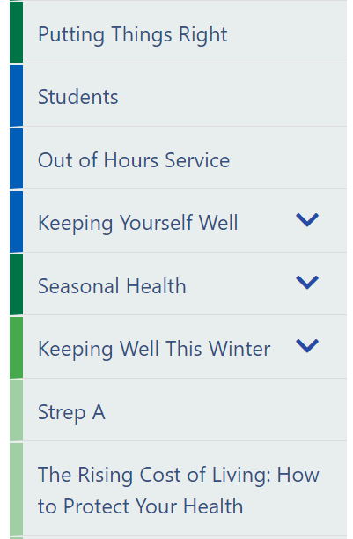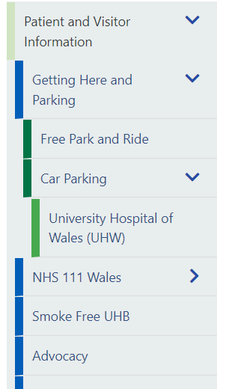  For further information see our Support site Guide: 3rd Level Nav | CMS Support Team
4.2.6 Mura Core Upgrade | We have now introduced the Mura Core Upgrade from v10.0.531 to v10.0.624. This consists of a full system upgrade.  Note worthy changes from the system upgrade.  The Container – When dragging & dropping a Layout/Plugin to sit inside a Container, users will now need to be more precise and only drop the item when you can see the 2 Red Lies. As in the image below.  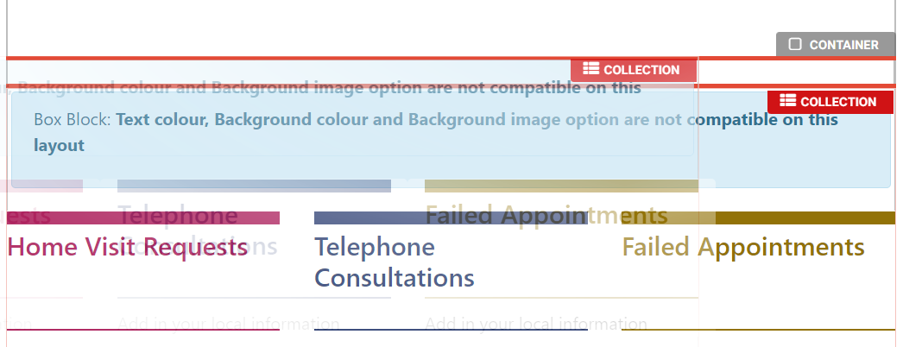  Default/List/List Advanced – When added any of these 3 Collection Layouts the text will now initially be defaulted to Black instead of Blue. This can then be amended within the Style Tab, by selecting Style Tab >Content > Text Colour > you can then use the colour picker to select any colour you wish to use.  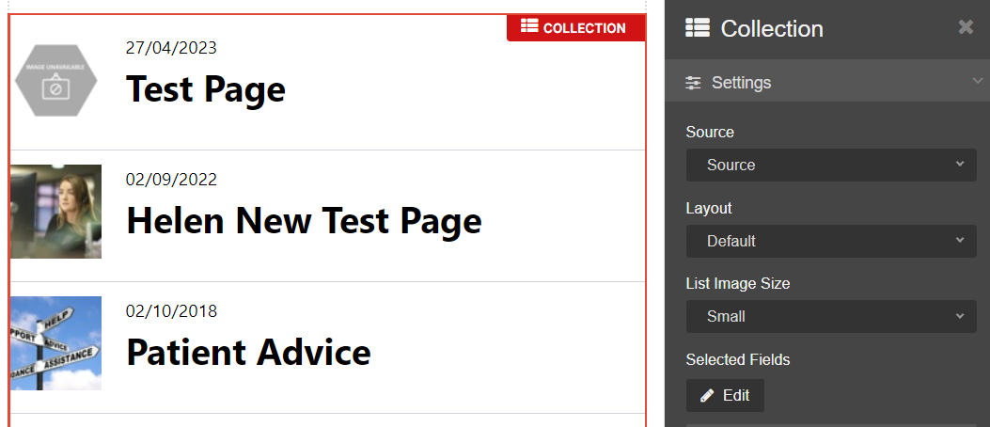 | CMS Support Team
Welsh Language Standards
4.2.7 Read Speaker Update | Currently when the ReadSpeaker Screen Reader is added to a Welsh language website the labels for users appear in English. We have now updated this so that the labels will appear in Welsh on the Welsh language websites.  English Language Labels Welsh Language Labels  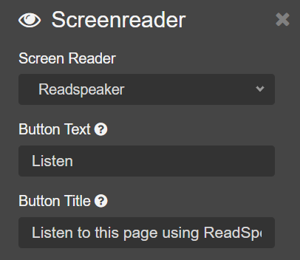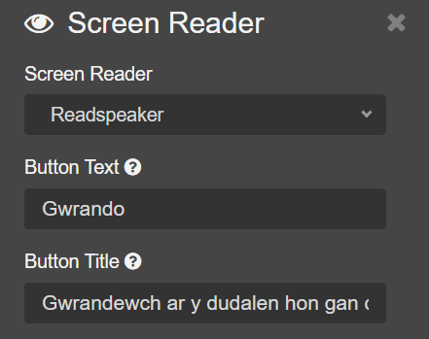  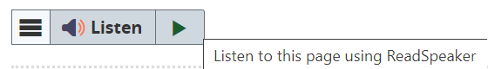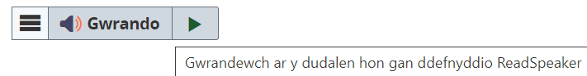  For further information see our Support site Guide: Read Speaker | CMS Support Team
Accessibility Standards
4.2.8 Accessibility Updates | Several Health Boards have undergone recent accessibility audits by Welsh Governments Digital Services. These automated tests were completed using the latest version of Axe.  As a result of these reports a small number of accessibility issues were identified and have now been resolved within the live application. | Welsh Government

Summary
Number of Changes
8

Plugin & Layout Updates | System Updates | Welsh Language Standards | Accessibility Standards
3 | 3 | 1 | 1

Problems Fixed
N/A

New Problems Identified During Testing and Associated Workarounds
N/A

Pre-requisites to Deploy the Release
N/A

Training Requirements
CMS Support Site will be updated with any changes that introduce new functionality or changes to workflow.

Step by Step Deployment Instructions
No Deployment actions required by Health Boards.

Deployment Plan
Changes to be implemented as specified in the Change Record. Release to be deployed via change record: Change 123633

Back-Out Plan
Back out as detailed on each change record

Release Available for Deployment Date
NHS Wales CMS: 16/08/2022

