Digital Health and Care Wales
NHS Wales IT Service Management

CMS MURA April 2023 Release Notes | Release ID: 788

These Release Notes describe the scope and content of
Release ID: 788 for the CMS MURA Service

Version: | 1.1
Status: | Final
Owner: | Helen McGrath
Author: | Helen McGrath
Approver: | Michele Golpaykar-Rad

Date: | 22/03/2023
Next Review Date: | 06/04/2023

1 DOCUMENT HISTORY 4
1.1 Revision History 4
1.2 Reviewers 4
1.3 Authorisation 4
1.4 Document Location 4
2 INTRODUCTION 5
3 SERVICE MANAGEMENT BOARD (SMB) 5
4 RELEASE NOTES REQUIREMENT 5
4.1 Release Identification 5
4.2 Description of New or Modified Functionality 5
5 Summary 8
5.1 Problems Fixed 9
5.2 New Problems Identified During Testing and Associated Workarounds 9
5.3 Pre-requisites to Deploy the Release 9
5.4 Training Requirements 9
5.5 Step by Step Deployment Instructions 9
5.6 Deployment Plan 9
5.7 Back-Out Plan 9
5.8 Release Available for Deployment Date 9

DOCUMENT HISTORY

Revision History
Date | Version | Author | Revision Summary
22/03/2023 | 1.0 | Helen McGrath | Document created for CMS MURA Release
06/04/2023 | 1.1 | Helen McGrath | Updated Instructions and Images

Reviewers
This document requires the following reviews:
Date | Version | Name | Position
06/04/2023 | 1.1 | Michele Golpaykar-Rad | Principal Support & Business Analyst

Authorisation
Signing of this document indicates acceptance of its contents.
Author’s Name: | Helen McGrath
Role: | Senior Support & Business Analyst
Signature: | Helen McGrath

Approver’s Name: | Michele Golpaykar-Rad
Role: | Principal Support & Business Analyst
Signature: | Michele Golpaykar-Rad

Document Location
Type | Location
Electronic | CMS MURA Support Site – What’s New

INTRODUCTION
The NHS Wales Release Management Policy considers that effective Release Management is essential for protecting the integrity of the operational environment. A key objective of the release process is ensuring that users, support staff and other stakeholders are kept informed as to what is planned and how this will affect them. One of the ways that this can be achieved is through the publication of release notes prior to deployment of the Release.
These notes contain information on the agreed scope and content of Release id CMS/02-2023 for the CMS descriptions of new or modified functionality and problem fixes, descriptions of new problems and workarounds identified during the testing of this Release, training requirements, deployment instructions, references to deployment and back-out plans and key dates within the release process.

SERVICE MANAGEMENT BOARD (SMB)
The CMS Service Management Board has overall responsibility for ensuring that these Release Notes accurately describes the Release and that it is kept under constant review and updated to reflect any modifications to the Release prior to its deployment.

RELEASE NOTES REQUIREMENT

Release Identification
788 - CMS/02-2023

Description of New or Modified Functionality

Item | Description of the Change | Requestor
Bug Fixes
4.2.1 Welsh Characters in a URL | Since the introduction of the Mura 10 upgrade, it has been noted that the CMS no longer allows users to create new content items with Welsh special characters or Trademark Symbols in the title (These items display as a 404 Error message).  Previously the system would automatically pull the Welsh character out of the URL Title field, this is now a manual task that users would need to complete.  This issue has now been resolved, users will now be able to create pages with Welsh special characters or Trademark Symbols in the titles without issue, as the system will now recognize to pull these out of the URL Title Field.  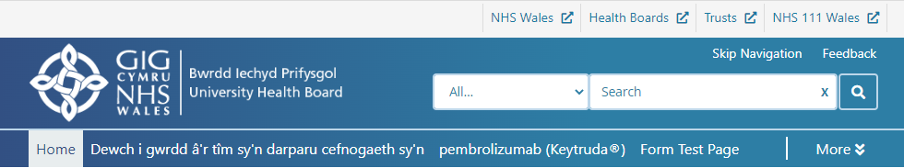 | CMS Support Team
4.2.2 Image Plugin Shadow | The Image Plugin is currently not honoring the ‘Show Image Shadow’ Tick box, when the Image is placed in any region other than the ‘Body’ region.  This issue has now been rectified. When the Image Plugin is placed in any region of the page the ‘Show Image Shadow’ Tick box will now add/remove the shadow as desired.    With Shadow Without Shadow   | CMS Support Team
Plugin & Layout Updates
4.2.3 Link Organiser - New Extra Functionality | An additional requested feature has now been added to the Links Organiser Layout.  This new function will allow your users to find area/regional specific content, by searching via their Postcode, your users would then be met with a link to content (within your site) that is relevant to them. This will be available within the Links Organiser Settings and used in conjunction with a Local Content Collection.  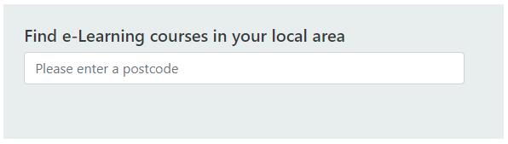  Once a Postcode valid has been entered  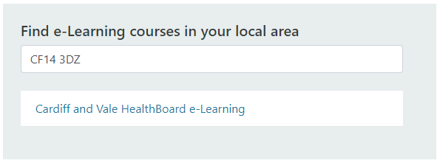  For further information see our Support site Guide: Link Organiser Take 2 | PHW
System Updates
4.2.4 Image Search– Slow Loading | Several improvements have been made to the site code to enhance the render speed of Images within the Search.  Image Searching within the CK Editor  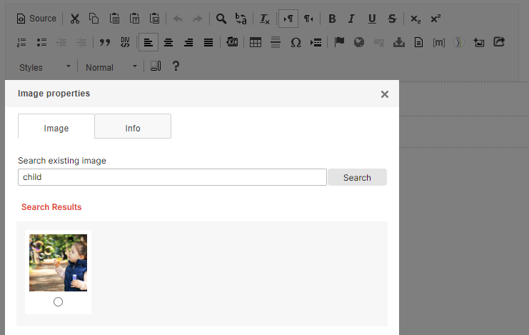  Image Searching within the Image Plugin  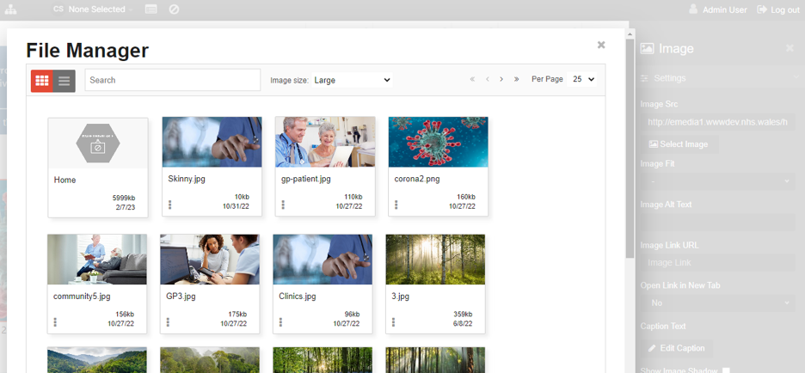  For further information see our Support site Guides: Image Plugin & Adding Images to Content | CMS Support Team
4.2.5 Advanced Table List – Slow Loading | Several improvements have been made to the site code to enhance the render speed of Items within the displayed list.  Advanced Table List Example  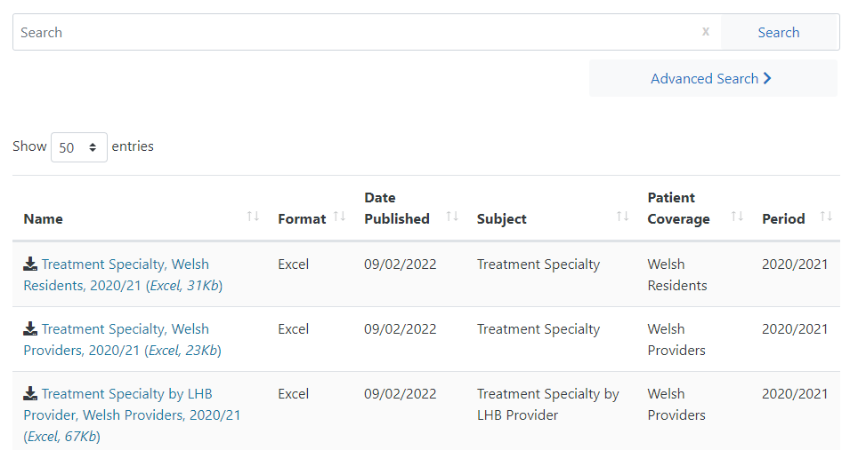  For further information see our Support site Guide: Advanced Table List | CMS Support Team
Welsh Language Standards
4.2.6 DoS – Welsh Text Update | On the DoS Plugin, the Postcode checker is currently showing a difference in the instruction between Welsh & English language, this has now been updated.  DoS Postcode instruction – English Language  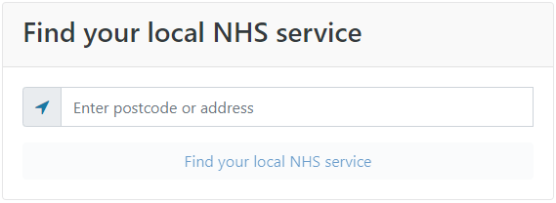  Updated DoS Postcode instruction – Welsh Language  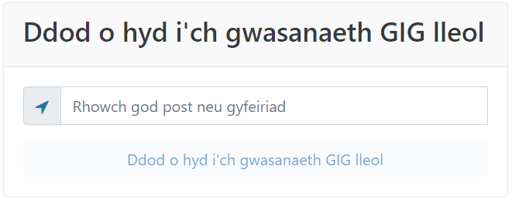  For further information see our Support site Guide: Directory of Services DoS | CMS Support Team

Summary
Number of Changes
6

Bug Fixes | Plugin & Layout Updates | System Updates | Welsh Language Standards
2 | 1 | 2 | 1

Problems Fixed
N/A

New Problems Identified During Testing and Associated Workarounds
N/A

Pre-requisites to Deploy the Release
N/A

Training Requirements
CMS Support Site will be updated with any changes that introduce new functionality or changes to workflow.

Step by Step Deployment Instructions
No Deployment actions required by Health Boards.

Deployment Plan
Changes to be implemented as specified in the Change Record. Release to be deployed via change record: Change 120163

Back-Out Plan
Back out as detailed on each change record

Release Available for Deployment Date
NHS Wales CMS: 26/04/2022

