Digital Health and Care Wales
NHS Wales IT Service Management

CMS MURA SEPTEMBER 2022 Release Notes | Release ID: 763

These Release Notes describe the scope and content of
Release ID: 763 for the CMS MURA Service

Version: | 1.1
Status: | Final
Owner: | Helen McGrath
Author: | Helen McGrath
Approver: | Michele Golpaykar-Rad

Date: | 12/09/2022
Next Review Date: | 22/09/2022

1 DOCUMENT HISTORY 4
1.1 Revision History 4
1.2 Reviewers 4
1.3 Authorisation 4
1.4 Document Location 4
2 INTRODUCTION 5
3 SERVICE MANAGEMENT BOARD (SMB) 5
4 RELEASE NOTES REQUIREMENT 5
4.1 Release Identification 5
4.2 Description of New or Modified Functionality 5
5 Summary 7
5.1 Problems Fixed 7
5.2 New Problems Identified During Testing and Associated Workarounds 8
5.3 Pre-requisites to Deploy the Release 8
5.4 Training Requirements 8
5.5 Step by Step Deployment Instructions 8
5.6 Deployment Plan 8
5.7 Back-Out Plan 8
5.8 Release Available for Deployment Date 8

DOCUMENT HISTORY

Revision History
Date | Version | Author | Revision Summary
12/09/2022 | 1.0 | Helen McGrath | Document created for CMS MURA Release
22/09/2022 | 1.1 | Helen McGrath | Updated Instructions and Images

Reviewers
This document requires the following reviews:
Date | Version | Name | Position
22/09/2022 | 1. | Michele Golpaykar-Rad | Principal Support & Business Analyst

Authorisation
Signing of this document indicates acceptance of its contents.
Author’s Name: | Helen McGrath
Role: | Senior Support & Business Analyst
Signature: | Helen McGrath

Approver’s Name: | Michele Golpaykar-Rad
Role: | Principal Support & Business Analyst
Signature: | Michele Golpaykar-Rad

Document Location
Type | Location
Electronic | CMS MURA Support Site – What’s New

INTRODUCTION
The NHS Wales Release Management Policy considers that effective Release Management is essential for protecting the integrity of the operational environment. A key objective of the release process is ensuring that users, support staff and other stakeholders are kept informed as to what is planned and how this will affect them. One of the ways that this can be achieved is through the publication of release notes prior to deployment of the Release.
These notes contain information on the agreed scope and content of Release id CMS/04-2022 for the CMS descriptions of new or modified functionality and problem fixes, descriptions of new problems and workarounds identified during the testing of this Release, training requirements, deployment instructions, references to deployment and back-out plans and key dates within the release process.

SERVICE MANAGEMENT BOARD (SMB)
The CMS Service Management Board has overall responsibility for ensuring that these Release Notes accurately describes the Release and that it is kept under constant review and updated to reflect any modifications to the Release prior to its deployment.

RELEASE NOTES REQUIREMENT

Release Identification
763 - CMS/04-2022

Description of New or Modified Functionality

Item | Description of the Change | Requestor
Bug Fixes
4.2.1 Google Map Update | It has been noted that the Find button within google maps module has lost its styles. We have now applied a change so that the button is more distinguishable.  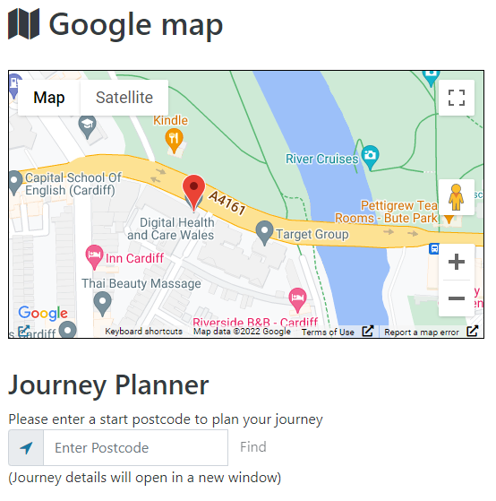 | CMS Support Team
4.2.2 Mobile Pagination Update | Pagination buttons in a folder module on mobile screen are wrapping incorrectly, we have now rectified this issue.  Current Display New Display  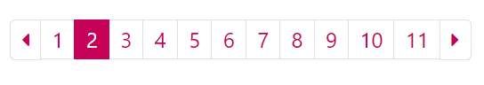  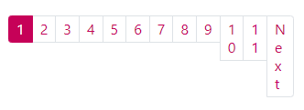 | CMS Support Team
 | Plugin & Layout Updates
4.2.3 A-Z Collection Update | When displaying an A-Z Collection Layout on a page, the parent Item of the content attached within the Content Collection Index shows up within the listings. We have now added in a new settings option to allow users to add/remove the parent folder as they wish.  Content Collection Display  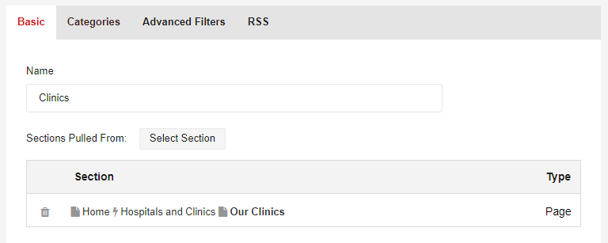  Current Display – Displaying the Parent Folder  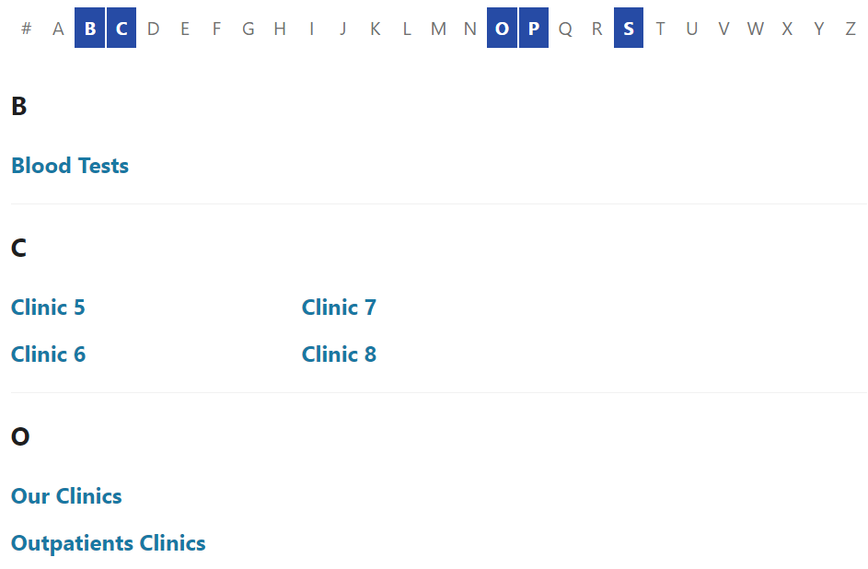  New Display Setting Not Displaying the Parent Folder  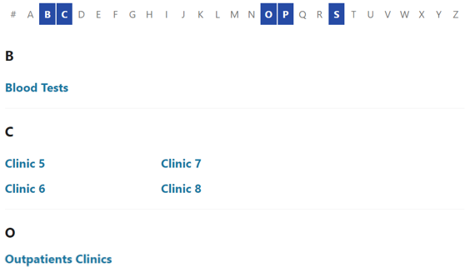 | CMS Support Team
System Update
4.2.4 HWHY -Healthy Weight Healthy You | Welsh Government have commissioned the creation of a new National website, Healthy Weight Healthy You. This website will be managed by WG & PHW.  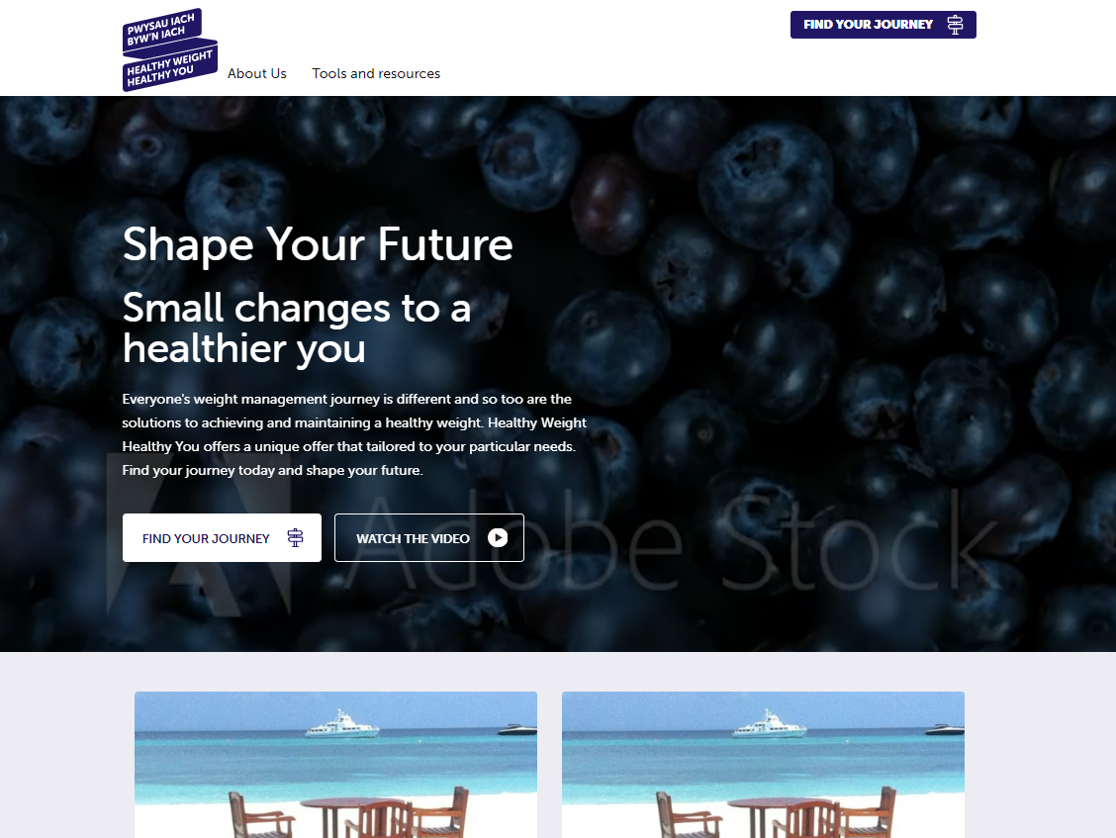 | WG

Summary
Number of Changes | Number of TFS Wok Items | Number of TFS Work Tasks
4 | 15 – Over 4 Sprints | 41 – Over 4 Sprints

Bug Fixes | Plugin & Layout Updates | System Update
2 | 1 | 1

Problems Fixed
N/A

New Problems Identified During Testing and Associated Workarounds
N/A

Pre-requisites to Deploy the Release
N/A

Training Requirements
CMS Support Site will be updated with any changes that introduce new functionality or changes to workflow.

Step by Step Deployment Instructions
No Deployment actions required by Health Boards.

Deployment Plan
Changes to be implemented as specified in the Change Record. Release to be deployed via change record: Change 112852

Back-Out Plan
Back out as detailed on each change record

Release Available for Deployment Date
NHS Wales CMS: 26/09/2022

