Digital Health and Care Wales
NHS Wales IT Service Management

CMS MURA NOVEMBER 2022 Release Notes | Release ID: 770

These Release Notes describe the scope and content of
Release ID: 770 for the CMS MURA Service

Version: | 1.0
Status: | Final
Owner: | Helen McGrath
Author: | Helen McGrath
Approver: | Michele Golpaykar-Rad

Date: | 19/10/2022
Next Review Date: | 03/11/2022

1 DOCUMENT HISTORY 4
1.1 Revision History 4
1.2 Reviewers 4
1.3 Authorisation 4
1.4 Document Location 4
2 INTRODUCTION 5
3 SERVICE MANAGEMENT BOARD (SMB) 5
4 RELEASE NOTES REQUIREMENT 5
4.1 Release Identification 5
4.2 Description of New or Modified Functionality 5
5 Summary 8
5.1 Problems Fixed 8
5.2 New Problems Identified During Testing and Associated Workarounds 8
5.3 Pre-requisites to Deploy the Release 8
5.4 Training Requirements 8
5.5 Step by Step Deployment Instructions 8
5.6 Deployment Plan 8
5.7 Back-Out Plan 8
5.8 Release Available for Deployment Date 8

DOCUMENT HISTORY

Revision History
Date | Version | Author | Revision Summary
19/10/2022 | 1.0 | Helen McGrath | Document created for CMS MURA Release
03/11/2022 | 1.1 | Helen McGrath | Updated Instructions and Images

Reviewers
This document requires the following reviews:
Date | Version | Name | Position
03/11/2022 | 1. | Michele Golpaykar-Rad | Principal Support & Business Analyst

Authorisation
Signing of this document indicates acceptance of its contents.
Author’s Name: | Helen McGrath
Role: | Senior Support & Business Analyst
Signature: | Helen McGrath

Approver’s Name: | Michele Golpaykar-Rad
Role: | Principal Support & Business Analyst
Signature: | Michele Golpaykar-Rad

Document Location
Type | Location
Electronic | CMS MURA Support Site – What’s New

INTRODUCTION
The NHS Wales Release Management Policy considers that effective Release Management is essential for protecting the integrity of the operational environment. A key objective of the release process is ensuring that users, support staff and other stakeholders are kept informed as to what is planned and how this will affect them. One of the ways that this can be achieved is through the publication of release notes prior to deployment of the Release.
These notes contain information on the agreed scope and content of Release id CMS/05-2022 for the CMS descriptions of new or modified functionality and problem fixes, descriptions of new problems and workarounds identified during the testing of this Release, training requirements, deployment instructions, references to deployment and back-out plans and key dates within the release process.

SERVICE MANAGEMENT BOARD (SMB)
The CMS Service Management Board has overall responsibility for ensuring that these Release Notes accurately describes the Release and that it is kept under constant review and updated to reflect any modifications to the Release prior to its deployment.

RELEASE NOTES REQUIREMENT

Release Identification
770 - CMS/05-2022

Description of New or Modified Functionality

Item | Description of the Change | Requestor
Bug Fixes
4.2.1 Image Gallery Update | 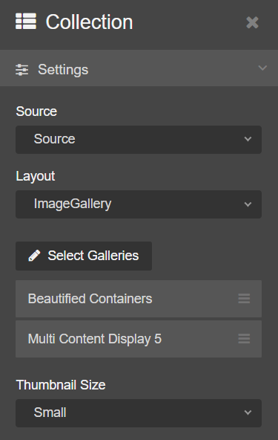  Currently when adding an Image Gallery Plugin to a page, users can add more than one Gallery in the configurator but are unable to rearrange to order that the Galleries appear in.  This fix will now allow users to drag & drop the attached Galleries to rearrange the order they appear in.  For further information see our Support site Guide: Image Gallery | CMS Support Team
4.2.2 Mobile Home Screen Tab | We have now introduced some new functionality to the Mobile Display of the CMS Websites. Some of our users promote the 'Add to Home Screen' function for phones for their pages. This functionality allows users to effectively add a Tile/Icon to their own iPhone/android phone which will then allow them to jump straight to a specific webpage on a site.  Select a Site Select the Icon Select Add to Home Screen  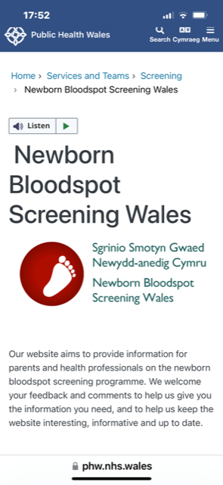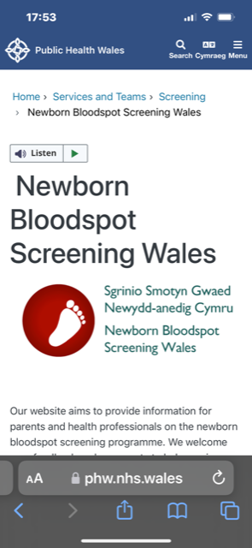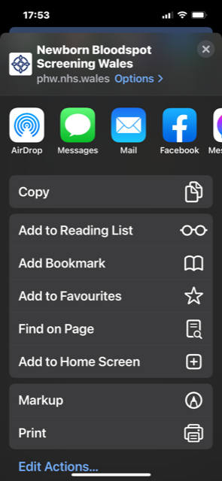  Name your new Tile/Icon & Add The new Tile/Icon will now display  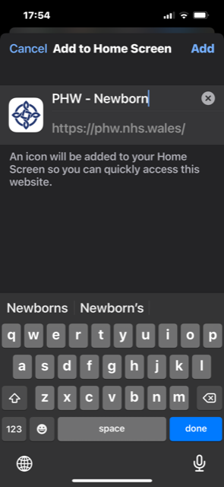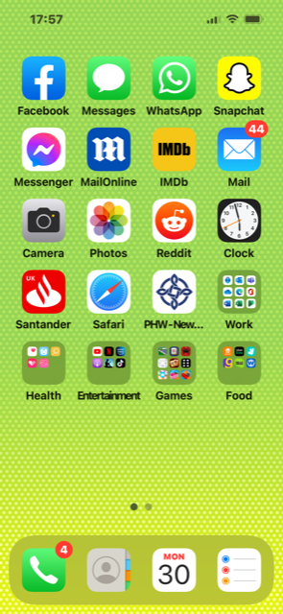  This Tile/Icon will now lead directly to the selected Page within the Selected Website | PHW
 | Plugin & Layout Updates
4.2.3 Audio Player Update | 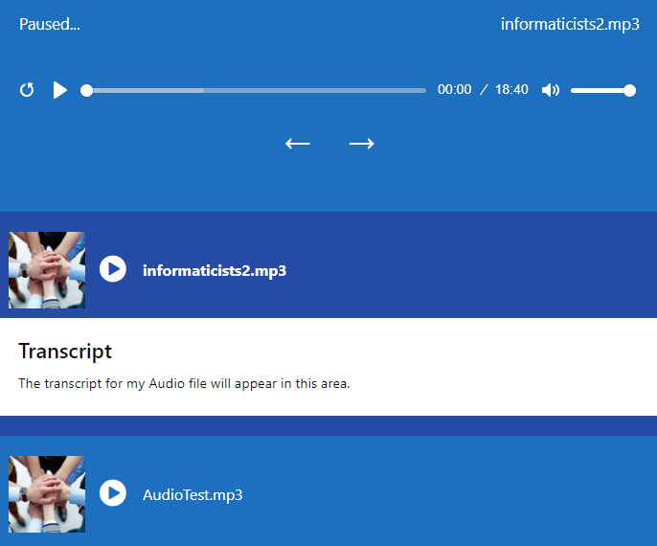  Within the Audio Player Layout, users are able to add a transcript within the Summary area of the uploaded file.  When viewed on the front of the site this Text appears when each Audio file is selected.  Users have noted that the embedded Title ‘Transcript’ appears in a large font, this font size has now been reduced.  For further information see our Support site Guide: Audio Player | PHW
4.2.4 GP eConsult Banner | 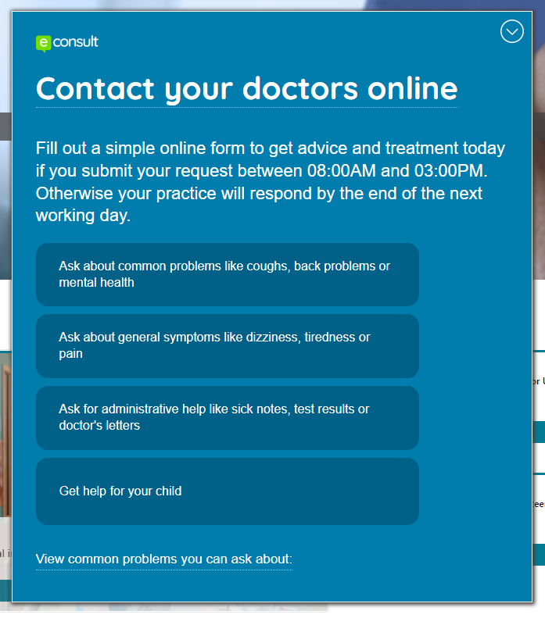  GP Practices are that are using an eConsult Banner are currently unable to add this as a pop-up banner to the site with the code provided by the 3rd party provider.  We have now developed a new plugin that will allow GP users to use their individual code to add the banner.  For further information see our Support site Guide: GP eConsult Banner | GP Practices

Summary
Number of Changes | Number of TFS Wok Items | Number of TFS Work Tasks
4 | 17 – Over 2 Sprints | 31 – Over 2 Sprints

Bug Fixes | Plugin & Layout Updates
2 | 2

Problems Fixed
N/A

New Problems Identified During Testing and Associated Workarounds
N/A

Pre-requisites to Deploy the Release
N/A

Training Requirements
CMS Support Site will be updated with any changes that introduce new functionality or changes to workflow.

Step by Step Deployment Instructions
No Deployment actions required by Health Boards.

Deployment Plan
Changes to be implemented as specified in the Change Record. Release to be deployed via change record: Change 112852

Back-Out Plan
Back out as detailed on each change record

Release Available for Deployment Date
NHS Wales CMS: 09/11/2022

