Digital Health and Care Wales
NHS Wales IT Service Management

CMS MURA JUNE 2022 Release Notes | Release ID: 740

These Release Notes describe the scope and content of
Release ID: 740 for the CMS MURA Service

Version: | 1.2
Status: | Final
Owner: | Helen McGrath
Author: | Helen McGrath
Approver: | Michele Golpaykar-Rad

Date: | 24/05/2022
Next Review Date: | 10/06/2022

1 DOCUMENT HISTORY 4
1.1 Revision History 4
1.2 Reviewers 4
1.3 Authorisation 4
1.4 Document Location 4
2 INTRODUCTION 5
3 SERVICE MANAGEMENT BOARD (SMB) 5
4 RELEASE NOTES REQUIREMENT 5
4.1 Release Identification 5
4.2 Description of New or Modified Functionality 5
5 Summary 13
5.1 Problems Fixed 14
5.2 New Problems Identified During Testing and Associated Workarounds 14
5.3 Pre-requisites to Deploy the Release 14
5.4 Training Requirements 14
5.5 Step by Step Deployment Instructions 14
5.6 Deployment Plan 14
5.7 Back-Out Plan 14
5.8 Release Available for Deployment Date 14

DOCUMENT HISTORY

Revision History
Date | Version | Author | Revision Summary
24/05/2022 | 1.0 | Helen McGrath | Document created for CMS MURA Release
30/05/2022 | 1.1 | Helen McGrath | Screenshots & Text Updated
10/06/2022 | 1.2 | Helen McGrath | Additional Items

Reviewers
This document requires the following reviews:
Date | Version | Name | Position
10/06/2022 | 1.2 | Michele Golpaykar-Rad | Principal Support & Business Analyst

Authorisation
Signing of this document indicates acceptance of its contents.
Author’s Name: | Helen McGrath
Role: | Senior Support & Business Analyst
Signature: | Helen McGrath

Approver’s Name: | Michele Golpaykar-Rad
Role: | Principal Support & Business Analyst
Signature: | Michele Golpaykar-Rad

Document Location
Type | Location
Electronic | CMS MURA Support Site – What’s New

INTRODUCTION
The NHS Wales Release Management Policy considers that effective Release Management is essential for protecting the integrity of the operational environment. A key objective of the release process is ensuring that users, support staff and other stakeholders are kept informed as to what is planned and how this will affect them. One of the ways that this can be achieved is through the publication of release notes prior to deployment of the Release.
These notes contain information on the agreed scope and content of Release id CMS/02-2022 for the CMS descriptions of new or modified functionality and problem fixes, descriptions of new problems and workarounds identified during the testing of this Release, training requirements, deployment instructions, references to deployment and back-out plans and key dates within the release process.

SERVICE MANAGEMENT BOARD (SMB)
The CMS Service Management Board has overall responsibility for ensuring that these Release Notes accurately describes the Release and that it is kept under constant review and updated to reflect any modifications to the Release prior to its deployment.

RELEASE NOTES REQUIREMENT

Release Identification
740 - CMS/02-2022

Description of New or Modified Functionality

Item | Description of the Change | Requestor
Bug Fixes
4.2.1 Multi Content 1 – Mobile View | When selecting MultiContentDisplay1 as the layout on a Folder Content Type it displays as expected on a desktop screen, however the content disappears when viewed on a mobile. What remains is the navigation arrows and the position indicator dots. This has now been repaired so that the content of this layout will show correctly across all platforms.  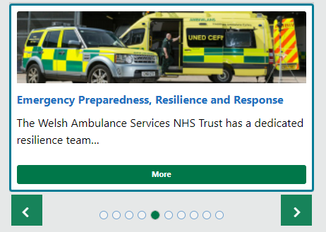  Current Mobile Display Repaired Mobile Display   | WAST
4.2.2 Text Box Update | Within the Text Plugin users are currently unable to use the Image Key within the CK Editor. We have now made an update to this plugin to allow the Image Key function to pull images in.  Please be aware that the functionality to add Images to the page via the Text Plugin is only available within the ‘Body’ Region of the page.  Initially the Image code will appear in the Text Box.  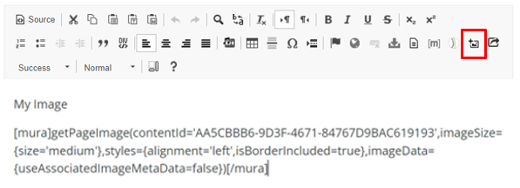  Once Saved and Published, the Image will then render to the page.   | NWSSP
4.2.3 Translation Tool Tip | Previously Users could hover over the 'i' icon & '?' icon in admin tab for content Translation and see a pop-up message. Since the Mura 10 update this function has not been available. This has now been repaired so that when a user selected the ‘i’ or '?' icons the correct Tool Tip is available.  Manually Mapping Pages  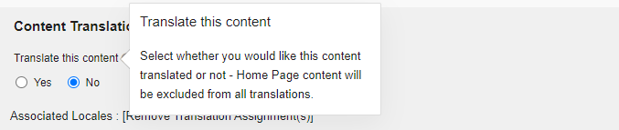  '?' icon  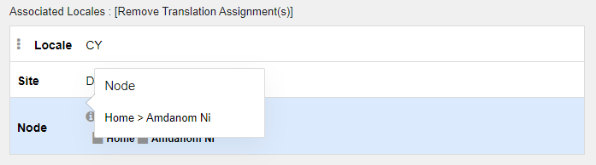  'i' icon | CMS Support Team
4.2.4 Event Update – Front-end Text | Within the settings of the Event Page, if a colour in not selected in ‘Event Type’ field, the default text ‘Select A Colour’ is then displayed on the front end of the page. We have now updated this function so that if no Event Type is selected then then this field will display empty.  Add a Calendar Event  Current Display  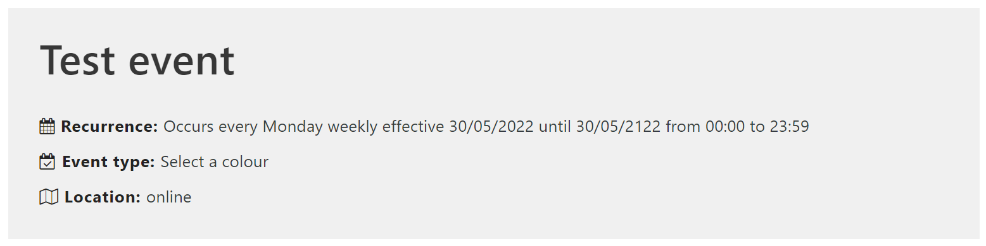  New Display  When no Event Type has been selected | CMS Support Team
4.2.5 DoS Geolocation Update | Currently the Geolocation button within the DoS is malfunctioning and sending users to an incorrect page. This functionality has now been corrected.  Directory of Services (DoS)  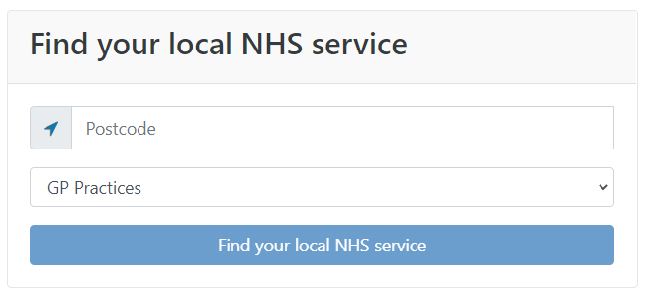 | CMS Support Team
 | Plugin & Layout Updates
4.2.6 Settings Update - Colour Options | We have made an update to the colour settings to various Plugin & Layout options available within the CMS. All colour picker options have now been relocated from the Settings Tab to the Style Tab - Colour Tab. This update is in to maintain consistency of the location of colour options across all Plugins & Layouts.  Style Tab – Colour Options  Current Display New Display  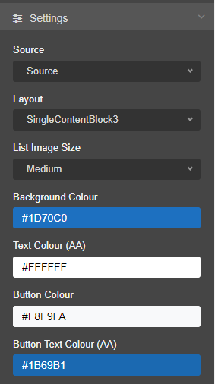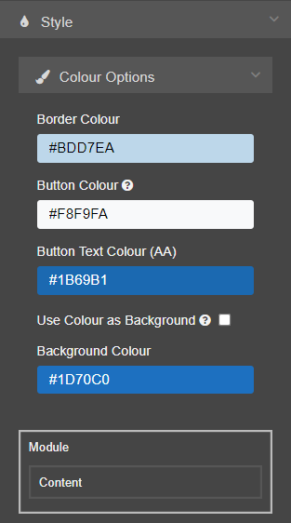 | CMS Support Team
4.2.7 PDF Viewer – Mobile View Update | Currently when Using the PDF Viewer Plugin and then viewing this on a Mobile; the content shrinks down to just display a Download PDF button in empty space, with no indication as to the size of the content is to be downloaded. This Plugin has now been updated to allow more context as to what is being downloaded to display.  PDF Viewer  Current Display New Display  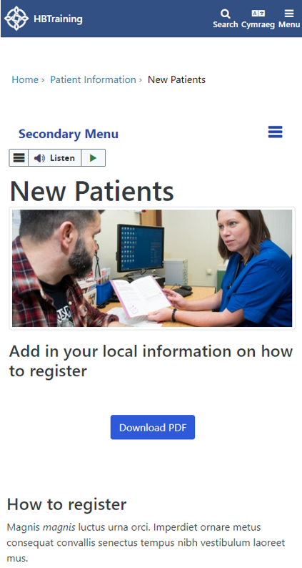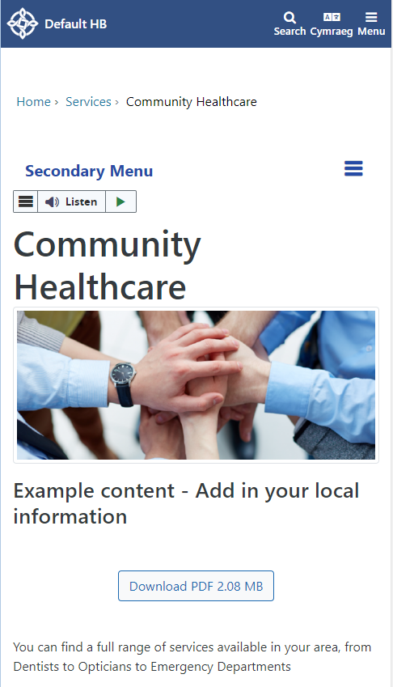 | CMS Support Team
4.2.8 Carousel Display Update | We have introduced New Functionality into the Carousel Plugin. This has increased the height of the Carousel when viewed on a Mobile and has also decreased the height of the black banner at the bottom of the Carousel, by relocating the text to the Left and the More Button to the Right.  How Do I Add a Carousel  Current Mobile Display New Mobile Display  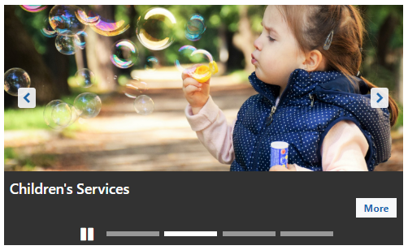  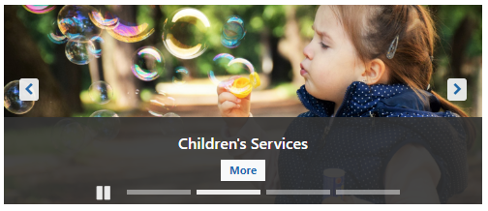  Displaying the Content Title and More button  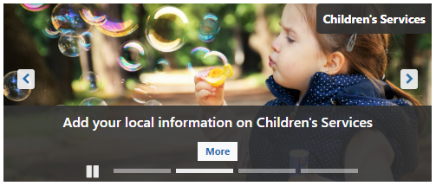    Displaying the Content Title, Summary and More button      Displaying the Content Title and Summary without a More button | CMS Support Team
New Functionality
4.2.9 Mobile Update – Add to Home Screen | We have now introduced some new functionality to the Mobile Display of the CMS Websites. Some of our users promote the 'Add to Home Screen' function for phones for their pages.  This functionality allows users to effectively add a Tile/Icon to their own iPhone/android phone which will then allow them to jump straight to a specific webpage on a site.  Select a Site Select the Icon Select Add to Home Screen  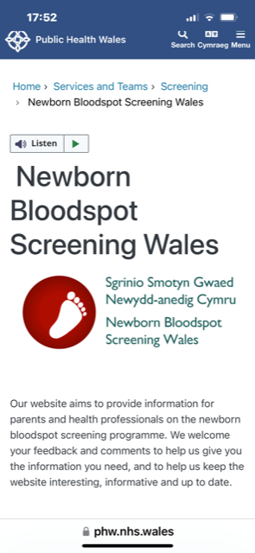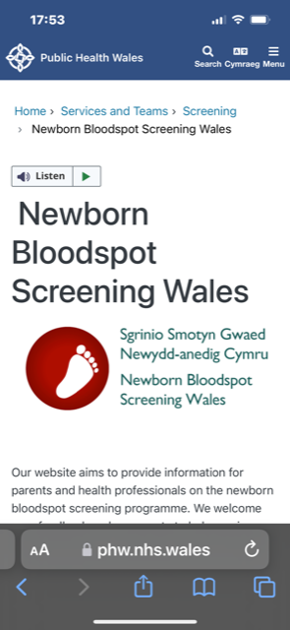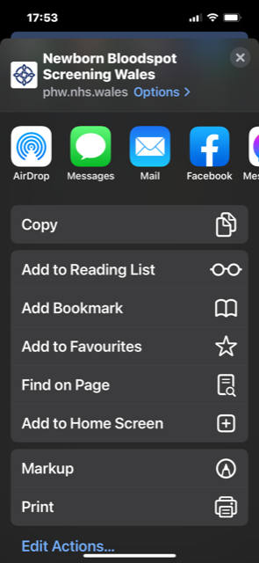  Name your new Tile/Icon & Add The new Tile/Icon will now display  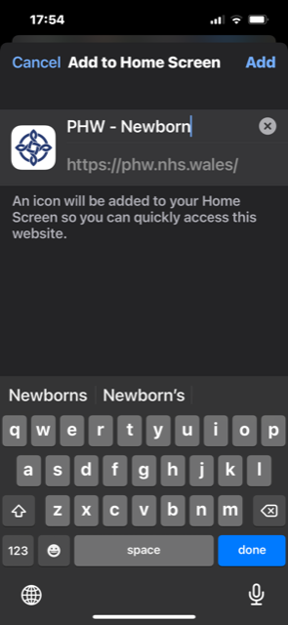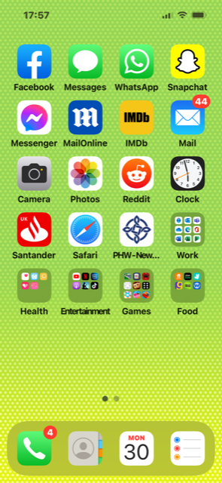  This Tile/Icon will now lead directly to the selected Page within the Selected Website | PHW
4.2.10 Forms Data Display Update | We have now added an update to the Forms Data Area. Currently when Form Data is selected the system attempts to render every Form submission to the page. If there are a large number of records then this process can be very slow and disable the ability to access the the Forms Filter.  We have now amended this behaviour so that the submissions will only render after a search Filter has been selected. The submissions will also display with pagination so that all submissions are not attempting to download all at once.  Creating Forms  Select Your Search Filters > Select View Data  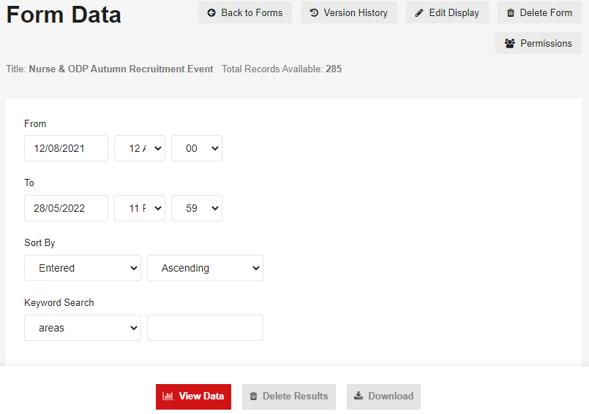  Submissions Pagination  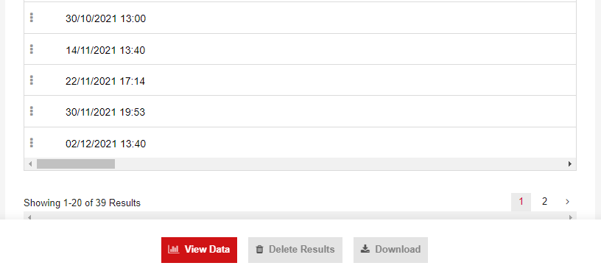 | CAVUHB
4.2.11 New Audio Player Layout | We have now created a new CMS Layout – Audio Player. This new layout will allow users to display Audio files that have been uploaded to the website.  How Do I Add an Audio Player  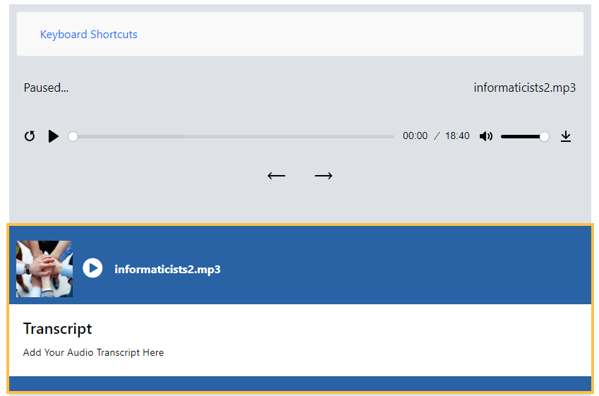  *Audio player is not completable with some older browsers. Users who are using unsupported HTML 5 audio tag to be presented with a message | PHW
Accessibility
4.2.12 Adding Accessibility Checker | To aid site admins in creating accessible websites we have introduced a New Settings Option within several our Layouts.  This new option will allow site admins to compare the colours that they are using and will provide a result as to whether or not these colours meet web accessibility standards. The results provided will be in the form of an Exclamation Mark, AA or AAA Icons depending on the result.  Accessibility Checker  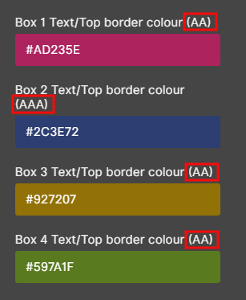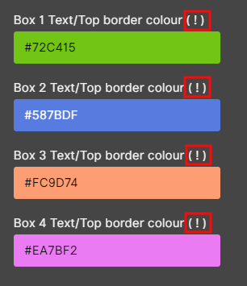 | CMS Support Team
4.2.13 Style Colours Accessibility | Since the introduction of the Mura 10 upgrade, it has been noted that the default Alert Colours within the CK Editor & Information Banner have been updated and no-longer meet AA accessibility guidelines. We have now reverted these colours back to their original Hex Codes.  Current Display Colours  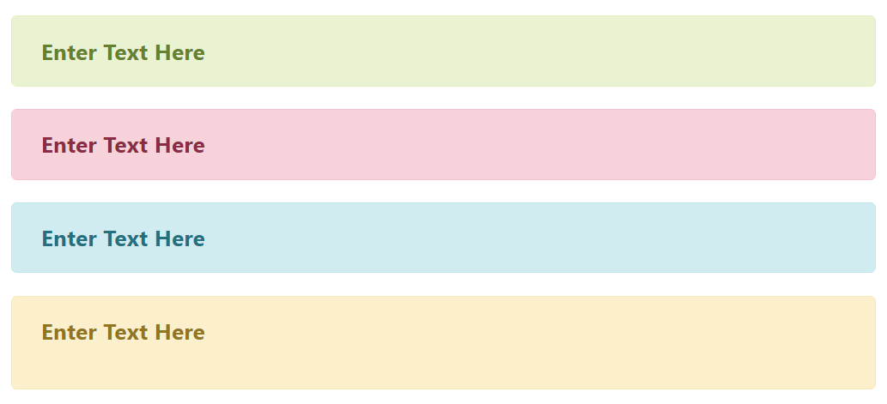  New Display Colours  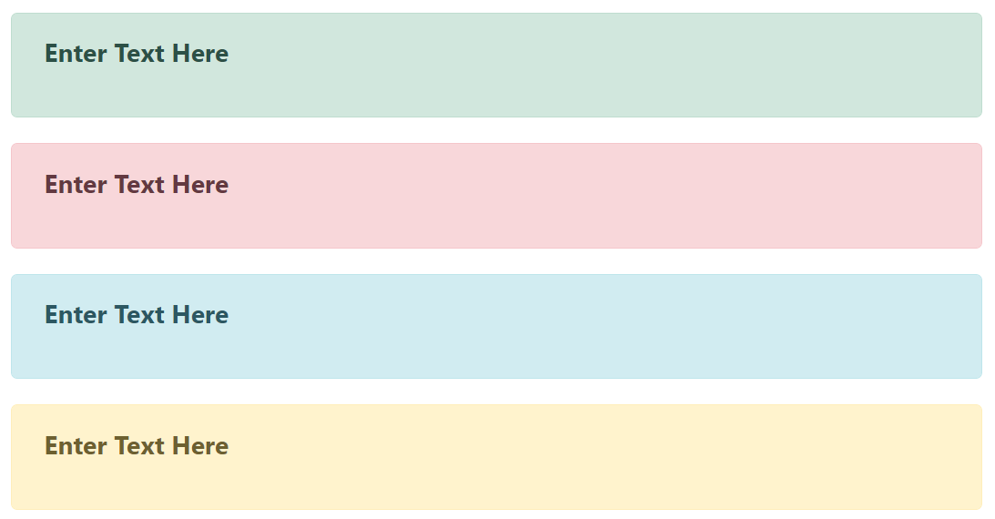 | CMS Support Team

Summary
Number of Changes | Number of TFS Wok Items | Number of TFS Work Tasks
13 | 21 – Over 4 Sprints | 57 – Over 4 Sprints

Bug Fixes | Plugin & Layout Updates | New Functionality | Accessibility
5 | 3 | 3 | 2

Problems Fixed
N/A

New Problems Identified During Testing and Associated Workarounds
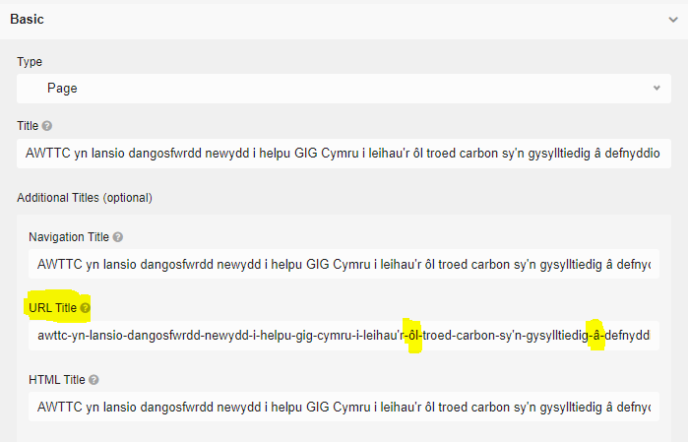
Issue with Welsh Characters in a URL
Since the introduction of the Mura 10 upgrade, it has been noted that the CMS no longer allows users to create new content items with Welsh special characters in the title (These items display as a 404 Error message).
Previously the system would automatically pull the Welsh character out of the URL Title field, this is now a manual task that users would need to complete.
This issue has been reported to Mura and we are awaiting a permanent fix.

Pre-requisites to Deploy the Release
N/A

Training Requirements
CMS Support Site will be updated with any changes that introduce new functionality or changes to workflow.

Step by Step Deployment Instructions
No Deployment actions required by Health Boards.

Deployment Plan
Changes to be implemented as specified in the Change Record. Release to be deployed via change record: 109756

Back-Out Plan
Back out as detailed on each change record

Release Available for Deployment Date
NHS Wales CMS: 22/06/2022

