Digital Health and Care Wales
NHS Wales IT Service Management

CMS MURA AUGUST 2022 Release Notes | Release ID: 756

These Release Notes describe the scope and content of
Release ID: 756 for the CMS MURA Service

Version: | 1.2
Status: | Final
Owner: | Helen McGrath
Author: | Helen McGrath
Approver: | Michele Golpaykar-Rad

Date: | 06/07/2022
Next Review Date: | 03/08/2022

1 DOCUMENT HISTORY 4
1.1 Revision History 4
1.2 Reviewers 4
1.3 Authorisation 4
1.4 Document Location 4
2 INTRODUCTION 5
3 SERVICE MANAGEMENT BOARD (SMB) 5
4 RELEASE NOTES REQUIREMENT 5
4.1 Release Identification 5
4.2 Description of New or Modified Functionality 5
5 Summary 9
5.1 Problems Fixed 9
5.2 New Problems Identified During Testing and Associated Workarounds 9
5.3 Pre-requisites to Deploy the Release 10
5.4 Training Requirements 10
5.5 Step by Step Deployment Instructions 10
5.6 Deployment Plan 10
5.7 Back-Out Plan 10
5.8 Release Available for Deployment Date 10

DOCUMENT HISTORY

Revision History
Date | Version | Author | Revision Summary
06/07/2022 | 1.0 | Helen McGrath | Document created for CMS MURA Release
25/07/2022 | 1.1 | Lisa Trowbridge | Additional Items & Screenshots
26/07/2022 | 1.2 | Helen McGrath | Text Update

Reviewers
This document requires the following reviews:
Date | Version | Name | Position
26/07/2022 | 1.2 | Michele Golpaykar-Rad | Principal Support & Business Analyst

Authorisation
Signing of this document indicates acceptance of its contents.
Author’s Name: | Helen McGrath
Role: | Senior Support & Business Analyst
Signature: | Helen McGrath

Approver’s Name: | Michele Golpaykar-Rad
Role: | Principal Support & Business Analyst
Signature: | Michele Golpaykar-Rad

Document Location
Type | Location
Electronic | CMS MURA Support Site – What’s New

INTRODUCTION
The NHS Wales Release Management Policy considers that effective Release Management is essential for protecting the integrity of the operational environment. A key objective of the release process is ensuring that users, support staff and other stakeholders are kept informed as to what is planned and how this will affect them. One of the ways that this can be achieved is through the publication of release notes prior to deployment of the Release.
These notes contain information on the agreed scope and content of Release id CMS/03-2022 for the CMS descriptions of new or modified functionality and problem fixes, descriptions of new problems and workarounds identified during the testing of this Release, training requirements, deployment instructions, references to deployment and back-out plans and key dates within the release process.

SERVICE MANAGEMENT BOARD (SMB)
The CMS Service Management Board has overall responsibility for ensuring that these Release Notes accurately describes the Release and that it is kept under constant review and updated to reflect any modifications to the Release prior to its deployment.

RELEASE NOTES REQUIREMENT

Release Identification
756 - CMS/03-2022

Description of New or Modified Functionality

Item | Description of the Change | Requestor
Bug Fixes
4.2.1 Advanced Table List Sort Order | Since the Mura 10 system update The Advanced Table List sort by is no longer honoring the selected settings.  This new fix will now mean that any sorting settings added on the front-end will now honor e.g., Release Date- Descending.  If you set the sorting in the back-end then it won’t update the sorting set on the front unless you open the front-end configurator, when the values will then come across and be set on Publish.  If set via the front-end configurator then they will update the values shown in the back-end admin when refreshed.  Advance Table List  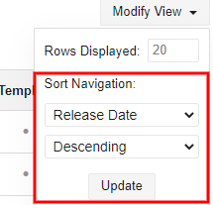  Settings Options Front-End Settings Options Back End  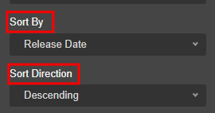 | CMS Support Team
4.2.2 Mobile Update – Add to Home Screen | This item was introduced in the CMS/02-2022 release, however currently users are only able to add link to a website Homepage. This new update will allow users to link directly to a specific page within a site.  CMS/02-2022  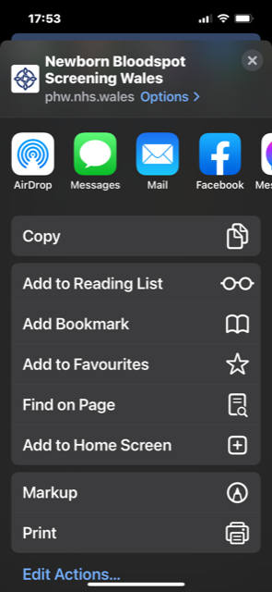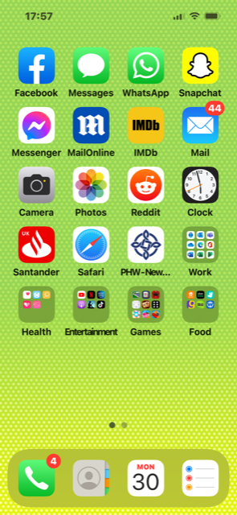 | CMS Support Team
4.2.3 Images Plugin File Manager | When using the File Manager within the Image Plugin, when selecting the 'Image Size' dropdown some of the images only display if you select the Image Size as Small, Medium, or Large. If you select any other size e.g., featureblockimage the “No image found” icon displays & the 3dots are not available.  This update will mean that all Images are available in all sizes.  Image Plugin  Current Display  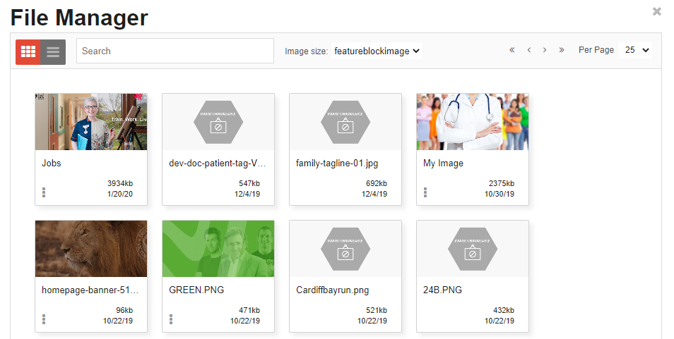  New Display  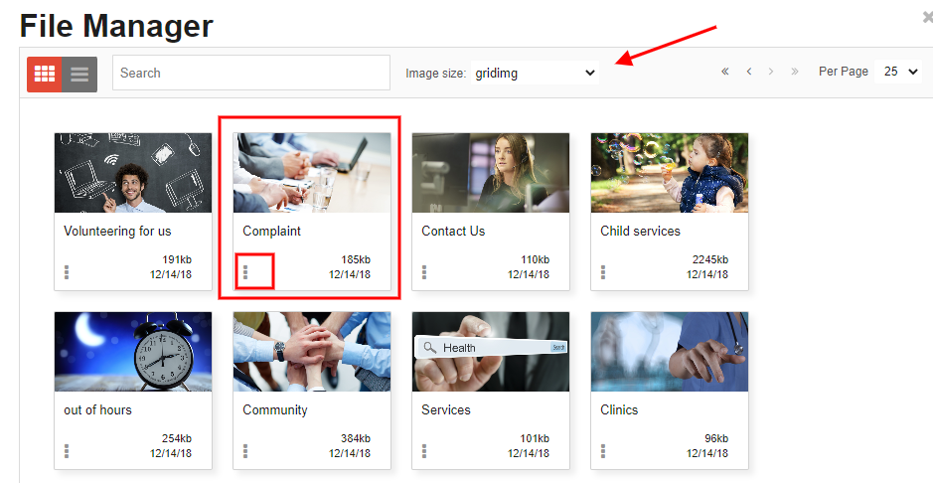 | CMS Support Team
 | Plugin & Layout Updates
4.2.4 Image Plugin Update | Currently when adding an Image via the Image Plugin, a Shadow is automatically added to the Image. We have now added a new option into the Image Plugin Settings that will allow users to control if the image should or shouldn’t display a shadow.  Image Plugin  Image Plugin New Setting  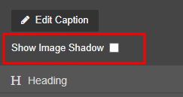 | DHCW
4.2.5 Table List Update | The Table List Layout can be found within the Collection Plugin. A Table List is a clear way to display your documents on a page. The content displayed can be pulled in via a folder, asset bucket or local index.  We have now added an extra option that will allow admins to select which column they would like the list to order by.  Table List  Table List Layout New Setting  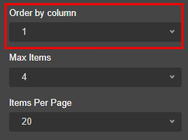 | CMS Support Team
System Update
4.2.6 Email Reply Link Update | Currently all website replies contain the email reply link: badmail@wales.nhs.uk  We have now updated this to: DHCW.NoReply@wales.nhs.uk  This is to avoid any confusion on the validity of the mailbox. This is informational only and will not have any adverse effect on any site users/admins. | CMS Support Team
4.2.7 Translation Map Audit – Export All to Excel | The Translation Map Audit currently only shows a maximum of 100 rows at a time, this was causing some issues when users were attempting to download the results into an Excel Spreadsheet.  We have now added the ‘Export ALL to Excel’ button which will Export the whole sites Translation items into one Excel spreadsheet.  Track My Translations  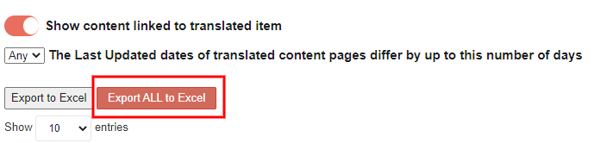 | BCUHB
Welsh Language Standards
4.2.8 Categories Display Update | Two missing Welsh Translations have been noted on the Categories Display navigation, these translations have now been updated.  Creating Categories  Current Display New Display  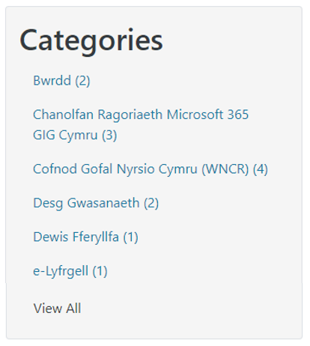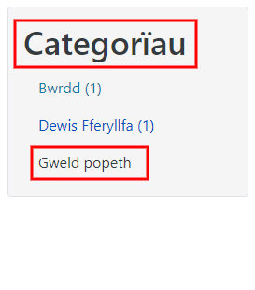 | DHCW

Summary
Number of Changes | Number of TFS Wok Items | Number of TFS Work Tasks
8 | 12 – Over 4 Sprints | 26 – Over 4 Sprints

Bug Fixes | Plugin & Layout Updates | System Update | Welsh Language Standards
3 | 2 | 2 | 1

Problems Fixed
N/A

New Problems Identified During Testing and Associated Workarounds
N/A

Pre-requisites to Deploy the Release
N/A

Training Requirements
CMS Support Site will be updated with any changes that introduce new functionality or changes to workflow.

Step by Step Deployment Instructions
No Deployment actions required by Health Boards.

Deployment Plan
Changes to be implemented as specified in the Change Record. Release to be deployed via change record: Change 111992

Back-Out Plan
Back out as detailed on each change record

Release Available for Deployment Date
NHS Wales CMS: 10/08/2022

