Digital Health and Care Wales
NHS Wales IT Service Management

CMS MURA MARCH 2022 Release Notes | Release ID: 704

These Release Notes describe the scope and content of
Release ID: 704 for the CMS MURA Service

Version: | 1.1
Status: | Final
Owner: | Helen McGrath
Author: | Helen McGrath
Approver: | Michele Golpaykar-Rad

Date: | 10/02/2022
Next Review Date: | 24/03/2022

1 DOCUMENT HISTORY 4
1.1 Revision History 4
1.2 Reviewers 4
1.3 Authorisation 4
1.4 Document Location 4
2 INTRODUCTION 5
3 SERVICE MANAGEMENT BOARD (SMB) 5
4 RELEASE NOTES REQUIREMENT 5
4.1 Release Identification 5
4.2 Description of New or Modified Functionality 5
5 Summary 16
5.1 Problems Fixed 17
5.2 New Problems Identified During Testing and Associated Workarounds 17
5.3 Pre-requisites to Deploy the Release 17
5.4 Training Requirements 17
5.5 Step by Step Deployment Instructions 17
5.6 Deployment Plan 17
5.7 Back-Out Plan 17
5.8 Release Available for Deployment Date 17

DOCUMENT HISTORY

Revision History
Date | Version | Author | Revision Summary
10/02/2022 | 0.1 | Helen McGrath | Document created for CMS MURA Release
10/03/2022 | 1.0 | Helen McGrath | Screenshots & Text Updated
24/03/2022 | 1.1 | Helen McGrath | Additional Items

Reviewers
This document requires the following reviews:
Date | Version | Name | Position
24/03/2022 | 1.1 | Michele Golpaykar-Rad | Principal Support & Business Analyst

Authorisation
Signing of this document indicates acceptance of its contents.
Author’s Name: | Helen McGrath
Role: | Senior Support & Business Analyst
Signature: | Helen McGrath

Approver’s Name: | Michele Golpaykar-Rad
Role: | Principal Support & Business Analyst
Signature: | Michele Golpaykar-Rad

Document Location
Type | Location
Electronic | CMS MURA Support Site – What’s New

INTRODUCTION
The NHS Wales Release Management Policy considers that effective Release Management is essential for protecting the integrity of the operational environment. A key objective of the release process is ensuring that users, support staff and other stakeholders are kept informed as to what is planned and how this will affect them. One of the ways that this can be achieved is through the publication of release notes prior to deployment of the Release.
These notes contain information on the agreed scope and content of Release id CMS/01-2022 for the CMS descriptions of new or modified functionality and problem fixes, descriptions of new problems and workarounds identified during the testing of this Release, training requirements, deployment instructions, references to deployment and back-out plans and key dates within the release process.

SERVICE MANAGEMENT BOARD (SMB)
The CMS Service Management Board has overall responsibility for ensuring that these Release Notes accurately describes the Release and that it is kept under constant review and updated to reflect any modifications to the Release prior to its deployment.

RELEASE NOTES REQUIREMENT

Release Identification
704 - CMS/01-2022

Description of New or Modified Functionality

Item | Description of the Change | Requestor
Full System Update
4.2.1 Mura 10 Core Software Update | Our much-anticipated Mura 10 system update has arrived! We have now fully implemented this upgrade into the CMS system. You will now have a few newly added extras to enjoy on the front and back ends of the system.  However, this update does mean that a few areas may work slightly different from how we have become accustomed to using them but have no fear the CMS Support Site has now been brought up to date to reflect all Mura 10 changes.  Please refer to the CMS Support Site for full details on exactly what changes have taken place. Mura 10 Update | CMS Support Team
Bug Fixes
4.2.2 Mobile Language Icon Update | We have made a slight update to the Mobile Language Icon. The Icon was previously showing a difference depending on if users were or were not logged into the CMS. We have now updated this so that the Icon will always remain consistent.  Old Display  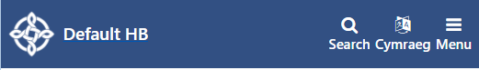  New Display  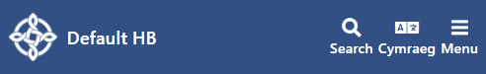 | CMS Support Team
4.2.3 Table List Dates Update | Within the Table List Layout dates were displaying in the American format, this has now been corrected to the English UK format.  Old Display Format  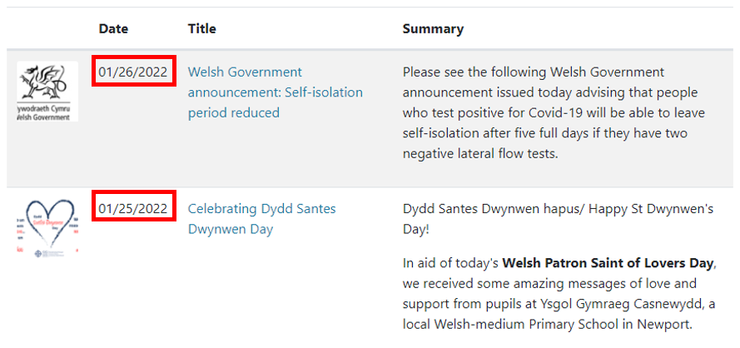  New Display Format  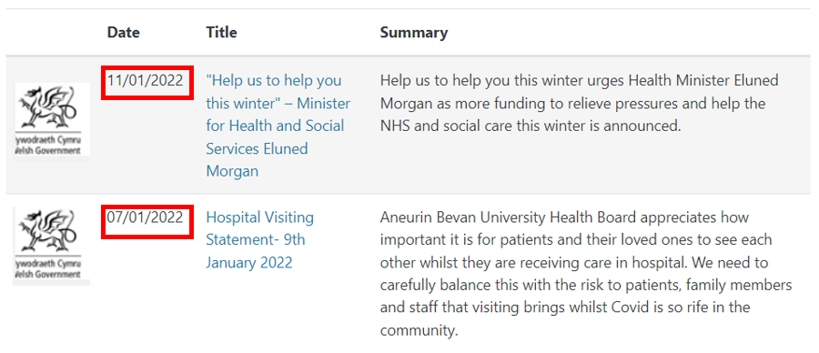 | CMS Support Team
 | Plugin & Layout Updates
4.2.4 Muted Video Header Update | We have made an update to the Muted Video Header. This update was to remove a step in the process to make this Layout simpler for the users to create and add to a page. Please refer to the CMS Support Site for full details.  Muted Video Header Guide  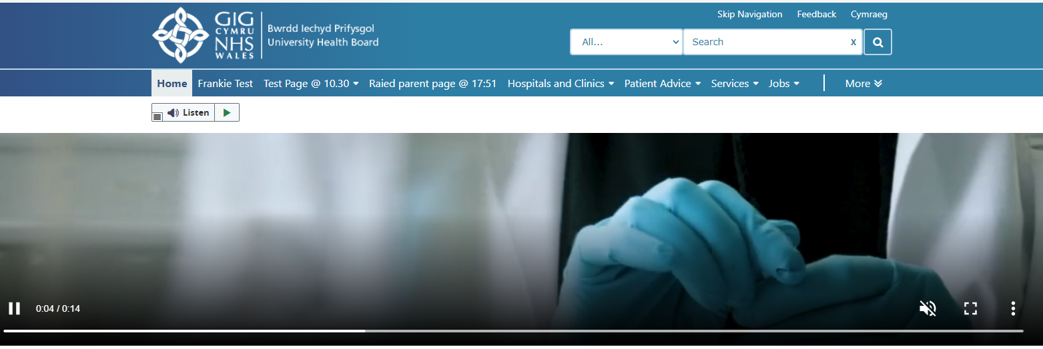 | CMS Support Team
4.2.5 Text Plugin Update | An update has been made to the Text Box Plugin to allow users to further format their content, allowing for Padding, Margins, colours & Images. Please refer to the CMS Support Site for full details on how to set these up on your site.  Formatting Text Boxes  Example 1  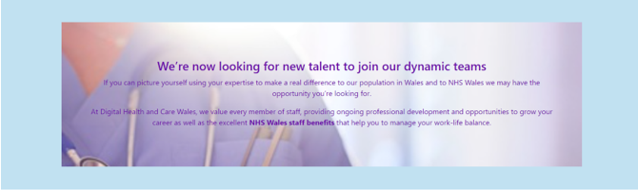  Example 2  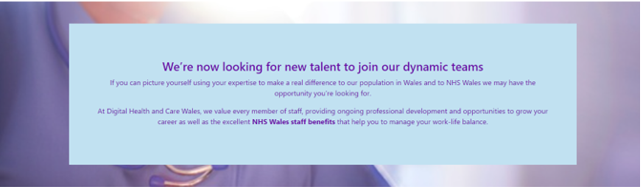 | CMS Support Team
4.2.6 Information Banner Update | We have made an update to the pop-out CK Editor Box within the Information Banner Layout. Previously the CK Editor box only opened within the right-hand plugin settings box, which appear squashed. Now when the EDIT field (below the ‘Message’ heading) is selected a full CK Editor box will pop out.  Creating an Information Banner  Old Display New Display  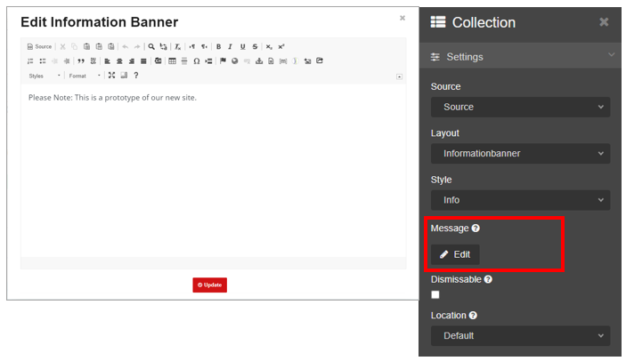  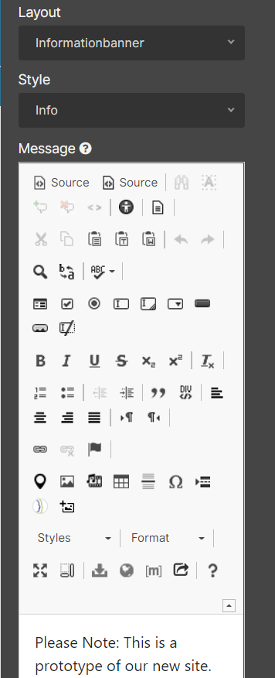 | CMS Support Team
System Updates
4.2.7 Form Update | We have made a small update within the Forms area. Currently after users have selected a Type of Form to create no further indication as to which Form Sub Type was selected is provided. We have now introduced the Type field within the Basic Tab – here users can see what Type of Form this is.  New Field Option  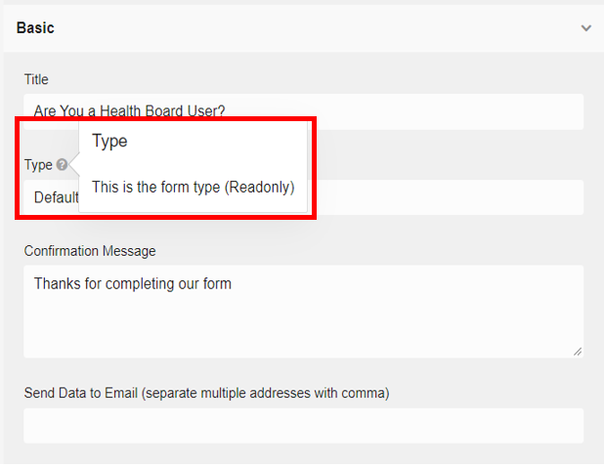 | CMS Support Team
4.2.8 Content Snippet Plugin Removed | 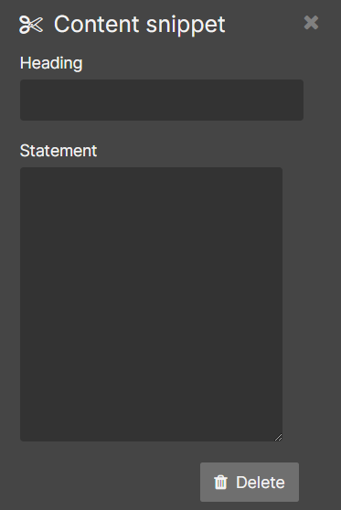  The Content Snippet Plugin has now been removed from the CMS Plugin list.  It was felt that with the added functionality with the Text Box & Container Plugins (due to the system update) that this Plugin is now defunct.  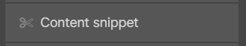 | CMS Support Team
4.2.9 Group Permissions Change Rollback | We have had to roll back a previous change that was made to aid users in the creation of site groups, as this change is not compatible with the new system update.  When setting up new user groups site Admins will need to go to the backend of their sites select Site Settings > Site Permissions and Tick the Checkboxes next to the site Group/s - This will allow the Group to have access to the site. These changes would also need to be made on your Welsh language website.  Creating Group Permissions  Permissions Field  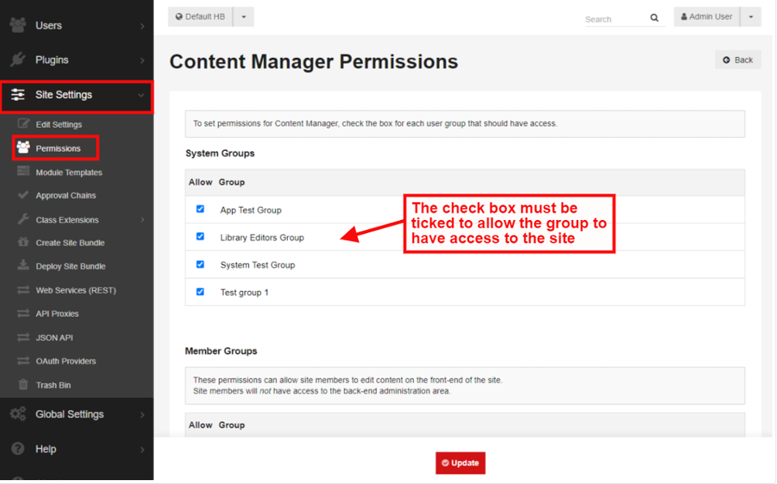 | CMS Support Team
New Functionality
4.2.10 Introduction of the Style Tab | With the release of the new system update the new Styling Tab has been introduced into many of the CMS Plugins & Layouts. The Style Tab allows you to further format and customise your content blocks.  You can do this by choosing Module and/or Content; each of these will customise different areas of your content. Each plugin has a variation of the settings below available within it, not all settings are available within every plugin. Please refer to the CMS Support Site or full details.  Styling Tab  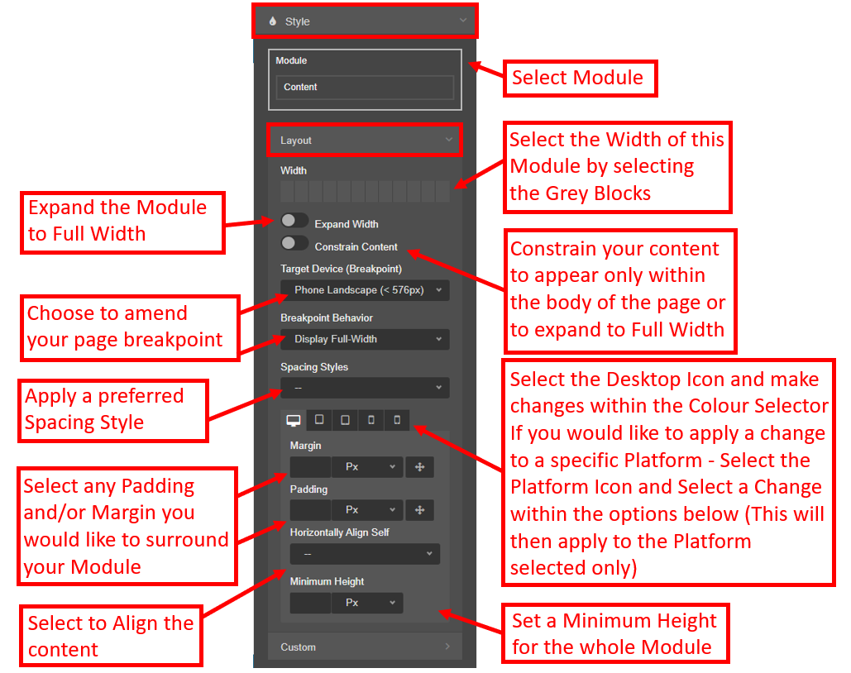  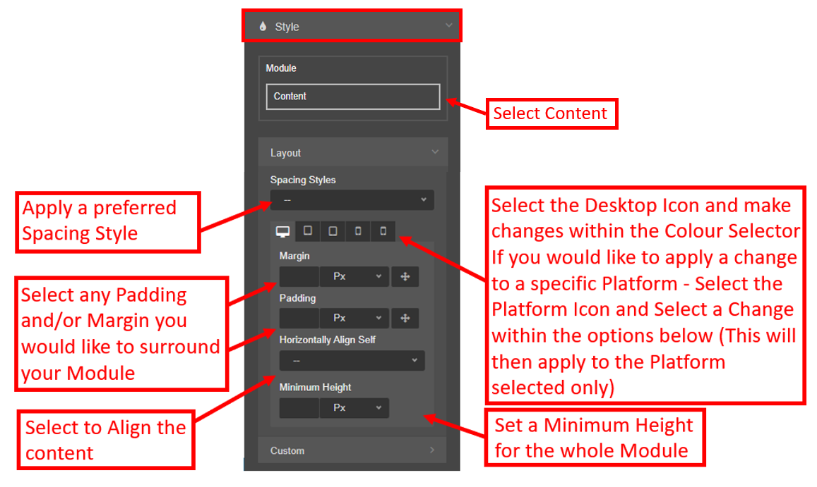 | CMS Support Team
4.2.11 New Plugin Video | The Video Plugin is a newly added plugin to the CMS. This enables site Admins to easily pull in Video’s from various third-party hosting services. This new plugin will allow the video to display within the body of content or users can add a Button/Icon to the page, that when selected will display the Video as a pop-out Modal. Please refer to the CMS Support Site or full details  Video Plugin  Modal Exampe  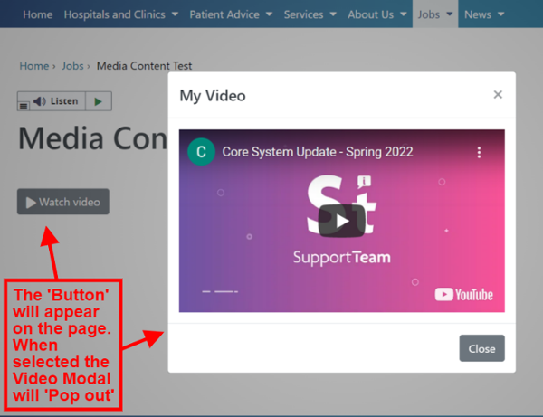 | CMS Support Team
4.2.12 New Plugin Image | The Image Plugin is a newly added plugin to the CMS. Admins can search for any previously uploaded image within their site and add an image to a page, they can then use the New Styling Tab to further size and format the Image. This method differs slightly from our other ways of adding images to a page. Please refer to the CMS Support Site or full details.  Image Plugin  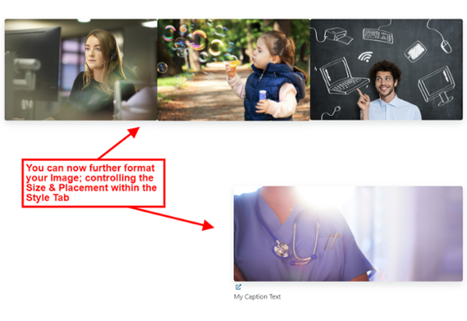 | CMS Support Team
4.2.13 New Plugin Resource Hub | Resource Hub is a newly added plugin to the CMS. This new Plugin will work in conjunction with your site categories. The Resource Hub will allow users to display mixed content within a list ie. Page,Link,File. This will then display Filter dropdown lists for your users to select to Filter the content displayed by any categories the content is marked with. Please refer to the CMS Support Site for full details on how to set these up on your site.  Resource Hub  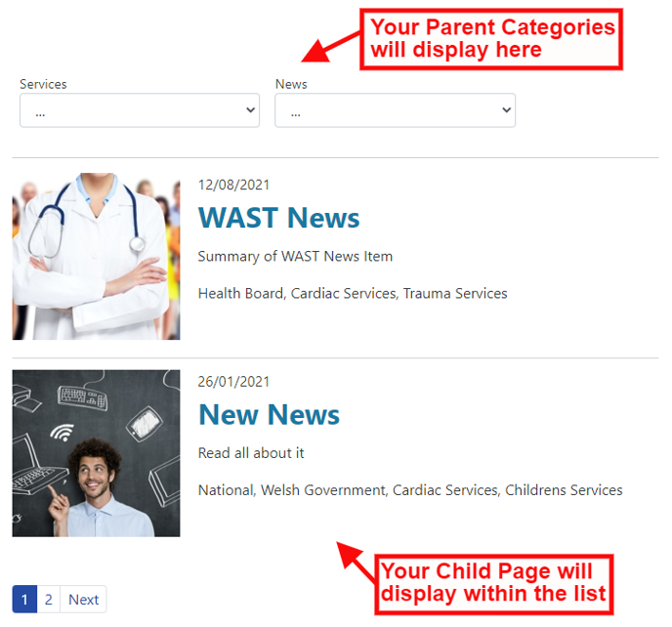 | CMS Support Team
4.2.14 New Plugin Horizontal Rule | Horizontal Rule is a newly added plugin to the CMS. This plugin will allow you to add formatted line breaks to your content. Please refer to the CMS Support Site or full details on how to set this up on your site.  Horizontal Rule  Examples  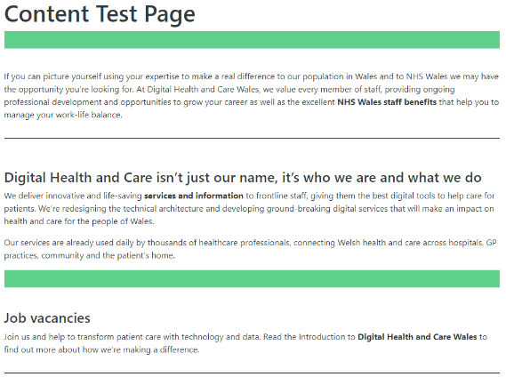  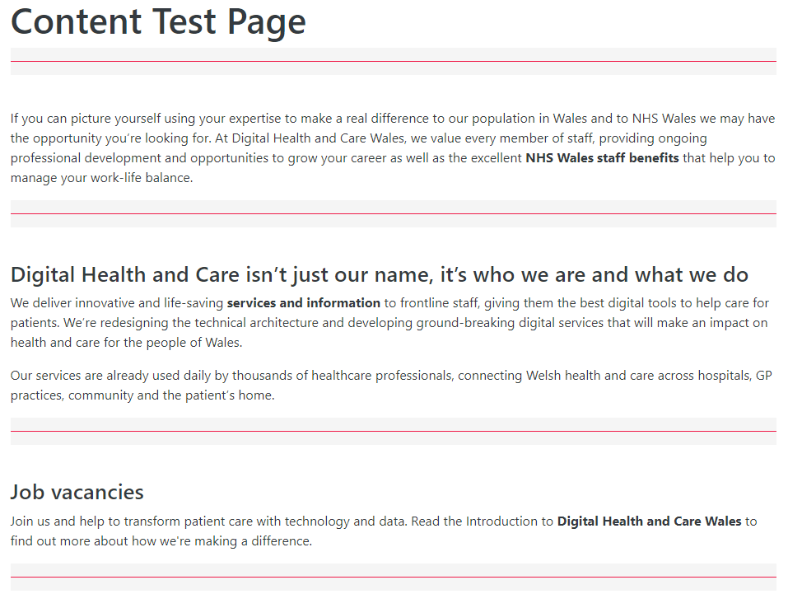 | CMS Support Team
4.2.15 Creating Friendly URLs | We have now introduced new functionality within the CMS that will allow Admins to create their own shortened Friendly URLs for any piece of content, this can be found in the Basic Tab on the Backend of your site. Please refer to the CMS Support Site or full details on how to set these up on your site.  Friendly URLs  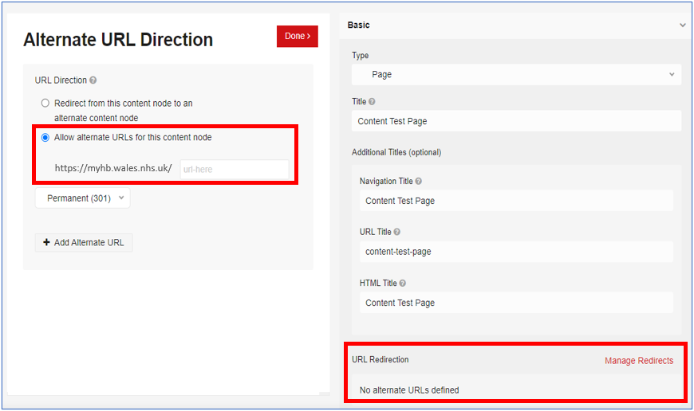 | CMS Support Team
4.2.16 Calendar Layout Update | We have introduced a new piece of functionality into the Calendar Layout, this will allow you to layer several separate calendars into one view for your users. Your users would then be able to Tick/Untick each Calendar by name to tailor their view. Please refer to the CMS Support Site or full details on how to set this up on your site.  Event Calendar  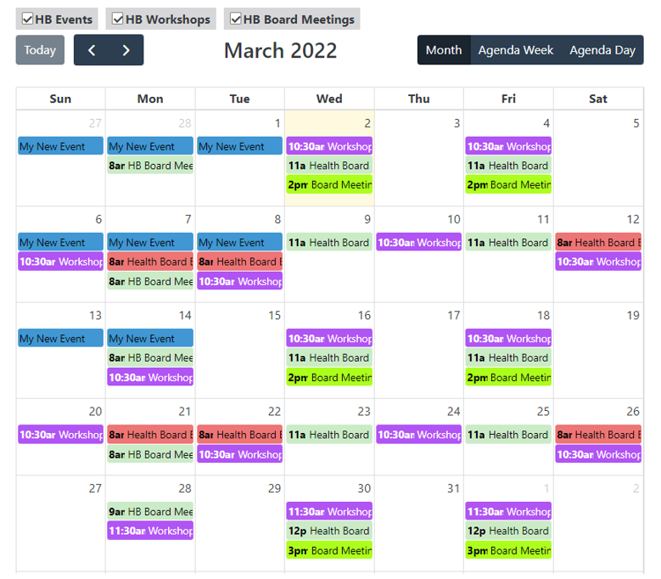 | CMS Support Team
4.2.17 Navigation Update | We have now introduced a Scroll bar for the Grey dropdown menu, this will indicate to users that there is further content available, and then allow users to scroll through this further content.  Navigation Updates  New Display  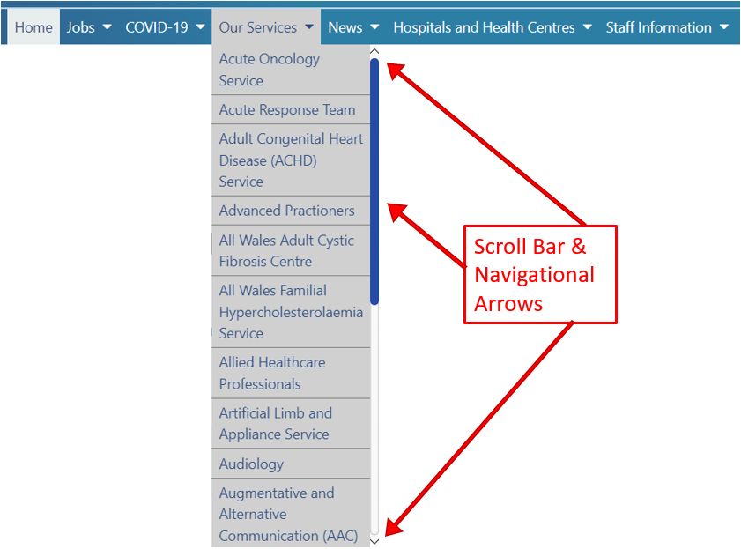 | CMS Support Team
4.2.18 XML Site Map | Google Sitemaps (for larger sites) are an easy way for webmasters to inform search engines about pages on their sites so that search engines can more intelligently crawl the site. Please refer to the CMS Support Site or full details on how to set this up on your site.  Google XML Sitemaps  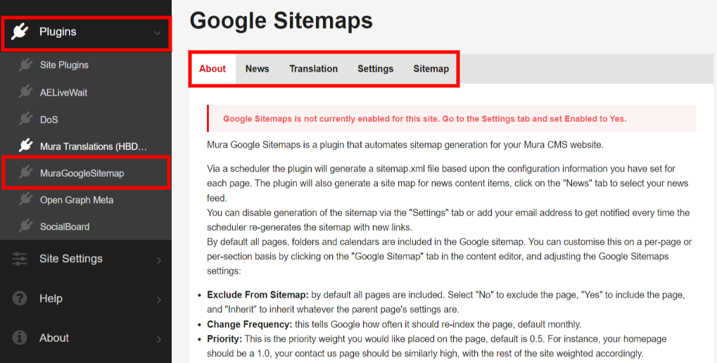 | CMS Support Team
Accessibility
4.2.19 A-Z Collection Layout Update | To meet Accessibility Guidelines, we have now made an update to the A-Z Collection Layout. The default colours within this plugin will now by default meet Accessibility Colour Contrast Guidelines. Users will still maintain the ability to amend the default colours to the colours of their choice. Please refer to the CMS Support Site or full details on how to set these up on your site.  A-Z Collection Layout  Old Display  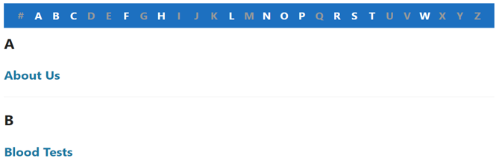  New Display  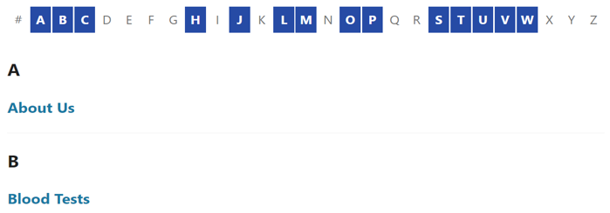 | CMS Support Team
4.2.20 ReadSpeaker Update in Carousels | We have now made an update to the ReadSpeaker to improve the functionality of this when used in conjunction with a Carousel. The ReadSpeaker will now read through all slides within the Carousel.  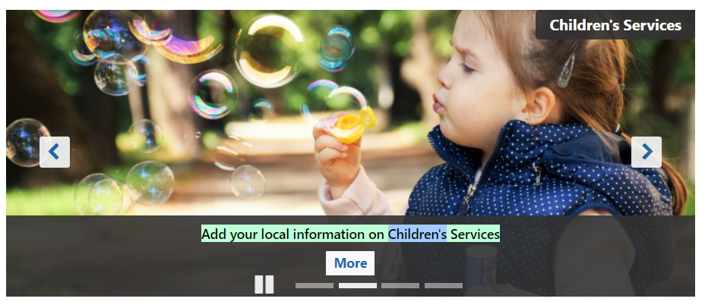 | CMS Support Team
4.2.21 ReadSpeaker Update Click & Listen | We have now enabled a further section within the ReadSpeaker. Your users will now be able to select ‘Click and Listen’ to activate this feature. Once activated ReadSpeaker will highlight and read a sentence when a user clicks anywhere within the sentence. On mobile devices, the feature works when you tap in the paragraph (‘Tap and Listen’). Please refer to the CMS Support Site or full details.  ReadSpeaker  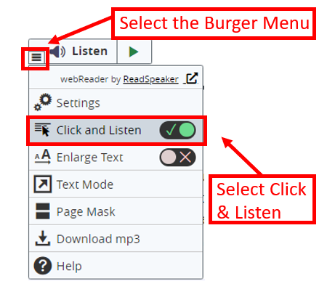  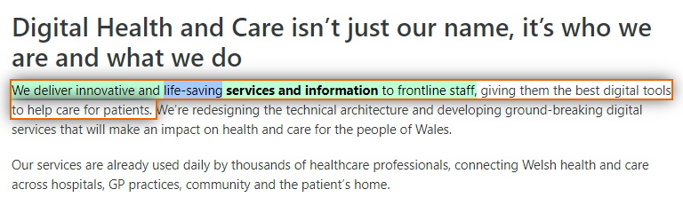 | CMS Support Team

Summary
Number of Changes | Number of TFS Wok Items | Number of TFS Work Tasks
21 | 37 (+mura 10work) – Over 5 Sprints | 52(+mura10work) – Over 5 Sprints

Full System Update | Bug Fixes | Plugin & Layout Updates | System Updates | New Functionality | Accessibility
1 | 2 | 3 | 3 | 9 | 3

Problems Fixed
N/A

New Problems Identified During Testing and Associated Workarounds
N/A

Pre-requisites to Deploy the Release
N/A

Training Requirements
CMS Support Site will be updated with any changes that introduce new functionality or changes to workflow.

Step by Step Deployment Instructions
No Deployment actions required by Health Boards.

Deployment Plan
Changes to be implemented as specified in the Change Record. Release to be deployed via change record: 100685

Back-Out Plan
Back out as detailed on each change record

Release Available for Deployment Date
NHS Wales CMS: 26/04/2022

