REL-ID 679 CMS/04-2021

NHS WALES IT SERVICE MANAGEMENT
CMS Release Notes
Release ID: 679 CMS/04-2021
These Release Notes describe the scope and content of
Release ID: 679 CMS/04-2021

CMS

Version No. 1.4
Status: Approved

Owner: CMS Service Management Board
Author: Helen McGrath
Approver: Michele Golpaykar-Rad
Date: 30/06/2021
Next Review Date: 21/07/2021
Tŷ Glan-yr-Afon
21 Heol Ddwyreiniol Y Bont-Faen, Caerdydd CF11 9AD
21 Cowbridge Road East, Cardiff CF11 9AD
Ffôn/Tel: 02920 500500
www.gggc.gig.cymru
www.nwis.nhs.wales

TABLE OF CONTENTS

1 DOCUMENT HISTORY 3
1.1 Revision History 3
1.2 Reviewers 3
1.3 Authorisation 3
2 INTRODUCTION 4
3 SERVICE MANAGEMENT BOARD (SMB) 4
4 RELEASE NOTES REQUIREMENT 4
4.1 Release Identification 4
4.2 Description of New or Modified Functionality 4
4.3 Summary 11
4.4 Problems Fixed 11
4.5 New Problems Identified During Testing and Associated Workarounds 11
4.6 Pre-requisites to Deploy the Release 11
4.7 Training Requirements 11
4.8 Step by Step Deployment Instructions 11
4.9 Deployment Plan 11
4.10 Back-Out Plan 11
4.11 Release Available for Deployment Date 11

DOCUMENT HISTORY

Revision History
Date | Version | Author | Revision Summary
30/06/2021 | 1.0 | Helen McGrath | Senior Support & Business Analyst
12/07/2021 | 2.0 | Helen McGrath | Senior Support & Business Analyst

Reviewers
This document requires the following reviews:
Date | Version | Name | Position
21/07/2021 | 3.0 | Michele Golpaykar-Rad | Principal Support & Business Analyst

Authorisation
Signing of this document indicates acceptance of its contents.
Author’s Name: | Helen McGrath
Role: | Senior Support & Business Analyst
Signature: |  | Date: | 21/07/2021

Approver’s Name: | Michele Golpaykar-Rad
Role: | Principal Support & Business Analyst
Signature: |  | Date: | 21/07/2021

INTRODUCTION
The NHS Wales Release Management Policy considers that effective Release Management is essential for protecting the integrity of the operational environment. A key objective of the release process is ensuring that users, support staff and other stakeholders are kept informed as to what is planned and how this will affect them. One of the ways that this can be achieved is through the publication of release notes prior to deployment of the Release.

These notes contain information on the agreed scope and content of Release id CMS/04-2021 for the CMS, descriptions of new or modified functionality and problem fixes, descriptions of new problems and workarounds identified during the testing of this Release, training requirements, deployment instructions, references to deployment and back-out plans and key dates within the release process.

SERVICE MANAGEMENT BOARD (SMB)
The CMS Service Management Board has overall responsibility for ensuring that these Release Notes accurately describes the Release and that it is kept under constant review and updated to reflect any modifications to the Release prior to its deployment.

RELEASE NOTES REQUIREMENT

Release Identification
679 CMS/04-2021

Description of New or Modified Functionality
Item | Description | Requestor
Bug Fixes
4.2.1 Alerts On-Screen | Some modules in which we are showing alerts for Admins; when a task has been completed incorrectly, are also displaying the alert message for site users. We have now added a fix so that these warnings will only appear to site Admins.  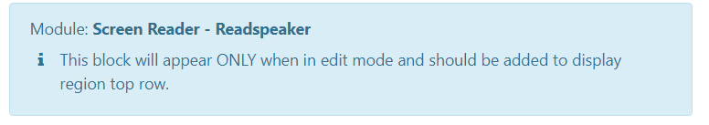 | CMS Support Team
4.2.2 Welsh Text within Events | During general testing, it was noticed that the Events pages on our Welsh Site are displaying days of the week in English. We have now implemented a fix to resolve this.  Current Display  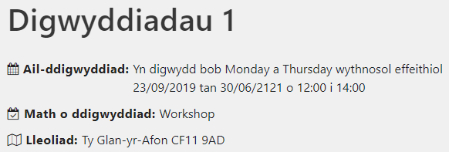  New Display  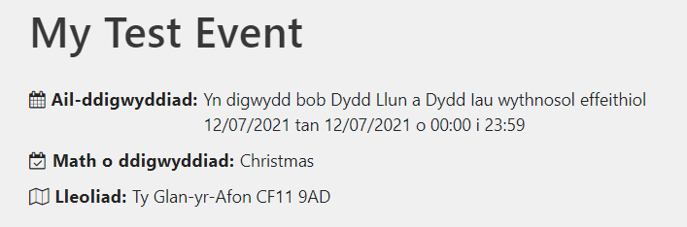 | CMS Support Team
System Updates
4.2.3 Navigation Menu Bar Update | This Navigation Bar update was approved at the Community of Practice Meeting.  On the Top-Level Navigation Bar (Blue Level) if there are more heading items than fit horizontally across the screen - the overflowing items can be seen by clicking on the 3 dots on the right of the menu bar. Sometimes the last item is only partially seen and isn't always clickable (for example if only the first couple of characters is visible).  We have now implemented a change so that as items start to fall off the Navigation Bar they will drop directly into a new menu.  System users also voted that the Grey Level Menu Bar would be more user friendly if amended from Horizontal to Vertical, this change has also now been implemented.  Current Site Navigation Bar – Top-Level  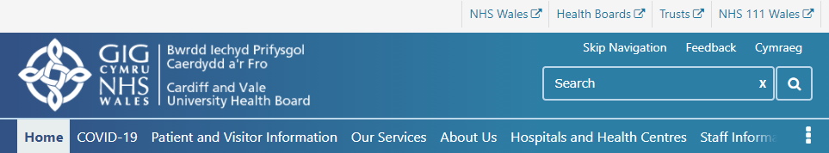  New Site Navigation Bar – Top-Level  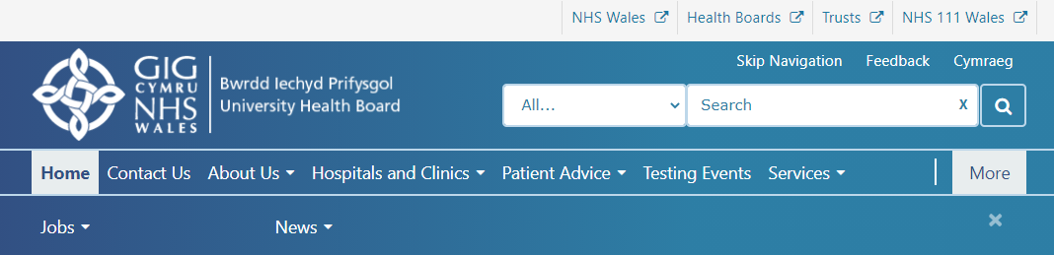  Current Site Navigation Bar – Horizontal Grey 2nd Level  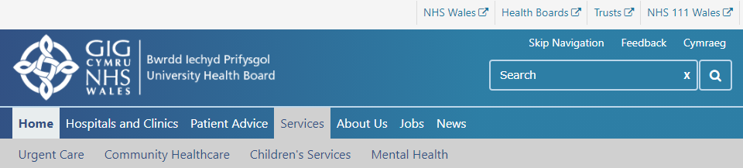  New Site Navigation Bar – Vertical Grey 2nd Level  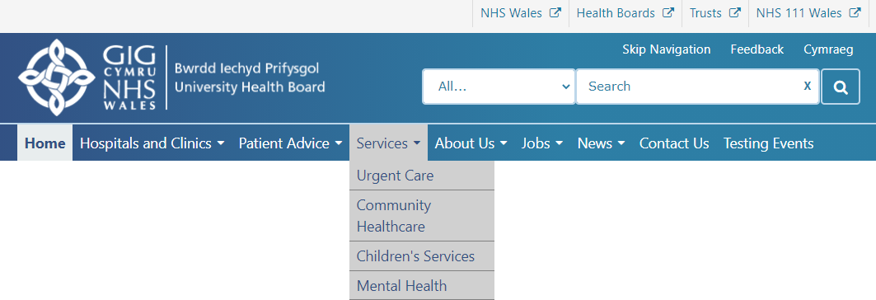 | CMS Support Team
4.2.4 Site Search Update – Contact Cards | Currently, users are unable to search; by name, for any Contacts that are created with the content-type: Page/Contact Card. A fix has now been implemented to allow Contact names to be searchable.   | CMS Support Team
4.2.5 Site Search Update - Breadcrumb | When using the Site Search currently similarly (or identically) named pages are brought back on the Search page, so a user has no way to differentiate between these pages.  A change has now been implemented so that all items brought back on the Search page will contain a Title, Summary and a Breadcrumb, in order for the user to identify where this item sits within the site.  Current Display  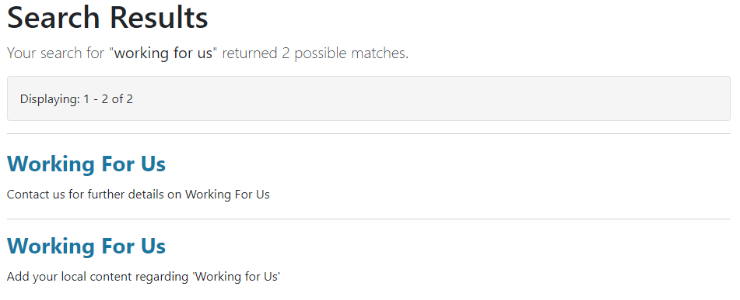  New Display  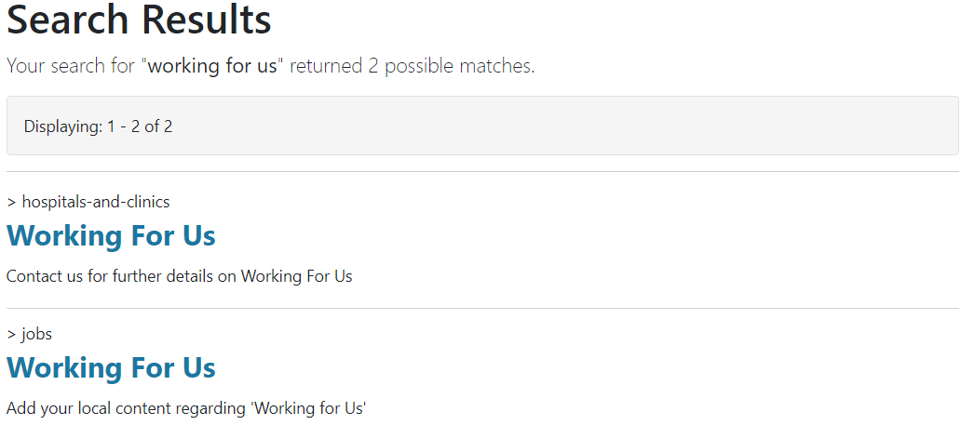 | PHW
4.2.6 Site Search Update – Additional Filter | We have now added extra functionality to the Site Search, this is a dropdown filter in order to further define searching. A dropdown box will now appear within the Search Bar, users will then see a dropdown list of all Titles (Areas) that are displayed on the Top-Level (Blue) Navigation Bar, When a user selects one of these any search the user runs will only be run against that specific area.  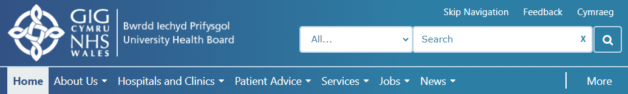  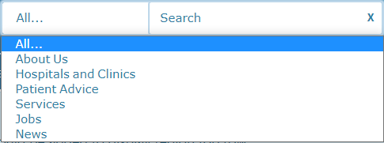 | CMS Support Team
4.2.7 Embed Plugin Title Field | When adding a Title (Label) to the Embed Plugin, currently this only allows the user to enter text with upper case letters. An update has now been added so that users can enter a fix of upper- and lower-case letters.  Current Display  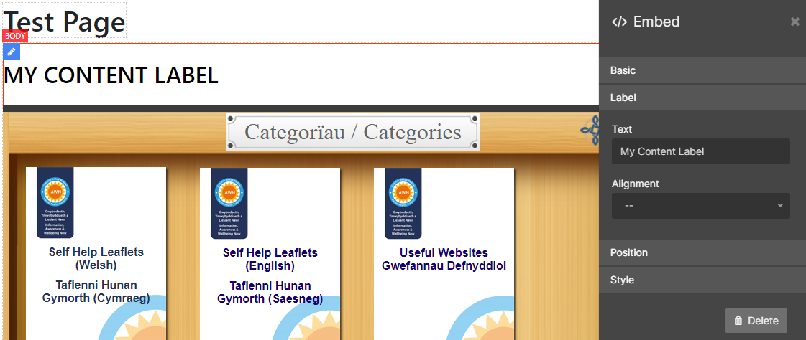  New Display  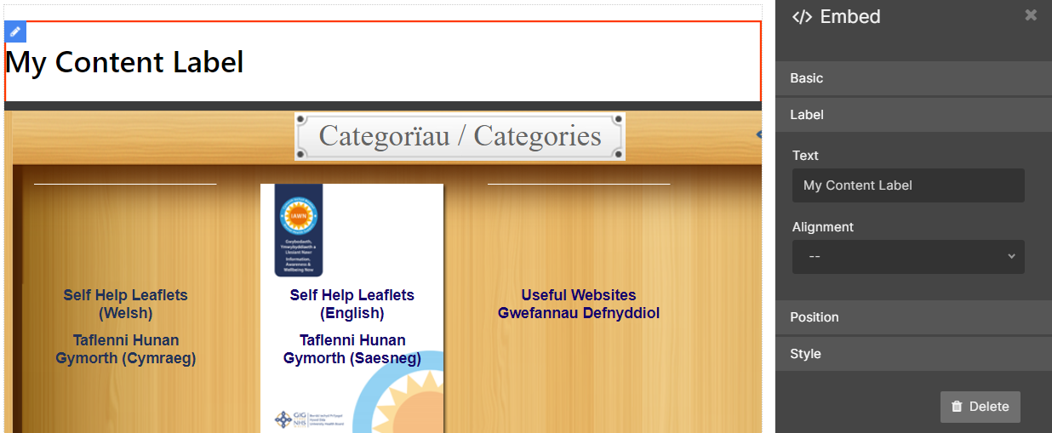 | CMS Support Team
4.2.8 Locked-Out Private Area Message Update | Within Password Protected areas where several people can share the same password, if one user locks out the account then all users will become affected. This can be confusing to users who know they have entered the password correctly. We have now added a user-friendly message informing the user that the account has been locked and letting them know the duration of time that this will last.  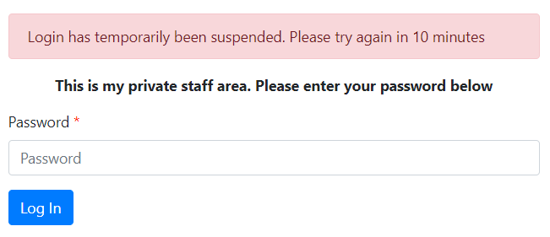 | CMS Support Team
Accessibility
4.2.9 Site Search Update – Colour Update | To aid users in identifying and accessing the Site Search we have amended the background colour within the Search Box to white and defaulted the text within to the sites default blue. This will allow the Search Box to stand out to users – This change is on a Desktop only.  Current Display New Display  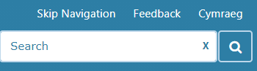  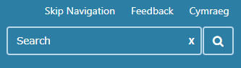 | PHW
4.2.10 Multi Content 1 - Mobile Update | When viewed on a mobile the Multi Content 1 Layout shrinks into a Carousel. To allow this to meet accessibility standards Navigation Arrows will automatically apply to this whenever viewed on a Mobile.  We have also added a swipe functionality in mobile to the Multi Content 1 & the Carousel Plugins.      Current Display New Display | CMS Support Team
New Functionality
4.2.12 Forms Update – Mandatory Fields | Within site Forms we have now added a Mandatory Field Indicator Icon (*) explanation that will display next to any questions that have Mandatory selected. Previously the Icon (*) had no explanation.  Current Display New Display  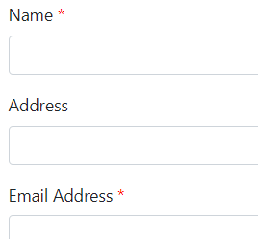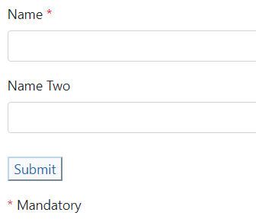 | CMS Support Team
4.2.13 Group Permissions Update | We have made an update to the process for when Site Admins are creating Site Permission Groups. Once a Group has been created this will be automatically allocated access to the site, this will remove one step that Admins currently have to complete on both their English and Welsh language sites. Admins will NO LONGER need to Go to Site Settings – Permissions – and tick the Group Access.  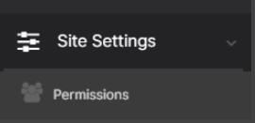  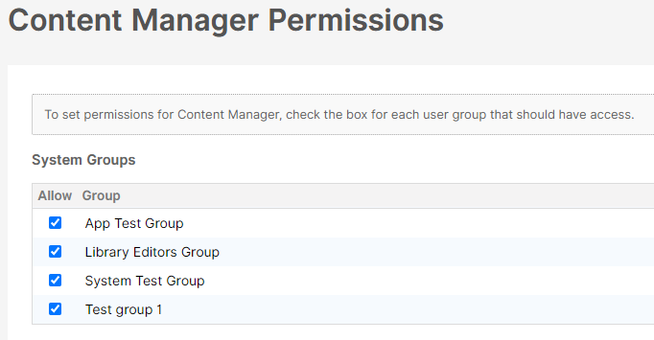 | CMS Support Team

Summary
Number of Changes | Number of TFS Work Items | Number of TFS Work Tasks
12 | 12 – Over 4 Sprints | 41 – Over 4 Sprints

Bug Fixes | System Updates | Accessibility | New Functionality
2 | 6 | 2 | 2

Problems Fixed
N/A

New Problems Identified During Testing and Associated Workarounds
Due to an incompatibility between the new menu and sticky menus on iOS, we have temporarily disabled sticky menus

Pre-requisites to Deploy the Release
N/A

Training Requirements
CMS Support Site will be updated with any changes that introduce new functionality or changes to workflow.

Step by Step Deployment Instructions
No Deployment actions required by Health Boards

Deployment Plan
Changes to be implemented as specified in the Change Record Release to be deployed via change record Change 97133

Back-Out Plan
Back out as detailed on each change record

Release Available for Deployment Date
NHS Wales: 07/09/2021

