Digital Health and Care Wales
NHS Wales IT Service Management

CMS MURA OCTOBER 2021 Release Notes | Release ID: 692

These Release Notes describe the scope and content of
Release ID: 692 for the CMS MURA Service

Version: | 1.0
Status: | Final
Owner: | Helen McGrath
Author: | Helen McGrath
Approver: | Michele Golpaykar-Rad

Date: | 07/10/2021
Next Review Date: | 14/10/2021

1 DOCUMENT HISTORY 4
1.1 Revision History 4
1.2 Reviewers 4
1.3 Authorisation 4
1.4 Document Location 4
2 INTRODUCTION 5
3 SERVICE MANAGEMENT BOARD (SMB) 5
4 RELEASE NOTES REQUIREMENT 5
4.1 Release Identification 5
4.2 Description of New or Modified Functionality 5
5 Summary 11
5.1 Problems Fixed 11
5.2 New Problems Identified During Testing and Associated Workarounds 11
5.3 Pre-requisites to Deploy the Release 11
5.4 Training Requirements 11
5.5 Step by Step Deployment Instructions 11
5.6 Deployment Plan 11
5.7 Back-Out Plan 11
5.8 Release Available for Deployment Date 11

DOCUMENT HISTORY

Revision History
Date | Version | Author | Revision Summary
28/09/2021 | 0.1 | Helen McGrath | Document created for September CMS MURA Release
06/10/2021 | 0.2 | Helen McGrath | Screenshots & Text Updated
14/10/2021 | 0.3 | Helen McGrath | Screenshots & Text Updated

Reviewers
This document requires the following reviews:
Date | Version | Name | Position
14/10/2021 | 1.0 | Michele Golpaykar-Rad | Principal Support & Business Analyst

Authorisation
Signing of this document indicates acceptance of its contents.
Author’s Name: | Helen McGrath
Role: | Senior Support & Business Analyst
Signature: | Helen McGrath

Approver’s Name: | Michele Golpaykar-Rad
Role: | Principal Support & Business Analyst
Signature: | Michele Golpaykar-Rad

Document Location
Type | Location
Electronic | CMS MURA Support Site – What’s New Section

INTRODUCTION
The NHS Wales Release Management Policy considers that effective Release Management is essential for protecting the integrity of the operational environment. A key objective of the release process is ensuring that users, support staff and other stakeholders are kept informed as to what is planned and how this will affect them. One of the ways that this can be achieved is through the publication of release notes prior to deployment of the Release.
These notes contain information on the agreed scope and content of Release id CMS/05-2021 for the CMS descriptions of new or modified functionality and problem fixes, descriptions of new problems and workarounds identified during the testing of this Release, training requirements, deployment instructions, references to deployment and back-out plans and key dates within the release process.

SERVICE MANAGEMENT BOARD (SMB)
The CMS Service Management Board has overall responsibility for ensuring that these Release Notes accurately describes the Release and that it is kept under constant review and updated to reflect any modifications to the Release prior to its deployment.

RELEASE NOTES REQUIREMENT

Release Identification
692 - CMS/05-2021

Description of New or Modified Functionality

Item | Description of the Change | Requestor
Bug Fixes
4.2.1 Advanced Table List - Multiple Lists Per Page | Currently only one Advance Table List can be placed per page. We have now made an update to the Advanced Table List; this change will allow admins to add more than one Advanced Table List to a page and allow that each list can work independently from each other. | CMS Support Team
4.2.2 Mobile Menu Updates | Currently some of the page publishing options are not functioning correctly, we have now added fixes for:  - Exclude from Mobile  - Include for Mobile only  - Exclude from Site Search  These options are now working as expected | CMS Support Team
4.2.3 Password Protected Areas | During testing for the New Style Menu, it was noticed that Password Protected areas were showing in the main nav bar. This has now been corrected, Password Protected Areas will not display within the site Nav if you do not have access to these. | CMS Support Team
4.2.4 Scheduling Content | Currently the Scheduling Content option is not functioning correctly, we have now added a fix that will ensure the Scheduled dates and times selected by the site Admin are reflected in the site Navigation. | CTMUHB
 | Layout Updates
4.2.5 Advanced Table List -Advanced Search | This update to the Advanced Table List will allow admins to add in further Advanced Search Options in relation to any extra columns that have been added through a site-specific document or page type.  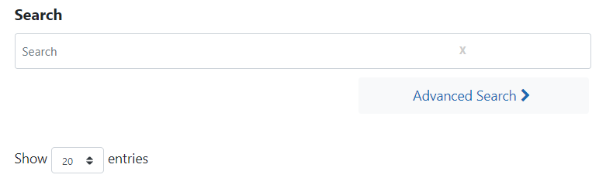  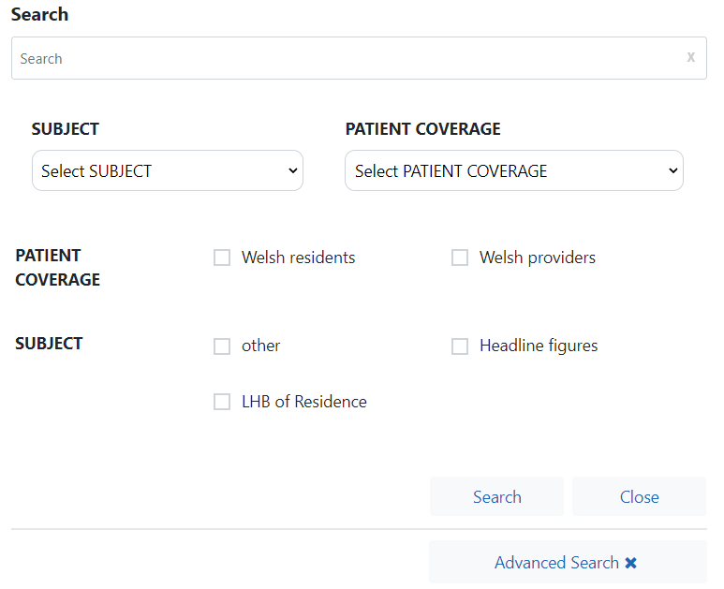 | CMS Support Team
4.2.6 Filter by Category Update | The filter by Category layout currently only displays Pages, we have now made an update to this Layout so that Files & Documents can now be displayed also.  We have also added in a new Tick Field ‘Show Badge Count’. Ticking this will display a number within the Tab if how many items have been tagged with this Category.  Display Example  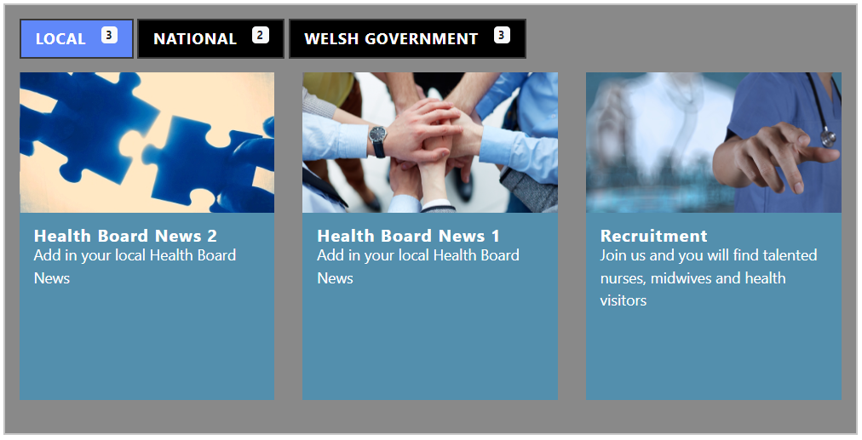 | CTMUHB
4.2.7 Additional Spacing options on a Mobile | 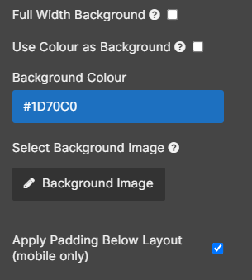  During testing it was noticed that the spacing on MultiContentDisplay1 (when viewed in a Mobile) can overlap content displayed below.  We have now added in extra padding options into the settings of this layout. The padding options will only apply to the Mobile view. | CMS Support Team
System Updates
4.2.8 Page Caching Update in Advanced Table List | To increase site performance we have now made an update to the Advanced Table List. This change will mean that only 1 page of data will be cached on a reload, this will increase the speed of the ATL bringing back results for users. | CMS Support Team
4.2.9 Read Speaker Update | A Screen Reader is an accessibility function that can be added to any page of your website. This function can aid your visually impaired readers with accessing your content. ReadSpeaker is an All-Wales Product which is free to use across all MURA NHS Wales websites. We have now made a code update to the ReadSpeaker to allow extra functionality.  Current Display New Display  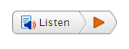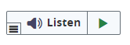  New Settings Options  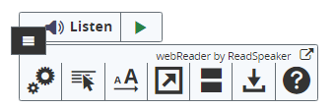 | CMS Support Team
Accessibility
4.2.10 Update to Nav Menu | To meet Web Accessibility Guidelines; we have updated the New style Navigation Bar. During testing it was noticed that there were some broken aria labels, these have now been updated. | CMS Support Team
New Functionality
4.2.11 New Video Header Layout | We have now created a New Layout Option within the Collection Plugin – Video Header. This new layout will allow admins to upload a display a short, muted Video Background Header.  Desktop Display  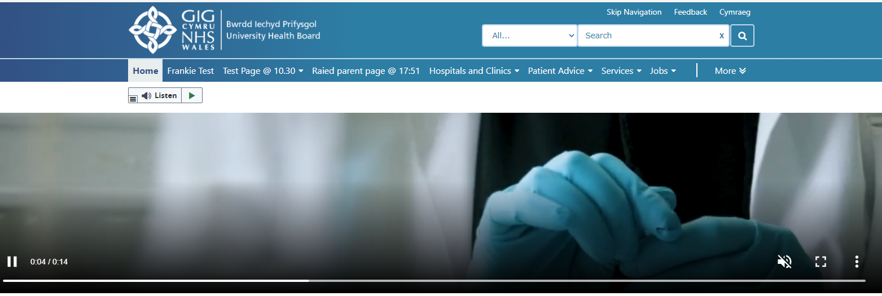 | CMS Support Team
4.2.12 New TravelLine Cymru Layout | *This item has been created but will NOT be release along with the full release on 27/10/21. This is due to several functionality issues that have been noted within the Welsh version of TravelLine These issues have been reported and passed over to Traveline Cymru’s web team to resolve. This item will go live as/when these issues are resolved by TravelLine Cymru.  We have now created a New Layout Option within the Collection Plugin. This new layout will allow admins to drag and drop a TravelLine Cymru module to their site page. The User will then enter the 'From' data and click 'Plan My Journey' to be taken to the Travel Link Cymru website for their travel details.  Desktop Display  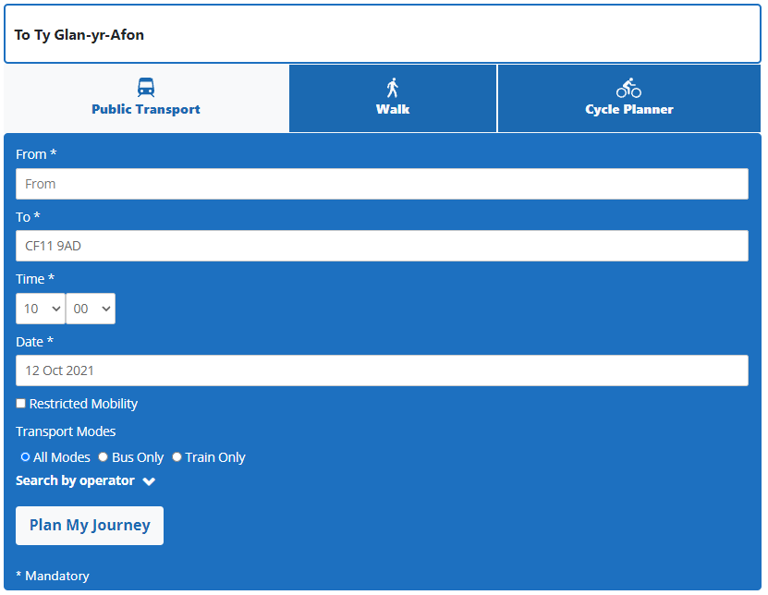  Mobile Display  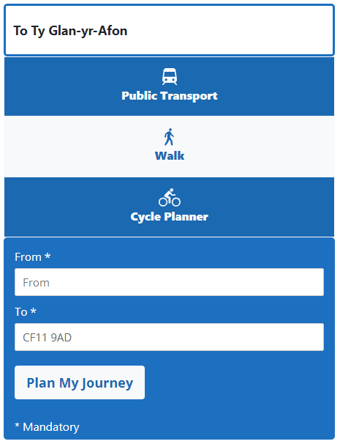 | ABUHB
4.2.13 New File Extension | A new file type extension has now been added into the CMS - .MP4 | CMS Support Team
4.2.14 New Image Gallery Layout | We have now amended the way in which admins will needed to add a Gallery Layout to a page. We have created a New Layout Option within the Collection Plugin. This new layout will allow admins to Drag and Drop an Image Gallery Module to their site page.  New Display    *Admins will no longer be able to add a Gallery through the Image Key on the CK Editor | HDUHB
4.2.15 Multi Point Map | We have now created a New Plugin – Multi Point Map. This new plugin will allow users to create Google Style Maps with the use of an uploaded .CSV file.  Map Display  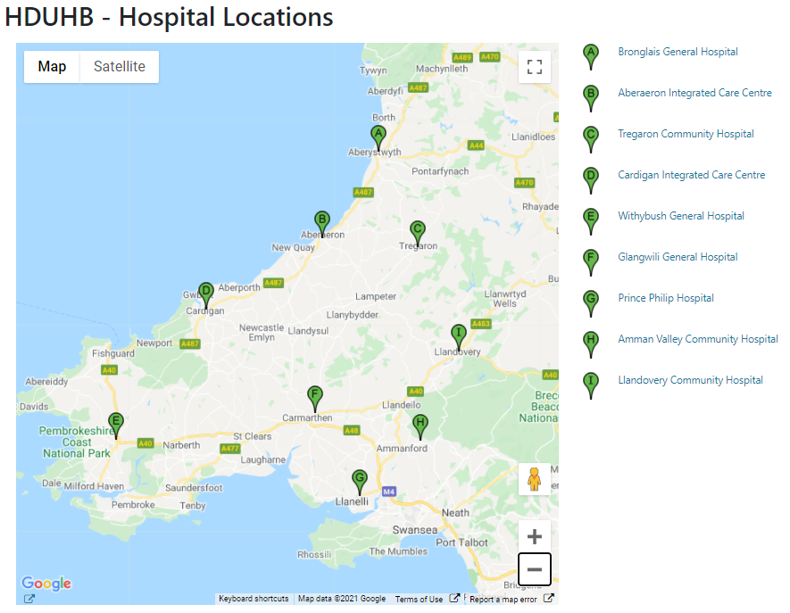 | HDUHB

Summary
Number of Changes | Number of TFS Wok Items | Number of TFS Work Tasks
15 | 31 – Over 5 Sprints | 60 – Over 5 Sprints

Bug Fixes | System Updates | Layout Updates | Accessibility | New Functionality
4 | 2 | 3 | 1 | 5

Problems Fixed
N/A

New Problems Identified During Testing and Associated Workarounds
Item 4.2.12 - Functionality issues have been reported and passed over to Traveline Cymru’s web team to resolve.

Pre-requisites to Deploy the Release
N/A

Training Requirements
CMS Support Site will be updated with any changes that introduce new functionality or changes to workflow.

Step by Step Deployment Instructions
No Deployment actions required by Health Boards.

Deployment Plan
Changes to be implemented as specified in the Change Record. Release to be deployed via change record: 100199

Back-Out Plan
Back out as detailed on each change record

Release Available for Deployment Date
NHS Wales CMS: 27/10/2021

