REL-ID 650 CMS/02-2021

NHS WALES IT SERVICE MANAGEMENT
CMS Release Notes
Release ID: 650 CMS/02-2021
These Release Notes describe the scope and content of
Release ID: 650 CMS/02-2021

CMS

Version No. 1.4
Status: Approved

Owner: CMS Service Management Board
Author: Helen McGrath
Approver: Michele Golpaykar-Rad
Date: 15/02/2021
Next Review Date: 15/04/2021
Tŷ Glan-yr-Afon
21 Heol Ddwyreiniol Y Bont-Faen, Caerdydd CF11 9AD
21 Cowbridge Road East, Cardiff CF11 9AD
Ffôn/Tel: 02920 500500
www.gggc.gig.cymru
www.nwis.nhs.wales

TABLE OF CONTENTS

1 DOCUMENT HISTORY 3
1.1 Revision History 3
1.2 Reviewers 3
1.3 Authorisation 3
2 INTRODUCTION 4
3 SERVICE MANAGEMENT BOARD (SMB) 4
4 RELEASE NOTES REQUIREMENT 4
4.1 Release Identification 4
4.2 Description of New or Modified Functionality 4
4.3 Summary 15
4.4 Problems Fixed 15
4.5 New Problems Identified During Testing and Associated Workarounds 15
4.6 Pre-requisites to Deploy the Release 15
4.7 Training Requirements 15
4.8 Step by Step Deployment Instructions 15
4.9 Deployment Plan 15
4.10 Back-Out Plan 15
4.11 Release Available for Deployment Date 16

DOCUMENT HISTORY

Revision History
Date | Version | Author | Revision Summary
15/02/2021 | 1.0 | Helen McGrath | Senior Support & Business Analyst
02/03/2021 | 2.0 | Helen McGrath | Senior Support & Business Analyst
07/04/2021 | 3.0 | Helen McGrath | Senior Support & Business Analyst

Reviewers
This document requires the following reviews:
Date | Version | Name | Position
15/04/2021 | 3.0 | Michele Golpaykar-Rad | Principal Support & Business Analyst

Authorisation
Signing of this document indicates acceptance of its contents.
Author’s Name: | Helen McGrath
Role: | Senior Support & Business Analyst
Signature: |  | Date: | 15/04/2021

Approver’s Name: | Michele Golpaykar-Rad
Role: | Principal Support & Business Analyst
Signature: |  | Date: | 15/04/2021

INTRODUCTION
The NHS Wales Release Management Policy considers that effective Release Management is essential for protecting the integrity of the operational environment. A key objective of the release process is ensuring that users, support staff and other stakeholders are kept informed as to what is planned and how this will affect them. One of the ways that this can be achieved is through the publication of release notes prior to deployment of the Release.

These notes contain information on the agreed scope and content of Release id CMS/02-2021 for the CMS, descriptions of new or modified functionality and problem fixes, descriptions of new problems and workarounds identified during the testing of this Release, training requirements, deployment instructions, references to deployment and back-out plans and key dates within the release process.

SERVICE MANAGEMENT BOARD (SMB)
The CMS Service Management Board has overall responsibility for ensuring that these Release Notes accurately describes the Release and that it is kept under constant review and updated to reflect any modifications to the Release prior to its deployment.

RELEASE NOTES REQUIREMENT

Release Identification
650 CMS/02-2021

Description of New or Modified Functionality
Item | Description | Requestor
Bug Fixes
4.1.1 Error Page Update | We have updated the 500 Error message page. This page previously displayed a broken ‘Previous Page’ Link, this has now been removed.  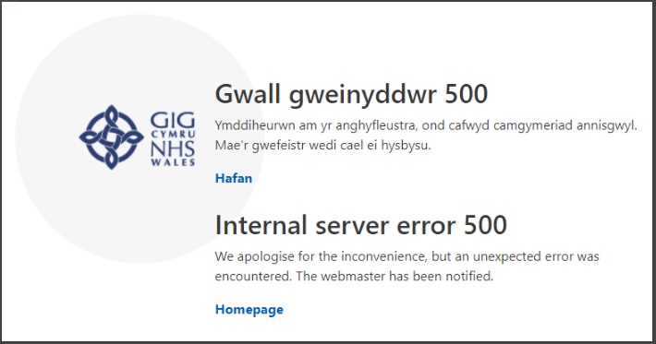 | HEIW
4.2.2 Galleries in IE | When viewed on IE, on the first load the gallery loads as expected but refreshing the page causes the gallery to become unavailable. This issue has now been resolved. | CMS Support Team
4.2.3 Archive Navigation Block | Currently When Archive Navigation is used, the navigation block recognises how many items are in each month (eg July 2020 has 23 items as in image) - but when you click on the month the results in the main pane are not filtered to only show those items.  A fix has now been implemented so that when a user now clicks on a month within the Archive Navigation block the items within the display pane will then filter by this.  Current Display  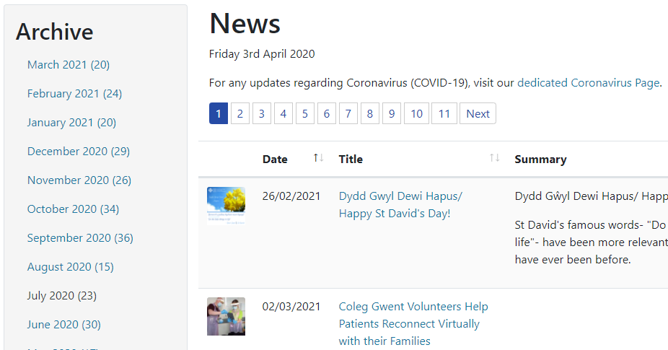  New Display  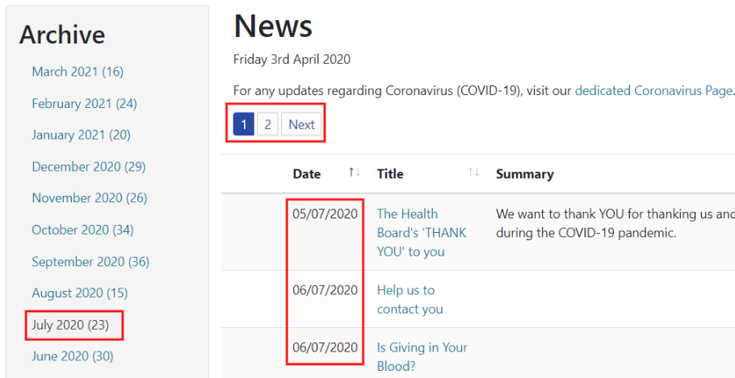 | HDUHB
System Updates
4.2.4 Carousel Update | We have updated the Carousel with additional functionality regarding how text added by a site admin is then displayed.  1. The ability to position text to left or right, rather than in the box at the bottom of the slide  2. The ability to add a gradient colour background, with a slider to adjust this in the configurator  Current Display    New Display Options  Text Left – with Gradient  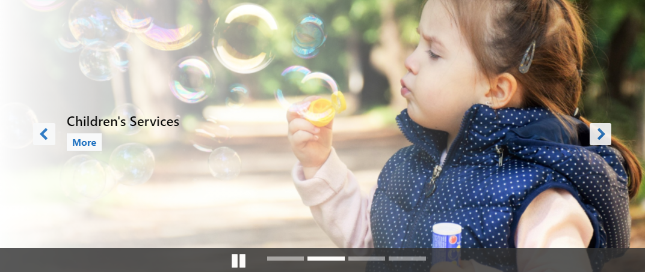  Text Right – with Gradient    Text Left – with No Gradient  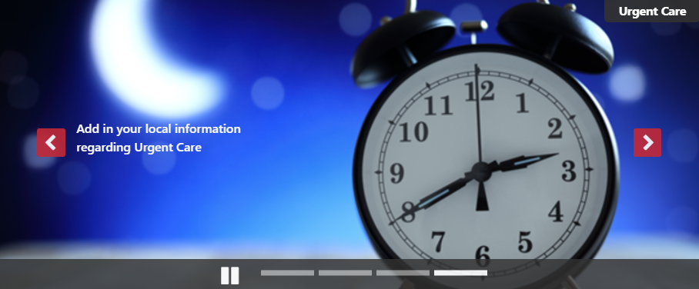 | PHW
4.2.5 Carousel Update 2 | We have updated the Carousel with additional functionality regarding the text that is displayed when the Carousel is viewed on a Mobile. We have introduced/updated the options within the Carousel options.  - 'Show/Hide Top Title Section Desktop'  - 'Show/Hide Top Title Section Mobile'  These options will allow further information to be displayed on a mobile view whilst not effecting the Desktop view layout  Mobile Display  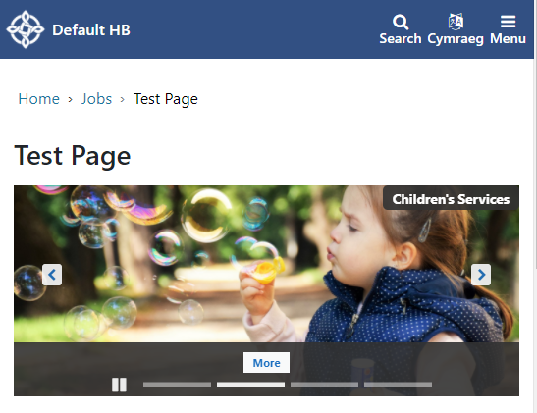 | BCUHB
4.2.6 Grid Layout Update | We have made an update to the Grid Layout to allow site admins the ability to change the colour of the title text displayed in this area. This new option is named ‘Link text colour’ in the layout settings.  Current Display    New Display   | PHW
4.2.7 Box Block Update | Currently the colours display on the Box Block Layout are fixed as shown below. We have now added 4 colour picker boxes to allow site admins the ability to change the colours displayed in this area. As a second change we have also decreased the size to the title text displayed on these blocks.  Current Display – Set Colours & Current Font Size: 200%  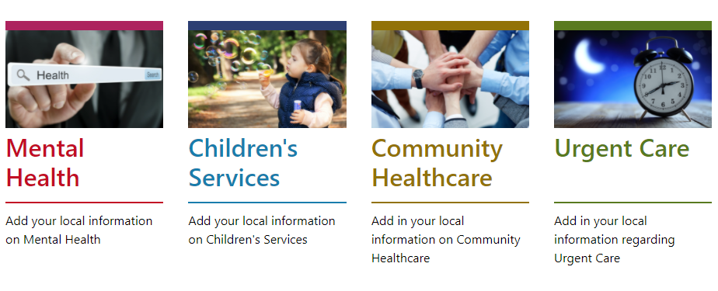  New Display – User Pick of Colours & New Font Size: 150%   | PHW
4.2.8 Single Content 4 Update | We have made an update to the Single Content 4 Layout, this will allow site admins to position text Left, Right or Centre. We have also added a new setting to allow for the background to be a gradient colour  Current Display    New Display Options  Using an Image – With Gradient – Text Left    Using a Block Colour – With Gradient -Text Right   | PHW
4.2.9 Single Content Block 4 Mobile Display Update | When the Single Content Block 4 is viewed on a mobile platform there is not enough real estate to reflect the Gradient (If any has been selected). We have made an amendment that when viewed on a mobile; if a gradient has been selected (and subsequently removed) the text on the block will now appear within a contrasting coloured block background.  Mobile View  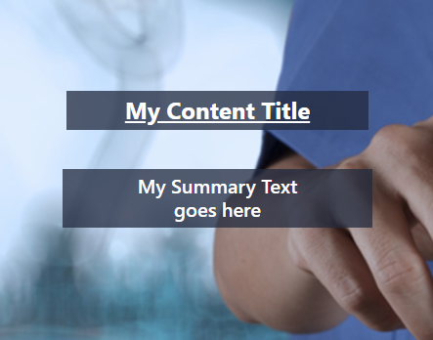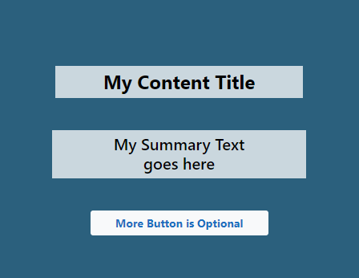 | CMS Support Team
4.2.10 Medical Performers List Update | Previously within Cascade a registration date was displayed when you hovered over 'Locum GMPI'. We have now made an update so that when you hover over the tick within the 'Locum GMPI' column the Registration Date will now display. | NWSSP
Accessibility
4.2.11 Colour Checker | To aid site admins in creating accessible websites we have introduced a new settings option within several our Layouts. This will allow admins to compare the colours that they are using and will provide a result as to whether these colours meet accessibility standards. The results provided would be an exclamation mark, AA or AAA icons depending on the result.  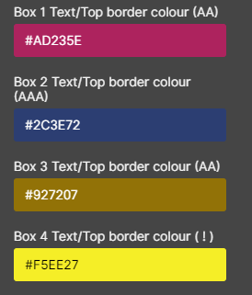  New Settings Option – (As displayed in Box Block Layout)  ! = Fails Accessibility Guidelines  AA = Meets AA Accessibility Guidelines  AAA = Meets AAA Accessibility Guidelines | CMS Support Team
4.2.12 Update ALT Text in Default Layout | To meet Web Accessibility Guidelines; we have updated the ALT Text that is linked to the images within the Default Layout. These images will now honour any ALT Text that has been added to the image.  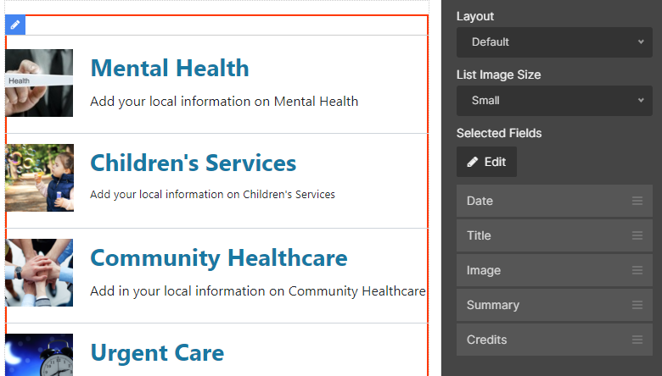 | CMS Support Team
4.2.13 Button Hover-Over Colour | To meet Web Accessibility Guidelines; we have updated the default colours of some of the layout buttons when the buttons are hovered over.  Old Default Colour: #1D70C0  New Default Colour: #1B69B1 | CMS Support Team
New Functionality
4.2.14 Additional Layout A-Z Block | We have created a new A-Z Block that will automatically poll in your content. This new A-Z Block can be found within the Collections Plugin. Once this is dragged to your chosen area admins can then amend the colours as you wish within the settings panel. To add your content, you would need to pull in a Local Index List, this list will then auto populate the A-Z Block with all links added automatically.  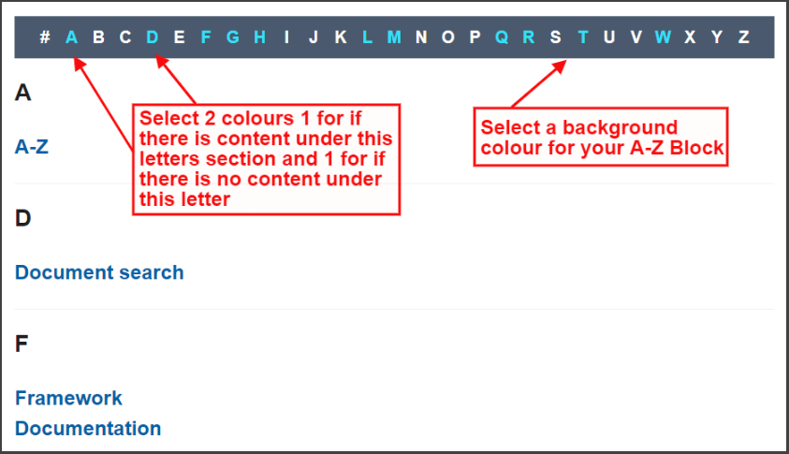 | CMS Support Team/WG
4.2.15 Additional New File Type | We have added the ability to upload an additional File Type .xlsb (Excel Binary Workbook)  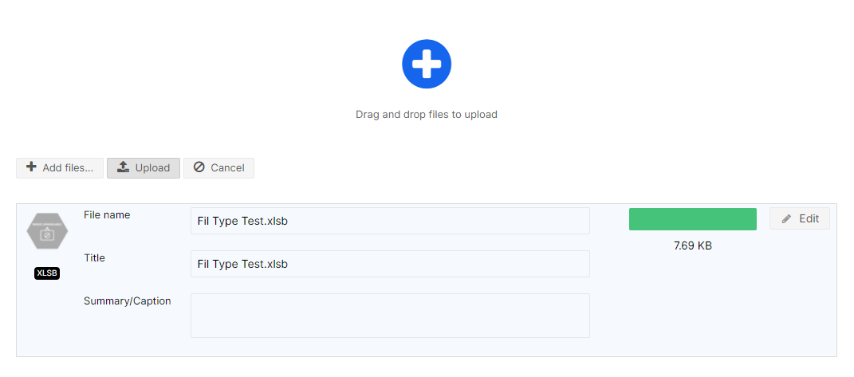 | PHW
4.2.16 Additional Layout – Grid 2 | We have created a New Layout ListAdvanced. When documents are displayed within this list type the user will have the ability to show/hide Date & Category metadata that your documents/page have been Categorized with.  Metadata Shown  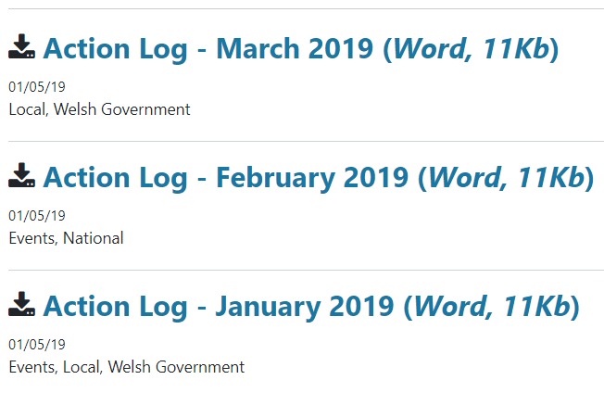  Metadata Not Shown  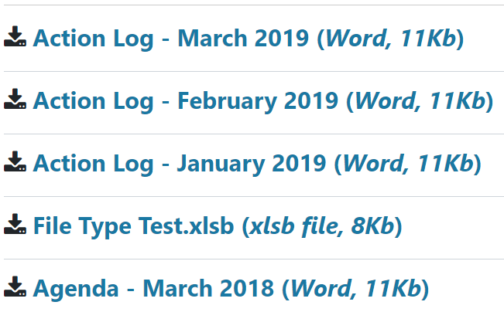 | CMS Support Team/WG
4.2.17 Additional Layout – Multi Content Display 3 | We have created a New Layout Multi Content Display 3. The Multi Content display 3 is an alternative to using a carousel.  Adding this layout to any page on your site provides a way of linking to up to 4 different pieces of content. The Image, Title & Summary of the content items will then be displayed. The module does require images, so if no image is set to the items the "no image available" image will display.  Desktop Display    Mobile Display  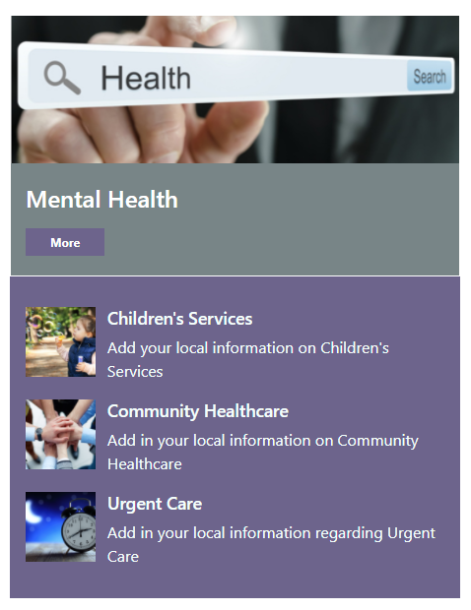 | CMS Support Team/WG

Summary
Number of Changes | Number of TFS Work Items | Number of TFS Work Tasks
17 | 26 – Over 7 Sprints | 53 – Over 7 Sprints

Bug Fixes | System Updates | Accessibility | New Functionality
3 | 7 | 3 | 4

Problems Fixed
N/A

New Problems Identified During Testing and Associated Workarounds
N/A

Pre-requisites to Deploy the Release
N/A

Training Requirements
CMS Support Site will be updated with any changes that introduce new functionality or changes to workflow.

Step by Step Deployment Instructions
No Deployment actions required by Health Boards

Deployment Plan
Changes to be implemented as specified in the Change Record Release to be deployed via change record 91311

Back-Out Plan
Back out as detailed on each change record

Release Available for Deployment Date
NHS Wales: 05/05/2021

