REL-ID 673 CMS/03-2021

NHS WALES IT SERVICE MANAGEMENT
CMS Release Notes
Release ID: 673 CMS/03-2021
These Release Notes describe the scope and content of
Release ID: 673 CMS/03-2021

CMS

Version No. 1.4
Status: Approved

Owner: CMS Service Management Board
Author: Helen McGrath
Approver: Michele Golpaykar-Rad
Date: 25/05/2021
Next Review Date: 16/06/2021
Tŷ Glan-yr-Afon
21 Heol Ddwyreiniol Y Bont-Faen, Caerdydd CF11 9AD
21 Cowbridge Road East, Cardiff CF11 9AD
Ffôn/Tel: 02920 500500
www.gggc.gig.cymru
www.nwis.nhs.wales

TABLE OF CONTENTS

1 DOCUMENT HISTORY 3
1.1 Revision History 3
1.2 Reviewers 3
1.3 Authorisation 3
2 INTRODUCTION 4
3 SERVICE MANAGEMENT BOARD (SMB) 4
4 RELEASE NOTES REQUIREMENT 4
4.1 Release Identification 4
4.2 Description of New or Modified Functionality 4
4.3 Summary 12
4.4 Problems Fixed 12
4.5 New Problems Identified During Testing and Associated Workarounds 12
4.6 Pre-requisites to Deploy the Release 12
4.7 Training Requirements 12
4.8 Step by Step Deployment Instructions 12
4.9 Deployment Plan 12
4.10 Back-Out Plan 12
4.11 Release Available for Deployment Date 13

DOCUMENT HISTORY

Revision History
Date | Version | Author | Revision Summary
25/05/2021 | 1.0 | Helen McGrath | Senior Support & Business Analyst
07/06/2021 | 2.0 | Helen McGrath | Senior Support & Business Analyst
16/06/2021 | 3.0 | Helen McGrath | Senior Support & Business Analyst

Reviewers
This document requires the following reviews:
Date | Version | Name | Position
16/06/2021 | 3.0 | Michele Golpaykar-Rad | Principal Support & Business Analyst

Authorisation
Signing of this document indicates acceptance of its contents.
Author’s Name: | Helen McGrath
Role: | Senior Support & Business Analyst
Signature: |  | Date: | 16/06/2021

Approver’s Name: | Michele Golpaykar-Rad
Role: | Principal Support & Business Analyst
Signature: |  | Date: | 16/06/2021

INTRODUCTION
The NHS Wales Release Management Policy considers that effective Release Management is essential for protecting the integrity of the operational environment. A key objective of the release process is ensuring that users, support staff and other stakeholders are kept informed as to what is planned and how this will affect them. One of the ways that this can be achieved is through the publication of release notes prior to deployment of the Release.

These notes contain information on the agreed scope and content of Release id CMS/03-2021 for the CMS, descriptions of new or modified functionality and problem fixes, descriptions of new problems and workarounds identified during the testing of this Release, training requirements, deployment instructions, references to deployment and back-out plans and key dates within the release process.

SERVICE MANAGEMENT BOARD (SMB)
The CMS Service Management Board has overall responsibility for ensuring that these Release Notes accurately describes the Release and that it is kept under constant review and updated to reflect any modifications to the Release prior to its deployment.

RELEASE NOTES REQUIREMENT

Release Identification
673 CMS/03-2021

Description of New or Modified Functionality
Item | Description | Requestor
Bug Fixes
4.1.1 Welsh Search Results URL | In Welsh sites the search pages with ‘search-results’ Vs ‘canlyniadau-chwilio’ in the URL title may work correctly to display the page. We have now added a fix so that either URL title will display the Search Results page.  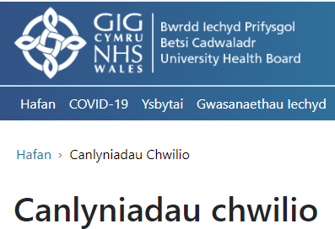 | CMS Support Team
4.2.2 Update to Grid Images | Currently when Grid image is used within the Grid module, as the page size is shrunk down in size the Grid Images fall out of alignment. We have now added a fix to resolve this so that the Grid Images will remain in-line with each other across all platform sizes.  Current Display  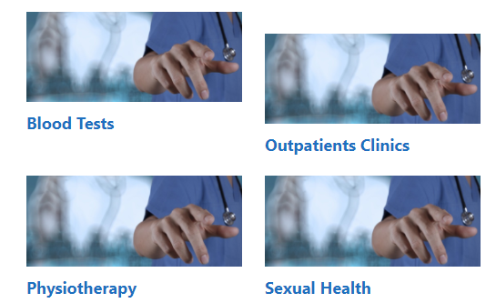  New Display  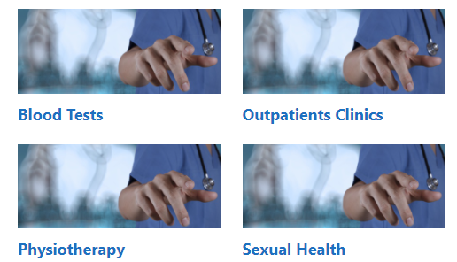 | CMS Support Team
4.2.3 Search Result Text | The Summary text within the Search Results area doesn’t always display Non-Breaking space (&nbsp;) correctly. We have now added a fix to the system to repair this issue.  Current Display  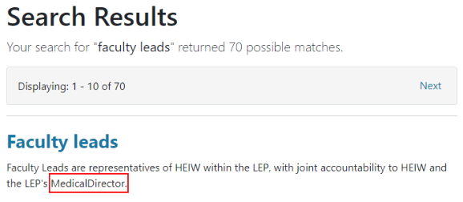  New Display  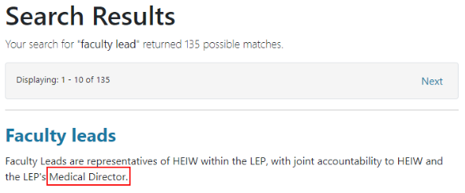 | HEIW
4.2.4 Advanced Table List Update | Within the Advanced Table Lists when new Columns are added within the Class Extensions area, the Multi Display Option is not allowing Multiple options to be displayed. A fix has now been added to repair this.  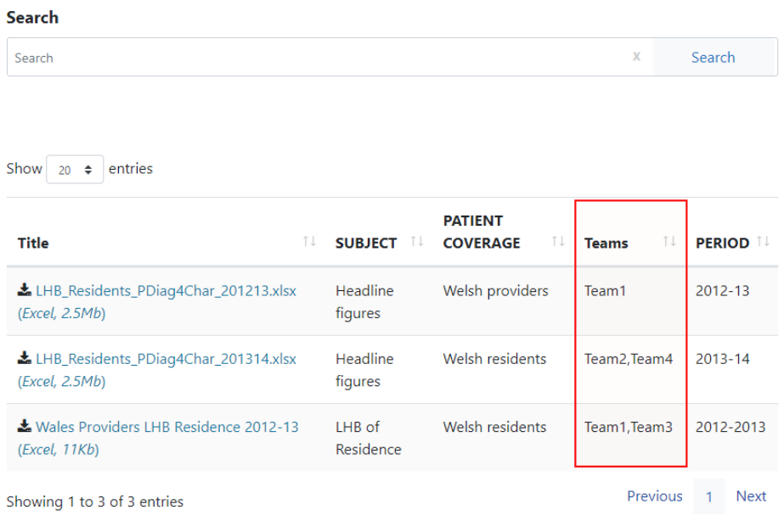 | CMS Support Team
System Updates
4.2.5 Update to Document Details | Currently when listing Document Items within some of the site plugins and modules the document details are not listed. We have now updated the system to that the document type (eg.PDF/Word/Excel etc) and Size (eg.187kb) will automatically display.  These will now display in: Default, FAQ List, List, List Advanced, Table List, Advanced Table List & Tabbed Content.  Examples: List & FAQ List  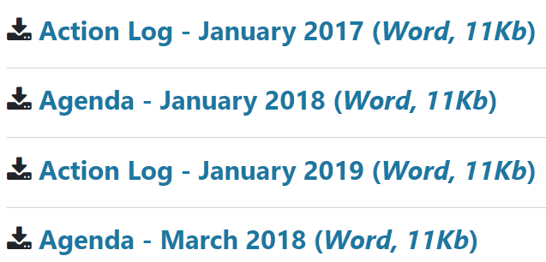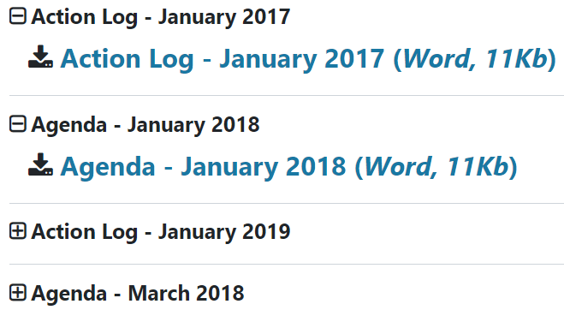 | CMS Support Team
4.2.6 Images Displaying on Events | We have now given Admins the ability to add images within content of Events. These can now be added through the Image Key on the CK Editor.  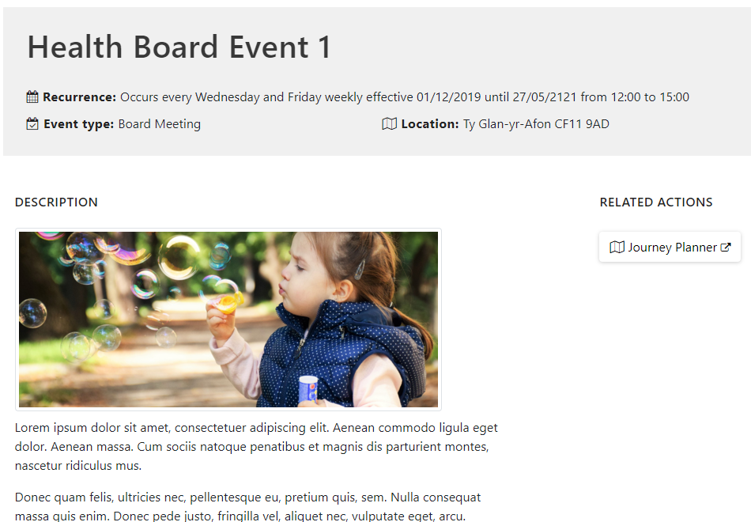 | DHCW
4.2.7 Filter By Category Update | The current Filter By Category layout displays an ‘Hide ‘ALL’ Tab’ by default. We have now created an additional option available within the Filter By Category settings to allow users to remove this option if required. We have also added in a small fix for pages using quotation marks, these can now be featured on the Filter By Category layout.  Current Display  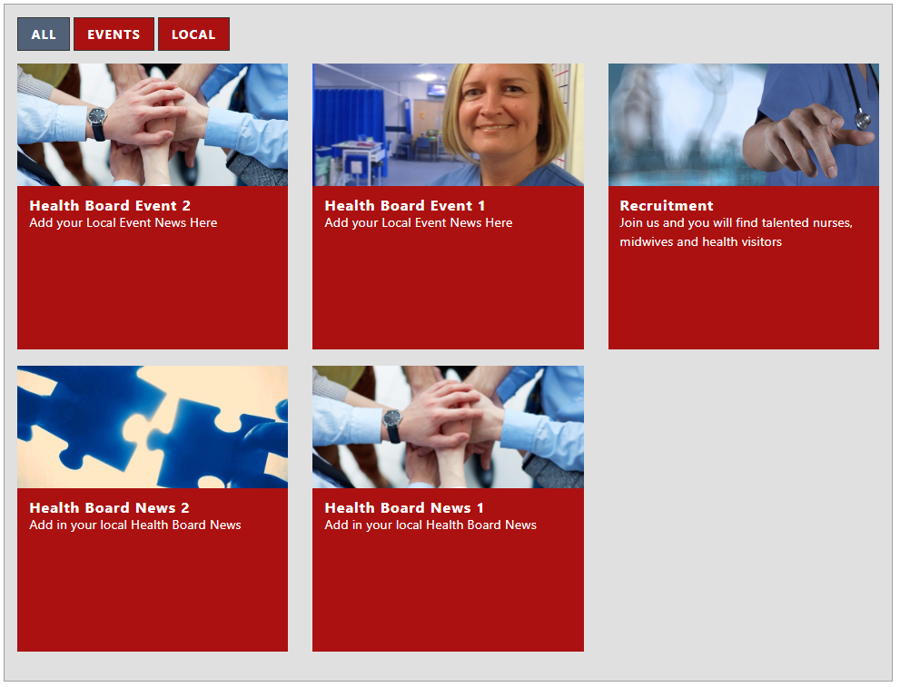  New Display Option   | CTMUHB
4.2.8 Table List Ordering Update | Currently the Table List is limited on how the content within can be ordered. We have now created an additional option available within the Table List settings. This will be in the form of a new dropdown field named ‘Order by Column’ that will then allow users to select which column the content should then order by.  Filtering by Column 1  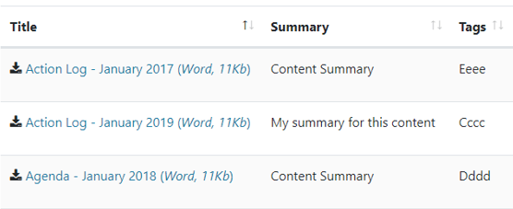  Filtering by Column 3  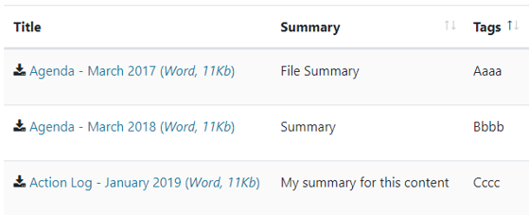 | PHW
4.2.9 Multi Content 1 Mobile Update | The Multi Content 1 when displayed on a Mobile becomes a Carousel. If the More Button/Indicator Arrows have been set as white (on the desktop) then the first (Active Indicator) appears to be missing. We have now added a new option within the Multi Content 1 settings called show/hide button.  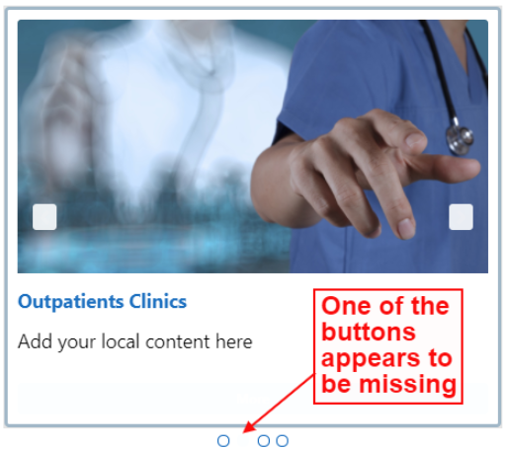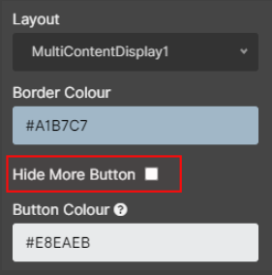 | HEIW
4.2.10 Advanced Table List Update 2 | We have made an update to the Advanced Table List to make some of the ‘Class Extensions Columns’ searchable on 'Page' Content type.  We have now made the Text Box option a searchable field and will work on making more of the column types searchable over the next few sprints of work.  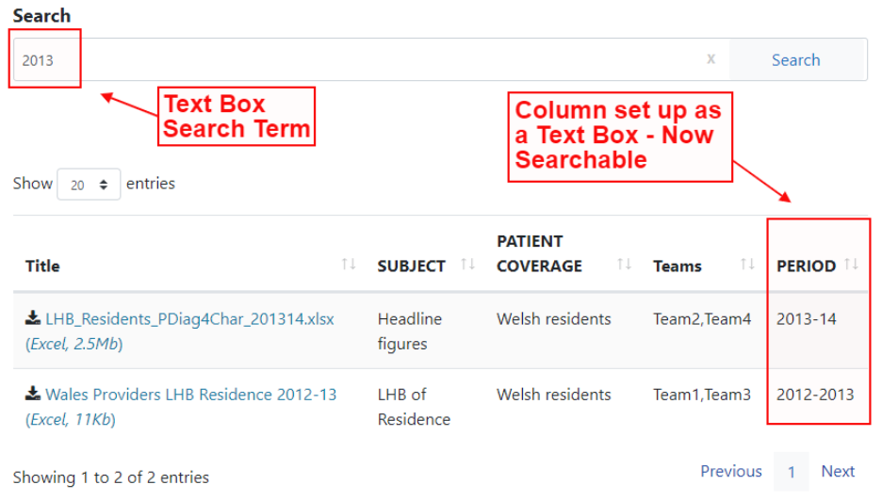 | CMS Support Team
4.2.11 Trac Code Update | We have now made a change to the snippet code for Trac which has recently been updated. This has included updating the styles and aria labels. This will not cause any disruption for the users. | PHW
4.2.12 Google Analytics Update | We have now updated the Google Analytics plugin to allow the use of ‘Google Analytics 4’ within the Mura CMS Sites. We can now accept both code types (G-xxxxxxx or UA-xxxxxx). | CMS Support Team
4.2.13 Update to Site Search | We have now made an improvement to the site search. This is a part of ongoing improvements that are being made to the Site Search.  We have added a ‘Like Words’ functionality.  This will mean that when a Search is conducted on a word such as ‘Health’  The results brough back would include results for other ‘Like Words’ such as ‘Healthy’, ‘Health Care’, ‘Health Board’ etc. | CMS Support Team
Accessibility
4.2.14 Accessibility on Mobile Navigation | The Mobile Navigation is currently showing accessibility errors for empty buttons on the mobile Chevrons, which are showing as empty buttons. We have now made a code change to resolve this issue. | HEIW
4.2.15 Accessibility on Multi Content 1 | The Multi Content 1 layout is currently showing accessibility errors for empty buttons on the content boxes, which are showing as empty buttons. We have now made a code change to resolve this issue. | HEIW
New Functionality
4.2.16 Update to the Internal Site Search | We have now made an update to the Internal Site Search that will allow users to Exclude content from the External Site Search but still allow the content to be found and added when adding content to plugins and Layouts. i.e. Box Block/Multi Content Displays etc  Exclude from Site Search  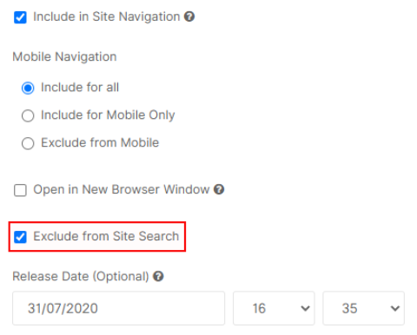  Available within the ‘Custom Edit Search Box’  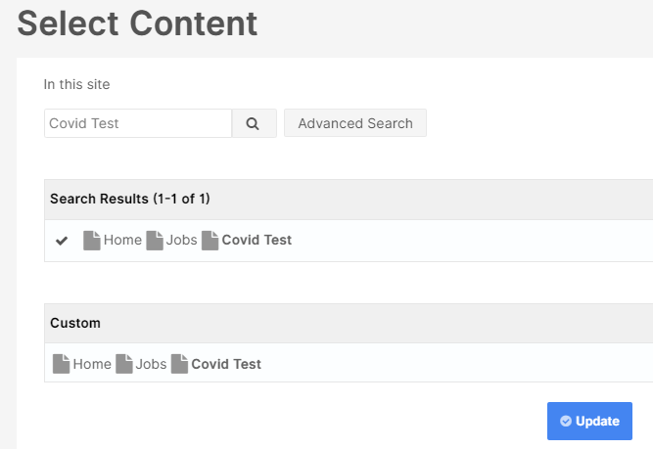 | CMS Support Team

Summary
Number of Changes | Number of TFS Work Items | Number of TFS Work Tasks
16 | 16 – Over 5 Sprints | 39 – Over 5 Sprints

Bug Fixes | System Updates | Accessibility | New Functionality
4 | 9 | 2 | 1

Problems Fixed
N/A

New Problems Identified During Testing and Associated Workarounds
N/A

Pre-requisites to Deploy the Release
N/A

Training Requirements
CMS Support Site will be updated with any changes that introduce new functionality or changes to workflow.

Step by Step Deployment Instructions
No Deployment actions required by Health Boards

Deployment Plan
Changes to be implemented as specified in the Change Record Release to be deployed via change record Change 96524

Back-Out Plan
Back out as detailed on each change record

Release Available for Deployment Date
NHS Wales: 23/06/2021

