REL-ID 638 CMS/01-2021

NHS WALES IT SERVICE MANAGEMENT
CMS Release Notes
Release ID: 638 CMS/01-2021
These Release Notes describe the scope and content of
Release ID: 638 CMS/01-2021

CMS

Version No. 1.4
Status: Approved

Owner: CMS Service Management Board
Author: Helen McGrath
Approver: Michele Golpaykar-Rad
Date: 30/12/2020
Next Review Date: 10/01/2021
Tŷ Glan-yr-Afon
21 Heol Ddwyreiniol Y Bont-Faen, Caerdydd CF11 9AD
21 Cowbridge Road East, Cardiff CF11 9AD
Ffôn/Tel: 02920 500500
www.gggc.gig.cymru
www.nwis.nhs.wales

TABLE OF CONTENTS

1 DOCUMENT HISTORY 3
1.1 Revision History 3
1.2 Reviewers 3
1.3 Authorisation 3
2 INTRODUCTION 4
3 SERVICE MANAGEMENT BOARD (SMB) 4
4 RELEASE NOTES REQUIREMENT 4
4.1 Release Identification 4
4.2 Description of New or Modified Functionality 4
4.3 Summary 16
4.4 Problems Fixed 16
4.5 New Problems Identified During Testing and Associated Workarounds 17
4.6 Pre-requisites to Deploy the Release 17
4.7 Training Requirements 17
4.8 Step by Step Deployment Instructions 17
4.9 Deployment Plan 17
4.10 Release Available for Deployment Date 17

DOCUMENT HISTORY

Revision History
Date | Version | Author | Revision Summary
30/12/2020 | 1.0 | Helen McGrath | Senior Support & Business Analyst
15/01/2021 | 2.0 | Helen McGrath | Senior Support & Business Analyst
22/01/2021 | 3.0 | Helen McGrath | Senior Support & Business Analyst

Reviewers
This document requires the following reviews:
Date | Version | Name | Position
22/01/2021 | 3.0 | Michele Golpaykar-Rad | Principal Support & Business Analyst

Authorisation
Signing of this document indicates acceptance of its contents.
Author’s Name: | Helen McGrath
Role: | Senior Support & Business Analyst
Signature: |  | Date: | 22/01/2021

Approver’s Name: | Michele Golpaykar-Rad
Role: | Principal Support & Business Analyst
Signature: |  | Date: | 22/01/2021

INTRODUCTION
The NHS Wales Release Management Policy considers that effective Release Management is essential for protecting the integrity of the operational environment. A key objective of the release process is ensuring that users, support staff and other stakeholders are kept informed as to what is planned and how this will affect them. One of the ways that this can be achieved is through the publication of release notes prior to deployment of the Release.

These notes contain information on the agreed scope and content of Release id CMS/01-2021 for the CMS, descriptions of new or modified functionality and problem fixes, descriptions of new problems and workarounds identified during the testing of this Release, training requirements, deployment instructions, references to deployment and back-out plans and key dates within the release process.

SERVICE MANAGEMENT BOARD (SMB)
The CMS Service Management Board has overall responsibility for ensuring that these Release Notes accurately describes the Release and that it is kept under constant review and updated to reflect any modifications to the Release prior to its deployment.

RELEASE NOTES REQUIREMENT

Release Identification
638 CMS/01-2021

Description of New or Modified Functionality
Item | Description | Requestor
Bug Fixes
4.2.1 Left-Hand Navigation Update | The left-hand Navigation Block does not currently respect any sort order applied to the child pages, within the backend of the site. We have now updated the code in this area to observe any changes made in this area.  Current Display New Display  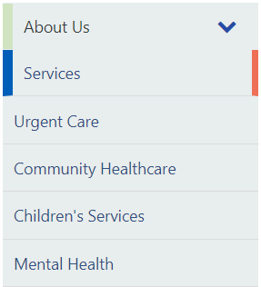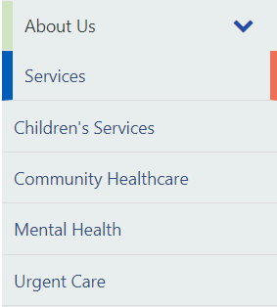 | CMS Support Team
4.2.2 Mobile Navigation Update | It has been brought to our attention that Links, although appearing when placed within the Desktop Navigation, are disappearing when the site Navigation is viewed on a Mobile platform. We have now introduced a fix that will ensure consistent Navigation items will display across all platforms.  Desktop Navigation  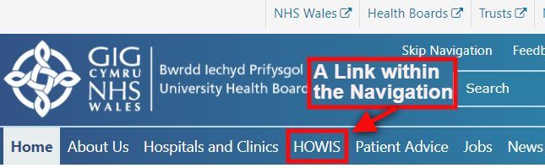  Current Mobile Navigation  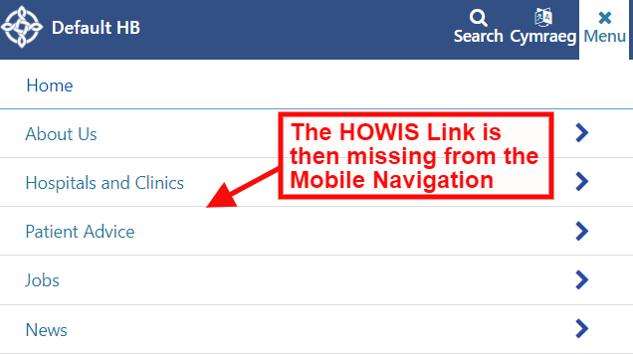  New Mobile Navigation  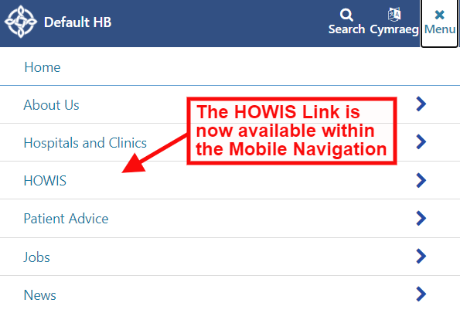 | PHW
4.2.3 Multi Content 1 Update | When using the Multi Content 1 layout if a user selects a width other than Full; The Navigational Arrows do not resize along with the block, this means that the arrows can appear on the other side of the page. We have now applied a fix so that the Navigational arrows will now resize according to the size of the block.  Current Display  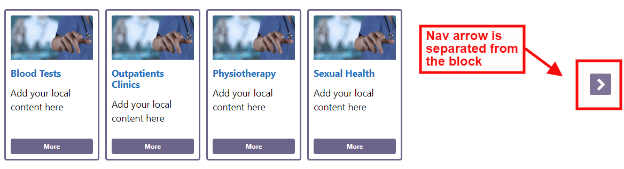  New Display  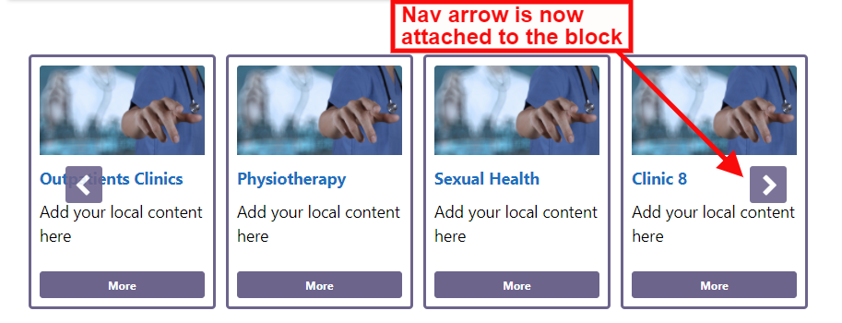 | PHW
System Updates
4.2.4 Forms Update | When users are replying to Mura Forms the ‘From’ email address (webteam) is often inadvertently being included in correspondence. To prevent this from happening in the future we have added a do not reply warning message:  "This e-mail has been automatically generated. Please do not reply to it as the mailbox it was sent from is not monitored.  To contact the person who submitted this request, please copy and paste the email address given above (if any) into a new message." | CMS Support Team
4.2.5 Screen Reader Update | When adding a screen reader to your site this is done on the Homepage level, however currently the screen readers will not appear or read the Homepage itself. This update will now allow screen readers to read the sites homepage. | CMS Support Team
4.2.6 3rd Level Navigation Update | We have now updated the 3rd Level Navigation block so that this is now able to show on top level pages, when these are set to start a new Cascade. The error message will no longer display.  Current Display New Display  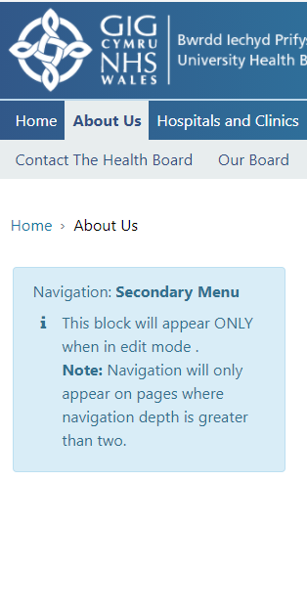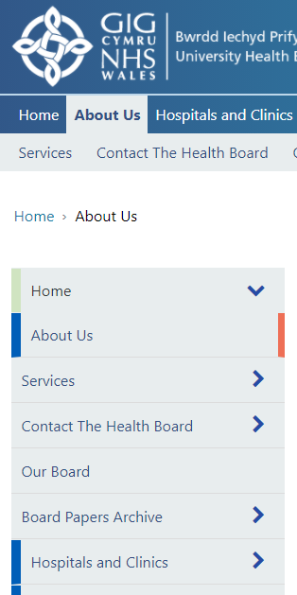 | CMS Support Team
4.2.7 Read Speaker Update | Read Speaker was previously available with the layouts section of the Collection Plugin. This has been migrated and is now available within the Screen Reader Plugin.  Current Settings New Settings  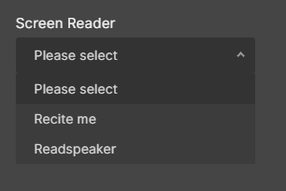  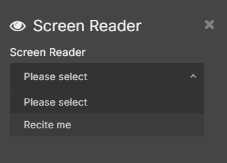 | CMS Support Team
4.2.8 Update to Medical Performers List | FAO. NWSSP - During testing of the Medical Performers List areas for necessary improvements were identified.  1. The Search function currently automatically runs without the use of a ‘Go’ button. To bring this search in line with all other search types within the system; a ‘Go/Search’ button has now been introduced. The Search will now only engage when a user selects this.  2. To bring this search in line with all other search types within the system; an ‘X’ for the users to clear the Search has now been included within the search term box.  Current Display  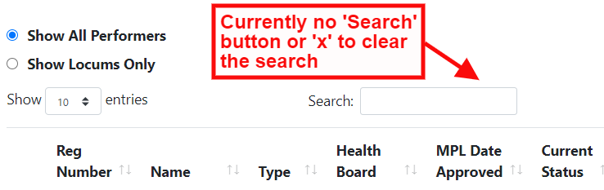  New Display  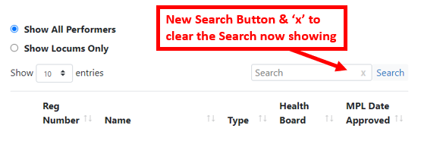 | CMS Support Team
4.2.9 YouTube Update | Currently to add a YouTube Video with the YouTube Plugin. users are required to add only the Video ID into the Plugin settings. We have now made an update in this area so that a user can add in the whole URL of the YouTube Video and the Plugin settings will identify and apply the required ID.  ID Only Full YouTube URL  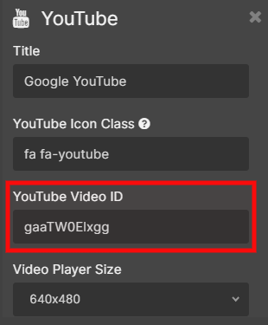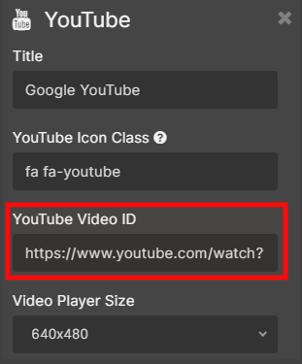 | CMS Support Team
4.2.10 Mobile View Update | We have made an update to the Page Titles Font Size when viewed on a mobile platform. This change will only apply to Mobiles and so will not affect titles on desktop/larger screen resolutions.  Current Display New Display  font-size: 2.5rem font-size: 1.75rem 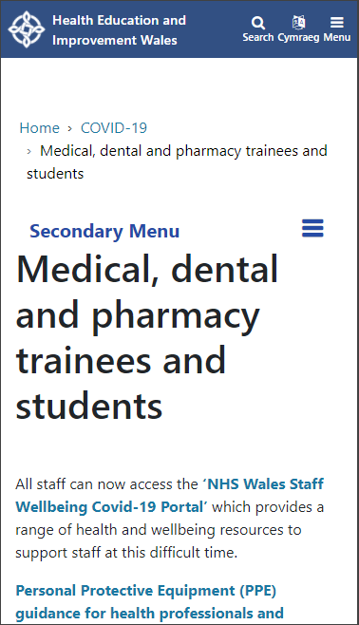 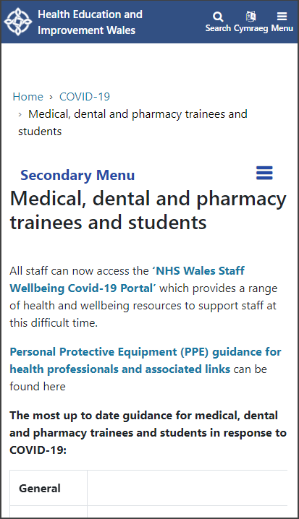 | CMS Support Team
4.2.11 A&E Plugin Update | Since applying a resent updated to add the Welsh language option to the data displayed in this area, the Hospital notes are appearing in curly brackets with inverted commas & colons. We have now updated these Plugins to remove this.  Current Display  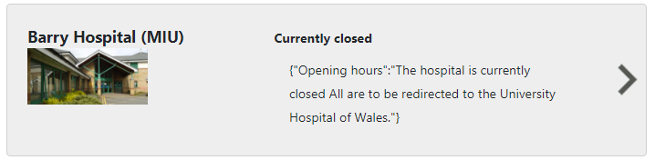  New Display  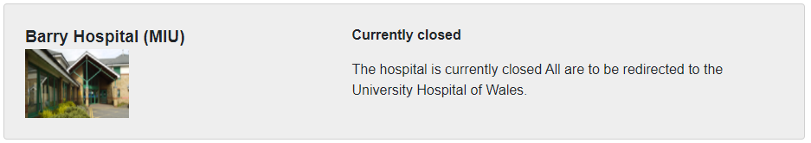 | CMS Support Team
4.2.12 Multi Content 1 Update | The Label buttons for the Multi Content 1 layout are currently set to a limit of 100 characters, this limit is proving difficult where Welsh text is needed, as the Welsh equivalent text does tend to be longer than the English. This character limit has now been increased to 120 characters.  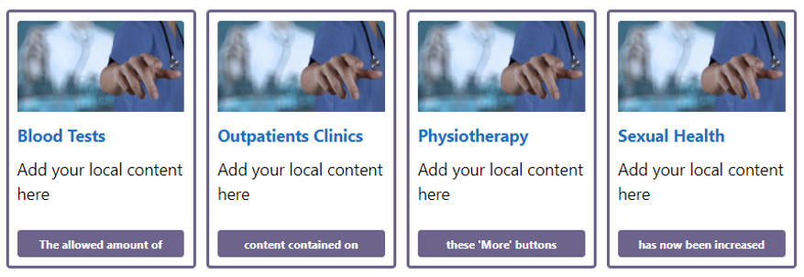 | HDUHB
Accessibility
4.2.13 Left-Hand Navigation Aria-label | To meet Web Accessibility Guidelines; we have updated the aria-label for child pages within the left-hand Navigation Menu. When clicking on a child link in on a left-hand menu the aria-label currently doesn't change from open to close or vice versa, this has now been updated. | CMS Support Team
4.2.14 Skip Nav Anchor WCAG Ref 2.4.1 | To meet Web Accessibility Guidelines; we have updated the code behind the Skip Nav Link. Adding a hidden skip nav which becomes visible when tabbing from address bar. This change will aide screen readers in reading the Menu items and so would not be visible for any other users.  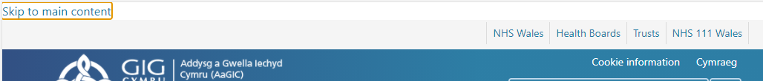 | CMS Support Team
4.2.15 Table Pagination button colour WCAG Ref 1.4.3 | To meet Web Accessibility Guidelines; we have updated the pagination for the unselected buttons (e.g. based on the image below Prev 1,3,4,5... Next) in the Table to ensure they meet accessibility standards.  Previous Colour: Button: #007BFF Text: #6497FF  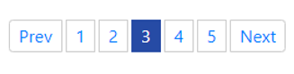  New Colour: Button & Text: #264BA5  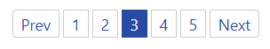 | CMS Support Team
4.2.16 Language Link Toggle WCAG Ref F96 | This relates to the Welsh/English language Toggle Link. To meet Web Accessibility Guidelines; we have updated this so that the visual label now appears in the accessible name of links and controls. Users that utilise speech control rely on being able to select elements using the visual label displayed on screen. If this isn't part of the accessible name, they are unable to select elements by name.  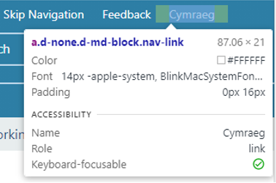 | HEIW
4.2.17 Search Button Update WCAG Ref F96 | To meet Web Accessibility Guidelines; we have updated the search button of the search form on the search results page, we have now included a missing aria-label. This change is to aide screen readers and so would not be visible for any other users. | HEIW
4.2.18 Navigation Bar Update WCAG Ref 2.1.1 & 4.1.2 | Currently when you view a page without a subnav (the grey bar) an empty UL tag is rendered which doesn't pass accessibility.  To meet Web Accessibility Guidelines; we have now updated the source code in this area. This change will aide screen readers in reading the Menu items and so would not be visible for any other users. | HEIW
4.2.19 Profile List Update | 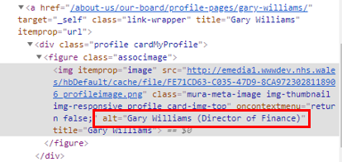  To meet Web Accessibility Guidelines; we have updated the Profile List ALT Text so that the ALT Text that is drawn onto the Profile List listing page reflects the ALT text that is attached to the Image on the individual Profile List pages.  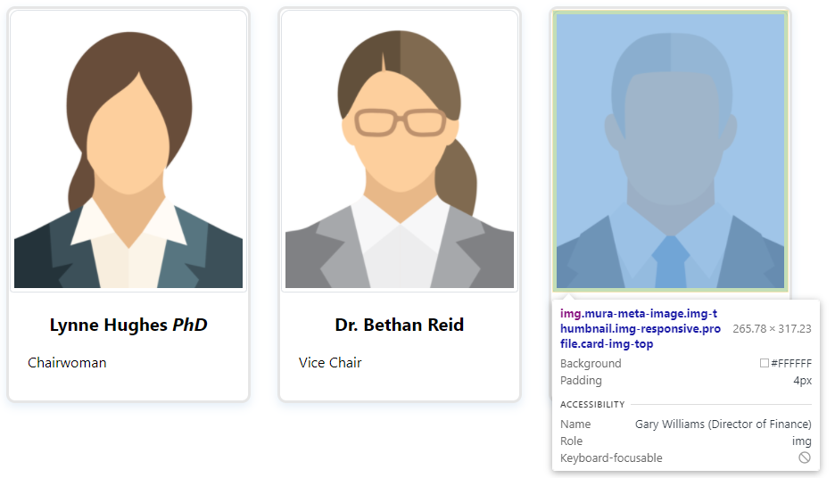 | HEIW
Additional Functionality
4.2.20 Additional File Type | We have now added the ability for users to upload an additional File extension type .WMA. This will now allow users to upload audio files to their sites.  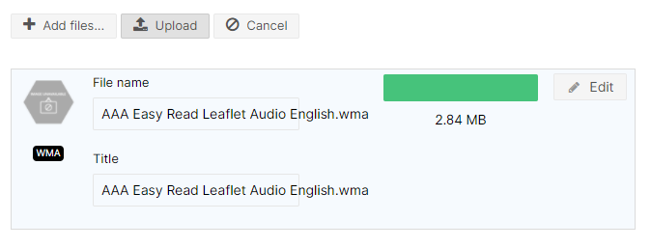 | PHW
4.2.21 New Shared Content Component | We have now added in a new function that will allow site admins to draw in specific pieces of content; that the CMS Support Team provided and manage. This is for use with such pages as your Accessibility statement. The current content that admins manually update can now be added through the RTE, this will then automatically update when the content is updated within the CMS Support Site. For full instructions on how to please refer to the Shared Content Guide.  New RTE Icon  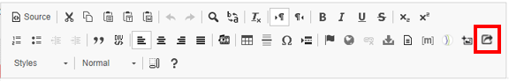  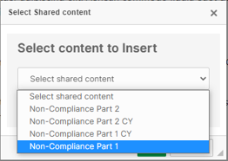  The New Shared Content Box  The content available for you to pull into your site will now appear in this pop-up list  The Code  This will now appear as code on the page (whilst viewing in Edit)  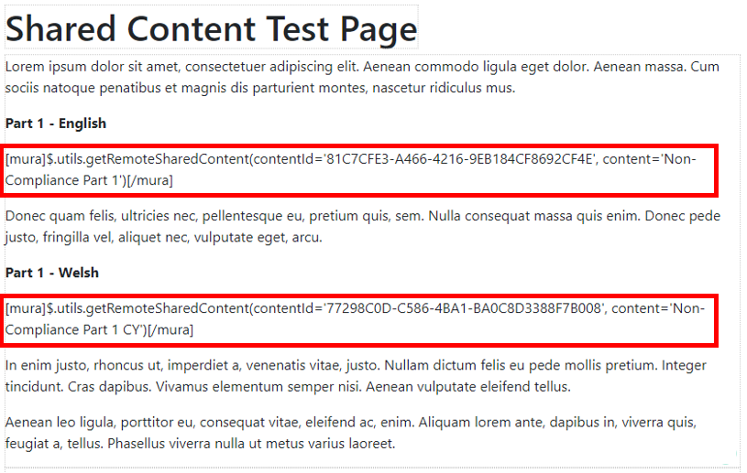  Public View  Once you save the page, these pieces of text will appear in the areas you have placed the code. The text will update automatically as it is updated on the CMS Support Site  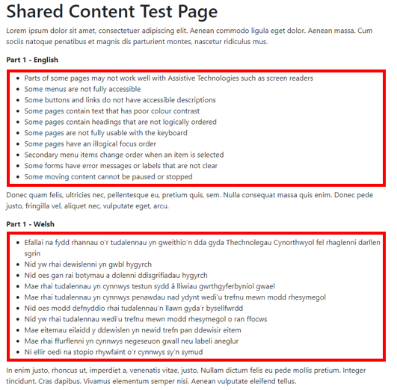 | CMS Support Team
4.2.22 COVID Addition to the DOS | We are trialling a new area within the DOS Plugin; this area will list COVID testing centres. The details held within this area will be supplied by and kept updated by the individual Health Boards.  This data can then be displayed in one of two options.  - Service Finder – allows a user to enter a Postcode on selecting search the nearest results will then be plotted on a map  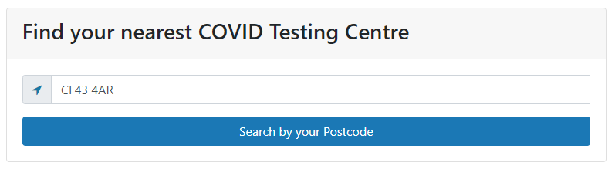  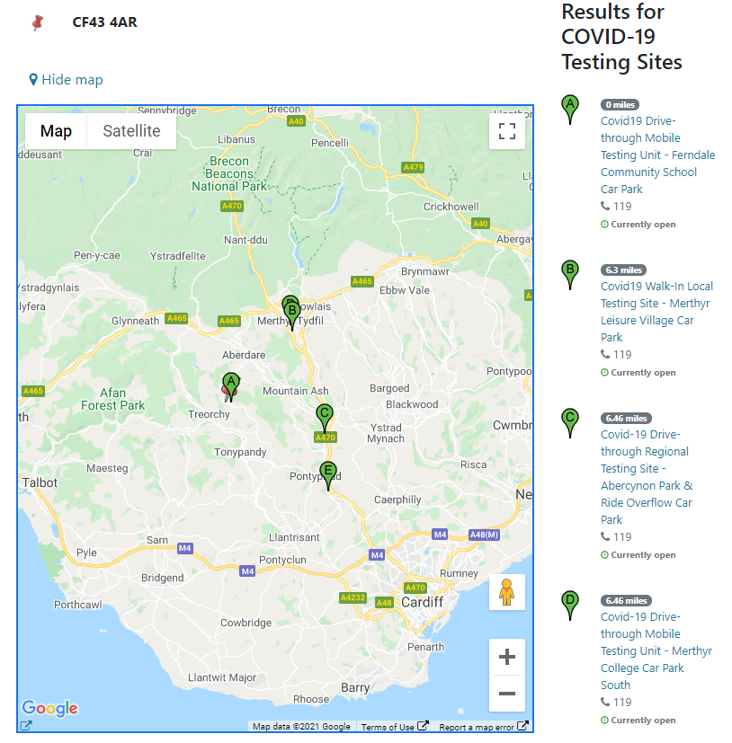  - Directory of Service – This option will show all listings in a full table. Users can then search my name/address/town/postcode etc  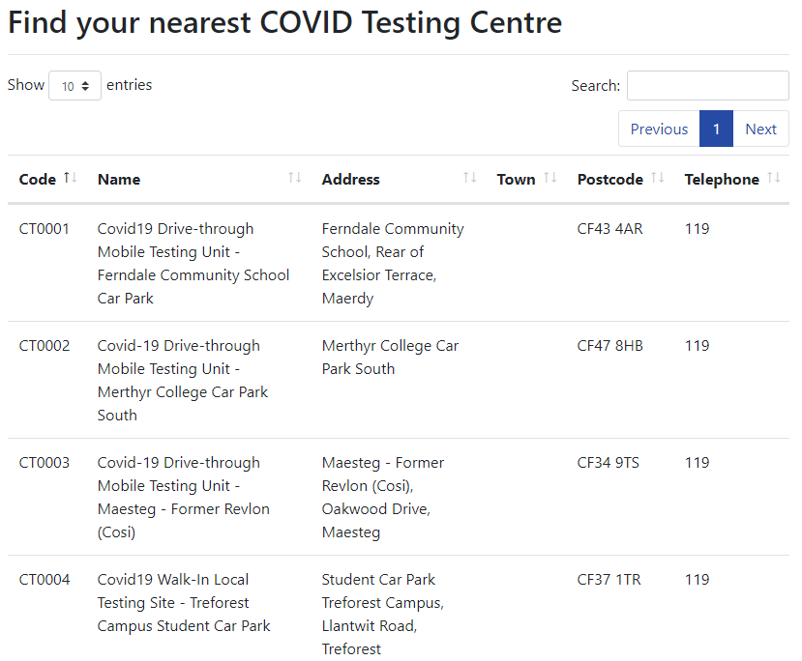 | CTUHB

Summary
Number of Changes | Number of TFS Work Items | Number of TFS Work Tasks
22 | 24– Over 3 Sprints | 44 – Over 3 Sprints

Bug Fixes | System Updates | Accessibility | Additional Functionality
3 | 9 | 7 | 3

Problems Fixed
N/A

New Problems Identified During Testing and Associated Workarounds
N/A

Pre-requisites to Deploy the Release
N/A

Training Requirements
CMS Support Site will be updated with any changes that introduce new functionality or changes to workflow.

Step by Step Deployment Instructions
No Deployment actions required by Health Boards

Deployment Plan
Changes to be implemented as specified in the Change Record Release to be deployed via change record 88400 Back-Out Plan
Back out as detailed on each change record

Release Available for Deployment Date
NHS Wales: 27/01/2021

