REL-ID 622 CMS/05-2020

NHS WALES IT SERVICE MANAGEMENT
CMS Release Notes
Release ID: 622 CMS/05-2020
These Release Notes describe the scope and content of
Release ID: 622 CMS/05-2020

CMS

Version No. 1.4
Status: Approved

Owner: CMS Service Management Board
Author: Helen McGrath
Approver: Michele Golpaykar-Rad
Date: 18/09/2020
Next Review Date: 29/09/2020
Tŷ Glan-yr-Afon
21 Heol Ddwyreiniol Y Bont-Faen, Caerdydd CF11 9AD
21 Cowbridge Road East, Cardiff CF11 9AD
Ffôn/Tel: 02920 500500
www.cymru.nhs.uk/gwybodeg
www.wales.nhs.uk/informatics

TABLE OF CONTENTS

1 DOCUMENT HISTORY 3
1.1 Revision History 3
1.2 Reviewers 3
1.3 Authorisation 3
2 INTRODUCTION 4
3 SERVICE MANAGEMENT BOARD (SMB) 4
4 RELEASE NOTES REQUIREMENT 4
4.1 Release Identification 4
4.2 Description of New or Modified Functionality 4
4.3 Summary 9
4.4 Problems Fixed 10
4.5 New Problems Identified During Testing and Associated Workarounds 10
4.6 Pre-requisites to Deploy the Release 10
4.7 Training Requirements 10
4.8 Step by Step Deployment Instructions 10
4.9 Deployment Plan 10
4.10 Back-Out Plan 10
4.11 Release Available for Deployment Date 10

DOCUMENT HISTORY

Revision History
Date | Version | Author | Revision Summary
18/09/2020 | 1.0 | Helen McGrath | Senior Support & Business Analyst
09/10/2020 | 2.0 | Helen McGrath | Senior Support & Business Analyst

Reviewers
This document requires the following reviews:
Date | Version | Name | Position
09/10/2020 | 1.0 | Michele Golpaykar-Rad | Principal Support & Business Analyst

Authorisation
Signing of this document indicates acceptance of its contents.
Author’s Name: | Helen McGrath
Role: | Senior Support & Business Analyst
Signature: |  | Date: | 09/10/2020

Approver’s Name: | Michele Golpaykar-Rad
Role: | Principal Support & Business Analyst
Signature: |  | Date: | 09/10/2020

INTRODUCTION
The NHS Wales Release Management Policy considers that effective Release Management is essential for protecting the integrity of the operational environment. A key objective of the release process is ensuring that users, support staff and other stakeholders are kept informed as to what is planned and how this will affect them. One of the ways that this can be achieved is through the publication of release notes prior to deployment of the Release.

These notes contain information on the agreed scope and content of Release id CMS/05-2020 for the CMS, descriptions of new or modified functionality and problem fixes, descriptions of new problems and workarounds identified during the testing of this Release, training requirements, deployment instructions, references to deployment and back-out plans and key dates within the release process.

SERVICE MANAGEMENT BOARD (SMB)
The CMS Service Management Board has overall responsibility for ensuring that these Release Notes accurately describes the Release and that it is kept under constant review and updated to reflect any modifications to the Release prior to its deployment.

RELEASE NOTES REQUIREMENT

Release Identification
622 CMS/05-2020

Description of New or Modified Functionality
Item | Description | Requestor
Bug Fixes
4.2.1 Site Map Update | When a user drags the System Plugin to a page and selects Site Map, the settings work as expected, however after publishing the settings within the Basic tab appear empty and does not display any options to the user. This issue has now been resolved.  Incorrect Settings Display Correct Settings Display  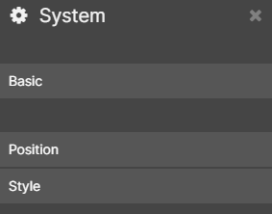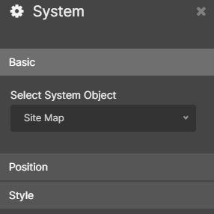 | CMS Support Team
4.2.2 DOS Post Code Finder | Within the Dos Plugin settings, the 'Postcode Service Provider' option is now no longer set when you first drag plugin to your page. Users will now need to actively select a value in this drop-down field.  User must set this option as NWIS  New Display & Settings  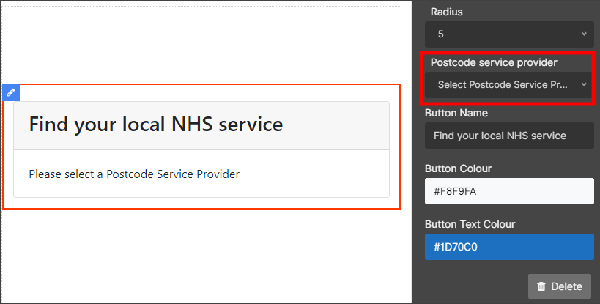  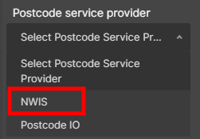 | CMS Support Team
4.2.3 Advanced Table List Update | When a user hovers over the Search button of an Advanced Table List, the button loses its colour and turns white. We have now added in an extra Settings option where admins can now select a ‘hover’ colour for this button.  New Settings Option  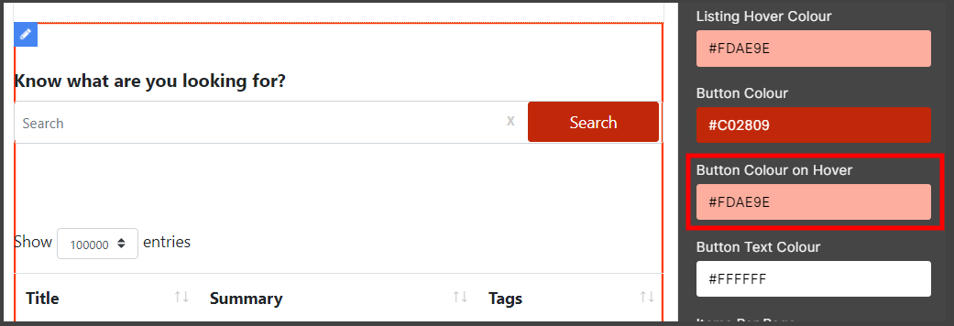 | CMS Support Team
Layout Updates
4.2.4 Events Location Update | Within Events adding a location postcode is a mandatory field and automatically includes a Journey Planner Link to the Event page. This field has now been reset so that postcode is no longer mandatory. Now when no postcode is entered the Journey Planner link will not display.  Current Display  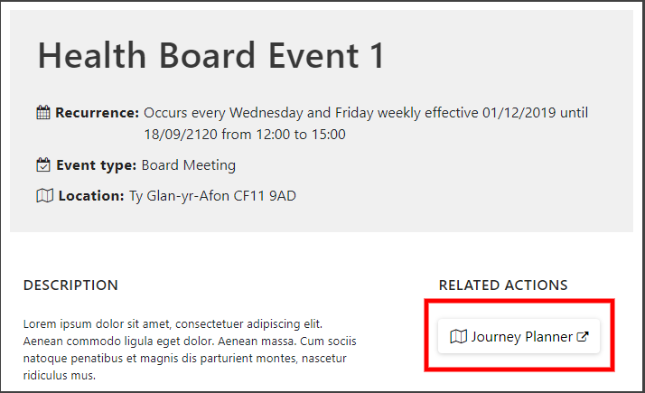  Back end Event Settings  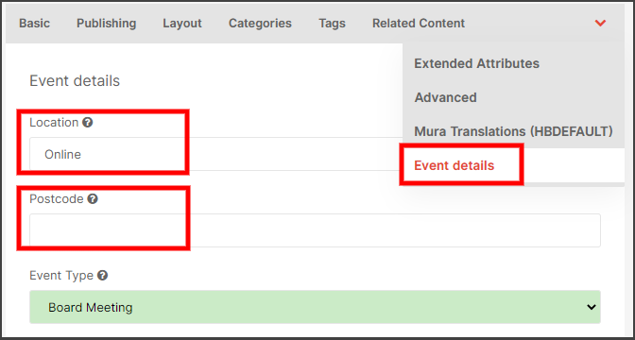  New Display  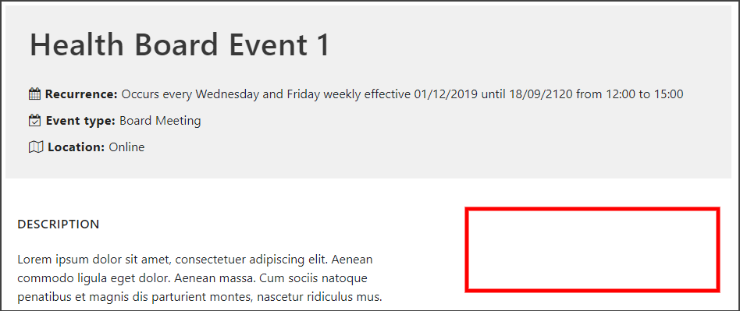 | PTHB
4.2.5 YouTube Update | We have added an update to the YouTube Plugin, this change will add 'Privacy Enhanced Mode' to the code of the current YouTube Plugin.  Previous Code  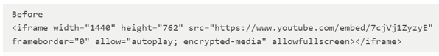  Updated Code  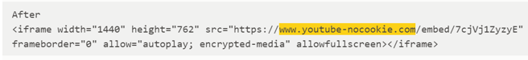 | CMS Support Team
4.2.6 Twitter Native Update | Within the Social Board Plugin there is a Twitter Native option, this option currently allows users to change the colour of Links through settings. Twitter no longer supports this functionality, so we have now removed this option from the Twitter Native settings menu.  Current Settings Options New Settings Options  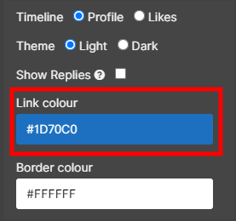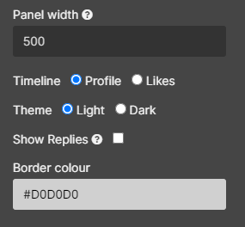 | CMS Support Team
Accessibility
4.2.7 Tabbed Content Update | The current colour of the header label within the Tabbed Content layout is hard coded as black. This fails accessibility due to recent changes that were applied to the colour schemes theme where the backdrop was defaulted to blue. We have now defaulted this text to White and added in a new option within the Layout settings that will allow users to amend this colour as they wish.  Current Display  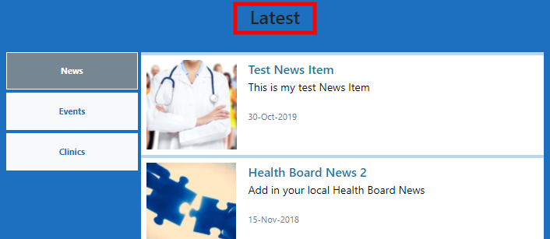  New Display  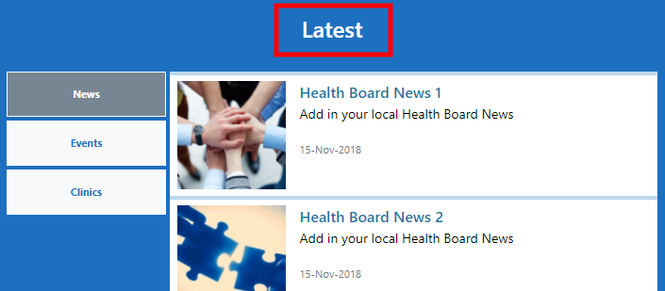  New Settings Option  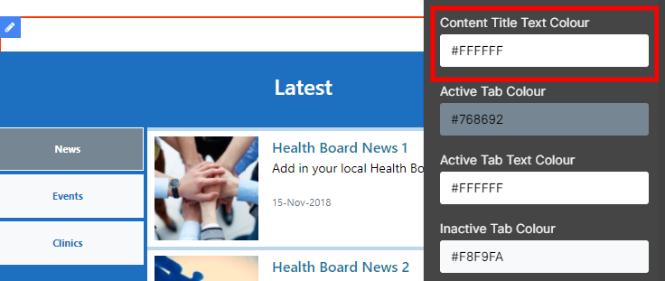 | CMS Support Team
Welsh Language Standards
4.2.8 Automatic Translation Update | When using the automatic Welsh Translation, it has been noted that the Google Translation does not handle Links correctly and was adding space to the URL; and therefore, breaking the Link. We have now updated this so that the Links will copy across correctly in a working state.  Current Broken Link  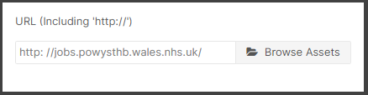  Correctly Displayed Links  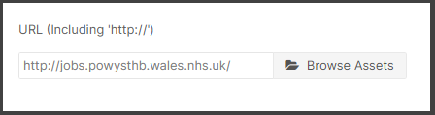 | PTHB
Additional Functionality
4.2.9 Mura Core Code Upgrade | Our Mura CMS has now been upgraded to a newer version of Mura (Version 7.1.505). This new Mura version has undergone extensive testing within the team to ensure its completability with our specific Plugins & Layouts. | CMS Support Team
Performance Improvement
4.2.10 Navigation Update | We have optimized the code behind the 3rd Level Navigation (Trust Navigation) This was conducted as a part of our regular service improvements, to improve the overall efficiency of the sites. | CMS Support Team

Summary
Number of Changes | Number of TFS Work Items | Number of TFS Work Tasks
10 | 18 – Over 6 Sprints | 45 – Over 6 Sprints

Bug Fixes | Layout Updates | Accessibility | Welsh Language Standards | Additional Functionality | Performance Improvement
3 | 3 | 1 | 1 | 1 | 1

Problems Fixed
N/A

New Problems Identified During Testing and Associated Workarounds
N/A

Pre-requisites to Deploy the Release
N/A

Training Requirements
CMS Support Site will be updated with any changes that introduce new functionality or changes to workflow.

Step by Step Deployment Instructions
No Deployment actions required by Health Boards

Deployment Plan
Changes to be implemented as specified in the Change Record Release to be deployed via change record 84769

Back-Out Plan
Back out as detailed on each change record

Release Available for Deployment Date
NHS Wales: 14/10/2020

