lREL-ID 565 CMS/01-2020

NHS WALES IT SERVICE MANAGEMENT
CMS Release Notes
Release ID: 565 CMS/01-2020
These Release Notes describe the scope and content of
Release ID: 565 CMS/01-2020

CMS

Version No. 1.0
Status: Approved

Owner: CMS Service Management Board
Author: Helen McGrath
Approver: Stephen Price
Date: 10/01/2020
Next Review Date: 15/01/2020
Tŷ Glan-yr-Afon
21 Heol Ddwyreiniol Y Bont-Faen, Caerdydd CF11 9AD
21 Cowbridge Road East, Cardiff CF11 9AD
Ffôn/Tel: 02920 500500
www.cymru.nhs.uk/gwybodeg
www.wales.nhs.uk/informatics

TABLE OF CONTENTS

1 DOCUMENT HISTORY 3
1.1 Template Revision History 3
1.2 Revision History 3
1.3 Reviewers 3
1.4 Authorisation 3
1.5 Document Location 3
2 INTRODUCTION 4
3 SERVICE MANAGEMENT BOARD (SMB) 4
4 RELEASE NOTES REQUIREMENT 4
4.1 Release Identification 4
4.2 Description of New or Modified Functionality 4
4.3 Problems Fixed 5
4.4 New Problems Identified During Testing and Associated Workarounds 5
4.5 Pre-requisites to Deploy the Release 5
4.6 Training Requirements 5
4.7 Step by Step Deployment Instructions 6
4.8 Deployment Plan 6
4.9 Back-Out Plan 6
4.10 Release Available for Deployment Date 6

DOCUMENT HISTORY

Template Revision History
Date | Version | Author | Revision Summary
6th March 2012 | 0.1 | Steve Finn | First Draft
15th March 2012 | 0.2 | Steve Finn | Second Draft following comments from SW
5th July 2012 | 0.3 | Steve Finn | Third Draft following release process modifications
26th July 2012 | 1.0 | Kelly Tremlett | Issued as approved version 1.0

Revision History
Date | Version | Author | Revision Summary
10/01/2020 | 1.0 | Helen McGrath | Senior Support & Business Analyst

Reviewers
This document requires the following reviews:
Date | Version | Name | Position

Authorisation
Signing of this document indicates acceptance of its contents.
Author’s Name: | Helen McGrath
Role: | Senior Support and Business Analyst
Signature: |  | Date: | 10/01/2020

Approver’s Name: | Stephen Price
Role: | Applications Manager (Corporate)
Signature: |  | Date: | 10/01/2020

Document Location
Type | Location
Electronic

INTRODUCTION
The NHS Wales Release Management Policy considers that effective Release Management is essential for protecting the integrity of the operational environment. A key objective of the release process is ensuring that users, support staff and other stakeholders are kept informed as to what is planned and how this will affect them. One of the ways that this can be achieved is through the publication of release notes prior to deployment of the Release.

These notes contain information on the agreed scope and content of Release id CMS/01-2020 for the CMS descriptions of new or modified functionality and problem fixes, descriptions of new problems and workarounds identified during the testing of this Release, training requirements, deployment instructions, references to deployment and back-out plans and key dates within the release process.

SERVICE MANAGEMENT BOARD (SMB)
The CMS Service Management Board has overall responsibility for ensuring that these Release Notes accurately describes the Release and that it is kept under constant review and updated to reflect any modifications to the Release prior to its deployment.

RELEASE NOTES REQUIREMENT

Release Identification
565 CMS/01-2020

Description of New or Modified Functionality
Item | Description | Requestor
Cross Site Search Update | There is currently a difference in performance of the Cross Site Search when using the Enter Key Vs Selecting the Search Button. This change will see that using either option will now draw back the same results.  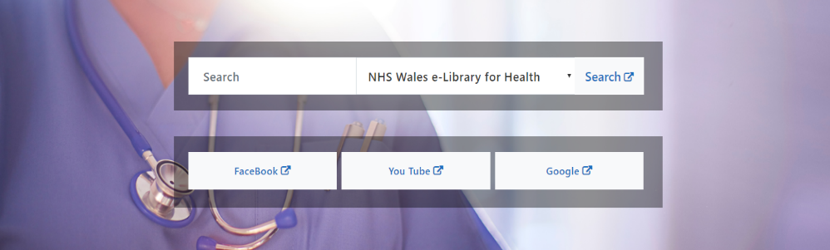 | CMS Support Team
BoxBlock Update | On the Box Block display the coloured underline and the summary text appear directly underneath the Titles.  This change will see an amendment made to the Box Block layout to allow the coloured underline and the summary text for all boxes remain in line with each other regardless as to the Title length.  Current Display  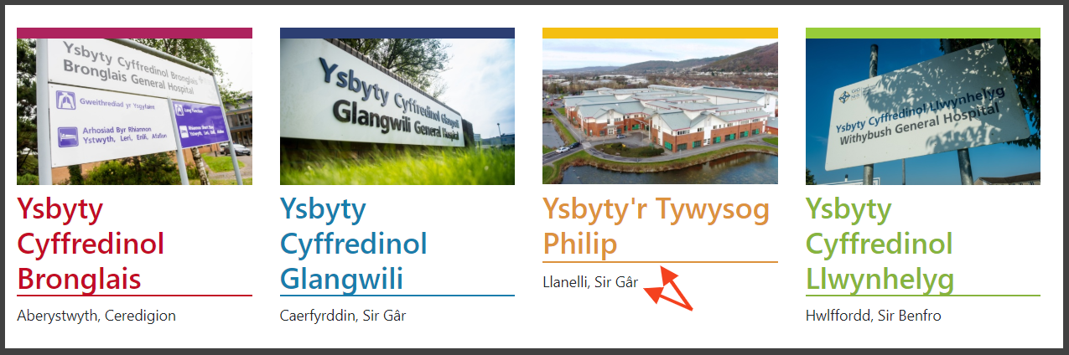  New Display  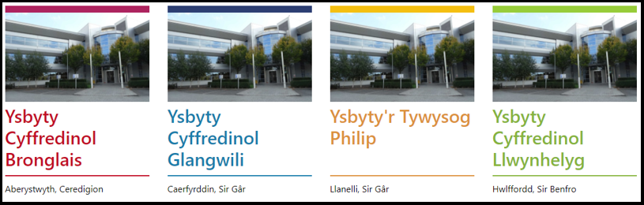 | HDUHB
Beautified Container Update | An amendment has been made to the ‘Clickable’ regions within a Beautified container.  Current Display New Display  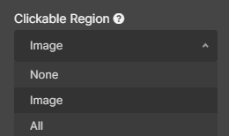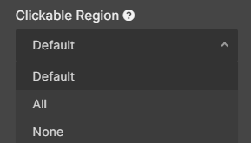  The New Options Explained:  None: None of the Beautified Container would be a clickable link  All: The whole block will be a clickable to the URL selected within the Settings.  Default: Any Links with the content drawn in will be selectable. The box itself will not have any link.  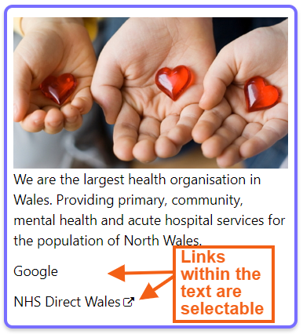 | CMS Support Team
External Link Icon | The ‘Open in an External Browser’ page setting will now be honoured across all the whole site in Text and layouts.  To meet accessibility guidelines; when the ‘Open in an External Browser’ setting is ticked a new External Indicator Icon will be added. This Icon will appear across all Navigation/Links/plugins.  External Link Icon Examples:  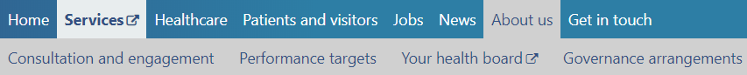  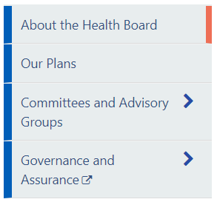    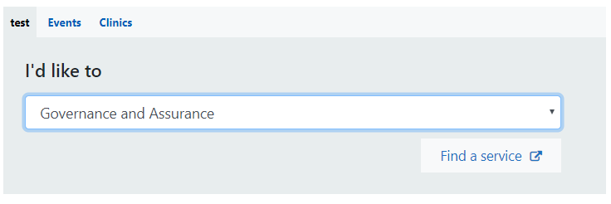 | CMS Support Team
Introduction of a Hover Over | When a user hovers over an Item within a Layout the whole area will now have a Highlighted outline. This will indicate to the user that the whole area now acts as the content link; where previously on the ‘Read More’ button acted as the link. This update has now been made to a number of the Layouts.  Hover Over Box Examples:  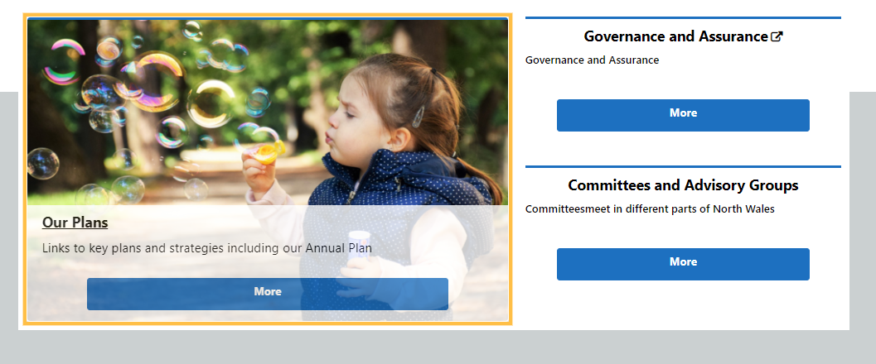  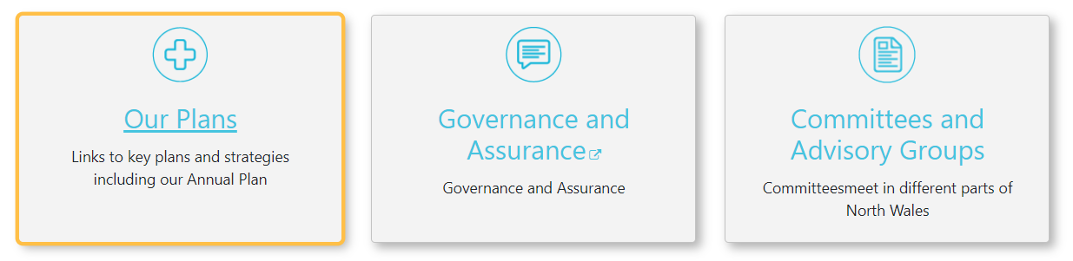  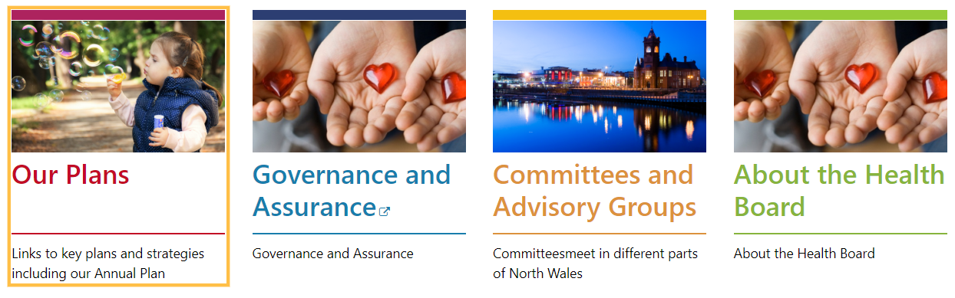  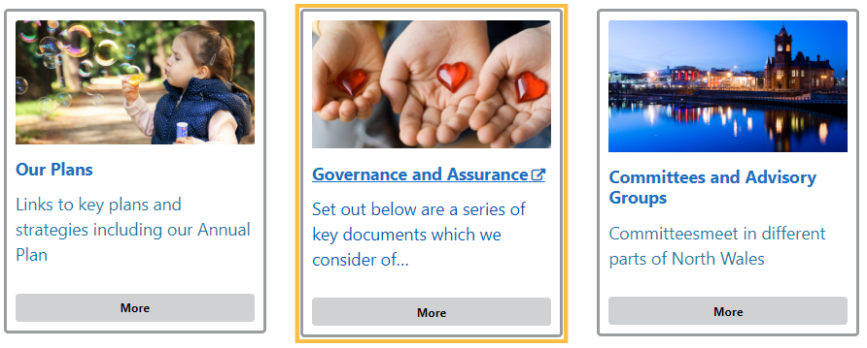 | CMS Support Team
Search Box Accessibility | Accessibility updates have now been made to the Search Bar. The Search Bar now has an ‘X’ which allows users to clear the search. We have also added a Search button which can be selected instead of using the enter key on your keyboard.  Current Display    New Display   | HDUHB
Canonical Tags | These Tags have now been automatically added into the background of each page; with the Tag being the URL of the page itself. If you would like the Tag to display a different URL this field is available to you within the Publishing Tab. Having these Canonical Tag available will help with sites SEO.  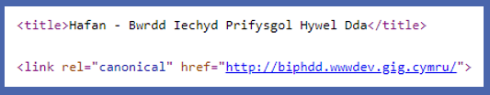  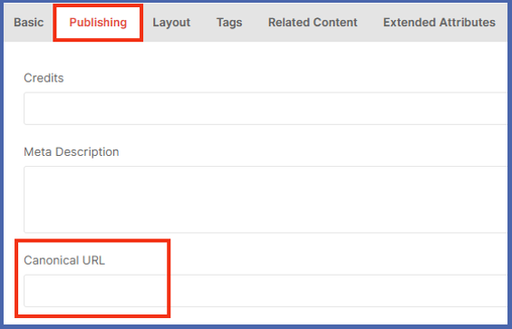 | CMS Support Team
Trac Plugin Welsh Language Update | An addition has been made to the code for the Trac Plugin. When you now apply this to your Welsh site the Plugin will automatically appear in Welsh, with no manual translation necessary  Current Display  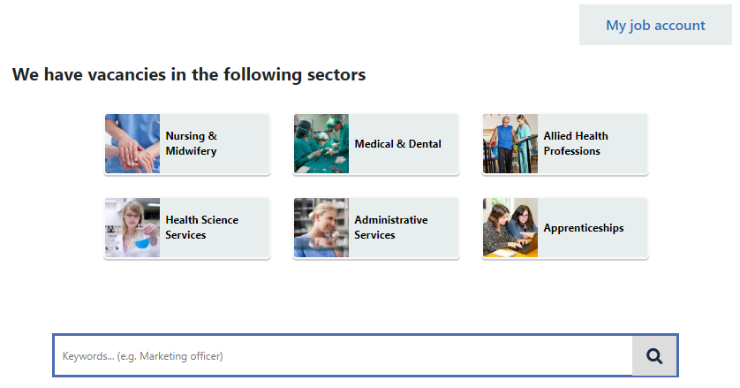  New Display  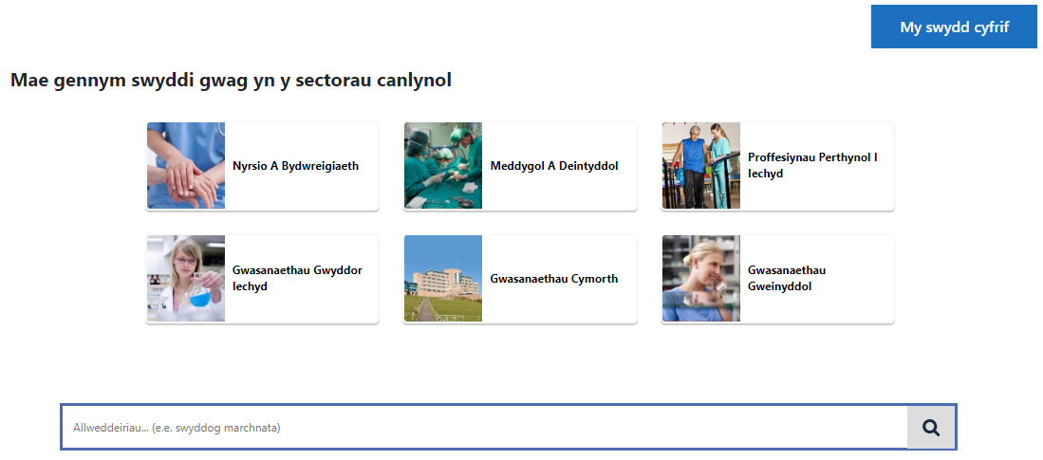 | CMS Support Team
Profile Card Update 1 | To meet accessibility guidelines, we have now removed the ‘About’ clickable button from all profile cards. As the ‘whole’ card is now the clickable link; screen readers will read aloud all text on the card.  This action was suggested and agreed by members of the Community of Practice Group.  Current Display    New Display   | Comm of Practice Group
Profile Card Update 2 | A second update to the Profile cards will allow admin users to choose to set the Profile Card as clickable or not. This function can be controlled from the settings; where a new tick box has been introduced.  This action was suggested and agreed by members of the Community of Practice Group.  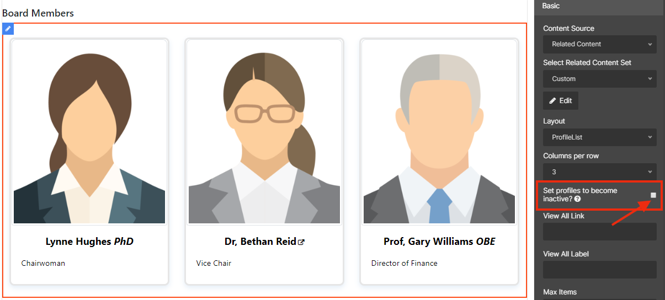 | Comm of Practice Group

Problems Fixed

N/A

New Problems Identified During Testing and Associated Workarounds
N/A

Pre-requisites to Deploy the Release
N/A

Training Requirements
CMS support Site will be updated with any changes that introduce new functionality or changes to workflow.

Step by Step Deployment Instructions
No Deployment actions required by Health Boards

Deployment Plan
Changes to be implemented as specified in the Change Record
Release to be deployed via change record 76403

Back-Out Plan
Back out as detailed on each change record

Release Available for Deployment Date
NHS Wales : 22/01/2019

