REL-ID 579 CMS/01-2020

NHS WALES IT SERVICE MANAGEMENT
CMS Release Notes
Release ID: 579 CMS/02-2020
These Release Notes describe the scope and content of
Release ID: 579 CMS/02-2020

CMS

Version No. 1.0
Status: Approved

Owner: CMS Service Management Board
Author: Helen McGrath
Approver: Stephen Price
Date: 11/02/2020
Next Review Date: 20/02/2020
Tŷ Glan-yr-Afon
21 Heol Ddwyreiniol Y Bont-Faen, Caerdydd CF11 9AD
21 Cowbridge Road East, Cardiff CF11 9AD
Ffôn/Tel: 02920 500500
www.cymru.nhs.uk/gwybodeg
www.wales.nhs.uk/informatics

TABLE OF CONTENTS

1 DOCUMENT HISTORY 3
1.1 Template Revision History 3
1.2 Revision History 3
1.3 Reviewers 3
1.4 Authorisation 3
1.5 Document Location 3
2 INTRODUCTION 4
3 SERVICE MANAGEMENT BOARD (SMB) 4
4 RELEASE NOTES REQUIREMENT 4
4.1 Release Identification 4
4.2 Description of New or Modified Functionality 4
4.3 Problems Fixed 5
4.4 New Problems Identified During Testing and Associated Workarounds 5
4.5 Pre-requisites to Deploy the Release 5
4.6 Training Requirements 5
4.7 Step by Step Deployment Instructions 6
4.8 Deployment Plan 6
4.9 Back-Out Plan 6
4.10 Release Available for Deployment Date 6

DOCUMENT HISTORY

Template Revision History
Date | Version | Author | Revision Summary
6th March 2012 | 0.1 | Steve Finn | First Draft
15th March 2012 | 0.2 | Steve Finn | Second Draft following comments from SW
5th July 2012 | 0.3 | Steve Finn | Third Draft following release process modifications
26th July 2012 | 1.0 | Kelly Tremlett | Issued as approved version 1.0

Revision History
Date | Version | Author | Revision Summary
08/01/2020 | 1.0 | Helen McGrath | Senior Support & Business Analyst
20/01/2020 | 1.1 | Helen McGrath | Senior Support & Business Analyst

Reviewers
This document requires the following reviews:
Date | Version | Name | Position

Authorisation
Signing of this document indicates acceptance of its contents.
Author’s Name: | Helen McGrath
Role: | Senior Support and Business Analyst
Signature: |  | Date: | 20/02/2020

Approver’s Name: | Stephen Price
Role: | Applications Manager (Corporate)
Signature: |  | Date: | 20/02/2020

Document Location
Type | Location
Electronic

INTRODUCTION
The NHS Wales Release Management Policy considers that effective Release Management is essential for protecting the integrity of the operational environment. A key objective of the release process is ensuring that users, support staff and other stakeholders are kept informed as to what is planned and how this will affect them. One of the ways that this can be achieved is through the publication of release notes prior to deployment of the Release.

These notes contain information on the agreed scope and content of Release id CMS/02-2020 for the CMS descriptions of new or modified functionality and problem fixes, descriptions of new problems and workarounds identified during the testing of this Release, training requirements, deployment instructions, references to deployment and back-out plans and key dates within the release process.

SERVICE MANAGEMENT BOARD (SMB)
The CMS Service Management Board has overall responsibility for ensuring that these Release Notes accurately describes the Release and that it is kept under constant review and updated to reflect any modifications to the Release prior to its deployment.

RELEASE NOTES REQUIREMENT

Release Identification
579 CMS/02-2020

Description of New or Modified Functionality
Item | Description | Requestor
Print Mode | When users are attempting to print pages in an enlarged size, the page text doesn’t reflow on zoom. So, when zoomed in at 200%, a great deal of text is cut off the page. The CMS style sheet has now been altered to so that a user will be able to print all content visible on screen.  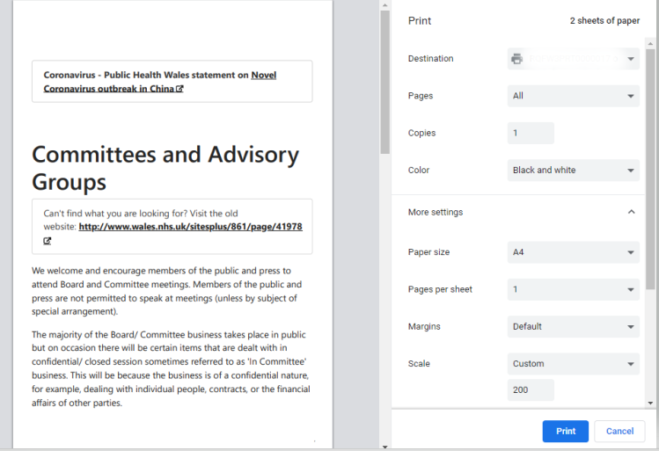 | Velindre
Tabbed Content Update | This update is an addition to the hover over indicator box that was recently added to the CMS. Currently when users select the Tabbed Content only the ‘Tabs’ themselves display the indicator box. This update will allow the indicator boxes to display on the individual content items as the user tabs through them. All links will be underlined and show external link indicator where applicable.  Current Layout  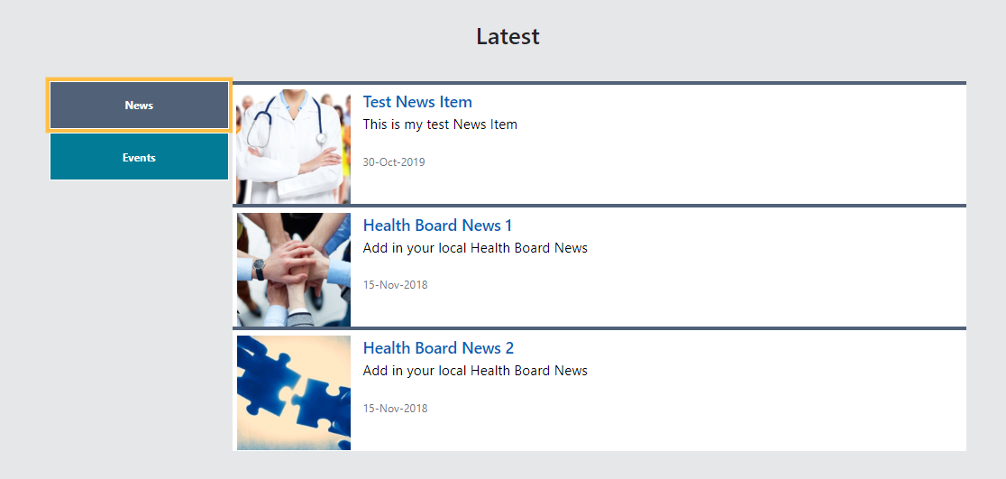  New Layout  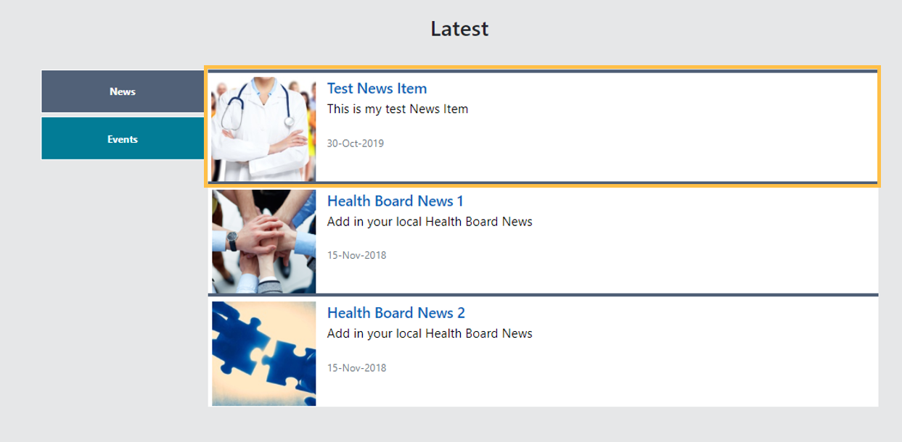 | CMS Support Team
Grid Layout Update | There is currently a difference in the link destination on of the Title and the Image within a Grid layout. This change will see both the Title and the Image honour the Title link destination and the addition over the hover over indicator box.   | NWSSP
Translation Content Update | Within the Translation Audit section, we currently show an audit of which pages have been linked between English/Welsh websites. We have now added an indicator to the pages which are linked to show the dates they have been updated.  The display will now show 5 columns:  Title - Date - Title - Date - Day Difference  *The 'Day Difference' column will depend on which site you are on, ie:  If on the English language version, then the day will be the days newer or older that the English page is in comparison to the Welsh page.  If on the Welsh language version, then the day will be the days newer or older that the Welsh page is in comparison to the English page.  Users are also able to export this data to excel  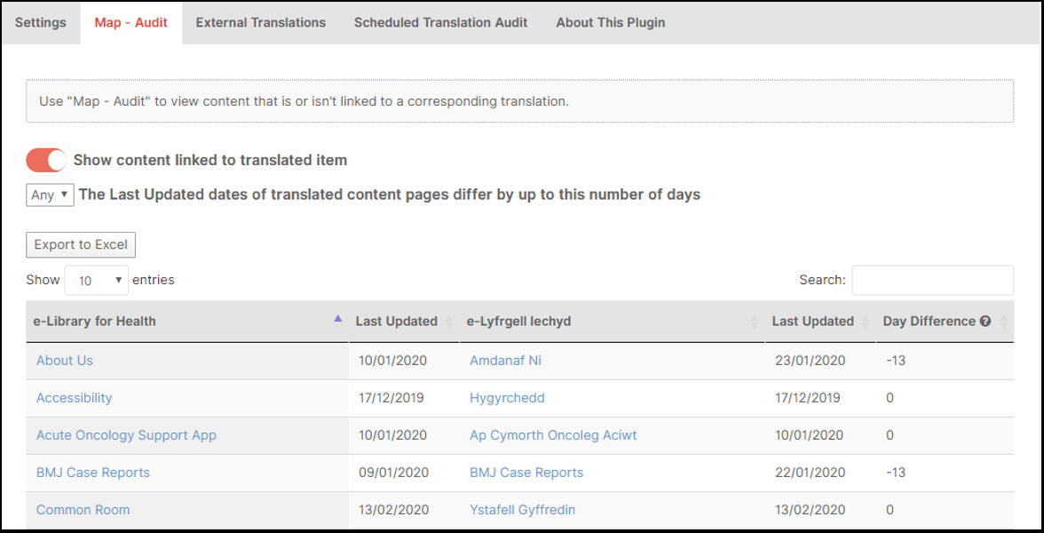 | CMS Support Team
Advanced Table List Update | The field names in Advanced Table List currently appear in English on both the English and Welsh sites. These titles have now been amended to appear in Welsh on the Welsh Language site  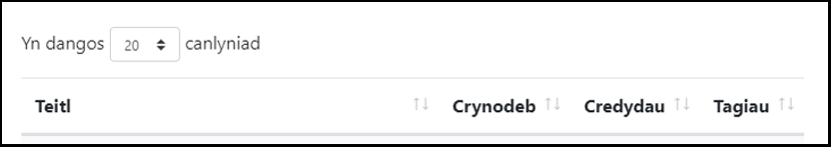 | CMS Support Team
Colour Contrast | The contrast of the link foreground colour (when inside alert classes) does not meet accessibility standards. Links within this area will now appear bold and with an underline when a user hovers over it.  Current Layout  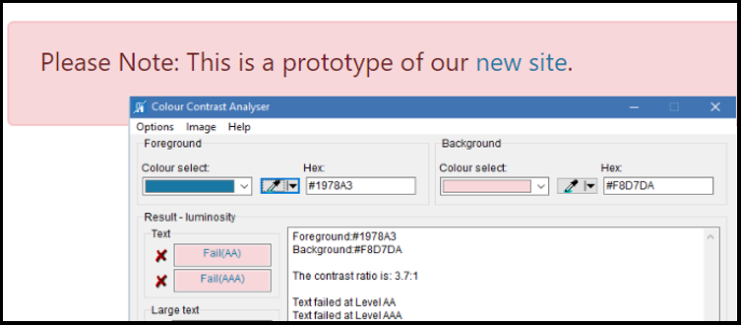  New Layout  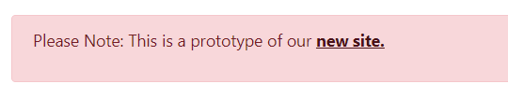 | HDUHB
Single Content Block 4 Update | An extra option has now been added to the Single Content Block 4 settings. This will now allow the users to add in a background colour to any text that they have added.  Settings  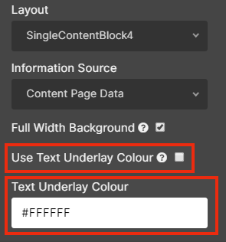  Current Layout  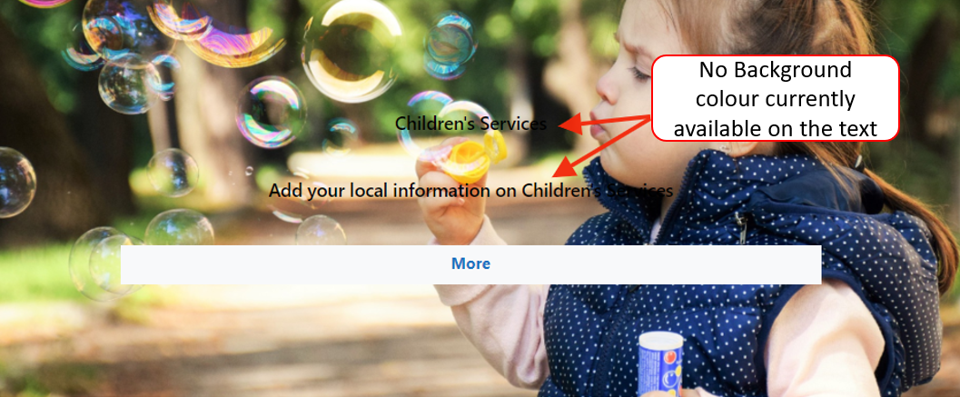  New Layout   | PHW
Links Organiser Update | This Links Organiser layout works in conjunction with a Local Index. An update has now been made so that the Links Organiser will now honour any Advanced Filters added to the local index. This will allow users to pull in specifically ‘tagged’ pages.  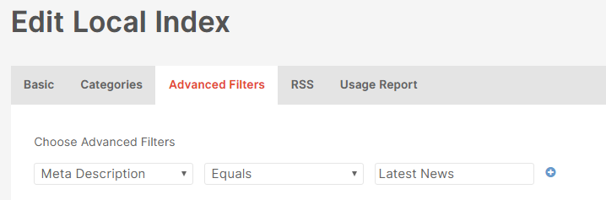 | PHW
Translation Mapping Update | Currently when assigning translation if the associated page has a large name or is several levels down within the structure, then the full-page name does not display making it difficult for users to easily identify the correct pages to link together.  An icon (i) has now been added within this area, when the user hovers over the icon the full-page title will display.  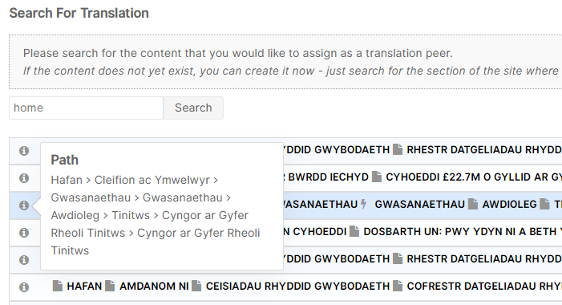 | BCUHB
Content Titles Size Limit | When entering a title for a File/Document type, if you have a title with 100 characters or over and then add this as a link on a page - the link breaks and produces an internal server error message. This change will allow longer content titles, with no errors caused. | PHW
Search Box Update | The Search box used on the Cross Site Search layout has now been updated; for accessibility purposes. An ‘X’ to enable users to clear the search has now been added to bring this in line with the Main site search bar.  Current Layout    New Layout   | CMS Support Team
Carousel Accessibility Update | When you set the Carousel's Top Title Section to visible, but then make that title NOT clickable - the title changes from white to a dark colour and can barely be seen. This update will amend the colour to ensure the text can be seen when set to visible.  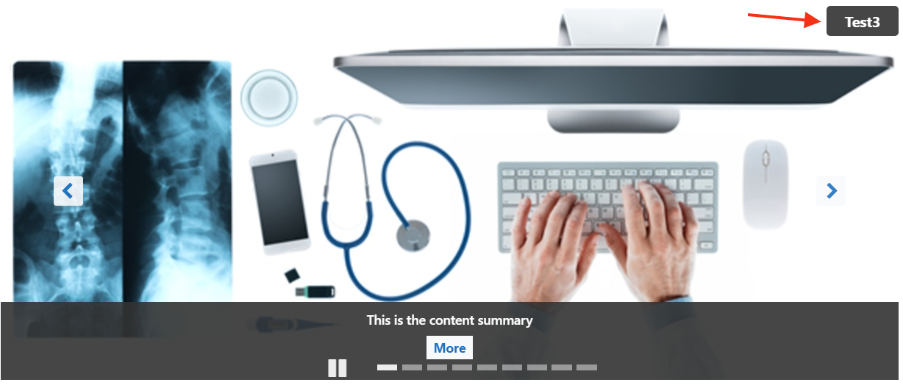 | CMS Support Team
Cache Busting Fix | When we release code, any changes made to JS or CSS are not implemented due to browser caching. This release will see the addition of a Cache Busting Fix that will mean users will not have to manually clear the cache on their machines to pull through the system updates. | Velindre
Spell Checker Function | The CMS now has an added spell checker function available. This is accessed differently across different browsers.  Chrome : Ctrl + Right Click  IE : Right Click | CMS Support Team

Problems Fixed

N/A

New Problems Identified During Testing and Associated Workarounds
N/A

Pre-requisites to Deploy the Release
N/A

Training Requirements
CMS support Site will be updated with any changes that introduce new functionality or changes to workflow.

Step by Step Deployment Instructions
No Deployment actions required by Health Boards

Deployment Plan
Changes to be implemented as specified in the Change Record
Release to be deployed via change record 78031

Back-Out Plan
Back out as detailed on each change record

Release Available for Deployment Date
NHS Wales : 26/02/2019

