REL-ID 628 CMS/06-2020

NHS WALES IT SERVICE MANAGEMENT
CMS Release Notes
Release ID: 628 CMS/06-2020
These Release Notes describe the scope and content of
Release ID: 628 CMS/06-2020

CMS

Version No. 1.4
Status: Approved

Owner: CMS Service Management Board
Author: Helen McGrath
Approver: Michele Golpaykar-Rad
Date: 09/11/2020
Next Review Date: 02/12/2020
Tŷ Glan-yr-Afon
21 Heol Ddwyreiniol Y Bont-Faen, Caerdydd CF11 9AD
21 Cowbridge Road East, Cardiff CF11 9AD
Ffôn/Tel: 02920 500500
www.cymru.nhs.uk/gwybodeg
www.wales.nhs.uk/informatics

TABLE OF CONTENTS

1 DOCUMENT HISTORY 3
1.1 Revision History 3
1.2 Reviewers 3
1.3 Authorisation 3
2 INTRODUCTION 4
3 SERVICE MANAGEMENT BOARD (SMB) 4
4 RELEASE NOTES REQUIREMENT 4
4.1 Release Identification 4
4.2 Description of New or Modified Functionality 4
4.3 Summary 14
4.4 Problems Fixed 14
4.5 New Problems Identified During Testing and Associated Workarounds 14
4.6 Pre-requisites to Deploy the Release 14
4.7 Training Requirements 14
4.8 Step by Step Deployment Instructions 14
4.9 Deployment Plan 14
4.10 Release Available for Deployment Date 14

DOCUMENT HISTORY

Revision History
Date | Version | Author | Revision Summary
09/11/2020 | 1.0 | Helen McGrath | Senior Support & Business Analyst
19/12/2020 | 2.0 | Helen McGrath | Senior Support & Business Analyst
27/11/2020 | 3.0 | Helen McGrath | Senior Support & Business Analyst

Reviewers
This document requires the following reviews:
Date | Version | Name | Position
02/12/2020 | 1.0 | Michele Golpaykar-Rad | Principal Support & Business Analyst

Authorisation
Signing of this document indicates acceptance of its contents.
Author’s Name: | Helen McGrath
Role: | Senior Support & Business Analyst
Signature: |  | Date: | 02/12/2020

Approver’s Name: | Michele Golpaykar-Rad
Role: | Principal Support & Business Analyst
Signature: |  | Date: | 02/12/2020

INTRODUCTION
The NHS Wales Release Management Policy considers that effective Release Management is essential for protecting the integrity of the operational environment. A key objective of the release process is ensuring that users, support staff and other stakeholders are kept informed as to what is planned and how this will affect them. One of the ways that this can be achieved is through the publication of release notes prior to deployment of the Release.

These notes contain information on the agreed scope and content of Release id CMS/06-2020 for the CMS, descriptions of new or modified functionality and problem fixes, descriptions of new problems and workarounds identified during the testing of this Release, training requirements, deployment instructions, references to deployment and back-out plans and key dates within the release process.

SERVICE MANAGEMENT BOARD (SMB)
The CMS Service Management Board has overall responsibility for ensuring that these Release Notes accurately describes the Release and that it is kept under constant review and updated to reflect any modifications to the Release prior to its deployment.

RELEASE NOTES REQUIREMENT

Release Identification
628 CMS/06-2020

Description of New or Modified Functionality
Item | Description | Requestor
Bug Fixes
4.2.1 Box Block Update | Currently when users add text to the summary area of the Bock Block layout, if an ‘X’ is used, this and all following text is removed. We have now updated this area so that all text entered within the summary can be displayed.  Current Display New Display  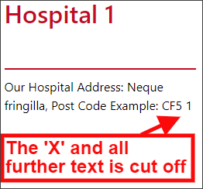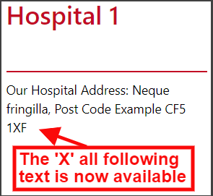 | CTMUHB
4.2.2 Call to Action Update | Currently, if a large amount of text is placed within the Call to Action Plugin; when this is then viewed on a smaller mobile device the ‘X’ to dismiss the message can be lost. This would mean that users would be unable to access your site. We have now amended this so that the content is scrollable.  Current Mobile Display New Mobile Display  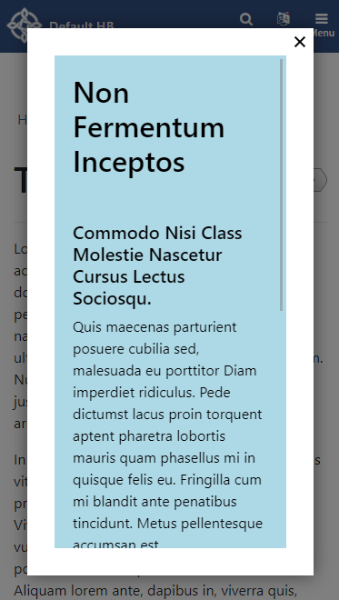  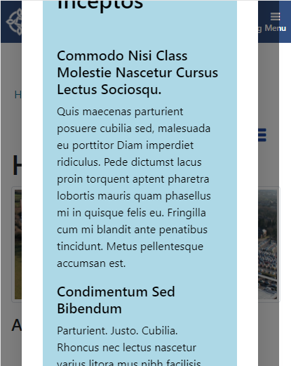 | CMS Support Team
4.2.3 Beautified Containers Update | When displaying text within a Beautified Container you can select ‘Default’ (within the settings) so that any Links within the text are clickable. However, the Link colour is not currently displayed so there in no indication to your users that there is a link within the text. We have now updated this so that all Links will display in the correct link colour (blue).  Current Display New Display  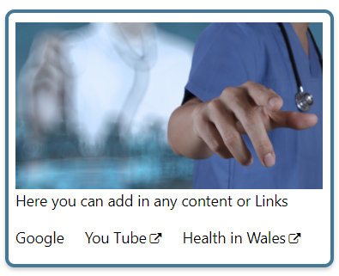 | CMS Support Team
Layout Updates
4.2.4 Profile List Update | Currently within the Profile List layout, if you have 1 image on a row this will display in the Carousel format (Landscape) in order to fill the space. We have now added a new option within the settings of this layout to allow you to control the image sizes. Under Image size you can now select from 3 Image types; Profile Image Only, Carousel Image Only and Mix. Mix would allow a mixture of both Profile and Carousel Image sizes.  Current Display  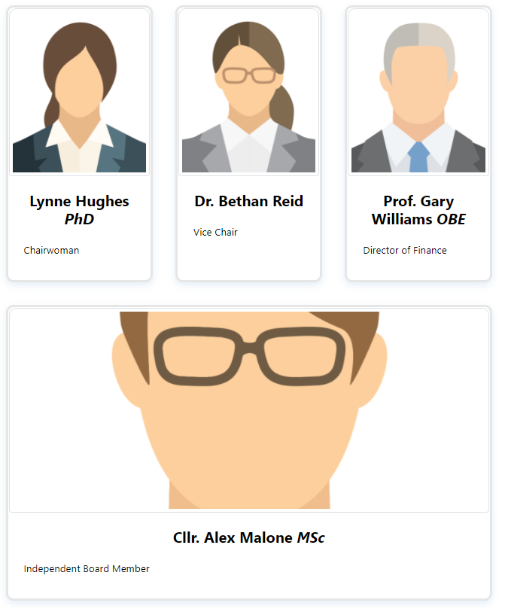  New Settings Option  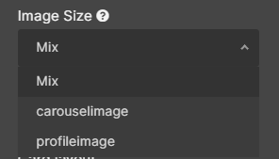  New Display  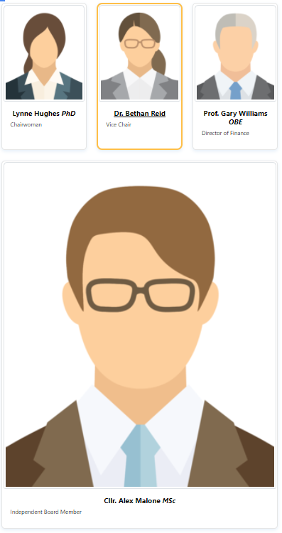 | HEIW
4.2.5 Advanced Table List Addition | We have updated the way in which Advanced Table Lists function, in order to allow admins to add Related Documents and have these appear as Links within the listing. To allow this to functionality admins would need to link the secondary documents within the Related Content area on the main document.  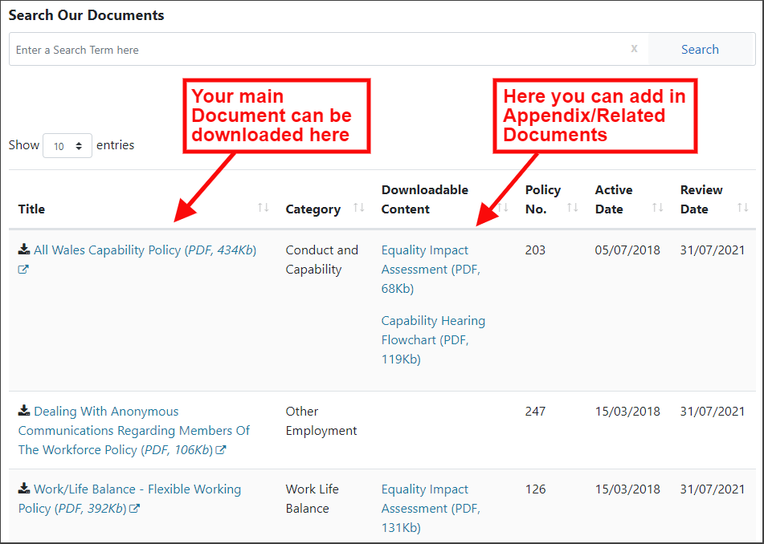 | HDUHB
4.2.6 Advanced Table List Update | When a user presses search button on the Advance Table List a request is made but, in some instances, it is not very clear that the search has been activated. This could cause the user to keep pressing the search; with multiple requests then made, the processing is slowed down. We have now resolved this issue so that when a user presses search button, the button disables and the text on it change to 'Processing...' and goes back to 'Search' once the data is displayed.  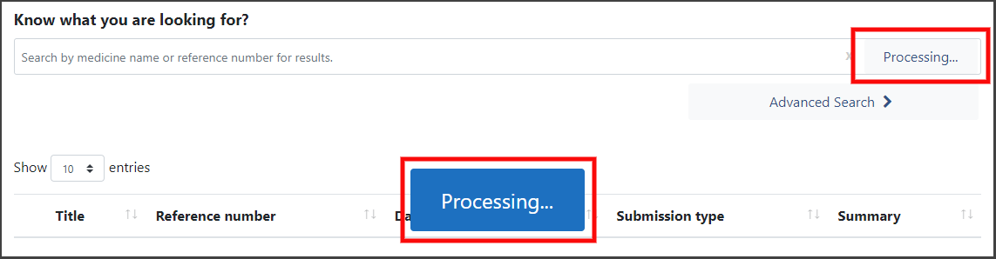 | CMS Support Team
4.2.7 Advanced Table List Load Time | We have reduced the amount of data loaded at any one time 6 pages' worth to 3 pages. This will increase the speed and efficiency with which the data is displayed back to your users. | AWMSG
Accessibility
4.2.8 Screen Reader Plugin | 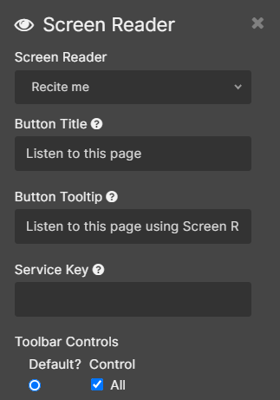  We have now created a new Plugin to allow you to add specific assistive technology to your site. This new ScreenReader Plugin will allow admins to select Recite Me as a screen reader. Admins will then need to add in your Organisations Service Key to enable this plugin.  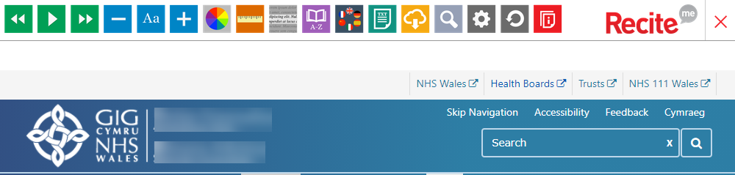 | CMS Support Team
4.2.9 Default Button Colour | To meet Web Accessibility Guidelines; we have updated to the default colour blue that appears on the Forms submit button and the Pagination buttons on Tables/Folders.  Previous Colour: Button: #007BFF Text : #FFFFFF  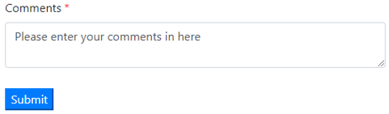  New Colour: Button: #F8F9FA Text : #1D70CB  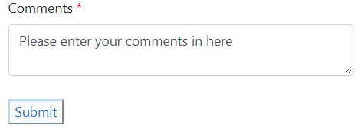  List Pagination  Previous Colour: Button: #007BFF Text: #6497FF  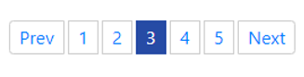  New Colour: Button: #F8F9FA Text: #1978A3  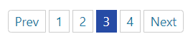 | CMS Support Team
4.2.10  Accordion Code Update | To meet Web Accessibility Guidelines; we have updated the code behind the Accordion. This change will aide screen readers in reading the Accordion options to visually impaired users. | CMS Support Team
4.2.11 Search Box Update | To meet Web Accessibility Guidelines; we have updated all Search Box within the CMS, in order to add Text for Search Box 'X'. This is only for use with Screen Readers and so would not be visible for any other users. | CMS Support Team
4.2.12 DOS Update | To meet Web Accessibility Guidelines; we have updated DOS Plugin. Missing labels within the dropdown fields have now been added in. This change will aide screen readers in reading the dropdown options to visually impaired users. | CMS Support Team
4.2.13 Main Menu Update | To meet Web Accessibility Guidelines; we have updated the source code behind the Main Menu. This change will aide screen readers in reading the Menu items and so would not be visible for any other users. | CMS Support Team
4.2.14 Layout Headers Update | To meet Web Accessibility Guidelines; we have updated the titles for all layouts. These have been amended to H2 headings. This will allow the Heading orders on a page to flow correctly for Screen Readers. We have not introduced any visible difference to the layout titles so admins will not see any difference.  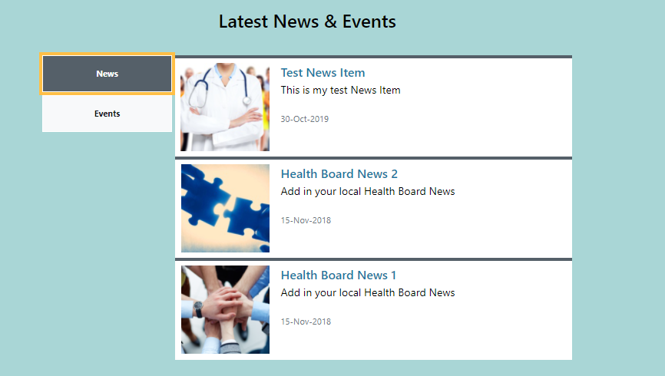  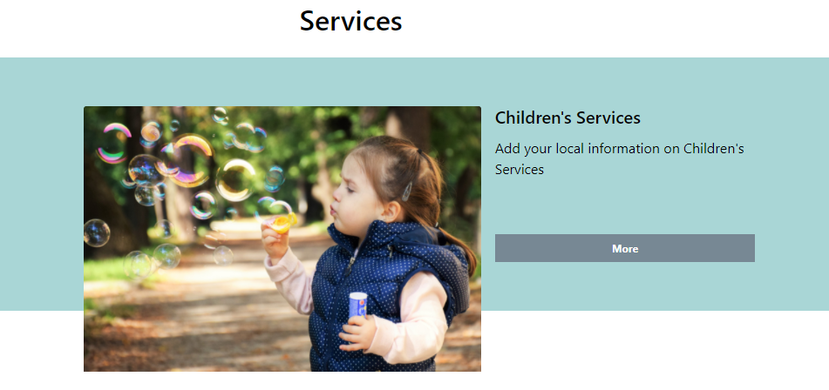  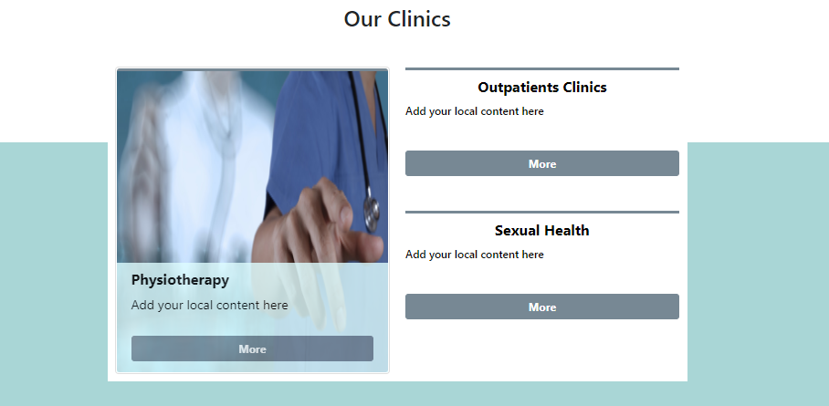 | CMS Support Team
Additional Functionality
4.2.15 3rd Level Navigation Update | We have created a new functionality of the 3rd Level Navigation (Left-hand Nav). This new option; to Not show Siblings, will now allow you to separate areas of the site so that only specific areas of the Navigation will be displayed.  Current Display – Siblings  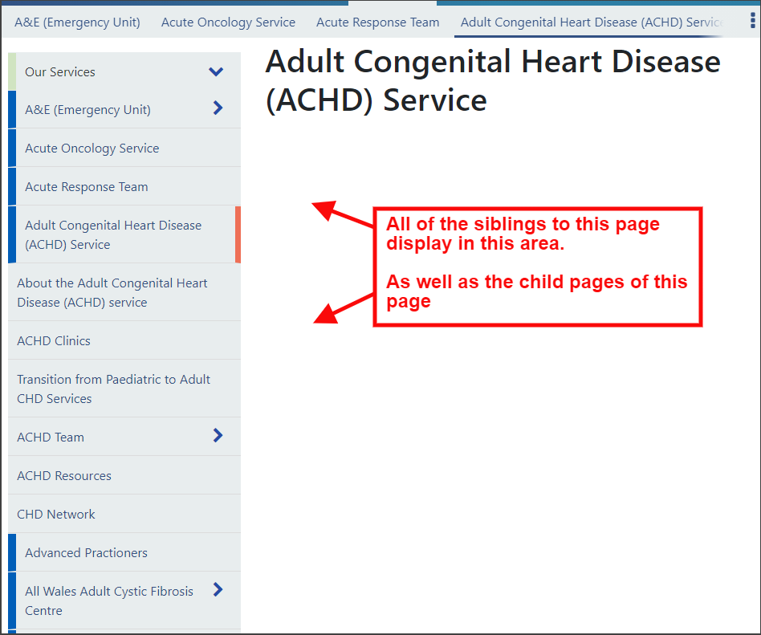  New Settings Option  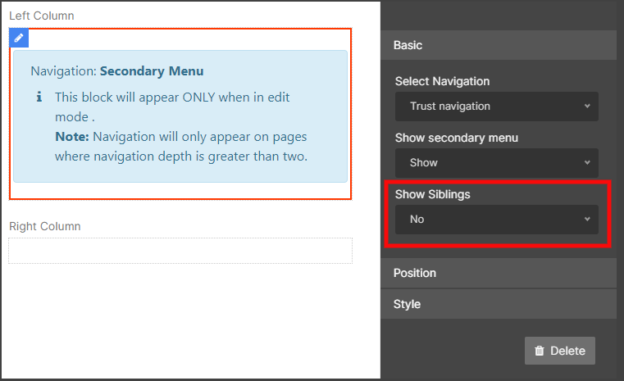  New Display – No Siblings  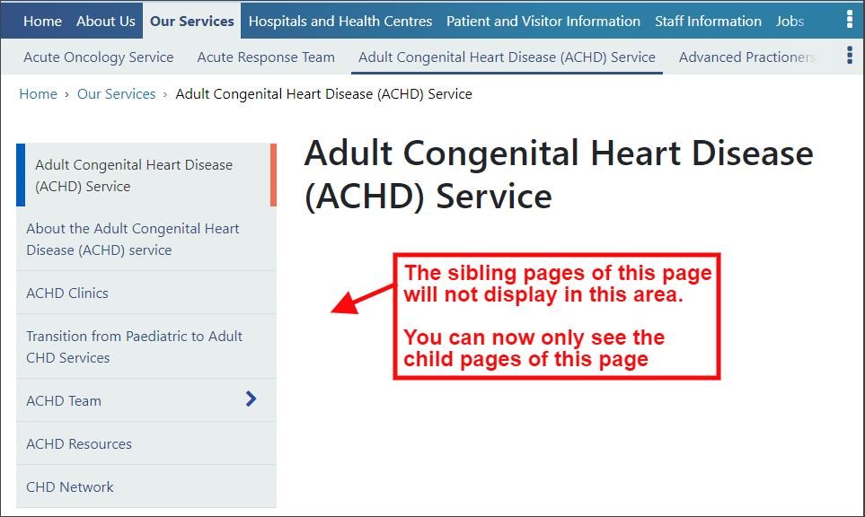 | CAVUHB
4.2.16 No Index Tagging | Admins can now choose to make a page unavailable for search engines to index; whilst still having this available in the sites internal site search.  To do this Admins will need to go to the page and add ‘noindex’ in the Meta Description area. This is not case sensitive, and it doesn’t matter if there is other content already in this area that you want to keep.  If “noindex” is in the Meta Description, then the page content will include the meta tag to exclude it from external search engines.  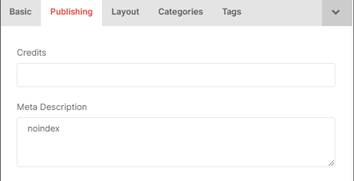 | PHW

Summary
Number of Changes | Number of TFS Work Items | Number of TFS Work Tasks
16 | 27 – Over 5 Sprints | 48 – Over 5 Sprints

Bug Fixes | Layout Updates | Accessibility | Additional Functionality
3 | 4 | 7 | 2

Problems Fixed
N/A

New Problems Identified During Testing and Associated Workarounds
N/A

Pre-requisites to Deploy the Release
N/A

Training Requirements
CMS Support Site will be updated with any changes that introduce new functionality or changes to workflow.

Step by Step Deployment Instructions
No Deployment actions required by Health Boards

Deployment Plan
Changes to be implemented as specified in the Change Record Release to be deployed via change record 86685 Back-Out Plan
Back out as detailed on each change record

Release Available for Deployment Date
NHS Wales: 09/12/2020

