REL-ID 600 CMS/04-2020

NHS WALES IT SERVICE MANAGEMENT
CMS Release Notes
Release ID: 600 CMS/04-2020
These Release Notes describe the scope and content of
Release ID: 600 CMS/04-2020

CMS

Version No. 1.4
Status: Approved

Owner: CMS Service Management Board
Author: Helen McGrath
Approver: Stephen Price
Date: 02/06/2020
Next Review Date: 31/07/2020
Tŷ Glan-yr-Afon
21 Heol Ddwyreiniol Y Bont-Faen, Caerdydd CF11 9AD
21 Cowbridge Road East, Cardiff CF11 9AD
Ffôn/Tel: 02920 500500
www.cymru.nhs.uk/gwybodeg
www.wales.nhs.uk/informatics

TABLE OF CONTENTS

1 DOCUMENT HISTORY 3
1.1 Revision History 3
1.2 Reviewers 3
1.3 Authorisation 3
2 INTRODUCTION 4
3 SERVICE MANAGEMENT BOARD (SMB) 4
4 RELEASE NOTES REQUIREMENT 4
4.1 Release Identification 4
4.2 Description of New or Modified Functionality 4
4.3 Summary 15
4.4 Problems Fixed 16
4.5 New Problems Identified During Testing and Associated Workarounds 16
4.6 Pre-requisites to Deploy the Release 16
4.7 Training Requirements 16
4.8 Step by Step Deployment Instructions 16
4.9 Deployment Plan 16
4.10 Back-Out Plan 16
4.11 Release Available for Deployment Date 16

DOCUMENT HISTORY

Revision History
Date | Version | Author | Revision Summary
02/06/2020 | 1.0 | Helen McGrath | Senior Support & Business Analyst
25/06/2020 | 1.1 | Helen McGrath | Senior Support & Business Analyst
06/07/2020 | 1.2 | Helen McGrath | Senior Support & Business Analyst
31/07/2020 | 1.3 | Helen McGrath | Senior Support & Business Analyst

Reviewers
This document requires the following reviews:
Date | Version | Name | Position
03/08/2020 | 1.3 | Stephen Price | Applications Manager (Corporate)

Authorisation
Signing of this document indicates acceptance of its contents.
Author’s Name: | Helen McGrath
Role: | Senior Support & Business Analyst
Signature: |  | Date: | 03/08/2020

Approver’s Name: | Stephen Price
Role: | Applications Manager (Corporate)
Signature: |  | Date: | 03/08/2020

INTRODUCTION
The NHS Wales Release Management Policy considers that effective Release Management is essential for protecting the integrity of the operational environment. A key objective of the release process is ensuring that users, support staff and other stakeholders are kept informed as to what is planned and how this will affect them. One of the ways that this can be achieved is through the publication of release notes prior to deployment of the Release.

These notes contain information on the agreed scope and content of Release id CMS/04-2020 for the CMS, descriptions of new or modified functionality and problem fixes, descriptions of new problems and workarounds identified during the testing of this Release, training requirements, deployment instructions, references to deployment and back-out plans and key dates within the release process.

SERVICE MANAGEMENT BOARD (SMB)
The CMS Service Management Board has overall responsibility for ensuring that these Release Notes accurately describes the Release and that it is kept under constant review and updated to reflect any modifications to the Release prior to its deployment.

RELEASE NOTES REQUIREMENT

Release Identification
600 CMS/04-2020

Description of New or Modified Functionality
Item | Description | Requestor
Bug Fixes
4.2.1 Alert Box Covering Content | When applied to the page, the Alert Box can envelope content that it is placed near to; such as covering an entire Carousel. This fix will ensure that this error can no longer occur.  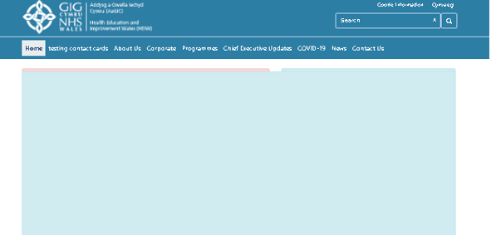 | CMS Support Team
4.2.2 Accordion Boarders Displaying | The Boarders of the Accordion Layout disappear at certain zoom levels on IE and Chrome. This change will see the boarders increased from 1px to 2px, this will then resolve this issue. | NWSSP
4.2.3 Button Text Wrapping | There has been an issue noticed with buttons in various layout displays. The text does not wrap if the length of text is greater than the length of the button.  Current Display  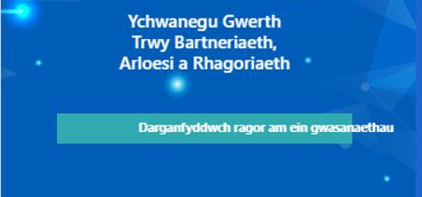  New Display   | CMS Support Team
4.2.4 Mura DOS Details | In the 'A&E services' column for Hospitals in DoS the ampersand character is being displayed as the HTML character reference &amp; or not displaying at all - this change will now ensure this is displayed as &  Current Display New Display  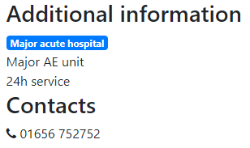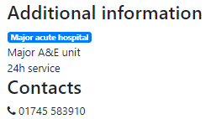 | CMS Support Team
4.2.5 Chevrons Within the Mobile Menu | When viewing the sites on a mobile platform, the chevrons on the left- and right-hand side of the menu there is currently a slight size/colour difference. This change will bring them in line with each other.  Current Display  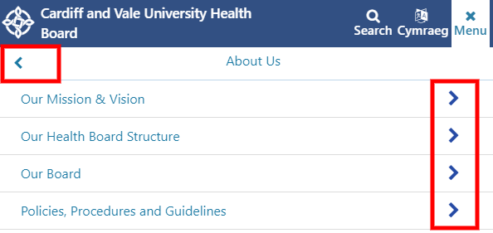  New Display  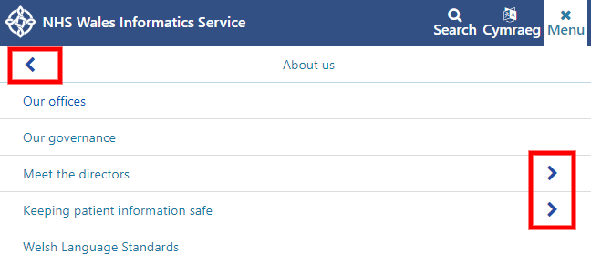 | CMS Support Team
4.2.6 Chevrons Within the Tabbed Content | When viewing the sites on a mobile platform, the chevrons on the Tabbed Content are not taking the colour from the title colour selected. This change will bring them in line with each other.  Current Display  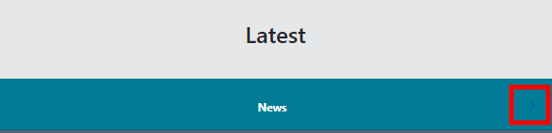  New Display  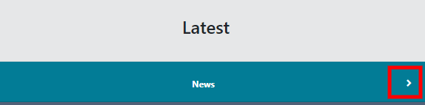 | CMS Support Team
4.2.7 Swipe Action on a Mobile | On a Mobile platform some plugins & layouts such as; Carousel and Multi Content 1, have a swipe action for the users. This was not functioning correctly, and a fix has now been applied. | CMS Support Team
Layout Updates
4.2.8 Content Type Selector | Currently the option to select a URL, Page Folder in configurator takes a long time to load; even when you are not interested in using it. We have now updated the logic adding a new field to select these within.  Current Display  Beautified Container Single Content 4  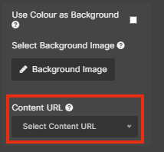  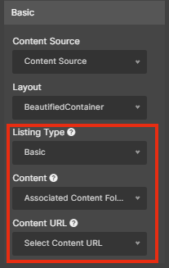  New Display  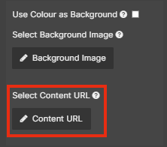  Beautified Container Single Content 4  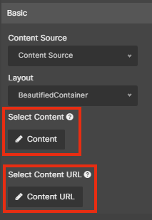  The New Selector Boxes  Image Selector  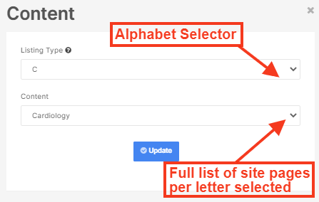  URL Selector  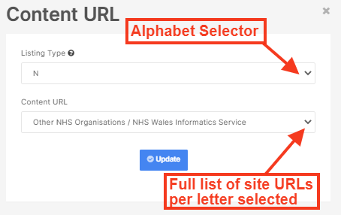 | CMS Support Team
4.2.9 Multi Contact Card Update 1 | Originally this layout was set to only work in conjunction with Related Content & Contact Card (Once enabled on in the back of the page). We have now updated this layout to bring this in line with the other layouts available. Admins will now be able to draw in content through a Local Index or Related Content & Custom.  Settings Options  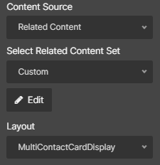  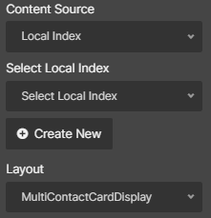  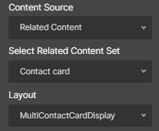  Contact Card Custom Local Index  Multi Contact Card Display  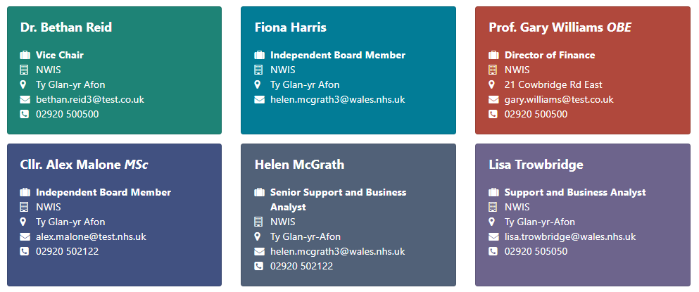 | CMS Support Team
4.2.10 Multi Contact Card Update 2 | This update to the Multi Contact Card display will now allow one card at 100% width, and this will allow text on the page to wrap correctly.  New Display  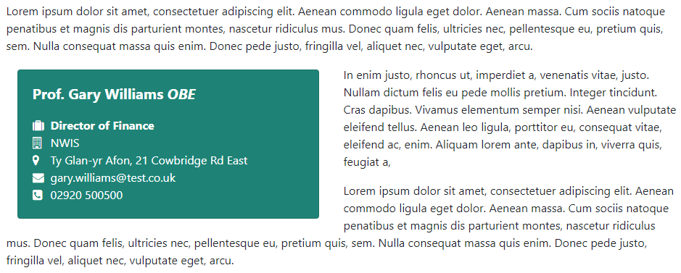 | CMS Support Team
4.2.11 Cross Site Search Update | 1. The Cross-Site Search was only designed to function on a One Column layout, this update will see that the Cross-Site Search can now be added to any page type and will now be responsive and resize accordingly.  2. When a large amount of text is added to one of the Buttons underneath the Cross-Site Search, this text will overflow out of the confines of the Button. This issue has now been resolved and the text will now wrap around.  3. We have now added the ability to add in more ‘Buttons’ below the Cross-Site Search. The display will now show 3 Buttons per row, further Buttons will start a second row. The buttons will resize to fill the space available  Current Display  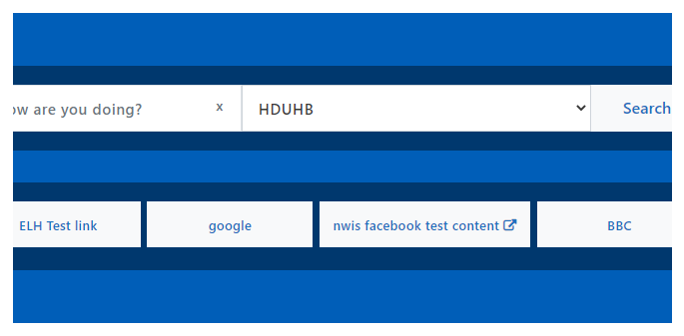  New Display  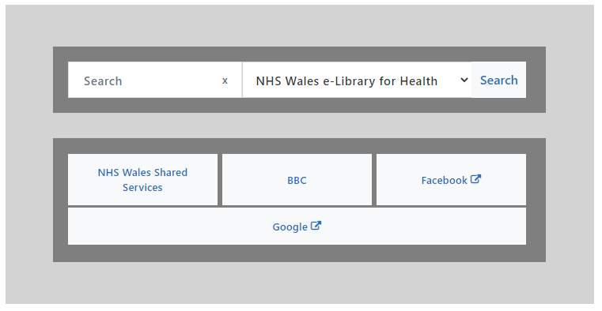 | CMS Support Team
4.2.12 Layout Default Colour Update | We have made an update to the default colour scheme that is drawn into the site Theme when you add any of the site Layouts. This is to bring all layout default colours in line with each other, when they are initially placed on your page. Users will still have full access to the layout settings to amend the colours of any layouts as they wish, this change will not affect any layouts currently in use.  New Default Displays Examples  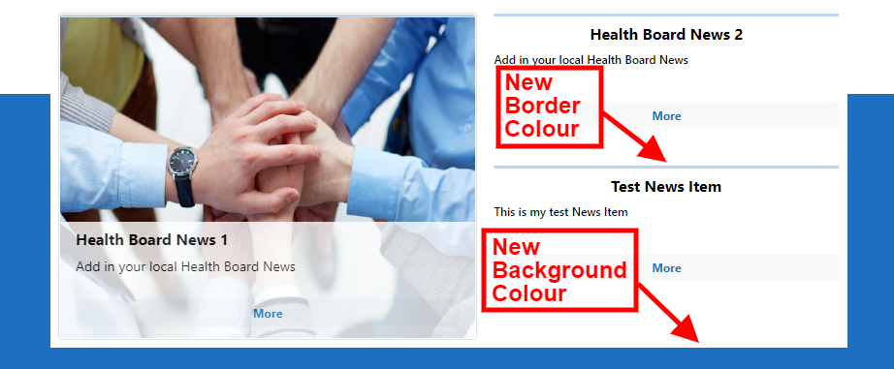  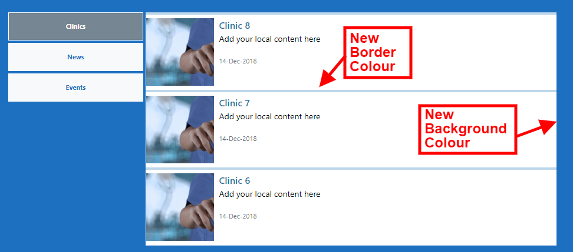   | CMS Support Team
Accessibility
4.2.13 Box Block Layout Update | The Box Block Layout has 4 pre-set colours; Red, Blue, Yellow and Green. Whilst testing it has been noted that the Yellow and Green shades do not meet accessibility. These colours have now been updated and now meet Accessibility Guidelines.  Current Display    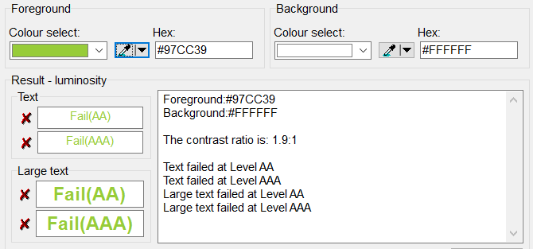  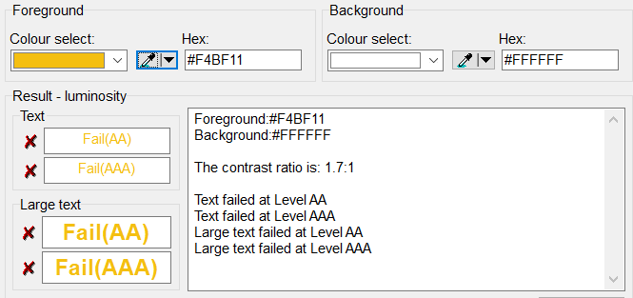  New Display    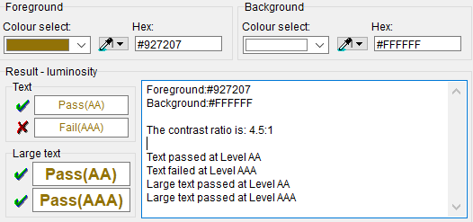  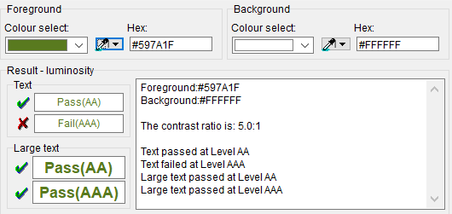 | HDUHB
4.2.14 Non-Descriptive Links | There is a link in the Header of the gradient theme entitled ‘/’ this is a part of the mobile menu. The link is ambiguous for screen readers that browse both in and out of context. This change will ensure this is hidden from screen reader users until the mobile platform is present. | CMS Support Team
Welsh Language Standards
4.2.15 Grid Layout Update | Within the Grid Layout there is a default ‘Read More’ text that can be added to the display. On the Welsh site this text was set to English, this has now been updated to default to the correct Welsh Language translation.  Current Layout  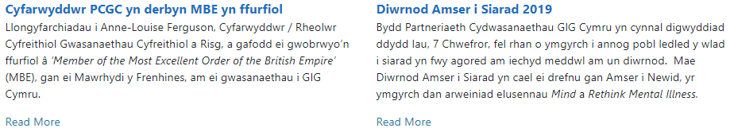  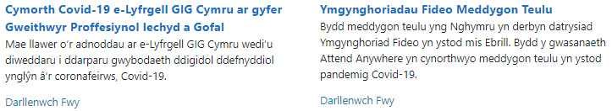  New Layout | NWSSP
Additional Functionality
4.2.16 New Image Size | A new Image size has been added to the system ‘gridimg’(221x530). This new image size is designed work with the grid layout. When displaying multiple Images on a page the page load time can be slow when using IE. This new image size will resolve this.     | NWSSP
4.2.17 Advanced Search Within Links | Within the CK Editor of the page; when users select the Link Icon, we have now added in an Advanced Search function. This will allow users to filter the results to find the correct items faster.  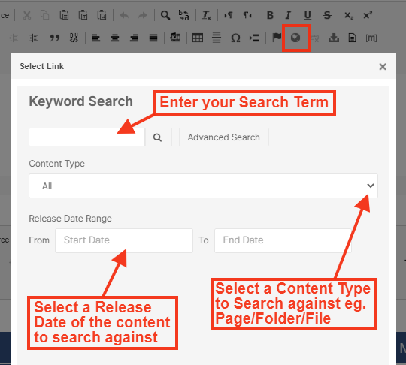
4.2.18 Mura User Account Inactive | We have added in new functionality where similarly, to Cascade; if a User has not logged into their account in over 12months the account will default into an Inactive state. Site Admins are able to ‘Reactivate’ Users accounts by selecting the User Account > Advanced > Mark as Active and Save  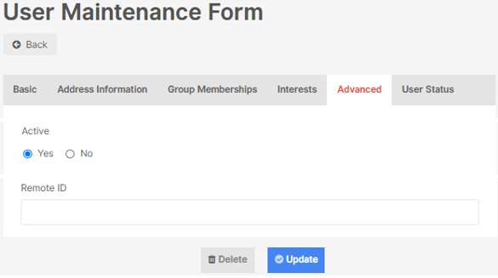 | CMS Support Team
4.2.19 Mura User Account Display | We have added in new functionality to the User maintenance area, there will now be a display area showing:  - When the Users Account was created  - When the User last Logged in  - The current status of the account  - When the User Account became Inactive  This is available when you select a User and select the new Tab – User Status  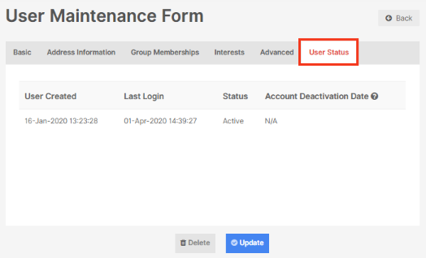 | CMS Support Team

Summary

Number of Changes | Number of TFS Work Items | Number of TFS Work Tasks
19 | 20 – Over 8 Sprints | 45 – Over 8 Sprints

Bug Fixes | Layout Updates | Accessibility | Welsh Language Standards | Additional Functionality
7 | 5 | 2 | 1 | 4

Problems Fixed
N/A

New Problems Identified During Testing and Associated Workarounds
N/A

Pre-requisites to Deploy the Release
N/A

Training Requirements
CMS Support Site will be updated with any changes that introduce new functionality or changes to workflow.

Step by Step Deployment Instructions
No Deployment actions required by Health Boards

Deployment Plan
Changes to be implemented as specified in the Change Record Release to be deployed via change record 81951

Back-Out Plan
Back out as detailed on each change record

Release Available for Deployment Date
NHS Wales: 08/08/2020

