REL-ID 585 CMS/03-2020

NHS WALES IT SERVICE MANAGEMENT
CMS Release Notes
Release ID: 585 CMS/03-2020
These Release Notes describe the scope and content of
Release ID: 585 CMS/03-2020

CMS

Version No. 1.4
Status: Approved

Owner: CMS Service Management Board
Author: Helen McGrath
Approver: Stephen Price
Date: 22/04/2020
Next Review Date: 28/04/2020
Tŷ Glan-yr-Afon
21 Heol Ddwyreiniol Y Bont-Faen, Caerdydd CF11 9AD
21 Cowbridge Road East, Cardiff CF11 9AD
Ffôn/Tel: 02920 500500
www.cymru.nhs.uk/gwybodeg
www.wales.nhs.uk/informatics

TABLE OF CONTENTS

1 DOCUMENT HISTORY 3
1.1 Revision History 3
1.2 Reviewers 3
1.3 Authorisation 3
2 INTRODUCTION 4
3 SERVICE MANAGEMENT BOARD (SMB) 4
4 RELEASE NOTES REQUIREMENT 4
4.1 Release Identification 4
4.2 Description of New or Modified Functionality 4
4.3 Summary 16
4.4 Problems Fixed 16
4.5 New Problems Identified During Testing and Associated Workarounds 16
4.6 Pre-requisites to Deploy the Release 16
4.7 Training Requirements 16
4.8 Step by Step Deployment Instructions 16
4.9 Deployment Plan 16
4.10 Back-Out Plan 16
4.11 Release Available for Deployment Date 16

DOCUMENT HISTORY

Revision History
Date | Version | Author | Revision Summary
03/03/2020 | 1.0 | Helen McGrath | Senior Support & Business Analyst
12/03/2020 | 1.1 | Helen McGrath | Senior Support & Business Analyst
06/04/2020 | 1.2 | Helen McGrath | Senior Support & Business Analyst
16/04/2020 | 1.3 | Helen McGrath | Senior Support & Business Analyst
22/04/2020 | 1.4 | Helen McGrath | Senior Support & Business Analyst

Reviewers
This document requires the following reviews:
Date | Version | Name | Position
21/04/2020 | 1.3 | Stephen Price | Applications Manager (Corporate)

Authorisation
Signing of this document indicates acceptance of its contents.
Author’s Name: | Helen McGrath
Role: | Senior Support & Business Analyst
Signature: |  | Date: | 22/04/2020

Approver’s Name: | Stephen Price
Role: | Applications Manager (Corporate)
Signature: |  | Date: | 22/04/2020

INTRODUCTION
The NHS Wales Release Management Policy considers that effective Release Management is essential for protecting the integrity of the operational environment. A key objective of the release process is ensuring that users, support staff and other stakeholders are kept informed as to what is planned and how this will affect them. One of the ways that this can be achieved is through the publication of release notes prior to deployment of the Release.

These notes contain information on the agreed scope and content of Release id CMS/03-2020 for the CMS, descriptions of new or modified functionality and problem fixes, descriptions of new problems and workarounds identified during the testing of this Release, training requirements, deployment instructions, references to deployment and back-out plans and key dates within the release process.

SERVICE MANAGEMENT BOARD (SMB)
The CMS Service Management Board has overall responsibility for ensuring that these Release Notes accurately describes the Release and that it is kept under constant review and updated to reflect any modifications to the Release prior to its deployment.

RELEASE NOTES REQUIREMENT

Release Identification
585 CMS/03-2020

Description of New or Modified Functionality
Item | Description | Requestor
Bug Fixes
4.2.1 Contact Cards Email Update | When creating a contact card, the email field currently has some forbidden characters; in this instance an apostrophe. This issue has now been resolved to allow extra characters.  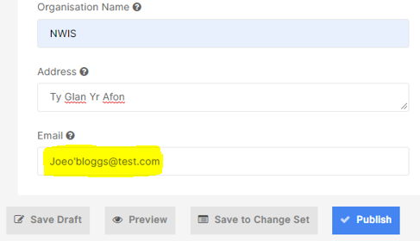 | CAVUHB
4.2.2 Pagination Update | Currently there is a formatting issue with Pagination on Table list on Mobile, Chrome and Firefox. Appearing as below:  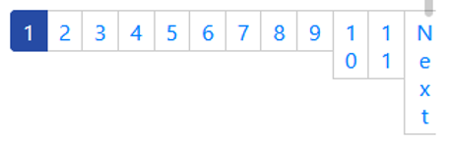  This has now been repaired and will appear across all platforms and browsers as it currently does in IE and Edge, as below:  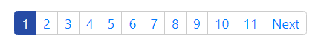 | CMS Support Team
4.4.3 Events & Calendar Updates | - On the Calendar the 'M' is currently missing from AM/PM. This has now been amended.  Current Display  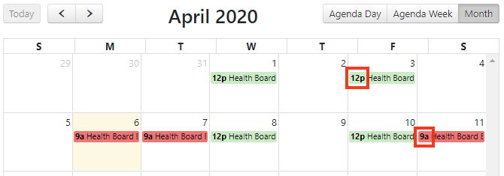  New Display  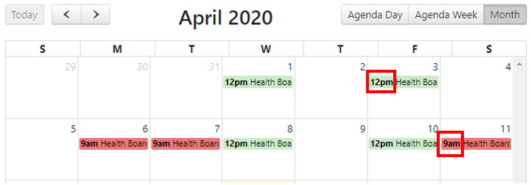  - Within the Events – The ‘Open in New Window’ indicator arrow on the Journey planner should be contained within the button and not next to it. This has now been amended  Current Display  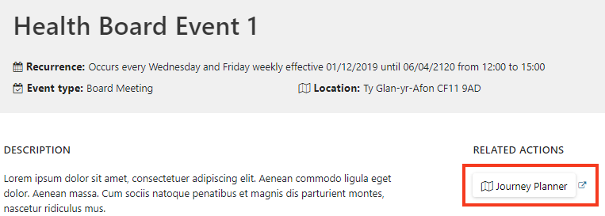  New Display  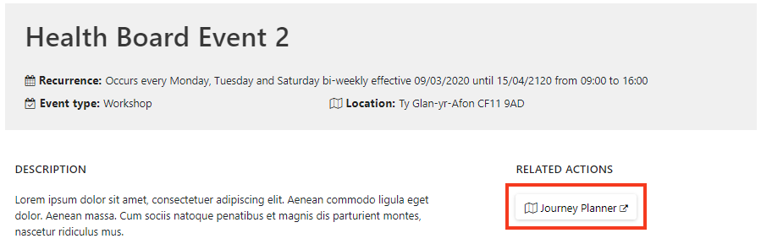 | CMS Support Team
Layout Updates
4.2.4 Twitter Update | Within the Social Board Plugin ‘Facebook’ and ‘Native Twitter’ have an option to allow the user to control the Height of the panel. This functionality will now also be available within the ‘Twitter’ option.  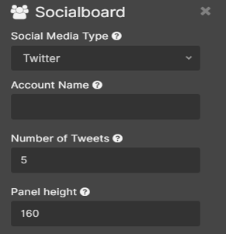 | CMS Support Team
4.2.5 Profile Card Layout Update | 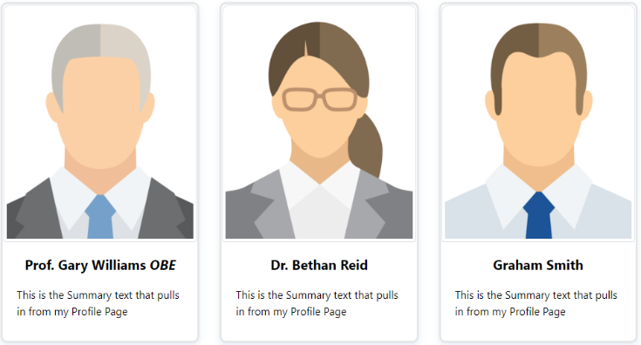  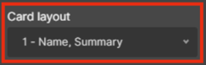  We have now updated the Profile Card Layout display options. This will now include four separate formatting options for users to choose from, these options will allow users to customise the information displayed on the individual Profile Cards.  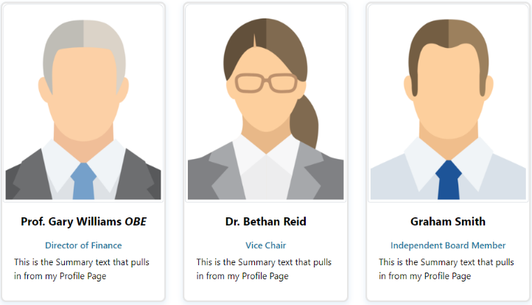  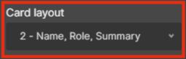  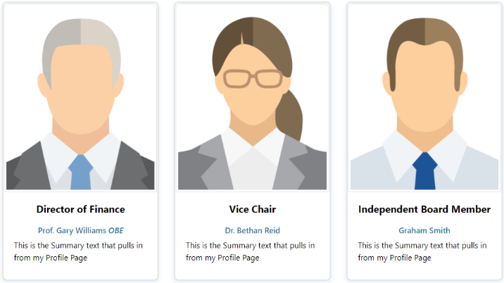  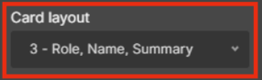  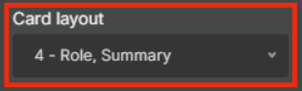  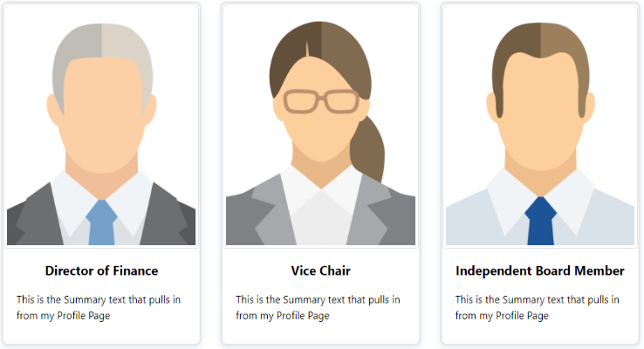 | HDUHB
4.2.6 Single Content 3 Update | Currently the Single Content 3 Layout is not fully responsive across all platforms, this has now been resolved. In addition, the ‘Read More’ text will now wrap and not fall outside of the button.  Current Display    New Display - Desktop    New Display – iPad    New Display – Mobile   | CMS Support Team
4.2.7 Multi Content 1 Update | There is currently too much white space appearing in-between these, when 2 or more of these layouts are placed on a page. The amount of white space has now been reduced.  Current Display  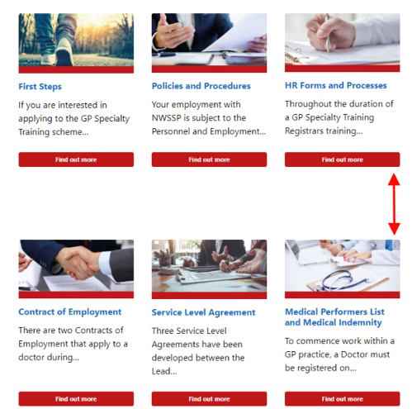  New Display   | NWSSP
4.2.8 Grid Layout Update | On the Grid Layout there is not currently enough white space appearing between the Image, Title and Summary areas. The amount of white space has now been increased.  Current Display    New Display  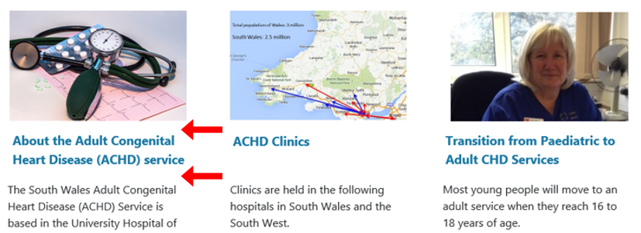 | CAVUHB
4.2.9 Events Update | When drawn into layouts such as Tabbed Content, Events scheduled for the future are not being displayed. This has now been amended to enable users to advertise upcoming Events.  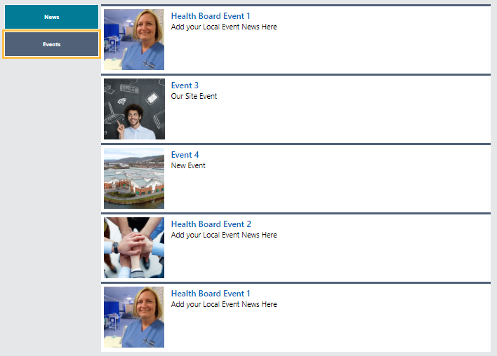 | CMS Support Team
4.2.10 Box Block 2 Update | We have now added an additional option in the Box Block 2 settings, this will allow users the option of an added a background image to their Box Blocks. User can select 1 image to appear on all 3 blocks or individual images to appear on each block. For full instructions see the CMS Support site.  Repeated Images  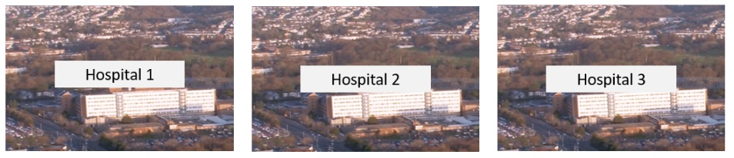  Individual Images  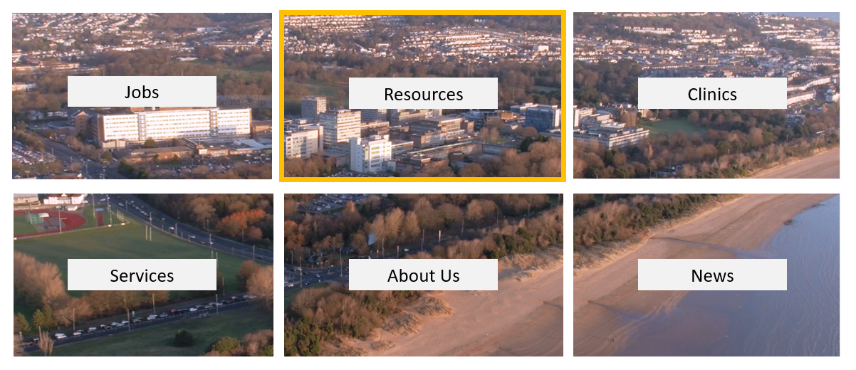 | CMS Support Team
4.2.11 Image Selector Update | The Image selector with Box Block 2 and Multi Content 4 has now been updated. This update will improve the load time of the settings for these layouts. When selected the new Image option will open up a new menu, allowing the user to browse alphabetically through the site images.  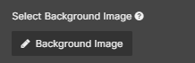  New Display – Setting Option  New Display – New Menu and Options  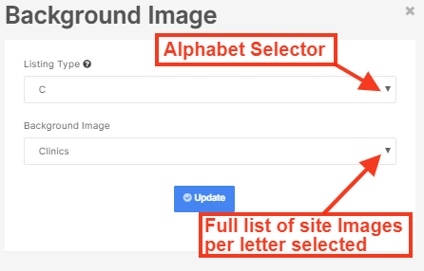 | CMS Support Team
4.2.12 Contact Card Display Update | Currently when more than one Contact Card is added to a page there is no space between these; making it difficult for users to distinguish one from another. We have created a new layout - Multi Contact Card Display - to now display multiple contact cards. These will display within a colour block; users can select the number of grid columns that they will appear in. For full instructions see the CMS Support site.  Current Display  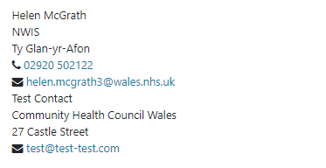  New Display  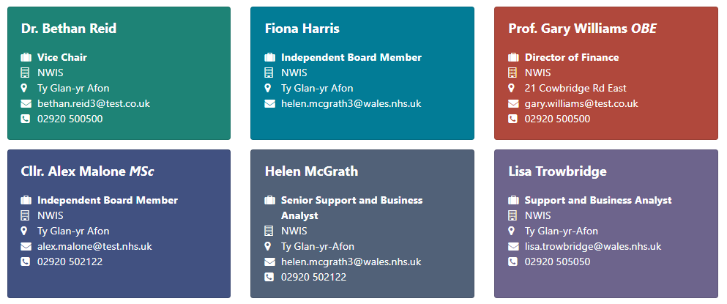 | CMS Support Team
4.2.13 Advanced Table List Pop-out Image | 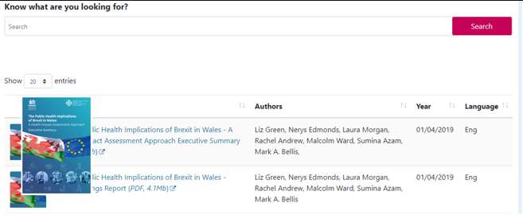  Within the Advanced Table List, we have now added a hover to the Images displayed here. When hovered over theses image will now display a ‘Pop-out’ of the full image. | CMS Support Team
4.2.14 Advanced Table List Date Column | The Date field in the Table List & Advanced Table List Layout is not pulling in any data, this has now been amended to pull in the Publish Date of the items displayed.  Current Layout  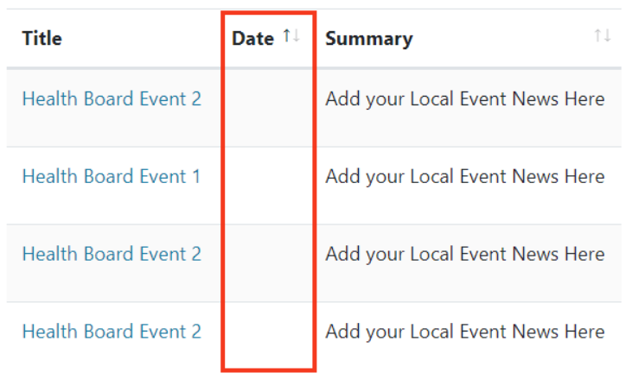  New Layout  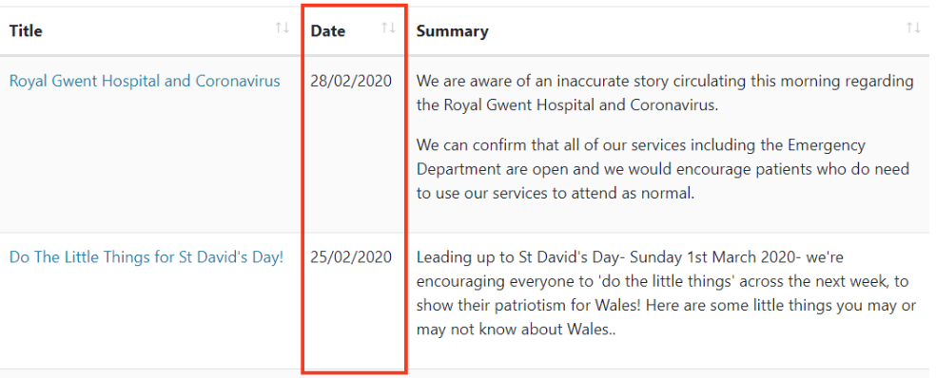 | CMS Support Team
4.2.15 Advanced Table List - Improve Filter | 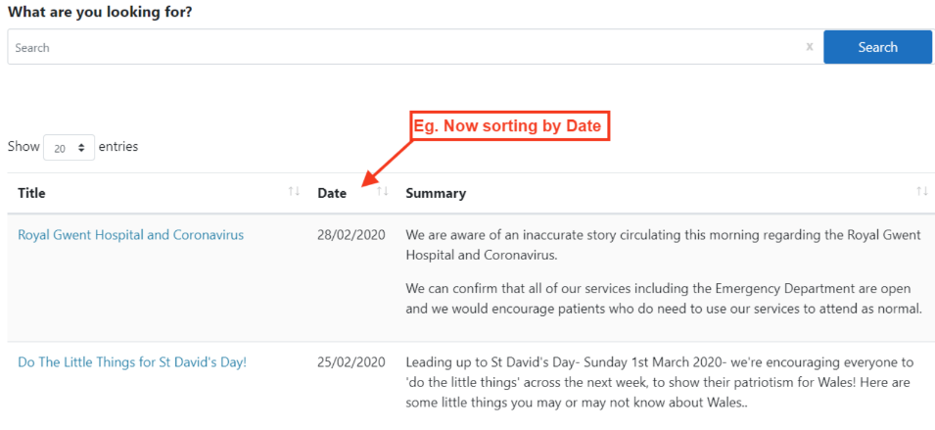  Currently the Advanced Table List only sorts by the item Title (alphabetically), this has now been amended so that users can select the sort order. This can be controlled through the local Index or Folder settings; depending on if this has been added to a Page or a Folder. | ABUHB
Accessibility
4.2.16 Alt Text for Images | We have updated the way that Images Alt text works in conjunction with display modules. Currently when adding a page with an associated Image to a display layout such as Box Block, Single or Multi Content; the Image will show alt or title text.  - If there is no Alt text - nothing will be added in the title tag  - If there is Alt text - the title of the content and not of the image will be the title tag  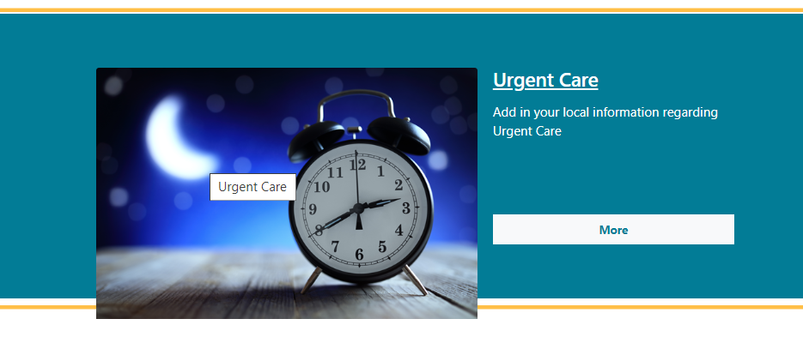 | CMS Support Team
4.2.17 Indicator Focus Update | When keyboard only users are tabbing through buttons in some modules the focus is not very visible, and the search buttons are hard to be identified as focussed. This has now been updated to make to focus area more prominent.  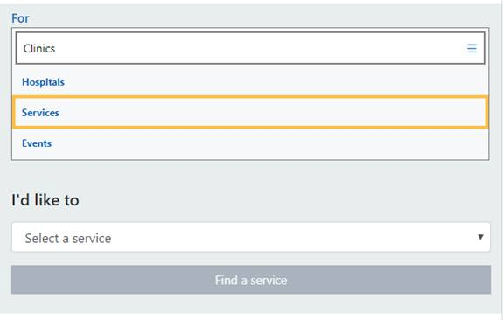 | CMS Support Team
4.2.18 Search Box Update | The Search box used on the Advanced Table List Layout has now been updated for accessibility purposes. An ‘X’ to enable users to clear the search has now been added to bring this in line with the main site search bar.  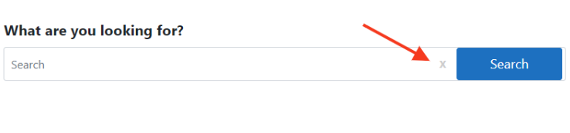 | CMS Support Team
Welsh Language Standards
4.2.19 Google Map Update | The Journey planner text on the Welsh sites is currently appearing in English. The Welsh translations have now been added into the correct areas.  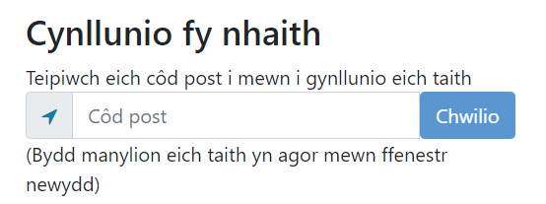 | CMS Support Team
4.2.20 Added Welsh Translations in Forms | When users have more than 1 page within their Forms ‘Next’ & ’Back’ buttons are added to the form. This currently appears in English on the Welsh sites. The Welsh translations of these buttons have now been added to the Welsh sites.  Next - Nesaf  Back – Yn Ôl | NWSSP
Additional Functionality
4.2.21 New File Extension | A new file type extension has now been added into the CMS - .twb (Tableau Workbook File) | NWSSP
4.2.22 Email Validation in Forms | We have now added in a Confirm Email Validation field within forms. This will ask your users to enter their email address a second time and will then confirm that both email address are matching before the form will submit. For full instructions see the CMS Support site.  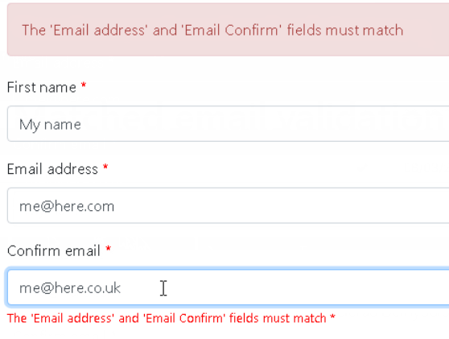 | CMS Support Team

Summary

Number of Changes | Number of TFS Work Items | Number of TFS Work Tasks
22 | 42 – Over 4 Sprints | 70 – Over 4 Sprints

Bug Fixes | Layout Updates | Accessibility | Welsh Language Standards | Additional Functionality
3 | 12 | 3 | 2 | 2

Problems Fixed
N/A

New Problems Identified During Testing and Associated Workarounds
N/A

Pre-requisites to Deploy the Release
N/A

Training Requirements
CMS Support Site will be updated with any changes that introduce new functionality or changes to workflow.

Step by Step Deployment Instructions
No Deployment actions required by Health Boards

Deployment Plan
Changes to be implemented as specified in the Change Record Release to be deployed via change record 78963

Back-Out Plan
Back out as detailed on each change record

Release Available for Deployment Date
NHS Wales: 22/04/2020

