REL-ID 544 CMS/09-2019

NHS WALES IT SERVICE MANAGEMENT
CMS Release Notes
Release ID: 544 CMS/09-2019
These Release Notes describe the scope and content of
Release ID: 544 CMS/09-2019

CMS

Version No. 1.0
Status: Approved

Owner: CMS Service Management Board
Author: Helen McGrath
Approver: Stephen Price
Date: 12/09/2019
Next Review Date: 18/09/2019
Tŷ Glan-yr-Afon
21 Heol Ddwyreiniol Y Bont-Faen, Caerdydd CF11 9AD
21 Cowbridge Road East, Cardiff CF11 9AD
Ffôn/Tel: 02920 500500
www.cymru.nhs.uk/gwybodeg
www.wales.nhs.uk/informatics

TABLE OF CONTENTS

1 DOCUMENT HISTORY 3
1.1 Template Revision History 3
1.2 Revision History 3
1.3 Reviewers 3
1.4 Authorisation 3
1.5 Document Location 3
2 INTRODUCTION 4
3 SERVICE MANAGEMENT BOARD (SMB) 4
4 RELEASE NOTES REQUIREMENT 4
4.1 Release Identification 4
4.2 Description of New or Modified Functionality 4
4.3 Problems Fixed 5
4.4 New Problems Identified During Testing and Associated Workarounds 5
4.5 Pre-requisites to Deploy the Release 5
4.6 Training Requirements 5
4.7 Step by Step Deployment Instructions 6
4.8 Deployment Plan 6
4.9 Back-Out Plan 6
4.10 Release Available for Deployment Date 6

DOCUMENT HISTORY

Template Revision History
Date | Version | Author | Revision Summary
6th March 2012 | 0.1 | Steve Finn | First Draft
15th March 2012 | 0.2 | Steve Finn | Second Draft following comments from SW
5th July 2012 | 0.3 | Steve Finn | Third Draft following release process modifications
26th July 2012 | 1.0 | Kelly Tremlett | Issued as approved version 1.0

Revision History
Date | Version | Author | Revision Summary
12/09/2019 | 1.0 | Helen McGrath | Senior Support & Business Analyst

Reviewers
This document requires the following reviews:
Date | Version | Name | Position

Authorisation
Signing of this document indicates acceptance of its contents.
Author’s Name: | Helen McGrath
Role: | Senior Support and Business Analyst
Signature: |  | Date: | 12/09/2019

Approver’s Name: | Stephen Price
Role: | Applications Manager (Corporate)
Signature: |  | Date: | 12/09/2019

Document Location
Type | Location
Electronic

INTRODUCTION
The NHS Wales Release Management Policy considers that effective Release Management is essential for protecting the integrity of the operational environment. A key objective of the release process is ensuring that users, support staff and other stakeholders are kept informed as to what is planned and how this will affect them. One of the ways that this can be achieved is through the publication of release notes prior to deployment of the Release.

These notes contain information on the agreed scope and content of Release id CMS/09-2019 for the CMS descriptions of new or modified functionality and problem fixes, descriptions of new problems and workarounds identified during the testing of this Release, training requirements, deployment instructions, references to deployment and back-out plans and key dates within the release process.

SERVICE MANAGEMENT BOARD (SMB)
The CMS Service Management Board has overall responsibility for ensuring that these Release Notes accurately describes the Release and that it is kept under constant review and updated to reflect any modifications to the Release prior to its deployment.

RELEASE NOTES REQUIREMENT

Release Identification
544 CMS/09-2019

Description of New or Modified Functionality
Item | Description | Requestor
Welsh Translation for Navigation Options | A number of the Navigation options within the Welsh language site were displaying in English. The terms within this plugin have now been updated to display the Welsh language by default.  Current Display New Display  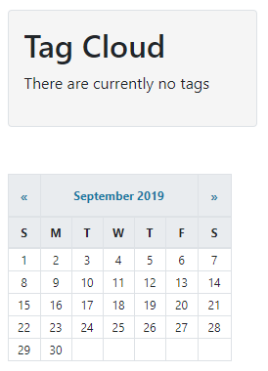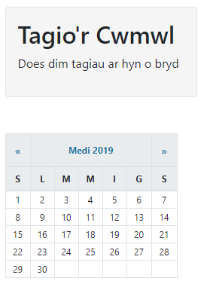 | CMS Support Team
Welsh Translation for ​​System Options | A number of the System options within the Welsh language site were displaying in English. The terms within this plugin have now been updated to display the Welsh language by default.  Current Display New Display  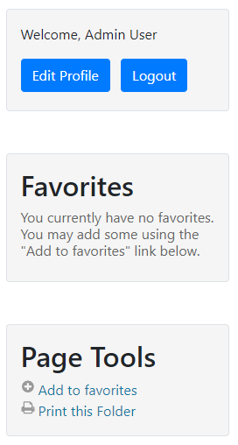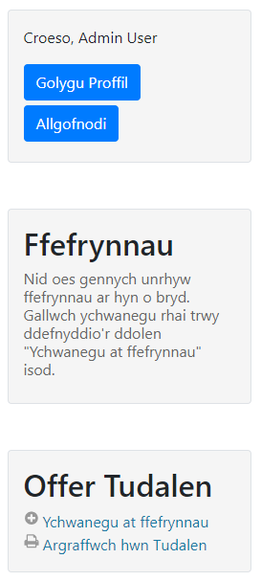 | CMS Support Team
Advanced Table List - Associated Image Field | When using Advanced Table List in conjunction with your specifically created page type, you will now have the ability to add an Image/Icon to display within the list.  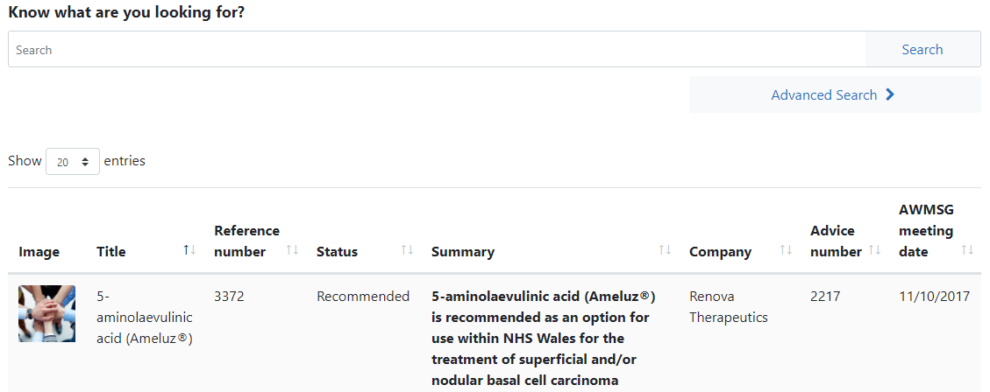 | AWMSG
Welsh Translation Options on Event Calendar | A Calendar navigation controls and heading text within the Welsh language site were displaying in English. These terms have now been updated to display the Welsh language by default.  Current Display  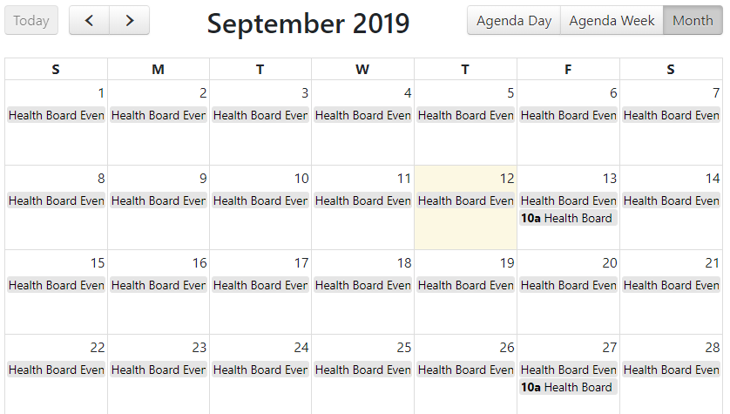  New Display  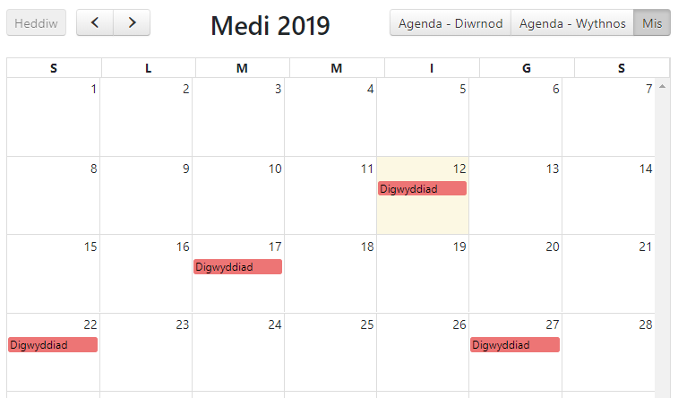 | CMS Support Team
Accessibility Update - Secondary Menu Colour Update | To meet Accessibility Guidelines we have updated the background colour of the Secondary Menu to match that of the grey bar on the Primary Menu, we have also removed the padding surrounding the menu items.  Current Display New Display  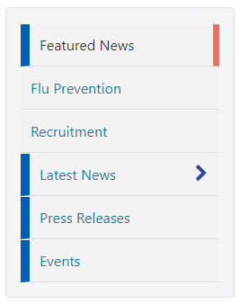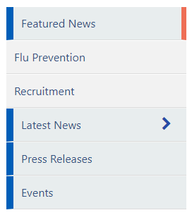 | CMS Developer Team
Accessibility Update - Missing Focus Indicator | A visual cue is required to indicate elements that have keyboard focus. When using a mobile layout the focus indicator for the Main Menu is missing. This update will see this indicator added to the system.  Current Display – with the visual cue box indicating Cymraeg    New Display - with the visual cue box indicating Menu   | CMS Developer Team
Accessibility Updates | Ongoing Accessibility updates to the CMS regarding screen readers, as advised by RNIB review. These updates regarding aira labels within the site code and will only impact on users operating screen readers. | CMS Developer Team

Problems Fixed

N/A

New Problems Identified During Testing and Associated Workarounds
N/A

Pre-requisites to Deploy the Release
N/A

Training Requirements
CMS support Site will be updated with any changes that introduce new functionality or changes to workflow.

Step by Step Deployment Instructions
No Deployment actions required by Health Boards

Deployment Plan
Changes to be implemented as specified in the Change Record
Release to be deployed via change record 73562

Back-Out Plan
Back out as detailed on each change record

Release Available for Deployment Date
NHS Wales : 18/09/2019

