REL-ID 548 CMS/10-2019

NHS WALES IT SERVICE MANAGEMENT
CMS Release Notes
Release ID: 548 CMS/10-2019
These Release Notes describe the scope and content of
Release ID: 548 CMS/10-2019

CMS

Version No. 1.0
Status: Approved

Owner: CMS Service Management Board
Author: Helen McGrath
Approver: Stephen Price
Date: 15/08/2019
Next Review Date: 22/08/2019
Tŷ Glan-yr-Afon
21 Heol Ddwyreiniol Y Bont-Faen, Caerdydd CF11 9AD
21 Cowbridge Road East, Cardiff CF11 9AD
Ffôn/Tel: 02920 500500
www.cymru.nhs.uk/gwybodeg
www.wales.nhs.uk/informatics

TABLE OF CONTENTS

1 DOCUMENT HISTORY 3
1.1 Template Revision History 3
1.2 Revision History 3
1.3 Reviewers 3
1.4 Authorisation 3
1.5 Document Location 3
2 INTRODUCTION 4
3 SERVICE MANAGEMENT BOARD (SMB) 4
4 RELEASE NOTES REQUIREMENT 4
4.1 Release Identification 4
4.2 Description of New or Modified Functionality 4
4.3 Problems Fixed 5
4.4 New Problems Identified During Testing and Associated Workarounds 5
4.5 Pre-requisites to Deploy the Release 5
4.6 Training Requirements 5
4.7 Step by Step Deployment Instructions 6
4.8 Deployment Plan 6
4.9 Back-Out Plan 6
4.10 Release Available for Deployment Date 6

DOCUMENT HISTORY

Template Revision History
Date | Version | Author | Revision Summary
6th March 2012 | 0.1 | Steve Finn | First Draft
15th March 2012 | 0.2 | Steve Finn | Second Draft following comments from SW
5th July 2012 | 0.3 | Steve Finn | Third Draft following release process modifications
26th July 2012 | 1.0 | Kelly Tremlett | Issued as approved version 1.0

Revision History
Date | Version | Author | Revision Summary
15/08/2019 | 1.0 | Helen McGrath | Senior Support & Business Analyst

Reviewers
This document requires the following reviews:
Date | Version | Name | Position

Authorisation
Signing of this document indicates acceptance of its contents.
Author’s Name: | Helen McGrath
Role: | Senior Support and Business Analyst
Signature: |  | Date: | 16/10/2019

Approver’s Name: | Stephen Price
Role: | Applications Manager (Corporate)
Signature: |  | Date: | 16/10/2019

Document Location
Type | Location
Electronic

INTRODUCTION
The NHS Wales Release Management Policy considers that effective Release Management is essential for protecting the integrity of the operational environment. A key objective of the release process is ensuring that users, support staff and other stakeholders are kept informed as to what is planned and how this will affect them. One of the ways that this can be achieved is through the publication of release notes prior to deployment of the Release.

These notes contain information on the agreed scope and content of Release id CMS/10-2019 for the CMS descriptions of new or modified functionality and problem fixes, descriptions of new problems and workarounds identified during the testing of this Release, training requirements, deployment instructions, references to deployment and back-out plans and key dates within the release process.

SERVICE MANAGEMENT BOARD (SMB)
The CMS Service Management Board has overall responsibility for ensuring that these Release Notes accurately describes the Release and that it is kept under constant review and updated to reflect any modifications to the Release prior to its deployment.

RELEASE NOTES REQUIREMENT

Release Identification
548 CMS/10-2019

Description of New or Modified Functionality
Item | Description | Requestor
Enable Right Click on Associated Images | Currently users are unable to right click on an associated image. This change will enable users to right click on any associated image and have the ability to view the image properties.  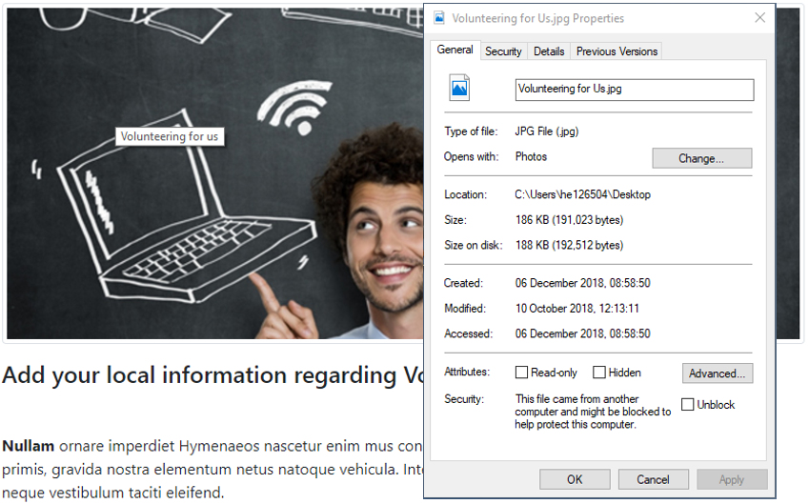 | CMS Developer Team
Mobile Navigation Icons Wrapping | Currently when switching from a large display to mobile display one of the three icons on the top right-hand side (of the site) is wrapping onto the next line. This change will ensure that all three icons remain aligned adjacent to each other.  Current Display  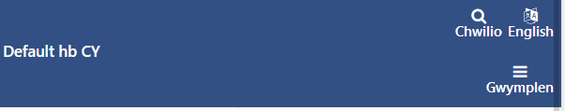  New Display   | CMS Developer Team
Illogical Focus Order on Modals | Modals such as The Cookie dialog box are currently last in the tab order, resulting in keyboard users having to tab through every link on the page before being able to dismiss them. This change will see such elements receive focus first, this will improve how users are able to interact with your site.  This update will also ensure that the appropriate second level menu will display, when the first level menu item receives focus via keyboard.  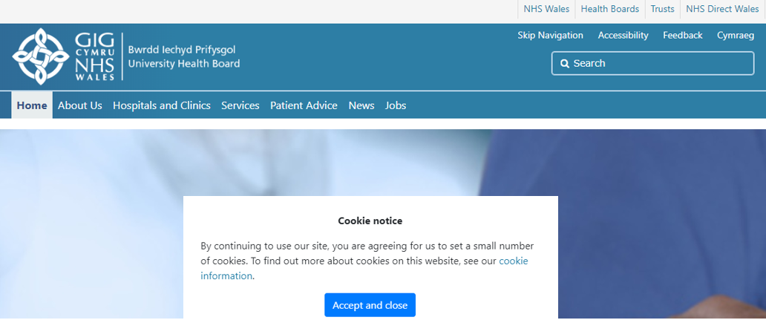 | CMS Developer Team
Carousel Navigation Controls Update | Currently the Carousel Navigation controls display in white; so, in regard to accessibility this only works on a darker background. This change will see that these controls are coloured to meet accessibility guidelines on any colour background that a user may wish to apply.  Current Display  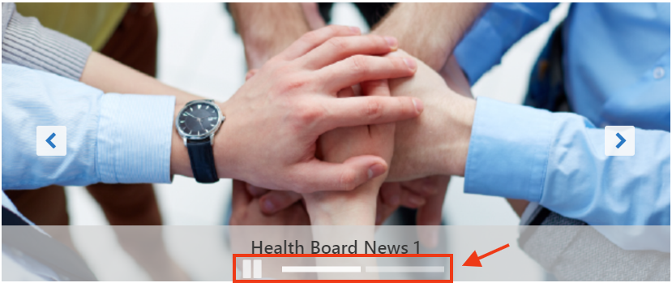  New Display    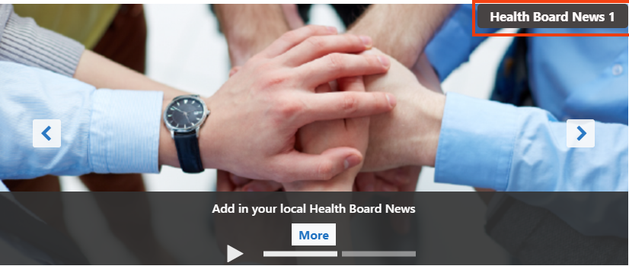 | CMS Developer Team
Advanced Table List Update | When an Advanced Table list is viewed on a Mobile all list fields are shown Vertically in an open state. This change will add in a collapsible feature that will better enable users to view the list entries.  Current Display  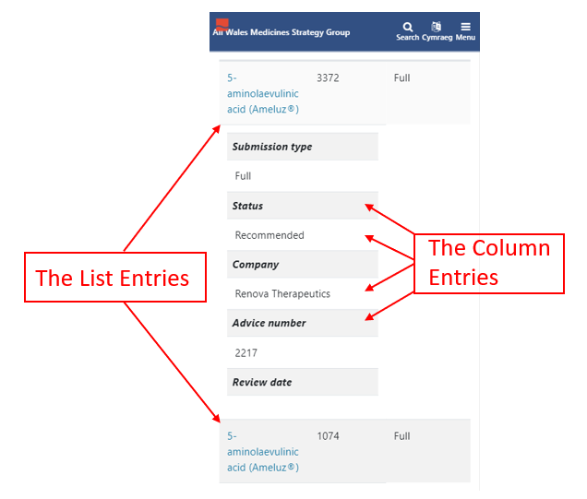  New Display  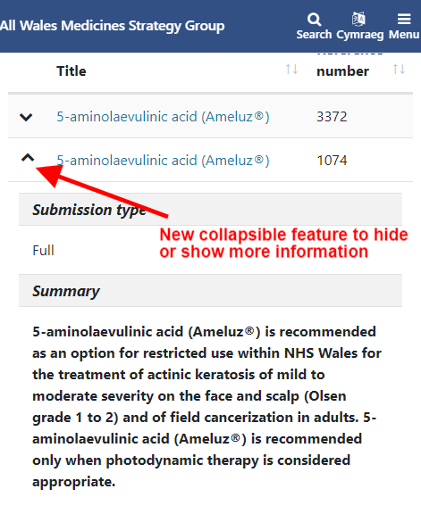 | CMS Developer Team
External Link Indicator Icon | To meet Accessibility guidelines for Indicating External Links will have added in an External Link Indicator Icon. This Icon will appear next to any and all links within a List or Table List; that have been selected to open externally to the site. This Icon will also be applied more widespread throughout the CMS in future releases.  External link icon    - This item was removed from the Release We have not included an External link indicator icon in this release as it has proved more complex to define the required behaviour than originally anticipated. We will look into the various scenarios in more depth and will revisit this when the requirements are more clearly defined | CMS Developer Team
Accordion Update – Adding Images | Users will now have the ability to add an Image to a page of content within their accordion; and have this image display upon expanding the accordion page.  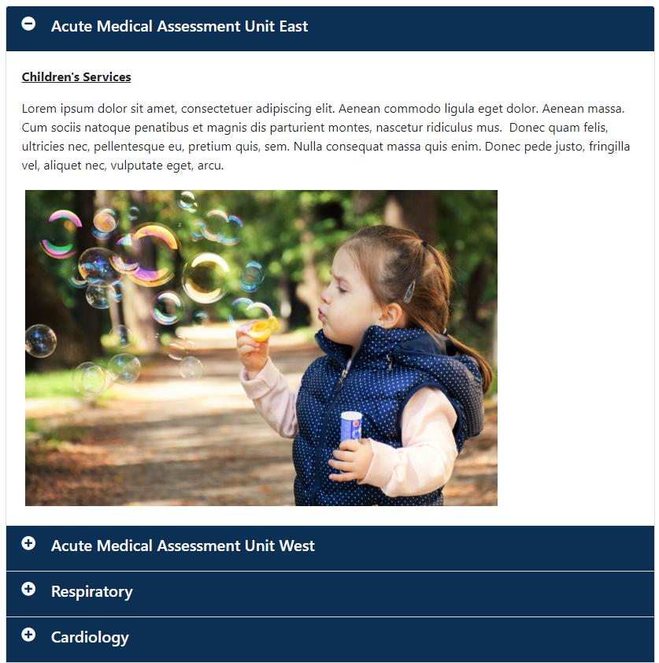 | CMS Support Team
Ability to Hide Invisible Folders from Breadcrumb Menu | Folders that are marked as 'Invisible' will no-longer be visible within the site breadcrumb trail. As per the example below; ‘Use of Site’ is an empty Invisible Folder so this will no-longer display  Current Display  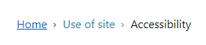  New Display  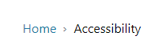 | BCUHB
Import MURA RSS Feed into Cascade | We have now added in the ability to pull in a MURA RSS Feed into your Cascade intranet website. To add this to your Site You will need to log a call with NWIS (Via the support site) listing the RSS Feed URL, we will then be able create a news feed within your Cascade intranet website.  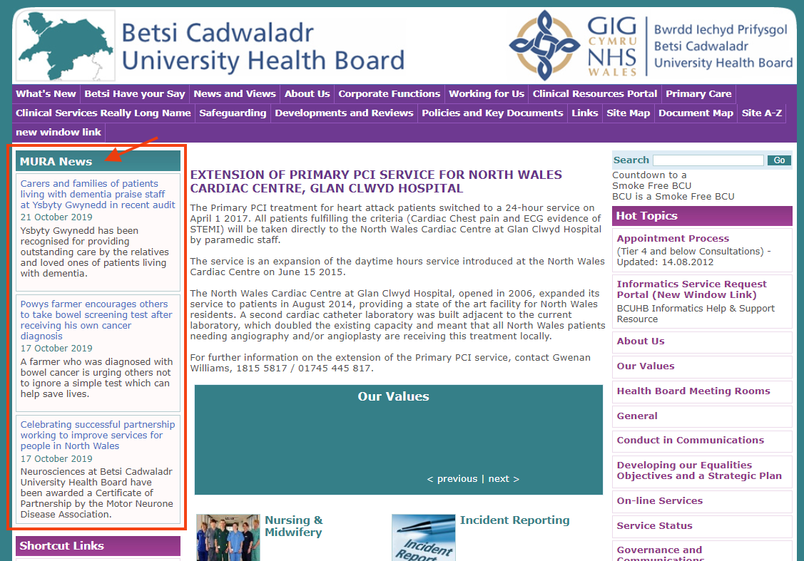 | BCUHB
Accessibility Updates | Ongoing Accessibility updates to the CMS regarding screen readers, as advised by RNIB review. These updates regarding the Navigation Bar and Accordions will only impact on users operating screen readers. | CMS Developer Team

Problems Fixed

N/A

New Problems Identified During Testing and Associated Workarounds
N/A

Pre-requisites to Deploy the Release
N/A

Training Requirements
CMS support Site will be updated with any changes that introduce new functionality or changes to workflow.

Step by Step Deployment Instructions
No Deployment actions required by Health Boards

Deployment Plan
Changes to be implemented as specified in the Change Record
Release to be deployed via change record 73820

Back-Out Plan
Back out as detailed on each change record

Release Available for Deployment Date
NHS Wales : 16/10/2019

