REL-ID 554 CMS/11-2019

NHS WALES IT SERVICE MANAGEMENT
CMS Release Notes
Release ID: 554 CMS/11-2019
These Release Notes describe the scope and content of
Release ID: 554 CMS/11-2019

CMS

Version No. 1.0
Status: Approved

Owner: CMS Service Management Board
Author: Helen McGrath
Approver: Stephen Price
Date: 20/11/2019
Next Review Date: 20/11/2019
Tŷ Glan-yr-Afon
21 Heol Ddwyreiniol Y Bont-Faen, Caerdydd CF11 9AD
21 Cowbridge Road East, Cardiff CF11 9AD
Ffôn/Tel: 02920 500500
www.cymru.nhs.uk/gwybodeg
www.wales.nhs.uk/informatics

TABLE OF CONTENTS

1 DOCUMENT HISTORY 3
1.1 Template Revision History 3
1.2 Revision History 3
1.3 Reviewers 3
1.4 Authorisation 3
1.5 Document Location 3
2 INTRODUCTION 4
3 SERVICE MANAGEMENT BOARD (SMB) 4
4 RELEASE NOTES REQUIREMENT 4
4.1 Release Identification 4
4.2 Description of New or Modified Functionality 4
4.3 Problems Fixed 5
4.4 New Problems Identified During Testing and Associated Workarounds 5
4.5 Pre-requisites to Deploy the Release 5
4.6 Training Requirements 5
4.7 Step by Step Deployment Instructions 6
4.8 Deployment Plan 6
4.9 Back-Out Plan 6
4.10 Release Available for Deployment Date 6

DOCUMENT HISTORY

Template Revision History
Date | Version | Author | Revision Summary
6th March 2012 | 0.1 | Steve Finn | First Draft
15th March 2012 | 0.2 | Steve Finn | Second Draft following comments from SW
5th July 2012 | 0.3 | Steve Finn | Third Draft following release process modifications
26th July 2012 | 1.0 | Kelly Tremlett | Issued as approved version 1.0

Revision History
Date | Version | Author | Revision Summary
11/11/2019 | 1.0 | Helen McGrath | Senior Support & Business Analyst

Reviewers
This document requires the following reviews:
Date | Version | Name | Position

Authorisation
Signing of this document indicates acceptance of its contents.
Author’s Name: | Helen McGrath
Role: | Senior Support and Business Analyst
Signature: |  | Date: | 20/11/2019

Approver’s Name: | Stephen Price
Role: | Applications Manager (Corporate)
Signature: |  | Date: | 20/11/2019

Document Location
Type | Location
Electronic

INTRODUCTION
The NHS Wales Release Management Policy considers that effective Release Management is essential for protecting the integrity of the operational environment. A key objective of the release process is ensuring that users, support staff and other stakeholders are kept informed as to what is planned and how this will affect them. One of the ways that this can be achieved is through the publication of release notes prior to deployment of the Release.

These notes contain information on the agreed scope and content of Release id CMS/11-2019 for the CMS descriptions of new or modified functionality and problem fixes, descriptions of new problems and workarounds identified during the testing of this Release, training requirements, deployment instructions, references to deployment and back-out plans and key dates within the release process.

SERVICE MANAGEMENT BOARD (SMB)
The CMS Service Management Board has overall responsibility for ensuring that these Release Notes accurately describes the Release and that it is kept under constant review and updated to reflect any modifications to the Release prior to its deployment.

RELEASE NOTES REQUIREMENT

Release Identification
554 CMS/11-2019

Description of New or Modified Functionality
Item | Description | Requestor
Interactive Image Maps | This new function will allow the addition of an Interactive Image Map. This Image Map will allow users to click on a mapped area of the Image and to then either jump to an area on the current page or link to another specific page.  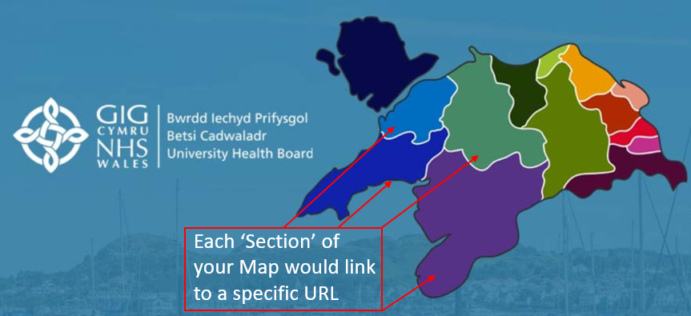 | BCUHB
Multi Content 1-IE Display Update | It has been noted that there can be a slight difference in how Multi Content 1 displays in Chrome Vs Explorer.  This change will bring the incorrect (stretched) Explorer display in line with the correct Chrome display.  Correct Display in Chrome    Incorrect Stretched Display in Explorer   | NWSSP
Ck Editor Mura Link Amendment | Previously when creating a link where ‘Open in New Browser Window’ had been selected, the system was not honouring this target value. An update to the Mura Link tab has now been made to correct this.  To check the target of your link > Right Click on your Link > Edit Link> Select the Target Tab.  Same Window (_self) = Will open the link in the same browser window  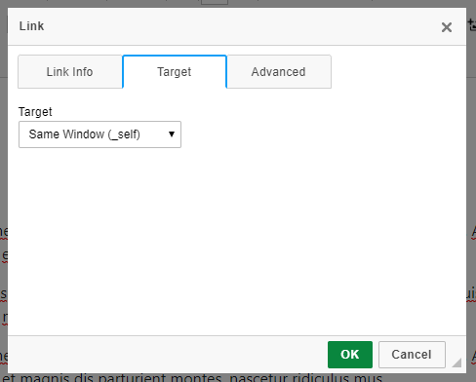  New Window (_blank) = Will open the link in a new browser window  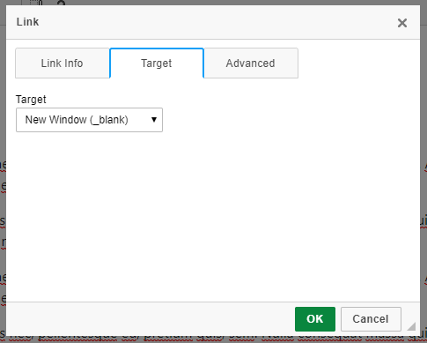 | CMS Support Team
Single Content 4 Update | Single content 4 provides a facility to add ‘Custom Data’ to a page. A modification has now been made to this function, so that the users now have flexibility to add or remove the ‘Read More’ button as desired.  Display with ‘Read More’ Button  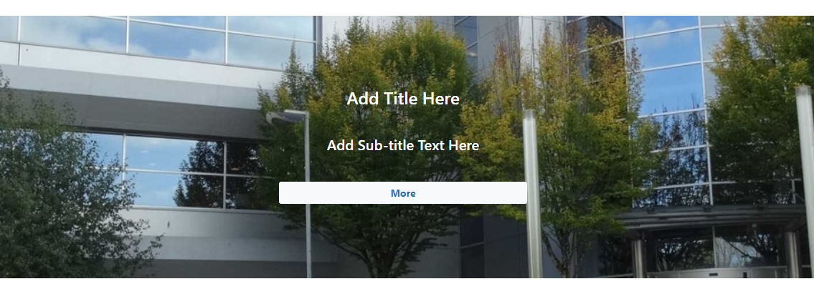  Display without ‘Read More’ Button  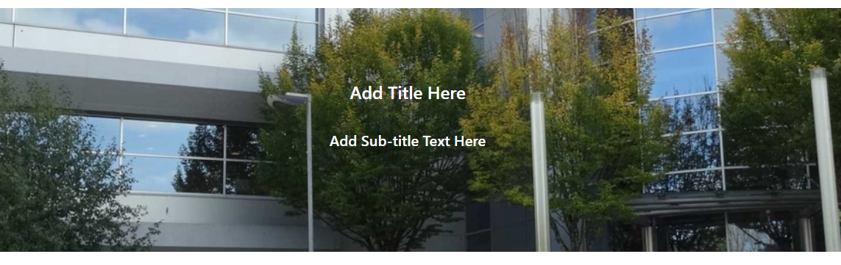 | CMS Support Team
Hide Invisible Folders from Breadcrumb Menu | This item was removed from last month’s release, this has now been re-instated. Folders that are marked as 'Invisible' will no-longer be visible within the site breadcrumb trail. As per the example below; ‘Use of Site’ is an empty Invisible Folder so this will no-longer display.  Current Display  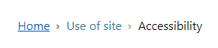  New Display  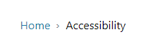 | BCUHB
Single Content 2 Update | Single content 2 allows the users to create a feature of a single piece of content; the display features a partial image cover over. This cover over is currently set as 55% of the Image height, this change will see the cover over level reduced significantly and only growing in comparison to the amount of text added onto the cover.  Current Display  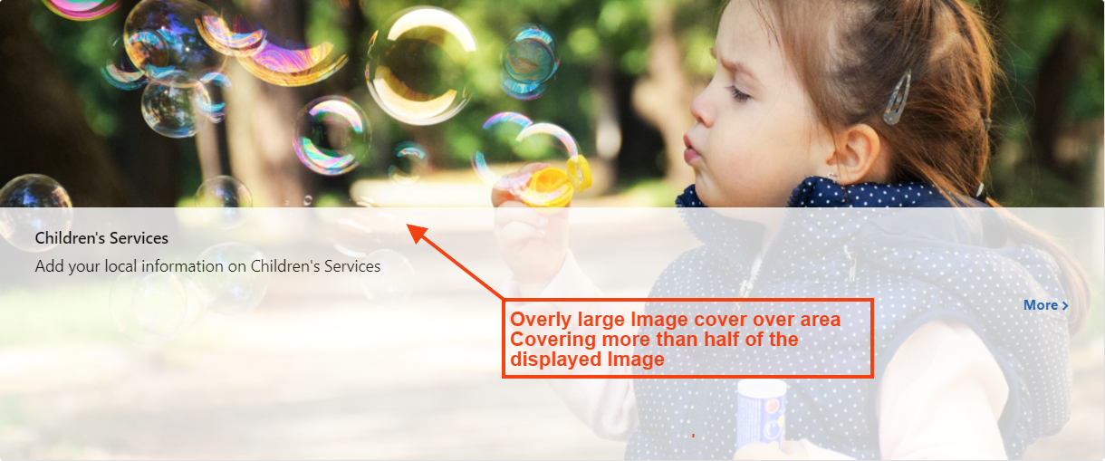  New Display   | CMS Support Team
Accordion Page Type Update | A new Page Type has been created for Accordion Pages, this new page type is to allow improved site search results. All existing Accordion Pages will be switched over to the new Page Type (no disruption will be caused).  Going forward when creating an Accordion, users will need to select the new Accordion Page Type not just Page.  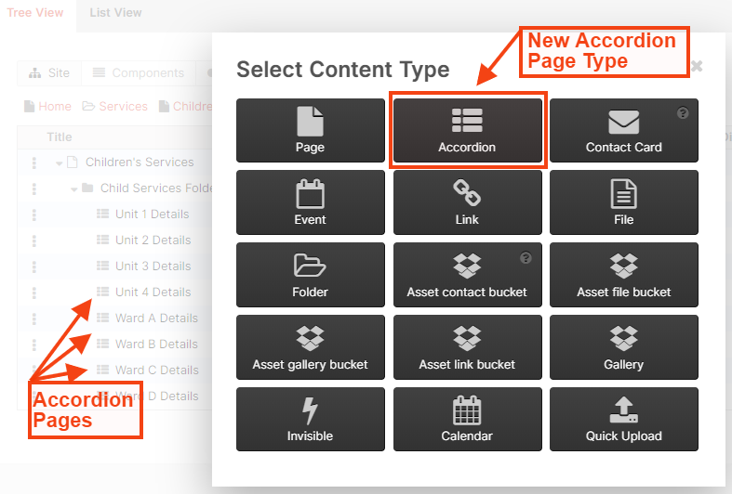 | CMS Support Team
Updating Site Map Styling | Currently the system Site Map is displaying with large spaces in between each Page/Sublevel. This change will see an update of the formatting in this area.  Site Map will now only be available from within the System Plugin  Current Display New Display  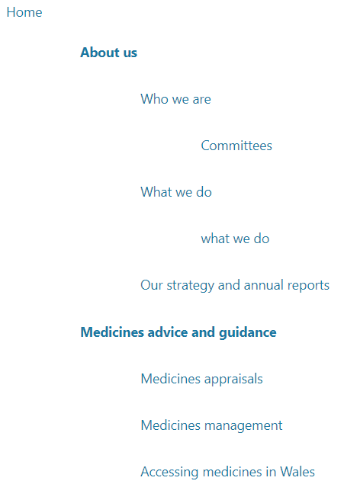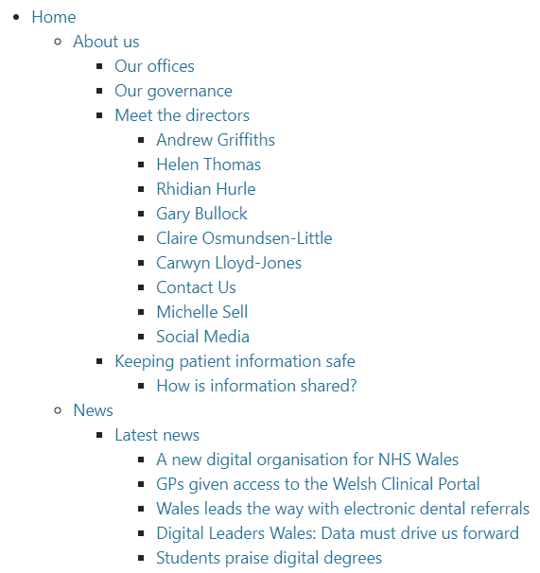 | Velindre
Profile Card Images Update | Currently if a user was to select 3 cards to sit side by side the crop of images is correct; however, if you select 2 cards the crop becomes distorted and can cut off the top of the Image.  This change will amend the size/crop of the Images drawn into the Profile Card (2column) Layout.  Current Display    New Display   | PHW
Increase Size/Spacing of Share Buttons | Interactive elements like buttons and links should be large enough (48x48px), and have enough space around them, to be easy enough to tap without overlapping onto other elements. A minimum recommended touch target size is around 48dp on a site with a properly set mobile viewport.  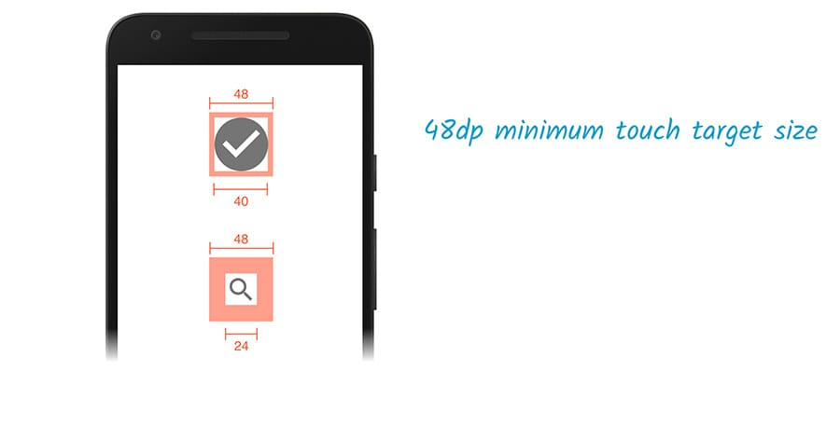
Accessibility Updates | Ongoing Accessibility updates to the CMS regarding screen readers, as advised by RNIB review. These updates will only impact on users operating screen readers. | CMS Support Team

Problems Fixed

N/A

New Problems Identified During Testing and Associated Workarounds
Item 1. Interactive Maps – If using Internet Explorer, Users will not have the ability to use the Inline Edit function on a page that has the Interactive Map present. The inline Edit function will remain fully available when using Chrome or Edge.

Pre-requisites to Deploy the Release
N/A

Training Requirements
CMS support Site will be updated with any changes that introduce new functionality or changes to workflow.

Step by Step Deployment Instructions
No Deployment actions required by Health Boards

Deployment Plan
Changes to be implemented as specified in the Change Record
Release to be deployed via change record 74944

Back-Out Plan
Back out as detailed on each change record

Release Available for Deployment Date
NHS Wales : 27/11/2019

