REL-ID 527 CMS/05-2019

NHS WALES IT SERVICE MANAGEMENT
CMS Release Notes
Release ID: 527 CMS/05-2019
These Release Notes describe the scope and content of
Release ID: 527 CMS/05-2019

CMS

Version No. 1.0
Status: Approved

Owner: CMS Service Management Board
Author: Helen McGrath
Approver: Michele Golpaykar-rad
Date: 10/05/2019
Next Review Date: 28/05/2019
Tŷ Glan-yr-Afon
21 Heol Ddwyreiniol Y Bont-Faen, Caerdydd CF11 9AD
21 Cowbridge Road East, Cardiff CF11 9AD
Ffôn/Tel: 02920 500500
www.cymru.nhs.uk/gwybodeg
www.wales.nhs.uk/informatics

TABLE OF CONTENTS

1 DOCUMENT HISTORY 3
1.1 Template Revision History 3
1.2 Revision History 3
1.3 Reviewers 3
1.4 Authorisation 3
1.5 Document Location 3
2 INTRODUCTION 4
3 SERVICE MANAGEMENT BOARD (SMB) 4
4 RELEASE NOTES REQUIREMENT 4
4.1 Release Identification 4
4.2 Description of New or Modified Functionality 4
4.3 Problems Fixed 5
4.4 New Problems Identified During Testing and Associated Workarounds 5
4.5 Pre-requisites to Deploy the Release 5
4.6 Training Requirements 5
4.7 Step by Step Deployment Instructions 6
4.8 Deployment Plan 6
4.9 Back-Out Plan 6
4.10 Release Available for Deployment Date 6

DOCUMENT HISTORY

Template Revision History
Date | Version | Author | Revision Summary
6th March 2012 | 0.1 | Steve Finn | First Draft
15th March 2012 | 0.2 | Steve Finn | Second Draft following comments from SW
5th July 2012 | 0.3 | Steve Finn | Third Draft following release process modifications
26th July 2012 | 1.0 | Kelly Tremlett | Issued as approved version 1.0

Revision History
Date | Version | Author | Revision Summary
10/05/2019 | 1.0 | Helen McGrath | Senior Support & Business Analyst

Reviewers
This document requires the following reviews:
Date | Version | Name | Position

Authorisation
Signing of this document indicates acceptance of its contents.
Author’s Name: | Helen McGrath
Role: | Senior Support and Business Analyst
Signature: |  | Date: | 10/05/2019

Approver’s Name: | Stephen Price
Role: | Applications Manager (Corporate)
Signature: |  | Date: | 10/05/2019

Document Location
Type | Location
Electronic

INTRODUCTION
The NHS Wales Release Management Policy considers that effective Release Management is essential for protecting the integrity of the operational environment. A key objective of the release process is ensuring that users, support staff and other stakeholders are kept informed as to what is planned and how this will affect them. One of the ways that this can be achieved is through the publication of release notes prior to deployment of the Release.

These notes contain information on the agreed scope and content of Release id CMS/05-2019 for the CMS descriptions of new or modified functionality and problem fixes, descriptions of new problems and workarounds identified during the testing of this Release, training requirements, deployment instructions, references to deployment and back-out plans and key dates within the release process.

SERVICE MANAGEMENT BOARD (SMB)
The CMS Service Management Board has overall responsibility for ensuring that these Release Notes accurately describes the Release and that it is kept under constant review and updated to reflect any modifications to the Release prior to its deployment.

RELEASE NOTES REQUIREMENT

Release Identification
527 CMS/05-2019

Description of New or Modified Functionality
Item | Description
Shadow Box on Images and ALT text amendment | This applies to Associated Images. This change will add in a default setting that if no ALT text is added to an Image the Image Title will be drawn in instead.  This change will also remove the opening of the Shadow Box when you click on an Image. This change was agreed by the Community Of Practice Group.  
Remove Whitespace above Breadcrumbs in Mobile view | When looking at the sites on a mobile there is a large amount of white space above the breadcrumbs of the page, this change will eliminate this space.  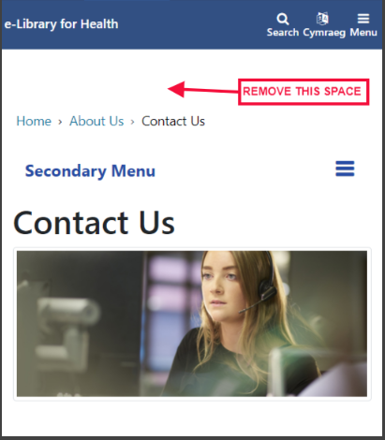
Remove Second Level of Navigation - Hiding Breadcrumbs | In full screen mode if looking at a page not in the navigation when, you hover over the navigation menu the second level of navigation pops up and half covers the breadcrumbs. If you press Escape or hover over the 'Home' menu option then the second level menu disappears and you can see the breadcrumbs again. We will also add in the ability to click elsewhere on the page to make the second level menu of navigation disappear  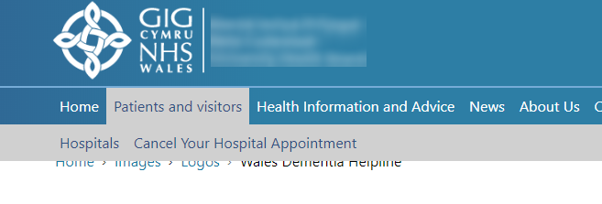
Missing Form Label | This change will improve accessibility. There are currently a number of instances where text fields do not have an associated label element (<label>) to provide a text label to assistive technologies. Screen reader users will be unable to identify the purpose of the form input and will have difficulty successfully completing forms.
Form Builder Submit Button Localisation | Adding a form on a page should show the "Submit" button with the correct label depending on the localisation.  For Welsh this currently says 'Submit' this will be amended to say 'Gyflwyno'  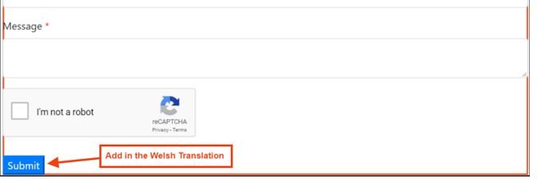
Colour Contrast | The top grey bar featuring "NHS Wales", "Health Boards", "Trusts" etc. links does not meet WCAG 2.1 conformance level AA for accessibility due to a lack of contrast between the foreground and background colours.  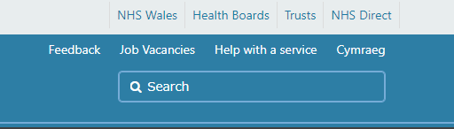
Twitter Bespoke Header Link | This change will Make header a link and clickable on twitter bespoke, this will open the Twitter feed for the related account name into a new window.  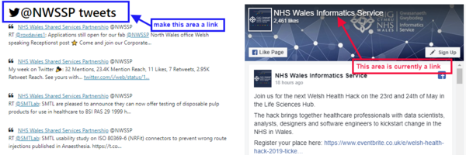
DoS Collapsible Result List | Currently a user is only able to collapse the map itself. This change will allow users to also be able to collapse the entire listing area.  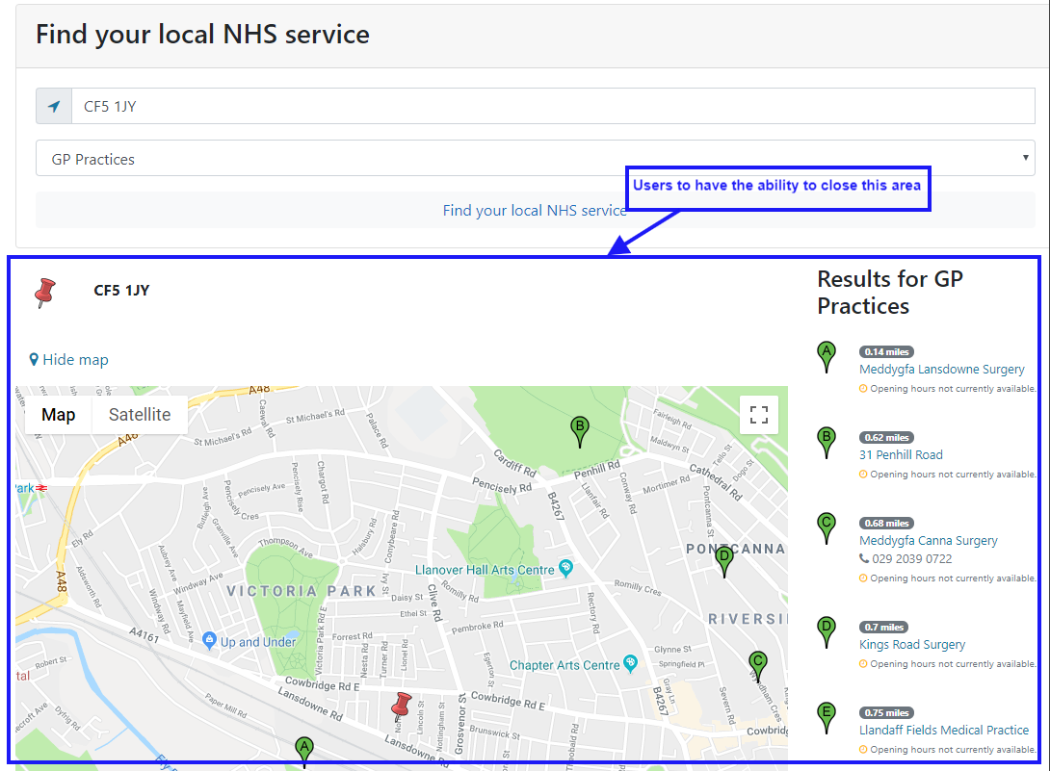
Twitter Native Option | The Socialboard plugin currently has 2 options in the Configurator - 'Facebook' and 'Twitter' which displays the relevant feeds when added to the Mura website page.  This change will add a further option called 'Twitter Native' which will allow the user to select from various options in order to generate a Twitter Native Feed.  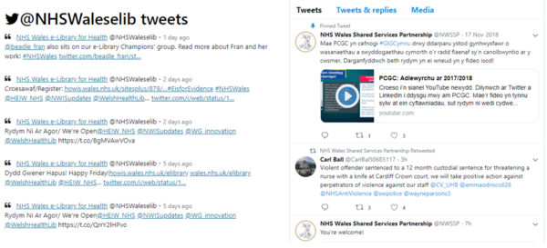
Tabbed Content Date Field | This change would align the date displayed in the Tabbed Content Module with the date displayed in the source folder. Currently (as shown) one shows date last published and the other shows date last updated.  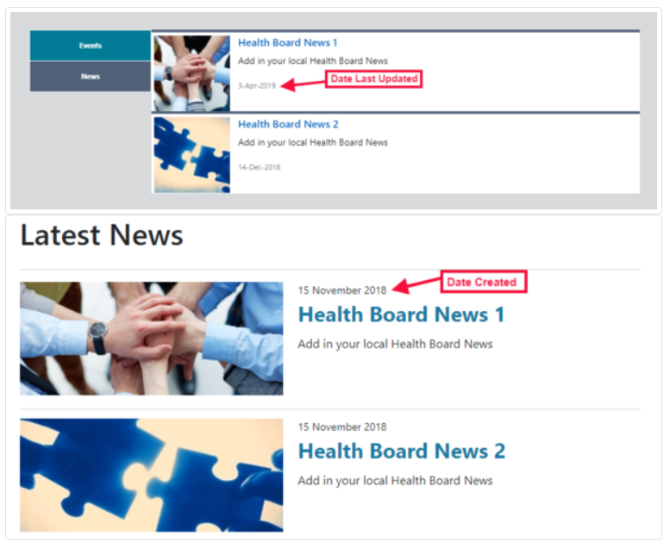
Drag and Drop on Tabbed Content | This change will apply drag and drop facility to the Tabbed Content module to allow user to select collection and order them however they wish  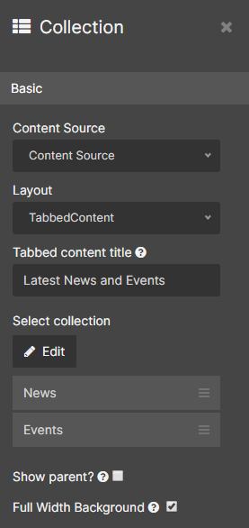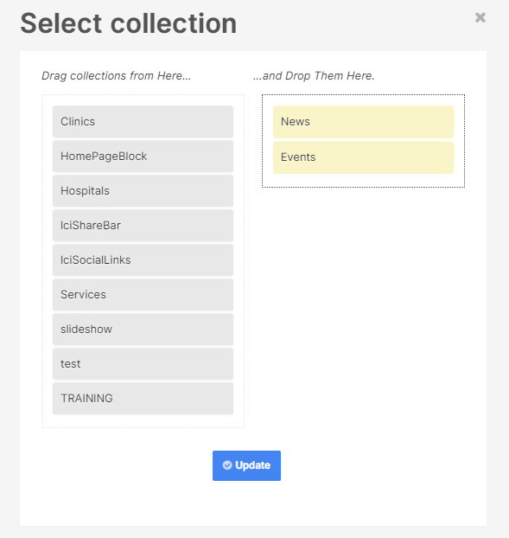
Drag and Drop on Link Organiser | This change will apply drag and drop facility to the Link Organiser module to allow user to select collection and order them however they wish  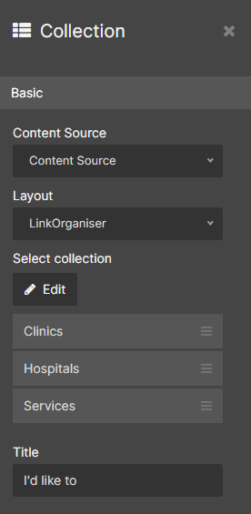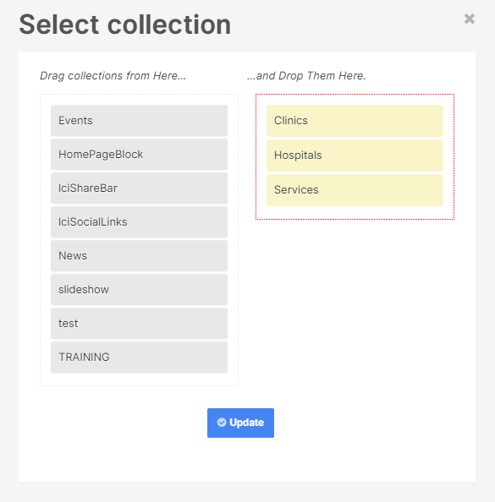
Remove whitespace (Single content block 1) | Single content block 1 seems to add a lot of white space below the image/text causing a big gap between it and the content below it. This change will eliminate this space.  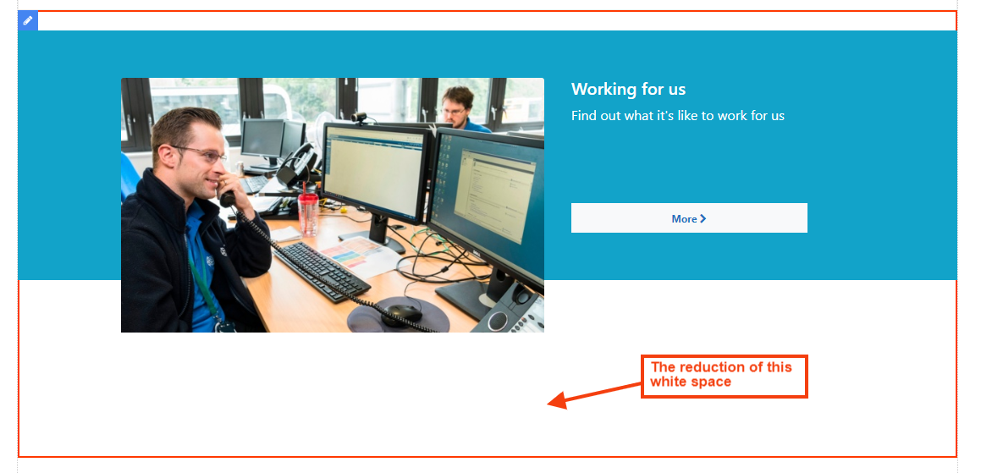
Set release date Upon content save | The Release Date will now be defaulted to ‘todays’ date unless the users enters a specific date. The text in this area will also be amended to:  Official Release Date (If left blank, todays date will be assigned)  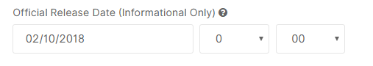
Cookie Acceptance Button | This change will see the removal of the little x button at the top of the modal and a change the cookie button so that it's centred and has the following text:  English Welsh  Accept and close Cytuno a chau  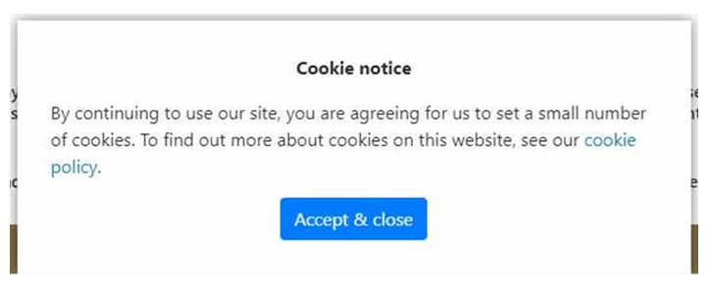  This change was agreed by the Community Of Practice Group.
Ckeditor Image Border | This change will give the user the option to add/remove a boarder on images placed within the body of content on any site pages  
Duplicated Content | When using the Translation option there was an issue where content was intermittently duplicating on to both the Welsh and the English sites, only in an English Language state.  This issue has now been resolved – The content will no longer duplicate on the English site and will be placed in a Welsh Language ‘Draft’ state on the Welsh site
Accordion Layout Changes | This change will see an ‘Indent’ placed within the Title of the Accordian pages so that the title does not fall under the + Icon  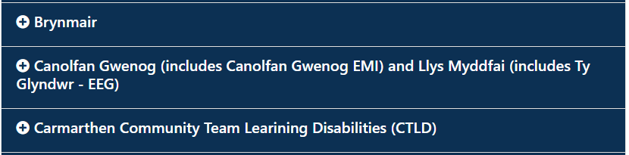
Beautified Container Content Returns | The content returns were limited to 20 per alphabet letter. This change will now see the returns defaulted to unlimited  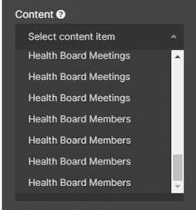

Problems Fixed

N/A

New Problems Identified During Testing and Associated Workarounds
N/A

Pre-requisites to Deploy the Release
N/A

Training Requirements
CMS support Site will be updated with any changes that introuduce new functionality or changes to workflow.

Step by Step Deployment Instructions
No Deployment actions required by Health Boards

Deployment Plan
Changes to be implemented as specified in the Change Record
Release to be deployed via change record 69729

Back-Out Plan
Back out as detailed on each change record

Release Available for Deployment Date
NHS Wales : 28/05/2019

