REL-ID 507 CMS/03-2019

NHS WALES IT SERVICE MANAGEMENT
CMS Release Notes
Release ID: 507 CMS/03-2019
These Release Notes describe the scope and content of
Release ID: 507 CMS/03-2019

CMS

Version No. 1.0
Status: Approved

Owner: CMS Service Management Board
Author: Michele Golpaykar-rad
Approver: Michele Golpaykar-rad
Date: 14/02/2018
Next Review Date: 14/11/2019
Tŷ Glan-yr-Afon
21 Heol Ddwyreiniol Y Bont-Faen, Caerdydd CF11 9AD
21 Cowbridge Road East, Cardiff CF11 9AD
Ffôn/Tel: 02920 500500
www.cymru.nhs.uk/gwybodeg
www.wales.nhs.uk/informatics

TABLE OF CONTENTS

1 DOCUMENT HISTORY 3
1.1 Template Revision History 3
1.2 Revision History 3
1.3 Reviewers 3
1.4 Authorisation 3
1.5 Document Location 3
2 INTRODUCTION 4
3 SERVICE MANAGEMENT BOARD (SMB) 4
4 RELEASE NOTES REQUIREMENT 4
4.1 Release Identification 4
4.2 Description of New or Modified Functionality 4
4.3 Problems Fixed 9
4.4 New Problems Identified During Testing and Associated Workarounds 10
4.5 Pre-requisites to Deploy the Release 10
4.6 Training Requirements 10
4.7 Step by Step Deployment Instructions 10
4.8 Deployment Plan 10
4.9 Back-Out Plan 10
4.10 Release Available for Deployment Date 10

DOCUMENT HISTORY

Template Revision History
Date | Version | Author | Revision Summary
6th March 2012 | 0.1 | Steve Finn | First Draft
15th March 2012 | 0.2 | Steve Finn | Second Draft following comments from SW
5th July 2012 | 0.3 | Steve Finn | Third Draft following release process modifications
26th July 2012 | 1.0 | Kelly Tremlett | Issued as approved version 1.0

Revision History
Date | Version | Author | Revision Summary
04/03/2019 | 1.0 | Michele Golpaykar-rad | Principal Support & Business Analyst

Reviewers
This document requires the following reviews:
Date | Version | Name | Position

Authorisation
Signing of this document indicates acceptance of its contents.
Author’s Name: | Michele Golpaykar-rad
Role: | Principal Support & Business Analyst
Signature: |  | Date:

Approver’s Name: | Stephen Price
Role: | Applications Manager (Corporate)
Signature: |  | Date:

Document Location
Type | Location
Electronic

INTRODUCTION
The NHS Wales Release Management Policy considers that effective Release Management is essential for protecting the integrity of the operational environment. A key objective of the release process is ensuring that users, support staff and other stakeholders are kept informed as to what is planned and how this will affect them. One of the ways that this can be achieved is through the publication of release notes prior to deployment of the Release.

These notes contain information on the agreed scope and content of Release id CMS/03-2019 for the CMS descriptions of new or modified functionality and problem fixes, descriptions of new problems and workarounds identified during the testing of this Release, training requirements, deployment instructions, references to deployment and back-out plans and key dates within the release process.

SERVICE MANAGEMENT BOARD (SMB)
The CMS Service Management Board has overall responsibility for ensuring that these Release Notes accurately describes the Release and that it is kept under constant review and updated to reflect any modifications to the Release prior to its deployment.

RELEASE NOTES REQUIREMENT

Release Identification
507

Description of New or Modified Functionality
Item | Description
New gradient theme | A new gradient theme will be applied to existing CMS websites. This was agreed by the CMS board on the 22nd Feb 2019.  Header example:  Footer example:  
DoS Plugin | The Directory of Services (DoS) plugin enables users to find a service in their area from a list of available services e.g. Emergency departments, GP Practices, Opticians, Dentists, etc.  This can be dragged and dropped onto a webpage and configured using the available list of options.  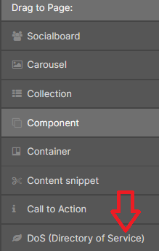  Service finder  The user can enter their postcode and find a local service. They will be presented with any results, map and address details.  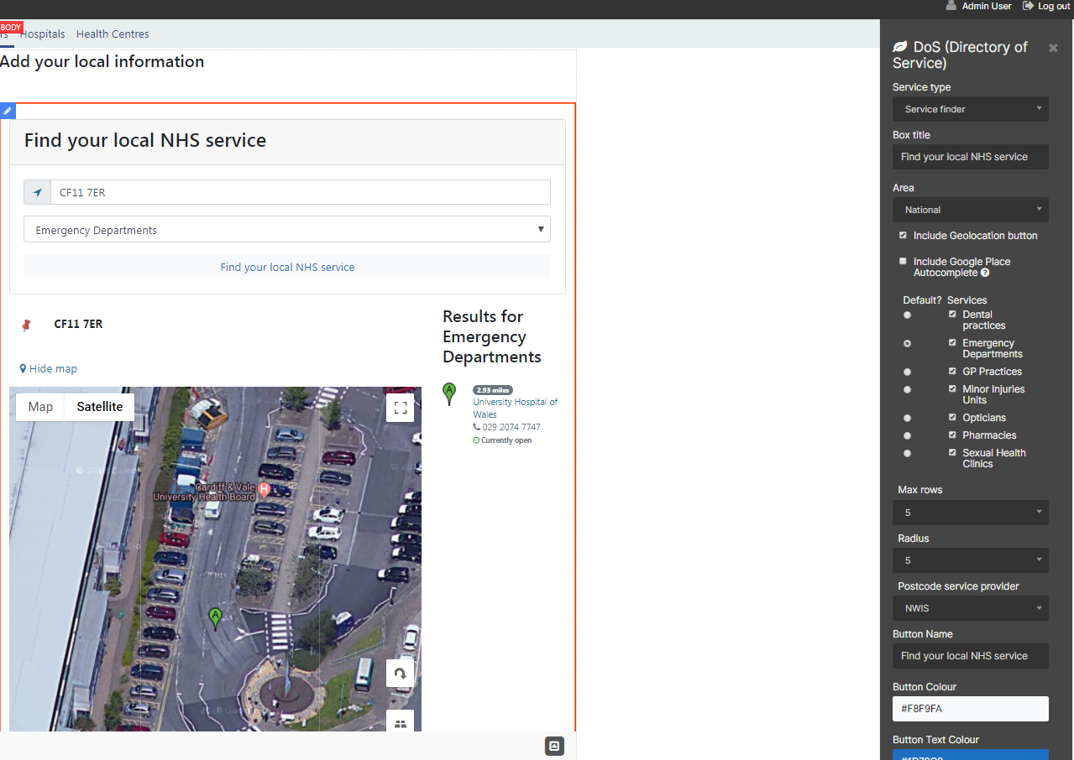  Directory Of Service  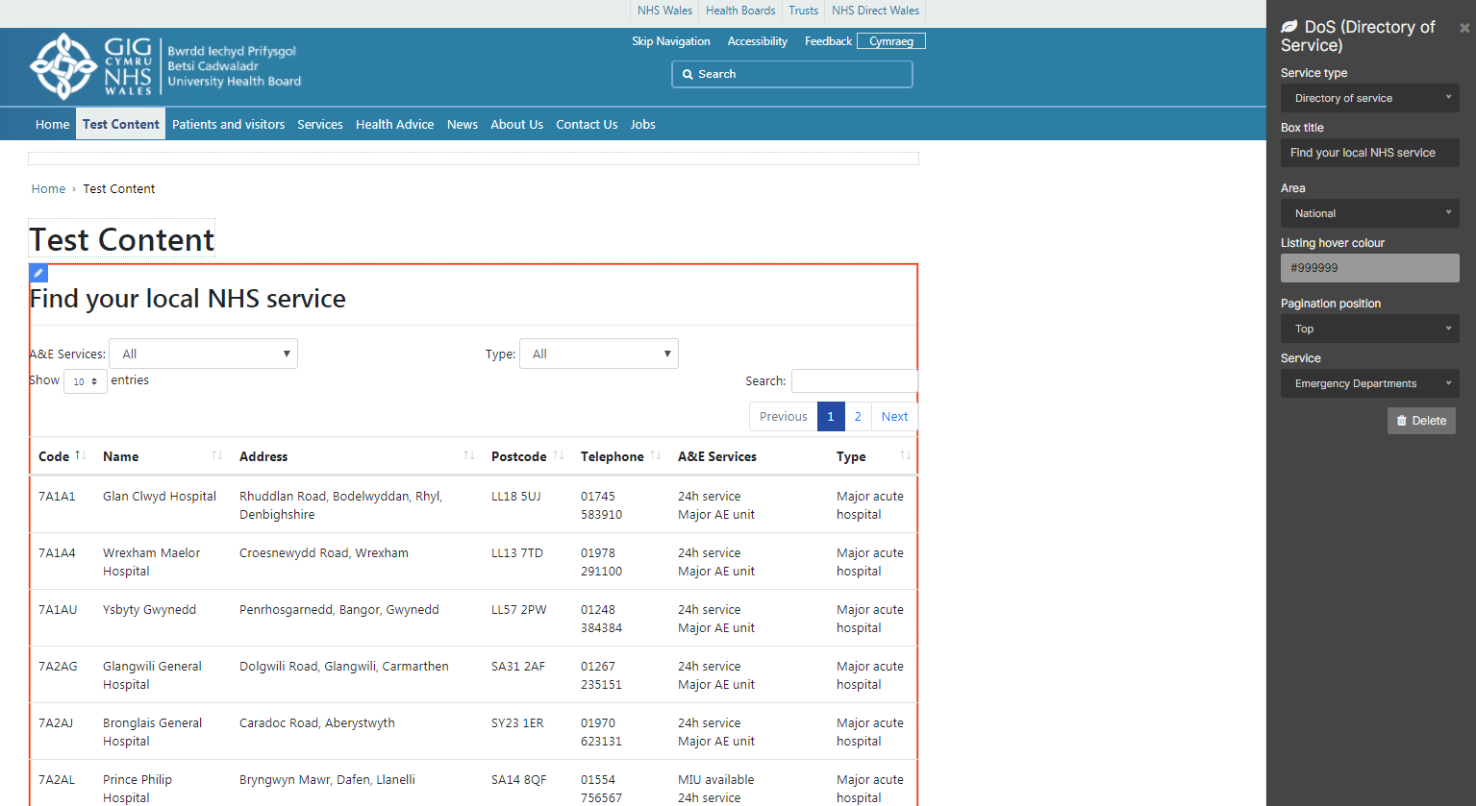  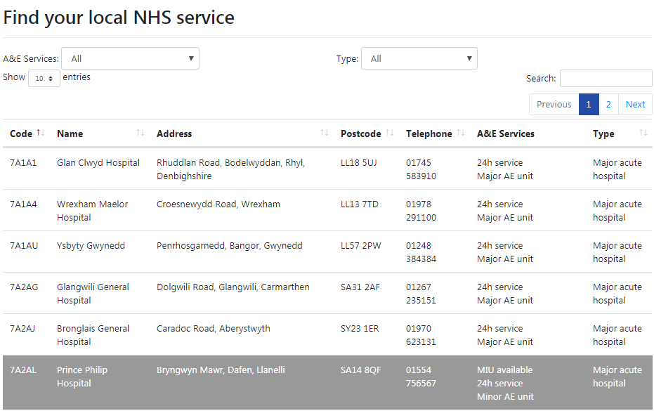  Please note: Sexual Health Clinics and Hospitals currently do not have a parent organization so please filter by ‘all’ rather, than Healthboard.  If you wish to have the DoS plugin activated for your organization please let us know.  Best Practice Tip: Only add one DoS plugin per page.
Mura Translation | Automatic Welsh translation tool, to copy an English page and to automatically produce a draft page in Welsh.
RTE image gallery hyphen bug fix | When using the Rich Text Editor image wizard, if searching for an image where the page has a hyphen in the title, it will not find related galleries on the inline edit. This change will prevent this from happening.
Related Content links | Related Content links can be added to a page via the Collection plugin. The admin can select ‘Edit’ to add a Custom list of pages to display as a related content set. The admin can choose to show the parent and children pages or just the parent. The admin can also change the title of the Box from the default label title of ‘Related Content’ to something more meaningful via the label option and change the text colour and background colour.  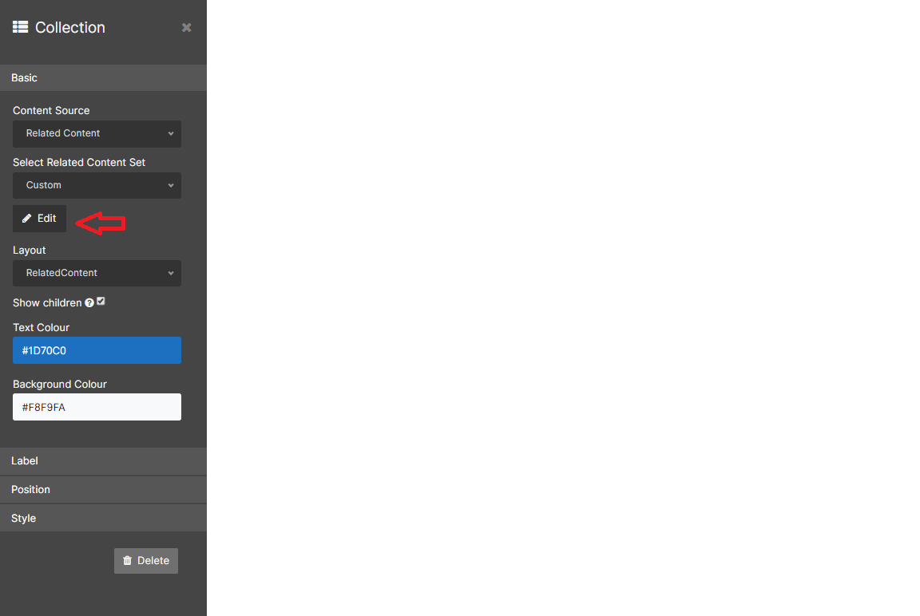  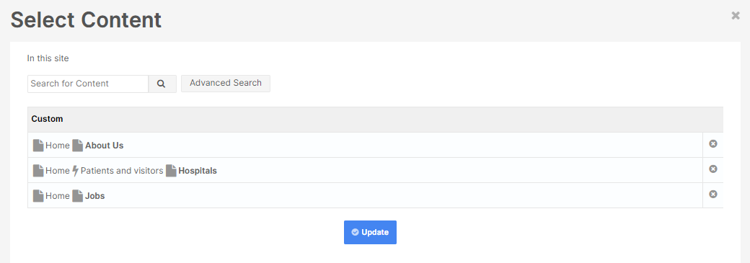  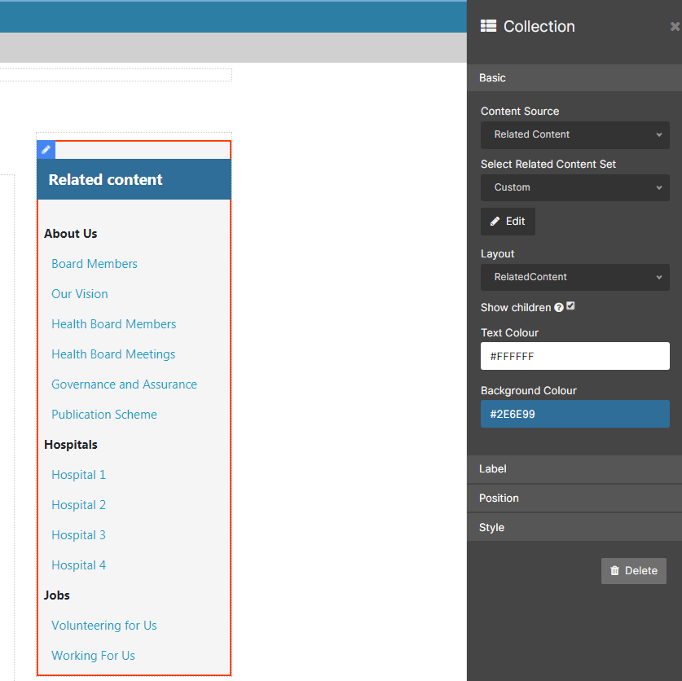  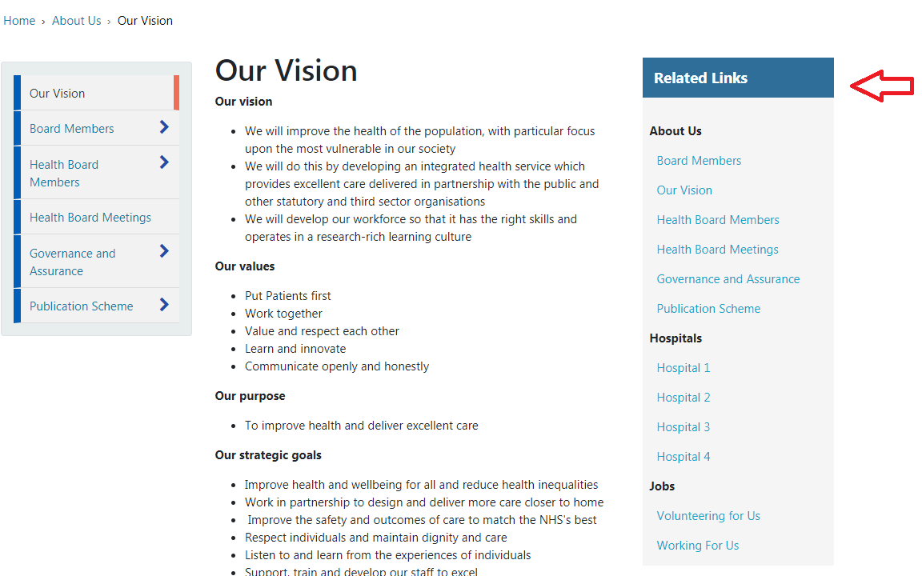
Page jump on mobile sites | On the mobile view, the header was snapping into place rather than scrolling smoothly. This change will fix this issue.
Remove Capitals only default from title | The title of a plugin currently defaults to capital letters regardless of the way the title is added. This change will mean the text will show as typed.  Before change:  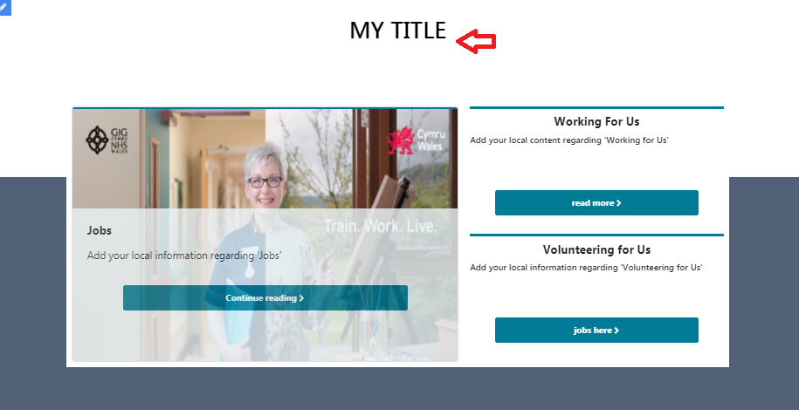  After change  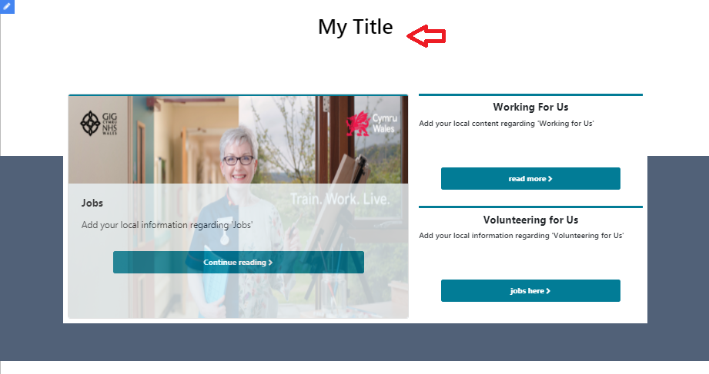

Problems Fixed

- RTE image gallery hyphen bug fix
When using the Rich Text Editor image wizard, if searching for an image where the page has a hyphen in the title, it will not find related galleries on the inline edit. This change will prevent this from happening.

- Page jump on mobile sites
On the mobile view, the header was snapping into place rather than scrolling smoothly. This change will prevent the jump and enable smooth scrolling.

New Problems Identified During Testing and Associated Workarounds
Directory of Services Plugin
Sexual Health Clinics and Hospitals do not have a parent organization so please filter by ‘all’ rather, than by Healthboard. This may be resolved before the release is implemented, but alternatively it will be fixed in the next release.

Pre-requisites to Deploy the Release
N/A

Training Requirements
CMS support Site will be updated with any changes that introduce new functionality or changes to workflow.

Step by Step Deployment Instructions
No deployment actions required by Health Boards

Deployment Plan
Changes to be implemented as specified in the Change Record
Release to be deployed via change record 67637

Back-Out Plan
Back out as detailed on each change record

Release Available for Deployment Date
NHS Wales: 20/03/2019

