REL-ID 531 CMS/06-2019

NHS WALES IT SERVICE MANAGEMENT
CMS Release Notes
Release ID: 531 CMS/06-2019
These Release Notes describe the scope and content of
Release ID: 531 CMS/06-2019

CMS

Version No. 1.0
Status: Approved

Owner: CMS Service Management Board
Author: Helen McGrath
Approver: Michele Golpaykar-rad
Date: 10/06/2019
Next Review Date: 25/06/2019
Tŷ Glan-yr-Afon
21 Heol Ddwyreiniol Y Bont-Faen, Caerdydd CF11 9AD
21 Cowbridge Road East, Cardiff CF11 9AD
Ffôn/Tel: 02920 500500
www.cymru.nhs.uk/gwybodeg
www.wales.nhs.uk/informatics

TABLE OF CONTENTS

1 DOCUMENT HISTORY 3
1.1 Template Revision History 3
1.2 Revision History 3
1.3 Reviewers 3
1.4 Authorisation 3
1.5 Document Location 3
2 INTRODUCTION 4
3 SERVICE MANAGEMENT BOARD (SMB) 4
4 RELEASE NOTES REQUIREMENT 4
4.1 Release Identification 4
4.2 Description of New or Modified Functionality 4
4.3 Problems Fixed 5
4.4 New Problems Identified During Testing and Associated Workarounds 5
4.5 Pre-requisites to Deploy the Release 5
4.6 Training Requirements 5
4.7 Step by Step Deployment Instructions 6
4.8 Deployment Plan 6
4.9 Back-Out Plan 6
4.10 Release Available for Deployment Date 6

DOCUMENT HISTORY

Template Revision History
Date | Version | Author | Revision Summary
6th March 2012 | 0.1 | Steve Finn | First Draft
15th March 2012 | 0.2 | Steve Finn | Second Draft following comments from SW
5th July 2012 | 0.3 | Steve Finn | Third Draft following release process modifications
26th July 2012 | 1.0 | Kelly Tremlett | Issued as approved version 1.0

Revision History
Date | Version | Author | Revision Summary
10/06/2019 | 1.0 | Helen McGrath | Senior Support & Business Analyst

Reviewers
This document requires the following reviews:
Date | Version | Name | Position

Authorisation
Signing of this document indicates acceptance of its contents.
Author’s Name: | Helen McGrath
Role: | Senior Support and Business Analyst
Signature: |  | Date: | 10/06/2019

Approver’s Name: | Stephen Price
Role: | Applications Manager (Corporate)
Signature: |  | Date: | 10/06/2019

Document Location
Type | Location
Electronic

INTRODUCTION
The NHS Wales Release Management Policy considers that effective Release Management is essential for protecting the integrity of the operational environment. A key objective of the release process is ensuring that users, support staff and other stakeholders are kept informed as to what is planned and how this will affect them. One of the ways that this can be achieved is through the publication of release notes prior to deployment of the Release.

These notes contain information on the agreed scope and content of Release id CMS/06-2019 for the CMS descriptions of new or modified functionality and problem fixes, descriptions of new problems and workarounds identified during the testing of this Release, training requirements, deployment instructions, references to deployment and back-out plans and key dates within the release process.

SERVICE MANAGEMENT BOARD (SMB)
The CMS Service Management Board has overall responsibility for ensuring that these Release Notes accurately describes the Release and that it is kept under constant review and updated to reflect any modifications to the Release prior to its deployment.

RELEASE NOTES REQUIREMENT

Release Identification
531 CMS/06-2019

Description of New or Modified Functionality
Item | Description
Navbar Layout Changes | This change will see the addition of a gap in the Blue indicator bar between Navigation Items when the user hovers over an item in the second level grey Navigation bar.  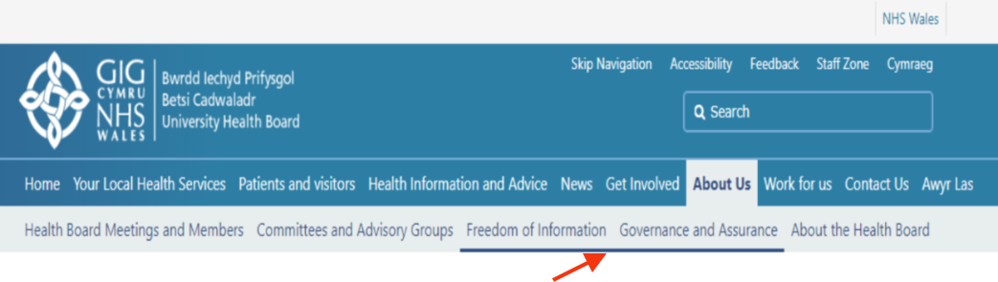
Displaying Associated Image Meta Data | When a user is adding an image through the CK Editor, you will now have a further Captions & Credits option. This option will allow the user to pull in the Meta Data from the page’s Associated Image.  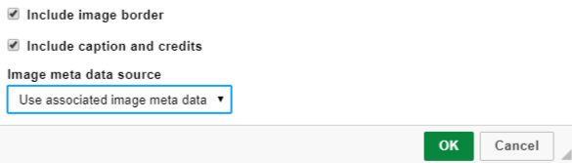  
Default Layout List – Mobile View | Currently when using the List layout this does not resize correctly on the Mobile View. This change will see this corrected to pull in a small thumbnail sized image.  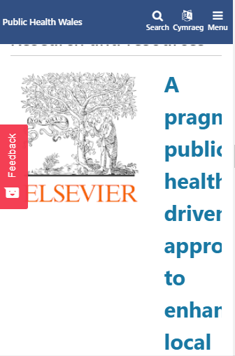
Menu falls into the Ellipsis | This change will lower the Ellipsis pop up menu, so that the 'X' is no longer covered.  We have also added in the ability to close this window by clicking anywhere on the screen.  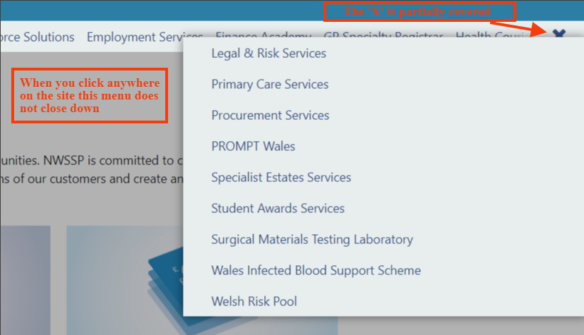
Use of the Ellipsis Menu – From a Hover Over | We recently introduced the ability to hide menus which appear on 'hover-over' by clicking anywhere else on the page, unfortunately this means that when you click on an ellipsis on the hover over secondary menu then the menu is hidden.  This change will add the ability to close the menu if you click anywhere on the page other than the menu's ellipsis.  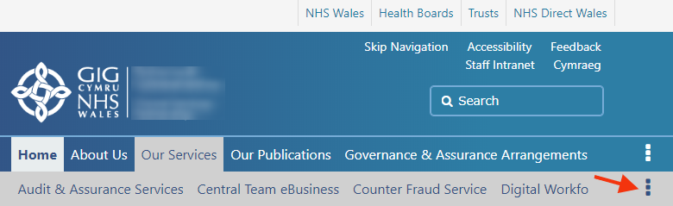
System Plugin | This plugin is not currently available to all sites, this addition will allow users to drag in further functionality such as Site Map and Content Rater.  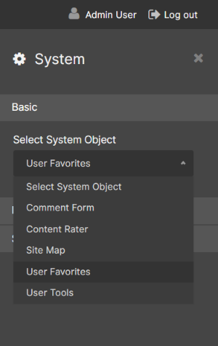
Option on Displaying an Associated Image on a Page | This change will introduce a New Radio Button (into the page edit) that will allow you to add an Associated Image to a Page; that would be pulled through to any plugins you are using, But the Image would not be viewable when you go to the page itself.  This change has be requested by service users.  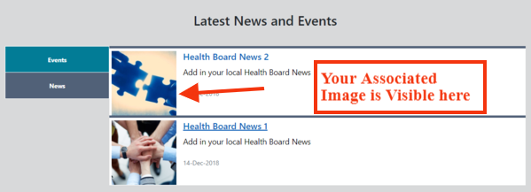  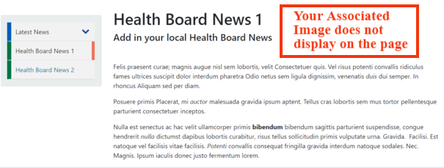
Wrap RGGallery Summary | This change will resolve the issue of incorrect text breaks in the summary when you resize the Gallery.  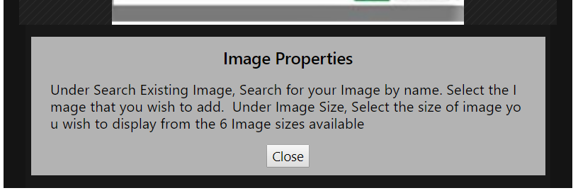
Image render issues – With Components | Currently when Images are placed within a Component this is showing in error when the Component is placed within the Body of content.  This change will resolve this issue.
Remove Gallery Tab from Components | This change will see the removal of the Gallery Tab as an option when placing a Component. The Gallery Tab has been relocated and can be found within the CK Editor Image Key.  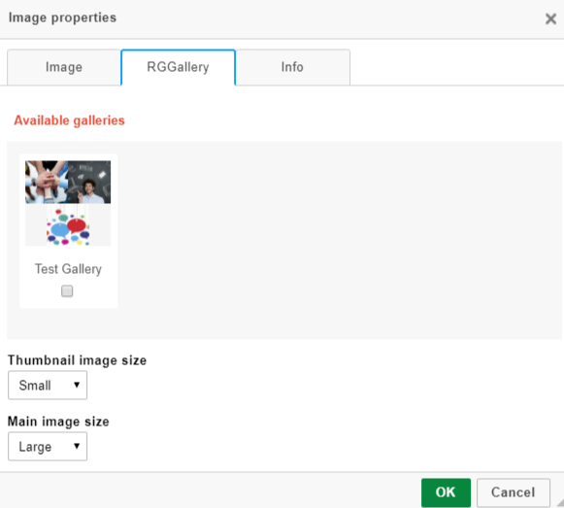
Box Block2 - Option to Remove Icons | This update will allow users to remove the Icons displayed on the plugin whilst not effecting the size and shape of the boxes, Text within will then become vertically aligned. This change has been requested by system users.  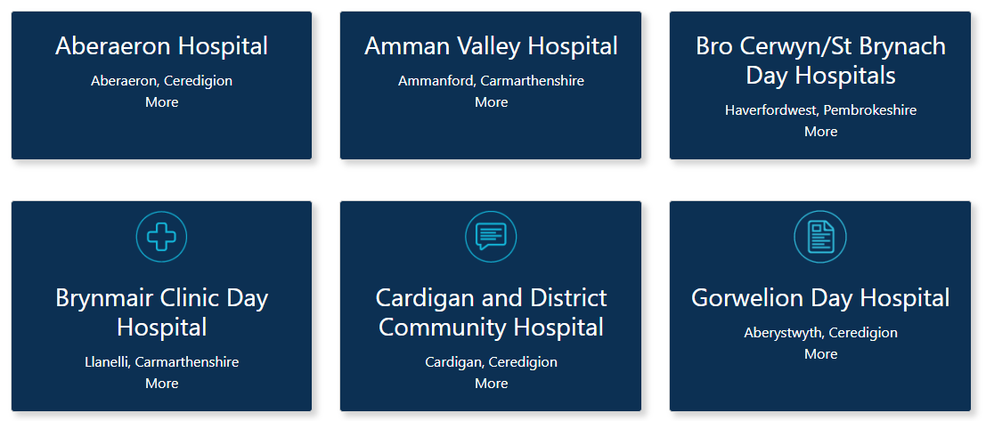
Single Content Block3 | The introduction of a new Single Content Block. This new block (as displayed) will see the associated image contained within the block.  This new block will have the same configurable settings as the existing Single Content Layouts.  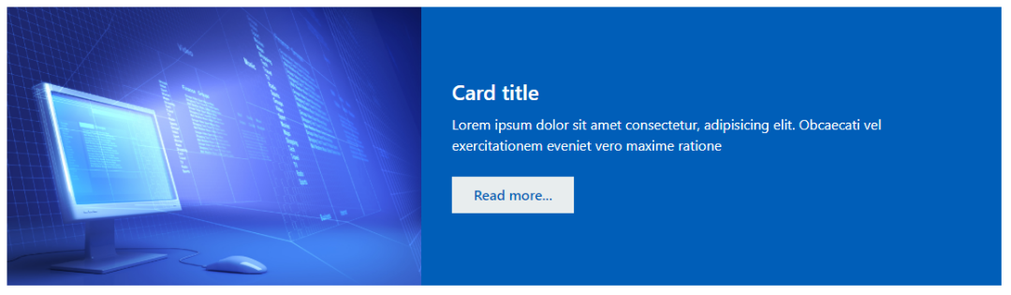
Add Journey Planner Functionality to Google Map Plugin | This change will see the addition of a 'Plan My Journey' function to the Google Map Plugin display.  The settings for this plugin will also be updated for ease of use when entering a destination (by post code or Longitude/Latitude)  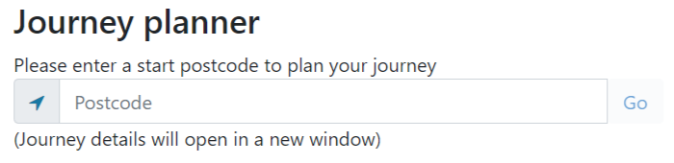
Homepage Carousel – a Number of Updates | This change will see the Homepage Carousel removed from the CMS, this will be replaced by the use of the dragable Carousel Plugin. When using the ‘Home.cfm’ page layout this Carousel Plugin will span across the whole site.  Amendment made:  - Slight increase the Font size of the Title text  - No increase in font made when pulling in the Summary text (to create a distinction between Title and Summary)  - Reduction in size of the More call to action button  *Note: For any sites that has Homepage Carousel, this will need to be re added by using the Carousel Plugin.  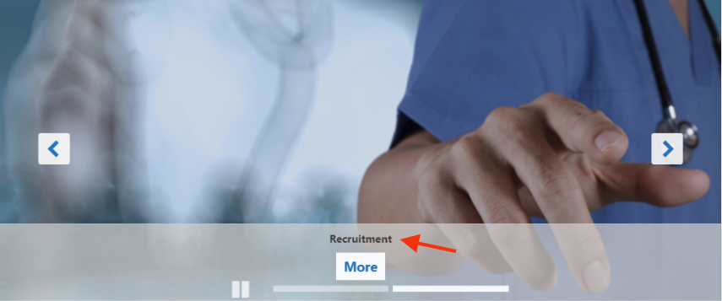
Reduce Page Image Plugin Dialog Height | This change will see a reduction in the height of the CK Editor Image Dialog box. The added options underneath the Image will now appear alongside each other inorder to cut the size of the box.  Current Size  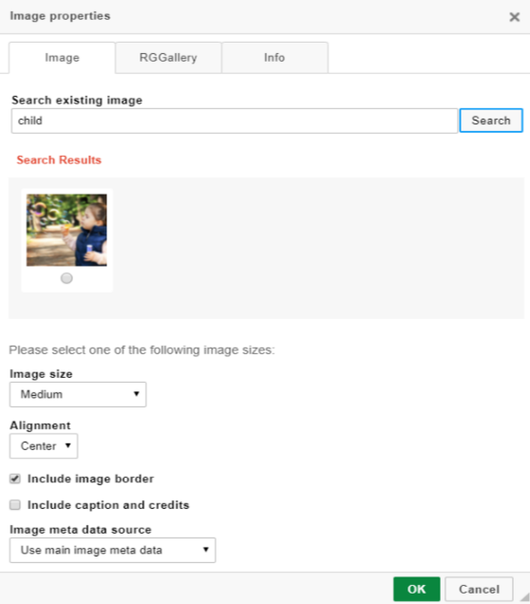
Mura Plugin A&E Wait Time Display Update | There has been a request updated to the display of the 'Typical Time in department' section of the A&E plugin used in the Mura sites.  For example in the screenshot below - we would no longer want to show the '45 mins' but instead show the text 'Up to' and then just the upper limit, i.e. in this example under 'Typical Wait time' it would just say 'Up to 2 hrs 45 mins'.  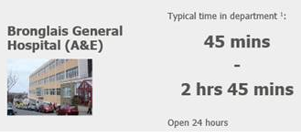
Welsh Translated Audit Interface | Within the Mura translation plugin admin section an audit interface has been developed. This interface will allow users to find out which pages have been linked to their respective translated pages in the corresponding sites.  The interface will also provide a toggle between the pages which have been or haven't been linked using a button.  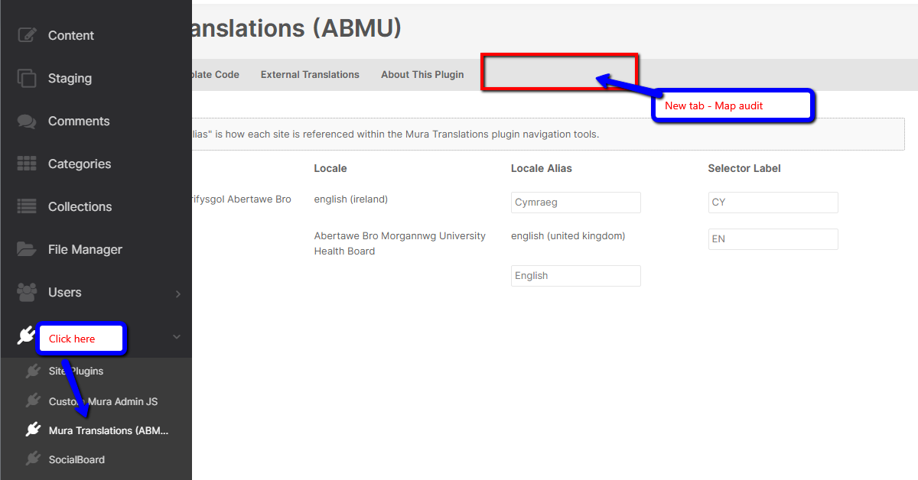
Low Graphic Colour Contrast | To meet accessibility guidelines the colour contrast of the Search box has been increased.  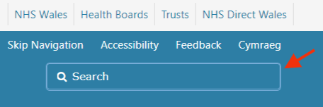
Accessibility on Embedded Social Media | The Twitter and Facebook feeds consist of a high number of links and buttons e.g. twitter handles, like buttons, comment buttons. There is no mechanism to bypass this embedded content, which results in users having to tab through all the focusable elements in the feeds in order to navigate to the next element.  This change will see this issue resolved.

Problems Fixed

N/A

New Problems Identified During Testing and Associated Workarounds
N/A

Pre-requisites to Deploy the Release
N/A

Training Requirements
CMS support Site will be updated with any changes that introduce new functionality or changes to workflow.

Step by Step Deployment Instructions
No Deployment actions required by Health Boards

Deployment Plan
Changes to be implemented as specified in the Change Record
Release to be deployed via change record 70373

Back-Out Plan
Back out as detailed on each change record

Release Available for Deployment Date
NHS Wales : 26/06/2019

