REL-ID 536 CMS/07-2019

NHS WALES IT SERVICE MANAGEMENT
CMS Release Notes
Release ID: 536 CMS/07-2019
These Release Notes describe the scope and content of
Release ID: 536 CMS/07-2019

CMS

Version No. 1.0
Status: Approved

Owner: CMS Service Management Board
Author: Helen McGrath
Approver: Michele Golpaykar-rad
Date: 15/07/2019
Next Review Date: 29/07/2019
Tŷ Glan-yr-Afon
21 Heol Ddwyreiniol Y Bont-Faen, Caerdydd CF11 9AD
21 Cowbridge Road East, Cardiff CF11 9AD
Ffôn/Tel: 02920 500500
www.cymru.nhs.uk/gwybodeg
www.wales.nhs.uk/informatics

TABLE OF CONTENTS

1 DOCUMENT HISTORY 3
1.1 Template Revision History 3
1.2 Revision History 3
1.3 Reviewers 3
1.4 Authorisation 3
1.5 Document Location 3
2 INTRODUCTION 4
3 SERVICE MANAGEMENT BOARD (SMB) 4
4 RELEASE NOTES REQUIREMENT 4
4.1 Release Identification 4
4.2 Description of New or Modified Functionality 4
4.3 Problems Fixed 5
4.4 New Problems Identified During Testing and Associated Workarounds 5
4.5 Pre-requisites to Deploy the Release 5
4.6 Training Requirements 5
4.7 Step by Step Deployment Instructions 6
4.8 Deployment Plan 6
4.9 Back-Out Plan 6
4.10 Release Available for Deployment Date 6

DOCUMENT HISTORY

Template Revision History
Date | Version | Author | Revision Summary
6th March 2012 | 0.1 | Steve Finn | First Draft
15th March 2012 | 0.2 | Steve Finn | Second Draft following comments from SW
5th July 2012 | 0.3 | Steve Finn | Third Draft following release process modifications
26th July 2012 | 1.0 | Kelly Tremlett | Issued as approved version 1.0

Revision History
Date | Version | Author | Revision Summary
15/07/2019 | 1.0 | Helen McGrath | Senior Support & Business Analyst

Reviewers
This document requires the following reviews:
Date | Version | Name | Position

Authorisation
Signing of this document indicates acceptance of its contents.
Author’s Name: | Helen McGrath
Role: | Senior Support and Business Analyst
Signature: |  | Date: | 15/07/2019

Approver’s Name: | Stephen Price
Role: | Applications Manager (Corporate)
Signature: |  | Date: | 15/07/2019

Document Location
Type | Location
Electronic

INTRODUCTION
The NHS Wales Release Management Policy considers that effective Release Management is essential for protecting the integrity of the operational environment. A key objective of the release process is ensuring that users, support staff and other stakeholders are kept informed as to what is planned and how this will affect them. One of the ways that this can be achieved is through the publication of release notes prior to deployment of the Release.

These notes contain information on the agreed scope and content of Release id CMS/07-2019 for the CMS descriptions of new or modified functionality and problem fixes, descriptions of new problems and workarounds identified during the testing of this Release, training requirements, deployment instructions, references to deployment and back-out plans and key dates within the release process.

SERVICE MANAGEMENT BOARD (SMB)
The CMS Service Management Board has overall responsibility for ensuring that these Release Notes accurately describes the Release and that it is kept under constant review and updated to reflect any modifications to the Release prior to its deployment.

RELEASE NOTES REQUIREMENT

Release Identification
536 CMS/07-2019

Description of New or Modified Functionality
Item | Description | Requestor
Rate this Content Styling | This change will see an update to the styling of this module. Currently the ‘Rate this’ plugin appears as a floating block, this will now be amended to match existing blocks within the System Plugin. (Such as the Page Tools block displayed below)  Current Display New Display  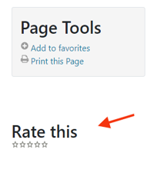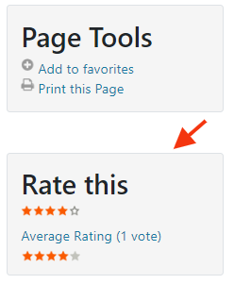 | CMS Support Team
List Layout Incorrect Formatting on Mobile View | When using the list layout and viewing this on a mobile phone the text indents to allow an image to display. However this indent appears regardless as to whether or not an image has been attached. This change will see this amended to only indent the text when an Image has been selected to display.  Current Display New Display  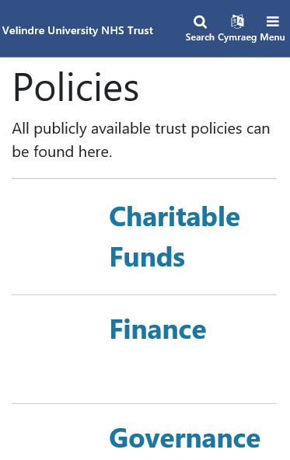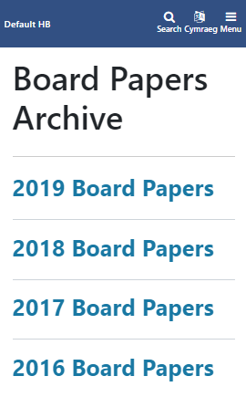 | Velindre
Table Resizing in Mobile View | Currently when a table is placed within an accordion it does not resize correctly when viewed on a Mobile. This change will amend this so that the Table will span the area of the accordion and present a scroll bar to make further content available.  Current Display New Display  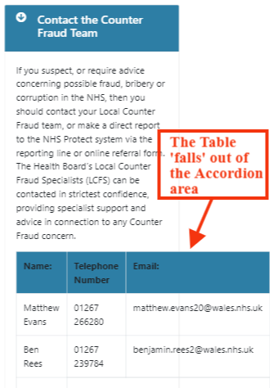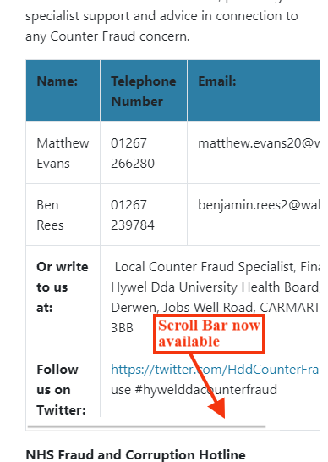 | HDUHB
Profile Page Update | Currently the summary text brought in on the cards in intermittently cutting off midway through the text. This change will see this repaired – all text entered into the summary area will pull through onto the card.  Current Display New Display  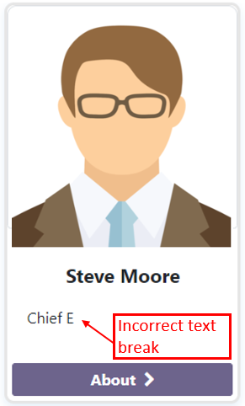 | HDUHB
Accessibility Updates | Ongoing Accessibility updates to the CMS regarding screen readers, as advised by RNIB review. These updates will only impact on users operating screen readers. | CMS Development Team

Problems Fixed

N/A

New Problems Identified During Testing and Associated Workarounds
N/A

Pre-requisites to Deploy the Release
N/A

Training Requirements
CMS support Site will be updated with any changes that introduce new functionality or changes to workflow.

Step by Step Deployment Instructions
No Deployment actions required by Health Boards

Deployment Plan
Changes to be implemented as specified in the Change Record
Release to be deployed via change record 71199

Back-Out Plan
Back out as detailed on each change record

Release Available for Deployment Date
NHS Wales : 25/07/2019

