REL-ID 497 CMS/01-2019

NHS WALES IT SERVICE MANAGEMENT
CMS Release Notes
Release ID: 497 CMS/01-2019
These Release Notes describe the scope and content of
Release ID: 497 CMS/01-2019

CMS

Version No. 1.0
Status: Approved

Owner: CMS Service Management Board
Author: Michele Golpaykar-rad
Approver: Michele Golpaykar-rad
Date: 14/11/2018
Next Review Date: 14/11/2019
Tŷ Glan-yr-Afon
21 Heol Ddwyreiniol Y Bont-Faen, Caerdydd CF11 9AD
21 Cowbridge Road East, Cardiff CF11 9AD
Ffôn/Tel: 02920 500500
www.cymru.nhs.uk/gwybodeg
www.wales.nhs.uk/informatics

TABLE OF CONTENTS

1 DOCUMENT HISTORY 3
1.1 Template Revision History 3
1.2 Revision History 3
1.3 Reviewers 3
1.4 Authorisation 3
1.5 Document Location 3
2 INTRODUCTION 4
3 SERVICE MANAGEMENT BOARD (SMB) 4
4 RELEASE NOTES REQUIREMENT 4
4.1 Release Identification 4
4.2 Description of New or Modified Functionality 4
4.3 Problems Fixed 7
4.4 New Problems Identified During Testing and Associated Workarounds 7
4.5 Pre-requisites to Deploy the Release 7
4.6 Training Requirements 7
4.7 Step by Step Deployment Instructions 7
4.8 Deployment Plan 7
4.9 Back-Out Plan 7
4.10 Release Available for Deployment Date 8

DOCUMENT HISTORY

Template Revision History
Date | Version | Author | Revision Summary
6th March 2012 | 0.1 | Steve Finn | First Draft
15th March 2012 | 0.2 | Steve Finn | Second Draft following comments from SW
5th July 2012 | 0.3 | Steve Finn | Third Draft following release process modifications
26th July 2012 | 1.0 | Kelly Tremlett | Issued as approved version 1.0

Revision History
Date | Version | Author | Revision Summary
22/01/2019 | 1.0 | Michele Golpaykar-rad | Principal Support & Business Analyst

Reviewers
This document requires the following reviews:
Date | Version | Name | Position

Authorisation
Signing of this document indicates acceptance of its contents.
Author’s Name: | Michele Golpaykar-rad
Role: | Principal Support & Business Analyst
Signature: |  | Date:

Approver’s Name: | Stephen Price
Role: | Applications Manager (Corporate)
Signature: |  | Date:

Document Location
Type | Location
Electronic

INTRODUCTION
The NHS Wales Release Management Policy considers that effective Release Management is essential for protecting the integrity of the operational environment. A key objective of the release process is ensuring that users, support staff and other stakeholders are kept informed as to what is planned and how this will affect them. One of the ways that this can be achieved is through the publication of release notes prior to deployment of the Release.

These notes contain information on the agreed scope and content of Release id CMS/01-2019 for the CMS descriptions of new or modified functionality and problem fixes, descriptions of new problems and workarounds identified during the testing of this Release, training requirements, deployment instructions, references to deployment and back-out plans and key dates within the release process.

SERVICE MANAGEMENT BOARD (SMB)
The CMS Service Management Board has overall responsibility for ensuring that these Release Notes accurately describes the Release and that it is kept under constant review and updated to reflect any modifications to the Release prior to its deployment.

RELEASE NOTES REQUIREMENT

Release Identification
497

Description of New or Modified Functionality
Item | Description
Mura Core upgraded from 7.1.273 | Mura core software has been updated to a later version.
New cookie message  *new sites only | This new Cookie message will now appear at the bottom of any new website created.  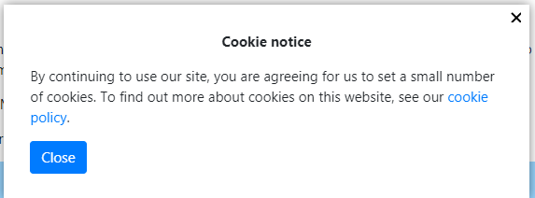  Please note: The new cookie message will be implemented to existing websites in the February Release.  The cookie message above, will replace the current grey default cookie that spans the page.
Tabbed content ordering improvement | Removed the sort order facility from the configurator in the front end inline editor, so it can be controlled by Mura’s collection index settings in the back end admin section. This is to prevent conflicts when ordering content.
CMS Support Site theme update | The new design for the CMS Support website will be applied to the current website.  Redesign of website with new logo, search bar move and banner.  CMS Support website only*  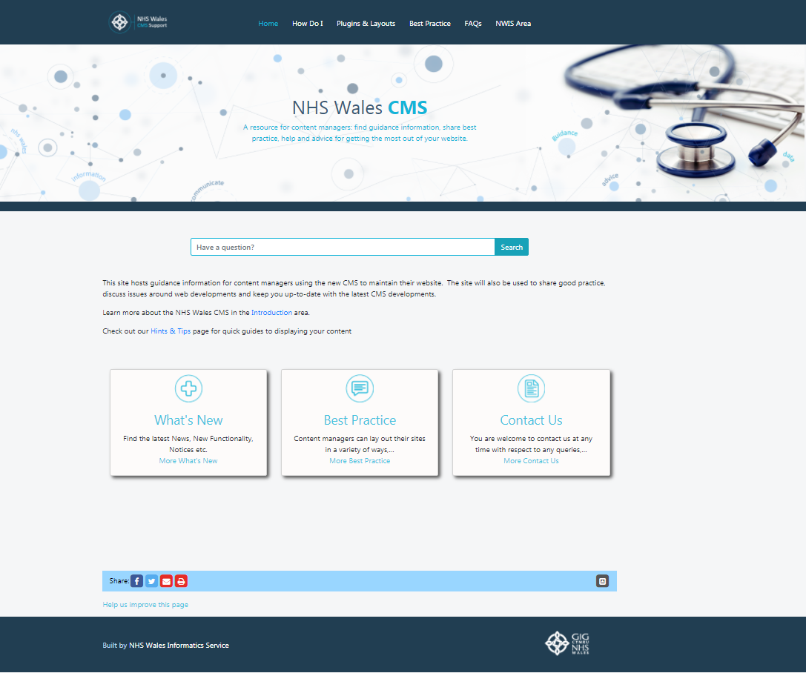
Theme update | Addition of a single line to separate footer from main body and to stay within border of the page and not to span the page.  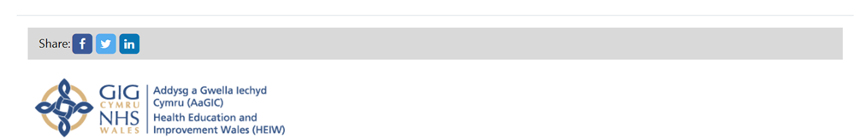
YouTube Video Open Graph Meta Data | In the open graph plugin, we currently add meta data about the page which includes description, site name and amongst other things we also include the image. However, in some cases a page may not include an image, but a video which is added by use of the YouTube module. This change will add the ability to include video meta data to the open graph plugin, to show in the share model of Facebook.
Image Unavailable Icon | If there is a page which has no image or a broken image, this new Image Unavailable icon will show on the Tabbed Content component and the Box Block 2.    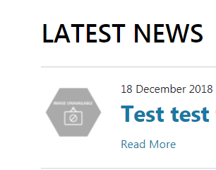
Multi content – evenly space content | The top right hand section of the Multi Display 2 box, was smaller than the bottom hand section. This has now been evenly spaced out.  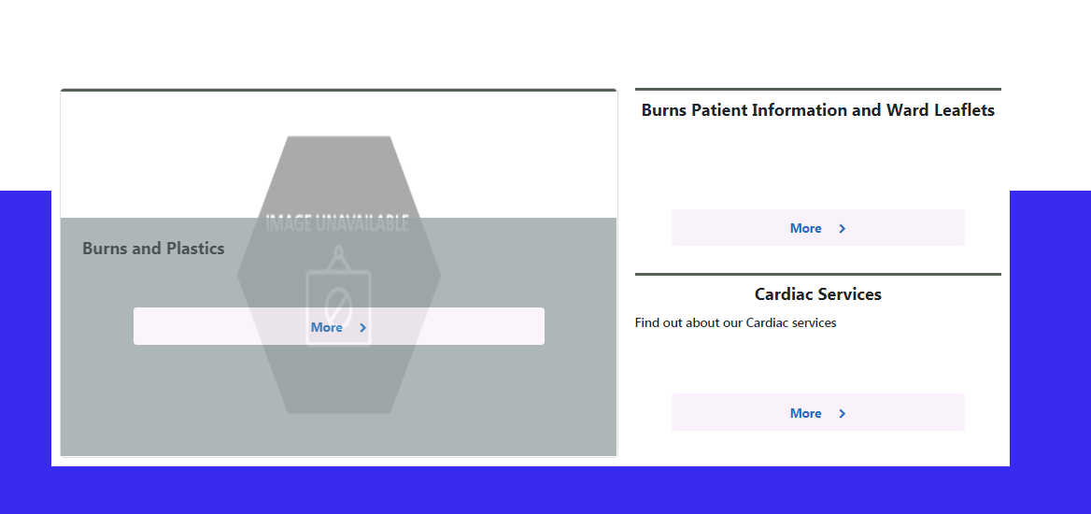
Localisation in Welsh | Labels will appear in Welsh on Welsh sites e.g. Search will be Chwillio  
Trust navigation placeholder | In the plugin 'Additional Display Regions', it has now been made obvious to the user if they have duplicated the Secondary Navigation Menu.  If more than one blue box with Secondary Menu shows in the Additional Display Region, it means it has been added more than once and this will cause issues with the menu. Any duplications should be removed.  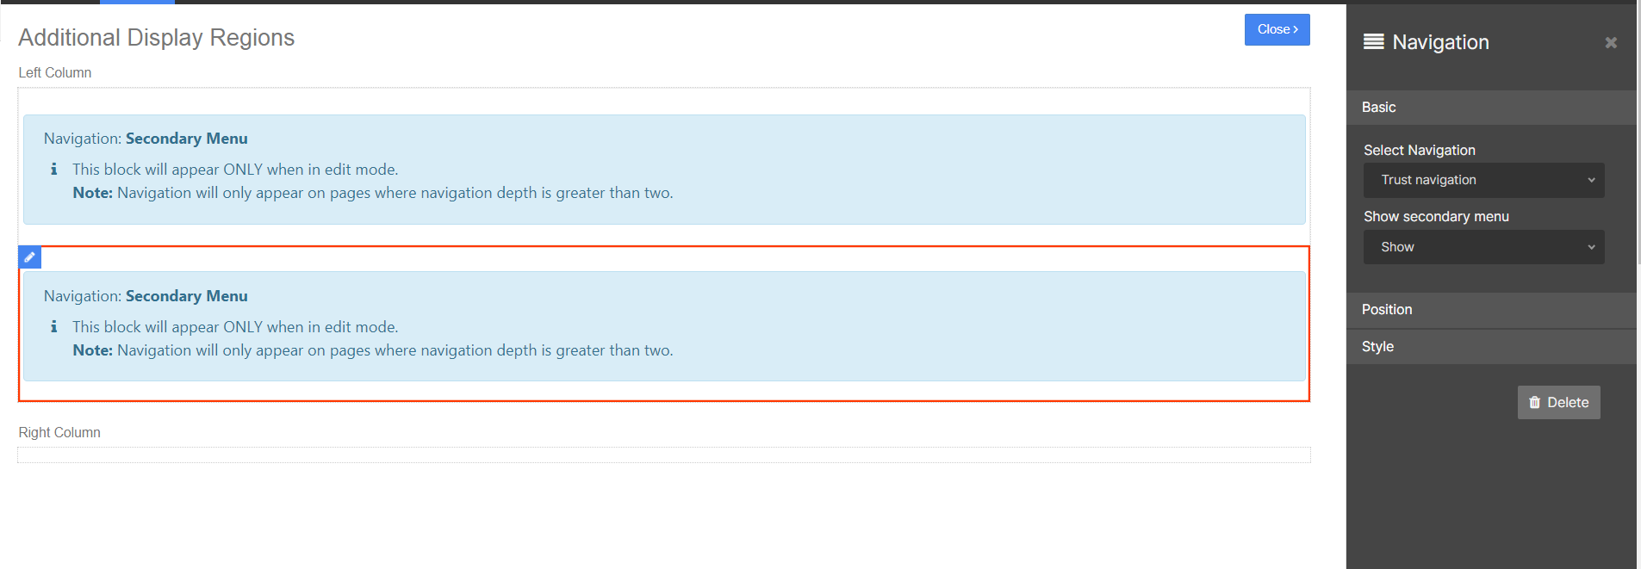

Problems Fixed

N/A

New Problems Identified During Testing and Associated Workarounds
N/A

Pre-requisites to Deploy the Release
N/A

Training Requirements
CMS support Site will be updated with any changes that introduce new functionality or changes to workflow.

Step by Step Deployment Instructions
No Deployment actions required by Health Boards

Deployment Plan
Changes to be implemented as specified in the Change Record
Release to be deployed via change record 66242

Back-Out Plan
Back out as detailed on each change record

Release Available for Deployment Date
NHS Wales: 28/01/2019

