REL-ID 502 CMS/02-2019

NHS WALES IT SERVICE MANAGEMENT
CMS Release Notes
Release ID: 502 CMS/02-2019
These Release Notes describe the scope and content of
Release ID: 502 CMS/02-2019

CMS

Version No. 1.0
Status: Approved

Owner: CMS Service Management Board
Author: Michele Golpaykar-rad
Approver: Michele Golpaykar-rad
Date: 14/02/2018
Next Review Date: 14/11/2019
Tŷ Glan-yr-Afon
21 Heol Ddwyreiniol Y Bont-Faen, Caerdydd CF11 9AD
21 Cowbridge Road East, Cardiff CF11 9AD
Ffôn/Tel: 02920 500500
www.cymru.nhs.uk/gwybodeg
www.wales.nhs.uk/informatics

TABLE OF CONTENTS

1 DOCUMENT HISTORY 3
1.1 Template Revision History 3
1.2 Revision History 3
1.3 Reviewers 3
1.4 Authorisation 3
1.5 Document Location 3
2 INTRODUCTION 4
3 SERVICE MANAGEMENT BOARD (SMB) 4
4 RELEASE NOTES REQUIREMENT 4
4.1 Release Identification 4
4.2 Description of New or Modified Functionality 4
4.3 Problems Fixed 9
4.4 New Problems Identified During Testing and Associated Workarounds 9
4.5 Pre-requisites to Deploy the Release 9
4.6 Training Requirements 9
4.7 Step by Step Deployment Instructions 9
4.8 Deployment Plan 10
4.9 Back-Out Plan 10
4.10 Release Available for Deployment Date 10

DOCUMENT HISTORY

Template Revision History
Date | Version | Author | Revision Summary
6th March 2012 | 0.1 | Steve Finn | First Draft
15th March 2012 | 0.2 | Steve Finn | Second Draft following comments from SW
5th July 2012 | 0.3 | Steve Finn | Third Draft following release process modifications
26th July 2012 | 1.0 | Kelly Tremlett | Issued as approved version 1.0

Revision History
Date | Version | Author | Revision Summary
14/02/2019 | 1.0 | Michele Golpaykar-rad | Principal Support & Business Analyst

Reviewers
This document requires the following reviews:
Date | Version | Name | Position

Authorisation
Signing of this document indicates acceptance of its contents.
Author’s Name: | Michele Golpaykar-rad
Role: | Principal Support & Business Analyst
Signature: |  | Date:

Approver’s Name: | Stephen Price
Role: | Applications Manager (Corporate)
Signature: |  | Date:

Document Location
Type | Location
Electronic

INTRODUCTION
The NHS Wales Release Management Policy considers that effective Release Management is essential for protecting the integrity of the operational environment. A key objective of the release process is ensuring that users, support staff and other stakeholders are kept informed as to what is planned and how this will affect them. One of the ways that this can be achieved is through the publication of release notes prior to deployment of the Release.

These notes contain information on the agreed scope and content of Release id CMS/02-2019 for the CMS descriptions of new or modified functionality and problem fixes, descriptions of new problems and workarounds identified during the testing of this Release, training requirements, deployment instructions, references to deployment and back-out plans and key dates within the release process.

SERVICE MANAGEMENT BOARD (SMB)
The CMS Service Management Board has overall responsibility for ensuring that these Release Notes accurately describes the Release and that it is kept under constant review and updated to reflect any modifications to the Release prior to its deployment.

RELEASE NOTES REQUIREMENT

Release Identification
502

Description of New or Modified Functionality
Item | Description
Text site name instead of logo on mobile view | The logo at the top left hand side of the webpage will be changed to display the organisation name in text on the mobile view. This is to make the organisation name easier to view on a mobile, as the full desktop logo with icon is hard to read. The NHS logo will still show in the footer on the mobile view.  Approved at the CMS project board on 15th January 2019.  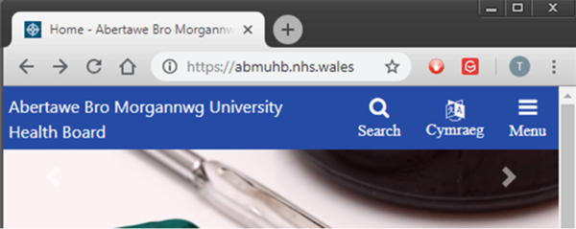
Profile content type | We are developing a profile content type, which will give admin users the ability to add Profile Cards to their pages. This module could be used to display board members or director’s information on a webpage.  
New RTE Image wizard | We plan to add a new feature to the Rich Text Editor to allow assigning an existing image to a page. This will allow the admin user to have more choice over the image sizes they can select from. The user can select the RTE Image wizard icon, then search for existing images and will have the option to pick an image out of a choice of one of the five default sizes. This will remove the reliance of knowing the content id and give greater flexibility of the image sizes that can be added.  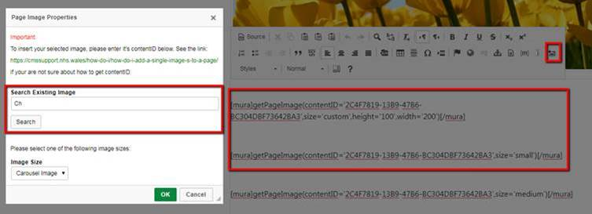  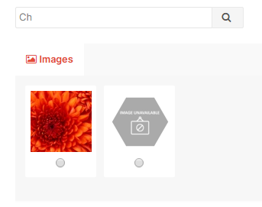
Carousel Module pause and play option | Addition of a new carousel module which will have the ability to play and pause the carousel and add alt text to help satisfy accessibility needs.  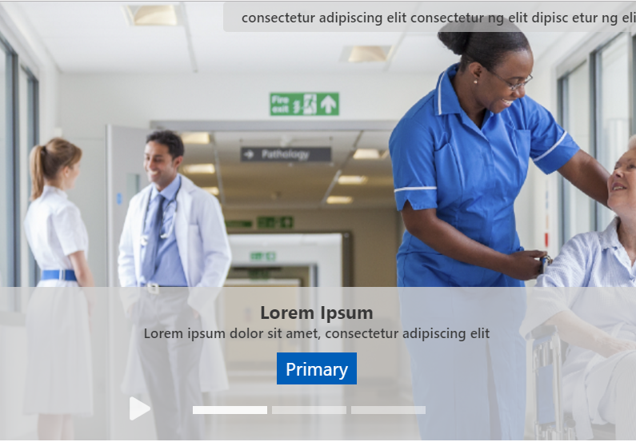
New Cookie prompt to be added to existing websites. | A friendlier cookie notice will replace the existing grey cookie message, which spans across the website. The new compact cookie message will display at the bottom of the page.  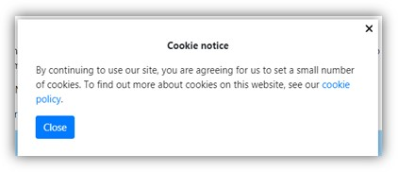
Delimiter to amend text label on links | Currently when adding in components with links to the full story, the user can change the label of the link via the View All Label field, but that label will be used for all sections e.g. ‘Continue Reading’ and cannot be changed per item. This new change will introduce a comma delimiter, so that each sections link can be editable to give it a more meaningful description to aid accessibility.  Allow the "View all" label to accept a list of multiple entries, separated by a comma, which are used as the button labels within a collection.  I.e. the first button takes the first entry in the list, the second the second entry etc. If no specific entry then use the default.  This will be added on these modules:  - Boxblock2  - Multi content display 1  - Multi content display 2  Before change  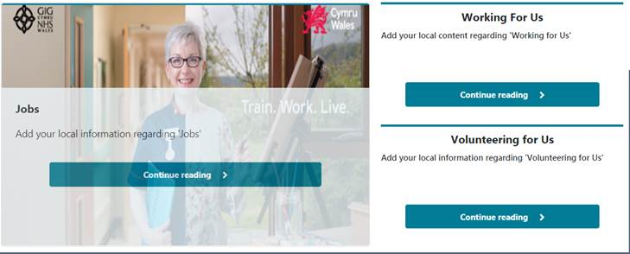  After change  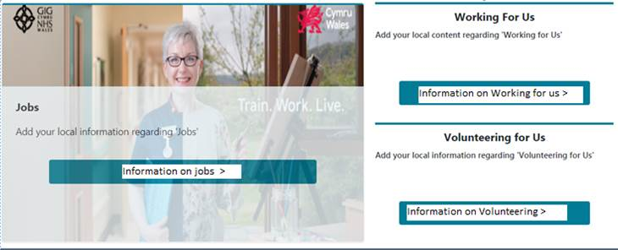
Fix mobile overlap in Mura emulator view | In the CMS Mura mobile emulator view (in internet explorer) the Cymraeg and burger menu button overlap, this change will prevent the overlap.  Mobile Emulator view before change:  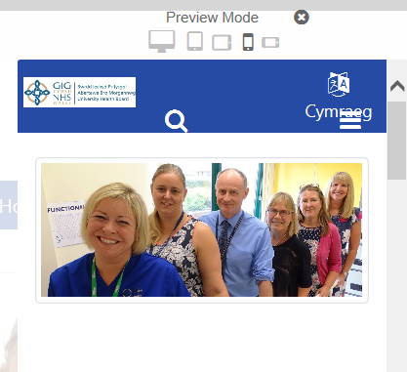  Mobile emulator view after change:  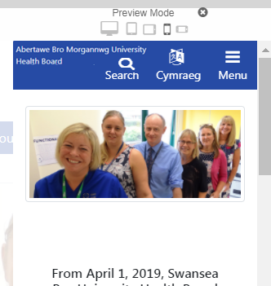
Search optimisation | Search optimisation to return a more relevant result  This change will take in the exact search phrase & words removing any ‘stop words’ (e.g. ‘at’, ‘and’, ‘or’, etc.) to return a more relevant result.  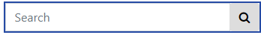
Links Organiser -duplicate links fix | This change will fix duplicate links appearing in the Links Organiser.  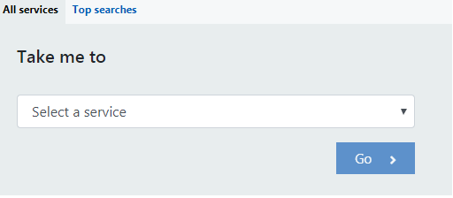  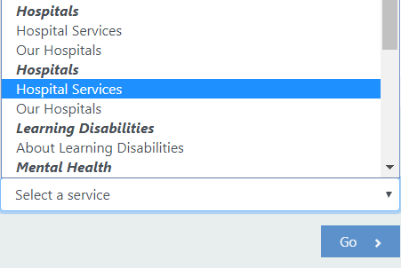
Gallery caching fix | This change will stop galleries that have been added to a page from disappearing.

Problems Fixed

- Mobile Emulator view menu overlap.
- Duplicate links appearing in the Links Organiser.
- Caching on galleries, which makes the gallery disappear.

New Problems Identified During Testing and Associated Workarounds
N/A

Pre-requisites to Deploy the Release
N/A

Training Requirements
CMS support Site will be updated with any changes that introduce new functionality or changes to workflow.

Step by Step Deployment Instructions
No deployment actions required by Health Boards

Deployment Plan
Changes to be implemented as specified in the Change Record
Release to be deployed via change record 66849

Back-Out Plan
Back out as detailed on each change record

Release Available for Deployment Date
NHS Wales: 26/02/2019

