lREL-ID 560 CMS/12-2019

NHS WALES IT SERVICE MANAGEMENT
CMS Release Notes
Release ID: 560 CMS/12-2019
These Release Notes describe the scope and content of
Release ID: 560 CMS/12-2019

CMS

Version No. 1.0
Status: Approved

Owner: CMS Service Management Board
Author: Helen McGrath
Approver: Stephen Price
Date: 10/12/2019
Next Review Date: 10/12/2019
Tŷ Glan-yr-Afon
21 Heol Ddwyreiniol Y Bont-Faen, Caerdydd CF11 9AD
21 Cowbridge Road East, Cardiff CF11 9AD
Ffôn/Tel: 02920 500500
www.cymru.nhs.uk/gwybodeg
www.wales.nhs.uk/informatics

TABLE OF CONTENTS

1 DOCUMENT HISTORY 3
1.1 Template Revision History 3
1.2 Revision History 3
1.3 Reviewers 3
1.4 Authorisation 3
1.5 Document Location 3
2 INTRODUCTION 4
3 SERVICE MANAGEMENT BOARD (SMB) 4
4 RELEASE NOTES REQUIREMENT 4
4.1 Release Identification 4
4.2 Description of New or Modified Functionality 4
4.3 Problems Fixed 5
4.4 New Problems Identified During Testing and Associated Workarounds 5
4.5 Pre-requisites to Deploy the Release 5
4.6 Training Requirements 5
4.7 Step by Step Deployment Instructions 6
4.8 Deployment Plan 6
4.9 Back-Out Plan 6
4.10 Release Available for Deployment Date 6

DOCUMENT HISTORY

Template Revision History
Date | Version | Author | Revision Summary
6th March 2012 | 0.1 | Steve Finn | First Draft
15th March 2012 | 0.2 | Steve Finn | Second Draft following comments from SW
5th July 2012 | 0.3 | Steve Finn | Third Draft following release process modifications
26th July 2012 | 1.0 | Kelly Tremlett | Issued as approved version 1.0

Revision History
Date | Version | Author | Revision Summary
10/12/2019 | 1.0 | Helen McGrath | Senior Support & Business Analyst
12/12/2019 | 1.1 | Helen McGrath | Senior Support & Business Analyst

Reviewers
This document requires the following reviews:
Date | Version | Name | Position

Authorisation
Signing of this document indicates acceptance of its contents.
Author’s Name: | Helen McGrath
Role: | Senior Support and Business Analyst
Signature: |  | Date: | 12/12/2019

Approver’s Name: | Stephen Price
Role: | Applications Manager (Corporate)
Signature: |  | Date: | 12/12/2019

Document Location
Type | Location
Electronic

INTRODUCTION
The NHS Wales Release Management Policy considers that effective Release Management is essential for protecting the integrity of the operational environment. A key objective of the release process is ensuring that users, support staff and other stakeholders are kept informed as to what is planned and how this will affect them. One of the ways that this can be achieved is through the publication of release notes prior to deployment of the Release.

These notes contain information on the agreed scope and content of Release id CMS/12-2019 for the CMS descriptions of new or modified functionality and problem fixes, descriptions of new problems and workarounds identified during the testing of this Release, training requirements, deployment instructions, references to deployment and back-out plans and key dates within the release process.

SERVICE MANAGEMENT BOARD (SMB)
The CMS Service Management Board has overall responsibility for ensuring that these Release Notes accurately describes the Release and that it is kept under constant review and updated to reflect any modifications to the Release prior to its deployment.

RELEASE NOTES REQUIREMENT

Release Identification
560 CMS/12-2019

Description of New or Modified Functionality
Item | Description | Requestor
Ability to Upload Additional File Types | Following user feedback, we have added in the ability to upload extra file types. Users will now be able to upload: Open Document Text (ODT) and Excel Macro-Enabled Workbook (XLSM)  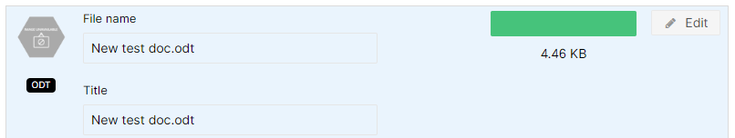  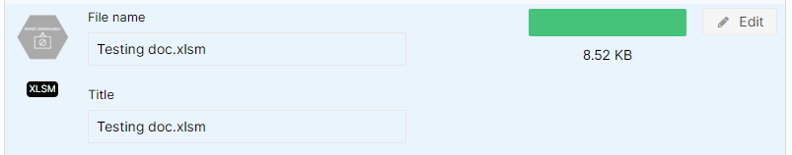 | PTHB
Upload Associated Images to Documents | A new Content Type has been introduced into the system ‘Document’. This new Content type give the user the ability to add an Image/Icon to a document you wish to upload.  Your added image would then be available (when selected) to display in document Lists such as ‘Table List’ and ‘Table List Advanced’.  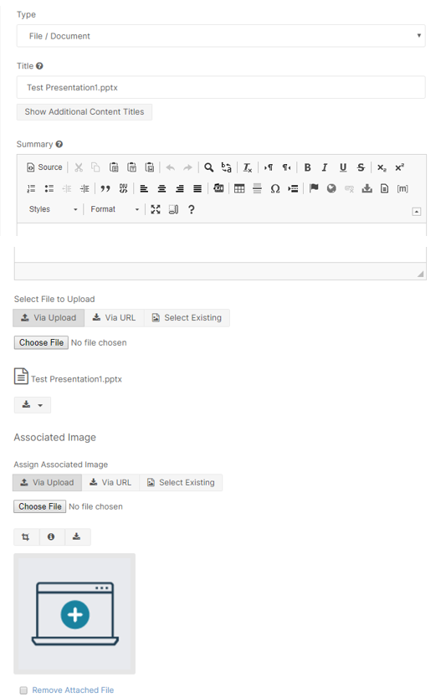 | PHW
Mobile Header Logo | The CMS Board came to the decision to re-introduce the NHS Celtic Knot into the sites mobile name display. This addition will be introduced to all sites.  Current Display    New Display  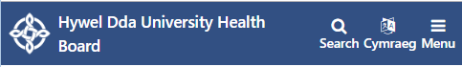 | The CMS Board
Update to FAQ List Display | Currently, when you place 2 FAQ Lists on the same page they will not function independently from each other. This change will see a fix added to the FAQ display so that when you display 2 on the same page they will now be unique; so, each list will no longer be affected by the other.  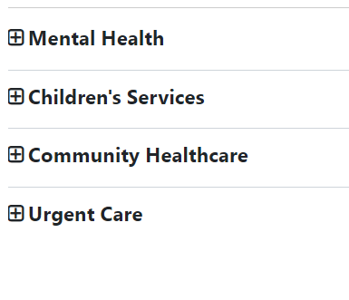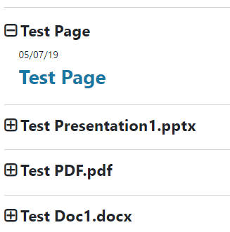 | AWMSG
Add Additional Editor Controls to Text Box | Following user feedback, we have added in further CK Editor options into the ‘Text’ Plugin. Some of the new options available are:  - Underline  - Text Align  - Tables  - Links  - Content Templates  - Styles & Format  Current Display  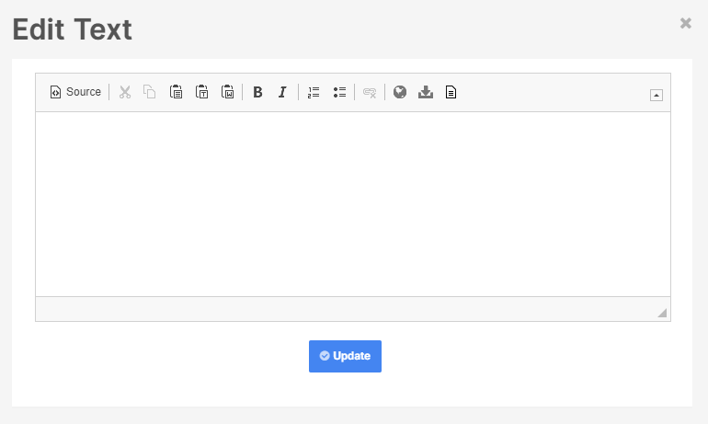  New Display  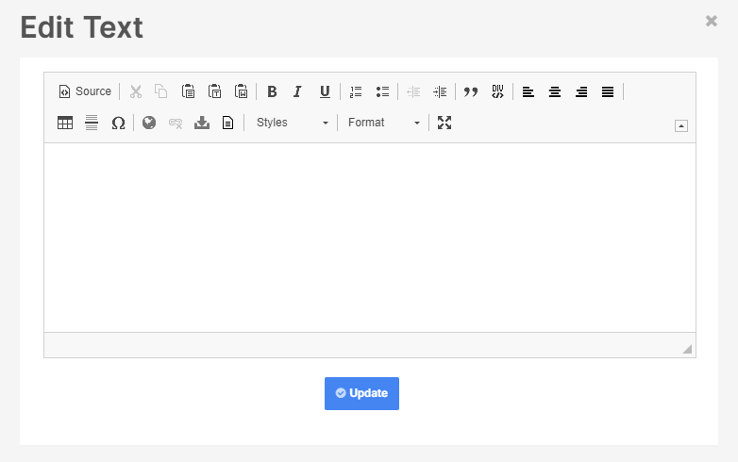 | NWSSP
Update to Multi Content 1 | This plugin has now been updated to include extra features. There will now be an option to add a background colour or Image and have this span the width of the site or remain within the bounds of the body of the page. We have also added in optional scrollable function, this would appear on your content block when 5 or more pieces of content are selected to appear.  Optional Background Colour/Image  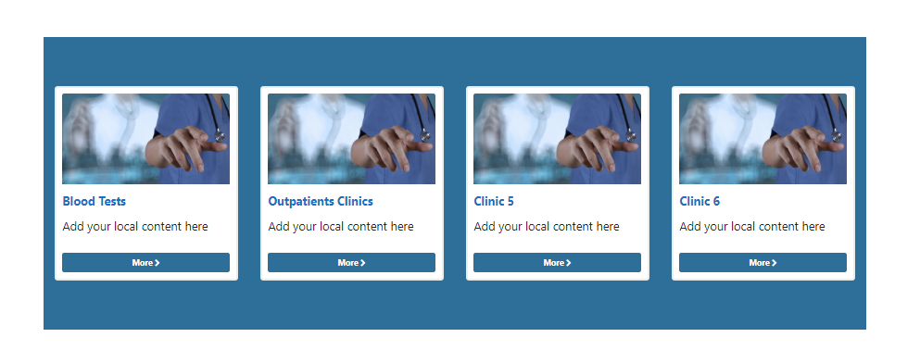  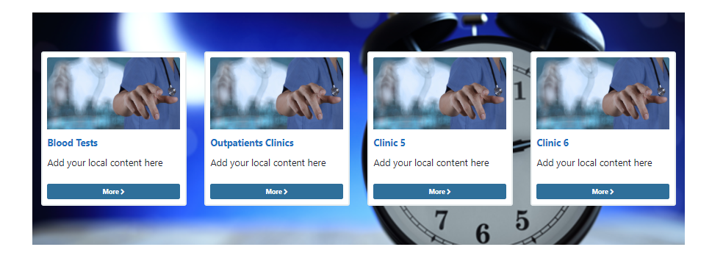  Optional Full Background & Scrollable Arrows     | CMS Support Team
Update to List Displays | Both the Table List and the Table List Advance have now received updates so that they are now able to display an Associated Image that has been added to the file.  *Please note: The Files Content Type must be ‘Document’ for the images to display.  Table List Example  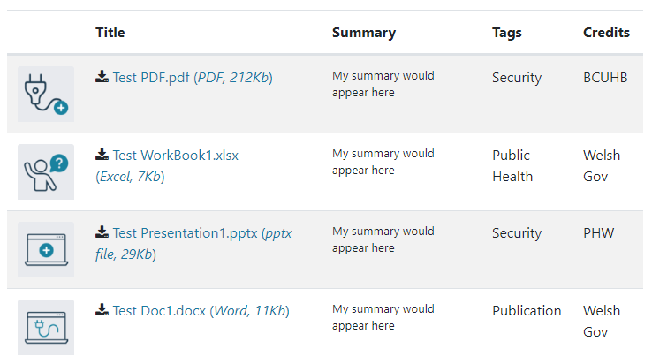  Advanced Table List Example  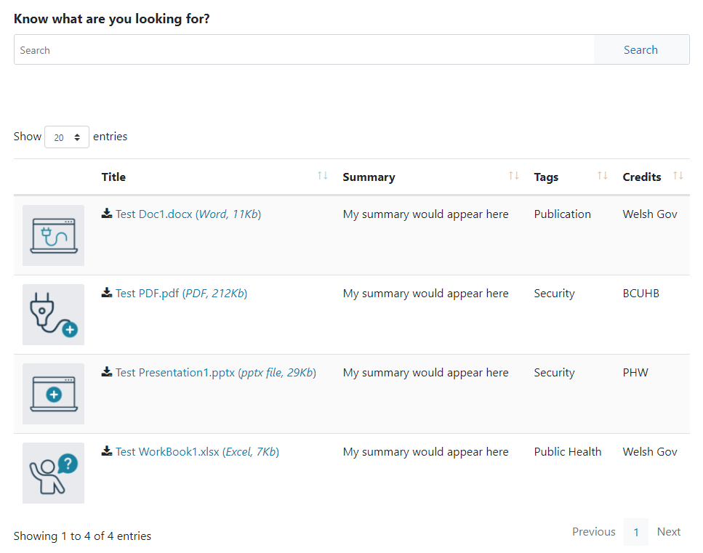 | CMS Support Team
Accessibility Updates | Ongoing Accessibility updates to the CMS regarding screen readers, as advised by RNIB review. These updates will only impact on users operating screen readers. | CMS Support Team

Problems Fixed

N/A

New Problems Identified During Testing and Associated Workarounds
N/A

Pre-requisites to Deploy the Release
N/A

Training Requirements
CMS support Site will be updated with any changes that introduce new functionality or changes to workflow.

Step by Step Deployment Instructions
No Deployment actions required by Health Boards

Deployment Plan
Changes to be implemented as specified in the Change Record
Release to be deployed via change record 75738

Back-Out Plan
Back out as detailed on each change record

Release Available for Deployment Date
NHS Wales : 18/12/2019

