REL-ID 539 CMS/08-2019

NHS WALES IT SERVICE MANAGEMENT
CMS Release Notes
Release ID: 539 CMS/08-2019
These Release Notes describe the scope and content of
Release ID: 539 CMS/08-2019

CMS

Version No. 1.0
Status: Approved

Owner: CMS Service Management Board
Author: Helen McGrath
Approver: Stephen Price
Date: 15/08/2019
Next Review Date: 22/08/2019
Tŷ Glan-yr-Afon
21 Heol Ddwyreiniol Y Bont-Faen, Caerdydd CF11 9AD
21 Cowbridge Road East, Cardiff CF11 9AD
Ffôn/Tel: 02920 500500
www.cymru.nhs.uk/gwybodeg
www.wales.nhs.uk/informatics

TABLE OF CONTENTS

1 DOCUMENT HISTORY 3
1.1 Template Revision History 3
1.2 Revision History 3
1.3 Reviewers 3
1.4 Authorisation 3
1.5 Document Location 3
2 INTRODUCTION 4
3 SERVICE MANAGEMENT BOARD (SMB) 4
4 RELEASE NOTES REQUIREMENT 4
4.1 Release Identification 4
4.2 Description of New or Modified Functionality 4
4.3 Problems Fixed 5
4.4 New Problems Identified During Testing and Associated Workarounds 5
4.5 Pre-requisites to Deploy the Release 5
4.6 Training Requirements 5
4.7 Step by Step Deployment Instructions 6
4.8 Deployment Plan 6
4.9 Back-Out Plan 6
4.10 Release Available for Deployment Date 6

DOCUMENT HISTORY

Template Revision History
Date | Version | Author | Revision Summary
6th March 2012 | 0.1 | Steve Finn | First Draft
15th March 2012 | 0.2 | Steve Finn | Second Draft following comments from SW
5th July 2012 | 0.3 | Steve Finn | Third Draft following release process modifications
26th July 2012 | 1.0 | Kelly Tremlett | Issued as approved version 1.0

Revision History
Date | Version | Author | Revision Summary
15/08/2019 | 1.0 | Helen McGrath | Senior Support & Business Analyst

Reviewers
This document requires the following reviews:
Date | Version | Name | Position

Authorisation
Signing of this document indicates acceptance of its contents.
Author’s Name: | Helen McGrath
Role: | Senior Support and Business Analyst
Signature: |  | Date: | 15/08/2019

Approver’s Name: | Stephen Price
Role: | Applications Manager (Corporate)
Signature: |  | Date: | 15/08/2019

Document Location
Type | Location
Electronic

INTRODUCTION
The NHS Wales Release Management Policy considers that effective Release Management is essential for protecting the integrity of the operational environment. A key objective of the release process is ensuring that users, support staff and other stakeholders are kept informed as to what is planned and how this will affect them. One of the ways that this can be achieved is through the publication of release notes prior to deployment of the Release.

These notes contain information on the agreed scope and content of Release id CMS/08-2019 for the CMS descriptions of new or modified functionality and problem fixes, descriptions of new problems and workarounds identified during the testing of this Release, training requirements, deployment instructions, references to deployment and back-out plans and key dates within the release process.

SERVICE MANAGEMENT BOARD (SMB)
The CMS Service Management Board has overall responsibility for ensuring that these Release Notes accurately describes the Release and that it is kept under constant review and updated to reflect any modifications to the Release prior to its deployment.

RELEASE NOTES REQUIREMENT

Release Identification
539 CMS/08-2019

Description of New or Modified Functionality
Item | Description |  | Requestor
Multi Content 1 Update | A swipe facility will be applied to this Plugin for use when viewing the site on a mobile. To aid accessibility the navigation arrows will now have a background colour to ensure they are visible no matter the colour image in use within the Plugin.  Current Display New Display  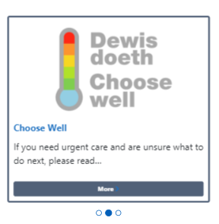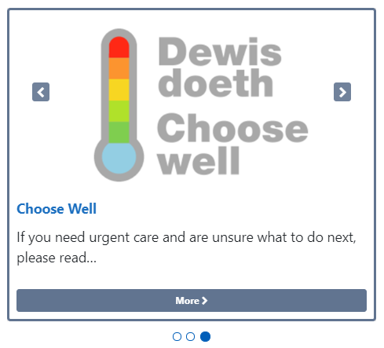 |  | PHW
Top Align Profile Card |  | Currently profile card sits as justified on the page, this causes the Image to ‘float’ further down the page depending on the amount of content added. When a large amount of content is added the image can appear very far down into the page. This change will see the profile image fixed at the top of the page.  Current Display New Display  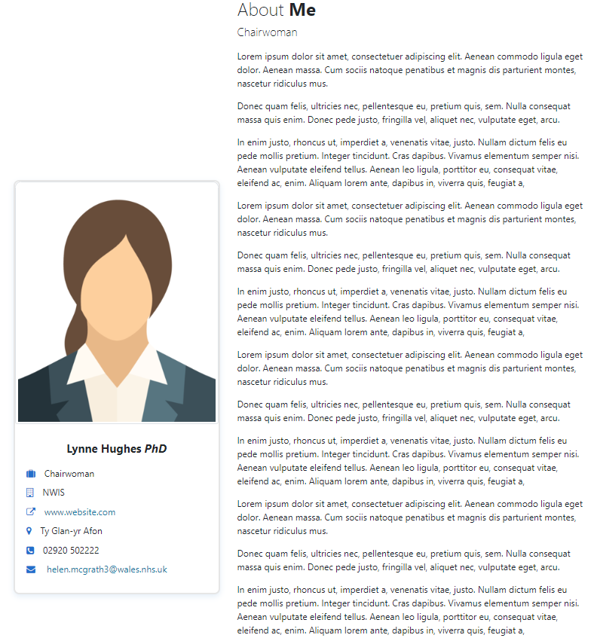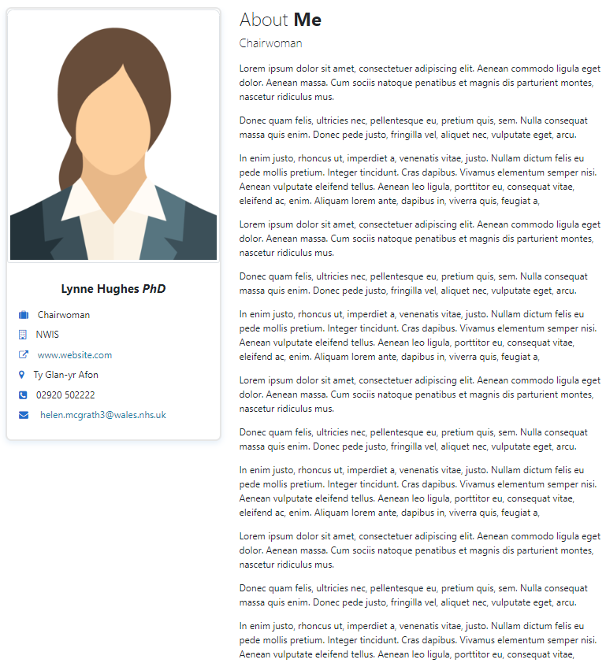 | CAVUHB
The Ability to Set Images as Links |  | This change will see the introduction of new functionality to the Image Key on the CK Editor bar. This Functionality will allow the users to set an Image as a Hyperlink. Once an Image has been selected there will now be a second search box available, when users type in the name of the desired link they can search for this within the site; Then select the Radio Button of the correct link.  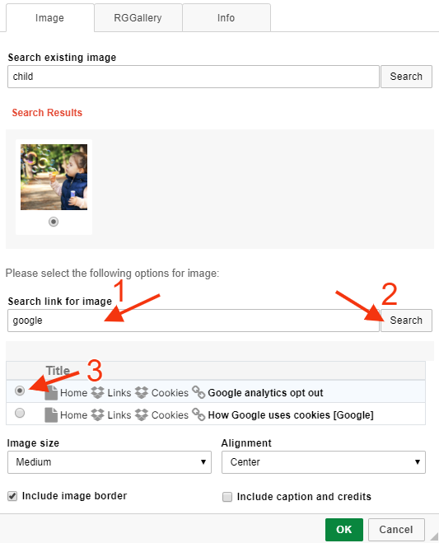 | CMS Support Team
Add Colour Coding to Events |  | Currently the Events are coded in only one colour within the Calendar display. This change will introduce the ability; within the page edit event detail, to select separate colours to highlight varied events.  Current Display  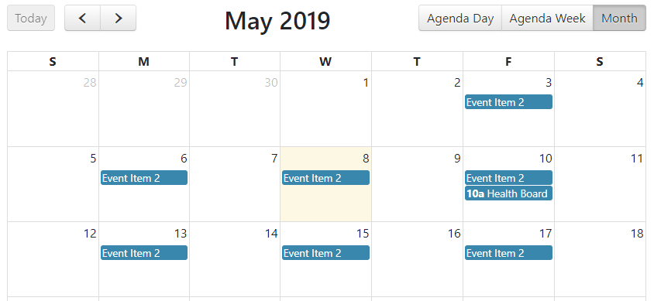  New Display  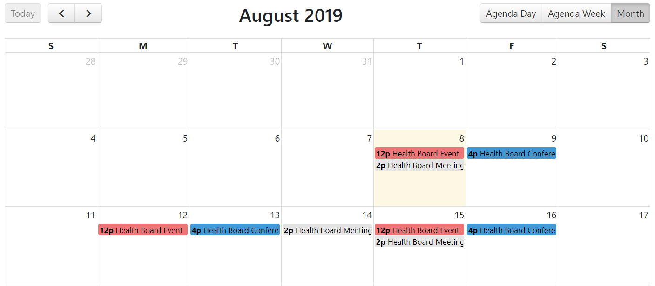 | HDUHB
New Events Standard Template |  | This change will introduce an Events Page Template. This new template will display information regarding your event, such as Location, time, date, related topics links and a journey planner. Users will also have the added option to add a contact card with the event organisers’ details.  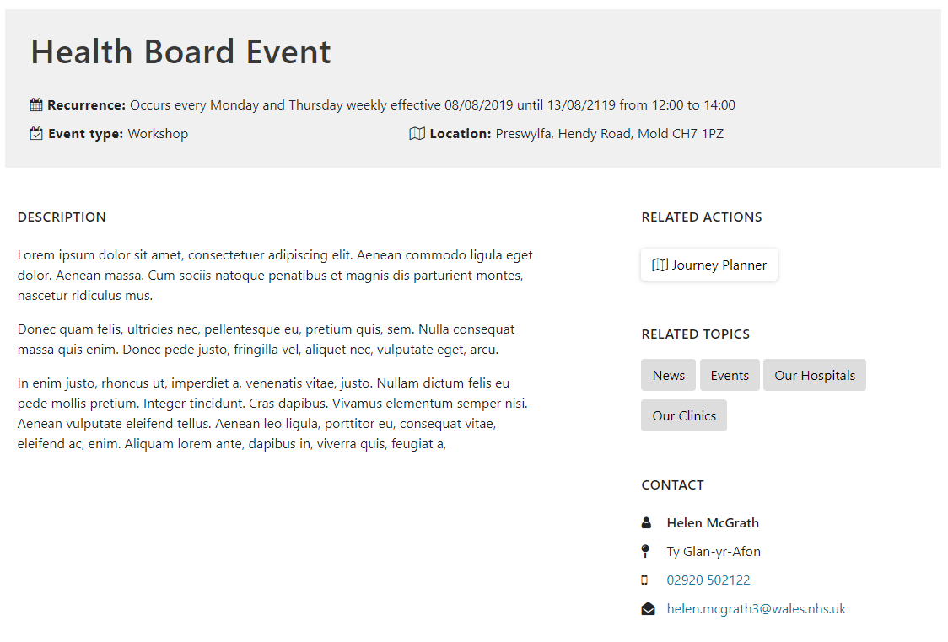 | CMS Support Team
Welsh Translation on Mobile Labels |  | When viewing the Welsh site on a mobile the Search and Menu options are currently showing in English, this change will see this text amended to Welsh. Search – Chwilio Menu - Gwymplen  Current Display  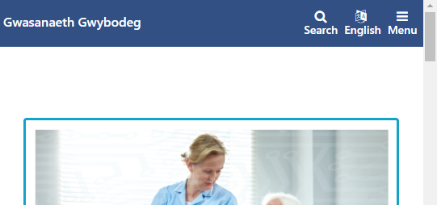  New Display  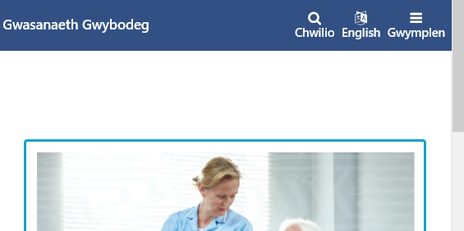 | CMS Developer Team
ALT Text Amendment |  | Currently the original name of the image is pulling through even though ALT Text has been added. This change will ensure that any ALT Text added to an Image will be accessable via a screenreader, whilst hovering over an Inage will display the Image Title.  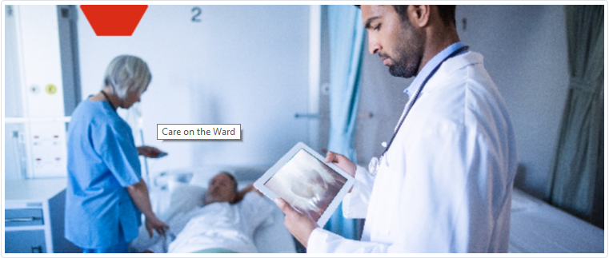  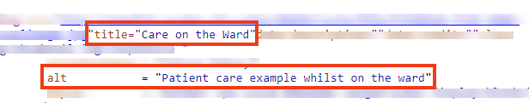 | SBUHB
Website Scroll Bar |  | Currently when you view the website there is a scroll bar in the footer, this scroll bar is added by the browser but is not warranted; as such this change will see this removed.  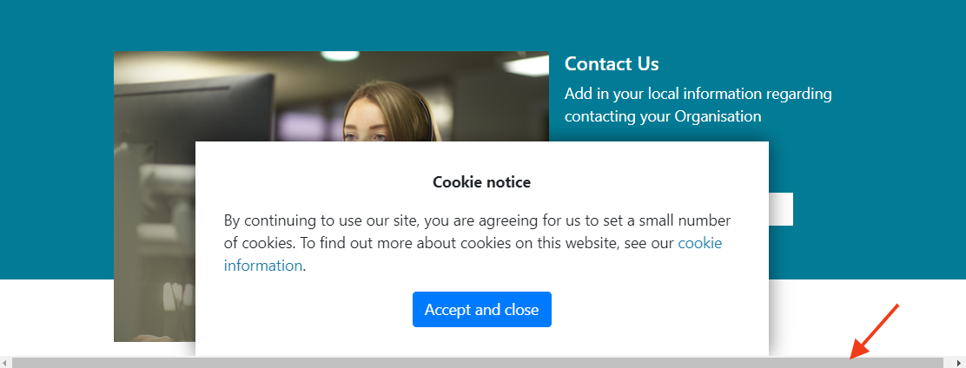 | CMS Developer Team
New Single Content Block 4 |  | We have created a new Single Content Block. This block will work slightly different to the current blocks available to users, the block will contain an Image, 2 levels of text and a Call to Action button. Each of these will be fully available to the user to customize.  The image would span the full width of the site but not be as tall as the current homepage carousel plugin.  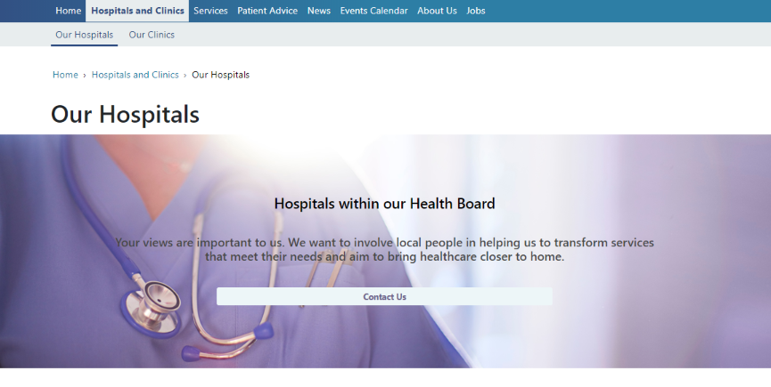 | NWSSP
Viewing Tables on a Mobile |  | When tables are placed on a page they are not resizing correctly when viewed on a mobile, and breaking the page.  This change will resolve this issue so that users of the website can clearly see information in the table when using mobile devices. Users will now see a scroll bar and have the ablilty to swipe to access further information.  Current Display New Display  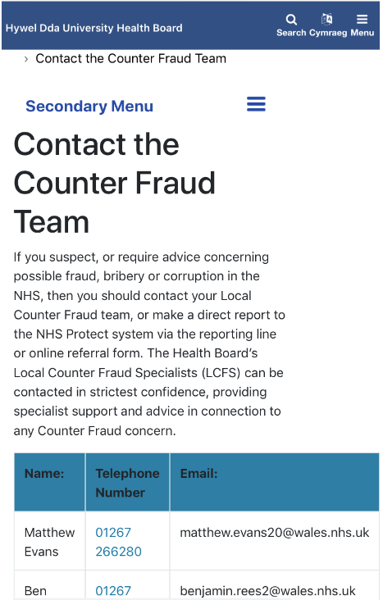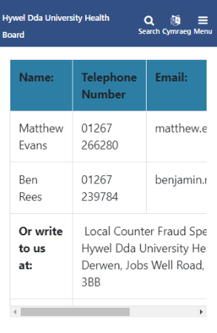 | HDUHB
Carousel Background Colour |  | Currently when you upload a transparent image to the Carousel a grey background colour is applied. This change will see this background colour turned off.  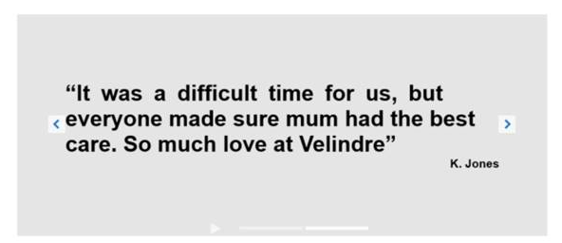 | Velindre
Links Organiser Update |  | Currently all fields within the Links Organiser are clickable links. This change will alter this behaviour so that Invisible (empty) Folders are set as place headers and are not available as clickable links.  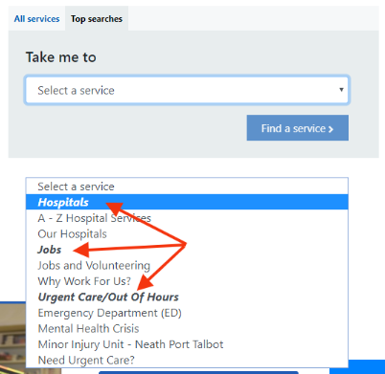 | Velindre
Advanced Table List Layout |  | A new Advance Table List Layout has now been created, this function is available within the Collection plugin.  The added benefit of this layout is an added Search and Advanced Search filter.  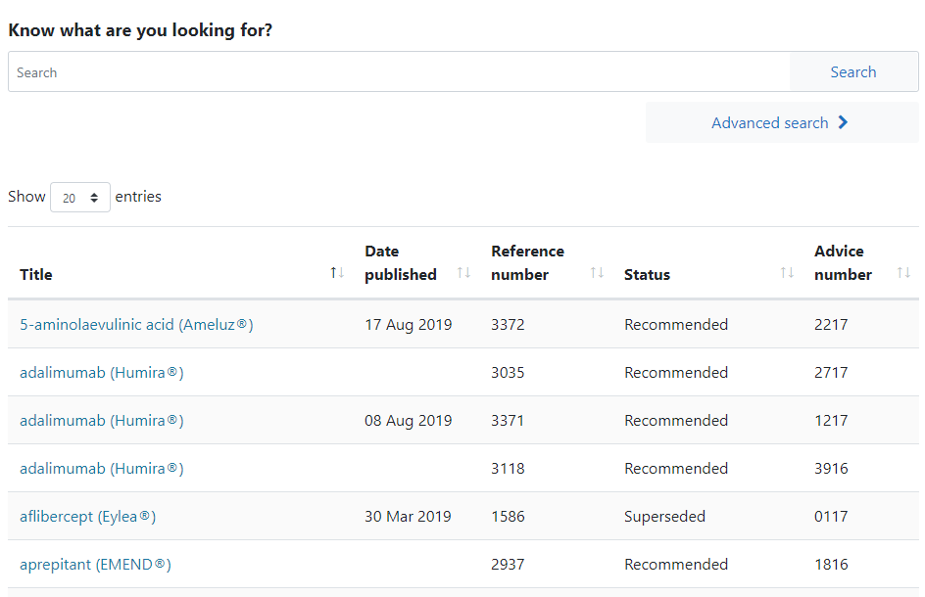 | AWMSG
New Search Function – Cross Site Search |  | The new Cross Site Search layout can be added to any page and provides a way of sending search text to search pages on external websites. There is also the ability to list up to three buttons below the search field which can take the user to related internal/external sites or pages.  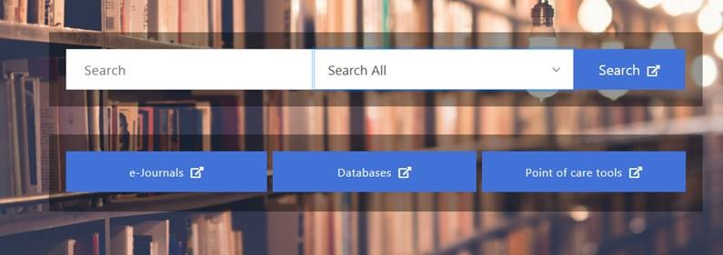 | eLibrary
Accessibility Update |  | A hidden H1 element will be added to the homepage of our websites. This is an Accessibility Requirement. Users with Screen readers would be scanning the homepage for the presence of a H1 tag. | CMS Developer Team
Accessibility Updates |  | Ongoing Accessibility updates to the CMS regarding screen readers, as advised by RNIB review. These updates regarding the Navigation Bar and Accordions will only impact on users operating screen readers. | CMS Developer Team

Problems Fixed

N/A

New Problems Identified During Testing and Associated Workarounds
N/A

Pre-requisites to Deploy the Release
N/A

Training Requirements
CMS support Site will be updated with any changes that introduce new functionality or changes to workflow.

Step by Step Deployment Instructions
No Deployment actions required by Health Boards

Deployment Plan
Changes to be implemented as specified in the Change Record
Release to be deployed via change record 72020

Back-Out Plan
Back out as detailed on each change record

Release Available for Deployment Date
NHS Wales : 04/09/2019

