REL-ID 512 CMS/04-2019

NHS WALES IT SERVICE MANAGEMENT
CMS Release Notes
Release ID: 512 CMS/04-2019
These Release Notes describe the scope and content of
Release ID: 512 CMS/04-2019

CMS

Version No. 1.0
Status: Approved

Owner: CMS Service Management Board
Author: Helen McGrath
Approver: Michele Golpaykar-rad
Date: 17/04/2019
Next Review Date: 29/04/2019
Tŷ Glan-yr-Afon
21 Heol Ddwyreiniol Y Bont-Faen, Caerdydd CF11 9AD
21 Cowbridge Road East, Cardiff CF11 9AD
Ffôn/Tel: 02920 500500
www.cymru.nhs.uk/gwybodeg
www.wales.nhs.uk/informatics

TABLE OF CONTENTS

1 DOCUMENT HISTORY 3
1.1 Template Revision History 3
1.2 Revision History 3
1.3 Reviewers 3
1.4 Authorisation 3
1.5 Document Location 3
2 INTRODUCTION 4
3 SERVICE MANAGEMENT BOARD (SMB) 4
4 RELEASE NOTES REQUIREMENT 4
4.1 Release Identification 4
4.2 Description of New or Modified Functionality 4
4.3 Problems Fixed 5
4.4 New Problems Identified During Testing and Associated Workarounds 5
4.5 Pre-requisites to Deploy the Release 5
4.6 Training Requirements 5
4.7 Step by Step Deployment Instructions 6
4.8 Deployment Plan 6
4.9 Back-Out Plan 6
4.10 Release Available for Deployment Date 6

DOCUMENT HISTORY

Template Revision History
Date | Version | Author | Revision Summary
6th March 2012 | 0.1 | Steve Finn | First Draft
15th March 2012 | 0.2 | Steve Finn | Second Draft following comments from SW
5th July 2012 | 0.3 | Steve Finn | Third Draft following release process modifications
26th July 2012 | 1.0 | Kelly Tremlett | Issued as approved version 1.0

Revision History
Date | Version | Author | Revision Summary
17/04/2019 | 1.0 | Helen McGrath | Support & Business Analyst

Reviewers
This document requires the following reviews:
Date | Version | Name | Position

Authorisation
Signing of this document indicates acceptance of its contents.
Author’s Name: | Helen McGrath
Role: | Senior Support and Business Analyst
Signature: |  | Date: | 17/04/2019

Approver’s Name: | Stephen Price
Role: | Applications Manager (Corporate)
Signature: |  | Date: | 17/04/2019

Document Location
Type | Location
Electronic

INTRODUCTION
The NHS Wales Release Management Policy considers that effective Release Management is essential for protecting the integrity of the operational environment. A key objective of the release process is ensuring that users, support staff and other stakeholders are kept informed as to what is planned and how this will affect them. One of the ways that this can be achieved is through the publication of release notes prior to deployment of the Release.

These notes contain information on the agreed scope and content of Release id CMS/04-2019 for the CMS descriptions of new or modified functionality and problem fixes, descriptions of new problems and workarounds identified during the testing of this Release, training requirements, deployment instructions, references to deployment and back-out plans and key dates within the release process.

SERVICE MANAGEMENT BOARD (SMB)
The CMS Service Management Board has overall responsibility for ensuring that these Release Notes accurately describes the Release and that it is kept under constant review and updated to reflect any modifications to the Release prior to its deployment.

RELEASE NOTES REQUIREMENT

Release Identification
512 CMS/04-2019

Description of New or Modified Functionality
Item | Description
A change to the Homepage Carousel | This will lower the overlay height on the Carousel image and add an optional back ground colour to the navigational arrows  
Multi Content Display 2 overlay height adjustment | This will lower the overlay height for multicontentDisplay2 so it isn't obscuring as much of the image  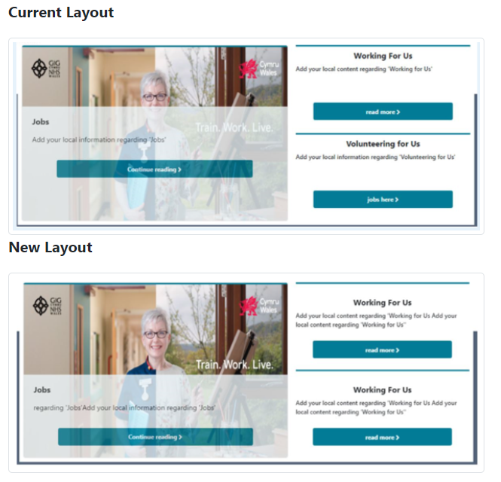
Tag cloud manager fix | Change the current logic so that the system knows the URL contains a tag and includes it in search terms  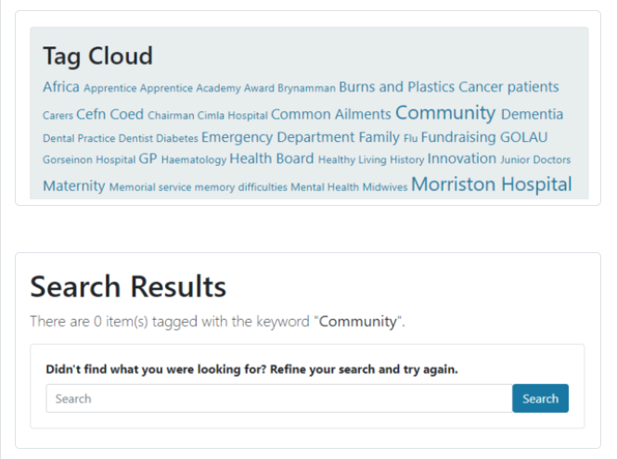
Improve Sharebar accessibility and consistency | - Allow admins to be able to change the colour of the text on the sharebar, as they can with the background colour.  - Ensure labelling is consistent so when you hover over the sharebar/social bar the text e.g 'Share this content on'  - When the label is changed on the sharebar the hover over text will now match  
HTML removal | Currently not leaving spaces between words in the collection module  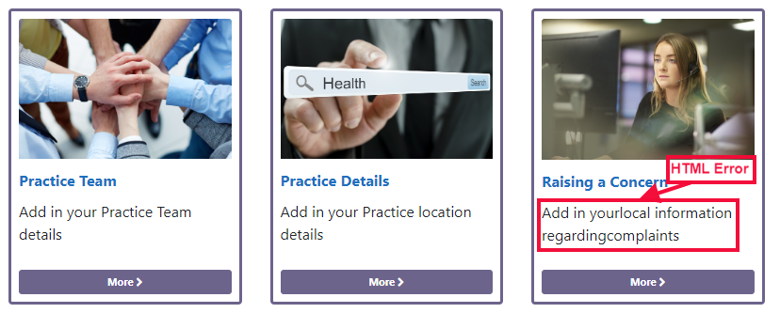
Update Train Work Live | This will update the Train Work Live site theme to latest bootstrap version - This change only applies to the Train Work Live website

Problems Fixed

N/A

New Problems Identified During Testing and Associated Workarounds
N/A

Pre-requisites to Deploy the Release
N/A

Training Requirements
CMS support Site will be updated with any changes that introuduce new functionality or changes to workflow.

Step by Step Deployment Instructions
No Deployment actions required by Health Boards

Deployment Plan
Changes to be implemented as specified in the Change Record
Release to be deployed via change record 69002

Back-Out Plan
Back out as detailed on each change record

Release Available for Deployment Date
NHS Wales : 29/04/2019

